Date: 26.12.2020
Group 2, Term 3
Proffesional Career Development report Lecturer: Hossein Shokri
Raya Lyubomirova Kardzhieva Student ID: 1916653

Content Page

Introduction/Lifeline p3

Self-Evaluation Pp 4-5

Goals Pp 5-6

SWOT Analysis Pp 6-7

Reflections p 7

Plan of Action Pp 7-8

Understanding and Expectations p 8

Reference List p 9

Appendix 1 p 10

Appendix 2 p 11

Appendix 3 p 12

Appendix 4 p 13

Appendix 5 p 14

Introduction

As a young adult, we all know how hard it is to make a career choice and what studies to choose at school to begin developing knowledge in the path we have decided to take. I was inspired by Architecture, creativity and art, when I was a teenager, therefore I chose to study Construction and Architecture in High School. Shortly after my first job was salon assistant in Hairdresser’s shop, I have realised I was drawn into creativity and art, not the Architecture itself. I discovered a passion to hairdressing and makeup/body art, that I never imagined I had. The owner inspired me to train as a hairdresser and encouraged me to use my skills as an artist to contribute within the team as an artist and gave me chance to work in the Fashion industry with him. This is how I began career in hairdressing after I have qualified within the industry. Since then I have worked as a hairdresser for 15 years and continuously learned new techniques and even barbering to be competitive in the field. With this experience I have built a wide knowledge of hair types and working with people from all over the world to expand my customer service skills. To get where I want to be today, my skills and knowledge are not quite enough to achieve my career goals and work what I am passioned about. I started researching options on what it is needed to be in Fashion/Film/TV with the skills I have while studying in university of Wales Trinity Saint David London Campus to help me achieve these goals. The in-class exercise we did in week 2, helped me visualise where I am at this point in my life with drawing a Lifeline and analyse what my motivations are and my weak points. (Neill, 2011) Drawing a Lifeline could help me structure my progress in life. (Refer to Appendix 1)

Self-Evaluation

As of where I stand today with 15 years of experience, I have not achieved what I wanted. Starting university motivated me to set up clear goals and understands how to structure step by step plan of action to reach the position I want at work. Motivation of success could be financial or mental within the work environment. (Bruno S. Frey, 2002) What motivates me is success being financial or by getting closer to set tasks or goals. Studying at University of Wales gives me the motivation of achieving and confidence of how to achieve those goal becoming a professional hair and make-up artist in TV/Film industry. My lack of confidence has been always a hurdle, that I have to overcome by expanding my knowledge to prepare me for job applications. Successful people around me motivates me to become more competitive in the industry and have higher standards for my skill sets.

In class we have discovered, that there are different learning styles where individuals use to achieve better results in learning depending on the specific method suitable for them. We are more effective in learning, if we are aware of the way accept the information easier. Cognitive styles have been developing since 1970’s , where many researches from phycologists have been made to create best learning styles for students to adapt to. (K. Logan, 2002) One of the ways to know how to be effective is to use the Honey and Mumford questions, that were designed to identify our learning style to help progress. (Rosewell, 2005) In class we were introduced and tested our learning styles to analyse what is the best method we are efficient in gaining the knowledge. Different minds adopt to different methods: Activists can be people learning by doing, which could be physical activity or by simply hand on trying and understanding. Theorists like to gather, understand and break down the information before they act on. Pragmatists use mainly concepts and experimenting with ideas and case studies to assess what is the best way to achieve or problem-solving solutions. Reflectors are more observing with their learning and like to watch what has happened before jumping to conclusions. They are more likely to take feedbacks and opinions from others to analyse plan of action in advance. (Rumson, 2017) The results I have received from the questionnaire are that my learning style is not categorised by just one method. Due to nature of my future career path, I have discovered, that in Hairdressing and Make-up, we have to watch and observe techniques on how to achieve desired results. From the Honey and Mumford methods of learning I have discovered that I have almost even results of being a Theorist and Pragmatist as you can see in Appendix 2. My approach of learning is when I watch, observe and be creative in how to achieve the desired results. I must know the theoretical, before beginning to act and develop a look or style. With the experience I have until today, it matches the way learn skills in the industry. It has been very interesting and helpful to understand how to be more efficient at my job and how to extract the best information and knowledge required to become successful in my field regarding career development.

Goals

Being motivated to achieve my goals, that I have set takes effort and determination in the process. Being able to structure them is part of my learning experience in Level 4 of my study. Positive and realistic approach is necessity to structure our SMART objectives developed idea by George T. Doran in the 1980’s. This framework has been also used widely within management to clarify strict goals to be followed in a team. (Blome, 2019) One of the SMART goals I have set is to become a Hair, Media Make-up and Prosthetics Artist in TV/Film production by 2025. (Refer to Appendix 4) I have always wanted to work in the industry, but there was numerous of challenges in the past, now I have the clear idea of the way this can be achieved, I can only now begin to follow with a plan. The steps are structured, and timeframe has been set that realistically can be achieved. Completing all the qualifications needed within 3 years is the first step to build the skills and knowledge. Building a portfolio is a very important step to showcase my skills, which will take practical experience and time, which I have given myself to be able to work on set. This could be achieved by collaborating with other students in film production studies or apprenticeships. Only then I can be confident and competitive to start applying for jobs. Strictly following my SMART objectives will lead to my desired success.

SWOT Analysis

Following up with my goals and setting them, I have learned how important it is to know where I stand and why I haven’t developed career to present. Using tools to analyse where I stand today and what I need to expand on, such as type of skills and knowledge is crucial to develop a desired career. The use of SWOT analysis in companies has been and it is until today put into practice to visualise a status within a company and even in personal prospective, before action is planned for improvement. The effectiveness of this tool is a step of planning how achieve goals or solve problems within a company or individuals. Understanding my weaknesses and strengths will help me to improve and be more competitive candidate to get the job I want. (Quast, 2013) Before I was aware of SWOT analysis, I did not know as of why I could not achieve my goals. Analysing myself and visualising what I need has been very effective for me. Once I have processed the information, I was ready to improve and realise what opportunities are available for me and what the threats are to be able to be more efficient. ( Refer to Appendix 3 ) Researching and gathering information about the industry and what opportunities are presented made me realise where I need to concentrate to become more competitive. Knowing that getting a job in Film/TV industry is very difficult and high competition gave me motivation to learn more in depth about to succeed.

Reflexions

Having this opportunity to study the module “Professional Career Development” gave me a prospective view on how to approach achieving my goals. Being able to understand what is desired from employers, have been very helpful. It is a complex process of many steps. It made me realize how much more effort is needed and determination to improve myself along the way. Having soft skills is one very important part of being competitive, that I never thought of before. Being able to communicate in a professional manner and have positive attitude is giving me a better chance in competing for a job position. It is not strictly by having the knowledge and experience in the position, being organised, determined to be creative, efficient and confident within yourself will be noticed by employers. (Anon., 2020)As we have experienced in class a role play attending a job interview helped me to build more confidence for future applications. I have also learned is how important it is to research the company and their culture and what their expectations are from the future employee. This role play will help me to be more aware of what to expect at an interview.

Plan of Action

To be able to accomplish my goal, I need a clear structure to follow step by step and realistic timescale. Therefore, I have structured a Personal Development Plan. ( Refer to Appendix 5 ) It is a structured and detailed list including how it will be proceeded, realistic time given and what do I need to achieve these. Once I have clear goals, I can begin planning. PDP helps me have a clear understanding of what I need to improve on, as well as how I am able to do it. Writing all the short-term goals will bring me to the final career track. (Rolfe, N/A)It has been very helpful tool to motivate me complete all those steps in a time frame and structured plan of action. As you can see in the Appendix, to become a Hair, Make-up and prosthetics designer is a complex skill set. In order to become one, I need to have managerial skills to run a hair and make-up department. This position it is not only having the practical skills and creativity, it requires working within a team and follow ideas/visions of producers and directors.

Understanding and Expectations

Theoretically I am prepared in terms of what to expect and have made a research of what is needed to get the job I have always wanted. Being flexible and add creativity is only beneficial for the role. Not having the experience in the industry is making me nervous to begin. Being determined to achieve my goals will help me build the confidence I need. Experience on being on set will help me understand in depth how the working day is proceeded and maybe what more is required for me to adapt to or learn. With positive approach everything I want is possible to achieve and the help of learning all the skills required will most certainly take me to my final goal.

Reference List:

Works Cited
Anon., 2020. Future Learn. [Online]
Available at: https://www.futurelearn.com/info/blog/soft-skills-what-they-are-and-how-to-develop-them
[Accessed 27 December 2020].
Blome, S., 2019. S.M.A.R.T. Goals Provide Structure and Orientation During a Project. [Online]
Available at: https://www.projectwizards.net/en/blog/2019/09/smart-goals
[Accessed 30 December 2020].
Bruno S. Frey, M. O., 2002. Successful Management by Motivation. Berlin: Springer.
K. Logan, P. T., 2002. In: Learning Styles in Distance Education Students Learning to Program.. UK: Department of Computing Open University, pp. 29-44.
Neill, C., 2011. Conor Neill. [Online]
Available at: https://conorneill.com/wp-content/uploads/2014/07/lifeline-exercise-rhetoricaljourney.pdf
[Accessed 23 12 2020].
Quast, L., 2013. Forbes. [Online]
Available at: https://www.forbes.com/sites/lisaquast/2013/04/15/how-to-conduct-a-personal-s-w-o-t-analysis/
[Accessed 1 January 2021].
Rolfe, A., N/A. Reed. [Online]
Available at: https://www.reed.co.uk/career-advice/personal-development-planning-what-you-need-to-know/
[Accessed 30 December 2020].
Rosewell, J., 2005. The open University, Learning Styles. [Online]
Available at: https://www.mcphedran.co.uk/uploads/4/5/0/7/45076511/learning_styles_-_open_university.pdf
[Accessed 01 January 2021].
Rumson, R., 2017. The E-learning network. [Online]
Available at: https://www.eln.io/blog/honey-and-mumford-learning-styles
[Accessed 1 January 2021].

Appendix 1

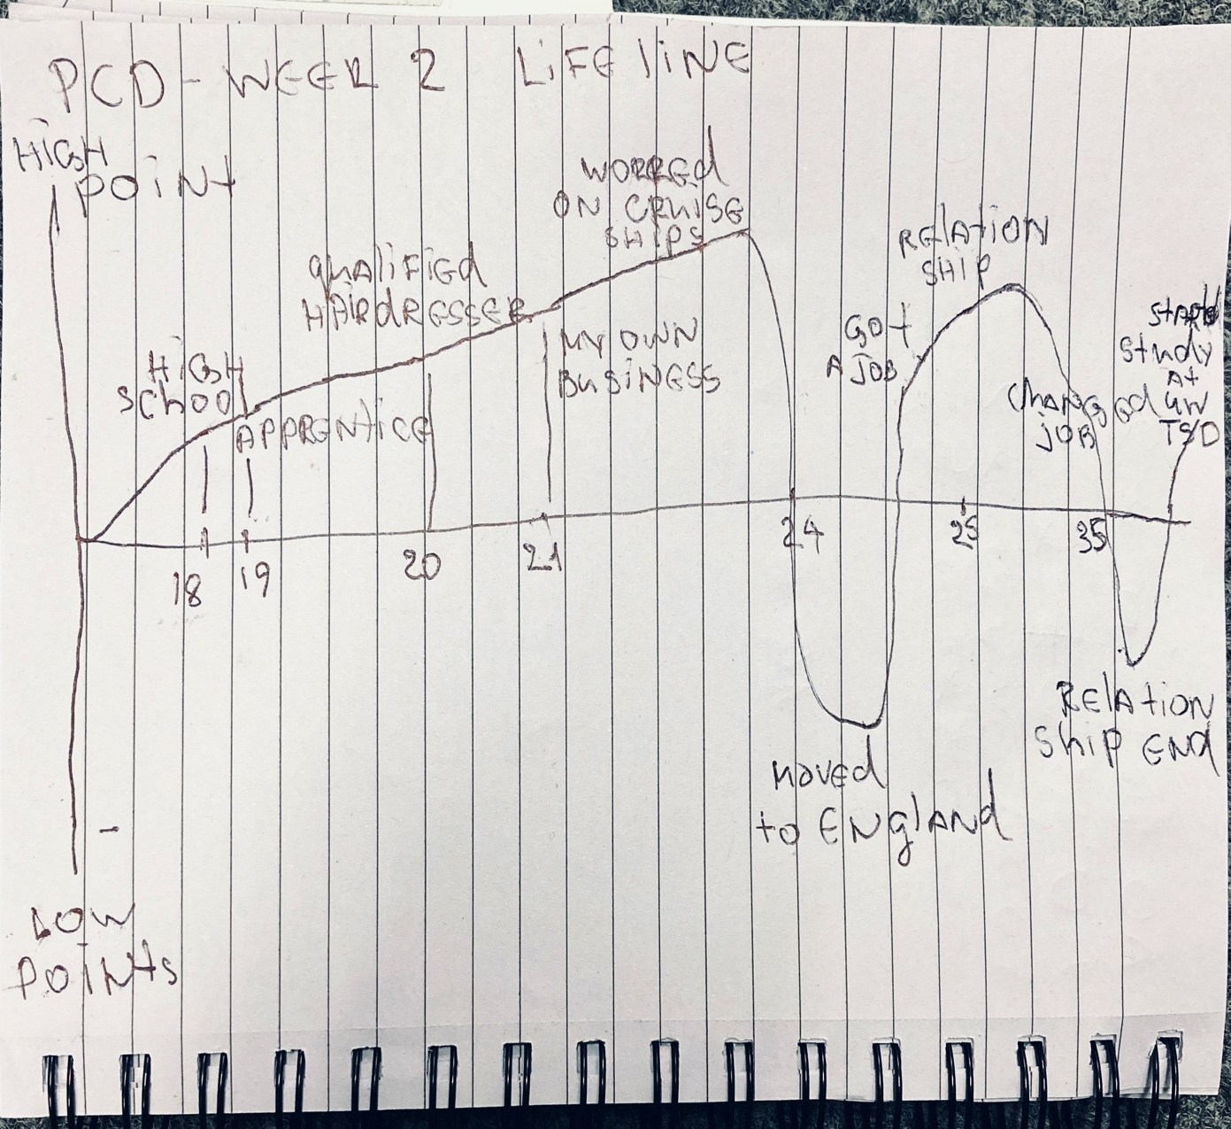

Appendix 2
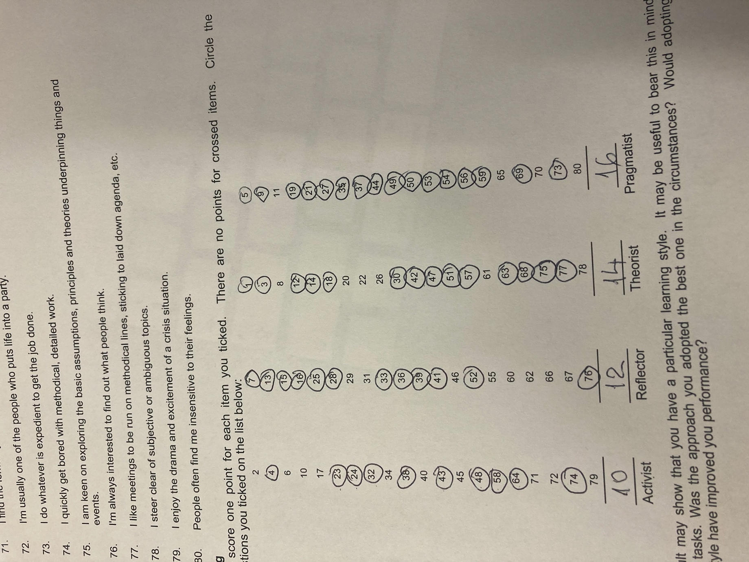
Appendix 3 SWOT

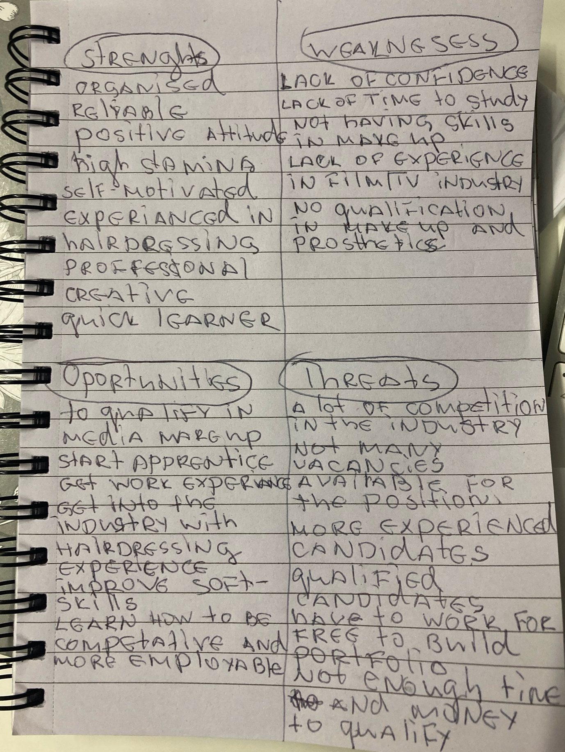

Appendix 4 SMART objectives

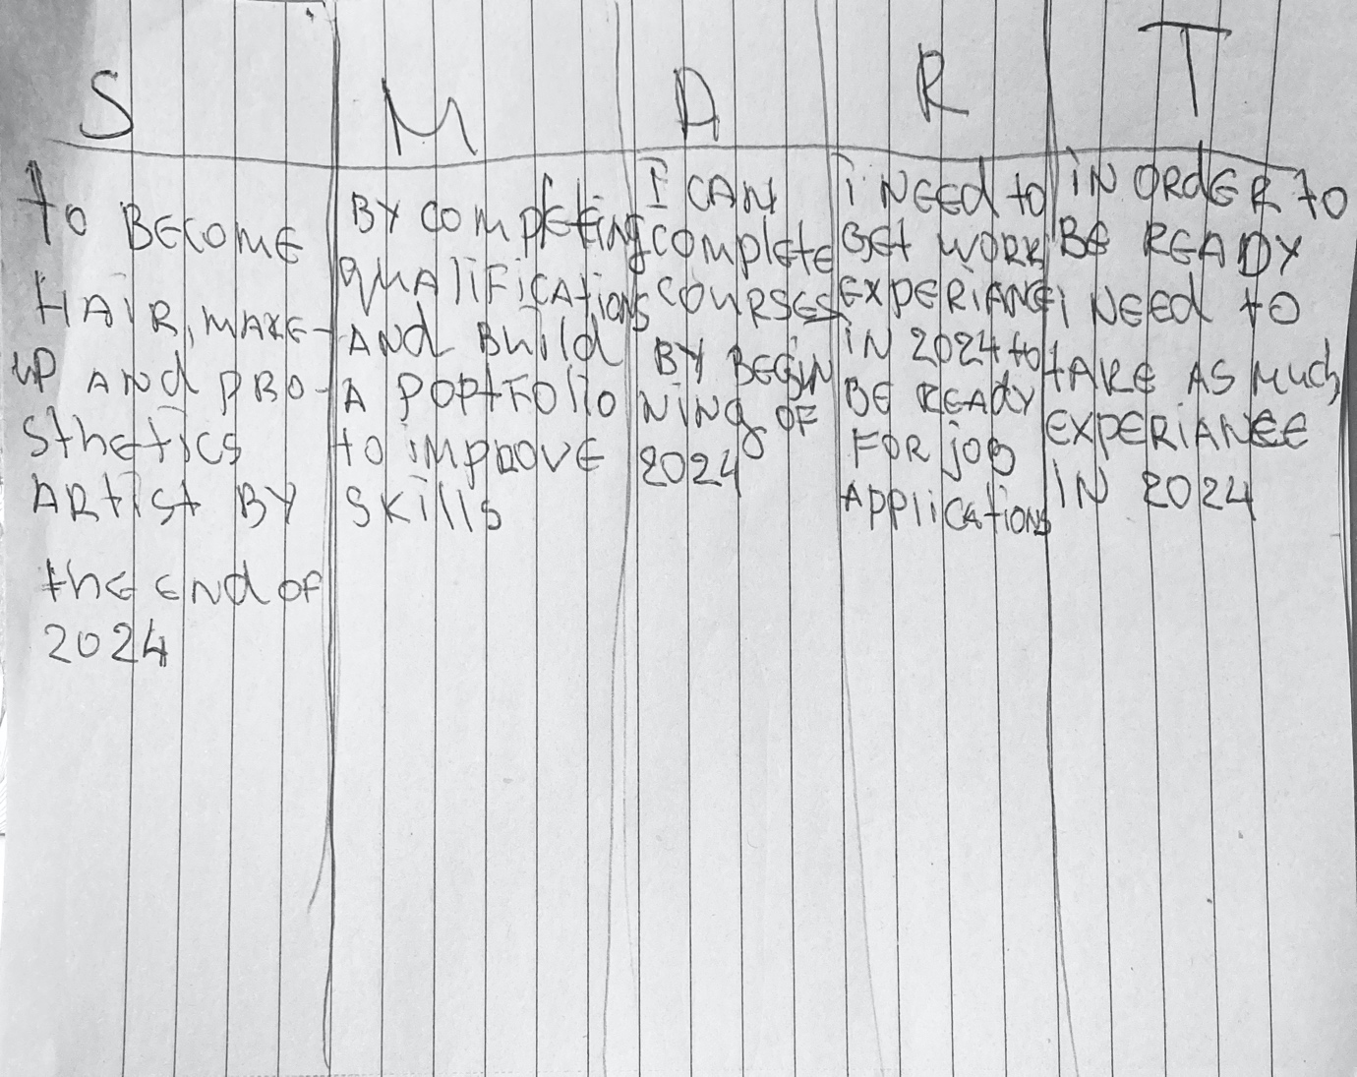
Appendix 5



