Assignment title: Strategic Management

Student Name: Neslihan Aydin
Student Number:1606007
Module Name: Strategic Management
Module Tutor: Gladius Kulothungan
Word Count: 4933

Table of Contents
Introduction 3
Section 1: Overview of Netflix 4
Section 1.1: Strategic management 4
Section 1:2 Netflix business environment strategic Analysis 5
Section 1.3: Netflix PESTEL Analysis 5-8
Section 1:4: Porter's five forces on Netflix 8-10
Section 2: Process of strategic management 10-11
Section 2:1 Formulation of Strategic 12
Section 2:2: Netflix Strategies and implementation 13-16
Section 3: The Corporate strategic direction 17
Section 3:1 Analysis of the Stake holders 17-18
Section 3:2 The Battle for India 18-19
Section 3:3 Recommendations 20
Conclusion 21
Reference List: 22-23

Introduction:
This report focuses on the analysis of Netflix from a case study and how the initial starts up of the company was first established in the United States to the status of the business now. To express how important strategic management is in any industry like media and the entertainment business. The ongoing plans of monitoring the business by analysing the objectives and goals. The strategies within the company to be successful the organization needs to adapt to changes within the environment. The models and theories are evaluated in development of emergent strategies in the stage of Netflix up scaling. They have used the theoretical frameworks and techniques to show evidence of their findings. Netflix has found the most suited strategic management by achieving competitive advantage by analysing the strategy implementation, formulation, and the strategic direction to help expand and grow the company even more than ever by entering new markets across the globe. Future recommendations will be made with also my own evidence of my own findings to support my research with secondary data.

Section 1:
Overview of Netflix:
Netflix was founded in 1997 by Marc Randolph and Reed Hastings. Where they originally had mail order rental of DVD being sent out to customer's personal addresses. By 2007 Netflix started streaming online and cancelled DVD rental being sent out. In 2019 Netflix had over 167 million paid customers across the world. In the last 50 years of television, it shows how much has changed from tapes to DVD and now online streaming via a smart device (Netflix, 2021).
Netflix structure is relevant to the companies needs to make quick decisions to keep up to date with the market of online entertainment changes. The Structure helps the company compete against other competitors such as, Amazon. The organizational structure has a U-form or unitary structure has the involvement of a hierarchy executive control of maintaining and the direction used within the organization. This structure is known to be flat compared to other businesses like for example, Organizational chart of Netflix the business executives must all report back to the CEO. This structure has less need for management levels which are used for escalating problems from company's online of the bottom line to the headquarters of the organization (Anderson, 2019).

Section 1.1:
Strategic management:
Is the way an organization is managed to help reach its objectives and goals. Strategic management contributes to the setting of the objectives, the competitive environment being analysed and evaluating strategies to ensure management helps place the strategies of the organization across the firm. An enforceable process to strategic management helps outline how it should be developed whereas, the descriptive process focuses on how strategic should be put into place. This could differ depending on how the strategic is developed and if all the opportunities and threats are foreseen or could be like a basic guiding principle being adapted (Mansa, 2021).
Section 1:2
Netflix business environment strategic Analysis:
This is the process which requires the tool application such as, the company SWOT, PESTLE, and porter five forces to show the answers the organization needs to analysis the company fully. The Internal analysis of Netflix is the business ability to help maintain a sustainable competitive advantage which is influenced by things such as, the core competencies and the strength which is embedded within the company by strategic recommendations. As a firm Netflix must identify the competencies, capabilities, and the resources to complete with their competition. Netflix has brand name recognition and has many Oscars award winning series which the viewers love to watch (Netflix, 2016). Netflix has become one of the leaders in development of providing online streaming services. The competitive advantage is the quality and the variety they provide to their customer base. The distribution network and infrastructure are exactly what they have for the content to align with VRIO decision tree, this is very costly, valuable, and almost rare which helps capture value. Netflix has another core competencies where they have a superior data collection and capabilities of analytical. This is implemented with the knowledge of their consumers by finding out their habits however, most of all Netflix best strength is having something for every age to watch.

Section 1.3:
Netflix PESTEL Analysis:
Being one of the leading streaming services providers online the company serves over 169 million subscribers across 190 different countries. Netflix has grown fast by the increase of people using Smartphone's and likes of 4G. This is one of the reasons why there were so many new customers from India as the internet was revolved and people had easy access to data. The popularity of Netflix has many different factors such as, experience of their customers, collection of the original movies or series but mainly due to marketing strategy being effective.

Pestle Analysis of Netflix:
The Political Factors: are always growing for technology companies worldwide. Even through Netflix is only a streaming company it is also a technology company, and they are also subject to the government scrutiny like the rest of the technology companies. Around the world the government has made it stricter for technology firms to get a hold of data collection and other practices. The government in the European union has become very strict on technology firms by not allowing them to target users by the collecting the data policy. Each market has its own level of regulation which Netflix must follow and tailor the services they provide to accommodate to that region. In countries like the EU there are new laws on tax which could affect Netflix growth of tax liability.
The Economic Factors: Having higher economic factors and the level of employment leads to spending money on entertainment and leisure activities. Within the past few years, the global economy performance has stayed impressive which means people across the world end up spending money on entertainment services like Netflix. In addition, since the spread of cornoavirus the economic activity has showed a decrease Netflix has showed an increase in customer joining. The economic activity is due to rise again once the stay-at-home rule relaxes. Netflix could have an adverse effect on their business if there is low economic activity for long period of time as people may tend to save if the lockdown continues. Another major factor due to cornoavirus is unemployment or work hours being reduced means people will have to cancel any unnecessary costs such as Netflix to save on money.
The Socio-cultural Factors: play an important role within the context of international business and strategy of the market. Having global audience Netflix must pay attention to people culture and different societies to have vary of preference for different customer taste. This is one of the reasons why Netflix has different genres and several languages for people to understand. The main target for Netflix has products tailored to cater for the modern generation. Technology mad and consumers entertainment online is the generation they have catered for.

Technology Factors: has driven competition and growth within the business industry. The core of the business model for Netflix is technology. Within the Netflix office there is always technology stuff discuss going on there. Customer experience has become one of the most important factors behind the surge of popularity. The improvement of user interface which gives subscribers the experience best in class. Main source of competitive advantage for Netflix is technology. Netflix uses algorithms and learning machine to individuals’ subscribers by recommending different movies and shows to watch. This is one of the reasons why Netflix has created a unique experience for their individual customers. In addition, technology is not just the cause of competitive advantage, but it is the reason why the competition within the industry is driving high. The competitive market means Netflix competes with different business such as, social media, gaming, and streaming services online. To overcome the competitive pressure Netflix must continue improvement of technology. Investment of research and development Netflix gives large amounts to help drive better user engagement and for popularity to grow.
The Environmental factors: Any large businesses are in content with environmental factors as the impact on the environment will have a straight impact on the brand image and social reputation. Any large brand must invest in the environment just like Netflix has too as Netflix entire business is based online unlike other businesses online operated, they will not have a direct or big environment impact. The processes of business which is related to global or large business the company cannot operate without the consuming resources in addition, Netflix must understand the impact the environmental has and as much as possible minimize it. Around 94,000 megawatt hours of energy were used in 2019. Netflix supports renewable energy projects within 20 countries and 15 states across within the United States.
The Legal Factors: The legal factors will always have a major role within the entertainment industry of technology and digital as the laws are evolving as the governments across the world are developing a strong legal framework for the technology industry to regulate. Many of the large technology companies such as, Amazon, Apple have faced a large amount of cases against the company related to user privacy and anticompetitive behaviour. Many of them have ended up paying large fines. For Netflix one of the most important concerns is the user privacy and protection of the user data. Noncompliance could result in heavy fines if legal compliance is more important than ever this can also cause damage to the brand reputation (Pratap, 2021).

Section 1:4:
Porter's Five Forces on Netflix:
The porter five forces will show an insight in the industry of Netflix by showing each of the five forces and how they affect the company profitability and business strategy by showing the company threat of new entrants, the buyer power, supplier power and threat of substitute products.
The Porter Five Forces:
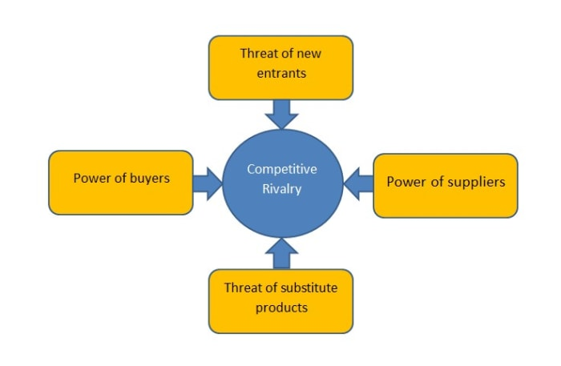
(Image 1: Source: Competitive strategy, Porter, 2019).
- The Threat of new entrants: The threat of new entrant becomes presence when dynamics support the company to help them become profitable and well established. The threat of new entrants is moderate for Netflix as they are in the entertainment industry. The level of threat being moderate is due to the technology evolving and the changes which emerge as technology is gradation. Adapting with changing technology like Netflix has by changing DVD rentals to purely online streaming by scraping the idea of sending the DVD’s by post they have managed to give a much easier access to online streaming to their customers. Netflix Business model is easy to replicate, but this is what gives Netflix the edge as they have a range of content within the company available and it is convenience (Sonenshine, 2018).

- The bargaining power of buyers: The entertainment and media industry give customers the power of having higher levels of bargaining over which service providers. The company revenue and sales are dependent of the subscribes and where they located across the globe. The switching cost being low gives the customers the option to cancel their subscription With Netflix. By seeking other providers of media has an increase to the company as a threat. Netflix has a lot of pressure and cannot charge any higher they need to keep the pricing strategy inrelaiton to the demand of consumers with the price increase being minimal. However, the customers preference and needs are results in maintaining service quality which is where higher bargaining power comes into force.

- The bargaining power of suppliers: Netflix is known to the suppliers as holding a high bargaining power. The influence on pricing is down to having only a few entities which produce entertainment and media content based. The suppliers have an edge were getting a contract and the licence to acquire in order to distribute the contents has negotiation on the pricing. Competing against other traditional media suppliers Netflix must show flexibility within the agreement unlike other traditional businesses. Whereas, Netflix has a weak bargaining power with the present of the broadcasting businesses but online streaming like Netflix has a higher level of influence from the suppliers (Netflix, Inc, 2018).

- The Threat of substitute products: The substitute of products has a moderate level of threat within the industry of media and entertainment, The threats Netflix faces is from other services which are substitute and offer similar services like online streaming or DVD rental. By adding the demand from their customer base Netflix must lower the level of threat by regularly adding or updating to their library with the latest movies or shows. The engagement within the market is necessary to ensure profitability and the expansion of customer base is maintained.

- The competitive rivalry: The entertainment and media industry have a high level of competitive rivalry and the pressure on the leading companies means they must offer affordable prices to ensure customer retainment. Netflix main competitor is Amazon as they both provide DVD rental online as they both are in the same position within the market. Aside from Amazon there is also other online streaming companies such as, Hulu which has become a stiff competition for Netflix (William, 2015).

Netflix Porter Five Force model shows the company has a very low threat of new entry as Netflix is in the entertainment and media industry unlike other technology companies. The power of buyers is moderate as if Netflix does not keep their prices down, they will low customers which means lost of profit. The supplier power Netflix must be flexible to agreeing to terms with their suppliers as Netflix has a weak bargaining power with them. The threat of substitute is sightly high as other companies offering better prices or more choices like Amazon. Therefore, the price must be kept as low as possible to retain customers. The rivalry within the media and entertainment industry is high as the pressure from other companies shows an competitive as Netflix and Amazon are in the same market and same position as they both provide the same online streaming service.

Section 2:
The Process of strategic management:
The term strategic management refers to the defining the organization strategy. It is also a process used by managers who can make choices to achieve better results within the organization, The process of strategic management is continuous by appraise of the industries and business where the organization is involved. The appraise has competitors and set goals which must be met by the present and future competitors by reassessing each strategy.

The Strategic management process:
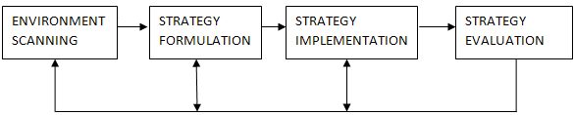
(Image 2: Source Juneja, 2021).

The strategic management process of the four steps as followed:
- The environmental scanning: This process refers to the scrutinizing and collecting information for the purpose of strategy. This process analyses the internal and external factor which could influence the organization. The management must evaluate the environmental analysis as a continuous process to strive improvement.

- The strategy formulation: Is the process of seeing which course of action is best for accomplishing the objectives of the organizational by achieving them. After environment scanning the manager formulate the corporate business and strategic functions.

- The strategy Implementation: Is where the process of the making of strategy work as needed or the chosen strategy into action for the organization. The implementation of strategy includes things such as, resources, the structure of the organisation, the development of the decision process and human resource management.

- The Strategy Evaluation: This is the final step of the process of strategy management. The strategy evaluations are the internal and external factor appraising which are the root of the present strategies by the performance being measured by actions of corrective or remedial. The evaluation ensures the organizational strategy by implementing the needs of the organizational objectives (Juneja, 2021).
Section 2:1
Formulation of Strategic:
The rewriting of the strategic business plans happens when the organizational structure is changing or if they need to respond to the change of the market new conditions. The process can be difficult and sometimes time is required for people to get on board with the decision-making process. The mission and vision statement are one of the tools that help clear articulation. The position of move will be repeated towards changing within the organization the engagement and motivation in the process.
Vision statement: The vision statement helps set the organization long term goals and the company aspiration concisely or clearly. The vision statement is meant to motivate and inspire the workforce company by providing the image of where the company is heading. The provider shows a reality check for the managers, who help compare the strategic objectives and plans of operational to help the vision statement. If the action is planned out the company cannot not move towards the vision, and this may be revised.
Mission statement: The mission statement helps the company sector in which the company operates by setting out the key purpose. This helps sum up what they company does and why. This also shows company conducts the business and help identifies key stakeholders e.g., shareholders, employees, and customers. The mission statement helps the employees see where they fit in within the company objectives. This also shows if the stakeholders want to do business within the organization as well (MacDonald, 2019).

Section 2:2:
Netflix Strategies:
Netflix mainly forces on the strategy by maximizing the competitive advantage of being cost effective and effective operational on information technologies. Netflix growth strategies requires a forceful marketing to help expand the streaming operations to become multinational Netflix business model is the corporate strategies where the market penetration has support and is cost reduced. The business framework online streaming implies strategic management support for technologies information for operations and expansion across the globe to be efficient. The operations management of Netflix helps set these strategic implications by making sure each area of the company operations is aligned to help make the business model stronger. The generic strategy is for the competitive advantage to help the intensive growth strategies by giving support.
Netflix Business Model:
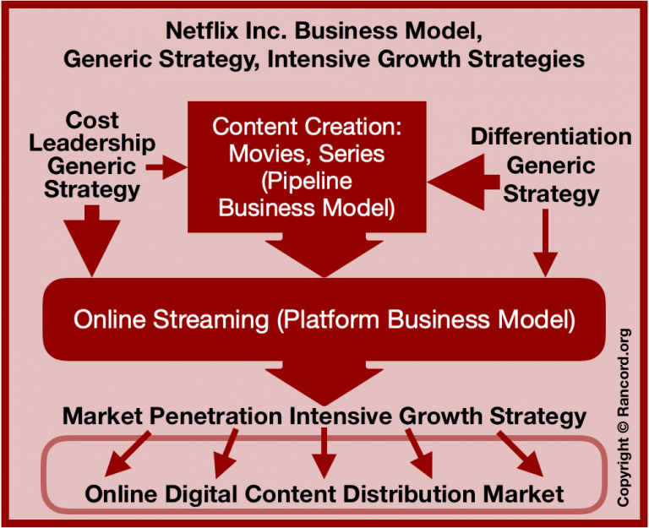
(Image 3: Source Moore, 2019).
Competitive strategy of Netflix:
- Leadership cost: The generic strategy for Netflix is cost leadership, where in Micheal E. Porter’s Model shows they minimize cost and by reducing selling prices. This enables the industry of online entertainment business model show competitiveness with low costs and the ability to have affordable prices, without being the provider with the best cost. To acquire more customers for the online streaming industry Netflix must focus on the strategies which purely focuses on the segment of the market.

- The Differentiation: Netflix also uses differentiation within the business operations. The differentiation is the involvement of development of the business online and the products different in a unique way to help Netflix stand out from the rest of the competitive. One main example of Netflix development of competitive advantage by having it own original content exclusive to Netflix only aside from third parties’ companies they normally use. The business model helps retain and attract customers by enforcing the differentiation strategy within the company.

The intensive growth strategies of Netflix:
- The Market Penetration: The main intensive growth strategy of Netflix is by expanding the operation of business and by reaching the multinational market. The growth strategy could mean selling one or more the company services streaming within the market if they already have the same one. The market share and the revenue growing all depends on Netflix strategy and how they maintain the competitive advantage to retain even more customers within the current market. For example, Netflix mix marketing 4P helps strengthen the business strategies and the tactic they have for penetration within the market.

- The development of the market: The development of market is by selling the company online streaming services they currently have to new markets. One of Netflix goal is to grow the company by entering more countries across the world and this is known as the new market for Netflix to enter the market within that country. It is essential for Netflix business model to have competitive advantage which helps increase profit within these new markets.

- The development of the product: The objective of growth strategy is for development and to sell new products within the current market for online companies. Netflix uses the strategy to produce new contents for their current customers this adds to the company value when time is spent watching these content. The new entertainment is a pipeline of the business model within Netflix as an organisation.

- The Diversification: Diversification is hardly ever applied to help grow Netflix operations this is because of the risks involved. This growth strategy aim is to help grow the company by applying new operations outside the current business of original content and online streaming. The competitive advantage focus on industries or businesses to media who stream online whilst the growth strategy is applied (Moore, 2019).

Market Penetration: Plays an important role for Netflix growth strategy as this role helps the business activities and the expansion of the company within the international market. The plan is to gain higher income and have more market share is the strategic target by applying a competitive advantage. The company market share depends on how the competitive edge is sustained to increase the share of the market and keep hold of the existing customers. The market penetration and the organization plans are used through the mix of the marketing and Netflix 4ps (Adamkhankasi, 2020).

Ansoff Matrix
Is an essential model for strategic market planning where the opportunities to help the grow the business revenue by the development of new services or products or by entering new markets. Sometimes it can also be called product market matrix. This is one of most used marketing models as it focuses purely on the company growth (Hanlon, 2020).
Netflix main goal is to enter different markets to gain more revenue. As they already keep up to date with the latest technology and must keep monthly fees subscription to retain customers the only direct forward is to enter new markets. By entering new market across different countries, the company would gain new opportunities and increase profit as well.

Netflix Ansoff Matrix
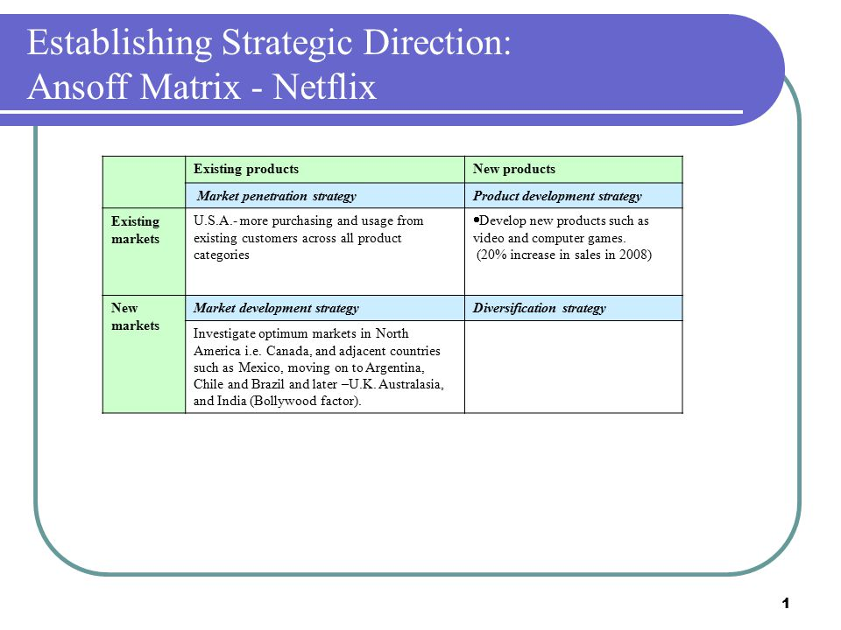
(Image 4: Source Mosley, 2021)
The Ansoff Matrix shows Netflix existing markets and new markets entry also the new products being developed. The existing market like the USA states the existing customers make sure of Netflix full list of products. But also shows the new markets such as, Mexico and Brazil and the United Kingdom and of course India the factor of Bollywood. The Ansoff Matrix shows Netflix goal which was to entry new markets across the global which it shows they have managed in over 19 different countries so far.
Section 3:
The Corporate strategic direction
The strategic direction is the implementation of the plans needed for the organization to set forward towards the vision by fulfilling the company goals. This helps the management and the owners to help communicate the employees important of work and help contribute to the business objectives being achieved. The important decisions of the organization’s direction for the company and the growth which include the strategy levels of the strategy of business and functional. The main four components of the corporate strategy are:
- The vision
- The setting of the objective
- Resources of allocation
- Trade off – Strategic (Wright, 2021).

Section 3:1
Analysis of the Stake holders
The stakeholder analysis is the process by identifying the people before beginning the project by grouping them to the level of participation, influence and interest within the project and seeing who is best involved by communicating with each of the stakeholder into groups.
Netflix is one of the leading online streaming entertainment service in the world. Globally Netflix has had 182.9 million paying membership in 2020. Netflix has 3 individual insider stakeholders they are Leslie J. Kilgore, David Hyman, and Greg Peters.
- Lesile J. Kilgore has a total of 35,196 Netflix shares, Miss Kilgore worked as Netflix chief marketing officer for 12 years before joining the board of directors since 2012.
- David Hyman has a total of 31,610 Netflix shares, Mr Hyman has been working for Netflix since 2002 he is responsible for the public and legal affairs.
- Greg Peters has a total of 13,090 Netflix shares, Mr Peters has been working for Netflix since 2009. He leads the product team which includes the building, design and optimizing the experience of Netflix.

The top 3 stakeholders institutional:
Global investors Capital research: The capital research owns 37.9 million shares of the company. Around 8.6% of the total shares. They invest in operations in number of mutual funds by focusing on the active management of the funds with 13F security worth at $254.9 billion the firm is Netflix second biggest shareholder.
Vanguard Group Inc has a share of 34.1 million totalling around 7.8% of the total shares. Vanguard is a mutual fund and ETF management business worth around $6.2 trillion in global assets. Netflix has 0.72% of VOO’s shareholding.
BlackRock Inc owns 28.4 million shares of Netflix a total of 6.5% as a stakeholder. They are mutual fund and management of ETF worth around $6.47 trillion. Netflix has 0.083% of IVV’S holding (Johnston, 2020).

Section 3:2
The Battle for India
By 2017 Netflix had more international subscribers than domestic. The issue was Netflix did not consider the markets of the international equal. Netflix only managed to enter India in 2016 by offering them the original series like the Hollywood movies and tv programs and around 100 Bollywood movies. Once Netflix entered the market many of Netflix executives visited India regularly. The consumer base showed the next 100 million customers were coming from the new market they entered India. The change of heart on Netflix joining forces with India was triggered by Jio Platforms. The launch of Jio 4G gave better rates of broadband services which were 75% cheaper and provided millions of consumers to fast data for the first time. Within 6 months the company has managed to subscribe to over 280 million people and had market share of 24%. This meant more and more people were able to afford internet which meant people were using the internet more on an average 5 hours a day. This was good news for Netflix as it meant more customers would join their services. By the end of 2017 Netflix had over 500,000 customers just in India. 2019 Netflix report showed they had 16 million paid customers within the Asia-pacific region and around two million customers were just from India. The price competing within the India market Netflix had to put in effort to ensure customers did not leave them and went with companies like Amazon and other leading online streaming companies.

Section 3:2
Recommendations:
My personal recommendation for leading media company like Netflix is to continue expanding in different countries and extending their collection online for different culture and background e.g., the language section or Bollywood movies as a member myself there is many Turkish movies and tv shows I have seen this is one of the main reasons I am a member of Netflix. This helps bring new customers from different backgrounds. Also, entering new markets globally all purpose must be the same for each country for example, the internet or technology they have must be considered for more people to join like the UK most broadband or phone providers have unlimited data whereas most global countries do not. When India sorted out, they internet issue and millions of people had easy access to internet more and more customers joined.
Another key factor Netflix need to upheld is keeping up to date with the latest technology for example HD options. Also keeping up the latest film rental or adding the exclusive shows which are only shown on Netflix to keep customer interested and to continue paying for the service they provide. Without these services they provide being updated regularly customers might leave and join other companies like Amazon.

Conclusion:
Netflix is a large company within the entertainment and media industry. They seem to keep up to date with new changes with the technology side of things and they also want their company to accommodate to people from all different cultures and backgrounds. However, the competitive market makes it difficult to compete with other leading brands like Amazon therefore the company must focus on research and marketing to stand out and being unique from the rest. Strategic management will always be an ongoing process for any company just like Netflix has to learn, adapt, and apply changes to the organization to be competitive against others within the market. Overall Netflix is moving in the right direction by building relationships with global countries and entering new markets. The prime example was Netflix joining the India market in 2017 and since then they have over 2 million customers just in India.
Reference List
Abhijeet Pratap, (2020) 'PESTEL analysis of Netflix' available at: notesmatic.com https://notesmatic.com/pestel-analysis-of-netflix/ (Accessed 10th May 2021).
Adamkhankasi, (2020) ‘Ansoff Matrix of Netflix’ available at: ansoffs.com/ https://ansoffs.com/ansoff-matrix-of-netflix/ (Accessed 10th May 2021).
Adamksai, (2019) ‘Porter’s Five forces of Netflix’ available at: porteranalysis.com https://www.porteranalysis.com/porters-five-forces-of-netflix/ (Accessed 10th May 2021).
Amelia Moore, (2019) ‘Netflix’s Generic Strategy, Business model & intensive Growth Strategies’ available at: .rancord.org https://www.rancord.org/netflix-business-model-generic-strategy-intensive-growth-strategies-competitive-advantage (Accessed 10th May 2021).
Annmarie Hanton, (2020) ‘The Ansoff Model’ available at: smartinsights.com/ https://www.smartinsights.com/marketing-planning/create-a-marketing-plan/ansoff-model/ (Accessed 12th May 2021).
Brennan, L. How Netflix expanded to 190 countries in 7 years. Harvard Business Review.
David Anderson, (2019) 'Netflix inc.'s Organizational structure & its strategic implications' available at: rancord.org https://www.rancord.org/netflix-organizational-structure-design-organizational-chart-characteristics (Accessed 10th May 2021).
Jalan, R. (2016). Netflix business strategy and future readiness.
Lynne MacDonald, (2019) ‘what do clear vision & mission statements contribute to the strategic management process?’ available at: smallbusiness.chron.com https://smallbusiness.chron.com/clear-vision-mission-statements-contribute-strategic-management-process-24100.html (Accessed 10th May 2021).
Matthew Johnston, (2020) ‘Top Netflix shareholders’ available at: investopedia.com https://www.investopedia.com/articles/insights/060716/top-3-netflix-shareholders-nflx.asp (Accessed 12th May 2021).
Netflix, (2021) https://about.netflix.com/en
Prachi Juneja, (2021) ‘Strategic Management Process- Meaning, Steps and components’ available at: managementstudyguide.com https://www.managementstudyguide.com/strategic-management-process.htm / (Accessed 10th May 2021).
Tom Wright, (2021) ‘Corporate Strategy: The four key components’ available at: cascade.app https://www.cascade.app/blog/corporate-strategy (Accessed 12th May 2021).
Will Kenton, (2021) 'Strategic management' Available at: investopedia.com https://www.investopedia.com/terms/s/strategic-management.asp (Accessed 10th May 2021).

