

“An investigation into the factors that impact employment opportunities for former offenders in South Wales”.

By Nikita Temple
1811156

Supervised by Dr. Gareth Hughes

University of Wales Trinity Saint David
May 2019

DECLARATION
This work has not previously been accepted in substance for any degrees and is not being concurrently submitted in candidature for any degrees.
Signed Nikita Temple
Date 15/05/2019
STATEMENT 1
This project is being submitted in partial fulfilment of the requirements for the degree of BA Business Management (Hons)
Signed Nikita Temple
Date 15/05/19
STATEMENT 2
This project is the result of my own independent work/investigation, except where otherwise stated.
Other sources are acknowledged by giving explicit references. A reference list is appended.
Signed Nikita Temple
Date 15/05/19
STATEMENT 3
I hereby give consent for my project, if accepted, to be available for photocopying and for inter-library loan, and for the title and summary to be made available to outside organisations.
Signed Nikita Temple
Date 15/05/2019

ACKNOWLEDGEMENTS

I would like to thank my dissertation supervisor Dr Gareth Hughes, for his advice and guidance throughout this dissertation along with the staff at University of Wales Trinity Saint David. I would also like to thank my family and friends for their support throughout my degree and helping me reach my goals.

Table of contents

Chapter 1 - Introduction ……………………………………………………………………………6
1.1 The research question …………………………………………………………………....…….6
1.2 The research problem ……………………………………………………………….....7
1.3 Background to the study …………………………………………………………………… …7
1.4 The remaining structure of dissertation …………………………….………………………….7

Chapter 2 - Literature review……………………………………………………………………...10
2.1 Chapter overview ……………………………………………………………………………..10
2.2 Context of study ………………………………………………………………………………10
2.3 Former offenders with mental health issues ………………………………………….11
2.4 Disclosure and barring service checks ……………………………………………….12
2.5 High level of prison population ………………………………………………………13
2.6 Reluctance for employers to give jobs ……………………………………………….14
2.7 Discrimination against former offenders …………………………………………….15
2.8 Return to work schemes ……………………………………………………………..16
2.9 Impact on employment opportunities for former offenders in America …………….17
2.10 Wales lowering the impacts of employment for former offenders…………………18
2.11 Conclusion …………………………………………………………………………19

Chapter 3- Methodology ……………………………………………………………………….…21
3.1 Aims and objectives and how they will be achieved ………………………………...21
3.2 What is research............................................................................................................21
3.3 Data collection techniques …………………………………………………………...21
3.4– The research onion ……………………………………………………………….…22
3.5- Philosophy…………………………………………………………………………...23
3,6- Approach………………………………………………………………………….….23
3.7- Time Frame ……………………………………………………………………….…24
3.8- Data Collection………………………………………………………………………25
3.9- Analysis ……………………………………………………………………………...25
3.10 Limitations and Ethical Considerations ……………………………………………..25

Chapter 4- Findings and data analysis ………………………………………………………………27
4.1 Aims and objectives of dissertation …………………………………………………………….28
4.2 Coding …………………………………………………………………………………………..28
4.3 Results …………………………………………………………………………………………..30
4.4 Themes identified through analysis …………………………………………………….34
4.5 Conclusions ……………………………………………………………………………………..35

Chapter 5 – Discussion chapter …………………………………………………………………….37
5.1 Findings…………………………………………………………………………………………37
5.2 Limitations ……………………………………………………………………………..37
5.3 Recommendations for future studies ………………………………………………...…38
5.4 Recommendations for future research ………………………………………………….38

References …………………………………………………………………………………..40

List of Figures

Figure 1 – Chart to show rate of imprisonment in Wales and England.
Figure 2 – Chart of progress within prisons.
Figure 3- Research onion
Figure 4- Example of Gantt chart
Figure 5 - Pie chart to show if the managers interviewed, employ former offenders in South Wales.
Figure 6 – Pie chart to show management employment decision.
Figure 7 - Pie chart to show which industries do employ former offenders and do not employ former offenders.

Appendices
Appendix 1 - Copy of completed interview questions

Chapter 1- Introduction

1.1 The research question
This dissertation is to provide an insight into if companies in Wales employ individuals with a criminal record. An investigation will be made into the crime rate in Wales and if there is an education system that are provided in prisons, to help convicts become employable after serving their sentence. The findings of this research will show an understanding of how many companies are willing to give convicts a second chance. There are studies exploring factors that impact former offenders but few exist to look at the impacts of employment opportunities for former offenders in South Wales, which is what this thesis will seek to address.

1.2 The research problem

There are studies on companies employing individuals with a criminal record and there is research available to access. However there exist a paucity in academic literature. There is no research focusing on companies in South Wales. An investigation is being made into this to see if there are employment possibilities for former offenders in South Wales.
Only 17% of former offenders succeed in getting a job after being released from prison. Former offenders finding a job on release are up to 9% less likely to reoffend. As 75% of employers in the UK will not employ a candidate because of a previous conviction, this likely the reason for recidivism (Minisrty of Justice, 2018).

The research aims and objectives
The aims and objectives for this dissertation are:
- Carry out a comprehensive literature review of exact literature factors that impact employment of former offenders.
- Conduct primary research in the form of qualitative research, interviews with staff with recruitment responsibilities within an organisation to find out if managers are employing former offenders with criminal records.
- Make recommendations to both prison services and plc organisations.
1.3 Background to the study
Working with prisoners and former offenders and offering them training and employment opportunities makes good business sense, as well as helping them get their lives back on track. It allows businesses to see opportunities and employ talented, highly motivated people who they may not have considered before. Employers have many concerns about employing an ex offender however 49% of businesses survey said that reliability is the main reason why they would not be considering employment (Minisrty of Justice, 2018). One of the main websites that will be used for this literature review is the government website (GOV.co.uk) this is a reliable source, as it gives access to all legislations to do with discrimination, rehabilitation and employment. This website will provide information about DBS checks and what rights employers have not to employ someone with a criminal record. This information is accurate and up to date and will give a clear understanding and answers to this investigation. Interpretivist will be the choice of philosophy for this dissertation as the collection of primary research will be completed in the form of interviews, this will then go forward to interpreting the data collected (Research Methodology, 2018).

1.4 The remaining structure of dissertation
Inductive research approach is all through the identification of a pattern when observing qualitative data and interpretation of the findings. This approach has been chosen as a research approach as this has a lot to do with qualitative data which will be used in the dissertation by interviews. A Research Strategy is a step-by-step plan of action, it gives direction to your thoughts and efforts, enabling you to conduct research systematically and on schedule to produce quality results and detailed reporting. This will help you become focused and improve on quality and save money (Jenny, 2014).
A survey is a collection of data from a popular choice of a group of individuals. I will use this in this dissertation. The benefits of using a survey is that it easy to analyse and it allows individuals to feel more candid with their responses. To get accurate data people need to be honest with their answers. Surveys provide more honest responses than other types of research methodology. If confidentiality is made clear to the individual they are more likely to answer honestly (SurveyMethods, 2017).

The research will facilitate semi structured interviews. Interviews will be administered to a manager of three public limited companies in Wales to see if they would employ a former convict with a criminal record to add to my research and investigation. Research choice will be Mono Method as this dissertation will be using qualitative data through the use of interviews. Qualitative research is a research strategy that usually emphasize words rather that quantification in the collection of data analysis. This research strategy is intuitivist, constructionist and interpretivist but these three are not always used together (Bryman, 2003). A cross sectional time horizon choice as researching a specific cohort. Collecting the data will not take a long time and this process will be focusing on something specific. The collection of data analysis will be collected through interviewing individuals. This will then be transcribed and analysed. To analyse the data an appropriate software will be used for example NVIVO. This software is reliable and helps keep all findings organised. The data will then be kept in a password protected document. Interviews will be completed by managers to get their professional opinion on employing former convicts with a criminal record. Some individuals will not be conformable answering all questions due to the topic sensitivity as questions are about former offenders. The participants will be informed about the study and their consent will need to be given before proceeding. Ensuring that all data collected is kept safe and following the General Data Protection Regulations Law (GDPR). All information will be kept confidential and safe. This will be done by not disclosing the information to anyone and keeping the information on password protected documents. The manager and the companies name will not be mentioned in the dissertation they will be listed as Company A and manager A to protect their identity.

The resources for this dissertation are important, the resources to be used in this dissertation will be websites, books, journals, interviews, reports and articles. These will be researched though the university online library, google and other search engines which access is available to at all times. Time is very important to this dissertation. Researching into this topic and identifying all the legislations and legal rights of companies will take time. Collecting data using surveys and interviews will take time to create, organize and complete. Conducting this research will identify the factors that impact employment opportunities for former offenders in South Wales.

Chapter 2 - Literature Review

2.1 Chapter overview
The purpose of this chapter is to conduct a review of available literature into the factors that impact employment for former offender in Wales and an investigation into how having a criminal record can affect their chance of employment. This chapter will explain the factors that impact the former offenders in general and then focus of the factors that impact employment in Wales and the legislations are in place to protect employers and employees. Consideration of previous literature will also assist the researcher in designing the primary research. Secondary data will be gathered form different sources these include internet research, UWTSD Library catalogue, newspapers and journals. There is a paucity of academic theory, frameworks and models which relate directly to this investigation.

2.2 Context of study
This thesis will carry out a comprehensive literature review of the factors that impact employment of former offenders. According to Prisoners Education Trust:

“People in prison are often among the most disadvantaged in our society. Many have had damaging childhoods, have experienced mental health and addiction problems, and have suffered multiple bereavements. Most step through the prison gates with a poor and limited history of education.” (Prisioners Education Trust, 2019).

The theory the Prisoners Education Trust have established is that the upbringing the individual has received and the uneducated childhood along with the life they have experienced is the reason for them committing a criminal offence and why they are disadvantaged in society. As former offenders are disadvantaged in society they find it difficult to adapt back in to society and find a job once released from prison.

2.3 Former offenders with mental health issues
There are many factors that impact employment opportunities for former offenders in South Wales. Many former offenders in England and Wales have developed mental health issues before entering prison, during prison and once released from prison. The Prison Education Trust say that 65% of women in prison and 42% of men in prison reported that they have mental health issues. If the former offenders are not assessed and supported during this time then it will make life after prison very difficult and will have a big impact on their employment opportunities (Prisioners Education Trust, 2019).

According to Holzer (2003), former offenders have a variety of characteristics and mental health issues that greatly limit their employability and earnings capacities. This is due to their limited education and cognitive skills and limited work experience. If the individual entered prison at a young age and have never had a job before then they will not have any work experience. Not having work experience and qualifications could have an impact on many individual’s application when applying for a job. Some companies require this information when applying for a job role and without it the employer could dismiss the application before even checking the criminal record. This is a factor that impacts employment opportunities for former offenders in South Wales as many companies require Maths and English GCSE levels and work experience before hiring as these skills are used within the workplace (Holzer, 2003).

2.4 How disclosure and barring service checks impact former offenders becoming employed
To apply for certain job roles in Wales there are background checks that have to be made before the employment process can continue. The disclosure and barring service checks which are also known as DBS checks, can have a big impact on employment. As these checks look at the individual’s background and criminal records former offenders may not want to apply for the job role as they know that their offence will show and feel as if they do not have a chance. Another impact for employment in South Wales is the individual’s attitude towards finding a job and the employer’s perception and concerns. Under the Rehabilitation of Offenders Act 1974 many ex-offenders are given certain employment rights if their convictions become ‘spent’. The Rehabilitation of Offenders Act 1974 states that “Anyone who has been convicted of a criminal offence and who is not convicted of a further offence during a specified period (the ‘rehabilitation period’) becomes a ‘rehabilitated person” However, if their conviction is a prison sentence more than 48 months then the conviction can never become spent (CareersWales.com, 2019).

This is where there are exceptions to the Rehabilitation of Offenders Act 1974 broadly relating to work with children, the sick, disabled people and the administration of justice. Companies can then ask for this information from the former offender, the employer will then decide on if they would like to employ the individual. They do not have to employ the individual by law as the category they will be working under involves vulnerable children and adults (CareersWales.com, 2019).
Wales has the highest rate of imprisonment in Western Europe, the first study of its kind has revealed. Sentencing and Immediate Custody in Wales: A Fact file found that in 2017 (the latest figures available) there were 154 prisoners per 100,000 of the population of Wales, compared with 141 per 100,000 of England, shown in the graph below (The Guardian , 2019).
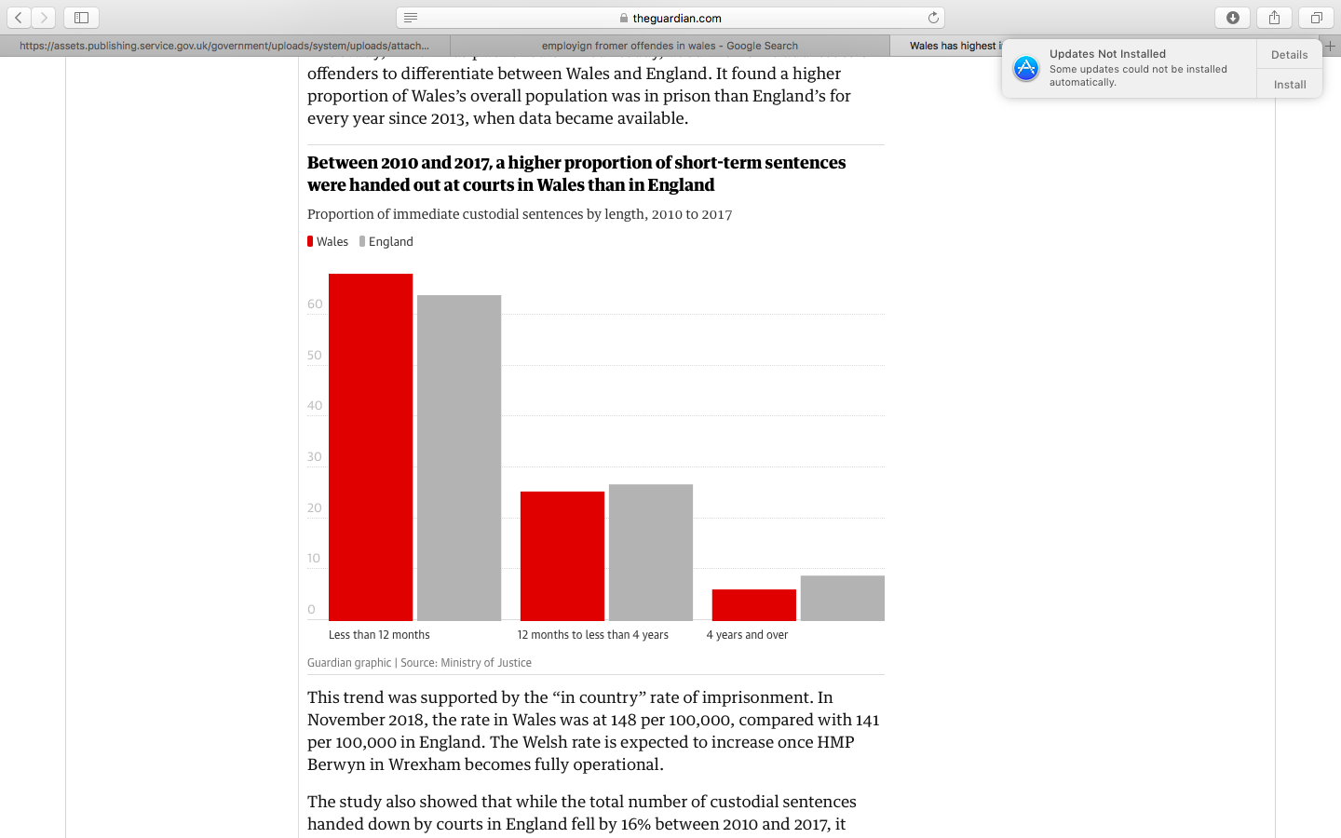
(Figure 1) Chapter 2 - Graph to show rate of imprisonment in Wales and England.
(The Guardian , 2019)
Many convicts are released from prison each year, after completing their sentence they will leave with a criminal record. Once they are released from prison, most individuals will try and get back to normality, they will start by looking for employment (Sturge, 2018). However, as there are factors that impact employment opportunities for former offender finding a job may not be a quick and easy process.
2.5 High level of prison population
In the UK 11 million people have a criminal record according to Business in the Community (2019), and they also say 75% of employers admit to discriminating against applicants with a criminal conviction (Pyke, 2019).It is difficult for former offenders to become employed as there are many companies who will not employ individuals with a criminal record as there are specific essential criteria’s that will need to be met for them to take on the role. For example, to apply for a career working with venerable children and young adults or for a career in the justice system a DBS (disclosure and barring service) check must be completed. This will search the individual’s criminal history, if this history is not clear and there is a criminal record then the individual will be dismissed from the application. The person who has applied for the job will receive a yes or no response with no further context. The companies do not know the full background of that individual’s conviction and when it happened. Therefore, many individuals who have a criminal record will not even try to apply for such roles as it is very off putting and they feel as if they do not have a chance (GOV.UK, 2019). Business in the Community also estimates that reoffending currently costs the tax payer £15 billion every year therefore employment of ex-offenders would secure significant savings for the taxpayer (Taylor, 2018).

2.6 Reluctance for employers to give jobs
Employers are able to accurately assess the risk of applicants by taking into account factors such as the nature of the crime, when the criminal activity took place, whether a past offense involved workplace behaviour, and other circumstances. Some employers think that they should not be required to adopt this more nuanced approach. Employers believe they should be free to avoid perceived risk to their business, however slight and whether or not well founded, or that individuals with criminal records simply do not deserve consideration. However, even if these employer feelings and concerns are legitimate, they are clearly not the only concerns that warrant consideration. There are many other societal and individual interests that need to be considered against the concerns that employers have regarding employing individuals with criminal records (NV, 2013).

There is a legislation called the Rehabilitation of offenders Act 1974 this is an Act to rehabilitate offenders who have not been reconvicted of any serious offence for periods of years, to penalise the unauthorised disclosure of their previous convictions, to amend the law of defamation, and for purposes connected therewith (legislation.gov.uk, 1974). This allows most convictions to be considered spent after a certain period. Once the individual has completed their sentence that is under 4 years then they no longer must legally inform an employer of their previous convictions. However, this does not apply to all job roles. Professional job roles such as accountant, doctors, nurse, midwife, solicitors, social services providers, teachers and jobs within a school or anything that includes supervision or training of people under the age of 18 will have to disclose information on spent convictions (TheInformaitonHub, 2019).

2.7 Discrimination against former offenders
Discrimination may occur as the result of institutional procedures rather than individual behaviours. If an employer believes that people with criminal records will make unsatisfactory employees and denies employment then this is discrimination against former offenders (Blank, Dabady and Citro 2004). Discrimination is one of the biggest factors that impact employment opportunities for former offenders in South Wales. Employment discrimination against former offenders reduces their attachment to the labour force, leaving them few options but to continue committing crime. The consequences of excluding ex-offenders from the job market are serious, not only for them but for the potential victims of crime (Lam, 2003).

Helen Lam says that “it is not surprising that many employers are reluctant to hire former offenders. Since many former offenders are people who have been found guilty of damaging persons or property, arguably, employers believe that they should have the right to not hire them. In hiring former offenders, employers may unnecessarily increase employee and customer exposure to potential harm and provide opportunities for former offenders to commit criminal offences under their roof” (Lam, 2003). This shows that many employers will discriminate against former offenders as they are worried about their business being at risk and their possessions stolen or damaged. More employers are believing that if someone has committed the crime once they will do it again and that they cannot be trusted.

Former offenders are sent prison for rehabilitation the aim of the prison is to raise awareness of the participants with a view to reduce the risk of recidivism. The objectives of prisons in the United Kingdom are to encourage participants to consider the consequences of their offending and introduce them to skills to help them manage their behaviour and understand the victim perspective (The Highland Council, 2019). If employers continue to discriminate against former offenders then the rate of recidivism will increase as they will not have a job and will be unable to adjust back into society.

2.8 Return to work schemes
As there are many things that impact employment opportunities for former offender’s prisons offer educational lessons for offenders to attend to help with their rehabilitation. Prisons in the UK offer educational lessons whilst in prison this is to ensure that convicts are developing skills to get a job when they have completed their sentence, this will prevent the individual re offending. Learning and Skills Council is strengthening education and training, while jobcentres will have new incentives to help offenders into jobs. Preventing criminals re-offending is an important aim of any criminal justice system. Shown below in figure 4 good progress has been made, there are many more individuals achieving basic skills for life awards.
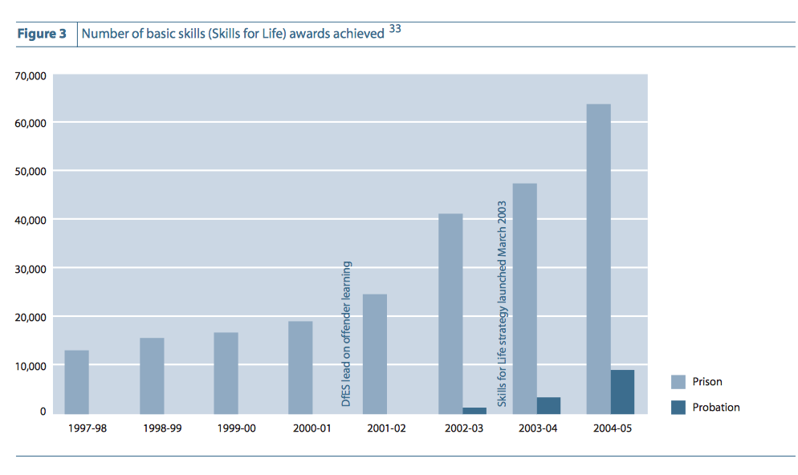
(Figure 2) - Chart of progress within prisons (HM Goverment, 2019).
There is currently limited research in the region of South Wales, UK which looks at the impact employment opportunities for former offenders. However, there remains some research in the United States of America, Canada and Spain which indicates a gap in research which has been identified and therefore serves the basis of this current research.

2.9 The factors that impact employment opportunities for former offenders in America
As there was not a lot of information on the factors that impact employment opportunities for former offenders in South Wales. Different countries were researched to see if there were any similarities of the impacts. There was a large amount of research available to access on the factors that impact employment opportunities for former offenders in America.

Mental health of inmates has become common over the last few years. According to Harvard Library 41% of inmates is the US have severe mental disorders. These illnesses could have been the reason for the individual offending and being imprisoned. Mental health issues also occur during imprisonment as the individual is in an isolated environment (Al-Rousan, 2017).
Mental illness and criminal activity are highly correlated therefore making such individuals vulnerable and complex in functioning within society. Individuals in prisons get used to the confinement of prison and become comfortable with their surroundings and environment. This has a big impact on the offender looking for employment and given the opportunity once they have completed their sentence. Individuals with mental health disorders are given Clozapine in American prisons to regulate complex symptoms and in the interest of public safety. This pharmaceutical drug is shown to reduce aggressive behaviour permitting stability and socially acceptable functioning. This will help the individual when they enter back into society after completing their sentence (Lloyd et al, 2010).

Between 2000 and 2010, the number of prisoners under state and federal correctional authority jurisdiction increased by 221,134, and the imprisonment rate increased from 478 to 500 per 100,000 residents.44 Between 2000 and 2010, more than 7.5 million people were released from state and federal prisons, and during 2010 alone, a total of 708,677 prisoners were released from state and federal prisons.45 Given these statistics, a significant number of job applicants will be affected negatively by employer policies that limit or even prohibit hiring ex-offenders (Fletcher, 2011).
Bushway states that the transition matters and that the process of building a new life is difficult: old ties must be cut and new ones created (Bales and Mears, 2008; Baskin and Sommers, 1998; Maruna, 2001; Uggen, 2000). Work programmes provide useful knowledge for starting a new life, but the problem lies in the prisoners’ ties after release from prison, which are often the ones they had before entry (Travis et al., 2001). Furthermore, Travis (2005) states that prisoners do have poor health and this should be the focus on release. However, the main problems for released prisoners is housing as many live with family others have nothing. This is the reason why work is only part of the reintegration process, together with emotional ties, healthcare and housing they all have an impact on impact employment opportunities for former offenders (Alós, 2014).

2.10 How Wales is trying to lower the impacts of employment for former offenders.
In South Wales there are many things that impact employment opportunities for former offenders. However, there are some companies in Wales trying to make a difference and give former offenders a chance. Three years ago, Welsh homelessness charity The Wallich launched their BOSS project. BOSS (Building Opportunities Skills and Success) looks to provide innovative employability and entrepreneurship training to ex-offenders and prisoners serving sentences in South Wales. “A criminal record can be a real barrier for someone willing and capable of getting back into work because of its stigma,” said Ellie Pearson, BOSS Project Manager at The Wallich. Some companies such as The Clink restaurant in Cardiff do employ individuals with a criminal record. They look to rehabilitate ex-prisoners in local communities, providing them with valuable work placements. They said that it is an initiative that they have always found to be enormously positive, in fact many of these employees have gone on to have really successful careers with them, and are regarded as some of the most valuable team members.” (Pyke, 2019).

2.11 Conclusion
From researching into the impact employment opportunities for former offenders in South Wales the main findings were that various companies request a DBS check during the application process to find out if the individual has a criminal record before employment, many former offenders leave prison with mental health issues due to the environment they live in and that many companies discriminate against employing former offenders. There is an absence of literature in this field of research, although there exists a substantial amount of research in America we can deduct elements of this research which infers beneficial outcomes for former offenders however more needs to be done in altering attitudes by employers to this particular cohort. If employers no longer discriminate against former offenders and change their attitudes towards employing former offenders then this will lower the impacts of them becoming employed and will help reduce rates of recidivism. Although there are exciting schemes in places that has shown to be effective so far research is yet to be established. The underlying mechanisms that could be contributing as a mediator factor.
There is a gap in research, not enough information on this topic is available through the use of articles, books or websites on how having a criminal record impact former offenders in South Wales. There is only research available in other courtiers such as the United States of America. The primary research will be conducted through interviews to different managers of companies in South Wales. This will give data on how former offenders are impacted on employment in South Wales and the reasons why.

Chapter 3 – Methodology

3.1 Aims and objectives and how they will be achieved
This chapter will consider the methods of research used to investigate the factors that impact employment opportunities for former offenders in South Wales. This chapter will explain the research methods used to conduct primary research in the form of qualitative research. Interviews with staff with recruitment responsibilities within an organisation will be used to collect data on if managers of different companies in South Wales that will employ individuals with a criminal record.
  - What is research
Research is a process of inquiry and investigation it can be systematic and methodical and it increases knowledge (Collins and Hussey, 2014). Primary research is important to this study as there is a gap in secondary research for the factors that impact employment opportunities for former offenders in South Wales.

3.3 Data collation techniques
Interviews with managers from different companies in South Wales will be conducted. The same questions will be asked to each manager form each company. The first question will ask if they have ever employed someone with a criminal record. The other five questions will be altered depending on if they do employ former offenders and if they do not employ former offenders.
To analyse the data collected it is important to be familiar with the data, therefore reading through the responses more than once. Labelling the whole text to ensure that it has been analysed correctly. It is important that themes with patterns are located when making sure that they fit with the data. Create a coherent narrative that includes quotes from the interviewees and linking each interview together discussing the similarities and the differences of the interviewee’s opinions on the factors that impact employment opportunities for former offenders in South Wales and if they employ former offenders and the reasons for or against. (Rucker, 2016).
  - The Research Onion
The research onion was developed by Saunders in 2007. It illustrates the stages that must be covered when developing a research strategy. Each layer of the onion describes a more detailed stage of the research process (Saunders et al., 2007). The research onion provides an effective progression through which a research methodology can be designed. (UK Essays).
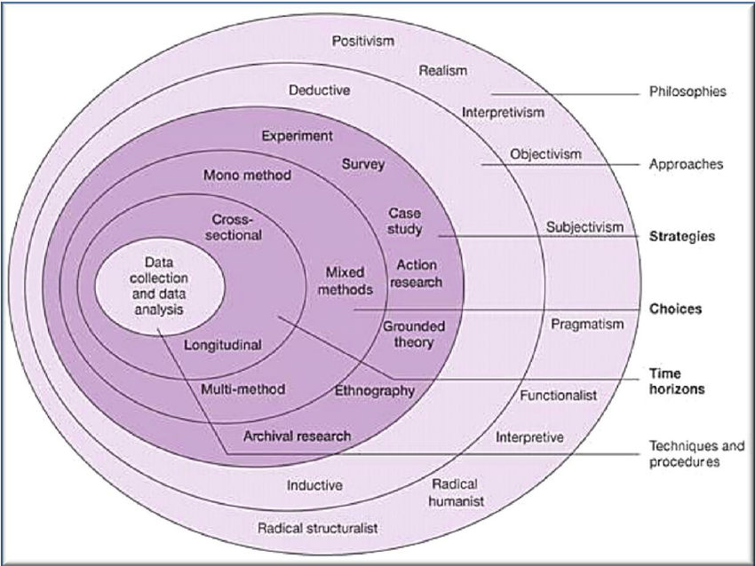
(Chapter 3 Figure 3) – The Research Onion (Saunders et al, 2007).
3.5 Philosophy
Research philosophy is positioned at the outer layer of the ‘research onion, it is a belief about the ways in which data about a phenomenon should be collected, analysed and used. Secondary and Primary data must be collected and the data must be analysed to answer the research question. The choice of a specific research philosophy is impacted by practical implications. There are important philosophical differences between studies that focus on facts and numbers. (Dudovskiy, 2016).
Within the scope of business studies in particular there are four main research philosophies: pragmatism, Positivism, Realism and Interpretivism (Interpretivist). (Dudovskiy, 2016). The main research philosophy used will be Interpretivist, this will be the choice of philosophy for this dissertation, and because this is a method used for qualitative data and will be beneficial for to this research philosophy.
As the collection of primary research will be completed in the form of interviews, and this will then go forward to interpreting the data collected.(Research Methodology, 2018).
3.6 Approach
There are two types of approaches outlined in the research onion, these are the deductive approach and the inductive approach. For this thesis the inductive research has been chosen. This approach is all through the identification of a pattern when observing qualitative data and interpretation of the findings. As the research will be conducted through the use of interviews, qualitative data in the main focus and the inductive approach will identify the patterns to complete a thorough analysis of the data collected.

3.7 Time Horizon
Time horizon is the length of time something will take for the research to be completed.
The cross-sectional time horizon has been chosen for this dissertation as the investigation includes researching a specific cohort. A snapshot of what is happening among organisations in contemporary South Wales to determine how they are dealing with the employment of former offenders. The collection of data using interviews will not take a long time to conduct as this process will be focusing on something specific. An example of this is shown below in figure 4.
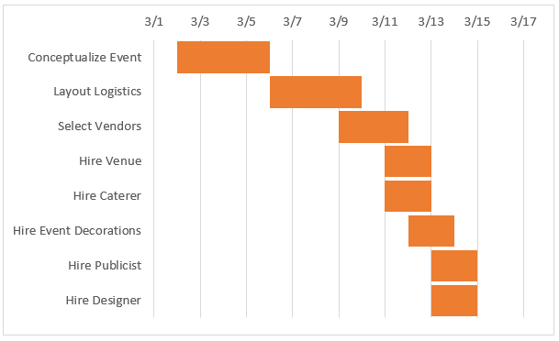
(Smart sheet, 2018) Chapter 3 – Figure 4 – Example of Gantt chart
3.8 Data Collection
According to Denzin and Lincoln (1994) Qualitative research is multimethod in focus, involving an interpretive, naturalistic approach to its subject matter. This means that qualitative researchers study things in their natural settings, attempting to make sense of, or interpret, phenomena in terms of the meanings people bring to them.
In this thesis, a semi structured interview will be taken to interviews with managers of different companies so that each manager is asked the same question in the same order (depending on if they do or do not employ former offenders) this is done to prevent accidental bias in response to question structure. The data collection method chosen for this investigation is appropriate as a large amount of data can be collected as the questions asked are open ended questions this means that the managers can elaborate on their answer and more analysis can be completed. This method is also completed in an economically way as interviews can take place face to face or over the phone (Denzin and Lincoln, 1994)
3.9 Analysis
Statistics can be used to summarise data, describing patterns, relationships, and connections. Statistics can be descriptive or inferential. To analyse the data collected an appropriate analysis will be used, therefore the thematic analysis, this will be created through the use of Microsoft Excel and Microsoft Word. The thematic analysis is reliable and helps keep all findings organised and safe. This data will then be kept in a password protected document on a computer ready to be analysed.
3.10 Limitations and Ethical Considerations
There are limitations when researching into the factors that impact employment opportunities for former offenders in South Wales. There is limited time to conduct a high amount of primary research and to plan meetings with managers to conduct interviews. A Gantt chart will be created to improve time management to ensure enough primary research gathered for this investigation. This will also ensure that all deadlines are met. The Gantt chart helps with organisation and will give a timescale for tasks and activities that need to be completed.
The ethical considerations are that companies can decline to take part in the interview. As the topic is about employing former offenders, some managers will not be conformable answering all questions due to the topic sensitivity. To avoid this, the individuals taking part in the interview will participate anonymously and will be named as Manager A and Company A to protect the identity of the manager and company. All data collected will be kept confidential and safe, the General Data Protection Regulations Law (GDPR) will followed. No information will be discoed to anyone and all information from collecting data will be kept safe using password protected documents on a computer that has anti-virus installed to ensure that all data is kept confidential.

Chapter 4 – Findings Chapter
This chapter will address the results of the primary research, in the form of interviews that have been conducted with five managers from five different companies in South Wales.
Below are the questions asked in the interviews with managers of different companies in South Wales. Every manager will be asked question 1 and question 2 in section A. If the manager does employ former offenders then they will be asked the questions in section B and if they do not employ former offenders then they will be asked the questions in section C.

These particular questions haven conducted to managers to see if they discriminate against employing former offenders. The questions will ask them why they have or have not employed former offenders and the reasons. These interviews will display the factors that impact employment opportunities for former offenders in South Wales.

Questions asked in interview
Section A

1. What industry do you work in?
2. Have you ever employed anyone with a criminal record before? YES/NO
If yes why did you employ the individual?
If no would you ever consider employing a former offender?

Section B

YES – If the manager does employ former offenders the following questions will be asked:
1. What convictions would you consider acceptable for employment?
2. Would you employ more former offenders?
3. Do you think other companies should be giving former offenders a chance of employment?
4. Do you think involvement with external companies will help change negative viewpoints on this topic?
5. Do you think by employing a former offender you have made a difference in their life and prevented them from re offending?

Section C

NO – If the manager does not employ former offenders then the following questions will be asked:
1. Why do you not employ former offenders?
2. If a former offender has attended basic skill educational lessons to help them adjust back into society. Would this effect your decision on their employment?
3. Would you consider employing a former offender on a basis of an extended probation?
4. What convictions would you consider acceptable for employment?
5. If the offence took place years ago would this still effect your employment decision?
6. Would you consider employing a former offender if a specialised role could be created for them (eg. someone who has committed an offence for fraud, could have a role as glass collecting and taking food orders in a restaurant away from till to prevent any risks)

4.1 Aim and objectives of dissertation
Data collection and analysis has been undertaken to fulfil the aim of this dissertation. The aims and objectives of this dissertation was to conduct primary research in the form of qualitative research, interviews with staff with recruitment responsibilities within an organisation to find out if managers are employing former offenders with criminal records. The following results will be interpreted and analysed. The evaluation of the interviews will be completed through a thematic analysis, with the use of open coding and axial coding.
4.2 Coding
The interview responses were looked over many times to ensure that a clear understanding was made regarding the information given by the managers. The coding process includes the identification of text segments, highlighting the key words and then placing this information into a table to see how many of the managers gave the same or similar response.

One of the most common ways of approaching qualitative data analysis is through conducting a thematic analysis (Bryman and Bell, 2011). Coding is a process that will be used in this dissertation to conduct thematic analysis. Coding is identifying a passage in the text or other data items (photograph, image), searching and identifying concepts and finding relations between them. Therefore, coding is not just labelling; it is linking of data to the research idea and back to other data (Cessda Training Wroking Group, 2018).

The grounded theory is constant comparative analysis, development of theoretical concepts and statements and theoretical sampling as well as usual supporting techniques of theoretical coding and memoing (Strauss and Corbin). The grounded theory method uses a data analysis procedure called theoretical coding to develop hypotheses based on what the research participants say (Auerbach and Silverstein,2003).

The open code will concentrate on the key topics by evaluating the answers given in the interviews and the axial coding will link the key areas to one theme. Many mangers from each company said that they employed former offenders to make a difference and to help them turn their life around. Other stated that they would only ever employ former offenders if their criminal record included minor offences only.

Open coding:
The four main topics that have shown when interpreting the interviews are:
“Make a difference”
“Turn life around”
“Minor convictions”
“Misdemeanours”
These four main topics were raised in the interviews conducted with managers of companies in South Wales. This show that the managers are willing to give former offenders jobs to change their life and to give them a second chance. This is only possible if their convection is minor. Not one company have said that they would employ someone who has committed a serious offence and that the possibility of their employment will depend on the crime they have committed.

Axial coding:
The two main themes shown in the interviews that have been conducted are transformation and minor crime. These themes show that employer do want to give former offenders a chance of employment and to change their life around, however they do not want to take the risk of employing an individual with a serious offence. Therefore, there are many factors that impact employment opportunities for former offenders in South Wales as employers are only looking and willing to employ individuals with minor offences.

The answers highlighted by some of the managers, that did not comply with any of the codes were highlighted for consideration. Some responses were not highlighted or used at all as they did not need coding. A table has been created for each theme recognised in the interviews, this will include statements from the managers. The responses had a final review to ensure that no information was unseen or recorded. The data analysis had been completed.
4.3 Results
Themes | Minor Convictions | Make a difference | Second chance | Turn life around
Manager A | “minor offences as in motoring offences would be the only convictions we would consider acceptable for employment” | “external companies will make a difference” | “depending on the individual and the offence they have committed but yes they do deserve a second chance” | “they are trying to turn their life around and trying to get back on track”
Manager B |  | “yes, they should be given a second chance if they are remorseful and they have learnt by their ,mistakes and want to become a better person then yes in certain circumstances they should be given a second chance” | “yes because if they are not given a second chance then they will re-offend, they need to get out of the circle of crime and try and better themselves”
Manager E | “Minor convictions would be the only one we would consider”
Manager F | “Minor convictions such as driving offences and drunk and disorderly offences” | “yes I have made a difference because giving them a job with responsibility and income will prevent them from re offending because they have too much to lose” | “after so many years they should be given a second chance as long as the individual is not violent or harmful to others”
Manager J | “driving convictions and drunk and disorderly” | “shows that they are ready to learn and want to make a difference in their life”

Chapter 4 - Figure 5 - Pie chart to show if the managers interviewed, employ former offenders in South Wales.

This chart shows that out of the managers interviewed only a few have employed former offenders. The other managers who have not employed former offenders were asked “why do you not employ former offenders?” Some managers have not received any applications from individuals with a criminal record, other managers stated that “better applicants have applied for the job” and that as a business they “rely on clear DBS checks as we visit schools and hospitals, ministry of defence sites and government buildings”. This shows that the research from the literature review for the UK is the same for South Wales. Employers are reluctant to give jobs to former offenders as there are certain procedures to the job application process for example DBS checks and when compared to better applicants their application could be over looked.

A question was asked to the 6 managers who said that they have not employed former offenders before “if the former offender has attended basic skill and educational lessons whilst in prison to help them adjust back into society. Would this effect your decision on their employment?” The results show below in figure // in the form of a pie chart.
Chapter 4 - Figure 6 – Pie chart to show management employment decision.

The chart shows that some managers think that through the former offenders attending educational lessons that they are showing “commitment” and are “ready for a second chance” therefore this would impact their employment decision. To contradict this, other managers have said that this would not make a difference to the employment decision, as the job “requires fully qualified and experienced individuals”. This is one of the factors that impacts employment for former offenders, the skills they are achieving in prison are only basic skills. Therefore, when they are released with a criminal record they are exempt from applying for many job roles, as the role requires higher qualifications.

The question “What industry do you work in?” followed by the question “Have you ever employed anyone with a criminal record before?” These questions were asked in the interviews to discover which companies in certain industries were giving former offenders a chance of employment.

Chapter 4 - Figure 7 - Pie chart to show which industries do employ former offenders and do not employ former offenders.

Figure 7 shows that the industries that require degrees or higher education, who deal with money and work with vulnerable children and adults and have not taken on former offenders. Industries who do not require higher education or degrees for the job role and do not deal with money have taken on former offenders. This shows that that the industries who do not have access to a lot of money or stock have employed former offenders. Whereas industries that do have access to a lot of money and vulnerable adults and children have not hired former offenders as there seems to be too much of a high risk for the company to take by employing a former offender with a criminal record.

4.4 Themes identified through analysis
Transformation
The rehabilitation of former offenders is a key feature of the modern UK criminal justice system. Every prison works to rehabilitate the prisoners. The main focus of rehabilitation is to reform the character and preventing the individuals from reoffending (politics.co.uk, 2019). The prisons main focus is to transform the individual into a better person and help them change and adjust so they are ready to fit back into society once they have left prison and find a job. The reason the prisons do this is so that the rates of recidivism are low.
Transformation was the main theme that was identified through the interviews conducted with managers. Many of the managers said that they would employ a former offender depending on the crime they committed. As they believe that they deserve a second chance in life as they understand that people do make mistakes. Some of the managers stated that they would like to give the former offender the opportunity to change their life around and make a difference. They believe that the opportunity of employment will transform their life and make them a better person and that the opportunity of employment that they have been given might prevent them from reoffending in the future.
Minor crime
Minor offences are usually considered to be less serious offences. Examples include road traffic offences, minor assaults, property damage and offensive behaviour (Victoria State Goverment, 2018). Many managers who were interviewed stated that they would consider employing a former offender only if they have committed a minor offence such as driving/motoring offences. According to Kang & Co Solicitors Limited (2018) there were 664,000 defendants prosecuted for driving offences throughout the United Kingdom in 2017. This shows that many people in the UK are prosecuted for committing minor offences, and even though these driving offences are classed as minor offences they will still appear on the individual’s criminal record which may have an impact on their employment decision. Many of the managers said that minor offences such as driving offences are accepted as it is not a serious offence and could have been a mistake.

4.5 Conclusions
The themes highlighted throughout this chapter are transformation and minor convictions. The interviews conducted with managers from different company’s show that they will only hire former offenders if the offence they have committed is minor. Some companies stated that they would not hire any former offenders as the job role includes working with vulnerable children or adults and a DBS check is required, the DBS check will locate all of the individuals criminal records and if this is not clear that the individual will not proceed any further in the job application process.
Other managers stated that certain higher qualifications and experience is required for the role and that the skills the former offenders develop through educational lessons in prison is not adequate as some job roles require degrees or high certificates.
There is discrimination against employing former offenders, companies only seem to be willing to give the opportunity to former offenders who have committed minor crimes. Other former offenders who have committed other crimes and have served their time are not given the chance or opportunity of employment as many companies still believe that if the individual has committed a crime once that they can do it again and that is not the risk that some businesses are willing to take. The next chapter will provide the reader with my finings.

Chapter 5 - Discussion Chapter

5.1 Findings
The aims of this dissertation were to investigate the factors that impact employment opportunities for former offenders in South Wales. The objectives for this study were to carry out a comprehensive literature review of exact literature factors that impact employment of former offenders. Conduct primary research in the form of qualitative research, interviews with staff with recruitment responsibilities within an organisation to find out if managers are employing former offenders with criminal records. The main findings from this research were that employers are reluctant to employ former offenders as they believe that they are a risk to their business. Prisons already offer educational lessons in prison to help the former offender develop skills so they are able to adjust back into society and find employment once released from prison. However, this does not seem to be enough to change the mind of employers about giving former offenders a job as they still believe that they are a risk and that if they have committed the crime once that they will commit the crime again. If the government got involved in this issue and offered financial incentives to companies to employ former offenders this would make a difference. More companies will be willing to give former offenders a job and following this the impacts of employment opportunities will decrease along with the rates of recidivism.

5.2 Limitations
The limitations that aroused in this dissertation were finding the time to conduct interviews with managers from companies in South Wales. Some interviews had to be conducted over the phone as the managers had no time to plan a meeting in person. An additional limitation to this was that there were not enough managers interviewed about this topic. More data could have been collected and analysled and additional themes identified. Existing research for South Wales was difficult to locate as most existing research and statistics available were England and Wales combined. There was a lack of previous academic research in this area meaning that the results of this dissertation cannot be compared with other studies in Wales or the United Kingdom.

5.3 Recommendations for future studies
The recommendations for future studies would be to improve time management and meet deadlines. Also use more than one method of primary research to ensure that enough data is collected and more themes can be identified.

5.4 Recommendations for future research
Many crimes are committed each year in the UK and individuals are locked away in prison to complete their sentence and are then released from prison with a criminal record. There are many recommendations for future research to ensure that the researcher has a full understanding of the factors that employment opportunities in South Wales.

An investigation into the reasons for individuals committing crimes and if there is a way that the UK could try and lower the rates of recidivism, introduce new laws and methods of rehabilitation other than prison. Research into the crimes committed in other countries and compare findings with the UK. An investigation into if other countries are using different methods for criminals other than imprisonment and if this works. More research into if other countries making changes to the law has had a positive or negative impact. For example, statistics on crime in England and Wales published in January 2017 show that there were 141,714 drug offences committed (Drugwise, 2019). Compare crime rates before and after legalisation of drugs in other countries to see if the crime rate would drop if drugs were also legalised in the UK.

Research into the financial factors for example the financial implications of putting people in prison and how this effects the economy. The gap between the rich and poor in the UK, future research could investigate into the crimes each social class commits. Also how the government giving financial incentives to employers to take on former offenders will help lower rates of recidivism.

References
Alós, R., 2014. Effects of prison work. European Journal of Criminology, p. 16.
Al-Rousan, 2017. Inside the nation’s largest mental health institution: a prevalence study in a state prison system. Harvard Libraray.
Balbuena, L. M. S., 2018. Does Clozapine promote employability and reduce offending among mentally disordered offenders?. Canadian Journal of Psychiatry, p. 6.
Bryman and Bell, 2011. Business Research Methods. third ed. New York: Oxford university press .
Bryman, A., 2003. Business Research Methods. New York : Oxford University Press .
CareersWales.com, 2019. Employing ex-offenders. [Online]
Available at: https://www.careerswales.com/en/employers/employment-and-legislation/employing-ex-offenders/
[Accessed 1 April 2019].
Cessda Training Wroking Group, 2018. Qualitative coding. [Online]
Available at: https://www.cessda.eu/Training/Training-Resources/Library/Data-Management-Expert-Guide/3.-Process/Qualitative-coding
[Accessed 14 May 2019].
Drugwise, 2019. How many drug crimes are committed?. [Online]
Available at: https://www.drugwise.org.uk/how-many-drug-crimes-are-committed/
[Accessed 26 May 2019].
Dudovskiy, J., 2016. The Ultimate Guide to Writing a Dissertation in Business Studies: a step by step assistance. 1 ed. s.l.:research-methodology.net.
Fletcher, D. R., 2011. THE DEVELOPMENT OF WORKING PRISONS: TRANSFORMING INMATES FROM THE LUMPENPROLETARIAT TO THE CONTINGENT WORKFORCE. British Journal of Community Justice, p. 8.
GOV.UK, 2019. Check someone's criminal record as an employer. [Online]
Available at: https://www.gov.uk/dbs-check-applicant-criminal-record
[Accessed 17 April 2019].
HM Goverment, 2019. HM Goverment. [Online]
Available at: https://assets.publishing.service.gov.uk/government/uploads/system/uploads/attachment_data/file/272207/6702.pdf
[Accessed 7 April 2019].
Holzer, H. J., 2003. Employment Barriers Facing Ex-Offenders. Employment Dimensions of Reentry: Understanding the Nexus between Prisoner Reentry and Work, 20 May, 1(1), p. 4.
Jenny, 2014. Clearly define your research strategy. [Online]
Available at: https://www.mackenziecorp.com/phase-2-clearly-define-research-strategy/
[Accessed 14 November 2018].
Kang & Co Solicitors Limited, 2018. Driving offences committed in the UK (2017). [Online]
Available at: https://www.greaterbirminghamchambers.com/latest-news/blogs/2018/6/driving-offences-committed-in-the-uk-2017/
[Accessed 26 May 2019].
Lam, H., 2003. The Use of Criminal Record: The Rights of Ex-offenders, Employers and Public. Journal of Business Ethics, Issue 1, p. 47.
legislation.gov.uk, 1974. Rehabilitation of Offenders Act 1974. [Online]
Available at: https://www.legislation.gov.uk/ukpga/1974/53
[Accessed 3 March 2019].
Minisrty of Justice, 2018. Employing Prisoners and ex- offenders. [Online]
Available at: https://www.gov.uk/government/publications/unlock-opportunity-employer-information-pack-and-case-studies/employing-prisoners-and-ex-offenders
[Accessed 13 November 2018].
NV, H. S. a. R., 2013. Negative Credentials: Fair and effective consideration of criminal records. Journal of American Business Law , p. 78.
Oxford, 2019. research. [Online]
Available at: https://en.oxforddictionaries.com/definition/research
[Accessed 20 April 2019].
politics.co.uk, 2019. Prison Rehabilitation. [Online]
Available at: https://www.politics.co.uk/reference/prison-rehabilitation
[Accessed 25 May 2019].
Prisioners Education Trust, 2019. What we do. [Online]
Available at: https://www.prisonerseducation.org.uk/what-we-do/
[Accessed 2 April 2019].
Pyke, C., 2019. Employers urged to stop asking about criminal record. [Online]
Available at: https://www.walesonline.co.uk/business/business-news/employers-urged-stop-asking-criminal-15632234
[Accessed 1 March 2019].
Research Methodology, 2018. Research Philosophies. [Online]
Available at: https://research-methodology.net/research-philosophy/
[Accessed 18 November 2018].
Rucker, M., 2016. 3 STRAIGHTFORWARD METHODS FOR ANALYZING QUALITATIVE INTERVIEW DATA. [Online]
Available at: https://unstick.me/3-straightforward-methods-for-analyzing-qualitative-interview-data/
[Accessed 23 April 2019].
Saunders et al, 2007. The Research Onion. [Online]
Available at: https://www.researchgate.net/figure/The-research-onion-Saunders-et-al-2012_fig2_282912642
[Accessed 13 November 2018].
Smart sheet, 2018. Gantt Chart. [Online]
Available at: https://www.smartsheet.com/blog/gantt-chart-excel-b
[Accessed 19 November 2018].
Sturge, G., 2018. UK Prison Population Statistics. House of Commons , 23 July .
SurveyMethods, 2017. Benefits and weaknesses of survey research. [Online]
Available at: https://surveymethods.com/blog/benefits-and-weaknesses-of-survey-research/
[Accessed 14 November 2018].
Taylor, S., 2018. Employing Ex-offenders. [Online]
Available at: http://www.acas.org.uk/media/pdf/1/1/Employing_Ex-Offenders.pdf
[Accessed 10 April 2019].
The Guardian , 2019. Wales has highest incarceration rate in western Europe – study. [Online]
Available at: https://www.theguardian.com/uk-news/2019/jan/16/wales-has-highest-incarceration-rate-in-western-europe-prison-population-england
[Accessed 3 April 2019].
The Highland Council, 2019. Criminal Justice Services. [Online]
Available at: https://www.highland.gov.uk/info/1396/criminal_justice_social_work/433/criminal_justice_services/6
[Accessed 15 May 2019].
TheInformaitonHub, 2019. Seeking employment with a spent conviction. [Online]
Available at: http://hub.unlock.org.uk/knowledgebase/convictions-employment-law-2/
[Accessed 2 March 2019].
Victoria State Goverment, 2018. Types of offences. [Online]
Available at: https://www.victimsofcrime.vic.gov.au/charges-laid/types-of-offences
[Accessed 25 May 2019].

politics.co.uk, 2019. Prison Rehabilitation. [Online]
Available at: https://www.politics.co.uk/reference/prison-rehabilitation
[Accessed 25 May 2019].
Victoria State Goverment, 2018. Types of offences. [Online]
Available at: https://www.victimsofcrime.vic.gov.au/charges-laid/types-of-offences
[Accessed 25 May 2019].
Kang & Co Solicitors Limited, 2018. Driving offences committed in the UK (2017). [Online]
Available at: https://www.greaterbirminghamchambers.com/latest-news/blogs/2018/6/driving-offences-committed-in-the-uk-2017/
[Accessed 26 May 2019].
Drugwise, 2019. How many drug crimes are committed?. [Online]
Available at: https://www.drugwise.org.uk/how-many-drug-crimes-are-committed/
[Accessed 26 May 2019].

Appendix
Appendix 1 – Copy of completed interview questions

Interviewee 1 – Manager A for Company A.

- What industry do you work in? “construction “

- Have you ever employed anyone with a criminal record before? “yes I have”
2a. if yes why did you employ the individual? “I believe that everyone deserves a second chance”

- Would you employ more former offenders “Yes depending on the person”

- What convictions would you consider acceptable for employment? “Minor convictions such as GBH but I would not employ someone who has been convicted for theft”

- Why do you employ more former offenders? “yes they are trying to turn their life around and trying to get it back on track all depends on the individual”

- Do you think other companies should be giving former offenders a chance of employment? “Depending on the offence the individual has committed but yes they do deserve a second chance”.

- Do you think involvement with external companies will help change negative viewpoints on this topic? “Yes as it will make a difference’

- Do you think by employing a former offender you have made a difference in their life and prevented them from re offending? “Yes, because they now have a support system in their colleagues a guaranteed income. I feel that the individual has learnt from their mistake and by me giving this chance of a job they work hard as they know that these opportunities don’t come around often.”

Interviewee 2 – Manager B Company B

1. What industry do you work in? “Materials handling”
2. Have you ever employed anyone with a criminal record before? YES
If yes why did you employ the individual? “Employed not knowing that he had a criminal record because he didn’t disclose it.”

YES – If the manager does employ former offenders the following questions will be asked:
- What convictions would you consider acceptable for employment?” Minor offences as in motoring offences would be the only convictions acceptable for employment “

- Would you employ more former offenders? “It would depend on what their offence was”

- Do you think other companies should be giving former offenders a chance of employment? ‘Yes, because they should be given a second chance if they are remorseful and they have learnt by their mistakes and want to become a better person then yes in certain circumstances they should be given a second chance’

- Do you think involvement with external companies will help change negative viewpoints on this topic? “Yes”

5. Do you think by employing a former offender you have made a difference in their life and prevented them from re offending? “Yes because if they are not giving a second chance then they will re-offend. They need to get out of the circle of crime and try and better themselves”

Interviewee 3 – Manager C Company C
Section A

1. What industry do you work in? “Engineering and inspection”
2. Have you ever employed anyone with a criminal record before? “No”
If yes why did you employ the individual?
If no would you ever consider employing a former offender? “Yes”

Section C

NO – If the manager does not employ former offenders then the following questions will be asked:
1. Why do you not employ former offenders? “Because we reply on clear CRB checks as we visit schools and hospitals and Ministry of defence sites and government buildings”

- If a former offender has attended basic skill educational lessons to help them adjust back into society. Would this effect your decision on their employment? “It would be difficult as we only recruit fully qualified and experienced engineers”

- Would you consider employing a former offender on a basis of an extended probation? “Would be considered but a clear DBS result still take priority”

4. What convictions would you consider acceptable for employment? “Minor motoring offences. As we rely on honesty on an integrity any theft or fraud would not be accepted.”

- If the offence took place years ago would this still effect your employment decision? “Personal decision wouldn’t have a problem but this would need to be escalated to HR for further guidance.”

6. Would you consider employing a former offender if a specialised role could be created for them (eg. someone who has committed an offence for fraud, could have a role as glass collecting and taking food orders in a restaurant away from till to prevent any risks). “Possibly if there was an office job position available but it would depend on the offence and how long ago it was and what position would best suit them.”

Interviewee 4 – Manager D Company D

Section A

1. What industry do you work in? ‘Hospitality”
2. Have you ever employed anyone with a criminal record before? “No”
If no would you ever consider employing a former offender? “It will depend on their conviction”

Section C

NO – If the manager does not employ former offenders then the following questions will be asked:
1. Why do you not employ former offenders? “Better applicants have applied without criminal conviction”
2. If a former offender has attended basic skill educational lessons to help them adjust back into society. Would this effect your decision on their employment? “Yes”
3. Would you consider employing a former offender on a basis of an extended probation? “Yes”
4. What convictions would you consider acceptable for employment? “Minor conviction such as driving convictions”
5. If the offence took place years ago would this still effect your employment decision? “It would depend on how many years ago the offence took place”
6. Would you consider employing a former offender if a specialised role could be created for them (eg. someone who has committed an offence for fraud, could have a role as glass collecting and taking food orders in a restaurant away from till to prevent any risks) “No”

Interviewee 5 – Manager E Company E

Section A

1. What industry do you work in? “Customer service contact centre”
2. Have you ever employed anyone with a criminal record before? “No”
If yes why did you employ the individual?
If no would you ever consider employing a former offender? “Yes dependent on the reason for the record”

Section C

NO – If the manager does not employ former offenders then the following questions will be asked:
1. Why do you not employ former offenders? “Have not had anyone apply with a criminal record”
2. If a former offender has attended basic skill educational lessons to help them adjust back into society. Would this effect your decision on their employment? “No if their conviction was not of minor it would not affect the decision of employment”
3. Would you consider employing a former offender on a basis of an extended probation? “Yes”
4. What convictions would you consider acceptable for employment? “Minor convictions”
5. If the offence took place years ago would this still effect your employment decision? “Yes, It would depend on how many years ago the offence took place and what the offence was”
6. Would you consider employing a former offender if a specialised role could be created for them (eg. someone who has committed an offence for fraud, could have a role as glass collecting and taking food orders in a restaurant away from till to prevent any risks) “yes as this would reduce the risk of potential against the business”.

Interviewee 6 -Manager F Company F
Section A

1. What industry do you work in? “Accommodation and food services”
2. Have you ever employed anyone with a criminal record before? “Yes”
If yes why did you employ the individual? “Seemed very keen to work, had good charisma”

YES – If the manager does employ former offenders the following questions will be asked:
- What convictions would you consider acceptable for employment?” ASBO and motoring offences such as speeding only”

- Would you employ more former offenders?” it would depend on the individual and how long ago the offence was”

- Do you think other companies should be giving former offenders a chance of employment? ‘Yes, after so many years they should be employed and given the chance as long as the individual is not violent or harmful to others”

- Do you think involvement with external companies will help change negative viewpoints on this topic? “Yes”

5. Do you think by employing a former offender you have made a difference in their life and prevented them from re offending? “Yes, because you’re giving them job with responsibility and income this will prevent a lot of re offending because they have too much to lose”

Interviewee 7 -Manager G Company G

Section A

1. What industry do you work in? “Banking”
2. Have you ever employed anyone with a criminal record before? “No”
If no would you ever consider employing a former offender? “It will depend on their conviction”

Section C

NO – If the manager does not employ former offenders then the following questions will be asked:
1. Why do you not employ former offenders? “As the individual will need to be trusted to complete everyday tasks and handle accounts and money”
2. If a former offender has attended basic skill educational lessons to help them adjust back into society. Would this effect your decision on their employment? “No”
3. Would you consider employing a former offender on a basis of an extended probation? “Yes, but as long as it is minor convictions such as driving convictions”

- What convictions would you consider acceptable for employment? “Minor conviction such as vandalism, driving convictions”
5. If the offence took place years ago would this still effect your employment decision? “It would depend on how many years ago the offence took place”
6. Would you consider employing a former offender if a specialised role could be created for them (eg. someone who has committed an offence for fraud, could have a role as glass collecting and taking food orders in a restaurant away from till to prevent any risks) “No”

Interviewee 8 – Manager H for Company H.

Section A

- What industry do you work in? “beauty”

Have you ever employed anyone with a criminal record before? “Yes”
2. a. If yes why did you employ the individual? “Employed the individual to give a second chance and thought she was perfect for the role”

Section C
YES – If the manager does employ former offenders the following questions will be asked:
- What convictions would you consider acceptable for employment? Drunk and disorderly offences

- Would you employ more former offenders? “maybe, it would depend on the individual ”

- Do you think other companies should be giving former offenders a chance of employment? ‘yes, if it is a one-time offence and if it is a minor conviction”

- Do you think involvement with external companies will help change negative viewpoints on this topic? “Yes”

5. Do you think by employing a former offender you have made a difference in their life and prevented them from re offending? “Yes, because they’ve been given an opportunity to peruse their career and have a better standard of life.

Interviewee 9 –Manager I Company I

Section A

1. What industry do you work in? “Education”
2. Have you ever employed anyone with a criminal record before? “No”
If no would you ever consider employing a former offender? “No as the individual would be around venerable children”

Section C

NO – If the manager does not employ former offenders then the following questions will be asked:
1. Why do you not employ former offenders? “A clean DBS check is required for employment”
2. If a former offender has attended basic skill educational lessons to help them adjust back into society. Would this effect your decision on their employment? “No”
3. Would you consider employing a former offender on a basis of an extended probation? “No”

- What convictions would you consider acceptable for employment? “driving offences”
- 5. If the offence took place years ago would this still effect your employment decision? “It would depend on how many years ago the offence took place”
- Would you consider employing a former offender if a specialised role could be created for them (eg. someone who has committed an offence for fraud, could have a role as glass collecting and taking food orders in a restaurant away from till to prevent any risks) “No”

Interviewee 10 -Manager J Company J

Section A

1. What industry do you work in? “Finance”
2. Have you ever employed anyone with a criminal record before? “No”
If no would you ever consider employing a former offender? “Yes but the conviction cannot include fraud or theft”

Section C

NO – If the manager does not employ former offenders then the following questions will be asked:
1. Why do you not employ former offenders? “I have a reputable business and the risk of theft or incompetence will detrimental to my businesses future success”
2. If a former offender has attended basic skill educational lessons to help them adjust back into society. Would this effect your decision on their employment? “Yes”
3. Would you consider employing a former offender on a basis of an extended probation? “Yes, depending on the offence committed”

- What convictions would you consider acceptable for employment? “driving convictions, drunk and disorderly”
5. If the offence took place years ago would this still effect your employment decision? “if it was fraud or theft no, if the offence was minor then this will be considered”
6. Would you consider employing a former offender if a specialised role could be created for them (eg. someone who has committed an offence for fraud, could have a role as glass collecting and taking food orders in a restaurant away from till to prevent any risks) “depending on the offence and the position we are in as a comp

