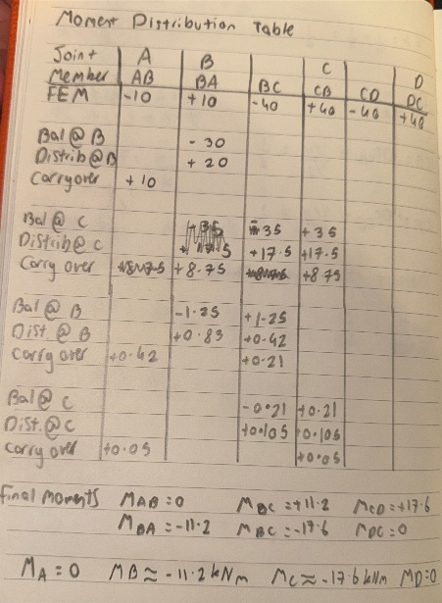
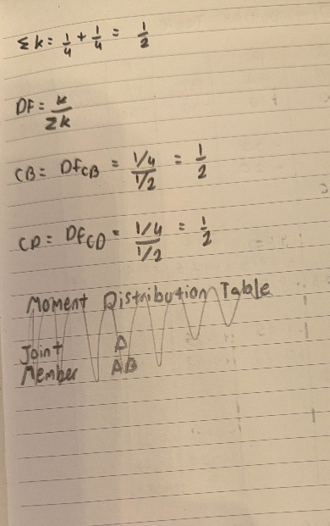
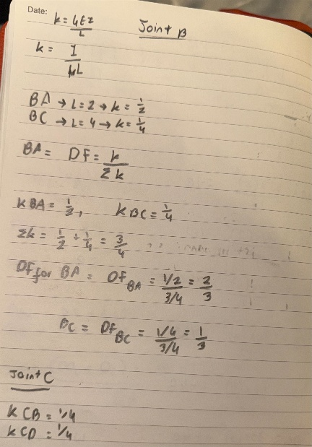
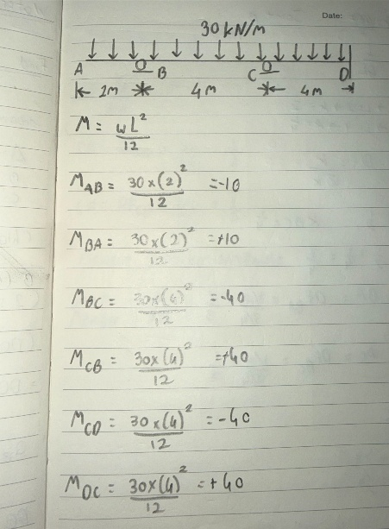
Figure 1

The moment distribution method was used to determine the end moments. Fixed end moments were calculated and distributed at joints B and C using stiffness-based distribution factors. Final moments were obtained after successive balancing and carry-over steps. 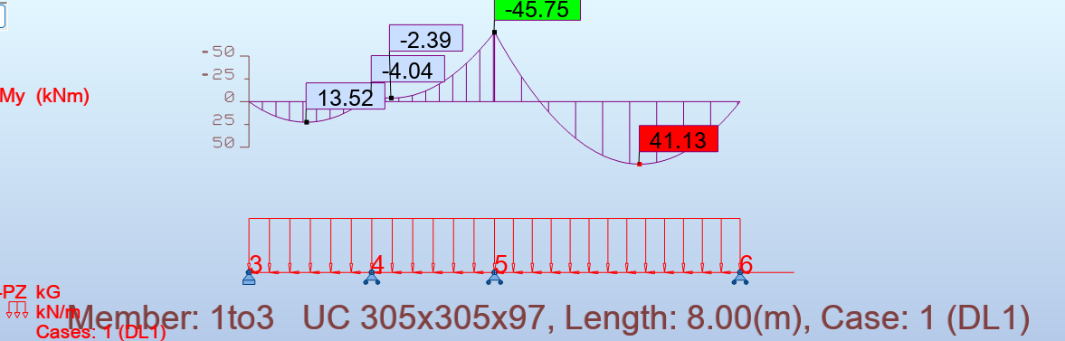
The Robot results closely matched the hand calculations, with zero moments at the end supports and hogging at the supports. The bending moment diagram shape was consistent, with only minor differences due to rounding.

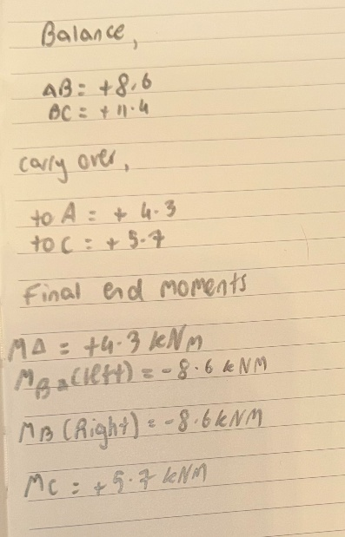
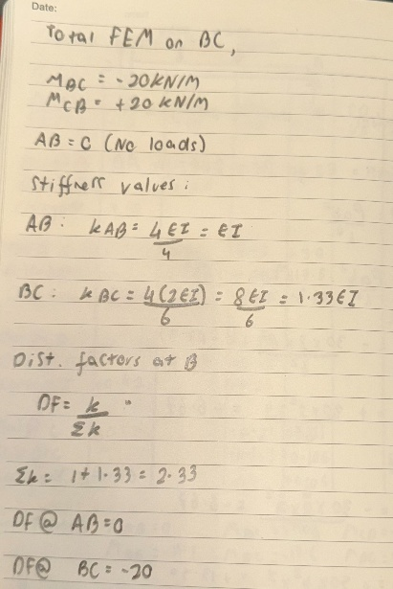
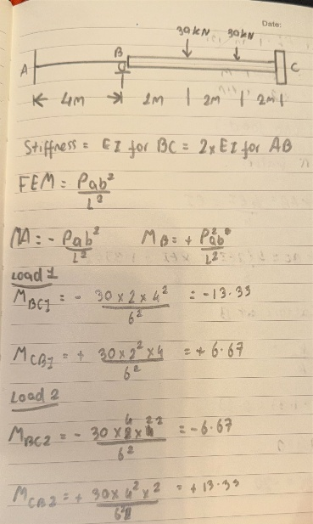
Figure 2

The moment distribution method was applied to determine end moments. Fixed end moments were calculated for the point loads on span BC. Stiffness values were adjusted due to the increased rigidity of BC (EI = 2AB). Distribution factors were calculated and joint moments were balanced iteratively until convergence.
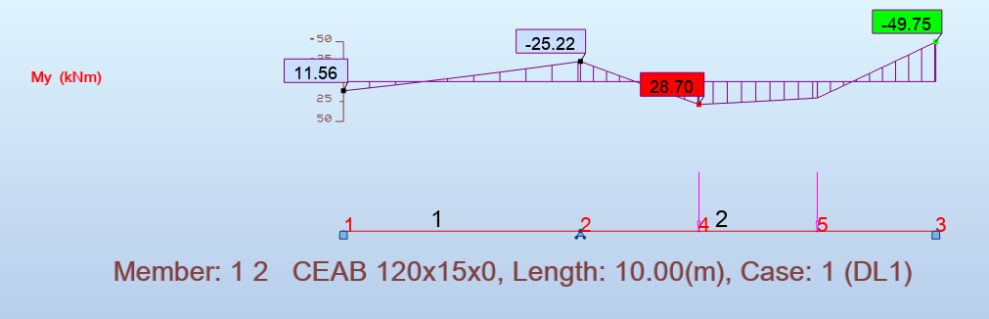
The Robot analysis showed a similar moment distribution to the hand calculations, with hogging at the fixed supports and reduced moment at the intermediate support. Small differences were due to stiffness modelling and rounding.

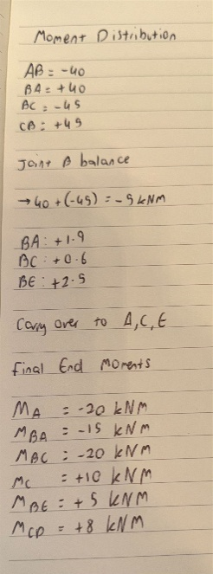
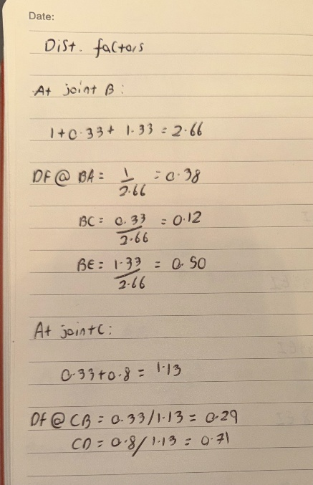
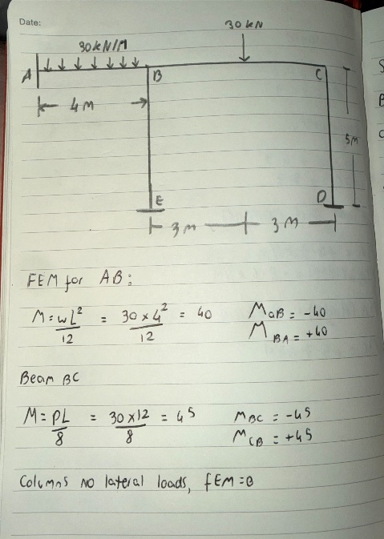
Figure 3
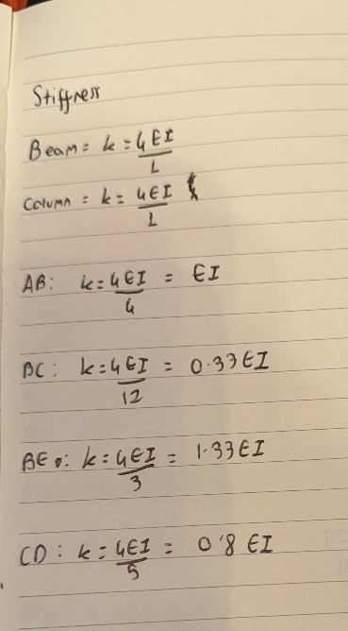
The portal frame was analysed using the moment distribution method. Fixed end moments were calculated for beam members subjected to UDL and point loading. Stiffness values were determined based on member lengths assuming constant EI. Distribution factors were calculated at joints B and C and iterative balancing was performed until convergence was achieved. 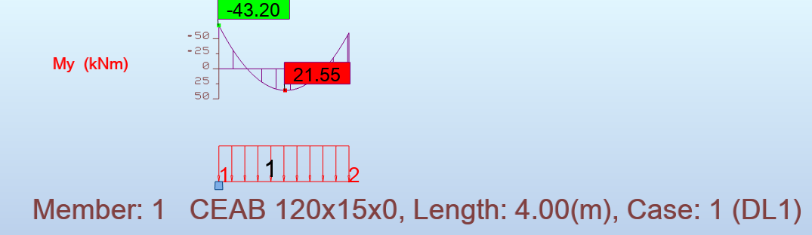
The Robot results agreed with the hand calculations, showing moments at beam-column joints and bending in the columns. Minor variations were due to modelling assumptions.

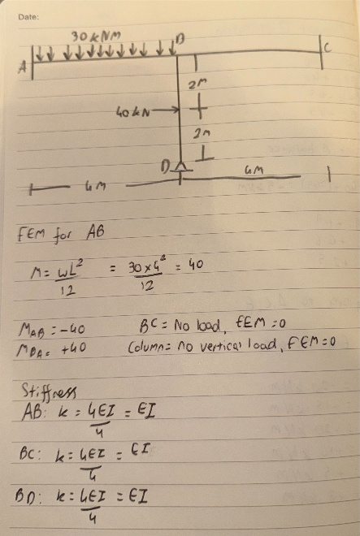
Figure 4
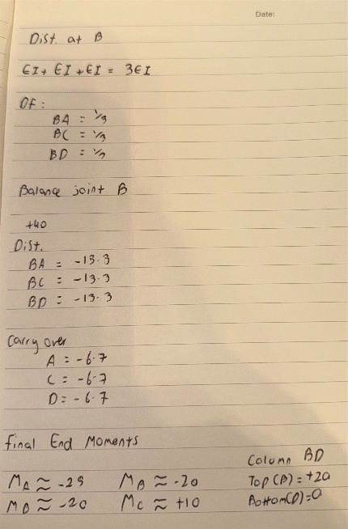

The frame was analysed using the moment distribution method considering both non-sway and sway conditions. The horizontal load introduced lateral displacement, resulting in additional moments in the column and beam members. Final moments were obtained by superposition of sway and non-sway effects. 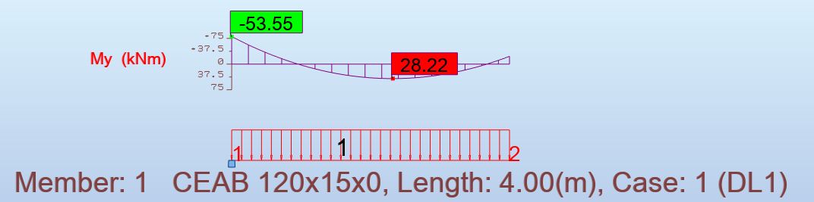
The Robot analysis confirmed frame sway under lateral loading, with asymmetric bending moments. Results were consistent with hand calculations, with slight differences due to manual approximations.

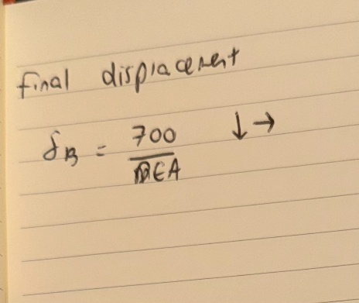
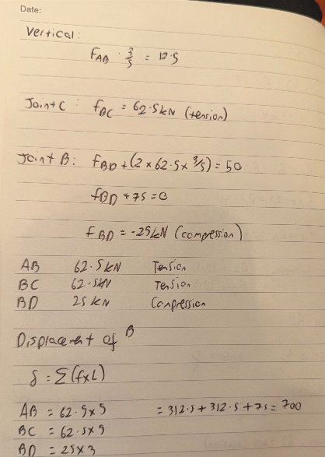
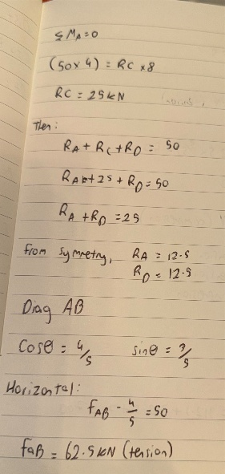
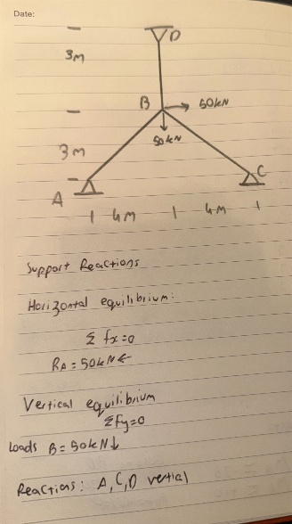
Figure 5

The truss was analysed using the method of joints to determine internal member forces. Reactions were calculated using equilibrium equations. The displacement of joint B was obtained using the principle of virtual work assuming constant 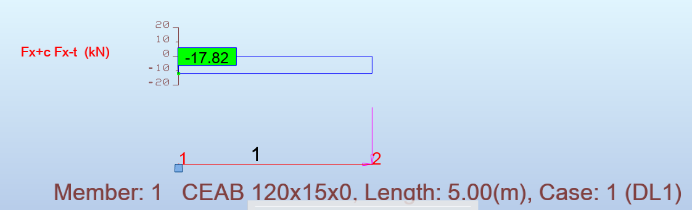
The Robot results closely matched the hand calculations, with correct identification of tension and compression members. Differences were negligible due to rounding.

