- A system is a collection/assembly of things that work together to complete a task that cannot be completed individually. The system takes an input and works together as a complex whole to produce the output that the observer wants to see.
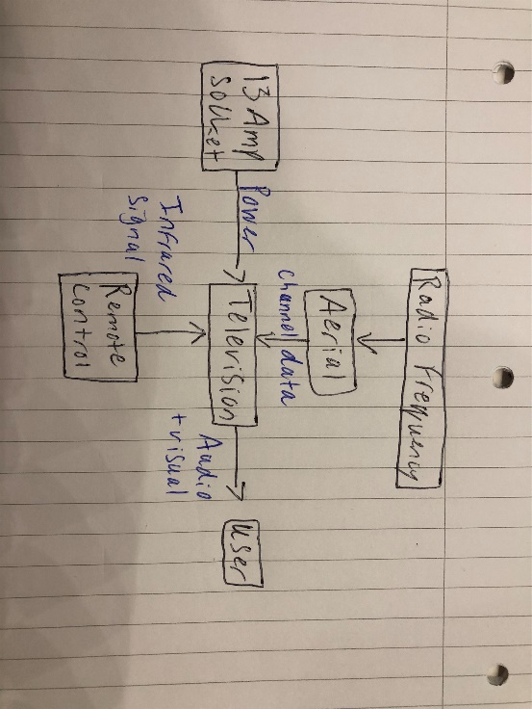
As shown, the TV takes inputs from the socket, aerial and the remote control, and individual parts inside the TV work together to produce an output to the user of visual and audio stimulation.

- Chance cause variation is the variation that always exists in the system, it can come from a variety of sources so is not assignable to a single cause. It can be measured and should produce a pattern over a longer period of time
Assignable cause variation is the variation that can be assigned to a single point, this could be a change in tooling, personnel or working conditions
The difference being one can be assigned to a single point and one cannot.

- Operational Requirement – a requirement that explains what the system is going to do, that should include some overarching constraints.
Functional requirement – noun-verb description of what the system must do
Non-Functional Implementation Requirement – a solutionised requirement that restricts how the system will be implemented
Non-Functional Performance Requirement – a requirement that is associated to a particular function of the system
Non-Functional System Requirement – a requirement that applies to the system as a whole

- Basic – requirements that are obvious to the system and the customer has not expressed them, though they would be dissatisfied if they were not included.
Expressed – requirements that have been expressed by the customer without any additional digging
Delighters – requirements that the customer does not know they want, however if it is given to them, they will be delighted
Assumed – requirements that are not basic but have become the normal or have been taken for granted so they are ‘assumed’ that the designer will include them, if they are not included then the customer would be dissatisfied, eg. A 2022 ferrari not having electric windows, you may not have asked for them as you would assume they are now an obvious requirement.

- No mixing
Too much mixing
Too little mixing
Unintended Mixing
Intermittent mixing

- A failure mechanism is the way in which the failure occurs, it can be either chemical or physical, take a bike chain for example, if it has a protective coating on to prevent rust, the failure mode could be ‘too little/not enough coating’ and the failure mechanism would be corrosion.

7.
Use Case: A clear verb/noun or actor/verb/noun that communicates the scope of the use Case
Use case for L8 Screening Grenade

Operational Requirement – The L8 Screening Grenade shall deploy from the Challenger 2 tank and provide a visibly and thermally opaque smoke screen to cover an area of 30 meters in width and 6 meters in height.
Author Josh Martin | Issue - 1 | Reviewed | Date 24/03/2022
Actors:- A list of actors who can engage in the activities described in the use case:-

Manufacturer – to make and deliver the L8 Screening grenade to the MOD
MOD – Receives L8 Screening grenades and deploys them as required to the tank crew
Tank Crew – Uses the L8 Screening grenade in operational and training environments
L8 Grenade (the system) – Shall provide an effective smoke screen consistently

Pre-conditions:- Anything that can be assumed to be true when the use case begins :-

Grenades are loaded and ready to use
Tank crew has been trained in the operation of the grenades
Tank crew has received orders to use the grenades

Post-Conditions:- Anything that must be true when the use case is complete.

A solid smoke screen has been produced
The grenade deployment system is clear and ready to be reloaded
The tank crew have not been harmed by the deployment of the grenade

Basic Flow:- The set of steps the actors take to accomplish the goal of the Use Case. A clear description of what the system does in response to each user action.

Manufacturer supplies grenades
MOD receives and stores grenades
MOD deploys grenades to operational field
Tank crew received grenades
Load grenades
Deploy grenade
Generate smoke screen
Manoeuvre tank
Reload

Alternative Flow:- Captures alternative user/system interactions, such as what happens if data is entered incorrectly.

Grenades not loaded correctly
Incorrect grenade used

Exception Flow :- The things that can happen to prevent the user from reaching their goal.

Pyrotechnic delay failure
Smoke composition failure – leading to the enemy knowing the position and destroying the crew
Grenade launcher faulty – filled with mud from the battlefield

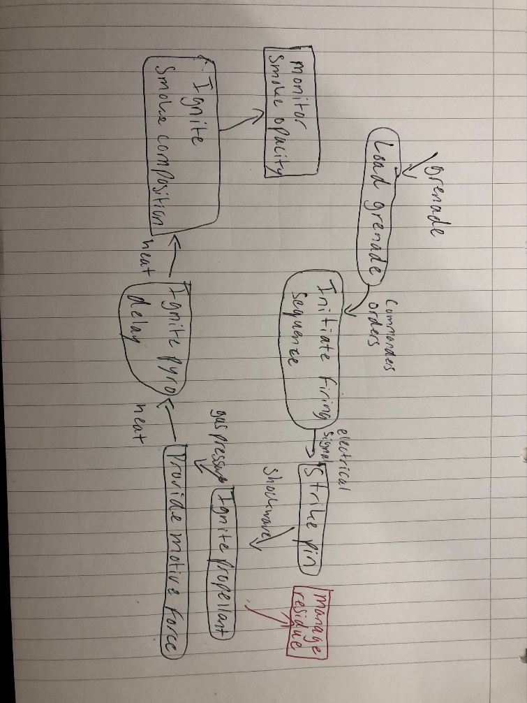
A functional FMEA would analyse each component in the assembly of the grenade and use the 5 failure modes to assist in designing out any potential unwanted emergent behaviour. By splitting it into the 5 failure modes, it makes it easier to determine the failure mechanisms associated with it and then score the failure under the categories of severity, likelihood, and detectability. The scoring will highlight the areas that need the most attention and should help to eliminate or minimise the failure occurring. Some failures may not be possible to fully eliminate but the FMEA helps to inform what control measures we need to put in place in what areas.

Example - Ignite pyro delay
Too much – Could speed up the burning of the pyrotechnic delay, producing smoke in the wrong area
Too little – Could delay the ignition of the smoke composition, the grenade may have landed already and would not produce the required smokescreen
Unintended – an unintended ignition could produce smoke at any point, this could lead to giving away the position instead of concealing it
Intermittent – this would also cause the smoke screen to be inefficient
None at all – no delay would result in the ignition not passing through to the smoke composition and therefore no screen would be delivered.
9.
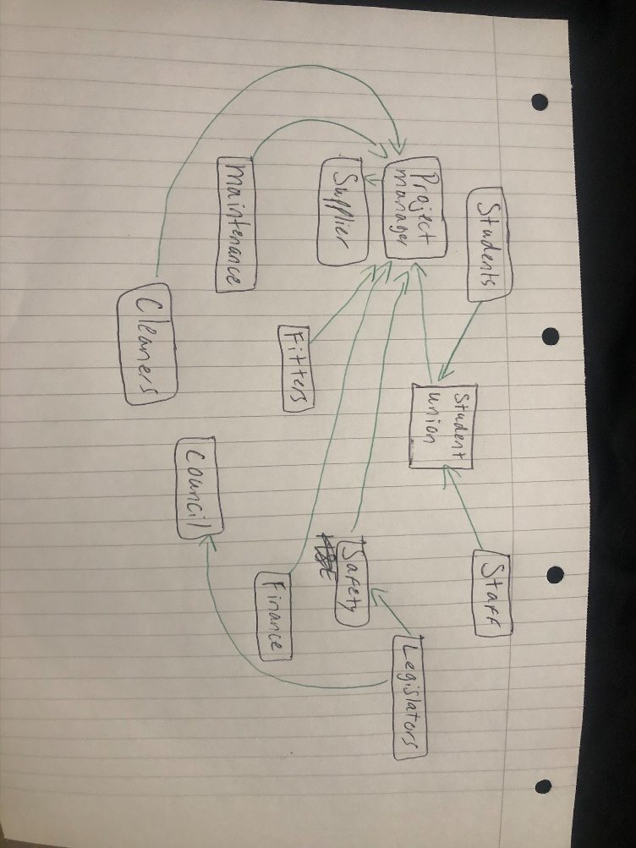
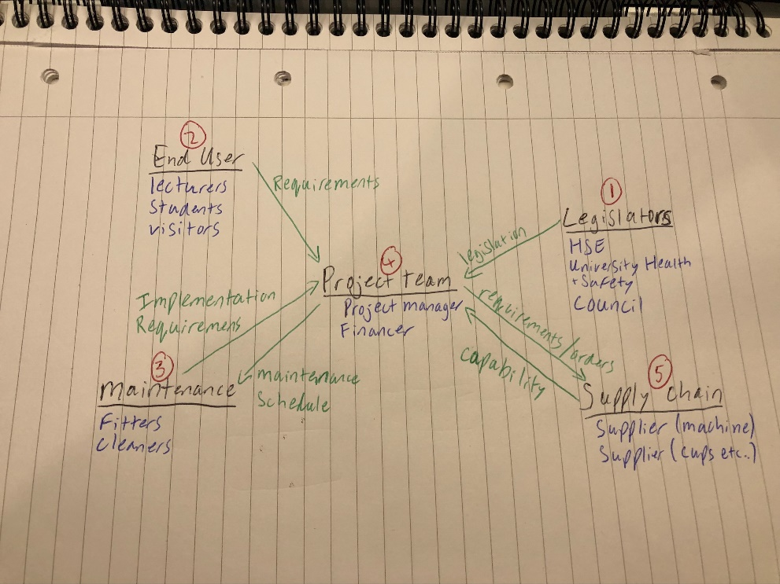
1 – The legislators would be the first to get requirements from because they have the legal power to stop the installation or bring legal action against the university if the did not follow the legal requirements. This gives an ultimate boundary for the installation of the coffee machine; nothing should be done before this stage so you don’t design or procure something that is illegal. Council is included in legislators as they may have local legislation surrounding waste procedures and what materials can be used, probably on a basis of recyclable materials.
2 – The end user should be next to gather requirements from, this is so you get a clear picture of what the users of the machine actually want, this comes into systems principle of ‘designing the right thing’ before you ‘design the thing right’. An unfiltered list of requirements before you are influenced by the financial restrictions is key to a satisfied user.
3 – maintenance should be considered as they will be able to tell you any requirements or restrictions in how the machine can be installed or maintained. There would be no point installing a machine that the maintenance team is unable to service because You didn’t check with them what is possible. These would most likely fall into the category of non-functional implementation requirements, once the NFIR’s have been obtained, it helps you build a desired specification for the machine.
4 – the project team should come together and list their requirements next including the financiers, this is to pull together the requirements from other stakeholder groups and fit in with the financial limitations and anything the project manager may need to add, they can analyse what has been given by each group and compile a list of requirements to send out to the potential suppliers. Getting the legal requirements first allows a check of other groups requirements against that boundary.
5 – finally requirements from the supply chain can be gathered, you should first get a picture of what is actually wanted by the users and what ‘must’ be done from the legislators, you can send out the specification and the suppliers can send back their requirements, as we may want something that the supplier cannot provide. If we wanted paper cups and the supplier could only provide recyclable plastic cups, they would send back a requirement to match.
The extra data flows are from the project team back to the maintenance group, as once a plan is in place then they can provide a maintenance schedule, and from the project team out to the supply chain, placing orders.

How
(Functional Requirements)
What  (Non Functional System Requirement) | Customer Importance  Can use a nominal figure, or use a pair wise comparison to determine priority | Relationships | What/How Much  (Metric/spec that must be met)
How Much
Metric/Spec that must be met
 |  | Technical assessments/trial
 |  | Importance weighting

The QFD determines the relationships between the non functional system requirements and the functional requirements, it can highlight if we have any relationships that need more analysis, any requirement that has a complete row/column without a relationship, means we are either missing a requirement somewhere else, or it is unnecessary itself.
Once you have entered the customer requirements/non functional system requirements, you assign a weighting to these, this could be a nominal figure to start off but a pair wise comparison could be done to assign a prioritisation figure against each requirement. Then with each relationship being scored as either a ‘no relationship’, or a 1, 3 or 9, the QFD multiples it all together to show the overall importance weighting of certain requirements.
The outcome of a QFD gives us our key requirements, any column/row that has several relationships shows that it is a key requirement, along with the scoring in the importance weighting section, that will give us our key functions. By including the metrics to measure against on the right hand column given by the customer, we can translate that against which functional requirement will be essential in meeting it. Once we know which functional requirement is responsible for meeting the required metric then we can add in a test/trial procedure that will ensure we meet those targets. These target values can aften be found within the non functional performance requirements.
A completed QFD should feed into a graph showing the key features and the process will have verified the requirements and show where any extra analysis may be needed to draw out more information on any missing relationships.

