

Student Name | Saima Ijaz
Student ID | 2237202
Module Details | Health, Wellbeing and Sustainable Development  (BMHP6030_BIRM)
Module Lecturer | Junaid Shaikh
Assignment Details | Component 2: Written Report

Contents Page No.
1. Introduction 3
2. Sustainable Development Goal 3 4
- Global policies to achieve SDG3 5
- UK Policies to achieve SDG3 5
- Local Policies to achieve SDG3 6
- Theories incorporate to with UK National & Local policies and SDG3 7
- Recommendations 8
4. Sustainable Development Goal 10 8
- Global policies to achieve SDG10 9
- UK Policies to achieve SDG10 9
- Local Policies to achieve SDG10 9
- Theories incorporate to with UK National & Local policies and SDG10 10
- Recommendations 11
5. Conclusion 11
References 12

Introduction
Sustainable Development Goals (SDGs) were adopted on 25 September 2015 by all member states of United Nations organization during Sustainable Development summit in New York. These SDGs replaced Millennium Development Goals which were adopted in 2000 for further upcoming 15 years. World Health Organization adopted them and aligned the work, policies and strategies with them because SDGs provided a detailed framework to improve global health and wellbeing (United Nations digital library, 2015).
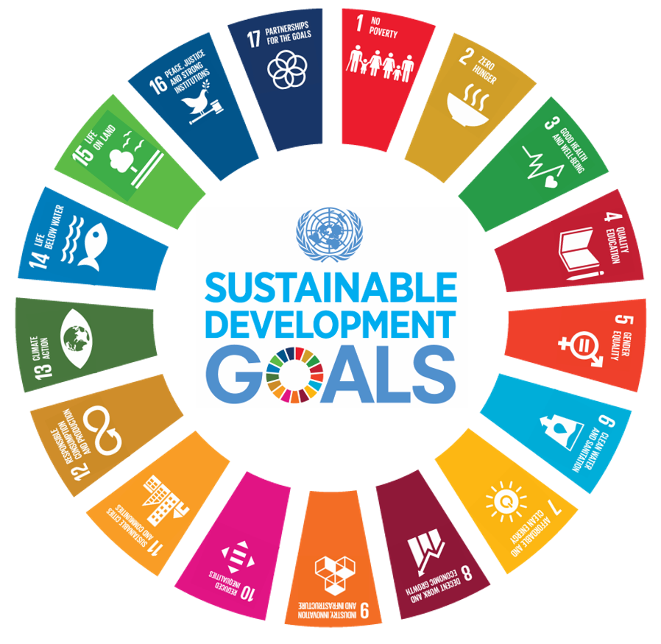 (Network 4 Sustainable Nano Technology, 2021)
SDGs are important because they provided a comprehensive global framework to tackle with major issues and challenges such as; poverty, health inequalities, lack of quality of education, clean water, sanitation and hunger. The aim of SDGs is to create a sustainable, peaceful and prosperous world by 2030. The SDGs help governments and organization to design policies, measure progress, and take collective actions to make sure that the development benefits to everyone while preserving resources for future generations (United Nations Development Programme, no date).
However, the report will identify the impact of SDG3 ‘Good Health and Wellbeing’ and SDG10 ‘Reduce Inequalities’ on the citizen’s health and wellbeing, as well as report will find that how the SDG3 and SDG10 interconnect with each other and critically evaluate these two sustainable development goals. Furthermore, report will explain that how international, national and local health initiatives effectively attain the results and improve health, wellbeing and sustainable development following Conclusion and recommendation.
The SDG3 and SDG10 are relatively interconnected with each other because health inequalities are the reason and resultant of broader social and economic inequalities. Achievement of SDG3 is based on the reduction of inequalities within and among countries (United Nations Digital Library, 2015).
Sustainable Development Goal 3: ‘Good Health and Wellbeing’
Good Health and Well-being aims to make sure that healthy lives and promote well-being for all at all ages. SDG 3 recognises that health is fundamental and crucial to sustainable development and requires coordinated and unified action across governments, healthcare systems, communities, and international organizations While SDG 3 played an important role to shape up and improve global health policies and their outcomes. Still progress and improvement is going on to make them even and free form challenges (United Nations Department of Economic and Social Affairs, 2024).
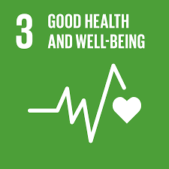
(United Nations, 2019)
SDG 3 has some major global health priorities, including:
- Reduce maternal mortality.
- End preventable deaths of newborn and children under 5 years of age.
- End the epidemics of AIDs, tuberculosis, malaria and neglect tropical diseases, combat hepatitis and other communicable diseases.
- Reduce non-communicable diseases and promote mental health and wellbeing.
- Strengthen the prevention and treatment of substance abuse.
- Road traffic.
- Sexual and Reproductive health.
- Universal health coverage.
- Environmental health. (World Health Organization, 2026)
Global policies to achieve
After the adoption of SDGs in 2015, global policies or initiatives have been taken to achieve SDG3. These initiatives produced notable improvements as well as they also have faced challenges including funding, inequalities, governance and health system resilience.
- Universal Health Coverage (UHC)
- Global Action Plan for Healthy Lives and Wellbeing for All
- Gavi, the Vaccine Alliance
- The Global Fund to Fight AIDS, Tuberculosis (TB) and Malaria
- COVID-19 Vaccines Global Access (COVAX) Initiative
- International Health Regulations (IHR)
The above mentioned initiatives were taken to ensure that all individuals receive quality health services without financial difficulties, vaccination programmes to strengthen the immunisation system in low income countries, fight against HIV/AIDS, Tuberculosis (TB) and malaria, to prepare for any future epidemic/pandemic, reduced child mortality as well as provide legal binding guidance for countries to detect, report and respond to public health emergencies (World Health Organization, 2026).
However, there are lots of limitations and weakness as well, such as; many countries still experience shortage of healthcare workers and infrastructure, financial constraints in low income countries, COVID-19 disrupted TB, Malaria and HIV programmes in many countries and donor dependency threaten the continuation of services (Frenk & Moon, 2013).
UK National policies to achieve SDG3
UK’s national health policies and local programmes are aligned with SDG3 and implemented through NHS which is the universal healthcare system in UK. Health and Care Act 2022, strengthening Integrated care system to improve collaboration between healthcare providers and local authorities. National vaccination programmes, legislation to control tobacco, obesity strategies and Mental capacity Act 2005 support SDG3. National programmes, such as;
- NHS Long Term Plan 2019
- Major Conditions Strategy (England)
- NHS Mental Health Implementation Plan
- Tobacco Control Plan
- COVID-19 Vaccination Programme
- Diabetes Prevention Programme
These national programmes support Integrated Care System, reducing future health care cost, emphasis on disease prevention and early intervention, encourages Person Centred Care, expanding community mental health services, Integration of mental and physical health and strengthen public health infrastructure (European Observatory on Health Systems and Policies, 2024).
Beside these strengths, still UK health care system is facing challenges, such as; persisting staff shortage, long waiting times, prevention policies need to take broader action obout health and other related issues (housing, education, employment, poverty), rising healthcare cost due to ageing population of UK and increasing prevalence of obesity and chronic diseases (GOV.UK, 2023).
UK Local initiatives to achieve SDG3
- Integrated Care Systems (ICSs)
- Healthy Child Programme (0-5 Years)
- Family Hubs and Start for Life Programme
- Social Prescribing
- A Better Start Programme
These local initiatives has some strengths, such as; reduces fragmentation between health and social care services, addresses determinants of health (housing, employment, education), support vulnerable families during first 1001 days of life, preventive approach to reduce long term cost, provide holistic family centred care, supports child development to achieve long term health outcomes, improved mental wellbeing, reduce social isolation and encourages collaboration with local authorities and community organisations (World Health Organization, 2025).
However, the overall effectiveness is affected due to funding difficulties, workforce shortages, and regional disparities. Future progress towards SDG 3 will require continuity in investment in local public health, stronger partnership across health and social care sectors and further collaboration between community organisations and local authorities (World Health Organization, 2026).
Theories or Models incorporated with UK National Policies, Local initiatives and SDG3
There are some models/theories which were incorporated with UK national policies and local initiatives to meet and achieve SDG3, such as:
- Dahlgren & Whitehead Model (1991)
- Ottawa Charter (1986)
- Health Belief Model
- Social Ecological Model
- Health in All Policies

I am going to explain Health Belief Model in detail that how this model is affecting UK policies and local initiatives as well as impact on citizen’s lives.

The Health and Belief Model (HBM)
The HBM has been valuable in supporting SDG 3 because it encourages preventive healthcare, promotes individual responsibility towards health and interventions which improve screening, vaccination and lifestyle behaviours. UK policies such as the NHS Long Term Plan, the NHS Diabetes Prevention Programme and Core20PLUS5 demonstrate these principles by using risk assessment, health education and behavioural support to reduce preventable disease (Becker, 1974).
However, the HBM does not fully account for wider social determinants of health such as poverty, housing, education and environmental conditions, which strongly influence health inequalities. Consequently, while HBM-informed interventions can improve individual behaviour, they may be less effective without broader structural policies addressing inequality. That’s why current UK strategies increasingly combine behaviour change approaches with population-level initiatives such as Core20PLUS5, which target disadvantaged communities and seek to improve equitable access to healthcare.

Recommendations
- NHS should promote Community-Based and Culturally Sensitive Interventions.
- Health inequalities should be reduced through action on social determinants of health alongside behaviour change.
Sustainable Development Goal 10: ‘Reduces Inequalities’
Sustainable Development Goal (SDG) 10: Reduced Inequalities aims to reduce inequality within and among countries. The goal recognises that economic growth is not sufficient if the benefits are not distributed equally. It makes sure that all individuals regardless of income, gender, age, disability, race, ethnicity, religion, migration status, or geographic location has equal right to access to the resources and services (United Nations, 2015). The Equality Act 2014 is completely aligned with SDG10.
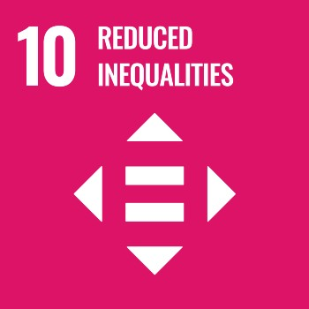
(United Nations Regional information centre for Western Europe, 2026)
The main types of inequalities addressed by SDG 10 include:
- Income inequalities
- Social inequalities
- Health inequalities
- Educational inequalities
- Economic inequalities
- Political inequalities
- Geographic inequalities
- Inequality among countries
(United Nations Regional information centre for Western Europe, 2026)
Global policies to achieve SDG10
- 2030 Agenda for Sustainable Development
- International Labour Organization
- World Bank Social Protection and Inclusion Programmes
- International Monetary Fund Reforms
- Global Migration Governance
- Trade and Development Policies
Most of policies based on voluntary commitments rather than any legal obligations. Often international financial institutions face criticism for promoting economic reforms that may be has conflict with social equity objectives. Inequalities are multidimensional and involving around employment, education, disability, disability, health and gender, demanding integrated policies rather than isolated interventions (GOV.UK, 2023).
Furthermore, globalisation increased economic growth but many countries still facing income disparities. Technology increased productivity as well as created complex situation for aged and uneducated people. Low income countries with their limited capacity hardly afford to take measures for climate and other environmental changes (World Health Organization, 2008).
National policies to achieve SDG10
- The Equality Act 2010
- Levelling up and Regeneration Act 2023
- English Devolution and Local Outcomes framework
- CORE20PLUS5
Local initiatives to achieve SDG10
- Affordable housing strategies
- Wealth building programmes for community
- Local anti poverty partnerships
- Integrated health and social care services
- Employment hubs
- Community engagement initiatives
UK’s national and local policies and initiatives decided to achieve SDG10 by promoting equal opportunities, reducing disparities, strengthen inclusive institutions and easy access to important services. National and local policies and initiatives are completely aligned with SDG10 to eliminate inequalities form society (SDG Data, 2025).
Theories or Models incorporated with UK National Policies, Local initiatives and SDG10
There are some theories/models which are incorporated with UK national and local policies and initiatives to align with SDG10 and achieve them by 2030. Such as:
- Social Justice Theory (John Rawls)
- Capability Approach (Amartya Sen & Martha Nussbaum)
- Social Inclusion Model
- Place-Based Approach
- Inclusive Growth Model
- Partnership Governance Model
- Levelling Up Framework
Social Justice Theory
John Rawl’s Theory of Social Justice provides an ethical foundation for SDG 10. Both advocate reducing inequalities through fairness, equal opportunities and prioritising disadvantaged communities. UK national initiatives such as Core20PLUS5, the NHS Long Term Plan, the Equality Act 2010 and the Health and Care Act 2022, together with local Health and Wellbeing Strategies and Health in All Policies approaches, demonstrate that resources should be directed towards disadvantaged groups of population. However, persistent socioeconomic and regional inequalities indicate that further cross-sector collaboration and investment are required to fully realise the aims of SDG 10 (Marmot et at., 2020).

Recommendations
- Increase Investment to improve and betterment of Disadvantaged Communities.
- Improve and strengthen monitoring and accountability mechanism for SDG10 implementation to eliminate health inequalities.
Conclusion
SDG 3 is the most important Sustainable Development Goals because good health provides a foundation for economic productivity, education, and social development. However, stronger international cooperation will require achieving SDG3 targets. It needs to be increased healthcare investment and effective national healthcare policies as well as ensure to reduce inequalities and strengthen health systems.
SDG 10 plays a crucial role in promoting social justice, economic inclusion, and improved health outcomes. It recognises that inequalities are must be addressed through coordinated policies. Government should prioritise disadvantaged populations and reduce barriers to opportunity. Heavy investment in education, healthcare, employment, social protection, and inclusive economic policies is essential to reduce these inequalities. Achieving SDG 10 by 2030 will require stronger political commitment, inclusive policies and sustained investment at global, national and local levels.
Inequalities limit people's opportunities as well as reduce quality of life. It leads to poorer health, lower educational achievement, unemployment, and social exclusion. Global policies and initiatives have established a strong foundation for reducing inequalities. World Health Organization and other active organisations have introduced important programmes to meet the targets of SDG 10 by 2030.

References
Becker, M.H. (1974). The Health Belief Model and Personal Health Behavior. Health Education Monographs, 2(4), 324–508. http://dx.doi.org/10.1177/109019817400200407.
Dahlgren, G. and Whitehead, M. (1991) Policies and strategies to promote social equity in health. Stockholm: Institute for Futures Studies. Available at: https://www.gov.uk/government/publications/health-profile-for-england/chapter-6-social-determinants-of-health. (Accessed: 01 July 2026).
European Observatory on Health Systems and Policies (2024) United Kingdom of Great Britain and Northern Ireland Health system in transition (HiT) Profile. Available at: https://www.eurohealthobservatory.who.int/monitors/health-systems-monitor/overview. (Accessed: 30 June 2026).
Frenk, J. & Moon, S. (2013) ‘Governance challenges in global health’, New England Journal of Medicine, 368(10), pp. 936–942. Available at: https://doi:10.1056/NEJMra1109339.
GOV.UK (2023) Profile for England: 2021. Available at: https://www.gov.uk/government/publications/health-profilr-for-england-2021. (Accessed: 02 July 2026).
GOV.UK (2023) Summary of strategic framework. Available at: https://www.gov.uk/government/publications/major-conditions-strategy-case-for-change-and-our-strategic-framework/summary-of-strategic-framework. (Accessed: 30 June 2026).
Marmot, M., Allen, J., Boyce, T., Goldblatt, P., & Morrison, J. (2020). Health Equity in England: The Marmot Review 10 Years On. Institute of Health Equity. Available at: https://www.health.org.uk/publications/reports/the-marmot-review-10-years-on. (Accessed: 18 July 2026).
Network 4 Sustainable Nano Technology (2021) United Nations Sustainable Development Goals. Available at: https://www.network4sustainablenano.org/un-sdgs/. (Accessed: 27 June 2026).
Sustainable Development Goals data (2025) UK data for the Sustainable Development Goals. Available at: https://www.sdgdata.gov.uk/. (Accessed: 02 July 2026).
United Nations Department of Economic and Social Affairs (2024) Sustainable Development Goal 3: Good Health and Well-being. Available at: https://www.sdgs.un.org/goals/goal3. (Accessed: 29 June 2026).
United Nations Development programme (no date) What are the Sustainable Development Goals? Available at: https://www.undp.org/sustainable-development-goals. (Accessed: 27 June 2026).
United Nations Digital Library (2015) Transforming our world: the 2030 Agenda for Sustainable Development. Available at: https://www.digitallibrary.un.org/record/3923923. (Accessed: 17 June 2026).
United Nations Organization (2019) SDG3. Available at: https://www.un.org/sustainabledevelopment/wp-content/upload/2019/02/SDG-3.gif. (Accessed: 30 June 2026).
United Nations Regional information centre for Western Europe (2026) Goal10: Reduce inequalities within and among countries. Available at: https://www.unric.org/en/sdg-10/. (Accessed: 30 June 2026).
World Health Organization (2008) Closing the Gap in a Generation: Health Equity Through Action on the Social Determinants of Health. Available at: https://www.who.int/publications/i/item/WHO-IER-CSDH-08.1. (Accessed: 02 July 2026).
World Health Organization (2025) Primary health care. Available at: https://www.who.int/news-room/fact-sheets/detail/primary-health-care. (Accessed: 01 July 2026).
World Health Organization (2026) Empowered communities as providers of care. Available at: https://www.who.int/teams/integrated-health-services/clinic-services-and-systems/emergency-and-critical-care/community-based-care. (Accessed: 01 July 2026).
World Health Organization (2026) Global Action Plan for Healthy Lives and Well-being for All. Available at: https://www.who.int/initiatives/sdg3-global-action-plan. (Accessed: 30 June 2026).
World Health Organization (2026) Health determinants, Promotion and Prevention. Available at: https://www.who.net/teams/health-promotion/enhanced-wellbeing/first-global-conference. (Accessed: 01 July 2026).
World Health Organization (2026) Targets of Sustainable Development Goals. Available at: https://www.who.int/europe/about-us/our-work/sustainable-development-goals/targets-of-sustainable-development-goal-3. (Accessed: 29 June 2026).

