5CO01 – Organisational Performance and Culture
Name: Sarah Waters
Student number: 2240422
Word Count: 4728
Evaluate the advantages and disadvantages of the organisation structure in your organisation (or an organisation with which you are familiar) and evaluate the advantages and disadvantages of one other organisation structure. Within the evaluation, you should include the reasons underpinning the structure. (AC 1.1)
Organisational design is the process of aligning the structure of an organisation with its overall objectives, with the aim of improving efficiency and effectiveness. More than designing a structure, it involves understanding the business processes, workflows, roles and responsibilities, volumes of work, activity analysis and resources as well as implementing and managing the change (Southampton University 2023).

Admiral Group PLC is an insurance company with an excellent reputation for organisation culture and the author of this assignment speaks with personal experience of working in HR within the company. Primarily Admiral Group PLC operates with a traditional hierarchical organisational structure, with a CEO (Chief Executive Office) with reporting HOD’s (Heads of Departments) coming off this and TM (Team Managers) and call centre staff branching off from them. The decision-making typically flows down from the top of structure, sometimes referred to as a pyramid, where each level of management has clear lines of responsibility and control (NI Business Info 2023), which is an advantage of this structure along with making the line of progression clear for development opportunities.
The main reason underpinning following this type of structure is in the main due to financial companies such as Admiral Group PLC being heavily regulated by the Financial Conduct Authority (FCA) and needing to ensure there are heavy compliance controls with an end point of someone being responsible and accountable for implementing this which is successful for them. Although there can be delays in communication filtering through the layers of this structure as well as a disconnect between employees and senior managers (NI Business Info 2023). This type of layered approach can also result in a lack of collaboration between the departments.
There are other structures that could be employed by organisations less compliance regulated, such as Nike Inc who use a matrix structure. Nike Inc have a global presence, are highly recognisable and are market leaders in footwear and accessories. This type of structure is ideal for a company such as this who have lots of campaigns and projects running side by side and underpins why Nike Inc apply this. This means employees will have a project manager as well as a functional direct line manager within their own departments. Organimi Inc (2023) state that this works successfully for them based on standard operational and communication processes meaning employees are aware of what is expected of them along with who they report too. This means there is an efficient use of resource with such collaboration although could mean employees feel conflicted between the expectations of their line managers and the priorities of the project.

Analyse connections between your organisation’s strategy (or an organisation with which you are familiar) and its products or services, and customers. (AC 1.2)
The connection between an organisation’s strategy, products/services and customers is important for overall business success. For example, Admiral Group PLC use their ethical approach to supporting their staff and customers, making them more competitively attractive as a brand and increasing overall sales and revenue.
CIPD (2023e) states ‘’Ethics are at the heart of professionalism’’. There is a belief that a company should take the right course of action in terms of its practices and act with integrity which lends itself to being a business case for acting ethically in decision making as it will help feed a company’s positive reputation as an employer and means potential customers maybe more likely to use the services, therefore boosting profitability as a result.
Admiral Group PLC’s strategy going in to 2023 has been the diversification of alternative methods of insurance i.e., home insurance, pet, travel as well as car insurance. This means offering discount for each additional product added to a multi brand policy, meaning the customer is saving on each product added as a customer loyalty strategy. This is profitable as they can retain low risk customers with all their insurables though relies on treating existing customer well i.e., being ethical and acting with integrity, for them to be willing to engage with this initiative CIPD (2023e). Diversification also means cross-training of existing staff and increasing call centre provisions to provide an efficient and knowledgeable service to the customers in all areas, sales, customer services and claims. Customers, especially in a claim’s environment need support and empathy as well as efficiency in dealing as an acknowledgement that this is an inconvenient and stressful time.
CIPD (2023e) claims an organisation's ethical climate matters. Ethical climate is influenced by policies and practices, meaning businesses need to pay attention to management practices and how they shape the ethical environment. This may shape the customer base; car insurance is an essential product but there are several available providers and standing out from the crowd is important for customer attraction.
Outside of private sector industries, this is also applicable in primary care settings, Dr Elliot Street in a podcast interview conducted by Thomas (2023) talks of the simulated environment for teaching being wider reaching that the traditional ‘watch one, do one, teach one’ approach that is long used in medicine. There are ethics around practicing on patients without assessing competency which can be overcome with this digital surgery platform which may change the NHS strategy for training.
Analyse three external factors or trends currently impacting your organisation (or one with which you are familiar). The impact of these factors or trends could be positive, neutral or negative, some are short-lived whilst others are long-lasting. dentify organisational priorities arising from the factors or trends analysed. (AC 1.3)

Organisations in the UK operate in a constantly changing environment. CIPD (2023b) refer to PESTLE (an acronym) as a management tool for business strategy and change management. The CIPD (2023b) states a PESTLE analysis study the key external factors that influence an organisation and including political, economic, legal, and environmental.
Insurance is a compulsory commodity, though economic factors such as the cost-of-living crisis has meant Admiral Group PLC has needed to remain competitive with its prices to attract new business or retain existing customers. This has been a priority of the organisation as profit for the business is paramount to its ongoing success. There have also been political changes to the National Minimum Wage Act (1998) and subsequent changes to the National Living Wage that has affected the cost of employees and therefore profits, which has a long-term impact.
Tayler & Woodhams (2022) state more flexible working patterns have had to be created due to more women in the labour market and an ethnically diverse workforce. There is a push to have a more transparent pay structures both legally and socially for transparency and equity, though if employees are forced to increase pay to be attractive at recruitment, they need to ensure they aren’t discriminating against existing employees which is a balancing act.
PESTLE states organisations have a social responsibility to the environment including being sustainable (CIPD 2023b). Admiral Group PLC are known for their active social responsibility to the environment including reducing their carbon footprint, encouraging a bike to work and car sharing schemes and having public transport season tickets offered a reduced rate for employees. This is extending to virtual methods of communication with customers, over email or webchat, reducing the need to post documents out having a positive impact on the carbon footprint of the organisation. Although, the environmental factors around climate change impact more negatively when it comes to increased household claims because of bad weather i.e., storms or flooding which influence profits and have seen an increase year on year.

When setting out its view on automation, AI, and technology, the CIPD states, ‘Automation, artificial intelligence (AI) and other workplace technologies are bringing major changes to work and employment.’ Assess the scale of technology within organisations and how it impacts work. (AC 1.4)

Admiral Group PLC have focussed the past 2 years on improving how customers are able to access support services. Webchat has been an advance in this area, meaning customers can access agents from their smartphone devices rather than spending unnecessary time on the phone. Due to not having individual conversations, agents have been able to service 2 or 3 customers at a time, with pre-populated responses which has in turn had a large impact on increasing productivity. This has led to the reduction in call centre working hours, benefitting UK based staff in terms of their work life balance but also replacing this with offshore resource. By utilising offshore services and its naturally cheaper labour, an organisation runs the risk of being seen as unfair or divisive Tayler & Woodhams (2022).

Dr Elliot Street in a podcast interview conducted by Thomas (2023), talks of innovation within the NHS. Whilst it is assumed primary care roles aren’t susceptible to being replaced by AI, there have still been advances here such as digitalising appointment letters and how surgeons are trained in the modern world. Thomas (2023) goes on to explain how through COVID-19 pandemic, training for surgeons slowed due to less operations going ahead and so Dr Elliot Street CEO of Inovus Medical designed and manufactured a digital surgery platform and likened this to ‘training surgeons in the same way you would train a pilot’. Despite being an expensive method, this has advantages such as being able to demonstrate how good someone may be at certain surgeries without this affecting live patients which they described as being an antiquated teaching method.

There is a nervousness amongst employees across all economic sectors about technological advances, there is an assumption it will lead to less staffing requirements and as a result less job security for people due to the unknown factors of the true capabilities of automation (BBC 2023). Although this is a financial benefit to employers, robots being designed to send letters means they are sent quicker and more efficiently, organisations need to be mindful that automated processes can be unreachable for some vulnerable customers i.e., the older demographic who may be less comfortable or have less access to the digital world.

Explain Edgar Schein’s model of organisational culture and explain one theory or model which examines human behaviour. (AC 2.1)

CIPD (2023f) states that every organisation is made up of human relationships and human interactions and organisational culture is an important part of running a successful business.
Edgar Schein’s culture model outlined below states there are three different layers to every organisational culture and these need to be examined in line with organisational problem solving.
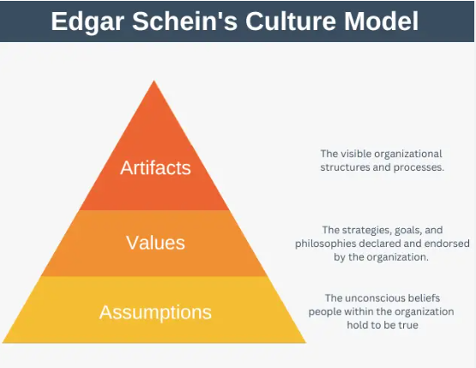
Figure 1 taken from Expert Program Management (2023)
To elaborate, artifacts are the elements of culture visible for people outside the organisation to see, i.e., the structure and processes in place. Underneath this and less visible are the values of a organisations which are the strategies, goals, and philosophies. Finally, the assumptions which are both conscious or unconscious assumptions and beliefs of employees based on their upbringing and diversity of background (CIPD 2023f). These assumptions can be unwritten and unspoken making them hard to interpret Expert Program Management (2023). This model is referred to as an iceberg, with artefacts being the ‘visible’ tip of the iceberg above the water and values and assumptions being the larger parts that lie beneath the surface (CIPD 2023f).
The drama triangle is a model of human behaviour outlined by Dr S Karpman and identifies three main roles that emerge in stressful, emotional, or high-conflict situations: the persecutor, the victim, and the rescuer Kissell (2020).
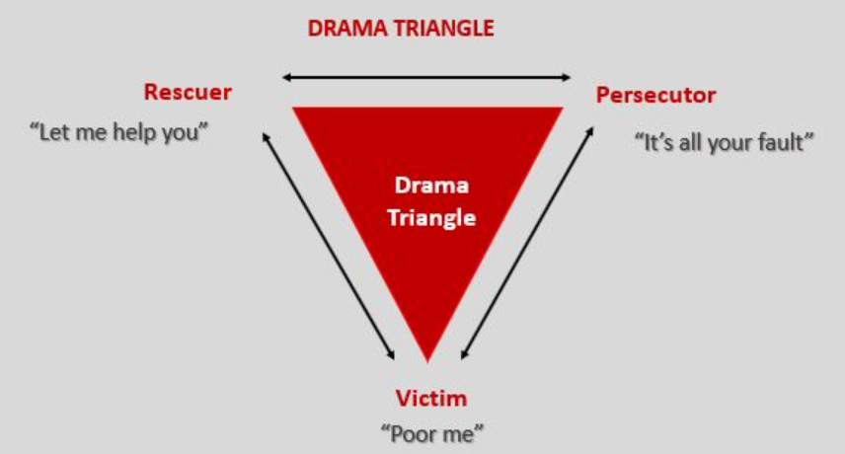
Figure 2 taken from Leadership Tribe (2024)
- The Persecutor – The persecutor will often blame the victim and be critical of the rescuer, with strict rules and intimidation.
- The Victim – The Victim will blame the persecutor and rely on the rescuer, failing to take responsibility for themselves. They often feel hopeless.
- The Rescuer – The rescuer will try to save the victim however this behaviour often keeps the victim dependent.

Leadership Tribe (2024) state humans are programmed to play one of these three roles. People can find themselves drawn to a particular role in the drama triangle, i.e., people in a care setting often assume the role of the rescuer or change roles throughout the conflict.
Assess how people practices in your organisation (or one with which you are familiar) impact both on organisational culture and behaviour, drawing on examples to support your arguments. (AC 2.2)

People practices and policy can in turn drive behaviour. Workplace norms, values and behaviours, traditions, perspectives, and beliefs of individuals are characteristics among people within the same organisation that create its culture (CIPD 2023).

Admiral Group PLC are a company dedicated to learning, funding courses for employees to enhance their skillset and the organisations credibility. They give time to learn and prioritise self-development of staff in annual reviews and personal development plans (PDP’s). This is both a selling point from a Recruitment perspective due to the positive impact at attracting and onboarding new employees, as well affecting retention of a more credible and skilled workforce and improved staff engagement levels. Increased engagement can lead to an increase in performance through discretionary effort given by employees.

“Discretionary effort is the level of effort people could give if they wanted to, but above and beyond the minimum required without being asked” (Olsen 2021). Employees who go above and beyond are naturally going to perform better and attend work more reliably than one who do the bare minimum, and this should be a driver for any successful employer. Purcell et all (2009) within Tayler & Woodhams (2022) state that managers discretionary effort in utilising HR practices also has a big impact on employee’s attitude and behaviour.

Admiral Group PLC have a very linear and structured short-term sickness disciplinary process, this means that once employees trigger 4 occasions and or 10 days of short-term sickness, they have a formal disciplinary meeting with their manager and HR. This differs from other organisations such as the NHS or the Police service who give warnings via letter once stages are hit. Admiral Groups PLC’s approach does have a good success rate of reduced overall short-term sickness % across the company but does come under some criticism for being too punitive. Care should be taken to ensure HR practices and policies are not too penal to not result in disengagement and quiet quitting.

‘Quiet quitting’ refers to employees emotionally checking out and completing minimum job requirements and not going above and beyond. BBC (2022) notes this isn’t a new concept and states discontented workers find ways of disengaging from their jobs whilst still wage. Fox (1966) states when a person is loyal to an organisation and its goals, they willingly do what is expected of them and do not do things which are harmful.

Peter Cheese, current CEO of CIPD asserts, ‘People professionals are a vital function in supporting businesses to adapt to rapidly changing circumstances’. Explain two different models or theories to managing change. (AC 2.3)

An organisation must constantly change to adapt to the ever-changing landscape of the UK economic climate and to remain competitive Expert Program Management (2023). When done correctly, change can improve performance due to encouraging innovation, diversity, and impact positively on morale. Though there are set back’s if change is managed incorrectly. The pace of change has increased exponentially over the last few decades, with vast legislative, political, and economic shifts, as well as rapid advances in technology (CIPD 2023i).
Lewin’s 3 stage change model (1974) is outlined by CIPD (2023i) as change being in three stages:
- The ‘unfreeze’ stage - this is the initial stage of identifying the need for change, the benefits of the change and starting the communication and engagement process.
- The ‘move’ stage - acting, making the changes, and involving people in that process are all important steps in making the change happen.
- The ‘refreeze’ stage - making the change permanent, establishing new ways of working and ensuring the desired outcomes are rewarded. This last stage is essential ensuring people don’t revert to old practices.

Lewin’s model is dated but still relevant, it has formed the basis for more modern models of managing change due to being simple to understand. Though due to age, it maybe that it is hard to implement in more modern business structures CIPD (2023i).
Alternatively, there is Kotter’s 8 step change model, outlined below. This model has many similarities to Lewin, the 8 steps can be split into 3 main stages, though this breaks it down further.

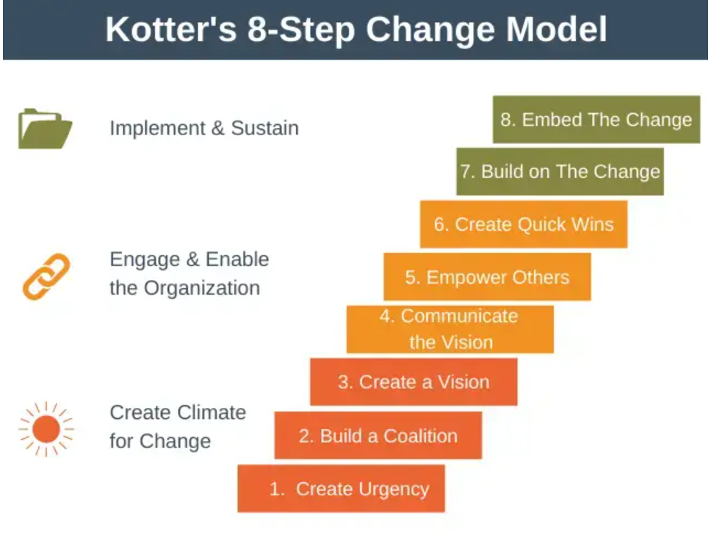
Figure 3 taken from Expert Program Management (2023)
The first three stages group the first three steps into ‘getting the right climate for change’. The next three stages involve communicating to gain buy in, empowering action and creating short-term wins which is the engaging and enabling stage. Kotter’s final two stages cover implementing change and sustaining the change, which again is essential to ensure the change embeds and is used consistently CIPD (2023i).
A variety of models have been developed to explain how change is experienced. Discuss one model that explains how change is experienced. (AC 2.4)
The change curve is amended from the work of Elizabeth Kubler-Ross (1969) when analysing grief reactions and has been accepted worldwide to explain how the change process is experienced EKR Foundation (2024). The five stages of grief are denial, anger, bargaining, depression, and acceptance, this has been well socialised though has evolved over time to be used in change management and outlines the five stages a person may go through when faced with change.
CIPD (2023i) describes the stages as.
- Shock/Denial stage – shock that the change has been proposed as well as denial that the change is needed and won’t be successful.
- Anger stage - involves expressions of anger or frustration at the prospect of the change.
- Uncertainty/Bargaining stage – CIPD (2023i) advises this can be the most challenging stage as people can attempt to bargain with the change as well as being uncertain, anxious, and overwhelmed.
- Depression stage - individuals may withdraw and experience feelings of hopelessness.
- Acceptance stage – accepting the change. CIPD (2023i) states the acceptance stage end when the new change is implemented, and people have adjusted to the new way of working.
The model has given space for organisations to review how change is experienced emotionally by employees, to prepare and support them. CIPD (2023i) advise that helping employees to work through each stage is important in both making and sustaining change. However, criticises the model for being too linear due to the nature diversity of between people. CIPD (2023i) states the stages may not be followed as outlined, it maybe they are experienced at different times and in alternative orders or even not at all, it could mean stages are re-visited or indeed not reached at all or people may never accept the change that has been made. Though EKR Foundation (2024) advise the stages were not meant to be linear, nor expected in a step-by-step manner.
CIPD (2023i) comments that the change curve was created based on grief reactions and not based around positive change and therefore it may lose relevance or people may experience emotions not described by the change curve. EKR Foundation (2024) counter this by advising ‘’the basic human emotions experienced during personal loss, change, death, or a dramatic experience remain the same therefore the model can be applied effectively in such situations’’.

The CIPD’s Health and wellbeing at work survey 2022 found, ‘There is less management focus on health and wellbeing compared with the first year of the pandemic’ and goes on to remark that this is disappointing. Assess the importance of wellbeing at work and factors which impact wellbeing. (AC 2.5)
Wellbeing at work is important from a social responsibility perspective, a legal compliance perspective and a business case perspective stated by Tayler & Woodhams (2022).

CIPD (2023d) outline 7 domains of wellbeing, including health (physical and mental), financial wellbeing, values and principles, personal growth, good lifestyle choices and collective/ social involving good working relationships and good work. The CIPD (2023d) then goes on to advise time pressure and workload were also considered as additional demands that could impact the effect of HR practices on employee wellbeing. Easing workload on employees has financial implications for an organisation and isn’t straight-forward to rectifying. Either employing more staff or utilising better systems or technically advancements to work smarter come at a cost and therefore organisations focussing on alternative ways of supporting staff is preferrable to them.

CIPD (2023d) state HR practices that promote employee participation and autonomy have a positive impact on all elements of employee wellbeing. Giving people the autonomy to choosing how, where and when work and having policies built around hybrid working and flexible working are key to this. This is the recognition that people have a life outside work and work life balance is important to employee engagement and wellbeing. It is also suggested that there are trade-offs between organisational benefits and employee costs which should be evaluated when creating HR policies (CIPD 2023d). If an organisation reduces its weekly working hours for example, this will mean less staff in to support the customers, though really needs to be offset in a cost – benefit analysis, as increased engagement levels mean employees are more productive and may achieve the same results in less working time.

The impact of poor wellbeing at work is burn out and quiet quitting which are both detrimental to any organisation as presenteeism and absenteeism lead to a reduction in productivity. Presenteeism occurs when people work when in ill health and has grown in evidence base since the COVID-19 pandemic. Research by RAND Europe, outlined by CIPD (2020) suggests that presenteeism is mainly driven by stress, suboptimal mental health, lack of sleep and poor financial wellbeing.

The CIPD Profession Map states ‘People practices are the processes and approaches that we use across the employee lifecycle’. Discuss the links between the employee lifecycle and different people practice roles. (AC 3.1)

There are many subsections of a successful People department including Recruitment, Learning and Development (L+D), Benefits and HR teams driving people practices through policies and procedures. They all collaborate and form the employee lifecycle, which starts from onboarding through to exit from the organisation.

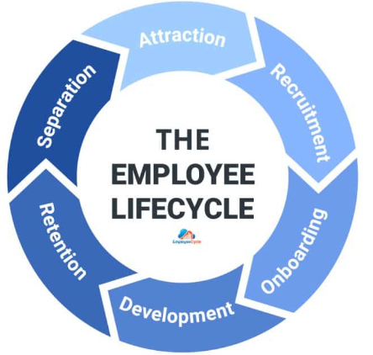
Figure 4 taken from Employee Cycle (2024)

For example, for attraction and recruitment, the Benefits team will benchmark salaries and ensure there are adequate provisions for non-monetary incentives for staff making an organisation an attractive proposition for new recruits, though such incentives must ensure they aren’t discriminatory i.e., an attendance bonus for 100% attendance in 12 months and aren’t in breach of the Equality Act (2010).

Another example of this correlation is the HR team at Admiral Group PLC run an attrition project which is made up of managers from each of the departments of the organisations. The project profiles both leaver details and success stories, finding trends from data of each stage of their employment i.e., absence and disciplinary data to directly influence and inform recruitment strategies. This has been a direct collaboration between the HR team and Recruitment to enhance overall financial business performance from improvements in attrition.

CIPD (2023g) outlines good line management as an important element of wellbeing at work, having effective people management policies and training for line managers to implement them. This integrates the L+D department to arrange and facilitate this training and ensure consistency amongst decision-making, meaning all managers are competent to enforce and deliver the relevant policies and procedures which is a further example of collaboration. The L+D team are also crucial throughout the employee lifecycle, from induction training to sign of competency to complete the role individuals are recruited for, throughout employment to ensure development opportunities. CIPD (2017) state ‘’poor professional development is a more significant cause of burnout than work overload’’.

HR policies and procedures such as disciplinary policies and ill-health capability policies give employers a legally safe way to exit employees who are falling under the desired standards to keep the business running successfully. Care must be taken here to ensure compliance with legislation and using the ACAS code of practice (no date) as a guide to ensure employee rights are considered with a best practice approach and to ensure fairness.
Overall people practices are connected throughout the employee lifecycle, with each role having specific responsibilities. Effective collaboration between these roles can directly impact the success of an organisation.

Analyse how people practice connects with other areas of an organisation and supports wider people and organisational strategies. (AC 3.2)

Ulrich’s business partnering (BP) model is successful in aligning people practices with an organisation’s strategies, through HR being integrated with the business and helping drive business success with their expertise. This is useful as it helps to support strategic objectives by helping shape policies that connect people practices to high organisational performance CIPD (2023f). Though a BP needs to be competent, blending knowledge with experience with excellent relationship building capabilities to encourage successful stakeholder buy in, without which this is unlikely to be a successful way of using HRM to support business strategy i.e., HR BP’s can help drive performance management of employees in order to provide efficient and competent service to an organisations customers and feed into it’s Key Performance Indicator’s (KPI’s).

Admiral Group PLC have a strategy to be an employer of choice in South Wales and do so by pushing a well socialised wellbeing focus into its people practises in all roles of the organisation. This is pulled through a BP HR model, ensuring that people practises are being utilised in all departments to support employee wellbeing. Tayler & Woodhams (2022) state that to create a healthy workplace, an employer needs to ensure that it’s culture, leadership and people management are the bedrock to build a fully integrated wellbeing approach. They claim that wellbeing is the responsibility of all members an organisation, including HR, management, and stakeholders.

Wellbeing is signposted through a specialised wellbeing portal for staff through shared services, with a view of coaching into how best to care for their own wellbeing before it comes an issue leading to absence or reduced performance. This spills over into financial wellbeing, Admiral Group PLC attempts to educate staff around consequences of poor financial health which could also affect their employment, due to being regulated by the Financial Conduct Authority (FCA). Employees could face disciplinary action from the HR teams if in breach of any financial governed people policies, bearing in mind attrition leads to the need to recruit which is expensive to an organisation so astringent onboarding checks are paramount here from the Recruitment team in HR.

CIPD (2023a) state ‘’financial and related mental health issues are affecting a significant and growing proportion of the workforce, negatively impacting employee wellbeing and performance’’ supporting this as a strategy. The wellbeing support on offer to staff is also commercially sensible i.e., to attract and recruit new employees in the belief they will be cared for as an employee, lending itself to improved commitment. Though care needs to be taken with this strategy as there is a reputation that Admiral Group PLC are supportive of mental health cases and therefore there are cases of people previously unable to work due to their underlying mental health struggles joining the organisation when this isn’t necessarily in their best interests due to the demanding nature of some of the roles.
Overall, investing time and money into being an employer of choice needs to be balanced. Naturally there is a cost to offering such meaningful wellbeing initiatives, and this must be built into the financial budget for the year. Though it is worth offsetting this against the lack of heightened marketing funds needed for recruitment and customer base, word of mouth has been very successful for Admiral Group PLC as they have grown in success.

Discuss processes you have, or could use, for consulting and engaging with internal customers of the people function in order to understand their needs. (AC 3.3)

Tayler & Woodhams (2022) believe that management in an organisation must demonstrate through actions and decisions that employees and diversity are valued to embed this in the culture of an organisation. Olsen (2021) advises ‘'There’s no team without trust'’ and believe creating a culture of trust will bear higher levels of engagement, increased motivation and better performance which are all desirable to an organisation.

Employee Consultative Group (ECG) forums increase employee participation in organisations, by consulting with employees on workplace and employment matters quarterly for feedback and to pass on messages. This promotes a culture of continuous listening as well as clear communication helping employees understand and buy into the organisational strategies. Following up in a ‘you said, we did’ manner exampled in the University of Exeter colleague health and wellbeing survey (2020) is a great way to enhance the productivity of this method and give employees the sense that the organisation values the employee voice and participating in the process is valuable otherwise this could be disengaging.
ECG meetings can also enhance employees’ sense of belonging as they feel they have a say in how the organisation is run. Belonging is making people feel they are part of a bigger picture and have a sense over ownership in the company. This is true of Admiral Group PLC who due to being a publicly traded company, give their employees a set number of shares per year on which they receive dividend payments. This helps drive retention of employees as they have tax implications if sold before they reach 5-year maturity and rewards long -service and commitment.
Like ECG forums and the related benefits, a suggestion box process encourages communication, which may increase engagement when suggestions are considered and acted on by an organisation. Suggestions can be gathered via a digital or physical suggestion box, anonymously or otherwise, the latter meaning it is possible to offering formal recognition or incentive for the best suggestion (CIPD 2023h). Due to not being publicised like the above methods, there is a concern that suggestion box process may have low uptake.
Surveys are a quick and cost-effective way of collating feedback from employees, though the results of this will be qualitative rather than detailed. Surveys can be rolled out quickly across media channels to gather a snapshot of information on a topic, which is helpful when decision making. Though care must be taken to avoid ‘‘survey fatigue’’, which leads to lower numbers of employees engaging with surveys.
Overall, having varied methods of consulting and engaging staff helps maximise impact for the benefit of employee and employer CIPD (2023h).

REFERENCES
ACAS Code of Practice (no date) Disciplinary and grievance procedures Disciplinary and grievance procedures | Acas Accessed 15th January 2024
BBC (2022) Why quiet quitting is nothing new Available at: https://www.bbc.com/worklife/article/20220825-why-quiet-quitting-is-nothing-new Accessed 17th December 2023
BBC (2023) AI: anxiety: The workers who fear losing their jobs to artificial intelligence Available at: AI anxiety: The workers who fear losing their jobs to artificial intelligence - BBC Worklife Accessed 22nd January 2024
CIPD (2017) Analysis: Are employers underestimating the importance of training? Available at: Analysis: Are employers underestimating the importance of training? | CIPD Accessed 15th January 2024
CIPD (2020) Managing the challenge of workforce presenteeism in the COVID-19 crisis Available at: Managing the challenge of workforce presenteeism in the COVID-19 crisis | CIPD Accessed 22nd December 2023
CIPD (February 2023a) Employee financial wellbeing Available at: Employee financial wellbeing | CIPD Accessed 15th January 2024
CIPD (March 2023b) PESTLE analysis Available at: https://www.cipd.org/uk/knowledge/factsheets/pestle-analysis-factsheet/ (Accessed 12th December 2023).
CIPD (May 2023c) Organisation Development Available at: Organisation Development | Factsheets | CIPD Accessed 8th December 2023
CIPD (June 2023d) Wellbeing at work Accessed at: Wellbeing at Work | Factsheets | CIPD Accessed 22nd December 2023
CIPD (August 2023e) Ethical Practice and the Role of People Professionals Available at: Ethical Practice and the Role of People Professionals | Factsheets | CIPD (Accessed 15th November 2023).
CIPD (September 2023f) Business Partnering Available at: Business Partnering | Factsheets | CIPD Accessed 14th January 2024
CIPD (October 2023f) Organisational climate and culture Organisational climate and culture | Factsheets | CIPD Available at: Accessed 8th December 2023
CIPD (October 2023g) HR practices: What are the trade-offs for employee wellbeing Available at: HR practices: What are the trade-offs for employee wellbeing? | CIPD Accessed 22nd December 2023
CIPD (October 2023h) Individual voice channels: Guide for people professionals Available at: Individual voice channels: Guide for people professionals | CIPD Accessed 14th January 2024
CIPD (December 2023i) Change management: A guide for people professionals Change management: A guide for people professionals | CIPD Accessed 10th January 2024
Educational Business Articles (2021) Change Curve – Understanding the typical stages we all go through Change Curve - Understanding the typical stages we all go through (educational-business-articles.com) Accessed on 22nd December 2023
EKR Foundation (2024) Kübler-Ross Change Curve Kübler-Ross Change Curve® - EKR Foundation Accessed on 10th January 2024
Employee Cycle (2024) HR Metrics For Every Phase Of The Employee Life Cycle- Employee Cycle Available at: HR Metrics For Every Phase Of The Employee Life Cycle- Employee Cycle Accessed 22nd January 2024
Equality Act (2010) Available at: Equality Act 2010 (legislation.gov.uk) Accessed 15th January 2024
Expert Program Management (2023) Edgar Schein’s Organizational Culture Model Available at: Edgar Schein's Organizational Culture Model (expertprogrammanagement.com) Accessed 8th December 2023
Expert Program Management (2023) Kotter’s 8 -step Change Model Available at: Kotter's 8-Step Change Model - Expert Program Management Accessed 8th December 2023
Fox, A (1966) Managerial Ideology and Labour Relations British journal of industrial relations, 1966, Vol.4 (1-3), Oxford, UK: Blackwell Publishing Ltd
Harvard Business Review (1995) Leading Change: Why Transformation Efforts Fail Available at: Leading Change: Why Transformation Efforts Fail (hbr.org) Accessed 8th December 2023
Kissell, K (2020) Karpman’s Drama Triangle Available at: Karpman’s Drama Triangle - Kathryn Kissell (drkathrynkissell.com) Accessed on 15th January 2024
Leadership Tribe UK (2024) The Drama Triangle Explained Available at: The Drama Triangle Explained - Leadership Tribe UK Accessed on 8th January 2024
NI Business Info (2023) Hierarchal organisational structure Available at: Hierarchical organisational structure | nibusinessinfo.co.uk Accessed on 21st December 2023

Olsen, J (2021) HR magazine, creating a high-performance workplace by tapping into discretionary effort Available at: https://www.hrmagazine.co.uk/content/comment/creating-a-high-performance-workplace-by-tapping-into-discretionary-effort/ Accessed 10th December 2023

Organimi inc (2023) Nike’s Organisational Structure Available at: Nike's Organizational Structure [Interactive Chart] | Organimi Accessed on 21st December 2023
Taylor, M (2023) Health on the Line ‘Dr Elliot Street : Reimagining surgery training’ [Podcast] Available at: Dr Elliot Street: Reimagining surgical training - Health On The Line | Acast Accessed 2nd January 2024
Tayler, S & Woodhams, C (2022) Human Resource Management: People and Organisations, Third Edition, Kogan Page
Southampton University (2023) Organisational development & design explained Available at: Organisational development & design explained | Human Resources | University of Southampton Accessed 8th December 2023
University of Exeter colleague health and wellbeing survey (2020), Available at: https://www.exeter.ac.uk/staff/wellbeing/2020surveyoutcomes/ Accessed 17th December 2023

