Cristian Ailincai
Student number: 2029264

Introduction
Superstore is a company that deals in the procurement and sale of office supplies, furniture and technology. It deals with a number of consumer segments across several regions and it has recorded its sales and profits over the course of 4 years from 2009 to 2012 among other things such as the customer names and below is the analysis of the data to identify the decrease in sales and profits over the years.

Number of orders per region

Count of orders Region
1991
2161
 |  |  | 1706 | 1991  2161
 | 781 |  | 1706 | 1991  2161
59
79
Yukon 542
West
Quebec
Prarie
Ontario
Northwest Territories
North Carolina
Atlantic 1080
0 500 1000 1500 2000 2500

From the data it is evident that there are 8399 data entry points representing the sales and profits received by superstore sales over a four-year period i.e., 2009 – 2012. From this data it can be seen that the number of sales are represented not only by the province that the product is being sold to but also the region. For this reason, the chart above represents the number of sales per region. Ontario leads the park with a total of 2161 orders followed by West at 1991 orders and Prarie at 1706 orders. This goes to show that most of the superstore customers come from these three regions with Ontario leading the pack.

Profit per region

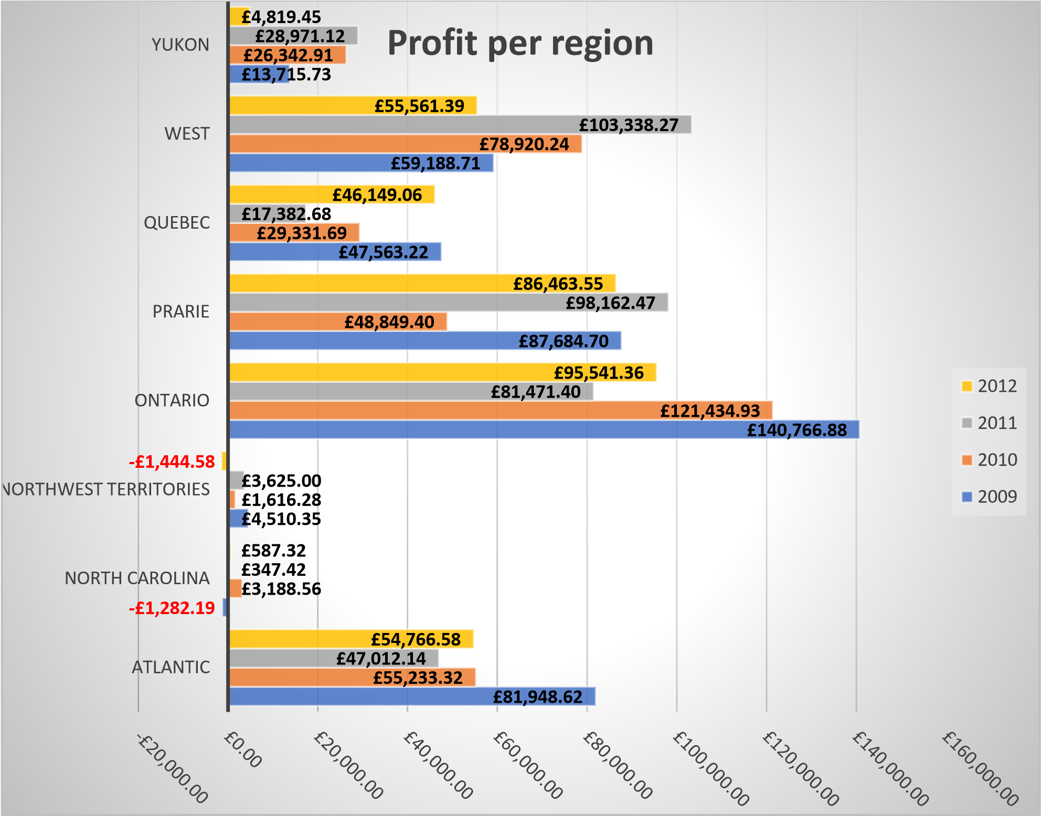

The profits per region are also varied as can be seen from the chart above. Each region is represented for the 4 recorded years. Ontario which leads in terms of the number of orders that came from there also led in terms of the profits the region generated. However, this was the case in only three of the four years. The highest recorded profits were made in 2009, £ 140,766.88 and since then the company has been unable to attain such fetes. The next closest amount of profit was attained in 2010 by the same region but was still significantly lower than the preceding year. In 2011, the West came close in terms of profits made by making a total of £ 103,338.27 which was the highest profit made across all regions. In the same breadth, there were also regions that incurred losses such as North Carolina in 2009 and the Northwest territories in 2012. These two regions have the lowest recorded profits over the years barely making above £ 5,000. Superstore should thus look into this to ensure not only the improvement in sales in these 2 regions but also seek to maintain high levels of profit that will help the business stay afloat and operational.

Region specific profits (Ontario)

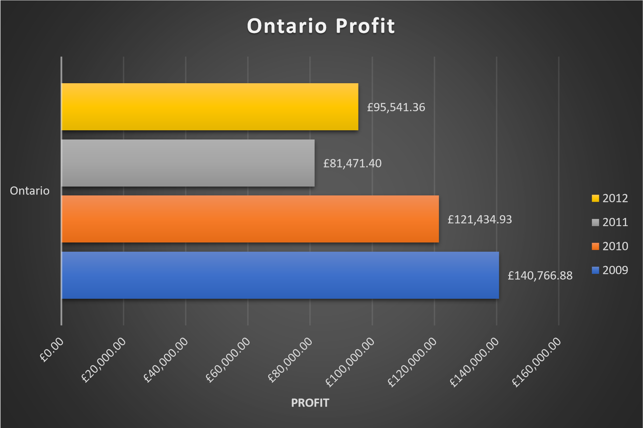

From the data it can be seen that the sales in this region have been on a steady decline since 2009.
The most significant dip in profits was experience in 2011. Profits dropped from £ 121,434.93 to £ 81,471.40. considering this region leads the pack not only in sales made but also the profits generated it sets a worrying precedent bringing forth questions as to what exactly could be going wrong and where should the company make adjustments to ensure such does not occur again. Profits did however improve in 2012 but they were nowhere as close to those made in 2009.

Ship mode numbers

1159
992
6248
0
1000
2000
3000
4000
5000
6000
7000
Delivery Truck
Express Air
Regular Air
Count per Ship Mode

From the data presented, there were three modes of shipping for the goods ordered. This included use of a delivery truck, express and regular air services. This was so as to allow them to have a far-reaching effect in terms of sales and to cater for customers who live far. Based on this shipping modes it can be seen that most orders were delivered through the regular air service at 6248 which is more than 75% of the total orders that were delivered. The second most orders were done by the delivery truck at only 1159 and express air which only managed to deliver 992 orders. This can be attributed to the fact that express air is slightly costly as compared to the other two and thus not as convenient despite its time efficiency.

Numbers based on the priority of the orders

1608
1766
1721
1632
1672
1500
1550
1600
1650
1700
1750
1800
Critical
High
Low
Medium
Not Specified
Count of Order Priority

From the data it was identified that there were 5 categories of the priority by which orders were placed. These included critical, high, medium, low and not specified. Goods with critical and medium priority were least ordered with 1608 and 1632 orders respectively. High priority goods were the most ordered with 1766 orders.

Customer segment numbers

1649
3076
2032
1642
0
500
1000
1500
2000
2500
3000
3500
Consumer
Corporate
Home Office
Small Business
Count of Customer Segment

The orders made at the superstore were made from four distinct consumer segments. These were ordinary consumers, consumers with a home office, small businesses and even corporates. From these consumer segments it could be seen that sales made to corporates were the highest in number at 3076 orders followed by home office users at 2032 and finally by ordinary consumers and small business owners at 1649 and 1642 orders respectively.

Order priority profits

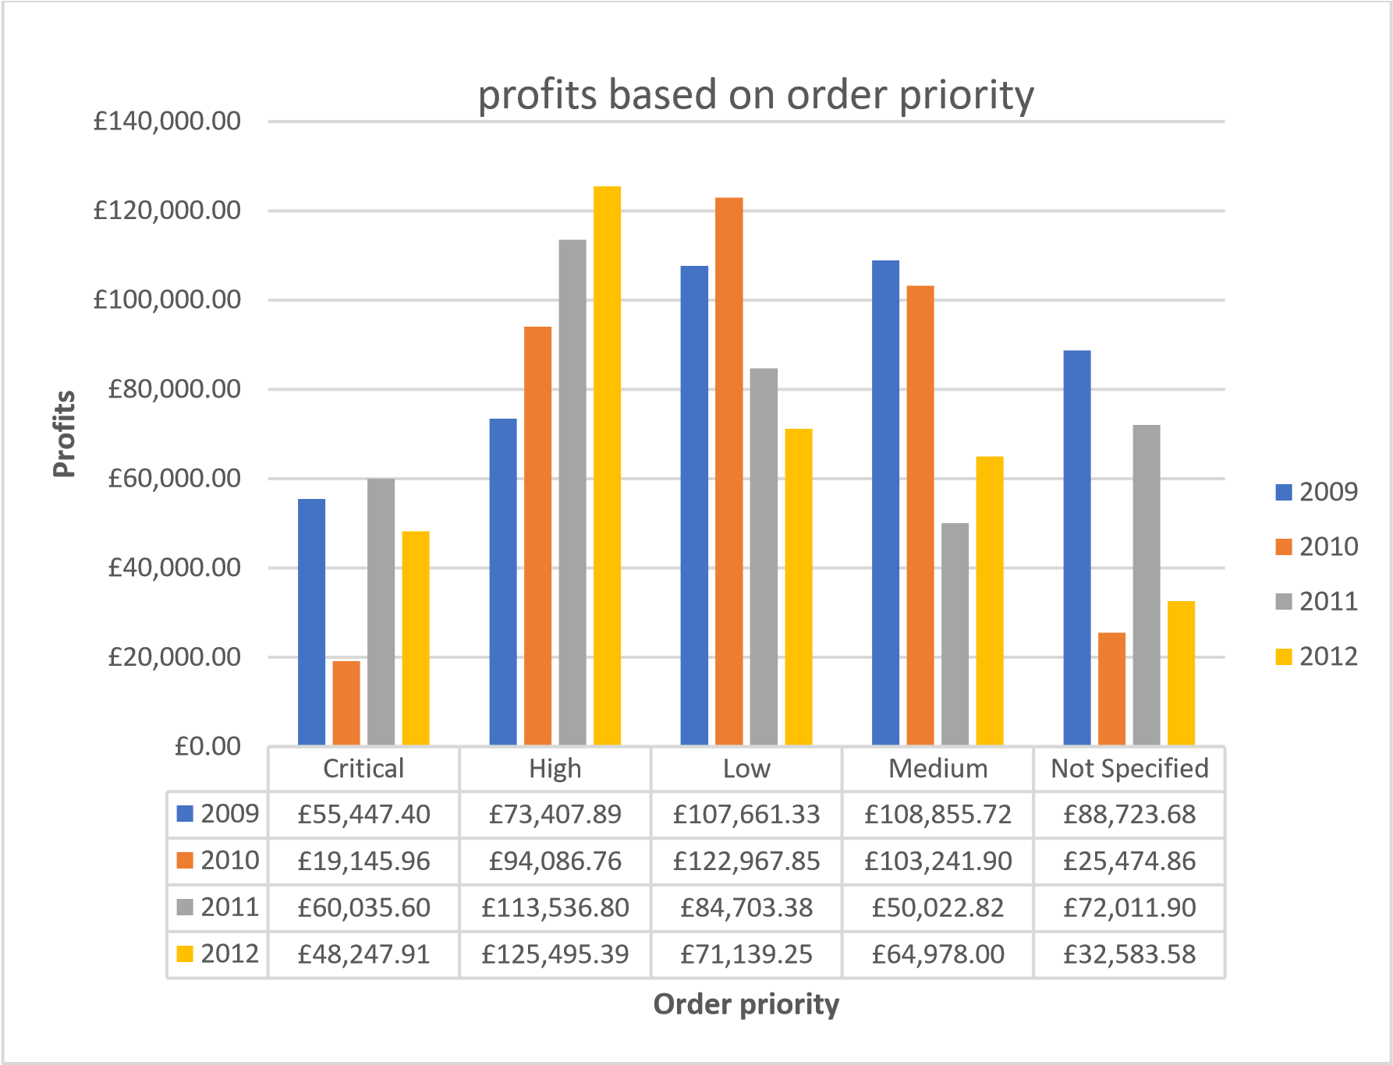

In 2009 medium order goods generated the highest profits at £ 108,855.72. this trend however ceased to exist in the following year as profits not only dipped but they were also lower than those made by low priority orders which had a profit of £ 122,967.85. since then, high priority orders have significantly than all other orders, making it the most profitable segment based on the priority of orders made. All other order priority has experienced drop in profits over the years thus indicating that the company should look into this to find out what might be the reason for these fluctuations and inconsistencies.

Critical and high priority orders

Crit
ical
High
2009
£55,4
47.40
£73,407.89
2010
£19,1
45.96
£94,086.76
2011
£60,0
35.60
£113,536.80
2012
£48,2
47.91
£125,495.39
£0.00
£20,000.00
£40,000.00
£60,000.00
£80,000.00
£100,000.00
£120,000.00
£140,000.00
Profit
Order Priority
Critical and high profits
2009
2010
2011
2012

To further highlight this phenomenon an in-depth comparison was made between critical and high priority orders as shown in the chart above. As can be seen, critical priority goods have been fluctuating up and down on a yearly basis indicating lack of stability. This is however not the case for high order priority goods which have been experiencing a steady rise in sales over the years having generated the most profits in 2012 at £ 125,495. This analysis should be of use to superstore to either maximize sale of high priority orders or make steps towards improving the demand for the other types of order priorities.

Corporate profits

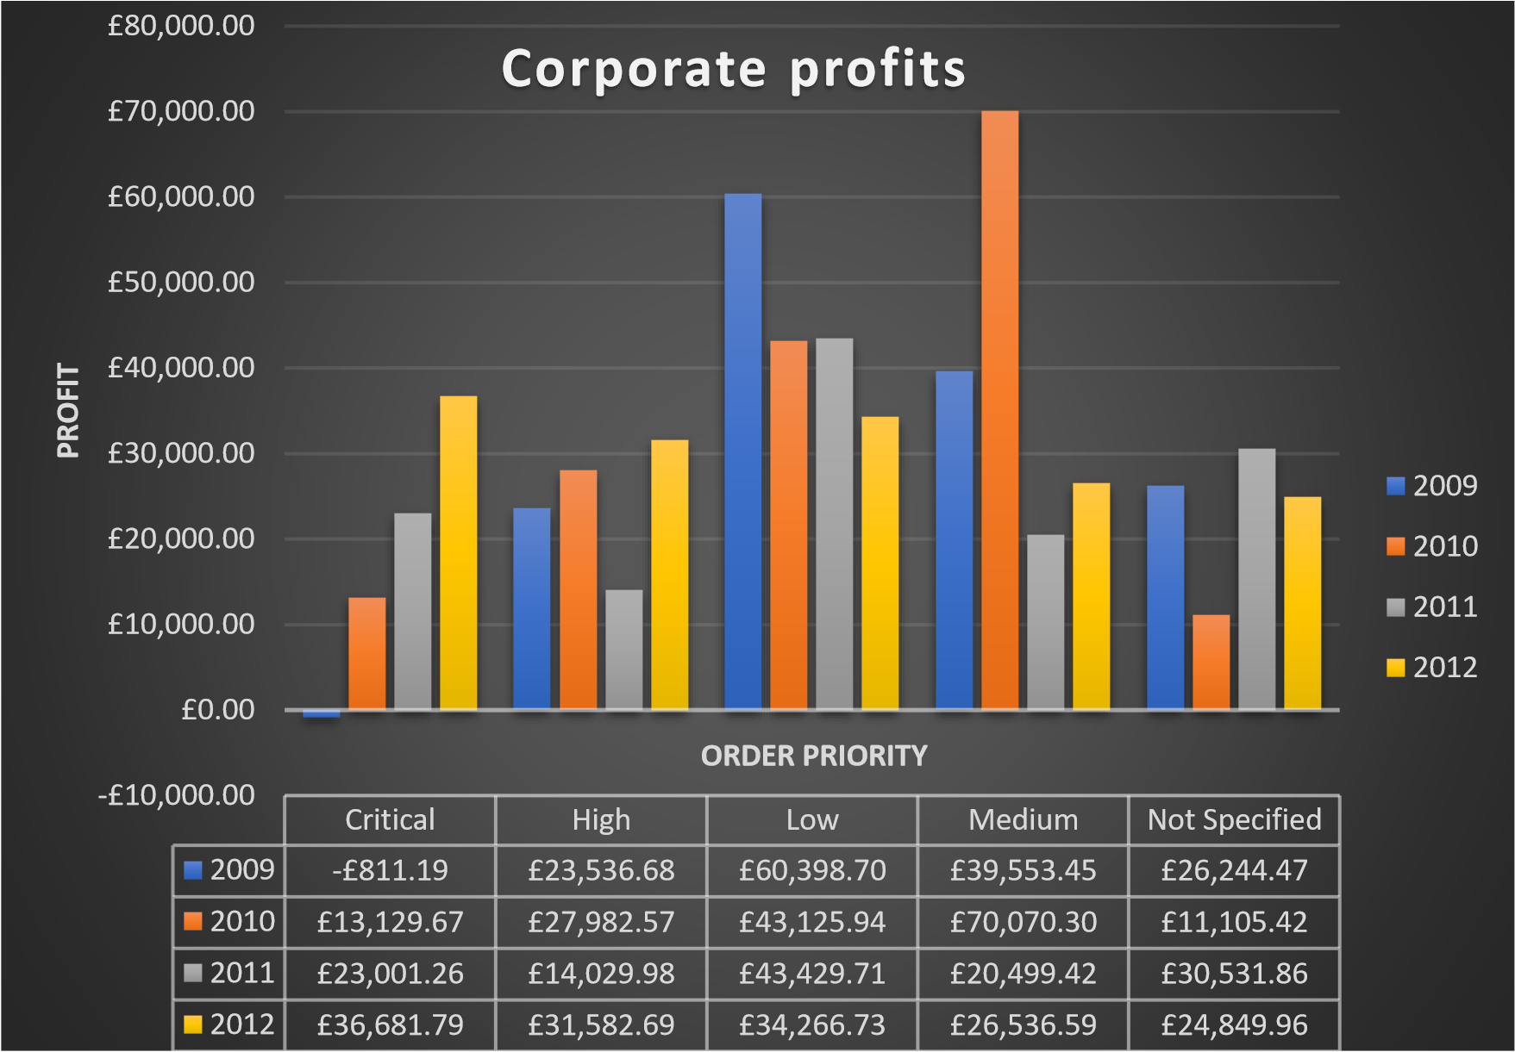

As earlier indicated was the fact that corporate consumers accounted for the highest number of orders made to superstore. The chart above is thus a breakdown of the profits generated from sales made to corporates as per order priority. From the chart it can be seen that in 2009 goods with a low order priority generated the highest profits. In 2010 medium priority orders had the most profits at £ 70,070. This was also the highest profit made by corporates over the course of the 4 years. A noteworthy entry is that of critical priority orders made in 2009 which incurred a loss of £ 881.19. It should however be noted that no losses have been incurred since then though profits have been fluctuating frequently over the years.

Profits based on shipping mode used

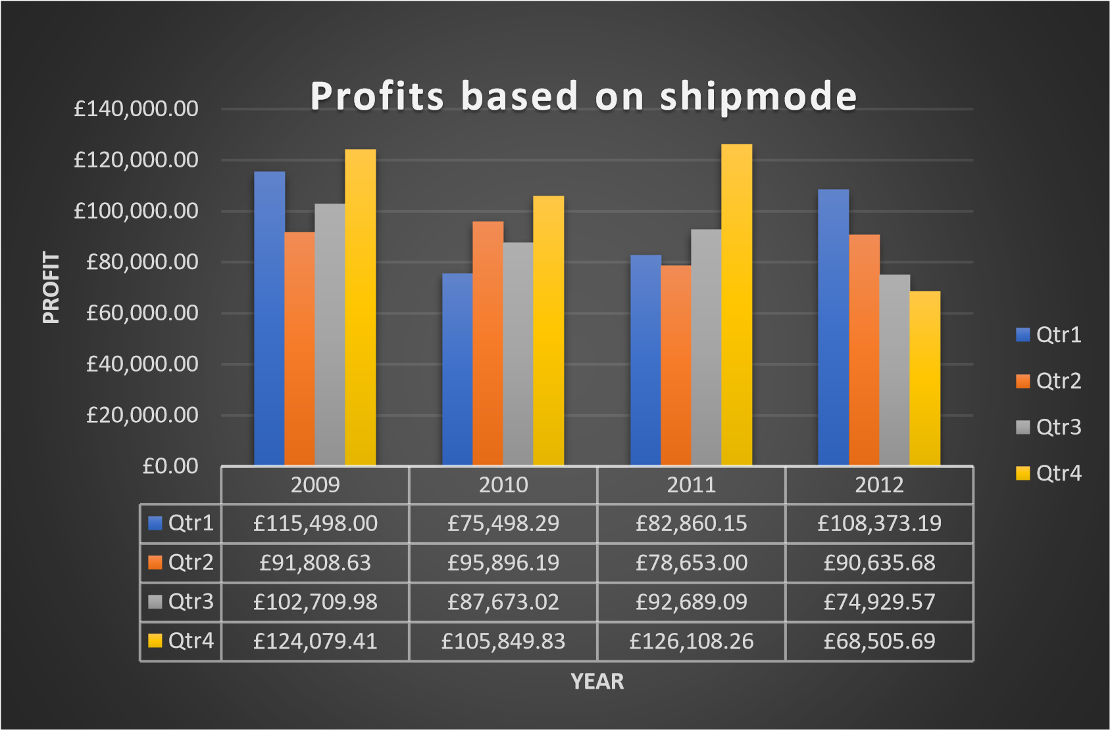

Looking at the profits generated over the years on a quarterly basis by looking at the type of ship mode used to transport the commodities quarter 4 has the highest recorded profits from 2009 to 2011 till finally experiencing a significant drop in 2012 at £ 68,505.69. The year 2012 is significant due to the fact that in that year profits consistently dropped in each and every quarter with no signs of improvement. This is a worrying trend and should be looked at by the company stakeholders to identify what might be the problem.

Regular air



2009
2010
2011
2012
Qtr1
£85,311.75
£67,147.84
£60,738.34
£72,220.15
Qtr2
£82,220.96
£57,616.77
£58,118.77
£72,612.42
Qtr3
£86,822.24
£64,789.06
£66,347.88
£53,952.23
Qtr4
£93,236.12
£54,846.54
£70,915.17
£59,453.96
£0.00
£10,000.00
£20,000.00
£30,000.00
£40,000.00
£50,000.00
£60,000.00
£70,000.00
£80,000.00
£90,000.00
£100,000.00
Profit
Year
Regular Air profit
Qtr1
Qtr2
Qtr3
Qtr4

Regular air transport was the preferred choice of shipping mode made by most consumers catering for almost 75% of the orders made. Above is thus the chart representing the profits generated from use of this transport service during the 4-year period. As from the table, 2009 had the highest generated profit with margins of up to £ 93,236 which was the highest overall profit made over the years. The lowest recorded profit was observed in the 3rd quarter of the year 2012 which was at £ 53,952. This just goes to show that the general dip in sales explained above affected all shipping modes including even the most popular one which is regular air travel.

Express air



2009
2010
2011
2012
Qtr1
-£10,283.34
£2,650.33
£7,712.51
£10,032.27
Qtr2
£13,233.61
£6,370.28
£5,441.26
£17,056.42
Qtr3
£10,083.28
£20,450.16
£4,550.87
£9,803.96
Qtr4
£10,239.95
£19,250.67
£13,912.27
£7,280.50
-£15,000.00
-£10,000.00
-£5,000.00
£0.00
£5,000.00
£10,000.00
£15,000.00
£20,000.00
£25,000.00
Profit
Year
Express Air profit
Qtr1
Qtr2
Qtr3
Qtr4

Express air on the other hand had a significant loss of £ 10,283 generated in the 1st quarter 2009. It however managed to bounce back properly in the 2nd quarter making a profit of £ 13,233.61. The highest recorded profits were attained in 2010 having generated £ 20,450 in the 3rd quarter and £ 19,250.67 in the 4th quarter. In 2012 however express air order did quite well in the 2nd quarter but failed to maintain the momentum till the end of the year as profits dropped in each and every subsequent quarter after that.

Delivery Truck



2009
2010
2011
2012
Qtr1
£40,469.59
£5,700.12
£14,409.30
£26,120.77
Qtr2
-£3,645.94
£31,909.14
£15,092.97
£966.84
Qtr3
£5,804.46
£2,433.80
£21,790.34
£11,173.38
Qtr4
£20,603.34
£31,752.62
£41,280.82
£1,771.23
-£10,000.00
-£5,000.00
£0.00
£5,000.00
£10,000.00
£15,000.00
£20,000.00
£25,000.00
£30,000.00
£35,000.00
£40,000.00
£45,000.00
Profit
Year
Delivery Truck Profit
Qtr1
Qtr2
Qtr3
Qtr4

Delivery truck orders had the most distinct fluctuations as can be seen from the chart above. For example in 2009 Q1 recorded profits of £ 40,469.59 but in Q2 all this went down the drain with a loss of £ 3,645.94. Something similar happened in 2010 but this time round Q1 had profits as low as
£ 5,700 but they later surged up to £ 31,909 in Q2 before dropping again in Q3 and going up again in
Q4. The highest recorded profit was made in Q3 of the year 2011 with profits amounting to £ 41,280.82. 2012 as per findings mentioned above did not go very well for this shipping mode having made very little profits in the 2nd and 4th quarters.

Sales and profits

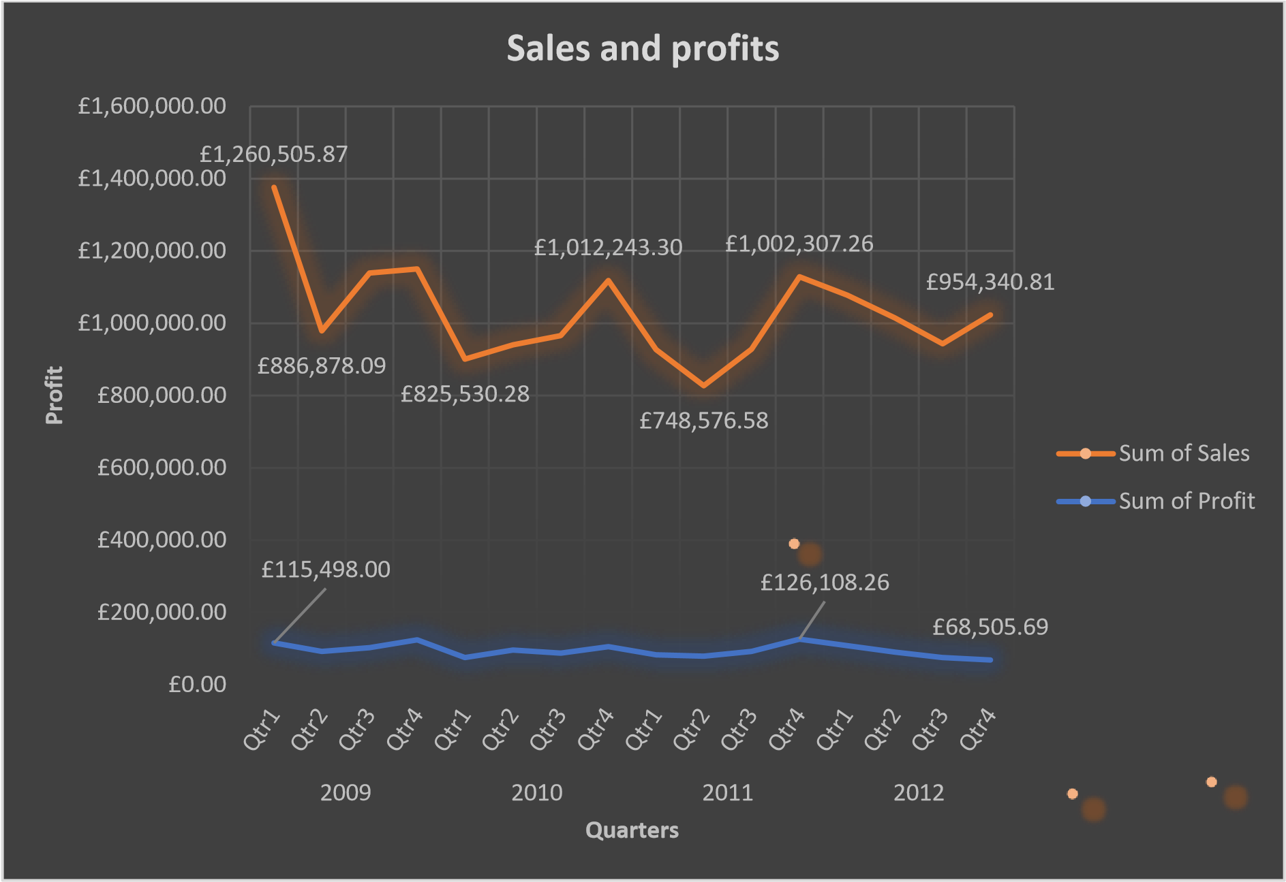

The sales recorded by superstore have been fluctuating over the years with the highest number of sales recorded was in Q1 of 2009 whereby sales amounted to £ 1,260,505.87. They however fell to £ 886,878 in Q2 of the same year. Represented in the chart above it is evident that sales have been oscillating on a quarterly basis with peaks and troughs running in tandem. This indicates a lack of stability in terms of sales made and thus no conclusive amount can be set as the baseline of sales made. The lowest sales were recorded in Q2 of 2011 which were at £ 748,576.58.
On the profit end of things in Q1 of 2009 the company earned £ 115,498 in profits which went slightly down in Q2 and improved in Q3 & Q4 respectively. The highest attained profit was £ 126,108.26 which was achieved in Q4 of 2011. Seeing as 2012 was not such a promising year in terms of profits generated, it is quite evident in the graph as profits continually reduced throughout the year till Q4 where profits made amounted to £ 68,505.69.

Ship mode against priority



Delivery Truck
Express Air
Regular Air
Critical
-£17,422.80
£34,723.22
£165,576.45
High
£77,463.97
£41,148.89
£287,913.98
Low
£97,811.27
£26,148.57
£262,511.97
Medium
£64,590.96
£33,099.03
£229,408.45
Not Specified
£45,189.38
£12,665.29
£160,939.35
-£50,000.00
£0.00
£50,000.00
£100,000.00
£150,000.00
£200,000.00
£250,000.00
£300,000.00
£350,000.00
Profit
Order Priority
Ship mode vs priority
Critical
High
Low
Medium
Not Specified
When shipping mode was compared to order priority with the profits used as the yardstick for measurement the above chart was produced. For the delivery truck, critical goods incurred a loss of £ 17,422.80 with low priority goods making the highest profit at £ 97,811.27. Express air was relatively stable in terms of profits made but non-specified priority order made the least profit of £ 12,665.29. regular air transport generated the highest profits across all order priorities. High order priority goods however outdid the rest with profits amounting to £ 287,913.98.

2.1: How many students like vanilla flavour of ice-cream?
Flavor
 |  | Frequency | Percent | Valid Percent | Cumulative Percent
Valid | Vanilla | 95 | 47.5 | 47.5 | 47.5
Valid | Chocolate | 47 | 23.5 | 23.5 | 71.0
Valid | Strawberry | 58 | 29.0 | 29.0 | 100.0
Valid | Total | 200 | 100.0 | 100.0
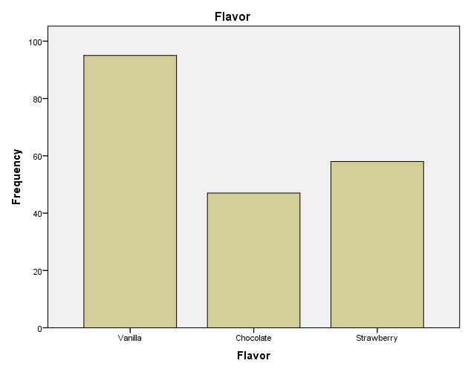

The number of students who like vanilla ice cream is 95 out of a total of 200 students.

2.2: How many students are Male and Female?

Gender
 |  | Frequency | Percent | Valid Percent | Cumulative Percent
Valid | Male | 91 | 45.5 | 45.5 | 45.5
Valid | Female | 109 | 54.5 | 54.5 | 100.0
Valid | Total | 200 | 100.0 | 100.0

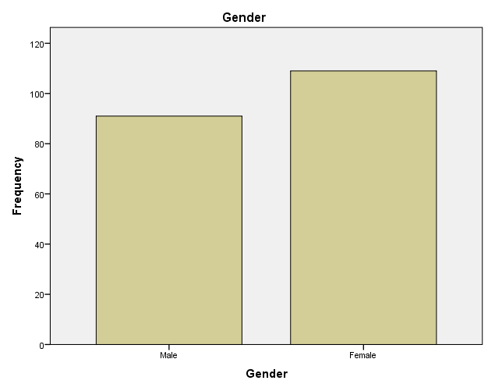

There are a total of 91 male students and 109 female students as illustrated above.

2.3: What are the Mean and Median of participants who likes chocolate and strawberry flavour ice-cream?

Flavor
 |  | Frequency | Percent | Valid Percent | Cumulative Percent
Valid | Vanilla | 95 | 47.5 | 47.5 | 47.5
Valid | Chocolate | 47 | 23.5 | 23.5 | 71.0
Valid | Strawberry | 58 | 29.0 | 29.0 | 100.0
Valid | Total | 200 | 100.0 | 100.0

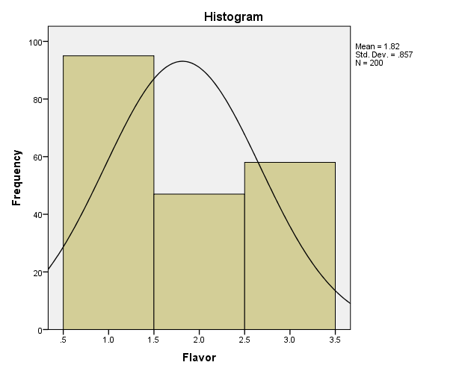

The mean of those students who like chocolate and strawberry flavors are 0.235 and 0.29.

2.4: Using the dataset Ice_cream_csv provided in conjunction with SPSS, give a specific example of clustering (ex. K-Means). Show your workings with screenshots and clearly explain your results.

Initial Cluster Centers
 | Cluster
 | 1 | 2 | 3
Test Results | 29 | 55 | 72
Test Results | 26 | 71 | 31
Flavor | 2 | 1 | 1
Gender | 1 | 1 | 0

Iteration Historyª
Iteration | Change in Cluster Centers
Iteration | 1 | 2 | 3
1 | 16.287 | 12.810 | 17.590
2 | 3.070 | 1.812 | 1.038
3 | 1.793 | .968 | .329
4 | 1.400 | .798 | .376
5 | 1.097 | .683 | .472
6 | .407 | .115 | .616
7 | .000 | .000 | .000
a. Convergence achieved due to no or small change in cluster centers. The maximum absolute coordinate change for any center is .000. The current iteration is 7. The minimum distance between initial centers is 43.313.

Final Cluster Centers
 | Cluster
 | 1 | 2 | 3
Test Results | 41 | 58 | 56
Test Results | 46 | 61 | 39
Flavor | 2 | 2 | 2
Gender | 1 | 1 | 0

ANOVA
 | Cluster |  | Error |  | F | Sig.
 | Mean Square | df | Mean Square | df | F | Sig.
Test Results | 5889.952 | 2 | 39.226 | 197 | 150.153 | .000
Test Results | 7430.226 | 2 | 40.994 | 197 | 181.253 | .000
Flavor | 1.703 | 2 | .725 | 197 | 2.351 | .098
Gender | .403 | 2 | .248 | 197 | 1.628 | .199
The F tests should be used only for descriptive purposes because the clusters have been chosen to maximize the differences among cases in different clusters. The observed significance levels are not corrected for this and thus cannot be interpreted as tests of the hypothesis that the cluster means are equal.

Number of Cases in each Cluster
Cluster | 1 | 67.000
Cluster | 2 | 101.000
Cluster | 3 | 32.000
Valid |  | 200.000
Missing |  | .000

2.5: Explain the most common data mining and text mining methods that can be used in business with real world examples.
Anomalies/outlier detection
This is a form of data mining whereby the data analyst after conducting the various tests identifies objects that do not follow or beave in a predictable manner (Miller, 2022). It uses tests such as regression analysis and after drawing the line of best fit, any value that does not follow the pre-determined regression test is considered an outlier and thus considered null and void for purposes of the research. A real-world example can be seen when a financial institution is checking for fraudsters in its system thus the use of anomaly detection aids the process of identifying any behavior that is far from the norm thus ensuring security of services offered (Alton, 2017).
Classification analysis
This is a data mining method that is used to distinguish items in the data set into various classes / groups. It manages this by dividing the data into separate and distinct categories that are based on characteristics identified from the data set. Classification analysis is a 2-step process where step one is the learning step or the training phase of the algorithm that will be used (Pedamkar, 2021). This algorithm is called the classification algorithm and its work is to build the classifier that helps classify the data set (Pedamkar, 2021). This step is then followed by the classification step where the test data is used to estimate the precision of the classification rules which were determined by the classification algorithm (Pedamkar, 2021). A real-world example is when a group of people are classified for credit worthiness by a bank as either being high, medium or low risk applicants (Pedamkar, 2021).
Clustering
This method is similar to classification in that it classifies data into sets. The difference comes in the fact that the clusters are made based on the similarities of the data items. This data mining method can also be called data segmentation due to the fact that it partitions huge data sets into groups according to the similarities that have been identified. Clustering is used by firms such as insurance companies and it enables them group consumers based on their age, nature of policy, income and even the different types of insurance claims (Pedamkar, 2021).. There are different types of clustering which include but are not limited to the following:
- Density-based methods
- Grid-based methods
- Hierarchical agglomerative methods
- Partitioning methods
- Model-based methods
Association relation analysis
This method helps in uncovering meaningful dependencies between a huge number of variables in enormous and large data sets. The association rule offers two pieces of information one being the support which helps identify how often the rule is applied (Pedamkar, 2021). The second piece of information is the confidence level whereby the association analysis helps to identify how often does the rule come out as correct (Pedamkar, 2021). A real-world example to explain this phenomenon is the market basket analysis which aims to find out which two or more commodities that a consumer is likely to buy together such as milk and eggs (Pedamkar, 2021).. This sort of analysis is useful in recommendations in online retail apps whereby they suggest other commodities that could be of interest based on what the consumer wants to buy.
Prediction
This data mining technique predicts the future based on the past and present trends of the provided data set. An example of this is when an airline wants to identify how much they charge for ticket sales based on seasonality and number of bookings made. This can be of help to them to know how much they should charge during certain periods of time through prediction analysis. This method is combined with other data mining methods such as classification pattern matching and trend analysis among others (Alton, 2017). The process begins by the formulation of a prediction model or sequence that needs to be analyzed and tested (Pedamkar, 2021). A prediction algorithm is then formulated and run in the model which finally brings forth the prediction that will be used to predict the future (Pedamkar, 2021).
Decision trees
This form of data mining looks like a tree whereby each branch of the tree is viewed as a classification question that helps break down the identified model/problem. The leaves of the tree are considered as partitions of the data set and are used for exploration analysis, data prediction and that of preprocessing the data (Pedamkar, 2022). The internal nodes of the tree represent a test on the attributes (Pedamkar, 2021). The branches denote the results while the terminal nodes hold the class label (Pedamkar, 2021). The topmost node is referred to as the root node and it is basically a simple question with two or more answers from which more questions can be generated to further subdivide the decision tree (Pedamkar, 2021). An example of the use of a decision tree is in the issuance of a driving license by the government where an automated decision tree helps in identifying if an applicant is legible or not (Pedamkar, 2021).
Neural networks
This method is borrowed from the broad data science field that is Artificial Intelligence (Pedamkar, 2021). It involves a collection of interconnected neurons which thus form single or multiple layers. This formation of neurons and their interconnections is called the architecture of network. This method is automated to a certain extent and thus most of its operations are run by the machines responsible and the codes that have been run (Pedamkar, 2022). It is thus a powerful predictive modelling technique. The nodes of the neural network match the neurons in the human brain while the links freely matches to the connections between the neurons in the human brain (Pedamkar, 2021). This method involves three key components which include the model, the learning algorithm which can be supervised/unsupervised and finally the activation function (Pedamkar, 2021). Used in the detection of frauds in various industries.

2.6: Discuss the advantages and disadvantages of using SPSS and Excel using relevant practical examples and present your discussions in a table.
Advantages
Excel | SPSS
- Easy and effective for data comparison, visualization and in making presentations through use of features such as pivot tables, various charts and graphs (Joshi & Poutintsev, 2021).  - It is easily accessible and promotes collaboration as one can access it through the web and allows for sharing and editing of documents from its cloud services (Joshi & Poutintsev, 2021). One does not need to carry around the actual document for discussions about the data to take place.  - It is a very effective tool for data and its subsequent analysis (Joshi & Poutintsev, 2021). Very efficient in the organization of data as the user sees fit.  - The availability of macros which allows for recording of processes and reusing them and also plenty of predetermined templates that make it easy for one to use excel for processes such as budgeting and even a travel planner (Myayan.com, 2021).  - Allows for password protection of documents thus one can secure important files and make them tamper proof (Myayan.com, 2021). It is also not easy for one to mistakenly delete important lines of text as it has plenty of control prompts that ensure that one is sure if they want to delete something  - Excel as a software is well armed with an artillery of formulas and calculation features that are very useful for computational purposes as the user sees fit (Myayan.com, 2021).  - Office integration with other software makes it possible for excel to be used alongside other software seamlessly thus making it an important tool in data analysis (Lemoine).  - It is also equipped with third party support since it is widely used and has been around since 1986 (Lemoine). | - It has comprehensive data management tools that encompass a variety of areas such as planning, data collection, analysis, reporting and implementation (Advantages and disadvantages of SPSS 2018)  - SPSS as a software is a fast code builder thus time efficient in analyzing large sets of data (IBM SPSS Modeler Reviews & Ratings 2023 2021).  - It has excellent graphical display options that work well in the visualization of analyzed data and perfect for making presentations (Advantages and disadvantages of SPSS 2018)  - Metadata or information about the available data is well presented in one row making an effective tool (IBM SPSS Modeler Reviews & Ratings 2023 2021).  - The software is equipped with a broad range of statistical models that are useful in analyzing data, visualizing it and even conducting of tasks such as predictive analysis (Advantages and disadvantages of SPSS 2018).  - Data required can be imported from other sources including the widely used excel.  - It has an easy to learn menu driven interface that makes it easy for one to understand how to go about using the software (IBM SPSS Modeler Reviews & Ratings 2023 2021).  - Use of visual code makes it easy for one to see what is happening as they go about their analysis (IBM SPSS Modeler Reviews & Ratings 2023 2021).

Disadvantages
Excel | SPSS
- The software is not easy to learn and requires plenty of practice for one to fully grasp the operational capabilities that it harnesses (Lemoine)  - Excel is prone to calculation errors particularly when its dealing with fractions and decimals (Lemoine). This makes it difficult for experts to conduct collaborative work since data produced will be filled with errors and wrong conclusions to the various hypothesis tests.  - It is highly time consuming as it tends to hang and lag when dealing with very large sets of data (Joshi & Poutintsev, 2021). This is due to the fact that its wizard has to go through each and every element on a row-by-row basis to ascertain if it is ready for analysis.  - To get the full benefits of it as a package for your business it will require you to incur a significant cost thus making it an expensive software (Lemoine).  - The software encounters a variety of problems with statistical analysis due to bugs (Joshi & Poutintsev, 2021).  - Excel formulas are difficult to learn and implement if one is not accustomed to the software (Lemoine).. | - The software provides excessive level of information that confuses the user rather than clarifying the info given out (Maya, 2022)  - It is costly to purchase the software though it has an option for it to be used for free for non-commercial users (IBM SPSS Modeler Reviews & Ratings 2023 2021).  - The learning curve involved is steep and requires constant practice and watching of tutorials (Maya, 2022).  - It is a difficult to use software for non-tech persons who wish to implement advanced modelling which requires programming software such as python and R (IBM SPSS Modeler Reviews & Ratings 2023 2021).  - Some advanced statistical functions cannot be done through the menu (IBM SPSS Modeler Reviews & Ratings 2023 2021).

References
(2018) Advantages and disadvantages of SPSS. Available at: https://comp.soft-sys.stat.spss.narkive.com/cvPmvpem/advantages-and-disadvantages-of-spss (Accessed: January 4, 2023).
Alton, L. (2017) The 7 most important data mining techniques, Data Science Central. Available at: https://www.datasciencecentral.com/the-7-most-important-data-mining-techniques/ (Accessed: January 4, 2023).
IBM SPSS Modeler Reviews & Ratings 2023 (2021) TrustRadius. Available at: https://www.trustradius.com/products/ibm-spss-modeler/reviews?qs=pros-and-cons#product-details (Accessed: January 4, 2023).
Joshi, A. and Poutintsev, F. (2021) Pros and cons of using ms excel, Honest Pros and Cons. Available at: https://honestproscons.com/pros-and-cons-of-using-ms-excel/#:~:text=1%20Pros%20of%20MS%20Excel%201.%20Easy%20and,Data%20and%20Growth%203.%20Time%20Inefficiency%203%20Conclusion (Accessed: January 4, 2023).
Lemoine, J. (no date) Advantages & Disadvantages of Microsoft Excel, Techwalla. Available at: https://www.techwalla.com/articles/advantages-disadvantages-of-microsoft-excel (Accessed: January 4, 2023).
Maya, P.C. (2022) What are the advantages and disadvantages of the SPSS program? –, La Cultura de los Mayas. Available at: https://culturalmaya.com/what-are-the-advantages-and-disadvantages-of-the-spss-program/ (Accessed: January 4, 2023).
Miller, A. (2022) Data Mining Methods: The top Five, DMNews. Available at: https://www.dmnews.com/data-mining-methods/#:~:text=Data%20Mining%20Methods%3A%20The%20Top%20Five%201%201.,5.%20Analysis%20of%20Regression%3A%20Relationships%20of%20Variables%20 (Accessed: January 4, 2023).
Myayan.com (2021) What are the advantages and disadvantages of Ms Excel, myayanblog. Available at: https://www.myayan.com/advantages-and-disadvantages-of-ms-excel (Accessed: January 4, 2023).
Pedamkar, P. (2021) Data mining methods: Top 8 types of data mining method with examples, EDUCBA. Available at: https://www.educba.com/data-mining-methods/ (Accessed: January 4, 2023).
Pedamkar, P. (2022) Data Mining Techniques: Top 7 amazing data mining techniques, EDUCBA. Available at: https://www.educba.com/data-mining-techniques/ (Accessed: January 4, 2023).

