
Master of Business Administration
Module Code: LCMB7034
Module Title: International Business Concepts
Assignment Title: Individual Report 1

Student Name: Md Moinul Hasan Bappy
Student ID: 2503567

Lecturer: Jean Wang
Submission date:27/04/2026
Word Count: 5351

AI Acknowledgement Statement
I acknowledge the use of ChatGPT (https://chatgpt.com/) on various dates between March and April 2026 to support the development of this assignment. The tool was used to assist with structuring the research, enhancing subject knowledge, conducting deeper analysis, and proofreading.
The types of prompts used included:
• Analysis of Mercedes-Benz in the USA market
• Evaluation of electric vehicle (EV) factors in the USA
• Market analysis of Mercedes-Benz in the USA
• Application of Hofstede’s cultural dimensions relevant to Mercedes-Benz in the USA
• Analysis using Porter’s Diamond Model
• Competitive landscape of the US automotive and the automotive market analysis.
I confirm that I have not presented any AI-generated text as my own work without critical evaluation and modification. I have reviewed, edited, and integrated all outputs to ensure academic integrity. I also confirm that I have retained copies of drafts, notes, and other resources used before and after the use of AI tools, which I can provide as evidence if required.

Table of Contents
Section 1: Report 4
1. Introduction 4
2. Industry and Country Overview (USA Automotive Industry) 5
a. Introduction to the Automotive Industry in the USA 5
b. Size, Scope, and Economic Importance 6
c. Competitive Landscape and Comparative Positioning of Key Firms 7
3. Application of Porter’s Diamond Model: Global Competitiveness of the U.S. Automotive 9
3.1 Overview of Michael Porter’s Diamond Model 9
3.2 Factor Conditions 10
3.3 Demand Conditions 11
3.4 Related and Supporting Industries 12
3.5 Firm Strategy, Structure, and Rivalry 12
3.6 Government and Chance 13
4. Critical Evaluation of Factors Affecting the Success of Mercedes-Benz Group in the U.S. Automotive Industry 14
4.1 Introduction to the Selected MNC 14
4.2 Market Attractiveness Analysis 16
4.3 Political Factors 16
4.4 Economic Factors 17
4.5 Legal Factors 18
4.6 Cultural Factors: Application of Hofstede’s Cultural Dimensions 19
4.7. Critical Assessment of Success Factors 20
5. Conclusion 22
Section 2 23
Reflective Account using Gibbs Reflective Cycle 23
References 28

Section 1: Report

1. Introduction
The international business is the trading of goods, services, capital, and technology across international boundaries to allow firms to reach beyond the domestic markets and gain a competitive edge (Griffin and Pustay, 2020). The modern globalized economy has been characterized by the existence of multinational companies like Mercedes-Benz Group, which are operating in diverse environments that are influenced by economic, political, and cultural dynamics. The US automotive market is considered the prime dynamic and competitive markets in the world, with a high level of technological innovation, consumer demand, and fast rates of transformation to electrification (Statista, 2025). This report will analyse the automotive industry in the USA, determine its competitive environment and critically analyse the determinants that affect the performance of the Mercedes-Benz Group in the industry.

2. Industry and Country Overview (USA Automotive Industry)

a. Introduction to the Automotive Industry in the USA
The United States vehicle sector is among the most technologically developed and economically important industries, with an estimated production of 10.6 million vehicles in 2023, which places the United States among the leading world manufacturers (Statista, 2025). The industry has more than 10 million jobs, which are almost 5 per cent of the total American employment, and it is the core of the manufacturing production and innovation (Statista, 2025).
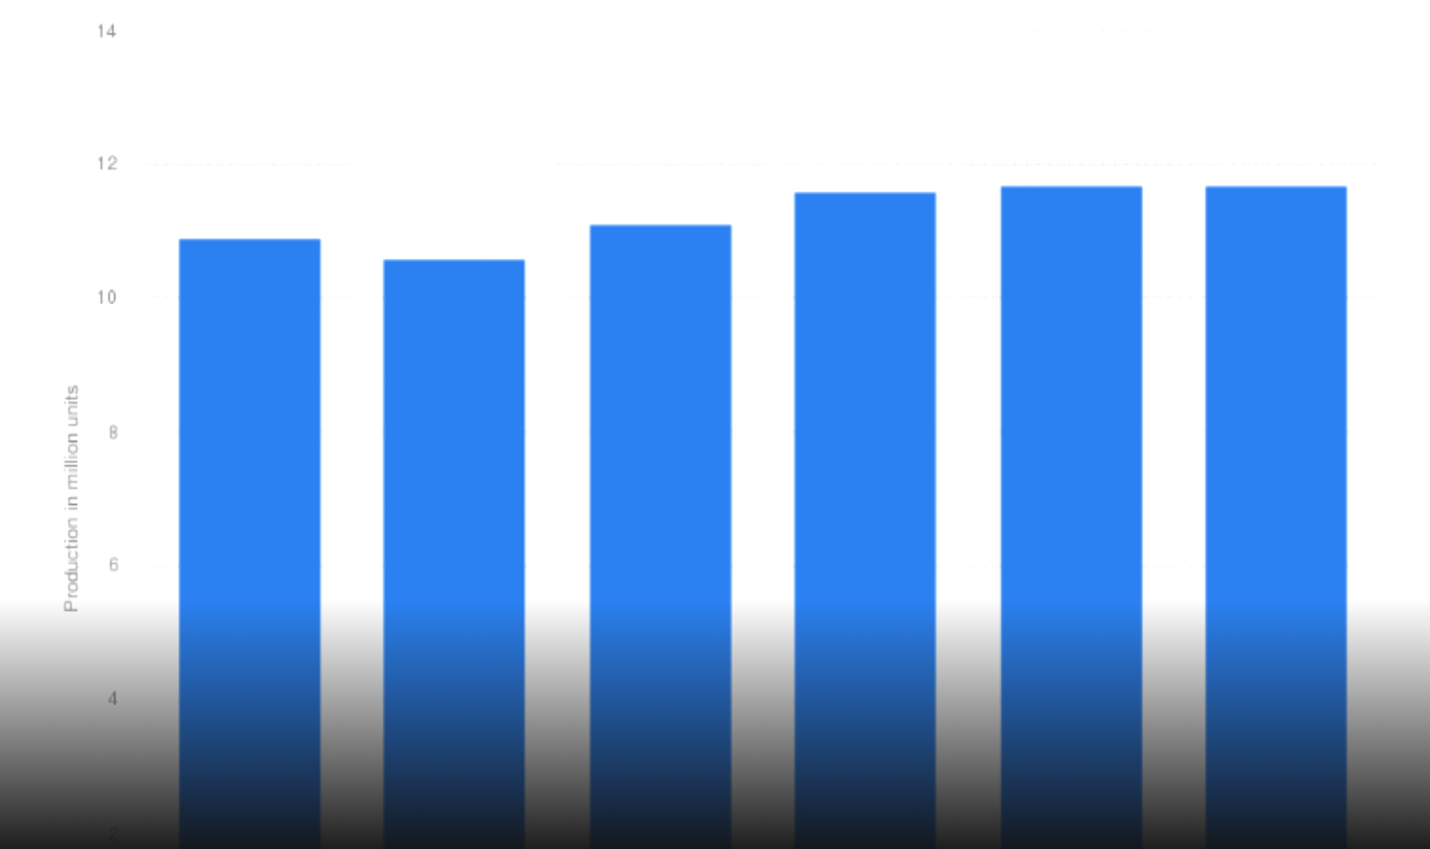
Figure 1: The USA Automobile Production Forecast 2020-2025
Source: (Statista, 2025)
The industry is in the process of a high transformation rate as a result of electrification, automation, and digitalisation. In 2023, electric vehicle (EV) sales surpassed 1.2 million vehicles, which is about 7.6% of all vehicle sales, which signifies a transition to sustainable mobility. Government subsidies, such as tax credits of up to 7500 per EV, have hastened the switch and raised competition among home and international companies (Statista, 2025).

b. Size, Scope, and Economic Importance
Market Size and Growth:
In 2024, the U.S. automotive industry brought about 1.59 trillion in revenue, which constituted between 3-3.5 per cent of the national GDP (Statista, 2023). The US automotive market size was estimated at approximately USD 4.35 billion in 2023 and it is estimated to reach around 10.67 billion USD, by 2032. The vehicle sales of 15.5 million units in 2023 are an indicator of the recovery and consistent growth in demand. Because of increasing in demand for EVs and high-end cars, the automotive market is expected to increase at a CAGR of 34% until 2030.
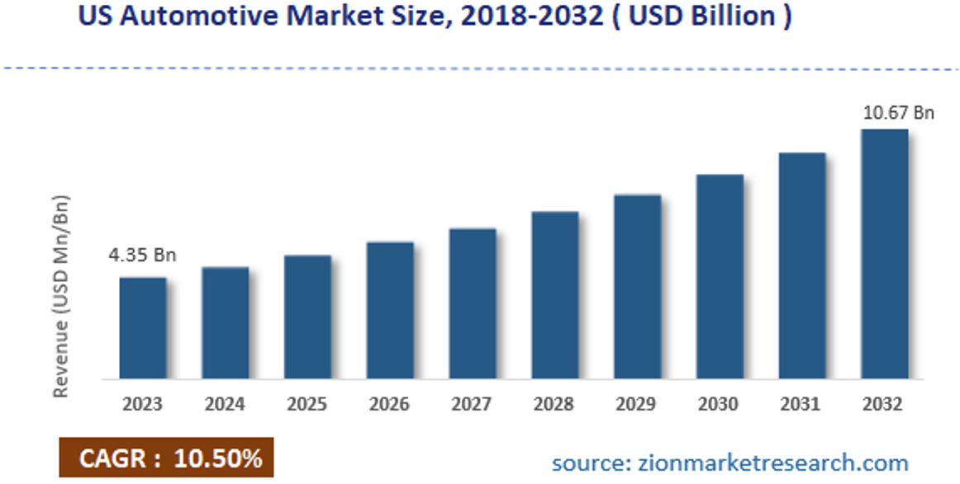
Figure 2: The US Automotive Market Size
Source: (Zion Market Research, 2024)
Industry Scope and Value Chain:
The industry contains a wide value chain from raw materials to the final sale of vehicles, and after-market services. The industry has more than 4,500 manufacturing plants in the U.S., and its automotive R&D is spending more than 18 billion a year, which is an indication of good innovation capacities (Platzer and Harrison, 2023). Moreover, by 2030, more than 95 per cent of new cars will be connected, which will expand the industry into digital mobility services (Platzer and Harrison, 2023).
Economic Contribution:
The industry is a major source of international trade, with the export of over 160 billion dollars every year (Nagy and Jámbor, 2024). It is also a destination of high foreign direct investment (FDI), especially by companies such as Toyota Motor Corporation, BMW Group and Mercedes-Benz Group, in the USA, they funded billions of dollars for manufacturing locations and hired thousands of employees.

c. Competitive Landscape and Comparative Positioning of Key Firms
Major Domestic and Multinational Firms:
The automotive market of the U.S. is dominated by both local and foreign companies (Underwood, 2025). The local companies like the Ford Motor Company and General Motors contribute about 30-35 per cent of the total market share, which is mainly due to high sales in trucks and SUVs. It has a market share of approximately 14 per cent, making it one of the best-selling brands in the U.S., with Toyota Motor Corporation being a multinational company that is leading the top luxury brands in the market, followed by Mercedes-Benz Group and BMW Group. In the meantime, Tesla, Inc. dominates the EV market with an estimated 55-60 per cent market share in 2023, which means that the company possesses a great innovation advantage.
Comparative Analysis of Strategies, Market Segments, and Performance:
Strategic Approaches:
In the US automotive industry, domestic companies tend to focus on cost leadership and economies of scale, high volume production of trucks and SUVs, which produce more than 60 percent of industry revenues. Conversely, the multinationals use differentiation, where they focus on innovation, high technology and high branding in order to conquer the international markets. For instance, firms like Tesla, Inc. and Mercedes-Benz Group highlight innovation and luxury positioning, reinforcing competitive advantage internationally (ALBERTO, 2025).

Market Segmentation:
It is divided into a very clear segregation of the market into mass, mid-range, and premium markets.
Mass Market: The local manufacturers control the price-sensitive segments, with cars priced between 30,000 and 50,000 USD, with multinational companies also competing with cost-effective models (EBSCO, 2024).
Mid- Range / Value Segment: Domestic and multinational industries serve the middle-income consumers, emphasizing reliability and fuel efficiency, and multinational companies tend to be the pioneers in terms of innovation.
Premium Segment: Multinationals hold a dominance in the high-income markets with advanced features and prices of more than 55000 to 80000 with limited representation of domestic manufacturers.
EV Premium Segment: Multinational industry is the pioneer of eco-friendly and technological innovations, and the EV demand increases more than 40 percent a year (ALBERTO, 2025).
Performance Comparison:
Domestic and multinational automotive industries in the U.S. have a considerably different level of performance as domestic companies experience a high level of sales volume and profitability, which is driven by high demand in truck and SUV types as witnessed in the case of Ford. Conversely, growth rate and profit margin are higher in multinational companies due to being globalized and premium-priced, as the examples of Tesla and Mercedes-Benz depict (Nagy and Jámbor, 2024).
Perceptual Map Positioning (Price vs Quality):
A perceptual map based on price and quality/performance highlights the relative positioning of key firms:
- High Price / High Quality: Luxury positioning is a domain of Multinational firms (e.g. Mercedes-Benz Group, BMW Group) because of the robust global brand equity.
- High Price / High Innovation: Multinationals are technological leaders (e.g. Tesla, Inc.).
- Mid-Price / High Reliability: Multinationals beat domestic companies (e.g., Toyota Motor Corporation).
- Low to Mid-Price / Moderate Quality: Domestic companies (e.g., Ford Motor Company, General Motors) control the mass-market divisions. 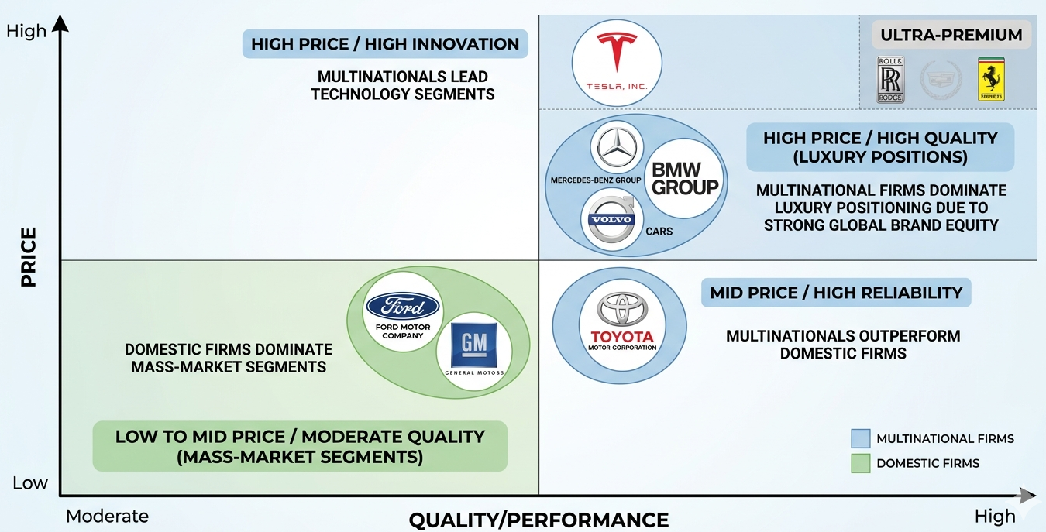
Figure 3: Perceptual Map
Source: (Self-Made)
This perception map shows that Mercedes-Benz Group has a unique premium position that is not only based on price but also on high quality, new technology, and brand recognition, which distinguishes it among the mass-market and EV-centric rivals.

3. Application of Porter’s Diamond Model: Global Competitiveness of the U.S. Automotive

3.1 Overview of Michael Porter’s Diamond Model
Michael Porter discusses in the diamond model about the impact of national factors on the global competitiveness of industries in four determinants, namely factor conditions, demand conditions, related and supporting industries, and firm strategy, structure, and rivalry (Jin and Moon, 2025). Additionally, government and chance act as external influences shaping industry performance and competitiveness. These determinants explain why the United States automotive industry remains globally competitive.
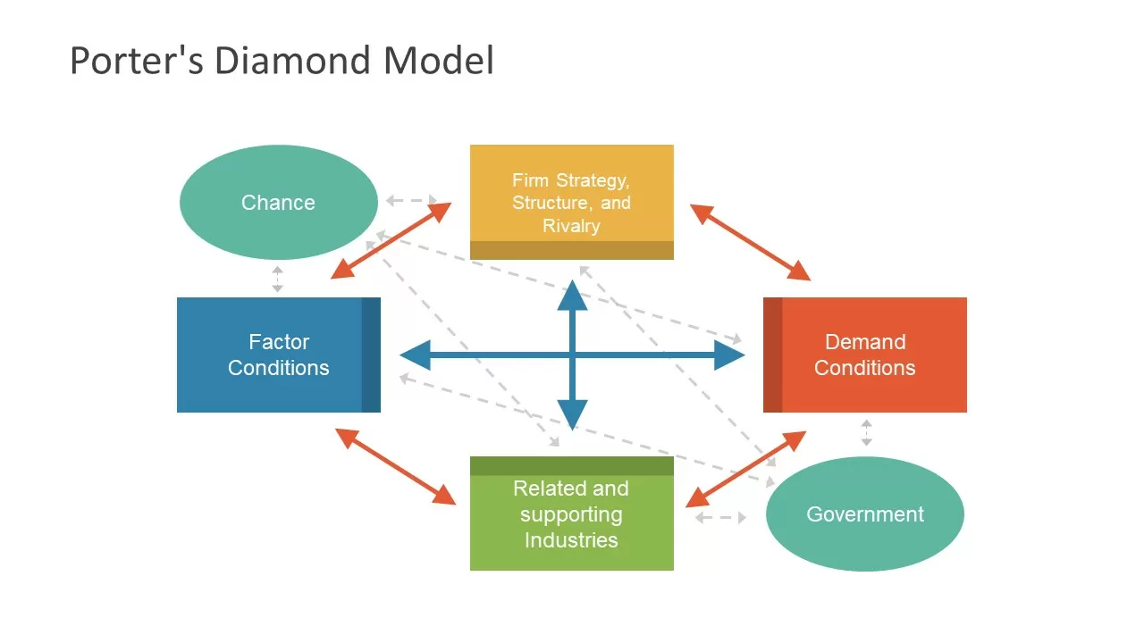
Figure 4: Porter's Diamond Model
Source: (Lopez, 2023)

3.2 Factor Conditions
Advanced Human Capital and Innovation Capacity: The automotive industry in the U.S. enjoys the advantage of having an experienced staff of more than 10 million workers, most of whom are knowledgeable in engineering and artificial intelligence, as well as manufacturing technologies. The automotive R&D in the country has a yearly investment of about 18-20 billion, which allows the country to be innovative with electric vehicles (EVs) and autonomous driving, as well as connected technologies (Elison, 2024). For example, Tesla, Inc. and General Motors are the leaders in EV and battery technology, which hold more than 55 per cent of all EV technological patents in the world's developed economies.

Infrastructure and Capital Availability: The U.S. boasts of more than 4,500 manufacturing facilities in the automobile industry and has a well-developed logistics network with highways covering a total of more than 6.8 million km, enabling the country to be served effectively. Easy access to capital markets also enables the automotive companies to attract billions of dollars in investments, such as more than 50 billion dollars invested in EV development by the large American automakers between 2022 and 2025. Therefore, government invests in domestic supply chains and critical mineral sourcing to increase production stability (Shiquan and Deyi, 2022).
However, the industry relies much more on imported materials, like lithium and semiconductors. This makes the supply chain vulnerable and affects production stability. Therefore, the government should invest in supply chains and critical mineral sourcing to ensure production stability.

3.3 Demand Conditions
Large and Sophisticated Domestic Market: All over the world, the US automotive market is one of the largest sectors, and in 2023, 15.5 million vehicles were sold in the country, which is about 18- 20 per cent of the whole world (Vecteezy, 2023). The U.S. consumers are characterised by high purchasing power, which is manifested through the GDP per capita of more than 76,000, and they are seeking advanced and high-quality cars.
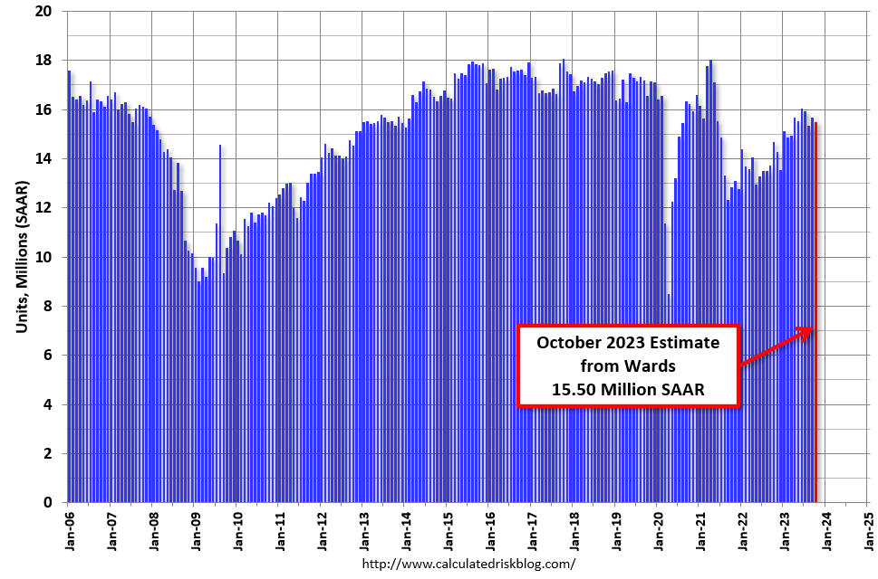
Figure 5: The USA Vehicles Sold in 2023
Source: (Vecteezy, 2023)
Growing Demand for Innovation and Sustainability: The demand of consumers moves towards EVs and sustainable mobility in increasing numbers, as the number of EVs sold exceeds, in 2023, around1.2 million units, with the year-on-year growth rate of more than 40 per cent (Vecteezy, 2023). This has prompted companies such as Mercedes-Benz Group and Ford Motor Company to hasten their electrification plans, such as the pledges of 40-50 per cent of EV sales by 2030. These advanced demand requirements compel companies to be innovative at all times, and this improves global competitiveness.
However, fluctuating demand toward creates uncertainty. Thus, firms should focus on accelerate EV innovation and affordability to meet evolving preferences (Prakhar, Gupta and Jaiswal, 2025).

3.4 Related and Supporting Industries
Strong Supplier and Technology Ecosystem: The automotive industry in the USA has a well-developed supply chain of suppliers, including more than 5,600 manufacturers of components, which helps the industry in its efficiency and innovativeness (Sturgeon, 2024). The existence of the strongest technological companies like Intel Corporation and NVIDIA Corporation reinforces the development of autonomous driving and AI systems.
Integration with Energy and Digital Industries: The convergence of the automotive industry with renewable energy and the digital platform is more competitive. Indicatively, automaker-battery partnerships have already led to more than 30 billion dollars of investments in U.S. battery plants by 2025. Also, the emergence of the connected cars, which are projected to be 95 per cent of all new cars sold by 2030, is an indicator of healthy inter-industry cooperation (Skeete, 2023). Nevertheless, dependency on global networks of semiconductor sources is still a limitation, with the lack of them lowering the production of vehicles by about 1-2 million in 2021-2022.
Reliance on global semiconductor supply creats vulnerability; thus, strengthen domestic chip manufacturing capacity.

3.5 Firm Strategy, Structure, and Rivalry
Intense Domestic Competition: The automotive industry in the U.S. is very competitive, and companies like Ford Motor Company, General Motors, and Tesla, Inc. are competing with multinational companies like Toyota Motor Corporation and Mercedes-Benz Group. The availability of more than 15 leading car manufacturers intensifies competition, which leads to constant innovation and efficiency enhancement (Yeung, 2023).
Strategic Diversity and Global Expansion: Companies have a variety of strategies for staying competitive. Indicatively, Tesla, Inc. is an innovation-oriented company with direct sales, with revenue growth of more than 20 per cent per year, whereas the Ford Motor Company is a company that focuses on cost leadership in trucks and commercial automobiles. Meanwhile, Mercedes-Benz Group adheres to a premium differentiation strategy, with profit margins of 12-14, compared to many mass-market competitors (Horváth, László András, 2025). Such strategic diversity makes the U.S. automotive industry more competent in the world markets.
However, high competition create pressure on profitability. Thus, firms should adopt differentiation and strategic alliances for sustainable advantages.

3.6 Government and Chance
The government has a major role to play in the competitiveness of United States automotive sector with policies like EV subsidies, environmental regulations, and trade tariffs. Electric vehicle (EV) subsidies promote innovation and take-up of electric cars, bolstering market development (Lukszo, 2022). Environmental regulations drive manufacturers to improve sustainability and technological advancement. Finally, tariffs also support local manufacturers by shielding them from global competition and promote domestic manufacturing, improving global competitiveness.
Tax credits and incentives such as safety and emission regulations motivate companies to adopt the electric vehicles and use the incentives to be more sustainable (Hardman and Chandan, 2023).
The unpredictability of events, such as the COVID-19 pandemic and global semiconductor shortages, have impacted supply chains and lowered production levels.
However, unstable policy and exposure to foreign shocks.To address this, government should develop long term stable policies and build resilient diversified domestic supply chains to reduce risks and maintaina stable growth in the industry.

4. Critical Evaluation of Factors Affecting the Success of Mercedes-Benz Group in the U.S. Automotive Industry

4.1 Introduction to the Selected MNC
Company Overview:
Mercedes-Benz Group is played a vital role in the US luxury car market, helping the company remain competitive in the US. Mercedes-Benz Group has reported global revenue of approximately €132.2 billion (US$157.3 billion) in 2025 showing consistent growth of 2-3 per year (Statista, 2026). In 2023, the United States automotive market registered nearly 15.5 million vehicle sales, which is almost 18 -20 per cent of the world's automotive demand, and therefore, it is one of the most appealing markets in the world (David, 2024). The industry value stood at over 1.5 trillion, which contributed about 33.5 per cent to the U.S. GDP, and this clearly shows that the industry is very important economically.
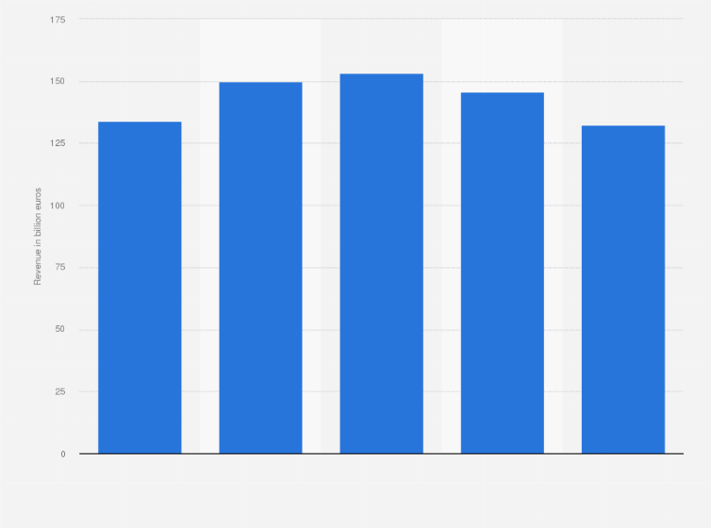
Figure 6: Revenue of Mercedes-Benz from 2021 to 2025 (in billion euros)
Source: (Statista, 2026)
The company is extremely active in terms of innovation, investing about 7-8 billion every year in research and development (R&D), which is about 5 per cent of the total revenue of the company, allowing it to achieve its electric mobility, artificial intelligence, and autonomous driving technologies. Besides, the long-term strategic interests of Mercedes-Benz Group towards sustainability and technological leadership will be reflected in the targeted goal of becoming fully electric, where market conditions permit it to do so by 2030 (Mercedes-Benz Group, 2025).
Presence and Strategic Importance of the U.S. Market:
The United States remains a critical market not only for revenue generation but also for strategic localisation. Mercedes-Benz Group operates successfully through its Tuscaloosa production plant, which enables the company to avoid import tariffs, reduce logistics costs, and respond quickly to local demand patterns. Sales increased in 2023 by 8% to 447,800 units Worldwide for Mercedes-Benz Vans. In the Europe and North America markets, which are strategically important to the company, the sales increased by 8 percent and 13 percent, respectively, to 279,400 units and 86,400 units, respectively (Best-Selling Cars, 2023).
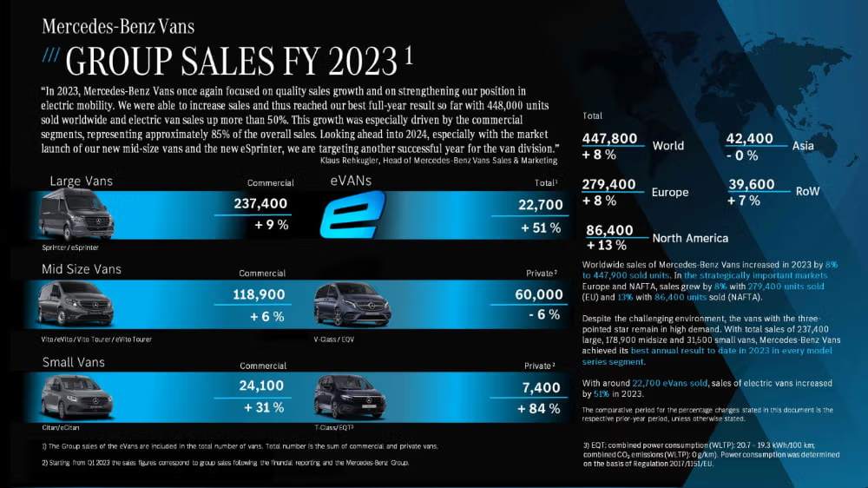
Figure 7: Mercedes-Benz Group Vans Sales FY 2023
Source: (Best-Selling Cars, 2023)
The U.S. market of luxury cars, with a valuation of over $200-250 billion a year, accounts for about 13-15 per cent of all vehicle sales, and Mercedes-Benz Group occupies about 12-14 per cent of the market segment, which makes it one of the top three luxury brands along with BMW Group and Lexus.

4.2 Market Attractiveness Analysis
Competitive Intensity and Industry Structure:
The automotive industry in the U.S. is competitive, with significant competition from local and global companies, such as Ford Motor Company, General Motors, Toyota Motor Corporation and Tesla, Inc. (Holweg, 2022). The luxury automobile market is highly competitive with BMW Group, Audi and Lexus. Amid this competition in the U.S. market, Mercedes-Benz Group has continued to thrive, with brand equity, differentiation and innovation, maintaining its competitive edge in the luxury car market.

4.3 Political Factors
Political Stability and Governance: The politically stable environment of the United States provides a strong foundation for long-term investment decisions. Mercedes-Benz Group benefits from consistent regulatory frameworks and transparent governance, which reduce uncertainty and allow strategic planning in manufacturing and innovation (Milner, 2022). It has always scored high in the world governance indexes of rule of law, quality of regulations, and effectiveness of the government. This stability leads to the creation of a favourable environment in the area of foreign direct investment (FDI), and annual inflows have been observed to be between 300 billion and 350 billion in recent years. In the case of multinational companies such as Mercedes-Benz Group, this stability has guaranteed consistency in policy-making, enforcement of the law and infrastructural development (Mercedes-Benz Group, 2025).
Trade Policies, Tariffs, and Localisation: U.S. trade policies, particularly tariffs on imported vehicles, have directly influenced the operational strategy of Mercedes-Benz Group. The rates of importation tariffs are comparatively moderate at about 2.5 per cent for passenger cars, but may go up to 25 per cent for light trucks, putting upward pressure on the cost of imported models. The tariffs promote localisation policies, which make firms set up local production plants so as to stay competitive (Mercedes-Benz Group, 2025).
Government Incentives and Industrial Policies: Government policies promoting electric vehicles, including tax incentives and funding for clean energy, create significant opportunities. Mercedes-Benz Group can use these incentives by diversifying its electric car lineup and committing to sustainable technologies. EV tax credits of up to 7500 dollars per vehicle were introduced in the Inflation Reduction Act (IRA) of 2022 with a local sourcing and manufacturing requirement (Bown, 2023). Besides, the Act will allocate more than 370 billion to climate and energy projects, such as renewable energy infrastructure, battery manufacturing, and EV charging networks.

4.4 Economic Factors
Economic Strength and Consumer Demand: The economic power of the United States makes Mercedes-Benz Group is specifically successful, which is characterised by high GDP and expendable income. The US has the highest economy in the world with a gross domestic product (GDP) of more than $32.38 trillion, and GDP growth rate is 2.32% in March 2026 (Worldometer, 2026). It has a high standard of living, and consumer purchasing power is high, as indicated by its GDP per capita, which is above $76, 000 (Worldometer, 2026). This financial prowess provides a high market base of high-end and luxury products, such as high-end cars. The U.S. automotive market is also one of the largest in the world, as the annual sales of vehicles are more than 15 million units. This is a great opportunity in the case of Mercedes-Benz Group, which caters to the upmarket customers who value quality, performance, and brand image.
Income Distribution and Luxury Demand: The distribution of incomes in the United States is skewed, where the 20 per cent of the households occupy over half of the total national income. Such a concentration of wealth provides a luxury automaker with a large target audience. High-income households have a strong tendency to concentrate wealth, which is a great benefit to Mercedes-Benz Group. Luxury vehicle consumers usually possess a household income of over 100,000-150,000 annually, which is very close to the pricing strategy of the Mercedes-Benz company; its cars are priced between about 55,000 and far beyond 100,000 (Fortune Business Insights, 2020).
Inflation, Interest Rates, and Consumer Financing: Consumer purchasing behaviour is greatly determined by the macroeconomic environment, such as inflation rates and interest rates. U.S. inflation showed a steady decline from its 2022 peak, falling to 4.12% in 2023 and further to 2.95% in 2024 (Ribba, 2024). This decreasing trend presents a major opportunity to Mercedes-Benz Group since consumer confidence is enhanced and the costs are stabilised. Nevertheless, with interest rates still being 4-5 percent, vehicle financing is still rising, albeit with a moderate impact on affordability due to high demand in the luxury market.

4.5 Legal Factors
Regulatory Environment and Compliance: The legal climate in the United States is rather stringent and demands compliance with safety and operation requirements. Mercedes-Benz Group can effectively work in this structure through having high-quality engineering and compliance systems. The major laws are the National Traffic and Motor Vehicle Safety Act, which is implemented by the National Highway Traffic Safety Administration (NHTSA), and this prescribes stringent safety standards for all vehicles (NHTSA, 2023).
Environmental and Sustainability Regulations: The innovation in Mercedes-Benz Group is driven by environmental regulations, especially fuel efficiency and emission regulations. The Corporate Average Fuel Economy (CAFE) Standards present the automakers with the goal of reaching increasingly high levels of fuel efficiency, whereas the Inflation Reduction Act (2022) facilitates the use of EVs by providing financial support (U.S. Department of Transportation, 2021).
Legal Risks and Intellectual Property Protection: Innovation is aided by the high level of intellectual property protection that exists in the U.S. to protect technological innovations. Mercedes-Benz Group enjoys this structure by safeguarding its proprietary technologies and preserving its competitive advantage. The US has one of the best intellectual protection systems in the world, which is under the laws that include the Patent Act (35 U.S.C.) and the Lanham Act (Reid and Tu, 2026). These systems promote innovation through safeguarding the technology and brand name. But the legal environment is also a major threat to the companies, especially in terms of the product liability suit under laws like the Product Liability Act. In the case of Mercedes-Benz Group, considering the high quality of products and existing compliance is the key to avoiding legal risks and preserving a brand image.

4.6 Cultural Factors: Application of Hofstede’s Cultural Dimensions
Hofstede Cultural Dimensions theory used to understand the role of cultural values in behaviour in various societies (Miller, 2022). The application of this model is as follows:
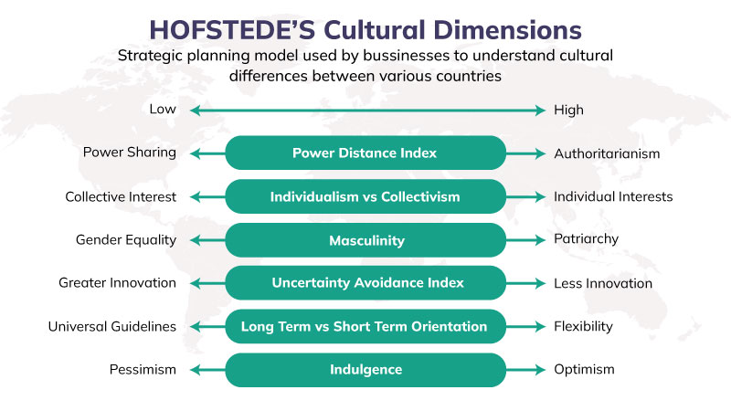
Figure 8: Hofstede's Cultural Dimension
Source: (Miller, 2022)
Individualism vs Collectivism:
One of the most applicable reasons that can justify the success of Mercedes-Benz Group is its highly individualistic culture of the United States. The U.S. consumers also enjoy personal achievement, self-expression and status with a score of 91 on individualism, which makes the consumers demand luxury vehicles that are linked with prestige and individuality (Miller, 2022). In the case of Mercedes-Benz Group, this cultural characteristic aids in high positioning of high-end cars as a symbol of individual achievement and social status.

Masculinity vs Femininity
Another aspect of culture that is very pertinent to the case of Mercedes-Benz Group in the U.S. market is masculinity. Masculinity in the U.S is 62 referring to a competitive, achievement and performance driven society. This fits well with the trend of innovation, engineering excellence and high-performance vehicles that Mercedes-Benz Group is keen on, and enhances consumer attraction in the market, which highly regards success and high-quality products (Mercedes-Benz Group, 2025).
Uncertainty Avoidance
The moderate level of uncertainty avoidance in the United States indicates a strong openness to new technologies and innovation. This cultural characteristic significantly benefits Mercedes-Benz Group, particularly in its transition towards electric vehicles and digital mobility solutions. The U.S. has an intermediate score in uncertainty avoidance of 46, which implies that it tolerates uncertainty well and is open to innovation. Consumers are also ready to use new technologies and experiment with new products (Singh and Liébana‐Cabanillas, 2023).
Indulgence vs Restraint
Another cultural aspect that has led to the success of Mercedes-Benz Group in the United States is indulgence. The U.S. society highly values lifestyle, enjoyment and personal satisfaction with a score of 68. This is in favor of luxurious cars that are comfortable, prestigious and emotionally satisfying. The advantage of such cultural orientation is that Mercedes-Benz Group is able to position its vehicles as lifestyle products and not as transport solutions (Peterson and Thomas, 2017).

4.7. Critical Assessment of Success Factors
Key Opportunities: The American automotive market has great opportunities because of a high number of consumers, a high level of disposable income, and a high demand for luxury and electric cars (Boyd and Mellman, 2024). The sales of EVs are increasing very fast with the help of governmental incentives, technological solutions, and infrastructure. The mentioned factors lead to a favourable environment in which Mercedes-Benz Group can increase its presence and position in the premium EV segment.
Key Challenges: In spite of such opportunities, the market is very competitive and complex. Firms like Tesla, Inc. control the EV market with a good level of innovation and brand loyalty, whereas BMW Group continues to be a major competitor in the luxury car market. Also, the cost of operations, supply chain issues and the changes in the regulatory requirements are enormous challenges that may affect the profitability and market entry tactics.
Strategic Implications: Mercedes-Benz Group needs to pursue an innovative, cost-efficient, and localisation strategic approach to ensure long-term success (Mercedes-Benz Group, 2025). It will be important to expand its EV portfolio, invest in sustainable technologies, and increase digital customer experiences. Moreover, the company can use its good brand image and history to sustain a competitive edge in the dynamic and fast-changing automotive market in the U.S.

5. Conclusion
In conclusion, the U.S. automotive market presents a very favourable but very competitive scenario to foreign companies. Its market base is large, the economic fundamentals are stronger, the technological environment is highly developed, and the demand for electric and high-end cars is increasing, which opens great opportunities to multinational firms. This analysis shows that Mercedes-Benz Group occupies a good position in the segment with high prices and quality based on high brand equity, innovativeness and differentiation strategy.
However, the company experiences significant threats posed by the conventional competitors, including BMW Group and the disruptive innovators, including Tesla, Inc., especially in the booming electric vehicle market. Market complexity is also augmented by external forces such as regulatory forces, changing consumer tastes and macroeconomic forces. Mercedes-Benz Group should keep investing in electrification, digitalisation, and localised production strategies and use its premium status to continue to achieve long-term success. Finally, the competitiveness and growth of the firm in the U.S. automotive industry will be based on its capacity to respond to technology change and future market dynamics.

Section 2

Reflective Account using Gibbs Reflective Cycle
Graham Gibbs Reflective Cycle is a systematic model that facilitates learning through experience because it involves six steps, which include description, feelings, evaluation, analysis, conclusion, and action plan (Channell, 2023). This model is used in a critical reflection on research, analysis and preparation of the section above.

Figure 9: Gibbs Reflective Cycle
Source: (Channell, 2023)
1. Description
When accomplishing Section 1 of this assessment, I engaged in a systematic research and analytical exercise on the U.S. automotive industry and the strategic position of Mercedes-Benz Group. It started by searching the relevant academic journals, industry reports, and statistical databases, including Statista and annual reports of the company.
I collected quantitative market size, EV adoption, GDP contribution, and competitive positioning quantitative data in a systematic manner. This was then accompanied by the application of analytical models like the Diamond Model of Porter's Diamond Model and Hofstede's Cultural Dimensions Theory developed by Hofstede to explain the macro and micro environmental forces.
The report was subsequently structured into logical parts such as industry overview, competitive landscape and critical evaluation. I also added comparative analysis of some of the major competitors like Tesla, Inc., Toyota Motor Corporation and BMW Group to enhance the discussion.
2. Feelings
I was confident at the onset of the task because I had an idea of the concepts of international business before. Nevertheless, in the course of my progress, I felt a little indecisive about the credibility of data sources and the possibility of combining several analytical frameworks in a single report. I was also challenged in understanding large amounts of statistical data and being correct without breaking the standards of academic writing. Nevertheless, I built up confidence slowly because I sorted the information and connected theory and practice in the business world.
At the conclusion of the task, I was pleased to have mastered the skill of critical assessment of the U.S. automotive industry and was able to provide a structured and evidence-based analysis of it. This is in line with the concept that reflective learning improves self-awareness and academic progress
3. Evaluation
The use of credible and up-to-date data sources was one of the strengths of my approach because it enhanced the reliability of the analysis. The incorporation of theoretical models like the Diamond Model created by Porter allowed me to critically analyse the competitiveness in the industry instead of merely explaining it (Grant, 2021). According to Cavusgil, Knight, and Riesenberger (2021), the comparison of various firms offered a better insight into the strategic positioning of the automotive industry. This improved the quality of the analysis of the report.
Nevertheless, it had its own drawbacks. The report was at times too descriptive and not critical in its analysis, especially where statistical data was involved. Moreover, time management was also a problem, and data gathering and confirmation from various sources were time-consuming. The other weakness was the poor application of the visual tools, like diagrams or charts, which would have enhanced clarity and presentation.
4. Analysis
The experience highlighted the need to incorporate both formal research and critical thinking in order to come up with a quality academic report. According to Yin (2018), successful research is not limited to data collection but needs significant interpretation, which I used in connecting industry data with theoretical frameworks. The Diamond Model, created by Michael Porter and Cultural Dimensions developed by Geert Hofstede allowed for a more profound insight into the competitiveness and consumer behaviour in the U.S. automotive market. This supports Hill (2022), who articulates that theory and real-world evidence combine to enhance international business analysis.
Moreover, it was also mentioned that credible and up-to-date sources should be used in the research process. Clark et al. (2022) says, reliability and validity are important aspects of creating an academically rigorous work. I used peer-reviewed journals and industry data to enhance the quality of the overall analysis. Nevertheless, a weakness was that I tended to pay more attention to the presentation of data than to critical assessment. This is consistent with Saunders et al. (2009), who assert that academic work at the higher-level needs synthesis and critical interaction as opposed to description. Another important issue that also affected the quality of my work was time management. Lack of time to revise minimised the chances of improving arguments and critical perceptions. Further, although I have managed to use the theoretical frameworks, I realised that further comparative analysis of companies may have made the report better.
Overall, this experience improved my ability to connect theory with practice and strengthened my research skills. Simultaneously, it also demonstrated the necessity to develop the skills of critical thinking, data synthesis, and time management further to attain a greater level of academic performance in future assignments.
5. Conclusion
This reflection indicates that I have developed my research and analytical abilities in doing the assignment. This is because the theoretical frameworks and reliable sources were used to make the analysis structured and evidence-based. Nonetheless, effective international business analysis involves constant enhancement of critical thinking. I was able to determine some of the main areas of improvement, such as a more thorough appraisal, enhanced time management, and information synthesis. By dealing with these, I will be able to write more succinct, critical, and quality academic work in the future.
6. Action Plan
Area for Improvement | Action | Timeline | Expected Outcome
Critical Analysis Skills | Practice writing more analytical paragraphs using academic sources and case studies | Next 2 months | Improved ability to evaluate rather than describe
Time Management | Create a detailed study schedule with milestones for each stage of assignments | Immediate | Reduced last-minute pressure and better-quality work
Source Selection | Use academic databases like Google Scholar and Scopus for high-quality sources | Ongoing | Stronger academic credibility
Data Synthesis | Practice summarising and integrating multiple sources into clear arguments | Next 1–2 months | Better clarity and coherence in writing
Application of Theory | Engage in more case-based learning and real-world examples | Ongoing | Improved ability to link theory with practice
Academic Writing Skills | Attend workshops or use university writing support services | Within semester | Enhanced structure, referencing, and presentation
Table 1: Action Plan for Future Development
Source: (Self-Made)

References
Alberto, C. (2025). Valuing a Disruptor Innovator: Tesla’s Impact on the Electric Vehicle Market. [online] thesis.unipd.it. Available at: https://thesis.unipd.it/handle/20.500.12608/59488 [Accessed 19 Apr. 2026].
Best-Selling Cars (2023). 2023 (Full Year) Global: Mercedes-Benz and Smart Worldwide Car Sales. [online] www.best-selling-cars.com. Available at: https://www.best-selling-cars.com/brands/2023-full-year-global-mercedes-benz-and-smart-worldwide-car-sales/ [Accessed 12 Apr. 2026].
Bown, C.P. (2023). Industrial Policy for Electric Vehicle Supply Chains and the Us-Eu Fight Over the Inflation Reduction Act. SSRN Electronic Journal, [online] 7(3). doi: https://doi.org/10.2139/ssrn.4449020.
Boyd, J.Hayden. and Mellman, R.E. (2024). The effect of fuel economy standards on the U.S. automotive market: A hedonic demand analysis. Transportation Research Part A: General, 14(5-6), pp.367–378. doi: https://doi.org/10.1016/0191-2607(80)90055-2.
Clark, T. et al. (2022) Bryman’s social research methods. 6th edn. Oxford: Oxford University Press. Available at: https://librarysearch.uwtsd.ac.uk/permalink/44WHELF_UWTSD/1vbe9ev/alma99100411002702421 (Accessed: 25 April 2026).
Cavusgil, S.T., Knight, G. and Riesenberger, J.R. (2021). International Business: The New Realities. 5th edn. Pearson. DOI: https://doi.org/10.4324/9780429490453
Channell, M. (2023). Gibbs Reflective Cycle – A Practical Guide. [online] TSW Training. Available at: https://www.tsw.co.uk/insights/gibbs-reflective-cycle/ [Accessed 16 Apr. 2026].
David, G. (2024). Toyota Sets New Global Sales Record, Remains Top Automaker in 2025. [online] alphaspread.com. Available at: https://www.alphaspread.com/market-news/earnings/toyota-sets-new-global-sales-record-remains-top-automaker-in-2025 [Accessed 6 Apr. 2026].
EBSCO (2024). Toyota Motor Corporation | EBSCO. [online] EBSCO Information Services, Inc. | www.ebsco.com. Available at: https://www.ebsco.com/research-starters/business-and-management/toyota-motor-corporation [Accessed 18 Apr. 2026].
Elison, F. (2024). Collaborative automotive R&D for safe, energy-efficient and affordable mobility of people and goods on European roads. [online] Available at: https://media.neliti.com/media/publications/626465-trends-in-r-d-spending-in-the-automotive-9543cdd9.pdf [Accessed 19 Apr. 2026].
Fortune Business Insights (2020). Luxury Car Market Size, Share, Trends | Report, 2027. [online] www.fortunebusinessinsights.com. Available at: https://www.fortunebusinessinsights.com/luxury-car-market-104453 [Accessed 6 Apr. 2026].
Grant, R.M. (2021) Contemporary strategy analysis. 11th edn. Chichester: John Wiley & Sons. Available at: https://doi.org/10.1002/9781119815235 (Accessed: 25 April 2026).
Griffin, R.W. and Pustay, M.W. (2020). International business a managerial perspective. 9th, global edition. Harlow, England: Pearson.
Hardman, S. and Chandan, A. (2023). The effectiveness of financial purchase incentives for battery electric vehicles – A review of the evidence. Renewable and Sustainable Energy Reviews, [online] 80(80), pp.1100–1111. doi: https://doi.org/10.1016/j.rser.2017.05.255.
Hill, C.W.L. (2022). International Business: Competing in the Global Marketplace. 13th edn. McGraw-Hill. DOI: https://doi.org/10.1036/9781260260472
Holweg, M. (2022). The Evolution of Competition in the Automotive Industry. Build To Order, [online] 1(1), pp.13–34. doi: https://doi.org/10.1007/978-1-84800-225-8_2.
Horváth, László András (2025). Premium brand strategy in the automotive industry: what are the characteristics of a successful premium automotive strategy? Handle.net, [online] 5(3). doi: https://doi.org/10.34726/hss.2014.23647.
Jin, B. and Moon, H. (2025). The diamond approach to the competitiveness of Korea’s apparel industry. Journal of Fashion Marketing and Management: An International Journal, 10(2), pp.195–208. doi: https://doi.org/10.1108/13612020610667504.
Lopez, P. (2023). Porter’s Diamond Model: An Essential Guide for Global Achievement. [online] SlideModel. Available at: https://slidemodel.com/porters-diamond-model/ [Accessed 17 Apr. 2026].
Lukszo, Z. (2022). Business innovation and government regulation for the promotion of electric vehicle use: lessons from Shenzhen, China. Journal of Cleaner Production, 134(4), pp.371–383. doi: https://doi.org/10.1016/j.jclepro.2015.10.013.
Mercedes-Benz Group (2025). Mercedes-Benz Plant Tuscaloosa. [online] Mercedes-Benz Group. Available at: https://group.mercedes-benz.com/company/locations/production-network-tuscaloosa.html [Accessed 4 Apr. 2026].
Miller, K. (2022). Hofstede’s Cultural Dimensions: Implications and How to Apply. [online] Crowjack. Available at: https://crowjack.com/blog/strategy/hofstedes-cultural-dimensions [Accessed 22 Apr. 2026].
Milner, H.V. (2022). International Political Economy: Beyond Hegemonic Stability. Foreign Policy, 7(110), pp.112–123. doi: https://doi.org/10.2307/1149280.
Nagy, J. and Jámbor, Z. (2024). Competitiveness in global trade: The case of the automobile industry. Economic Annals, [online] 63(218), pp.61–84. Available at: https://doiserbia.nb.rs/Article.aspx?ID=0013-32641818061N [Accessed 6 Apr. 2026].
NHTSA (2023). NHTSA. [online] NHTSA. Available at: https://www.nhtsa.gov/ratings [Accessed 25 Apr. 2026].
Peterson, M F & Thomas, D.C. (2017). Cross- cultural management : essential concepts. 4th ed. International student edition. SAGE.
Platzer, M. and Harrison, G. (2023). The U.S. Automotive Industry: National and State Trends in Manufacturing Employment Specialist in Industrial Organization and Business CRS Report for Congress Prepared for Members and Committees of Congress. [online] Available at: https://ecommons.cornell.edu/server/api/core/bitstreams/2b74278b-95d4-490c-869c-a41f47accd29/content [Accessed 17 Apr. 2026].
Prakhar, P., Gupta, S. and Jaiswal, R. (2025). Battery technology and charging infrastructure for EVs: a resource-based and dynamic capability view of entrepreneurial opportunities. Information Discovery and Delivery, 6(3). doi: https://doi.org/10.1108/idd-09-2024-0143.
Reid, A. and Tu, S.S. (2026). Fundamentals of United States Intellectual Property Law: Copyright, Patent, and Trademark. Torrossa.com, [online] 5(2), pp.1–472. Available at: https://www.torrossa.com/it/resources/an/5831307 [Accessed 20 Apr. 2026].
Ribba, A. (2024). The joint dynamics of inflation, unemployment and interest rate in the United States since 1980. Empirical Economics, 31(2), pp.497–511. doi: https://doi.org/10.1007/s00181-005-0031-8.
Saunders, M., Lewis, P. and Thornhill, A. (2009) Research methods for business students. 5th edn. Harlow: Pearson Education Limited.
Shiquan, D. and Deyi, X. (2022). The security of critical mineral supply chains. Mineral Economics, 36(6). doi: https://doi.org/10.1007/s13563-022-00340-4.
Singh, V. and Liébana‐Cabanillas, F. (2023). Factors affecting adoption intention of electric vehicle: a cross-cultural study. Environment, Development and Sustainability, 26(7). doi: https://doi.org/10.1007/s10668-023-03865-y.
Skeete, J.-P. (2023). Motorsport and Autonomous Vehicles: Examining the EU’s regulatory framework for energy-efficient innovation (EEI) in the automotive industry - White Rose eTheses Online. Whiterose.ac.uk, [online] 4(3). doi: https://etheses.whiterose.ac.uk/id/eprint/19758/1/JPS%20PhD%20Thesis%20minor%20correcitons%20accepted%20final.pdf.
Statista (2023). Topic: U.S. Automotive Industry. [online] www.statista.com. Available at: https://www.statista.com/topics/1721/us-automotive-industry/ [Accessed 19 Apr. 2026].
Statista (2025). Automobile production forecast - United States 2025| Statista. [online] Statista. Available at: https://www.statista.com/statistics/290835/united-states-light-vehicle-production-outlook/?srsltid=AfmBOorxjvoyz6kFqCvWd9O4uLVl_5EneimZ2nxxws60tLOAasjwLnaM [Accessed 19 Apr. 2026].
Statista (2026). Mercedes-Benz revenue 2025| Statista. [online] Statista. Available at: https://www.statista.com/statistics/1542071/mercedesbenz-revenue/?srsltid=AfmBOorUAf5vqWoPM6SZFXuyV5OQ_lQWoVcnW_6ihAsiAhLmsXJHye2y [Accessed 19 Apr. 2026].
Sturgeon, T.J. (2024). Global value chains in the automotive industry: an enhanced role for developing countries? International Journal of Technological Learning, Innovation and Development, 4(1/2/3), p.181. doi: https://doi.org/10.1504/ijtlid.2011.041904.
U.S. Department of Transportation (2021). Corporate Average Fuel Economy (CAFE) Standards. [online] US Department of Transportation. Available at: https://www.transportation.gov/mission/sustainability/corporate-average-fuel-economy-cafe-standards [Accessed 17 Apr. 2026].
Underwood, R.L. (2025). Automotive foreign direct investment in the United States: Economic and market consequences of globalization. Business Horizons, 55(5), pp.463–474. doi: https://doi.org/10.1016/j.bushor.2012.04.004.
Vecteezy, R. (2023). Vehicles Sales decrease to 15.5 million SAAR in October; Up 6% YoY. [online] Calculatedriskblog.com. Available at: https://www.calculatedriskblog.com/2023/11/vehicles-sales-decrease-to-155-million.html [Accessed 19 Apr. 2026].
Worldometer (2026). GDP by Country. [online] Worldometer. Available at: https://www.worldometers.info/gdp/gdp-by-country/ [Accessed 25 Apr. 2026].
Yeung, G. (2023). Competitive dynamics of lead firms and their systems suppliers in the automotive industry. Environment and Planning A, 56(2). doi: https://doi.org/10.1177/0308518X231202390.
Yin, R.K. (2018) Case study research and applications: Design and methods. 6th edn. Thousand Oaks, CA: SAGE Publications. Available at: https://doi.org/10.4135/9781071802631 (Accessed: 25 April 2026).
Zion Market Research (2024). US Automotive Market Size, Share, Growth and Forecast 2032. [online] Zion Market Research. Available at: https://www.zionmarketresearch.com/report/us-automotive-market [Accessed 6 Apr. 2026].

