

Assessment 2

Student name:​ Michael Abak
Student ID: ​1917009
Module name: Mental Disorders and Psychopathology​
Module code: BMHP6006
Lecturer name: Bianca Sanfilippo ​
Date: 29 April 2022

Contents
Introduction 3
The ICD-10 classification of GAD 3
Causes of GAD 4
The symptoms and signs associated with GAD 4
Stage of diagnosing GAD 4
Present Treatments of GAD 4
Treatments based on psychology 4
Recommendations for improving anxiety 6
NICE care principles of people with GAD 6
Schizophrenia 6
Causes of the disorder 6
Symptoms 7
Diagnoses 7
Treatments of the disorder 7
The measurements of rehabilitating people with schizophrenia 8
NICE GUIDELINES 8
Recommendations for improvement 8
AUTISM 8
Classification of autism 8
Autism statistics nationally and globally 8
Causes 9
The signs and symptoms of autism 9
Diagnoses 9
Current treatment of autism 9
Rehabilitation measurements 10
NICE guidelines on autism 10
Conclusion 10
Reference list 10
Appendix A 14

Introduction
This report will critically analyse three mental disorders from the international classification of diseases ICD-10(WHO,2010) including how it is classified, diagnosed, treated and measurements related to rehabilitation. The focus will be on General anxiety disorder, schizophrenia, and autism.

The NHS (2021) defined generalized anxiety disorder as a continual feeling of fear and stress that negatively impacts a person’s daily life including their physical and mental state.

The ICD-10 classification of GAD.
In the ICD-10, GAD is addressed in F40-F48
Disorders related to stress, somatoform, and neuroticism. GAD can specifically be found in F41.1
Statistics of anxiety sufferers in the UK
Approximately 19 million adults in Great Britain have reported a high level of anxiety (Office for National Statistics, 2020). Anxiety affects people regardless of status (see figure 1).
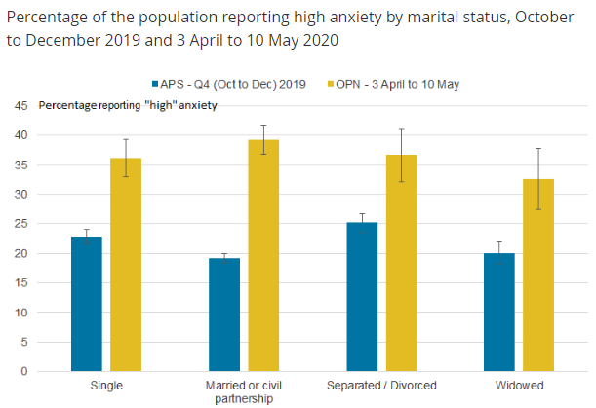

Fig 1(Office for National Statistics, 2020)

Causes of GAD
There is no clear reason for the cause of GAD, but studies have suggested the following causes:
Discrepancies in the brain by chemicals that control and regulate mood, too much activity in the part of the brain that controls behaviour and emotion, inherited genes from parents increases the risk 5 times, people that have historically passed through a stressful and traumatic like being abused in childhood, being bullied, and suffered domestic violence, those that historically misused drugs and those that suffer from a long-term medical condition like arthritis. (NHS, 2021). Current conditions of life can also be a cause (Mind, 2021).
The symptoms and signs associated with GAD.
Symptoms might be psychological or physical. Psychological symptoms can be being restless, having a constant sense of impending doom, concentration problems, being on edge, and being irritated all the time.Physical symptoms can be being dizzy or tired, tense, and painful muscle aches, sweating excessively, sweating profusely, headaches, racing heartbeat, and sleep problems. (NHS, 2021).

Stage of diagnosing GAD
The probability of a person being diagnosed with GAD is high if their symptoms have lasted for over six months. Difficulty in managing anxiety symptoms can also be an indication that the person is suffering from GAD. The GP can also perform examinations of a physical nature including blood tests to eliminate other conditions that may be responsible for the symptoms such as anaemia, which is a deficiency in iron and vitamin B12 which is a thyroid gland that is overactive. Questionnaires may also be used. The GP can also get information through questionnaires (NHS, 2021).

Present Treatments of GAD
People that are diagnosed with GAD are usually offered psychological treatment options before they are prescribed medication.

Treatments based on psychology
Psychologically based treatments that are offered can be CBT, which is the cognitive behavioural therapy, another option is applied relaxation. Anyone can refer themselves to the NHS psychological services (IAPT) without the need to see a GP beforehand.
A guided self-help course may be recommended by the GP to ascertain if the person can cope with their anxiety. It usually involves working with a workbook with the support of a therapist or a weekly group session with a therapist to assist in tackling the anxiety.in the event that these treatments fail, a more intensive psychological treatment or therapy will then be offered.
CBT treatment
The CBT treatment is very effective and lasts longer than medication treatment generally.it involves questioning negative or anxious thoughts and not avoiding things that make the person anxious.it involves hourly sessions with a therapist and can last for up to 4 months.
Applied relaxation
In applied relaxation a therapist trains the person to relax their muscles, responding to triggering words by relaxing muscles and relaxing when anxious. It involves meetings with a therapist approximately every 4 months or three.
Medication
Medication can be the next option if the earlier treatments fail. there area short6 term and long-term treatments. The GP will discuss the type, length and adverse effects of the medication with the person. Regular appointments with the GP is also carried out to ascertain how well the patient is coping with the treatment. Some of the medication-based treatments are:
Selective serotonin reuptake inhibitors (SSRIs)
This medication functions by increasing the levels of serotonin in the brain.
Disadvantages or side effects
Side effects include being agitated, sick, having indigestion, constipation, losing appetite, feeling dizzy, having blurred vision, headaches, reduced libido, erectile dysfunction in men etc.
Pregabalin
This is another alternative if SSRIs fail. It is used to treat epilepsy, but it was found to be e3ffective in the treatment of anxiety.
Side effects could be dizziness, vertigo, increased appetite, weight gain, headaches, and dry mouth. It is not known to affect sex drive as negatively as SSRIs.
Benzodiazepines
It is a form of sedative that is used for the short term when there is severe anxiety. it starts working in about 30 to 90 minutes, the drug usually prescribed is diazepam. The disadvantage is they cannot be used for a long time because it can cause addiction. After 4 weeks it starts to lose effectiveness, another disadvantage is that it causes trembling in the body, low sex drive etc
Referral to a specialist.
When all the treatments listed earlier fail, the person can be referred to a mental health specialist. Community mental health teams can be psychiatrists, psychiatric nurses, social workers, clinical, clinical psychologists and social workers.
Measuring rehabilitation
The term relates to all the tools appli9ed in the charting of progress during rehabilitation. It also includes the charting of the treatments to determine their effectiveness.
It is of paramount importance to measure the treatments provided; this is to evaluate its effectiveness. Through this method, treatments that are ineffective can be stopped and alternative treatments can be considered. The ‘Generalised Anxiety Disorder Questionnaire (GAD-7)’. (Appendix A). it is used in the measurement of anxiety levels in a two-week period.

Recommendations for improving anxiety
Complementary therapies can be used to improve anxiety, according to a study by Shohani et al. (2018) the use of yoga can be effective in the improvement of anxiety symptoms thereby limiting and eliminating the use of drugs and its side effects. Other recommended activities is reducing alcohol intake, meditation, sleeping well, staying active, taking time out from everything, eating and eating a balanced diet (ADAA, 2019)

NICE care principles of people with GAD
The NICE guidelines should be followed when treating people with GAD. Person-centered care, respect, dignity, etc.

Schizophrenia
It is a significant and long-term mental disorder (NHS, 2019) that is related to a breakdown in emotion, thought, and behaviour which leads to wrong perceptions, actions and feelings that are inappropriate, withdrawing from reality and relationships that are personal and replacing this with fantasy and delusion. with mental fragmentation. People with this disorder usually interpret reality abnormally (Mayo Clinic, 2020). The disorder affects about 24 million people, which is 1 in 300 people worldwide. It is not as prevalent as other mental disorders, and the onset is earlier in men than in women. They are two to three times more likely to die in comparison with the general population due to cardiovascular, metabolic and infectious diseases. (World Health Organisation, 2022). It is prevalent in men (Ochoa et al., 2012).
At every point in time, approximately 220,000 patients are being treated for schizophrenia in the UK. Those that suffer from it have a 10percent chance of dying through acts orchestrated by themselves (Living with Schizophrenia, 2017).
The disorder is classified within the ICD-10 as schizotypal and delusional disorders. (F20-F29).

Causes of the disorder
The precise cause of the mental disorder is unknown. Studies have suggested a combination of factors such as physical, psychological, genetic, and environmental conditions can cause a person to become schizophrenic.
Genetically, it tends to run in families. Evidence from the study of twins suggests that it is genetically inherited because if one identical twin has the disorder, the other twin is 1 to 2 times more likely to have it, even when they are separated and live differently.
Brain development can also be a factor. Studies have demonstrated that there are changes in the brain structure of those suffering from the disease.
Neurotransmitters have been known to be a cause. They are chemicals that transfer messages between brain cells and imbalance in the cells or insensitivity to the neurotransmitters by the body might trigger schizophrenia.
Complications in pregnancy such as premature delivery reduced birthweight and asphyxia during the period of delivery can affect brain development and cause the disorder.
Certain triggers might cause the mental disorder, examples are:
Stress-related psychological factors such as job loss, bereavement, home loss, divorce, termination of a relationship, and abuse such as physical, emotional, and sexual can trigger the disorder in people that are vulnerable to it.
Drug misuse can increase the probability of developing the condition or other mental health disorders. Drugs such as cannabis, amphetamines, and cocaine can trigger the disorder in people that are vulnerable to developing the illness (NHS, 2021)

Symptoms
There are several symptoms of the disorder. Delusions such as false beliefs that are not based on any form of reality can be a symptom. An example is when someone feels they are being harassed or being harmed, someone else is in love with the person or a significant catastrophe is about to happen. Delusions are common in people with schizophrenia.
Other factors are hallucinating, very disorganized motor behaviour, thinking or speech that is highly disorganized, and negative signs such as a reduction or lack of the ability to function in a normal manner such as neglecting personal hygiene. Teenagers can show symptoms such as a withdrawal from friends and family, poor school performance, loss of motivation, being irritated and depressed, and lack of sleep (Mayo Clinic, 2020)

Diagnoses
The condition is usually ascertained after an assessment by a professional. The GP will check the person’s symptoms to rule out other causes such as the use of recreational drugs.
Community mental health teams are for people that are suspected of having the disorder and are referred by the GP. It can be diagnosed if the person is experiencing one or more of certain symptoms for about a month: hallucinations, delusions, speaking incoherently, hearing voices, or symptoms that are negative, such as being in an emotional flat state.
It can also be when all other causes like recreational drug use and bipolar mental disorder have been ruled out, including if the symptoms have a major impact on working life, study life, and the ability to carry out routine daily tasks. Related illnesses to schizophrenia are bipolar disorder and schizoaffective disorder. Children and young people with the first schizophrenic episode should be referred to a specialized mental health service such as the children and young people’s mental health service (CYPMHHS) which is for children up to the age of 17 years or the early intervention service which is for over 14 years (NHS, 2021).

Treatments of the disorder
Treatment usually involves talking therapy and medication and they are usually treated through the community health teams. The CMHT team can be social workers, occupational therapists, pharmacists, psychologists, psychiatrists, and community mental health nurses.
The care program approach is directed at people with complex mental health conditions. It involves 4 stages.
Assessment is the stage when the health and social care necessities are ass4essed. This is followed by the care plan that is made to meet the health and social care requirements of the person. The next stage is the appointment of a key worker which is usually a social worker or a nurse. The next stage is the review stage, where the treatment will be reviewed, and changes will be made if required.
Acute episodes are treated with antipsychotic medicines and specialized care. Crises resolution teams and voluntary or compulsory detention are other options, including advance statements. Other treatment options include antipsychotics, psychological treatments, family therapy and arts therapy (NHS, 2019).

The measurements of rehabilitating people with schizophrenia
The quality of care and treatments provided are measured to avoid complications like substance misuse, self-harm, neglect, lacking dignity, and human rights violation. The measurements can be done with indicators that are usually used for mental disorders of a longer period.
‘Quality Indicator for Rehabilitative Care (QuIRC-SA)’ It is a systematic tool for quality assessment of specialist mental health in supported accommodation services. This tool shows the quality of care and how effective it is (see Appendix b). Because schizophrenia is a long-term condition, it is important to support the patients in having a decent quality of living. Indicators for rehabilitative care can be used for measuring especially as regards long-term mental health conditions (UCL, 2022).

NICE GUIDELINES
People-centered care should be employed when dealing with people with the disorder. A multidisciplinary approach should be adhered in other to engage all the services. Effective monitoring for other mental health conditions. The rights of the person should be respected, the mental health act should be taken into consideration and the privacy of the person should be always respected (NICE, 2016).

Recommendations for improvement
Holistic measures should be adopted in the management of symptoms of the disorder. Pharmacological and non-pharmacological treatments could be employed to improve the management of the disorder (Ganguly, Soliman and Moustafa, 2018).

AUTISM
Autism can be defined as a developmental disorder that becomes visible from about 3 years old and is characterized by problems in forming and keeping social relations, impairment of the ability to communicate verbally and non-verbally, patterns of behaviour that are repetitive, and being restrictive in interests and activities (Merriam-Webster, 2022). Autism spectrum disorder as it is also known is a diverse group of conditions (WHO, 2021). Those with the disorder may feel overwhelmed by loud music and bright lights (NHS, 2019).

Classification of autism
The mental disorder is classified in the ICD-10 under disorders linked with psychological development.
(F80-F89 Disorders of psychological development, ICD, 2010).

Autism statistics nationally and globally
According to the WHO, one in one hundred children have autism worldwide, although this is an average figure and some studies claim it to be higher in some countries (WHO, 2021).It occurs more in boys than in girls (Nicholette Zeliadt, 2018). Autism has been on the rise in the UK, it affects about one to two percent of the population in the UK. The UK has about one hundred thousand children with autism and approximately one million adults with the condition in the UK (Hey, 2021). The condition affects more men and boys in comparison to women and girls. The current ratio is about three to one (National Autistic Society, 2022).

Causes
Scientific knowledge currently available suggests that there are several factors that can make a child autistic notably environmental and genetic factors. the conclusion from current epidemiological data suggests that there is no evidence to prove that vaccines, measles, and mumps can cause autism (WHO, 2021).

The signs and symptoms of autism
Some of the main signs of autism include:
Having difficulty understanding how others think or feel
Anxiousness when socializing
Having difficulty making friends and choosing to be alone
Difficulty in expressing how they feel
Being blunt, impolite, or showing disinterest in others unconsciously.
Understanding things literally- for example being unable to understand sarcasm.
Repeating the same routine daily and being anxious when there is a deviation.
Some other signs could be not making eye contact, being too close to people or being very unhappy if touched by other people, being aware of little details and patterns that most people are unaware of, planning things very carefully before acting, and having a deep interest in particular activities or subjects. Autism can be different in men and women, this is because some autistic women can be quieter, hide their true feelings and appear to cope better in social situations. Acting this way makes it more difficult to detect autism in some women than in most men (NHS Choices, 2019).

Diagnoses
The first step is to talk to someone about it, such as a GP, health visitor (for children below five years), therapist or the special education needs staff in the child’s school. Then an autism assessment can be performed by specialists to determine if the person or their child is autistic. During the assessment, they usually ask about problems the person or their child is experiencing, observe how the person or their child interacts with others and chat with people that are well known to the person or their child, such as friends and family, GP or the child’s teacher. There may be one or several appointments with different professionals that work in a team.
A report will be given at the end of the assessment that will show if autism has been detected or diagnosed (NHS, 2019). The disorder can usually be detected and diagnosed at about two years of age (National Institute of Mental Health, 2018). A diagnostic tool can be the Autism Diagnostic Interview-Revised (ADI-R) which is a structured interview that is used in diagnosing autism (Science Direct, 2015). It involves a battery of tests (Rudy, 2022).

Current treatment of autism
Behavioural and communication-based therapies.
Therapies based on education
Family-based therapies
Other therapies such as occupational and physical therapies.
Medications (Mayo Clinic, 2018).

Rehabilitation measurements
The ‘Childhood Autism Rating Scale (CARS)’ (Moulton et al., 2019) and the ‘Autism Diagnostic Observation Schedule’ (Pacífico et al., 2019) ADOS are some of the methods used to assess and measure the effectiveness of rehabilitation and treatment.
Recommendations for improving autism
Complementary therapies such as yoga have been found to improve the symptoms of autism (Bhavanani et al., 2019).

NICE guidelines on autism
Some of the guidelines include:
Making sure that diagnosed children and young people have access to health care services
The provision of a key worker to assist in managing the child and family and coordinate options of treatment.
Taking steps to ensure that reviews and asse4ssments are not missed.
Professional advanced training in autism should be performed promptly by professionals (NICE, 2021).

Conclusion
The professionals handling autism cases should demonstrate the importance of a person-cantered approach. Their actions should have a basis and respect for the individual and they should consider the Human Rights Act. They should desist from discriminatory acts as stated in the Equality Act of 2010.

.

Reference list
ADAA (2019). Tips | Anxiety and Depression Association of America, ADAA. (online). Available at: https://adaa.org/tips [Accessed 22 Apr. 2022].
Bhavanani, A., Artchoudane, S., Ramanathan, M. and Mariangela, A. (2019). Yoga as a therapeutic tool in autism: A detailed review. Yoga Mimamsa, [online] 51(1), p.3. Available at: https://www.ym-kdham.in/article.asp?issn=0044-0507;year=2019;volume=51;issue=1;spage=3;epage=16;aulast=Artchoudane [Accessed 25 Apr. 2022].
Ganguly, P., Soliman, A. and Moustafa, A.A. (2018). Holistic Management of Schizophrenia Symptoms Using Pharmacological and Non-pharmacological Treatment. Frontiers in Public Health, (online) 6(166). Available at: https://www.ncbi.nlm.nih.gov/pmc/articles/PMC5999799/#:~:text=As%20mentioned%20in%20Table%20%E2%80%8B,managing%20schizophrenia%20symptoms%20(110). [Accessed 24 Apr. 2022].
Hey, L. (2021). Autism in the UK: prevalence, assessment and the impact of the Covid-19 pandemic. (online) Available at: https://www.hogrefe.com/uk/article/autism-in-the-uk-prevalence-assessment-and-the-impact-of-the-covid-19-pandemic#:~:text=The%20prevalence%20of%20autism%20in%20the%20UK&text=Autism%20currently%20affects%201%E2%80%932 [Accessed 24 Apr. 2022].
Living With Schizophrenia (2017). Facts and Figures. (online) Living With Schizophrenia. Available at: https://livingwithschizophreniauk.org/facts-and-figures/#:~:text=At%20any%20one%20time%20about [Accessed 23 Apr. 2022].
Mayo Clinic (2018). Autism spectrum disorder - Diagnosis and treatment - Mayo Clinic. (online) Available at: https://www.mayoclinic.org/diseases-conditions/autism-spectrum-disorder/diagnosis-treatment/drc-20352934 [Accessed 25 Apr. 2022].
Mayo Clinic (2020). Schizophrenia - Symptoms and causes. (online) Available at: https://www.mayoclinic.org/diseases-conditions/schizophrenia/symptoms-causes/syc-20354443#:~:text=Schizophrenia%20is%20a%20serious%20mental [Accessed 22 Apr. 2022].
Mayo Clinic (2020). Schizophrenia - symptoms and causes. (online) Available at: https://www.mayoclinic.org/diseases-conditions/schizophrenia/symptoms-causes/syc-20354443 [Accessed 23 Apr. 2022].
Merriam-Webster (2022). Definition of AUTISM. (online) Available at: https://www.merriam-webster.com/dictionary/autism [Accessed 24 Apr. 2022].
MIND (2021). What causes anxiety problems. (online) Available at: https://www.mind.org.uk/information-support/types-of-mental-health-problems/anxiety-and-panic-attacks/causes/ [Accessed 15 Apr. 2022].
Moulton, E., Bradbury, K., Barton, M. and Fein, D. (2019). Factor Analysis of the Childhood Autism Rating Scale in a Sample of Two Year Olds with an Autism Spectrum Disorder. Journal of autism and developmental disorders, (online) 49(7), pp.2733–2746. Available at: https://www.ncbi.nlm.nih.gov/pubmed/27743321 [Accessed 25 Apr. 2022].
National Autistic Society (2022). autism and gender identity. (online)Available at: https://www.autism.org.uk/advice-and-guidance/what-is-autism/autism-and-gender-identity [Accessed 25 Apr. 2022].
National Institute of Mental Health (2018). Autism Spectrum Disorder. (online) Available at: https://www.nimh.nih.gov/health/topics/autism-spectrum-disorders-asd [Accessed 25 Apr. 2022].
NHS (2018). Overview - Generalised Anxiety Disorder in Adults. (online) Available at: https://www.nhs.uk/mental-health/conditions/generalised-anxiety-disorder/overview/ [Accessed 15 Apr. 2022].
NHS (2019a). How to Get Diagnosed With Autism. (online0 Available at: https://www.nhs.uk/conditions/autism/getting-diagnosed/how-to-get-diagnosed/ [Accessed 25 Apr. 2022].
NHS (2019b). Overview - Schizophrenia. (online). Available at: https://www.nhs.uk/mental-health/conditions/schizophrenia/overview/ [Accessed 22 Apr. 2022].
NHS (2019c). Treatment - Schizophrenia. (online) Available at: https://www.nhs.uk/mental-health/conditions/schizophrenia/treatment/ [Accessed 23 Apr. 2022].
NHS (2019d). What Is autism? (online) Available at: https://www.nhs.uk/conditions/autism/what-is-autism/ [Accessed 24 Apr. 2022].
NHS (2021a). Causes - Schizophrenia. (online) Available at: https://www.nhs.uk/mental-health/conditions/schizophrenia/causes/#:~:text=The%20exact%20causes%20of%20schizophrenia [Accessed 23 Apr. 2022].
NHS (2021b). Diagnosis - Generalised anxiety disorder in adults. (online) Available at: https://www.nhs.uk/mental-health/conditions/generalised-anxiety-disorder/diagnosis/ [Accessed 15 Apr. 2022].
NHS (2021c). Diagnosis - Schizophrenia. (online) Available at: https://www.nhs.uk/mental-health/conditions/schizophrenia/diagnosis/#:~:text=Schizophrenia%20can%20usually%20be%20diagnosed [Accessed 23 Apr. 2022].
NHS (2021d). Overview - Generalised Anxiety Disorder in Adults. (online) Available at: https://www.nhs.uk/mental-health/conditions/generalised-anxiety-disorder/overview/ [Accessed 15 Apr. 2022].
NHS (2021e). Symptoms - Generalised anxiety disorder in adults. (online) Available at: https://www.nhs.uk/mental-health/conditions/generalised-anxiety-disorder/symptoms/ [Accessed 15 Apr. 2022].
NHS Choices (2019). Signs of Autism in Adults. (online) Available at: https://www.nhs.uk/conditions/autism/signs/adults/ [Accessed 25 Apr. 2022].
NICE (2016). Recommendations | Psychosis and schizophrenia in children and young people: recognition and management | Guidance | NICE. (online). Available at: https://www.nice.org.uk/guidance/cg155/chapter/recommendations [Accessed 24 Apr. 2022].
NICE (2021). Recommendations | Autism spectrum disorder in under 19s: support and management | Guidance | NICE. (online) Available at: https://www.nice.org.uk/guidance/cg170/chapter/Recommendations [Accessed 25 Apr. 2022].
Nicholette Zeliadt (2018). Spectrum. [online] Spectrum | Autism Research News. Available at: https://www.spectrumnews.org/news/autisms-sex-ratio-explained/ [Accessed 24 Apr. 2022].
Ochoa, S., Usall, J., Cobo, J., Labad, X. and Kulkarni, J. (2012). Gender Differences in Schizophrenia and First-Episode Psychosis: A Comprehensive Literature Review. Schizophrenia Research and Treatment, [online] 2012, pp.1–9. Available at: https://www.hindawi.com/journals/schizort/2012/916198/ [Accessed 22 Apr. 2022].
Office for National Statistics (2020). Percentage of the Population Reporting High Anxiety by Marital Status. Available at: https://www.ons.gov.uk/peoplepopulationandcommunity/wellbeing/articles/coronavirusandanxietygreatbritain/3april2020to10may2020 [Accessed 26 Apr. 2022].
Pacífico, M.C., de Paula, C.S., Namur, V.S., Lowenthal, R., Bosa, C.A. and Teixeira, M.C.T.V. (2019). Preliminary evidence of the validity process of the Autism Diagnostic Observation Schedule (ADOS): translation, cross-cultural adaptation and semantic equivalence of the Brazilian Portuguese version. Trends in Psychiatry and Psychotherapy, [online] 41(3), pp.218–226. Available at: https://www.scielo.br/j/trends/a/XBdxwQB3ht5yGQhpFprCfRS/abstract/?lang=en [Accessed 18 Dec. 2020].
Rudy, L.J. (2022). Who Should Test for Autism, and What Tests Should They Use? (online]). Available at: https://www.verywellhealth.com/adi-r-test-use-in-autism-diagnosis-260241 [Accessed 25 Apr. 2022].
Science Direct (2015). Autism Diagnostic Interview Revised - an overview | ScienceDirect Topics. (online) Available at: https://www.sciencedirect.com/topics/medicine-and-dentistry/autism-diagnostic-interview-revised [Accessed 25 Apr. 2022].
UCL (2022). Quality Indicator for Rehabilitative Care. (online) Available at: https://quirc.eu/quirc-sa/ [Accessed 24 Apr. 2022].
WHO (2021). Autism spectrum disorders. (online) Available at: https://www.who.int/news-room/fact-sheets/detail/autism-spectrum-disorders [Accessed 24 Apr. 2022].
World Health Organisation (2022). Schizophrenia. (online) Available at: https://www.who.int/news-room/fact-sheets/detail/schizophrenia [Accessed 22 Apr. 2022].

References

NICE – National Institute for Health and Care Excellence (2019) Generalised anxiety disorder and panic disorder in adults: management. (Online). Available at: https://www.nice.org.uk/guidance/cg113/chapter/1-Guidance#principles-of-care-for-people-with-generalised-anxiety-disorder-gad (date accessed: 19 April 2022).

NICE – National Institute for Health and Care Excellence (2021) Autism spectrum disorder in under 19s: support and management. (Online). Available at: https://www.nice.org.uk/guidance/cg170/chapter/recommendations (date accessed: 19 April 2022).

NICE – National Institute for Health and Care Excellence (2016) Psychosis and schizophrenia in children and young people: recognition and management. (Online). Available at: https://www.nice.org.uk/guidance/cg155/chapter/recommendations (date accessed: 19 April 2022).
UCL (2022) Quality Indicator for Rehabilitative Care. (Online). Available at: https://quirc.eu/quirc-sa/ (date accessed: 19 April 2022).

Appendix A

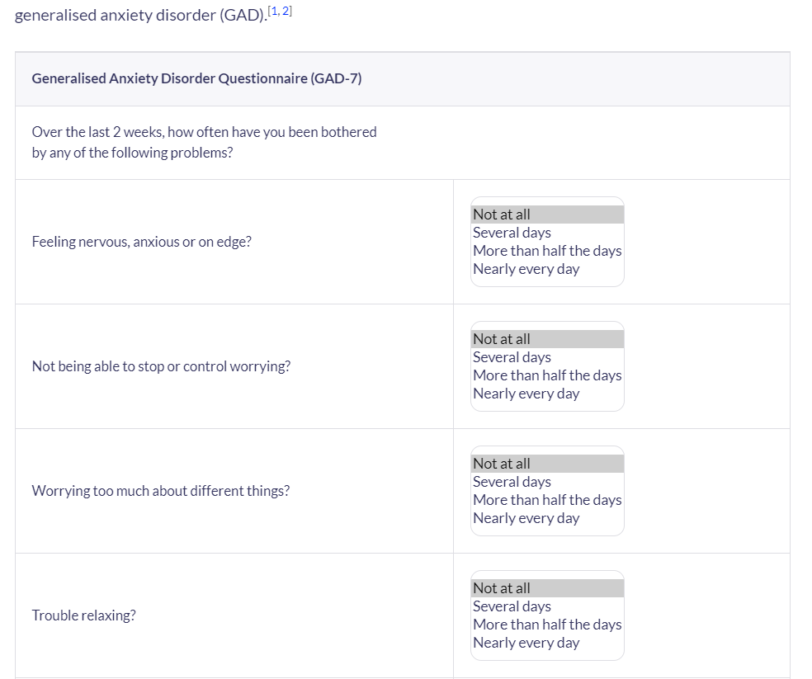
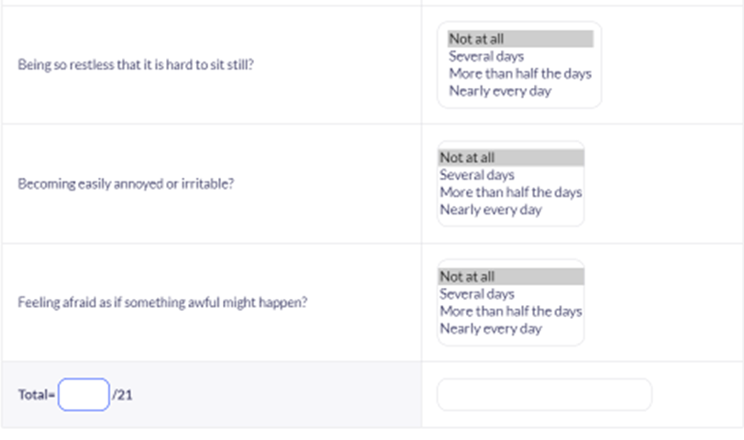

reference

