Professional Career Development in Health and Social Care (LCHS 4009)

ASSIGNMENT 2

Name of Student: NAZIA AZIMI

I.D. Number: 2511889

Name of Tutor: ODETTE JACK

Acknowledgement of AI use: I confirm that I have not presented any AI generated text as my own work. I acknowledge the use of Grammar.

Practical Portfolio

Introduction:

Professional profile: Compassionate, motivated and reliable Health and Social Care student with previous experience as a Care Assistant, providing practical and emotional support to clients while promoting their dignity, wellbeing and independence. Currently completing a Certificate of Higher Education Skills for the Workplace (Health & Social Care), with a strong interest in developing a career within healthcare.
Experienced in supporting personal care, assisting with food and drink, supporting medication-related care, maintaining accurate records and liaising with healthcare professionals. Additional professional experience in reception, community mobilisation, monitoring and evaluation has developed strong communication, organisation, teamwork, administration and attention-to-detail skills.
A confident communicator who speaks Dari, English and Urdu, with the ability to work respectfully with people from different backgrounds. Keen to contribute positively to a healthcare team and continue developing professional knowledge and practical skills within an NHS environment. i
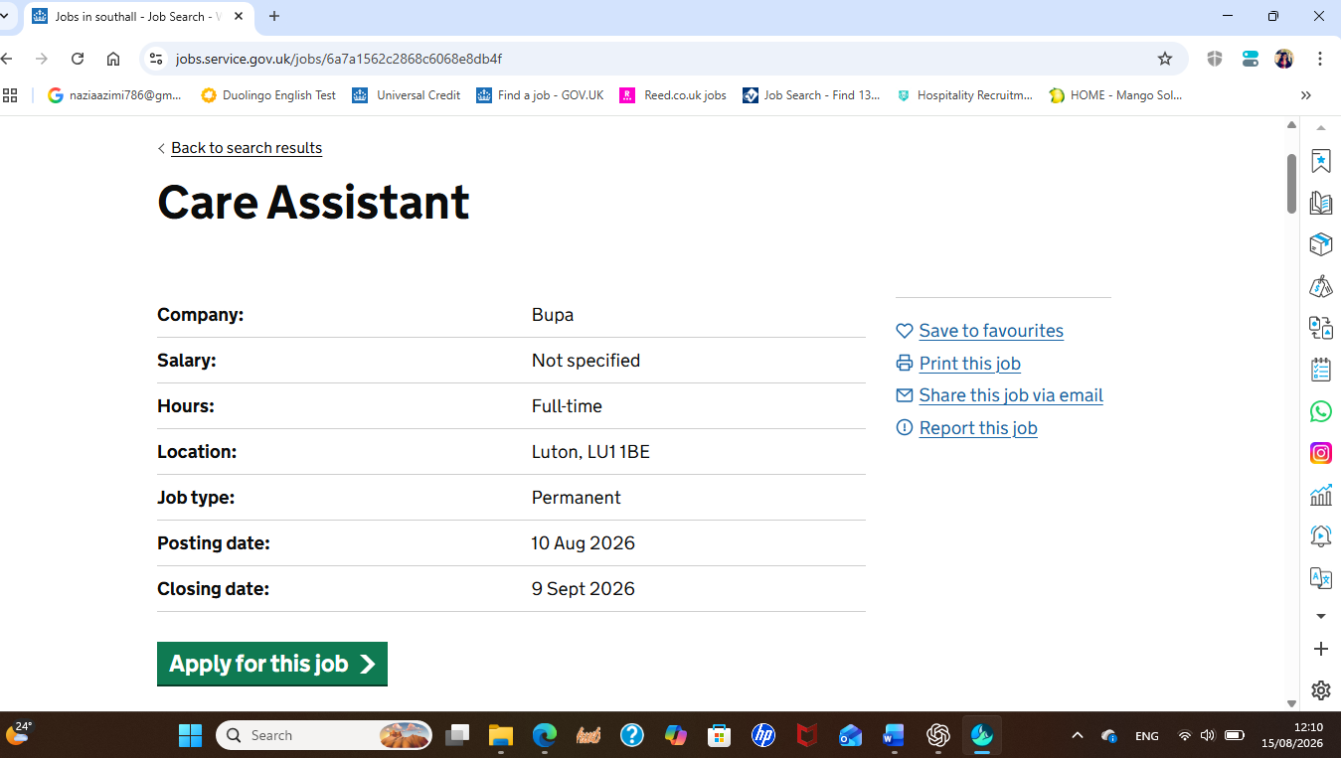
NHS Jobs

Professional CV (Task 1 of 4)

NAZIA AZIMI
Healthcare Assistant Candidate
UB3 4QX
07355 265909
naziaazimi786@gmail.com

KEY SKILLS
- Person-centred care and support
- Supporting clients' physical and emotional wellbeing
- Communication and interpersonal skills
- Teamwork and collaboration
- Respect, dignity and compassionate care
- Supporting personal care needs
- Food and drink preparation and assistance
- Medication-related support and record keeping
- Maintaining accurate records
- Attention to detail
- Organisation and time management
- Microsoft 365 and Microsoft Outlook
- Liaising with healthcare professionals
- Problem solving and responsibility
- Multilingual communication: English, Dari and Urdu
- Professional and confidential handling of information

EDUCATION
Certificate of Higher Education Skills for the Workplace (Health & Social Care)
University of Wales Trinity Saint David, London
2025–2026
Master of Arts – International Studies
Symbiosis School of International Studies, Pune, India
2018–2020
BA English Literature
Balkh University, Afghanistan
2012–2015

HEALTHCARE EXPERIENCE

Care Assistant
March 2023 – December 2023
- Supported clients with personal care activities, including bathing and dressing, while maintaining dignity and respect.
- Assisted clients with the preparation, serving and consumption of food and drink.
- Supported medication-related care and liaised with healthcare professionals when required.
- Maintained records relating to treatment and care provided.
- Supported clients' physical and emotional wellbeing through respectful and compassionate interaction.
- Assisted with maintaining a clean, safe and comfortable environment.
- Responded to individual client needs and provided practical support in daily activities.
- Developed the ability to communicate appropriately with clients and professionals in a care environment.

ADDITIONAL PROFESSIONAL EXPERIENCE

Receptionist
April 2024 – September 2024
- Welcomed clients and visitors and directed them appropriately.
- Answered and routed telephone calls professionally.
- Managed and scheduled appointments for staff and clients.
- Prepared and distributed documents and correspondence.
- Maintained organised files and records.
- Coordinated office services and maintained an organised working environment.
- Assisted with basic bookkeeping and administrative tasks.
- Developed strong communication, organisation, confidentiality and customer-service skills.

Community Mobilizer – Organization of Human Welfare (OHW), Samangan, Afghanistan
July 2022 – September 2022
- Raised awareness among districts regarding programme activities.
- Established communication with district and village authorities.
- Supported the identification of project beneficiaries.
- Facilitated and supported community-level activities.
- Assessed the training needs of beneficiaries.
- Prepared reports and communicated progress to the Project Manager.
- Developed experience working respectfully with diverse communities.

CP Monitor – Afghanistan Social Improvement Organization (ASIO) / World Food Programme
February 2021 – April 2021
- Entered and maintained beneficiary data accurately.
- Participated in beneficiary verification activities.
- Reported project progress and challenges to the project supervisor.
- Provided information to beneficiaries during distribution activities.
- Developed strong skills in communication, data accuracy and reporting.
Afghan Human Rights Research and Advocacy Organization (AHRRA)
January 2015 – December 2016
- Monitored field activities against project plans.
- Supported development of monitoring tools, questionnaires and databases.
- Collected, entered and analysed data accurately.
- Prepared regular reports for management.
- Participated in project evaluations and quality assessments.
- Worked collaboratively with colleagues and stakeholders.
- Supported project coordination and implementation activities.

LANGUAGES
- Dari – fluent
- English – proficient
- Urdu – fluent

IT SKILLS
- Microsoft 365
- Microsoft Outlook
- Data entry and database management
- Document preparation and digital communication

INTERESTS AND HOBBIES
I have an interest in health and social care, personal development and learning new professional skills. I also enjoy activities that allow me to communicate and work with people from different backgrounds.

REFERENCES
Available on request.
Personal Statement (task 2 of 4)
I am a motivated and compassionate Health and Social Care student with previous experience as a Care Assistant and a strong interest in developing my career within the healthcare sector. I am currently completing a Certificate of Higher Education Skills for the Workplace (Health & Social Care) level 4 at the University of Wales Trinity Saint David in London. I am applying for the care Assistant Outpatients role because I want to build on my previous care experience, develop my practical healthcare skills and contribute positively to the delivery of safe, respectful and person-centred care.
My previous experience as a Care Assistant provided me with valuable practical experience of supporting individuals with their daily needs. My responsibilities included assisting clients with bathing and dressing, preparing and supporting the consumption of food and drink, supporting medication-related care, maintaining treatment records and promoting clients' physical and emotional wellbeing. This experience taught me the importance of treating every individual with dignity, respect and compassion. It also helped me understand the importance of listening carefully to people's needs and providing support in a professional and responsible manner.i
My current Health and Social Care studies are further developing my understanding of healthcare practice and professional responsibilities. My academic background also includes a master’s degree in international studies (International Relations)and a BA in English Literature, which have strengthened my research, communication, analytical and written skills. I am keen to apply my academic knowledge in a practical healthcare environment and continue learning from experienced healthcare professionals.
I consider communication, teamwork, organisation and attention to detail to be some of my main strengths. Through my previous roles, I have communicated with clients, colleagues, community members and professionals from different backgrounds. I speak English, Dari and Urdu, which enables me to communicate with a wider range of people and can help individuals feel more comfortable and understood. My receptionist experience also strengthened my ability to manage appointments, maintain accurate records, communicate professionally and handle information appropriately.
I am a reliable and adaptable person who understands the importance of working as part of a team. My previous community and monitoring roles required me to collect accurate information, prepare reports, communicate with different stakeholders and complete responsibilities within required timescales. These experiences have strengthened my ability to remain organised, pay attention to detail and take responsibility for the quality of my work.
My main career aim is to develop a long-term career in health and social care and progressively increase my knowledge, confidence and practical abilities. I would value the opportunity to work within an outpatient healthcare environment because it would allow me to develop professionally while contributing to patients' experiences and wellbeing. I am committed to learning, accepting constructive feedback and maintaining high professional standards. I believe my previous care experience, current health and social care education, communication skills and compassionate approach would enable me to make a positive contribution to the healthcare team. i

SWOT analysis ( task 3 of 4)

The following SWOT analysis evaluates my current position in relation to my career goal of working as a care Assistant in the health and social care sector. It considers my existing skills and experience, areas that I need to develop, opportunities available to me and potential challenges that may affect my career progression.
Strengths:
Previously I have worked as a Care Assistant, supporting clients with personal care, food and drink, medication-related support, record keeping and emotional wellbeing. Health and Social Care education: I am currently completing a Certificate of Higher Education Skills for the Workplace (Health & Social Care) which is directly relevant to my career goal. Communication skills: I speak English, Dari and Urdu and have experience communicating with people from different backgrounds. Teamwork and collaboration: My previous care, community and professional roles required me to work with colleagues, beneficiaries and other professionals. Organisation and attention to detail: My previous roles involved maintaining records, entering data, preparing reports and managing appointments.i
Weaknesses:
Limited recent healthcare experience: My Care Assistant experience was in 2023, so I need to refresh and further develop my practical healthcare knowledge. Developing confidence in professional situations: Although I communicate well, I need to continue developing my confidence in healthcare environments, particularly when communicating with professionals and patients. Presentation skills: My Component 1 presentation went well, but I identified eye contact as an area that I can improve. Need for further clinical development: I need to continue developing my understanding of healthcare procedures, patient safety and other practical skills relevant to the Healthcare Assistant role. Limited NHS experience: I have experience in care but have not yet developed substantial experience working within an NHS setting. i

Opportunities:
NHS employment: A Healthcare Assistant position would provide an opportunity to develop practical experience within a professional healthcare environment. Further education and training: My current Health and Social Care studies can be supported by additional relevant training and professional development. Career progression: Healthcare Assistant experience could provide a foundation for further progression within health and social care. Use of multilingual skills: English, Dari and Urdu can help me communicate effectively with people from different cultural and linguistic backgrounds. Feedback and supervision: Working with experienced healthcare professionals would allow me to learn from others and identify areas for improvement. i

Threats:
Competition for healthcare roles: Healthcare Assistant vacancies can attract applicants with recent NHS or clinical experience. Changes in healthcare requirements: Healthcare practice and expectations can change, requiring continuous learning and adaptation. Balancing study, work and development: Managing academic responsibilities alongside employment and professional development may be challenging. Confidence and unfamiliar situations: Entering a new healthcare environment may initially be challenging and require me to adapt quickly. Maintaining professional standards: Healthcare work involves significant responsibility, including confidentiality, safeguarding, infection prevention and patient safety, requiring continuous attention and development. Ii

Personal Development Plan (PDP):

iMy Personal Development Plan focuses on three key areas: healthcare knowledge and practical skills, professional communication and confidence, and career development. The goals are designed to be achievable over the next two years and will support my preparation for and progression within a Healthcare Assistant role. I aim to have developed substantial relevant experience, improved my professional confidence and established a clearer long-term career direction. I will review my achievements against the original PDP goals and identify further qualifications, training or career opportunities. I will monitor my development through academic results, training certificates, workplace feedback, supervision, performance reviews, job applications and personal reflection. I will review the plan at least every three months and make adjustments when circumstances or career opportunities change. This approach will help me remain responsible for my own professional development while ensuring that my goals remain realistic and relevant to my progression within health and social care.

Reflection (Gibbs model Task 4 of 4)

Reflective practice is an important skill in health and social care because it allows professionals to consider their experiences, identify strengths and weaknesses, and use learning to improve future practice. Gibbs' Reflective Cycle provides a structured approach through six stages: description, feelings, evaluation, analysis, conclusion and action plan. I have used this model to critically reflect on my Component 1 presentation assessment, in which I prepared and delivered a PowerPoint presentation about the skill of reflection.

Before presenting, I experienced some nervousness because speaking in front of a class can create pressure to perform well. However, as I progressed through the presentation, I became more comfortable and focused on explaining my topic. I felt positive when I realised that I was able to continue speaking and complete the presentation within approximately eight minutes. After finishing, I felt satisfied because, from my perspective, the presentation had gone very well. One positive aspect of my presentation was time management. I was able to explain my topic within approximately eight minutes without allowing the presentation to become excessively long. i
However, effective presentation is not only about communicating information. It also involves engaging with the audience through verbal and non-verbal communication. Eye contact is an important aspect of professional communication because it can demonstrate confidence, attentiveness and engagement. This is particularly relevant to my future career in health and social care . Overall, my Component 1 presentation was a positive learning experience. I successfully prepared and delivered. The experience also showed me that preparation, organisation and time management are important strengths that I can use in future academic and professional situations.
However, I have identified eye contact as an area that requires further development. I also recognise that while notes can provide useful support, becoming less dependent on them could improve my confidence and engagement with an audience. This is particularly important because effective communication will be essential to my future work in health and social care.i

Reference list
CIPD (2026) How to use the Profession Map for your personal development. Available at: https://www.cipd.org/uk/the-people-profession/the-profession-map/how-it-works/for-myself/.
CIPD (2026) Performance management. Available at: https://www.cipd.org/uk/knowledge/factsheets/performance-factsheet/.
Gibbs, G. (1988) Learning by Doing: A Guide to Teaching and Learning Methods. Oxford: Further Education Unit, Oxford Polytechnic.
NHS Health Careers (2024) Health and social care roles. Available at: https://www.healthcareers.nhs.uk/.
University Hospitals of Derby and Burton NHS Foundation Trust (2025) Healthcare Assistant Outpatients. NHS Jobs. Available at: Healthcare Assistant – Outpatients vacancy.
NHS England (2026) Mental health personalised care framework: the modern care programme approach. Available at: NHS England.
NHS England (2026) Personalised care and support planning. Available at: NHS England. i

