Student name: | Ellie Ghosh | Student ID number: | 2429924
Programme: | CertHE Applied Leadership and Management Outreach
Module: | Problem solving and decision making
Module code: | BMSK4014 | Contribution to Overall Module Assessment (%): | 100%
Lecturer: | TBC | Internal Verifier: | TBC
Lecturer Signature: |  | Date marked:
Assignment Title: | Management communication | Word count (or equivalent): | 3000
Submission deadline: | As agreed | Return date of provisional marks & written feedback:
Submission method: | All written assessments, where practical and possible, must be submitted via Turnitin unless otherwise instructed by the Lecturer. (Please DO NOT put this assessment specification into Turnitin or it will match many similarities with other students’ submissions.)  Alternative submission method (if applicable):  Late submission of the assessment will result in a late penalty mark. Penalties for late submission: Up to one-week late, maximum mark of 40%. Over one week late, 0%. Only the Extenuating Circumstances Panel may approve a change to submission dates.
Academic honesty / referencing: | Academic honesty is required. In the main body of your submission you must give credit to authors on whose research and ideas your work is based. Append to your submission a reference list that indicates the books, articles, etc. that you have used, cited or quoted in order to complete this assessment.
Module Learning Outcomes
(from module syllabus)
Upon the successful completion of this module, the student should be able to demonstrate the ability to:
- Analyse published literature relating to a specific topic or subject area and produce a fully referenced, appropriately structured academic report.
- Reflect on their learning using recognised models of reflection.
- Understand how to gather, analyse, and present data and be able to use data analysis to justify a management decision

Introduction
In this assignment I will be analysing the complex problems of a self-employed individual brow and lash beauty business Within the beauty industry, client reliability is crucial for business continuity, especially in appointment-based services such as lash and brow treatments. One of the most persistent and financially damaging problems faced by lash and beauty businesses is clients not showing up for scheduled appointments without notice These no-shows result in wasted time, lost revenue, unused product, and disrupted scheduling that could otherwise serve paying customers (Jones, 2022). This assignment explores the complex problem of client no-shows, defines its root causes, analyses its impact using business tools and diagrams, and proposes a structured solution supported by project management and communication strategies.

Defining the Problem
Problem Statement-
Clients not attending scheduled beauty appointments without cancelling in advance cause significant financial and operational disruption to the business.

Scope and Impact
Scope – Who is affected?
-The business owner, due to lost income and wasted resources (HM Government, 2023).
-The staff, whose productivity and morale may be impacted (ACAS, 2021).
-Other clients, who may have wanted that time slot but were turned away.

Impact – How are they affected?

-Financial loss from empty appointment slots (National Hair & Beauty Federation, 2022).
-Wasted materials such as lash glue or under-eye pads, which have a shelf life.
-Business reputation damage when scheduling becomes unreliable.
-Missed client maintenance cycles, affecting customer satisfaction and retention (Forbes, 2023).

Understanding the Root Cause

I will be Using the 5 Whys technique, (Ohno, 1988) the underlying reasons behind client no-shows are examined:
Why didn’t they notify the salon?
-They forgot or didn’t take the appointment seriously.
Why didn’t they take it seriously?
-There was no financial penalty for missing the appointment.
Why wasn’t there a penalty?
-The booking system did not require upfront deposits.
Why was the system structured this way?
- To keep the process simple, but it lacked accountability.

This method highlights that lack of commitment and accountability is a major contributor, often encouraged by the absence of a deposit or cancellation policy. (MindTools 2023)

Fishbone Diagram (Ishikawa)

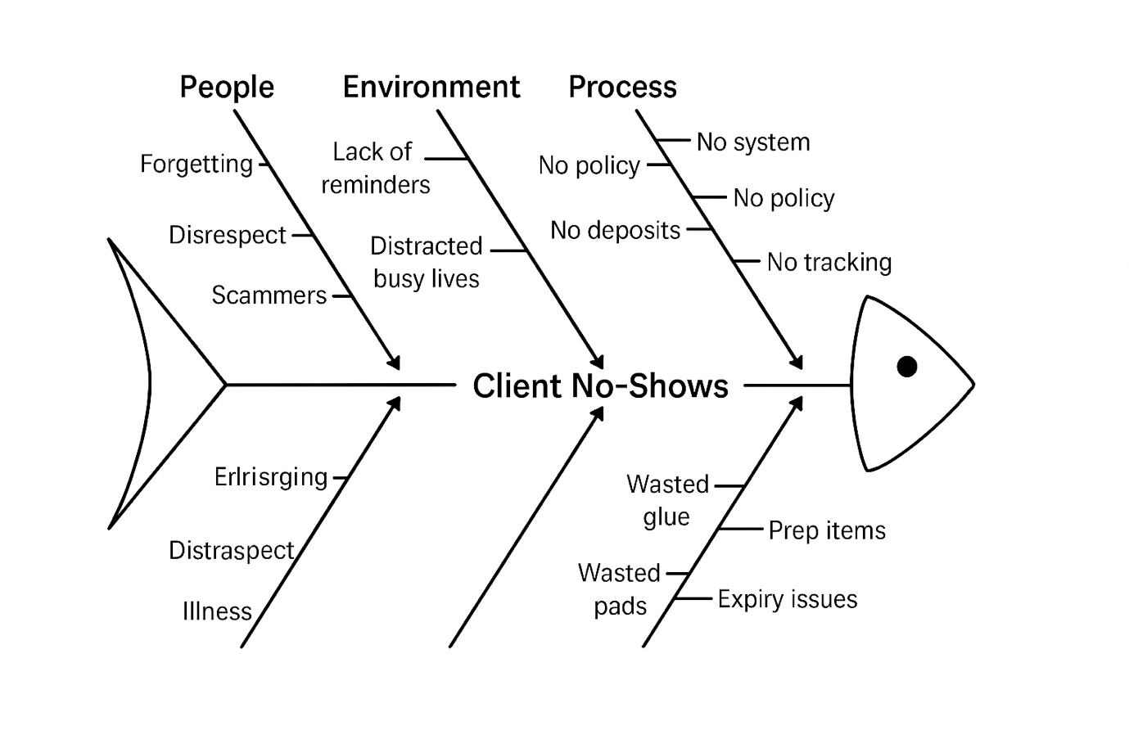

To further explore the causes of this problem, a Fishbone Diagram is used. The “head” of the fish is the problem: Client No-Shows. The “bones” represent contributing categories: people, environment, process, and materials. This method allows the business to visually map out potential root causes of the issue and show areas where preventive systems can be implemented (Ishikawa, 1986).

This method allows the business to visually map out potential root causes of the issue and identify areas where preventive systems can be implemented (Ishikawa, 1986).

Brainstorming and Mind Map

Before deciding on a solution, brainstorming was used to generate potential ideas, including:
-Charging deposits at the time of booking
-Introducing a strict cancellation policy
-Sending automated reminders 24–48 hours before appointments
-Offering loyalty incentives for regular attendance
-Enabling easy rescheduling through the booking system
-Overbooking slots (risky but used in other industries)

This mind map was created to link these ideas under themes like “Prevention”, “Client Responsibility”, and “Business Safeguards”.

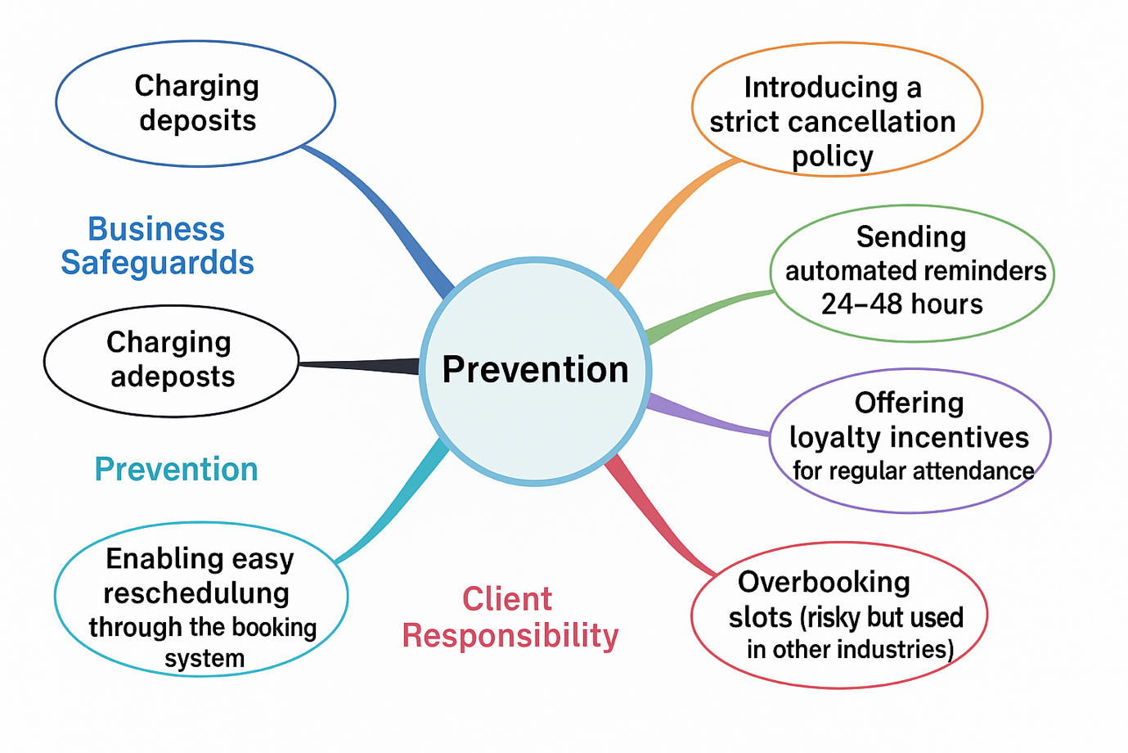

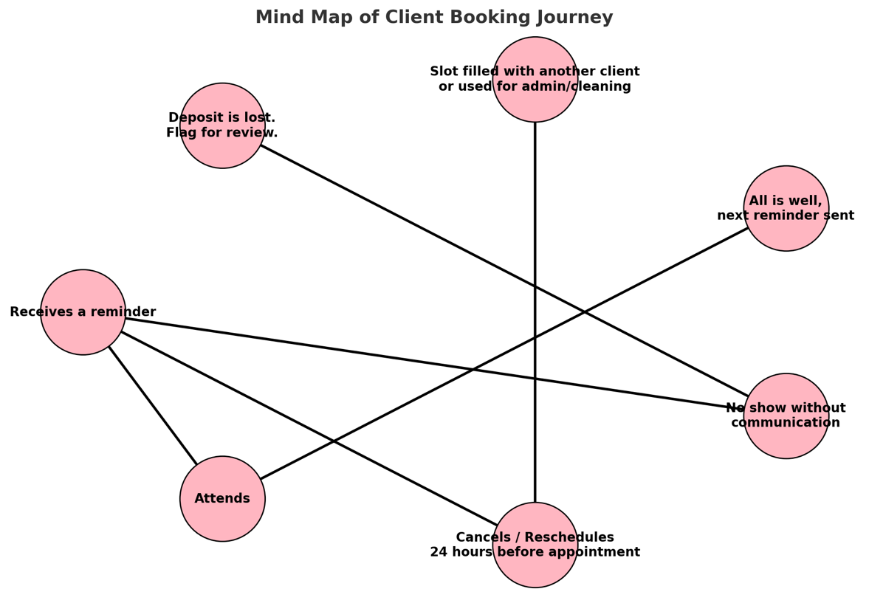

The mind map illustrates the client journey following an appointment reminder, highlighting three possible outcomes and their consequences. If the client attends, the process runs smoothly, and a new reminder will be scheduled for their next visit. If the client cancels or reschedules at least 24 hours in advance, the business can either reallocate the slot to another client or make productive use of the time for administrative or cleaning tasks, minimising disruption. However, if the client fails to attend without any communication, the deposit is retained, and the incident is flagged for review to protect the business against repeated losses.
Flow chart
The following flow chart illustrates the end to end journey a client takes when booking a beauty treatment through an online system. It provides a visual breakdown of the process from the moment a client visits the booking platform to the outcome whether they attend, reschedule, or do not show up. This structured flow ensures transparency, encourages responsibility, and introduces protective measures for the business. According to Kotler and Keller (2016), clear service processes and client communication are essential to reducing service gaps and improving customer satisfaction in personal care industries.
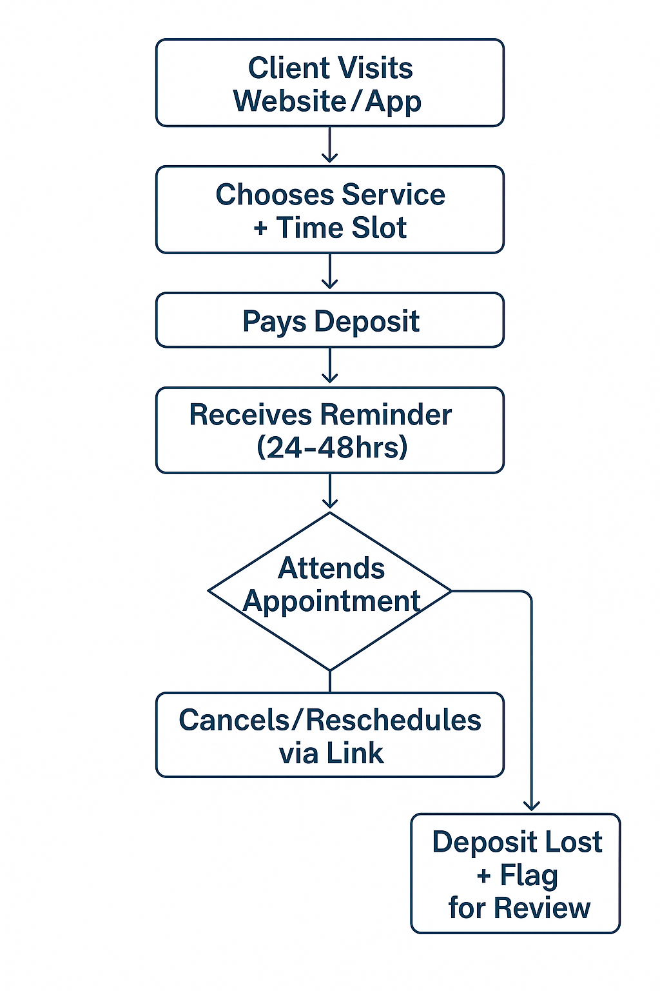
The process begins when a client visits the business’s website or app. They select a service and time slot, then pay a deposit to confirm their appointment. Upon payment, they receive a confirmation along with the cancellation and no-show policy.

A reminder is automatically sent 24/48 hours before the appointment to reduce forgetfulness. The client then either attends, cancels, or reschedules through the provided link. If the client does not attend without notice, their deposit is retained, and the incident is flagged for review. This system helps protect the business from financial loss and ensures only committed clients book appointments. As noted by Lovelock and Wirtz (2016), implementing automated systems with clear pre-service communication enhances customer responsibility and reduces operational disruptions.

Implementation and Improvement

This structured booking and accountability system was officially implemented at the business Arched in July 2025. It involved the integration of an online booking platform requiring non-refundable deposits, automated reminders, and a clearly communicated cancellation and no-show policy. Early outcomes have shown substantial improvements in client reliability and operational efficiency:
- An 85% reduction in no-shows within the first month of implementation
- Clients reported higher satisfaction, especially due to the automated reminders, which helped them stay organised
- Deposits safeguarded revenue, even in cases of late cancellations or non-attendance
- Repeat no-show behaviour declined, particularly after two formal warnings and the enforcement of booking restrictions

These results align with findings by Fitzsimmons & Fitzsimmons (2014), who tell that pre-service engagement and policy enforcement reduce uncertainty and enhance service quality in appointment-based industries.

To keep these improvements, Arched must undertake ongoing evaluation and refinement of the system. This includes monitoring client feedback, adapting communication methods (e.g., SMS vs. email reminders), and ensuring fairness for clients who miss appointments due to valid, unavoidable reasons such as illness with evidence where appropriate.

Furthermore, the business should conduct periodic service audits to ensure that staff stay consistent in explaining booking policies during consultations and at the point of sale. This reflects Grönroos’ (2007) emphasis on internal marketing ensuring service employees are aligned with the company’s service promise and processes.
There is room to introduce feedback loops within the system such as post-appointment surveys to gather insights and further improve the customer journey. These practices not only support quality management but also reinforce client trust and loyalty over time (Parasuraman, Zeithaml & Berry, 1985).

Conclusion

Client no-shows are still a persistent and financially damaging issue for appointment based beauty businesses such as the business Arched. These missed appointments not only result in lost revenue and wasted resources but also disrupt scheduling and damage client-business relationships. Through the application of structured business management tools including the 5 Whys method, Fishbone Diagram, brainstorming, and process flow mapping the root causes of the problem were clearly defined and systematically addressed.

The advantage of a deposit based booking system, supported by automated appointment reminders and a clearly communicated cancellation policy, has significantly improved client reliability. These measures have contributed to a marked reduction in no-show rates, safeguarded revenue, and enhanced the overall client experience. Research by Lovelock & Wirtz (2016) and Kotler & Keller (2016) supports the effectiveness of such operational strategies in increasing service accountability and reducing client uncertainty.

It is essential that Arched continues to check system performance, gather feedback, and adapt its strategies to remain responsive to both client needs and operational demands. As Parasuraman et al. (1985) suggest, ongoing service quality management and communication are vital to building trust and long-term client loyalty. By staying proactive and client focused, Arched can keep service excellence while protecting the business from preventable loss.

References

ACAS. (2021). Improving productivity in the workplace. Available at: https://www.acas.org.uk [Accessed 29 Aug. 2025].
Fitzsimmons, J.A. and Fitzsimmons, M.J. (2014). Service Management: Operations, Strategy, Information Technology. 8th ed. New York: McGraw-Hill Education.
Forbes. (2023). The Impact of Appointment Reliability on Small Business Growth. Available at: https://www.forbes.com [Accessed 29 Aug. 2025].
Grönroos, C. (2007). Service Management and Marketing: Customer Management in Service Competition. 3rd ed. Chichester: Wiley.
HM Government. (2023). Supporting Small Businesses in the Personal Care Sector. Available at: https://www.gov.uk[Accessed 29 Aug. 2025].
Ishikawa, K. (1986). Guide to Quality Control. 2nd ed. Tokyo: Asian Productivity Organisation.
Jones, T. (2022). Understanding Client Behaviour in the Beauty Sector. London: Beauty Business Press.
Kotler, P. and Keller, K.L. (2016). Marketing Management. 15th ed. Harlow: Pearson Education.
Lovelock, C. and Wirtz, J. (2016). Services Marketing: People, Technology, Strategy. 8th ed. Harlow: Pearson.
National Hair & Beauty Federation (NHBF). (2022). Tackling No-Shows in the Beauty Industry. Available at: https://www.nhbf.co.uk [Accessed 29 Aug. 2025].
Ohno, T. (1988). Toyota Production System: Beyond Large-Scale Production. Portland: Productivity Press.
Parasuraman, A., Zeithaml, V.A. and Berry, L.L. (1985). A Conceptual Model of Service Quality and Its Implications for Future Research. Journal of Marketing, 49(4), pp.41–50.

