Student: Ashley Williams
No: 2016511
4.0 Results chapter
4.1 Introduction
The objective of this section is to assess the findings from the questionnaire that was issued to South Wales police officers and members of the public who live in the same geographic area. This questionnaire was intended to take no more than 5-10 minutes to complete, although participants were informed that it may take longer if they wanted to elaborate on their responses. Over a three-week period, there were 100 replies from police officers and 106 from the public. To ensure that there was an equal number of replies to evaluate, the software used to collect the data intentionally eliminated six responses at random from the public. The questionnaire gathered information from police officers and the public on their opinions on the presence and usage of CEDs in modern policing and attempted to identify any potential negatives or benefits from their opinions.

4.2 Participants
For each group there were questions that related to gender and age bracket. A figure of 62% of the recorded police responses were male. If this figure is compared to the published figures which state as of 2022, males made up 64.5% of police constables in England and Wales (Clark, 2022) the figure is quite similar, implying a fair representation. However, the responses from the public were female dominant, with a response rate of 79% female. This may reflect in the results of the research. Participants age ranges were also requested with the majority of public responses received being between the ages of 35-44, with a figure of 33%. The majority of police responses were aged between 25-34, with a figure of 55%. Officers were also asked their length of service with the majority stating 2-5 years’ service, 51%. This suggests that over half of the police respondents are young in both age and service.

4.3 Presence of CEDs
A series of questions were asked regarding the presence of CEDs. The police respondents were asked if they were CED trained / carrying officers. To which the response showed 67% either carried CEDs or had done so previously. The public were asked if they believed that CEDs are becoming a more visual and standardised piece of police officer equipment as indicated by previous research. With a response of 31% selecting “strongly agree”, and 36% selecting “agree”. These figure show that as more officers are being equipped with CEDs the public are noticing and recognising them as a standardised piece of equipment. Although, 60% of police officers responded that they had been involved in an incident were a CED had been deployed, which would indicate that not all officers who carry CEDs are required to use them. Supporting this 79% of the public respondents stating that they had never witnessed a CED being deployed.
The public were also asked if the presence of an officer with a CED would affect officer approachability, with most responses showing that it would not.
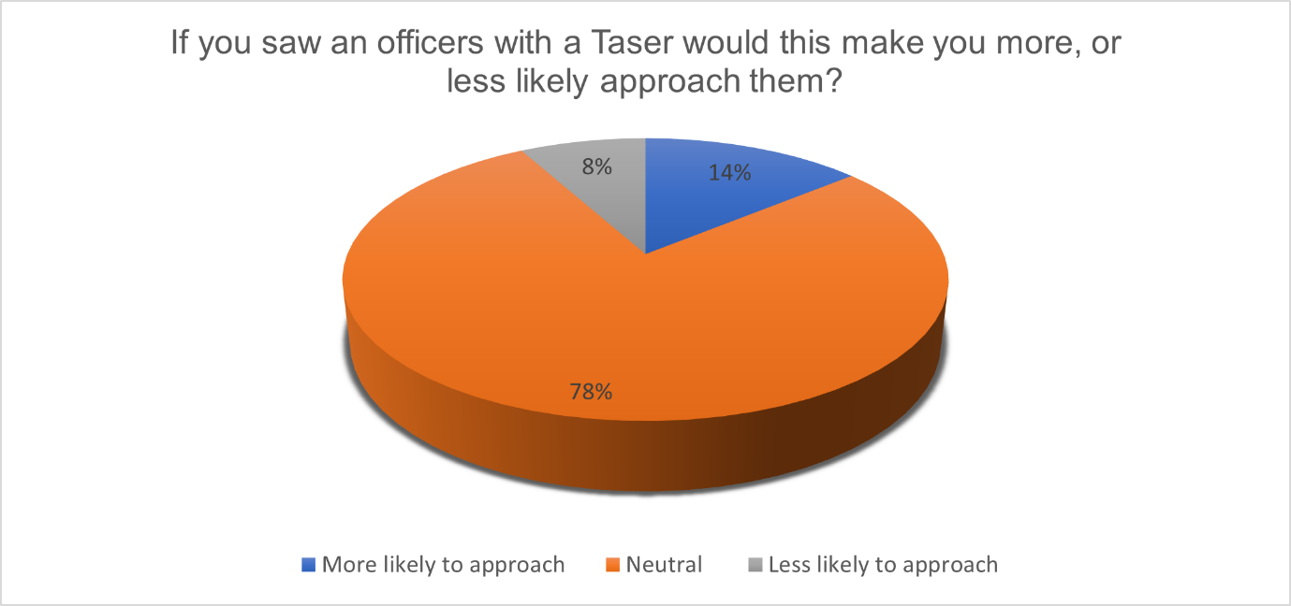
4.4 Opinion
Both groups of participants were asked a series of questions related to their personal opinion on the topic of officers carrying CEDs. One question being,
“Do you believe that all front-line police officers should be trained and issued with Taser?”
This question was presented with a yes/no/maybe response option, with the following question presenting the opportunity for the respondents to expand on their opinion in a free text format.
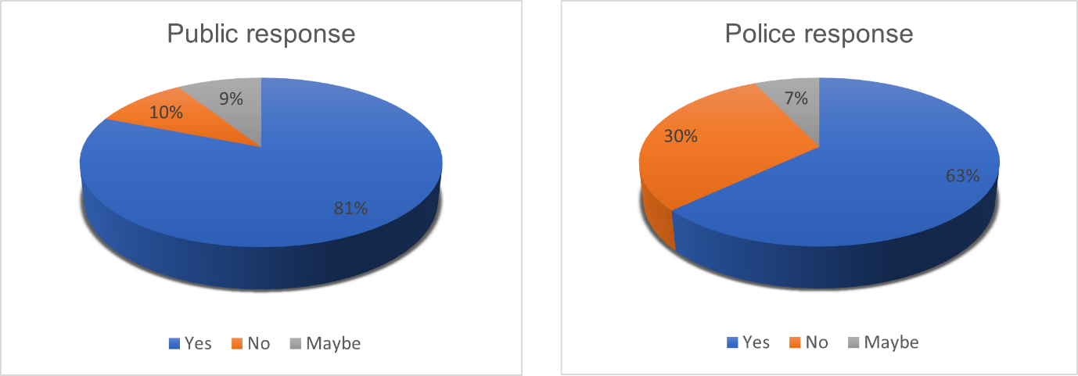
These results showed the police where less likely to support CEDs being equipped by all officers than the public. With comments from officers such as,
“New recruits should do a period of time without taser to enable them to speak with people and deal with conflict in other ways”, and,
“All front line should be trained but not all officers are tactical aware so Taser will not suit everyone”.
The public responses appeared to focus on the dangers officers face and expressed concern for officers’ safety with comments such as,
“I think it should be part of police training in order that all officers are able to deal with situations for their protection and of the public that might require the use of a taser”, and
“Police officers need protection as do victims. So tasers will provide peace of mind”.
The public participants were also asked if they have an overall positive or negative opinion, and officers were asked what they believe the public opinion is on them carrying CEDs, to which the responses were as follows.
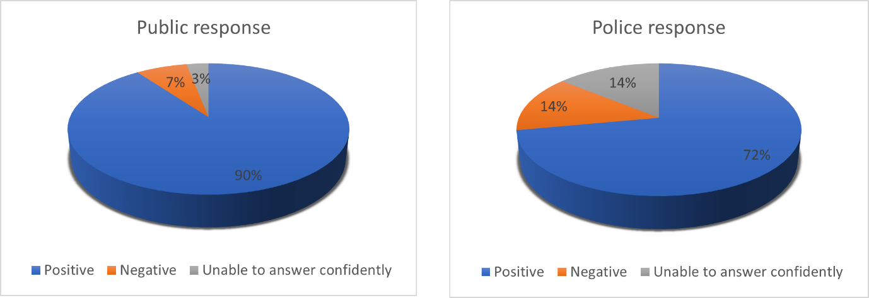
This shows that the public once again holds a more positive opinion than officers regarding CEDs.

4.5 Adequacy of CEDs in policing
Both groups of participants were asked if they believed that CEDs are an adequate piece of equipment in modern day and the possible threats to officers and the public. Which presented the following results,
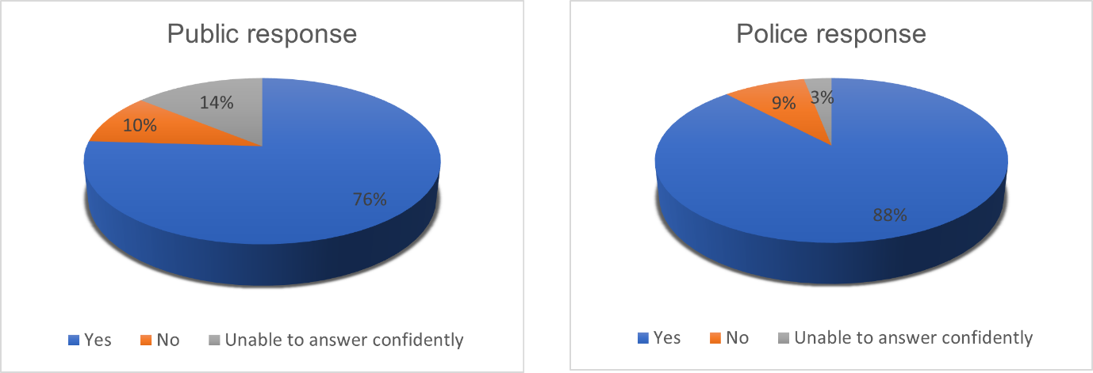
This showed that the majority of the results believed that CEDs were an adequate piece of equipment in modern day policing. These results where supported by an additional question which asked both groups if they believed that CEDs were a visual deterrent from crime. Results to this question shown below,
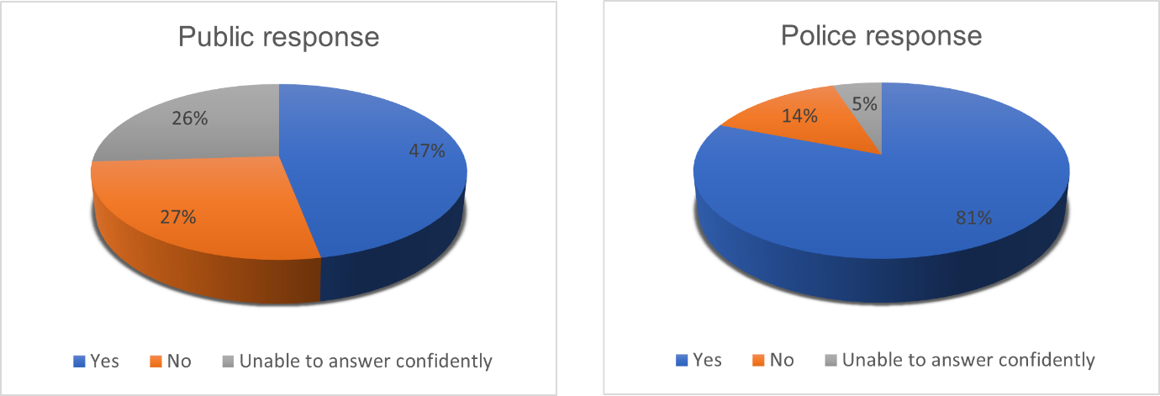

4.6 Previous research
Both groups of participants were also asked their opinion on previous research into officers being equipped with CEDs in attempts to obtain more up to date results and ascertain if these theories put forwards were still applicable. Participants were asked regarding previous research indicating that now more officers are equipped with CEDs this encourages offenders to carry weapons. Both groups answered similarly that they do not agree with this. As shown below,
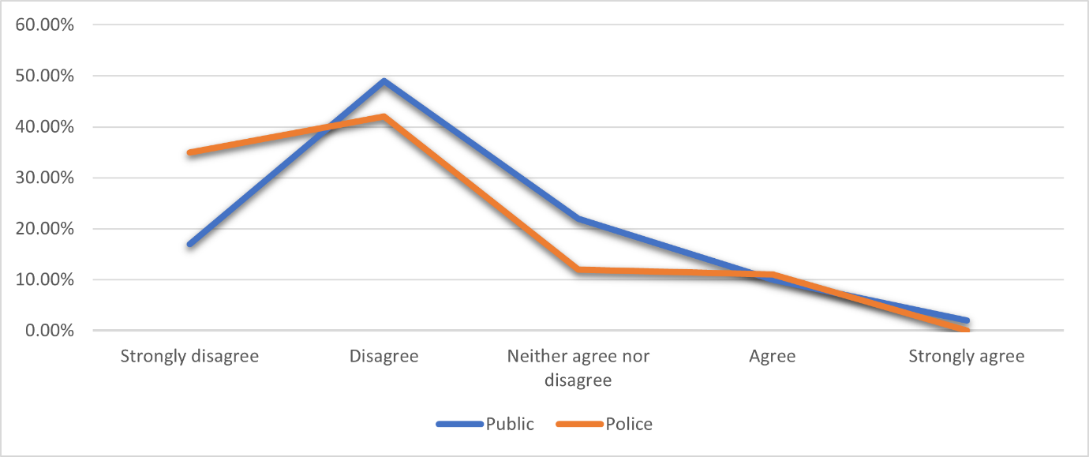
Participants also disagreed with the theory of the “weapon effect”, which states that the mere presence of a weapon, such as a CED, promotes violent behaviour. With both groups displaying results over 60% towards “strongly disagree”.
Police officers were asked an additional two specific questions related to previous research. One which indicates that offenders are becoming better equipped in defending themselves against the effects of CED. 52% of participants agreed that they believe this is true. Also, that a previous study showed that CED carrying officers used force 48% more frequent than officers not equipped with CEDs. 21% of respondents agreed with this. This could support the previous comments from officers who believe CED are not suitable for all officers.

When the replies to the questions are analysed and compared to past research, it is evident that the public is more supportive than previous data indicated. In regards to officers opinions, there is a possibility that past research was primarily unfavourable affecting the officers' viewpoint and outlook. However, this research has shown that points raised in previous research is not the main opinion. It must also be considered, combined with the fact that the public's responses were collectively more mature than the officers' responses, and the large proportion of officers being within their first 5 years of service, leads to the conclusion that younger officers who are younger in service made up the greatest proportion of respondents, and thus the data may not be a true representation of the workforce.
(1163 words)

Additional reference that will be added to bibliography
Clark, D., 2022. Statista. [Online]
Available at: As of 2022, men made up 64.5 percent of police constables in England and Wales.
[Accessed 19 4 2023].

