1600944 EAEE5002/C
Element 2
Brief description of the activity
The class spilt into three groups and each group will have a material in a tray in front of them. They will use these to draw different letters in while reading the rhyme e.g. M for Maisy mountain, mountain. Considering that these children have additional learning needs.
Aim/Objective of the activity
The aim of the activity is for the children to get involved in messy play which will also interlink with a read write inc lesson. Each group will have one tray each, one tray will include runny custard, another tray will include shaving gel and another tray will include flour. The children will be practicing their read write inc abilities and skills by writing different letters into their materials and by saying the rhyme while writing them. Taking into consideration that these children have additional learning needs, so the abilities will vary for each child. It will also help with their independent skills as for most children they would usually either copy write or over write in any types of written work but can’t do this in this type of activity. It will be effective when it comes to their written work in the future as it will be interesting to see if they can remember how to write letters/words without copying or over writing.
Your role
My role will be to assist one of the groups by either reading them a letter, making the sound of a letter, saying the rhyme or showing them an image of the letter for them to write in their material. These all depend upon the ability of the children in each group. I will be there to assist the children if they need any help. The other staff members of the class will also be doing the same role as me in the other two groups.
Positive aspects – why?
The positive aspects of this activity are that children are able to get messy and have fun and engaged while doing work. Involving messy play within the activity will distract the children from thinking that they’re doing work and learning at the same time. Also, messy play develops a child’s fine motor skills by touching and feeling the varied materials. Some of the children will love the feeling of the different materials and will enhance their creative minds. This activity also improves their read write inc skills by improving to write letters by saying the sounds and rhymes and identifying the differences between letters and their rhymes.
Challenging aspects – why?
The challenging part about this activity is that, due to the fact the children have additional learning needs, most of their differences and abilities are huge which makes it difficult to do any class activity based upon the whole class. Some of the children find it difficult to sit at the table for more than a few seconds, some of them find it difficult to engage within an activity and would rather do their own thing and get upset over the fact that they should be sat at the table doing work. But more specifically with this activity, some of the children find it difficult to identify different letters but also find it difficult to write these letters without additional help from a teacher. I felt like that not all the children were engaged due to the messy materials and it distracted them from the activity. Also, some of the children got upset and frustrated over the messy materials as some of them don’t like the feel of them or don’t like to get messy.
What knowledge was demonstrated?
I feel like the knowledge that I demonstrated was knowing each individual child’s additional needs and acting upon them, one factor being through communication, e.g. some children are non-vocal so need communication devices or will use sign language to communicate so I would need to communicate with them differently than to a child who is vocally able. I also know what to do and how to act if a child starts to have a behaviour and how to handle it, I’d say I handle it well as I’ve seen the children have a behaviour many of times in the past and I know how to act upon it and how to engage them again into the activity.
What skills were demonstrated?
I feel that the skills that I demonstrated is having to know sign language will communicating with the non-vocal children which helps a lot when trying to communicate with them. Another skill demonstrated is that I’ve seen many read, write, ink sessions in the past so I think I’ve took a lot of the teaching skills on board and demonstrated them in this activity, e.g. I have learnt each rhyme of the letters.
Which values were demonstrated?
When the children didn’t get the work quite right, I demonstrated encouragement and positivity, so they wouldn’t feel bad that they didn’t get it correct. The way I react to the children’s work is important, as some children always rely on the teacher’s reaction on how well they completed their work. If I didn’t use these values, then the children may lose determination to do their work and may feel upset over the fact that they didn’t get it quite right. I also praised the children when they were doing well which hopefully made them feeI motivated. I also displayed my relationship with each individual child. I think any child will feel more comfortable working with you if they’ve developed a relationship with you which means they will feel more relaxed, feel like they can ask questions, not feel uncomfortable around you etc.
What could have been done differently? Why?
If I was going to do this activity again then I would have not used messy materials for all of groups and I would have set different kind of materials for one group, e.g. a small white board and pen for each child. The fact that not all the children liked the messy play, I thought it made it unfair for those children as they couldn’t get the same experience of the activity as the other children. Next time I would make sure I set the activity which all the children would feel comfortable doing and would not get distracted by the materials being used.
The next stage of this activity, if progress is seen, is to start sound-blending by blending the letter-sounds. This will improve a child’s spelling while doing written work and reading while reading books in class etc.

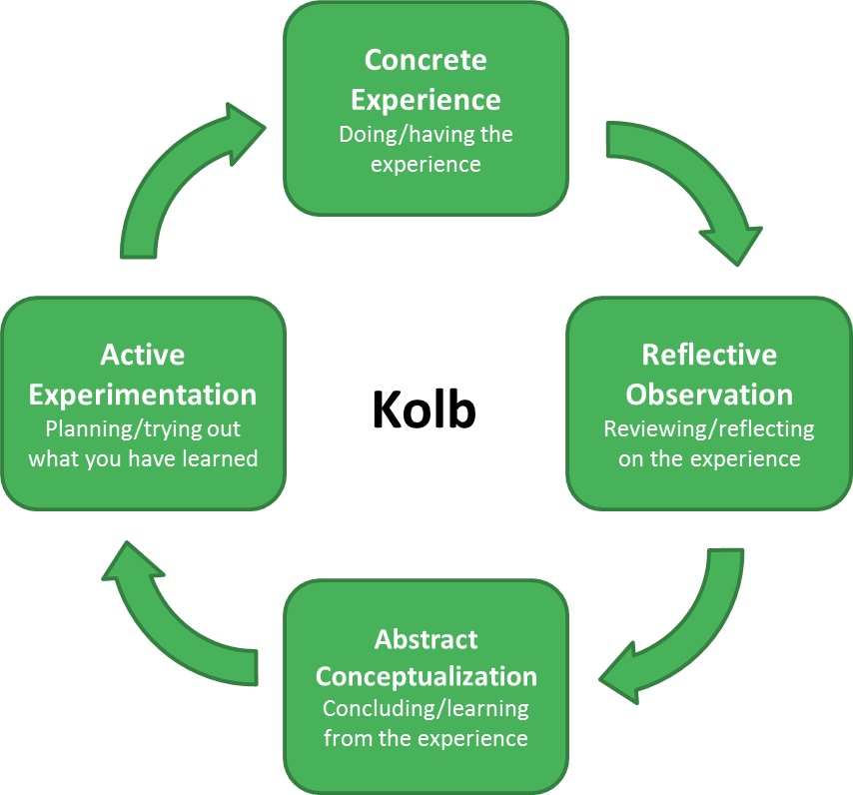
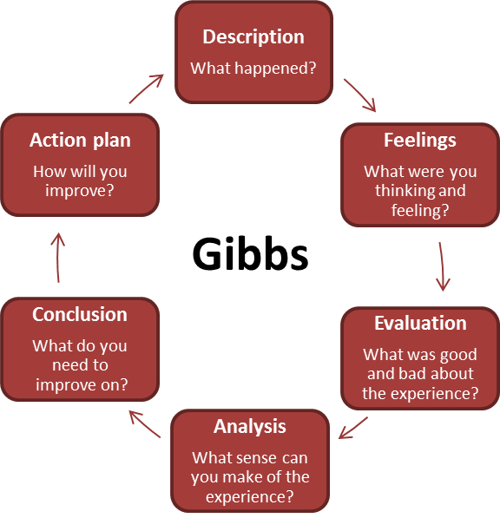
David Kolb’s model of reflection
Similarly, to Gibbs’ model, Kolb’s model is also set out as a cycle. The cycle is split into four stages which is concrete experiences which is actually doing it, reflection observation which is reflecting on the experience, abstract conceptualisation which is learning from the experience and active experimentation which is putting what you learned into actions. Kolb’s model reflects on experiences from every day and how they’ve made an impact on a person’s life and also compares that to their educational research to help improve (Cambridge-community.org.uk, n.d.). Kolb’s model suggests that a concrete experience can be followed by a process of reflective observation, and subsequently of abstract conceptualizations. Active experimentation is then used to text out the newly developed principle (Reflective Practice, 2013).
Graham Gibbs’ model of reflection
Gibbs’ model is a way of improving your work and used to continue learning through a reflective cycle when considering the phases of an activity for considerations for future events. The distinct phases being description, feelings, evaluation, analysis, conclusion and action plan. The model helps you to reflect one the activity/experience is complete/ Gibbs’ model is the one of any models that consider a practitioner’s feelings and emotions which play a part in a particular event. To split this model up into two sections, the first half is more aimed at what actually happened and the second half is concentrating how the practitioner can improve the situation (Cambridge-community.org.uk, n.d.).
Benefits of reflective practice for a practitioner:
• Increases learning
• Develops abilities to solve problems
• Promotes self-analysis, e.g. recognising your strengths and areas that need improvement
• Recognising educational needs
• Developing new knowledge and skills
• Learn through challenging situations
(SkillsYouNeed, 2017)
Reflective practice in practice:
• Self-questioning
• Experimenting with new ideas
• Discussing with other colleagues
• Discussing with students
• Observations and feedback
(Cambridge-community.org.uk, n.d.)
What is reflective practice?
Reflective practice can be seen as a way of improving your work and used to continue learning through a reflective cycle when considering the phases of an activity (Zwozdiak-Myers, 2012). You can do this by looking back at your work or a certain activity and thinking about what went right, what went wrong, how and where could you improve, this can be done by any of the following models discussed in this briefing paper. To ensure that being a reflective practitioner will be effective is to be aware of your strengths and weakness’, think about how your actions impact children, think about the methods you have been using and how to resolve any problems (Early Years Careers, 2018). This is to ensure that children are provided with the best care possible.
According to BrightKnowledge.org (2018), they define reflective practice as being:

“A way of studying your own experiences to improve the way you work. It is very useful for health professionals who want to carry on learning throughout their lives.”
From a theorists point of view, Donald Schon (1930) defines reflective practice as being ‘the practice by which professionals become aware of their implicit knowledge base and learn from their experience’ (Gray’s Research Reading Group, 2012).

This briefing paper is aimed at early years practitioners about the importance of reflective practice as a means of maintaining quality services for young children.
REFLECTIVE PRACTICE
Element 4
Area for further development | Why? | How? | Who/Where? | When?
- Knowledge - First aid | It’s so important to know first aid, especially in a school setting as it gives the staff a sense of purpose to think that they could hopefully save someone’s life. | Go on a first aid course to gain knowledge based on first aid and safety. | Look online for any courses in my area or ask in my current placement to find out whether they know about any courses happening. | I could start looking for courses as soon as possible and hopefully start straight away as it’s such an important knowledge base to have whilst working in any setting.
- Knowledge -Knowing disorders, e.g. ADD/ADHD, Austism/Aspergers, Cystic Fibrosis etc. | I think working in a setting with children who have all these different disorders, it’s vital that you can recognise the children’s disorder and how to react to them. | Maybe further my own researching skills by reading any books based upon these disorders or read articles online. | Online resources or books. | I could start this research straight away.
- Skills – Sign language | Even though I have a rough idea of sign language, I think it’s an essential skill to have while working in a setting with children who are constantly using sign language because of the children who have trouble communicating vocally. | Go on a course to further my sign language skills which will help me in my placement. | Look online for any courses going on in my area or ask other staff in my setting to find out the route they went down to learn sign language. | I could start looking for courses as soon as possible and hopefully start one I have free time, e.g. weekends, school holidays when I won’t be in university, work or placement.
- Skills – Maths GCSE. | By re-doing my maths GCSE, I could potentially achieve getting a B grade which will help me get a step further into doing a PGCE. | Going to study skills to see if they could lead me in the right direction by looking for maths GCSE classes, looking for a tutor etc. | Going to the study skills located at my university and if I can find a tutor then ensure that they’re based more local to my home. | Start looking for tutors or classes as soon as possible and start revision and going to a tutor or class when I have free time, e.g. weekends and half terms.
- Values – Commitment | If I’m willing to stick to the knowledge and skill factors that I want to further my knowledge on by going to a tutor or going on courses then I need to ensure that I stay committed to all these as well as my assignments, placement and work. | It’s important that I don’t slack in placement, my assignments, placement or where I work when trying to gain more knowledge and experience with my chosen factors. | Maybe by going to study skills to see if they have any advice on how I can separate my time but still ensure that I do 100% effort into all of these. | As soon as possible.
- Values – positivity | While juggling a lot of things that need 100% effort, it can tend to get a lot for a person and bring a person down, so being positive ensures that I am able to put 100% effort into these things. | While thinking about the negatives of juggling a lot, also think about the positives and how all these things will be worth it in the end. Also make time for myself and don’t let it all pile on top of me, | I am the only person who can keep positive thoughts in my mind but speaking to my personal tutor, family and friends who care, they can all assure me that it will be worth it in the end. | Being positive needs to be consistent.

Reference list
Brightknowledge.org. (2018). What is reflective practice?. [online] Available at: https://www.brightknowledge.org/medicine-healthcare/what-is-reflective-practice [Accessed 20 Jan. 2018].
Cambridge-community.org.uk. (n.d.). Getting started with Reflective Practice. [online] Available at: https://www.cambridge-community.org.uk/professional-development/gswrp/index.html [Accessed 20 Jan. 2018].
Early Years Careers. (2018). Reflective Practice - Early Years Careers. [online] Available at: http://www.earlyyearscareers.com/eyc/latest-news/reflective-practice/ [Accessed 20 Jan. 2018].
Gray's Research Reading Group. (2012). The Reflective Practitioner by Donald Schon. [online] Available at: https://graysreadinggroup.wordpress.com/2012/12/18/the-reflective-practitioner-by-donald-schon/ [Accessed 15 Jan. 2018].
Reflective Practice. (2013). Reflective Practice, 14(6), p.ebi-ebi.
Schön, D. (1930). The reflective practitioner. Aldershot : Arena.
SkillsYouNeed. (2017). Reflective Practice. [online] Skillsyouneed.com. Available at: https://www.skillsyouneed.com/ps/reflective-practice.html [Accessed 20 Jan. 2018].
Zwozdiak-Myers, P. (2012). The teacher's reflective practice handbook. London: Routledge, p.3.

