3/24/2025
University of Wales Trinity Saint David
London campus
E-Portfolio Link:
Module Name: Learning In the Digital Era
Module Code: ACCA 4025

Student Name: Rajeep Maharjan
Student ID: 2538568
Group: 1

Lecturer’s Name: Koushik Modak

LDE Assignment 1
E-Portfolio
Table of Contents
Introduction 2
Main Body 2
Task 1: Essential Academic and Employment Skills for the future career Path 2
Task 1 (a): Report on Essential Academic and Employment Skills 2
Task 1 (b): Evaluation of Task 1 (a) based on Similarity report 4
Task 2: Collaborative Mind Map and Individual Poster 4
Mind Map (Collaborative) 4
Poster (Individual) 4
Task 3: Virtual Collaboration and RefWorks 4
Report on Virtual Collaboration 4
Step-by-step process of using RefWorks with visuals 4
Task 4: E-Portfolio Creation and Evaluation 4
Task 4 (a): E-Portfolio Creation 4
Task 4 (b): Illustrative Review of E-Portfolio tool Selection 4
Conclusion 4
References 4
Task 1 References: 4
Task 3 References: 4

Introduction

Main Body

Task 1: Essential Academic and Employment Skills for the future career Path

Task 1 (a): Report on Essential Academic and Employment Skills

To succeed in software development, you need both technical skills and abilities you pick up during your studies. Key skills like programming, algorithmic thinking, version control, and testing are the basics every developer needs [1]. Employers now look for decision-making and communication skills too, since programmers often work in teams and have to explain their choices to people who are not technical [1]. Soft skills like adaptability, self-management, and a willingness to keep learning are also important because technology changes so quickly that no single course can cover everything [2]. Studies from work-based software engineering programs show that communication, focus, and flexibility are best learned by facing real challenges at work, not just in the classroom [3].
For my own career, building these skills while I study, like time management, doing research and referencing, and working on practical projects will help me get ready for work after I graduate. Good communication will help me work well in agile teams and explain technical choices to colleagues who are not technical. Being able to solve problems and adapt will make it easier for me to learn new tools and programming languages [4]. Having strong technical skills along with these employability skills, as shown in Figures 1 and 2, gives graduates a good start in software development and helps them move up after graduation with a stronger base for a career in software development and are more likely to move beyond junior roles after they finish their studies.

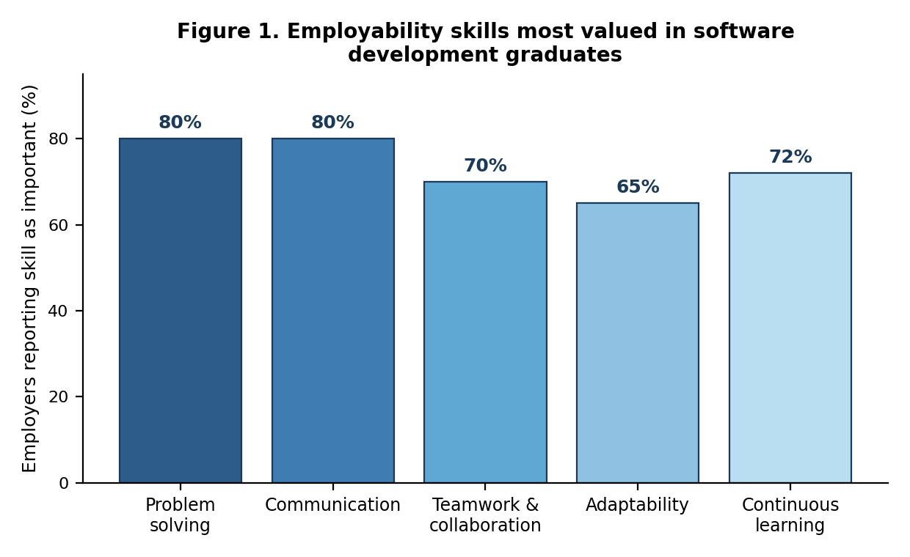
Figure 1:Employability skills most valued in software development graduates. Source: adapted from [1].
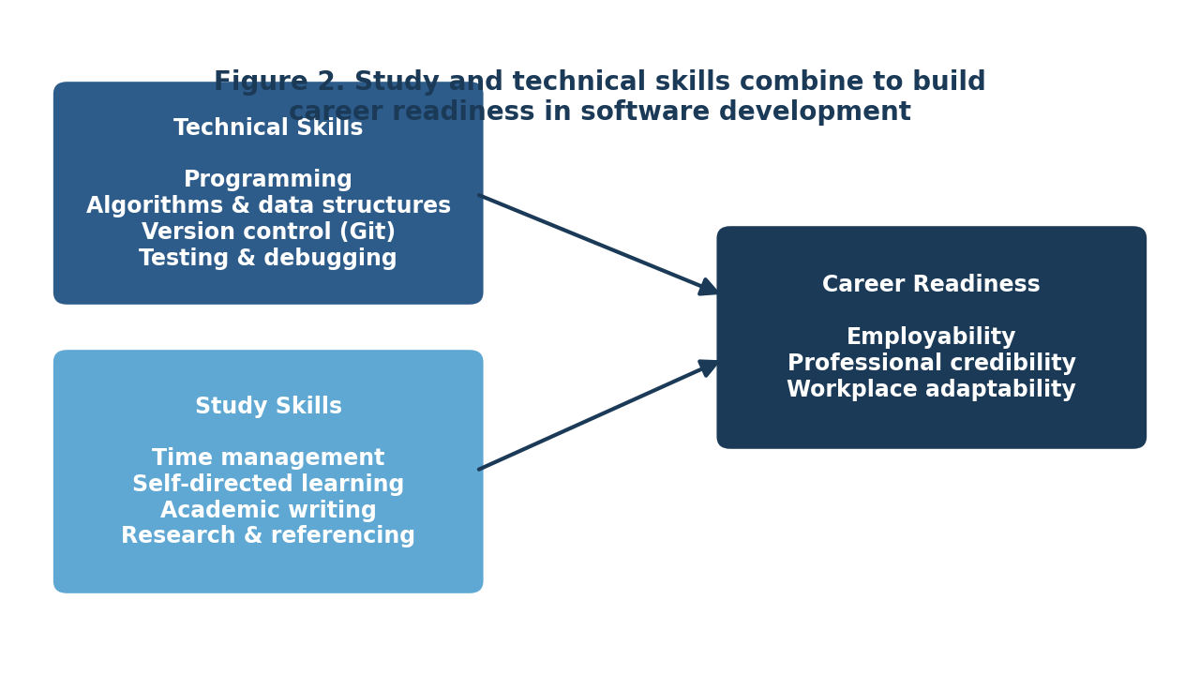
Figure 2:Study and technical skills combine to build career readiness. Source: author's own diagram
.

References

[1] | “2026 Most Valuable Skills You Build in a Software Development Degree and Which Career Use Them The Most,” Research.com, 2026. [Online]. Available: : https://research.com/advice/most-valuable-skills-you-build-in-a-software-development-degree-which-careers-use-them-most. [Accessed 21 July 2026].
[2] | J. Sonmez, Soft Skills: The Software Developer's Life Manual, Shelter Island, NY, USA: Manning Publications, 2015.
[3] | M. Barr and S. Nabi, “"The Development of Students' Employability Skills on a Work-Based Software Engineering Degree Programme," in 2022 IEEE Frontiers in Education Conf. (FIE),” no. 10.1109/FIE56618.2022.9962611, pp. 1-9, 2022.
[4] | ChatGPT, “Essential Software Development Skills,” 2026.

