The Proposed Housing Development
Brecon Park
Swansea
SA1
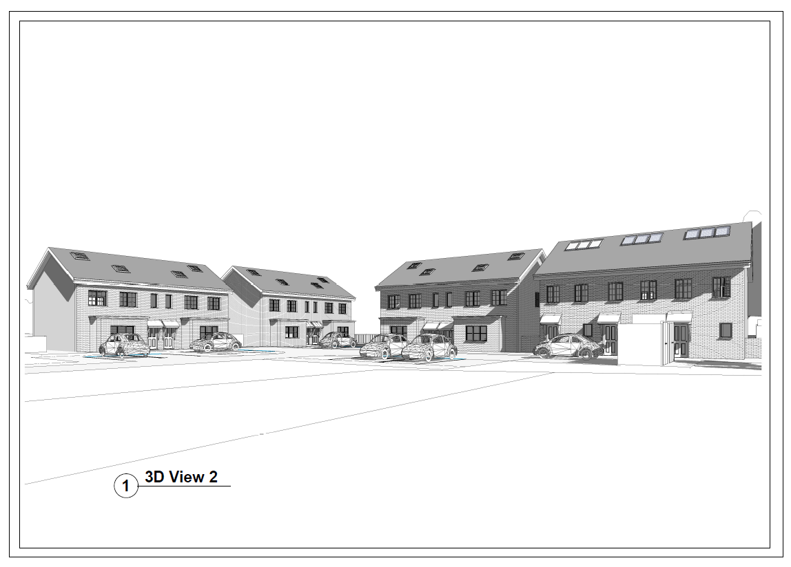

Student – Melanie Wright
University number - p144061
Course Title – Building Surveying
Module – Cost Studies
Date of report publication – 1st February 2019
Submitted to – N Tobin

Contents
Page
- Introduction 3

- Aim of the report 4

- Assumptions to be made 4

- Approximate Estimate for the proposed Housing Development 4
  - Schedule of accommodation
  - Approximate cost estimate

- Elemental Cost Plans for the proposed Housing Development 6

- Summary 8

- References 9
  - Books
  - Websites

- Appendix 10
1 - Breakdown of approximate estimate for semi-detached houses
2 - BCIS data for semi-detached houses
3 – Breakdown of approximate estimate for terrace houses
4 – BCIS data for terrace houses
5 – Breakdown of elemental cost plan for whole development

- Introduction
In this report a cost planning exercise is undertaken for a proposed housing development: Brecon Park, Swansea, SA1.
According to Ashworth and Perera (2015) cost estimates are required at an early stage of any project development to enable the client to ascertain the affordability of the proposed project and then to structure and set a comprehensive budget. This would then allow for any necessary early adaptations to be made before extensive works are carried out and/ or to secure extra funding if required.

RICS provides a set of documents under the New Rules of Measurement (NRM) in context with the RIBA Plan of Work and the OGC Gateway Process. NRM1 is the standard set of rules for the Order of Cost Estimating and Cost Planning for Capital Building Works.
There are three main methods of producing a detailed estimate (CIOB, 2009) and all three will be utilised in this report:
- Functional Unit Method
- Superficial (floor area) Method – Ground Floor Internal Area (GFIA)
- Elemental Cost Plan

According to CIOB (2009) all three methods rely on historical cost data. Some of this data is sourced through the BCIS website which allows access to a database for all building costs in the UK, on comparable builds. These cost often reflect the London market and may be somewhat out of date. To adjust these costs they need to be rebased to reflect an accurate area of the UK and a more accurate date of the proposed construction. Pricing also relies on data being acquired through pricing books such as SPON’S or BCIS. These are renewed annually but become out of date very quickly.
NRM1 (2013 p.22) defines the functional unit method as “a rough budget-setting technique which consists of selecting a suitable standard functional unit of use for the project, and multiplying the projected number of units by an appropriate cost per functional unit”. The unit cost is calculated by according to the buildings function and multiplied that by the population unit for the building.
NRM1 (2013 p. 22) defines the GIFA as “the area of a building measured to the internal face of the perimeter walls at each floor level”. The unit cost is calculated by multiplying the area of each floor per m² by the cost per m².
NRM1 (2013 p. 21) defined the elemental method as “a budget setting technique which considers the major elements of a building and provides an order of cost estimate based on an elemental breakdown of a building project”. The Elemental method is a more detailed method and individually breaks down the costs for all the elements of the build.

- Aim of the report
Working as a Chartered Surveyor I have been appointed by Knight Gardens Housing Development to produce an approximate estimate and an elemental cost plan for the prospective housing development, based on the drawings provided by the designer BAM Architect Ltd.
The proposed housing development site is based in Brecon Park, Swansea, SA1 and will house a total of 9 residential properties. Six 3 bedroom semi-detached houses and three 2 bedroom terraces houses.

- Assumptions to be made
The plans do not give any house measurements or details of the plot so the following assumptions have been made:
- According to DWH (2018) the average floor size for a three bed semi-detached is 315m² and for a two bed terrace 210m².
- The houses are all two storeys high (although the semi-detached has a room in the attic space) and according to Stanton Homes (2018) the average height of a two storey ceiling is 5.5 meters.
- The properties are all traditional brick built construction.
- Each property will have two parking spaces and gardens.
- The houses will be finished to a good standard and be equipped with fully fitted bathrooms and kitchens.
- The location of the site is known and is available for works to commence immediately.
- It is a brownfield site of around 4500m² that has been cleared of any previous building works.
- Comprehensive site investigations have been carried out. No indications of contamination have been found so no costings for remedial work has been added into the calculations.
- No site conditions have been identified but it will require hard and soft landscaping.
- No site constraints or initial risks have been identified.
- A two year timescale has been allowed for the build.

- Approximate Estimate for the proposed Brecon Park Housing Development

According to CIOB (2009) the objective of an approximate estimate is to produce a probable cost calculation for a proposed project. It is a rough approximation of the various quantities of materials and associated expenses that are likely to be incurred and is only as accurate as the information supplied.

  - Schedule of accommodation

Taken from the drawings supplied by BAM Architects Ltd.

Floors | Kitchen | Dining room  Sitting room  Bedroom  Study | Cloakroom  Bathroom | Door ext | Door int | Light | Sockets
3 bed | Semi’s
Ground | 1 | 2 | 1 | 2 | 3 | 6 | 10
1st floor |  | 3 | 1 shower  1 bath |  | 5 | 6 | 8
2nd floor |  | 1 | 1 bath |  | 2  (1 fire) | 2 | 2
Sub-total | 1 | 6 | 4 | 2 | 10 | 14 | 20
Total for all 6 | 6 | 36 | 24 | 12 | 60  (6 fire) | 84 | 120
2 bed | Terrace
Ground | 1 | 1 | 1 | 2 | 2 | 4 | 6
1st |  | 2 | 1 bath |  | 3 | 3 | 4
Sub-total | 1 | 3 | 2 | 2 | 5 | 7 | 10
Total for all 3 | 3 | 9 | 6 | 6 | 15 | 21 | 30
Total for all 9 houses | 9 | 45 | 30 | 18 | 75  (6 fire doors) | 105 | 150

4.2 Approximate Estimate Costs

Using the GIFA method of estimating on the floor sizes identified in the assumptions ie 315m² for a semi-detached and 210m² for a terrace the following calculations have been made.

All the following figures have been sourced from BCIS (2018) from properties similar to the ones in the proposal, a three bedroom semi-detached and a two bedroom terrace. These figures have been debased to reflect the prices in Wales and to reflect the current date of Quarter 3 in 2018.
- For a breakdown of the approximate estimate total costs for the semi-detached houses see Appendix 1.
- For the BCIS data used to calculate the approximate estimate for the three bedroom semi-detached houses see Appendix 2.
- For a breakdown of the approximate estimate total costs for the terrace houses see Appendix 3.
- For the BCIS data used to calculate the approximate estimate for the two bedroom terrace houses see Appendix 4.

Unit type | GIFA m² | Cost/m² | Unit cost | Total cost
Semi-detached  House (3 bed) | 315m² | £1,769 | £557,235
Sub-total for all 6 semi-detached | 1890m² |  |  | £3,343,410
Terrace house (2 bed) | 210 m² | £1,161 | £243,810
Sub total for all 3 terraces | 630m² |  |  | £731,430
Totals for all 9 properties | 2520m² |  |  | £4,074,840

5. Elemental Cost Plans for the proposed Brecon Park Housing Development

The objective of an elemental cost plan is to produce detailed costings broken down into a series of elements. The cost can be conveyed as the total cost, the cost/m² GIFA or the elemental unit rate. The total GIFA for all 9 properties is 2520m².

The works are broken down into the following list of elements. Sourced from Ashworth and Perera (2015, p.143) with the addition of numbers 11-14 sourced from NRM1 (2013 p.78).
- Facilitating works
- Sub-structure
- Super-structure
- Internal finishes
- Fitting, furnishings and equipment
- Services
- Prefabricated buildings and building units
- Work to existing buildings
- External works
- Main contractors preliminaries
- Main contractors overheads and profits
- Project/design team fees
- Other development/project costs
- Risks
- Inflation

The following costs in the spreadsheet have been taken from SPON’S (2019). With the exception of the bathroom fittings (Victoria Plum, 2018) and the internal doors (Howdens, 2018). The method used is either GIFA or functional unit. The total GIFA for all 9 properties is 2520m².
Overheads & Profits – the price range is SPON’S is a difference of 20% from lowest to highest figure. This report has allowed for a percentage of 24% to incorporate any fluctuation in price and cover the overheads such as site maintenance and salaries.
Design fees - are not included in these costs as the plans have already been done.
Other costs – to cover any planning fees, insurances and marketing costs.
Risks – this contingency figure is to cover all non-predicted construction risks such as poor site conditions. It also covers employer risks such as time changes or earlier than anticipated handover.
Inflation - for 2019 is predicted to stand at 2.17% according to Statista (2018), so this figure has been used in the calculations.

 | Element | GIFA  m² | GIFA price//m² | Unit | Price/unit | Sub-total | Total
1 | Sub-structure | 2520 | £155 |  |  | £390,600 | £390,600
2 | Super-structure – upper floor, roof, ext walls, windows & int partitions | 2520 | £645 |  |  | £1,625,400 | £1,650,744
 | Stairs |  |  | 9 | £1000 | £9,000
 | External doors |  |  | 18 | £440 | £7,920
 | Internal doors - softwood |  |  | 69 | £110 | £7,590
 | Internal fire doors - softwood (2nd floor) |  |  | 6 | £139 | £834
3 | Internal finishes | 2520 | £35.80 |  |  | £90,216 | £90,216
4 | Fittings – 3 bed kitchen |  |  | 6 | £3,800 | £22,800 | £43,020
 | 2 bed kitchen |  |  | 3 | £2,275 | £6,825
 | w.c & whb |  |  | 30 | £299 | £8,970
 | Baths |  |  | 15 | £295 | £4,425
5 | Services w.c & whb |  |  | 30 | £945 | £28,350 | £197,127
 | Baths |  |  | 15 | £340 | £5,100
 | Kitchen sink |  |  | 9 | £380 | £3,420
 | Showers |  |  | 3 | £249 | £747
 | Water installation | 2520 | £53 |  |  | £133,560
 | Electrical inst. - lights |  |  | 105 | £60 | £6,300
 | Consumer units |  |  | 9 | £350 | £3,150
 | Sockets |  |  | 150 | £110 | £16,500
8 | External works – roads, soft landscaping, fencing, drainage | 1980 | £167.15 |  |  | £330,957 | £379,767
 | Manholes |  |  | 18 units | £460 | £8,280
 | Road signs |  |  | 12 | £130 | £1,560
 | Services |  |  | 9 units | £4,330 | £38,970
9 | Main contractors prelims – office, toilets, signs, kitchen & power |  |  | 104 weeks | £286 | £29,744 | £73,304
 | Temporary works - road | 1980 | £22 |  |  | £43,560
 | Sub total |  |  |  |  |  | £2,824,778.00
10 | Overheads & profit |  |  |  |  | 24% | £677,946.72
12 | Other costs |  |  |  |  | 4% | £112,991.12
13 | Risks |  |  |  |  | 5% | £141,238.90
14 | Inflation |  |  |  |  | 2.17% | £61,297.68
 | Total cost of build |  |  |  |  |  | £3,818,252.42

- Summary
The Approximate Estimate method has been calculated using the GIFA method. The total costings for the whole development have come in at £4,074,840.
The Elemental Cost Plan method has been calculated using GIFA and Functional Unit method. The total costing for the whole development has come in at £3,818,252.42.
The second method is the most accurate and is the lowest calculation. This is beneficial for the client because the development will cost less than initially estimated for, so the budget will have much more scope and flexibility.

- References
7.1 Books
Aecom (2019). Spon’s Architect and Builders Price Book 2019. 144th edition. Oxon: CRC Press
Ashworth. A., and Perera. S. (2015). Cost Studies of Buildings. 6th Edition. Oxon: Routledge.
CIOB (2009). Code of Estimating Practice. 7th Edition. Oxford: Wiley-Blackwell
RICS (2018). BCIS Comprehensive Building Price Book - Major Works. 35th edition. Poole: BCIS
RICS (2013). NRM1 RICS New Rules of Measurement NRM 1: Order of cost estimating and cost planning for capital building works. 2nd Edition. Coventry: RICS

7.2 Websites
BCIS (2018). Analyses. [online] Available at
<https://service.bcis.co.uk/BCISOnlinelogin> [Accessed 30 November 2018].
DWH (2018). Average House Sizes in UK. [online] Available at <https://www.dwh.co.uk/library/Average-UK-house-sizes/> [Accessed 29 November 2018].
Howdens (2018). Internal Doors. [online] Available at <https://www.howdens.com/doors/internal/softwood-doors> [Accessed 30 December 2018].
Stanton Homes (2018). Is There a Standard Ceiling Height for New Homes? [online] Available at <https://stantonhomes.com/2018/01/23/is-there-a-standard-ceiling-height-for-new-homes/> [Accessed 29 November 2018].
Statista (2018). UK Inflation Rate. [online] Available at <https://www.statista.com/statistics/270384/inflation-rate-in-the-united-kingdom/> [Accessed 4 January 2019].
Victoria Plum (2018). Bathrooms. [online] Available at <https://victoriaplum.com/> [Accessed 30 December 2018].

- Appendix
Appendix 1 - breakdown of the Approximate Estimate total costs for the six semi-detached houses
Appendix 2 – the BCIS data used to calculate the approximate estimate for the three bedroom semi-detached houses
Appendix 3 - breakdown of the Approximate Estimate total costs for the three terrace houses
Appendix 4 - the BCIS data used to calculate the approximate estimate for the two bedroom terrace houses
Appendix 5 – breakdown of the Elemental Cost Plan for the whole proposed development

Appendix 1
Figures sourced from BCIS (2018) and based on a “3 bedroom semi-detached house” see appendix 2. The GIFA used for the following calculations is 315m²
 | Unit or Type | Cost / m² | Unit cost
1 | Substructure | £165 | £51,975
2A | Frame | 0 | 0
2B | Upper floors | £55 | £17,325
2C | Roof | £124 | £39,060
2D | Stairs | £20 | £6,300
2E | External walls | £218 | £68,670
2F | External windows & doors | £137 | £43,155
2G | Internal partitions | £45 | £14,175
2H | Internal doors | £58 | £18,270
2 | Superstructure | £657 | £206,955
3A | Wall finishes | £72 | £22,680
3B | Floor finishes | £73 | £22,995
3C | Ceiling finishes | £27 | £8,505
3 | Finishes | £172 | £54,180
4 | Fittings & fixtures | £33 | £10.395
5A | Sanitary appliances | £12 | £3,780
5B | Services equipment | 0 | £0
5C | Disposal installations | 0 | £0
5D | Water installations | £24 | £7,560
5E | Heat source | 0 | £0
5F | Space heating & air con | 0 | £0
5G | Ventilation systems | 0 | £0
5H | Electrical installation | £75 | £23,625
5I | Fuel installation | 0 | £0
5J | Lift & conveyor installations | 0 | £0
5K | Fire & lighting protection | 0 | £0
5L | Communication & security | 0 | £0
5M | Specialist installation | 0 | £0
5N | Builders work in connection | 0 | £0
5O | Management of commissioning | 0 | £0
5 | Services | £111 | £34,965
 | Building sub total | £1,138 | £358,470
6A | Site works | £121 | £38,115
6B | Drainage | £48 | £15,120
6C | External services | £56 | £17,640
6D | Minor building works | 0 | £0
6E | Demolition | 0 | £0
6 | External works | £225 | £70,875
7 | Preliminaries | £253 | £79,695
8 | Contingencies | £153 | £48,195
 | Total | £1,769 | £557,236
9 | Design fees | 0 | £0
 | Total contract sum |  | £557,236

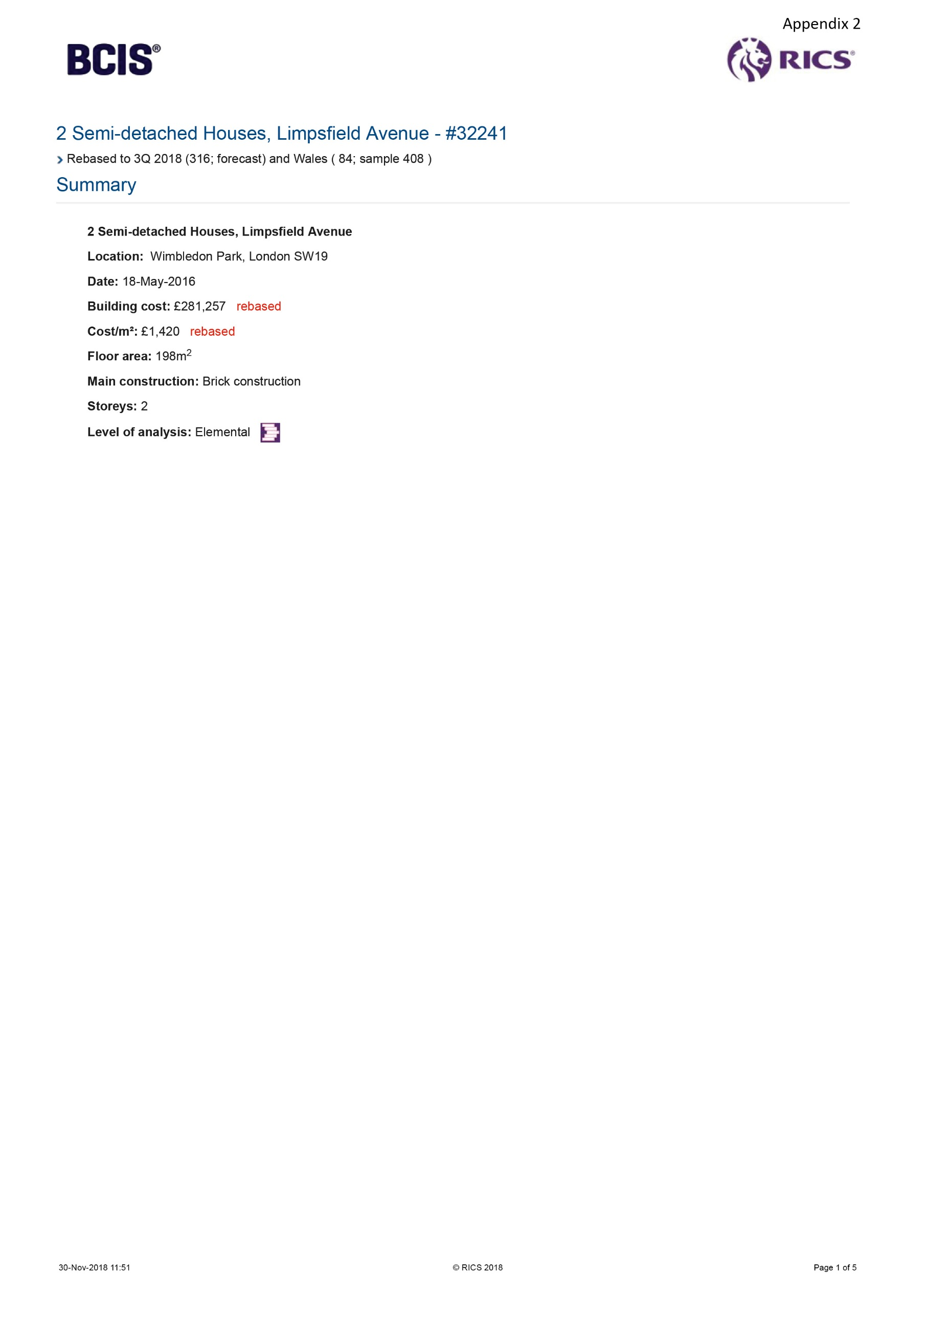
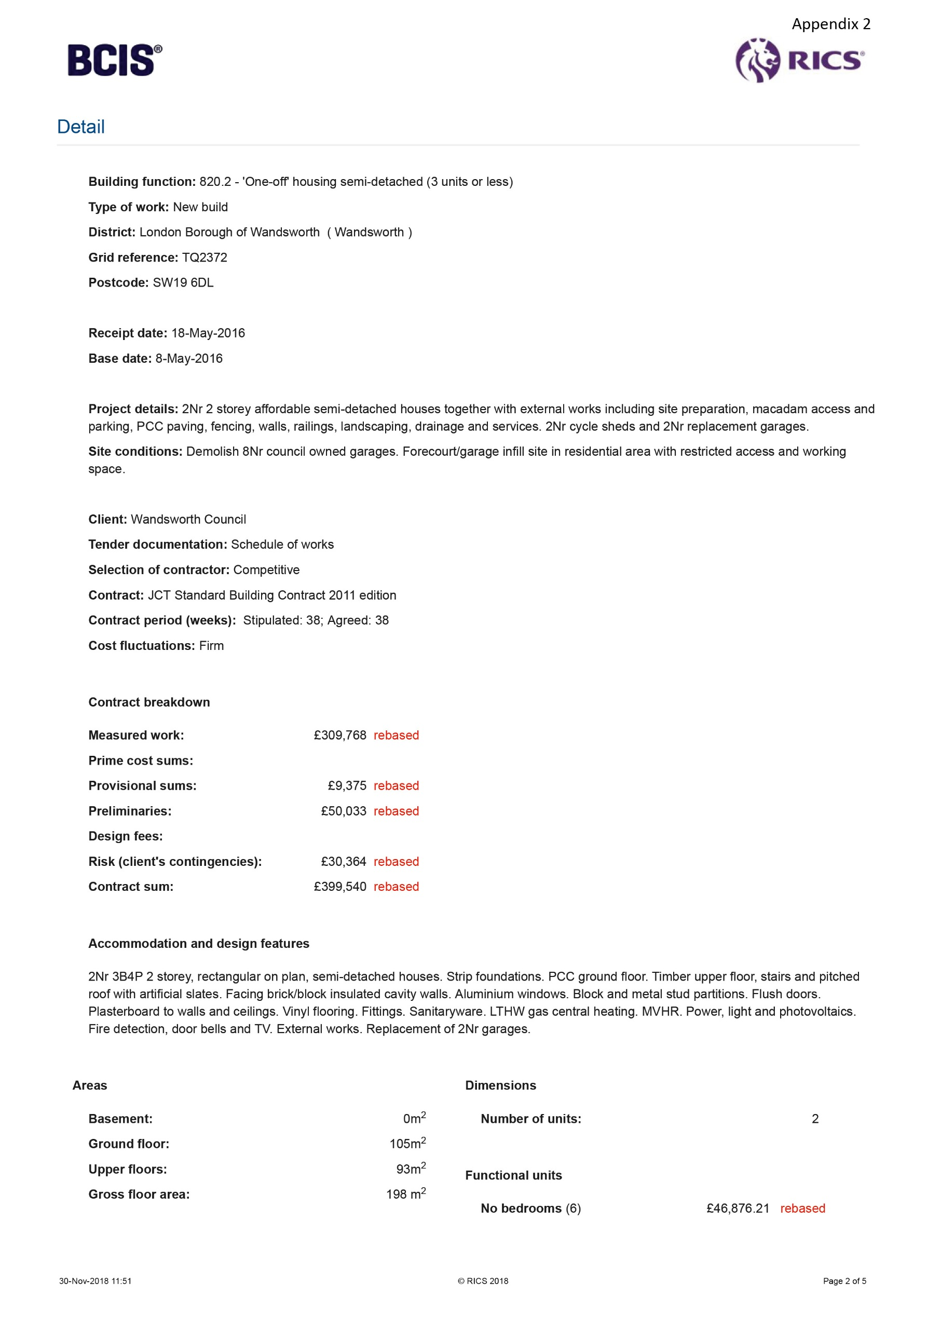
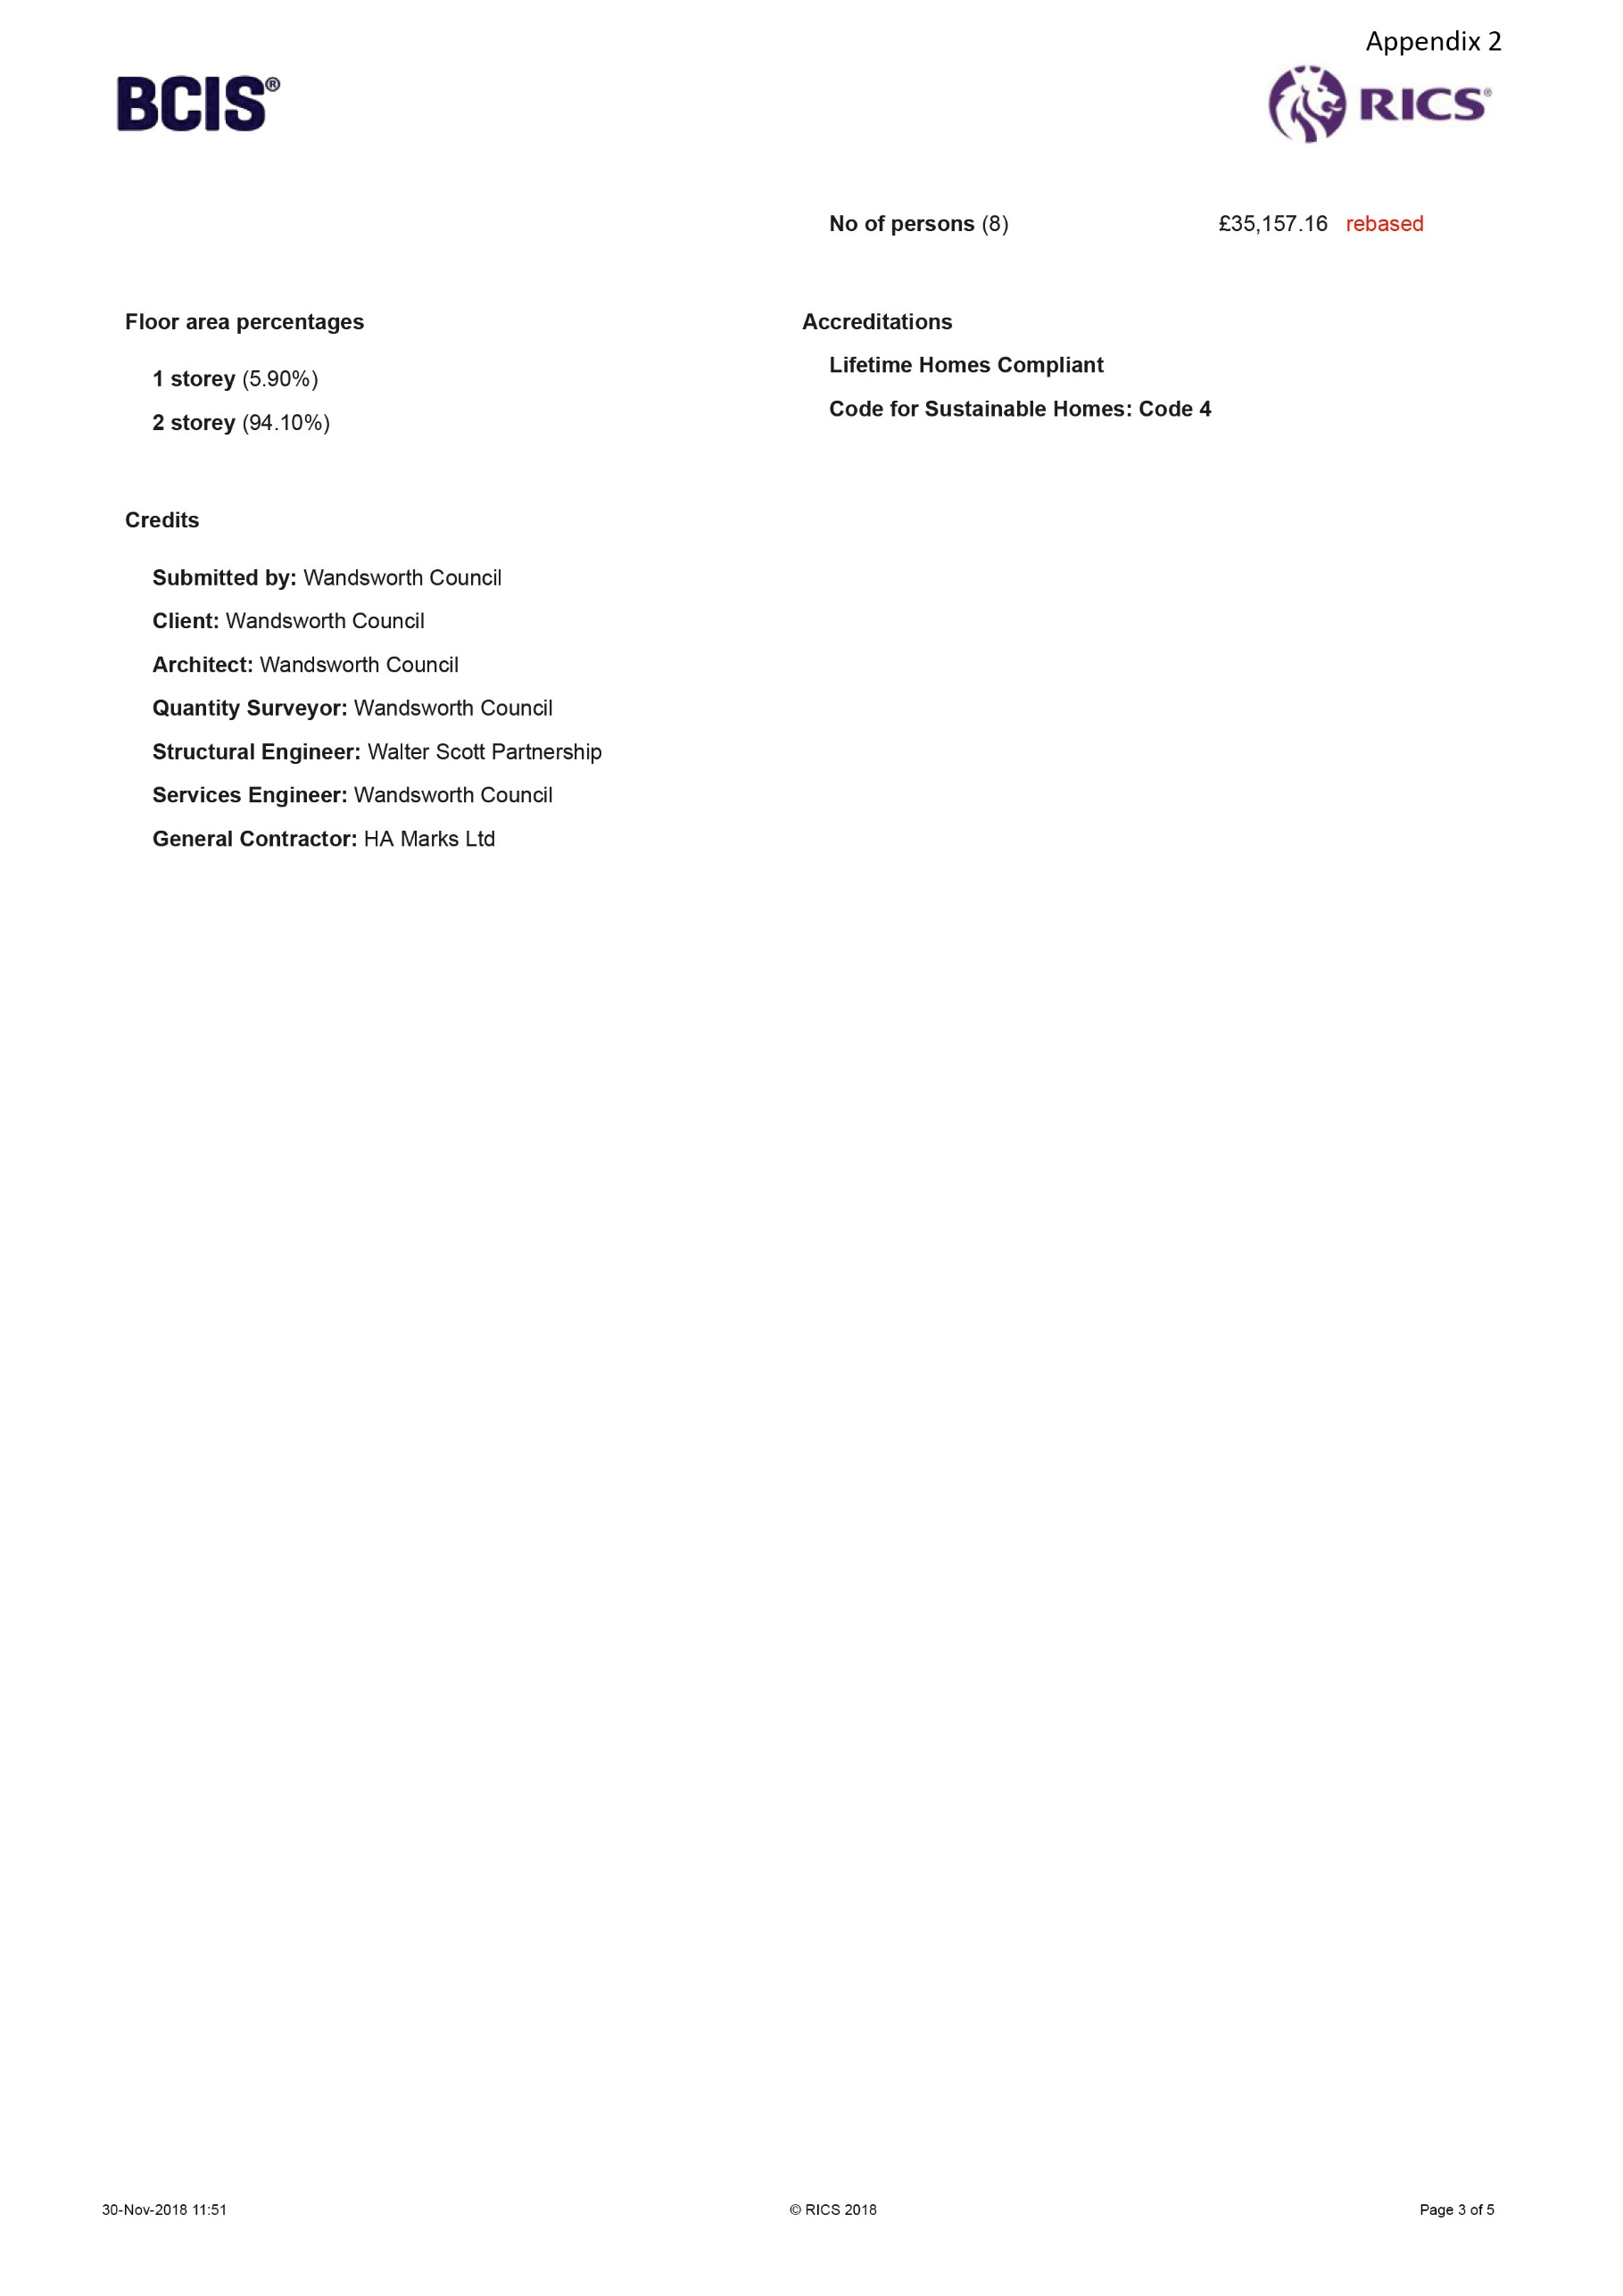
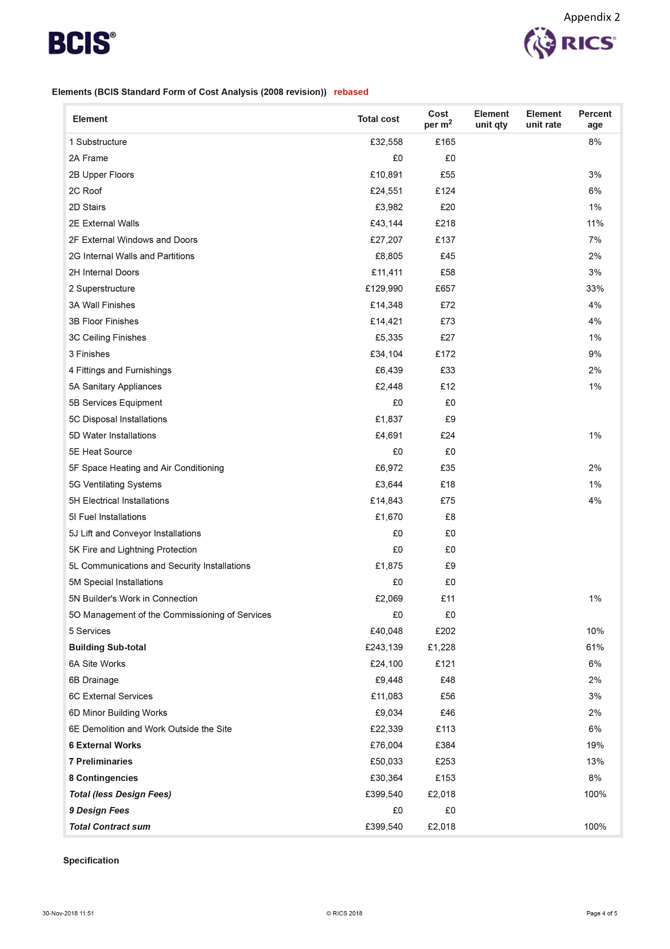
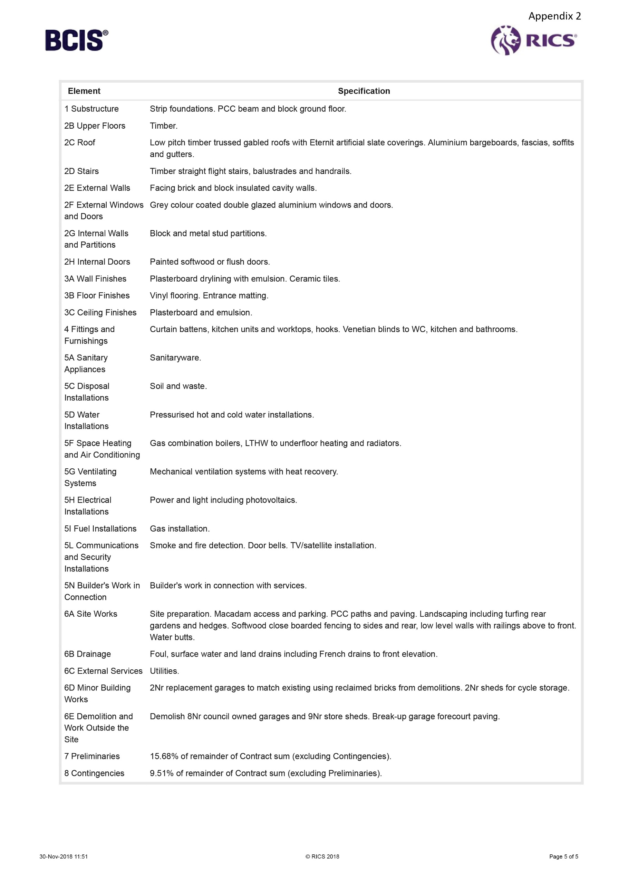
Appendix 3
Figures sourced from BCIS (2018) and based on a “2 bedroom terrace house” see appendix 4. The GIFA used for the following calculations is 210m². There were no calculations for 5A and 5D so the figures were used from appendix 1 for the semi-detached house.
 | Unit or Type | Cost / m² | Unit cost
1 | Substructure | £57 | £11,970
2A | Frame | 0 | £0
2B | Upper floors | £25 | £5,250
2C | Roof | £64 | £13,440
2D | Stairs | £15 | £3,150
2E | External walls | £103 | £21,630
2F | External windows & doors | £43 | £9,030
2G | Internal partitions | £49 | £10,290
2H | Internal doors | £32 | £6,720
2 | Superstructure | £331 | £69,510
3A | Wall finishes | £17 | £3,570
3B | Floor finishes | £38 | £7,980
3C | Ceiling finishes | £13 | £2,730
3 | Finishes | £68 | £14,280
4 | Fittings & fixtures | £17 | £3,570
5A | Sanitary appliances (see Appendix 1) | £12 | £2,520
5B | Services equipment | 0 | £0
5C | Disposal installations | 0 | £0
5D | Water installations (see Appendix 1) | £24 | £5,040
5E | Heat source | 0 | £0
5F | Space heating & air con | 0 | £0
5G | Ventilation systems | 0 | £0
5H | Electrical installation | £49 | £10,290
5I | Fuel installation | 0 | £0
5J | Lift & conveyor installations | 0 | £0
5K | Fire & lighting protection | 0 | £0
5L | Communication & security | 0 | £0
5M | Specialist installation | 0 | £0
5N | Builders work in connection | 0 | £0
5O | Management of commissioning | 0 | £0
5 | Services | £85 | £17,850
 | Building sub total | £558 | £117,180
6A | Site works | £60 | £12,600
6B | Drainage | £33 | £6,930
6C | External services | £108 | £22,680
6D | Minor building works | 0 | £0
6E | Demolition | 0 | £0
6 | External works | £201 | £42,210
7 | Preliminaries | £272 | £57,120
8 | Contingencies | £130 | £27,300
 | Total | £1,161 | £243,810
9 | Design fees | 0 | £0
 | Total contract sum |  | £243,810

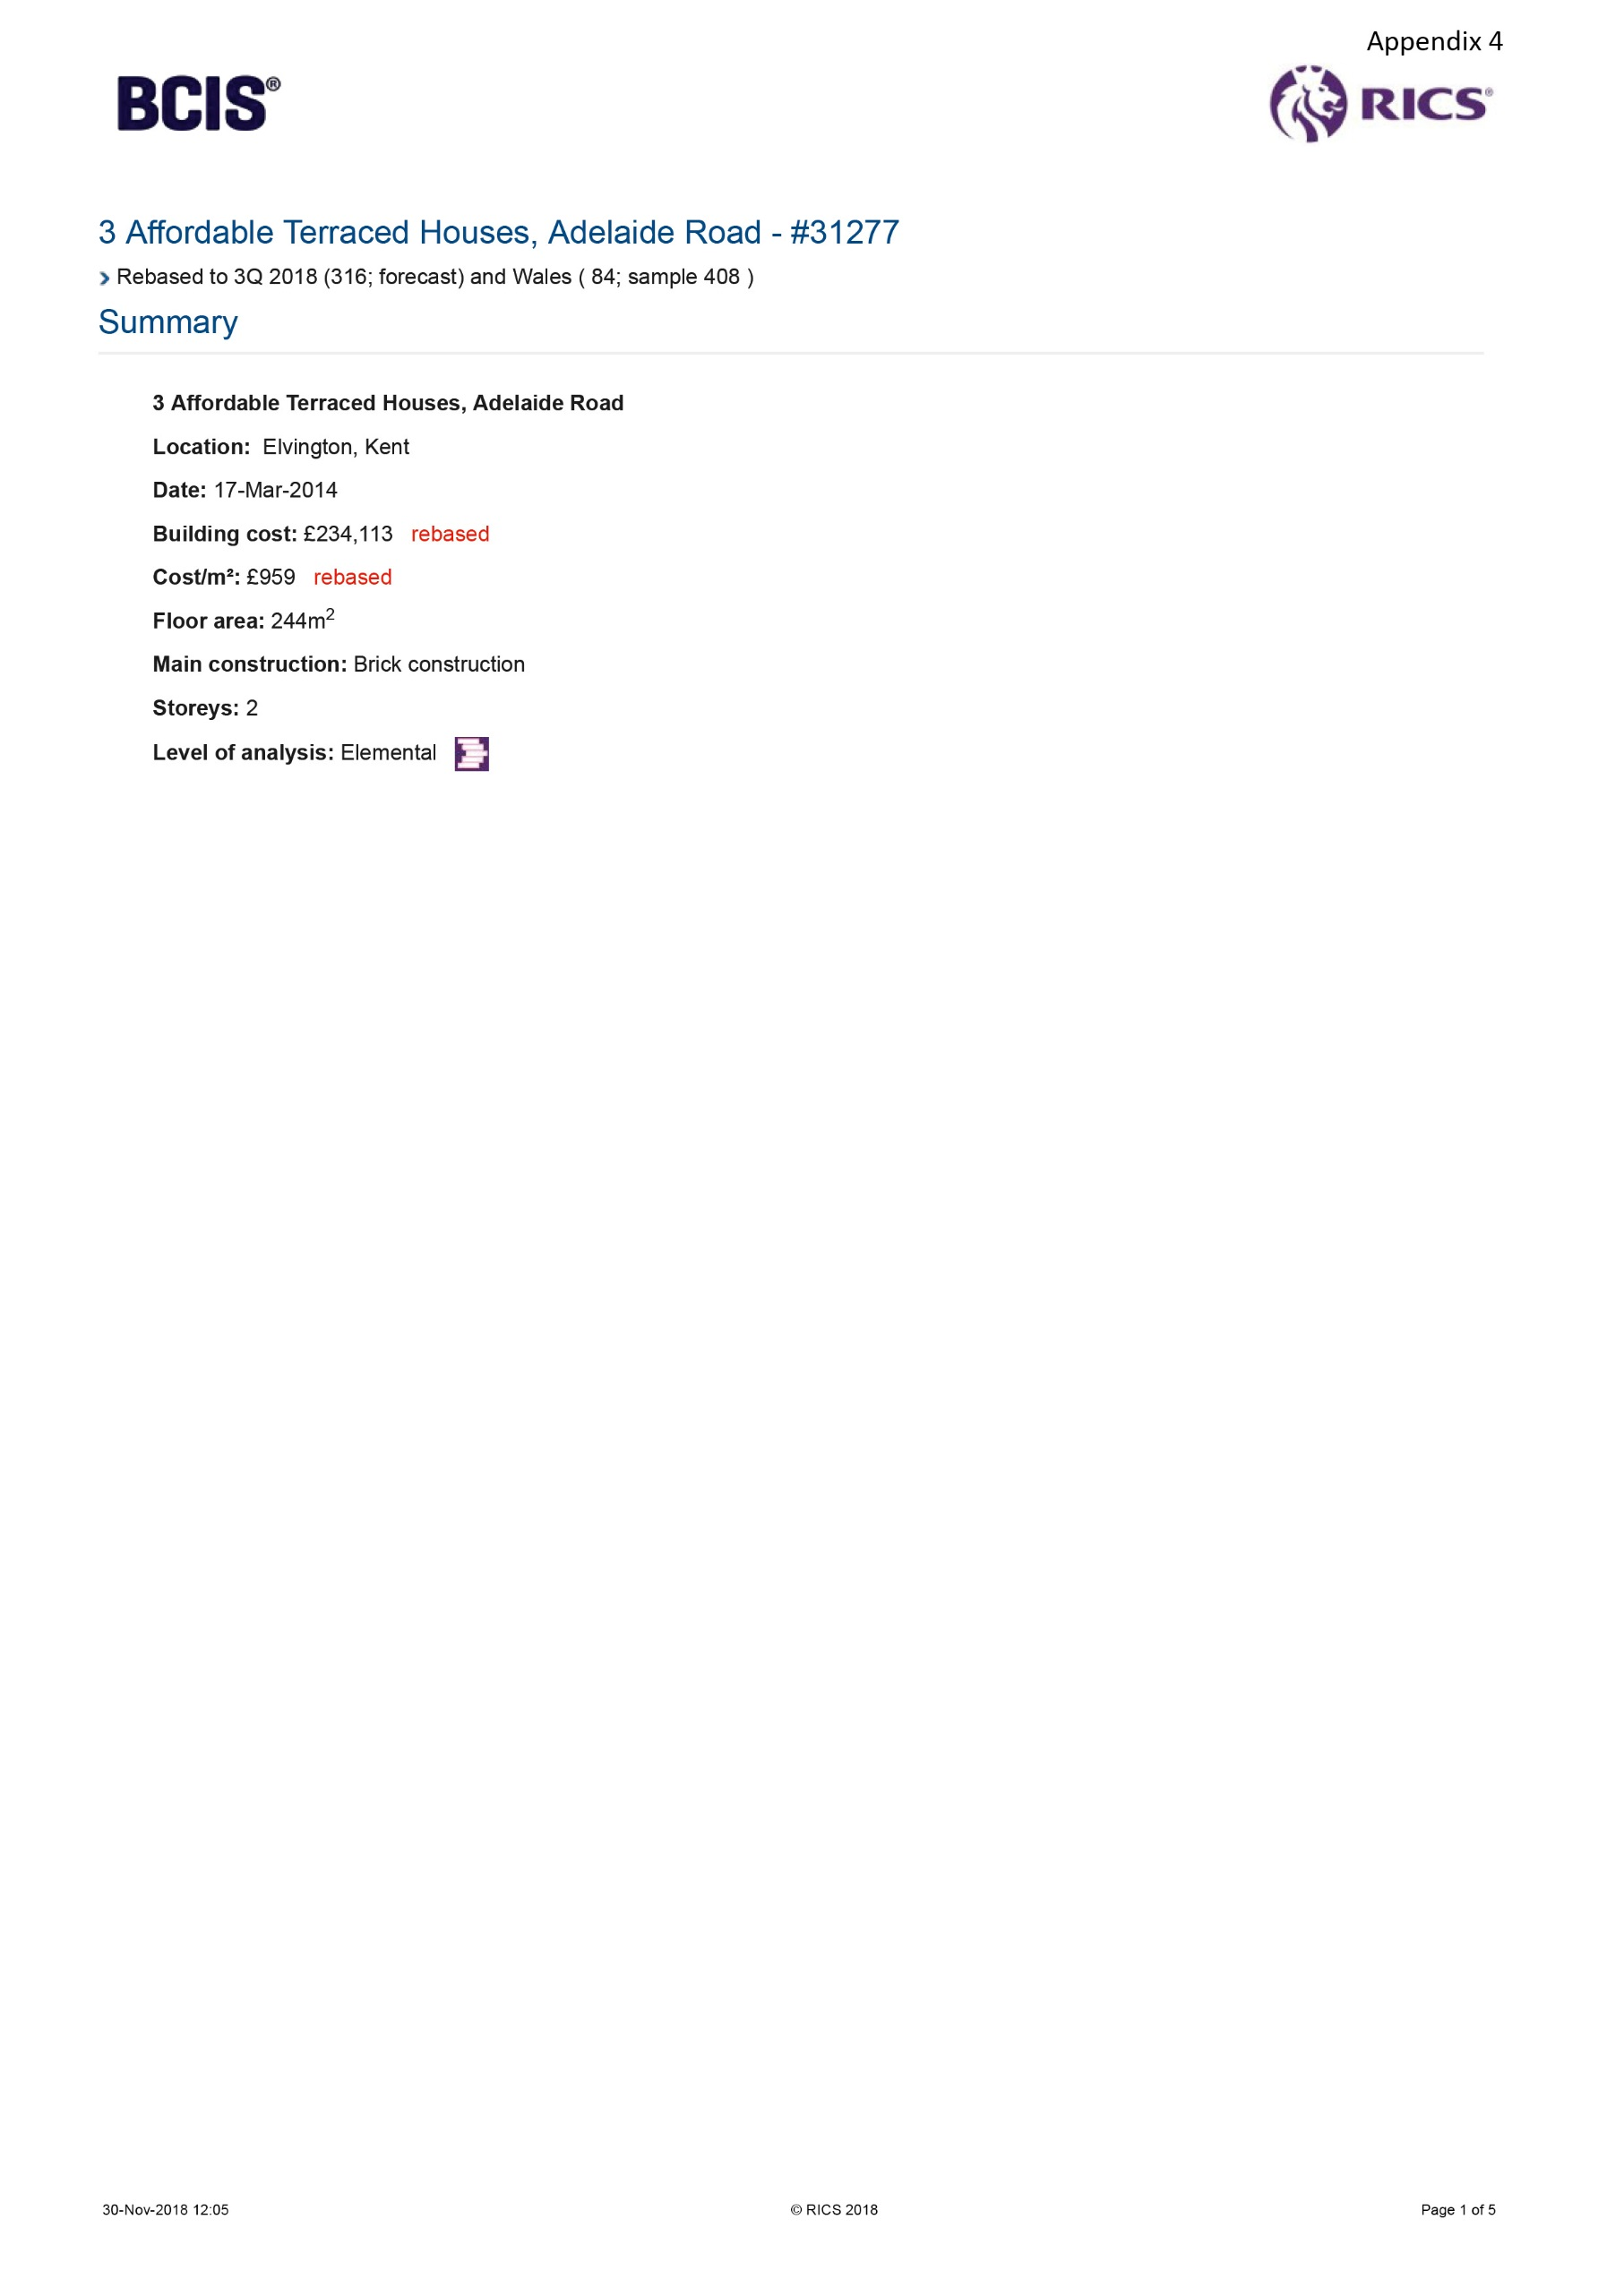
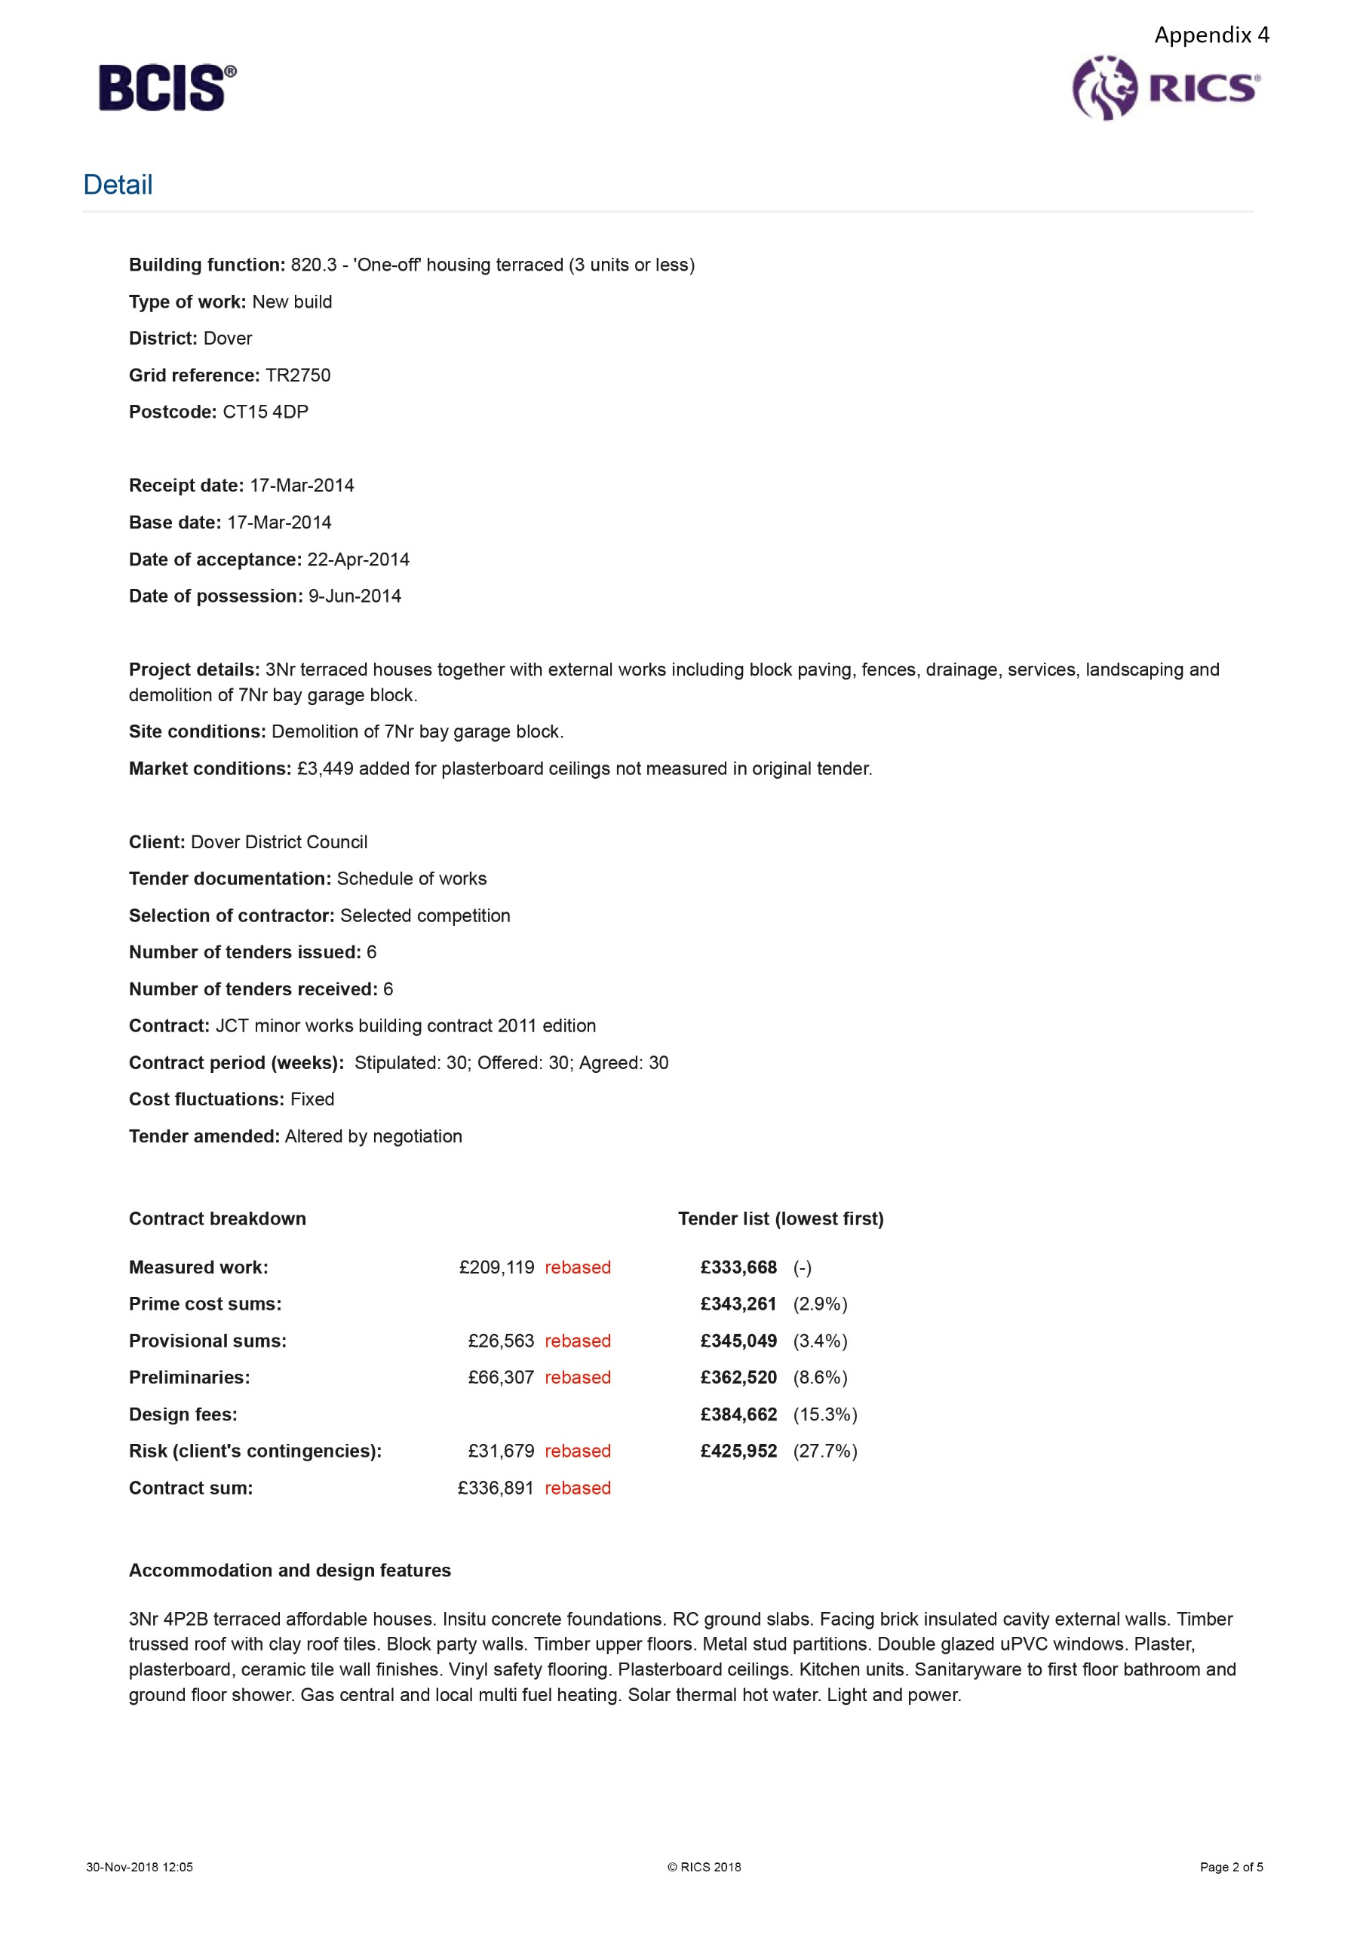
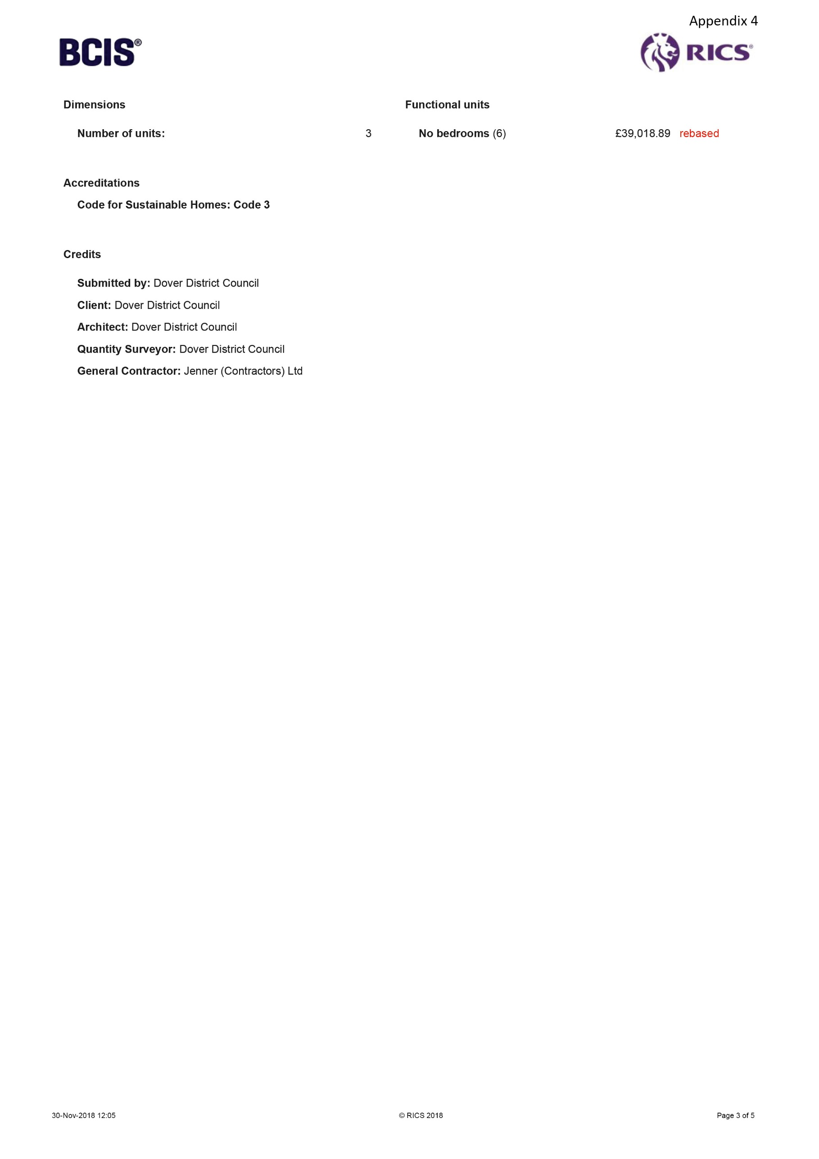
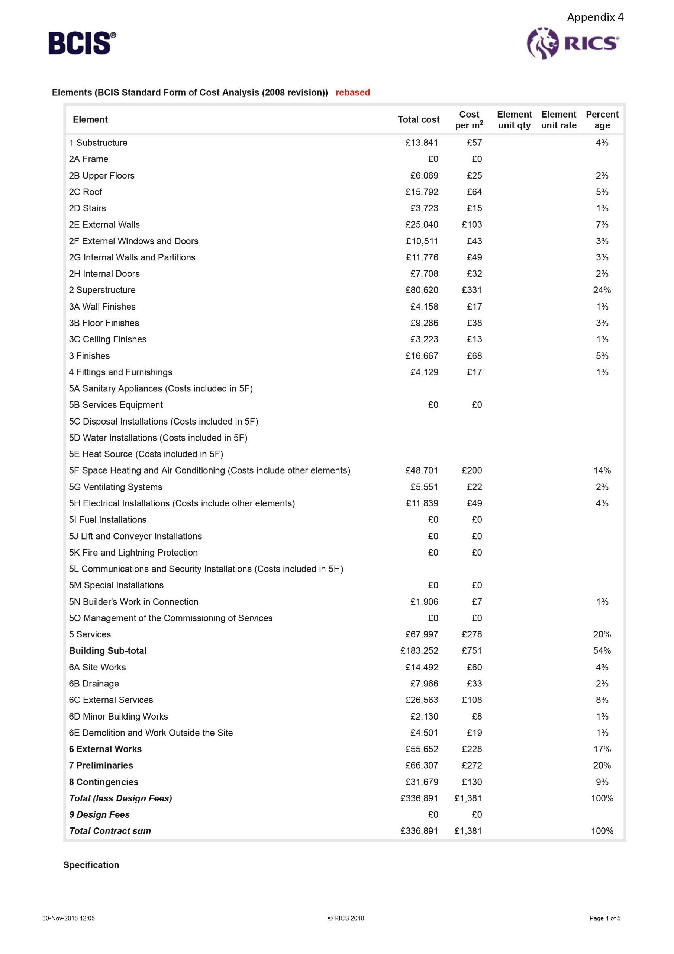
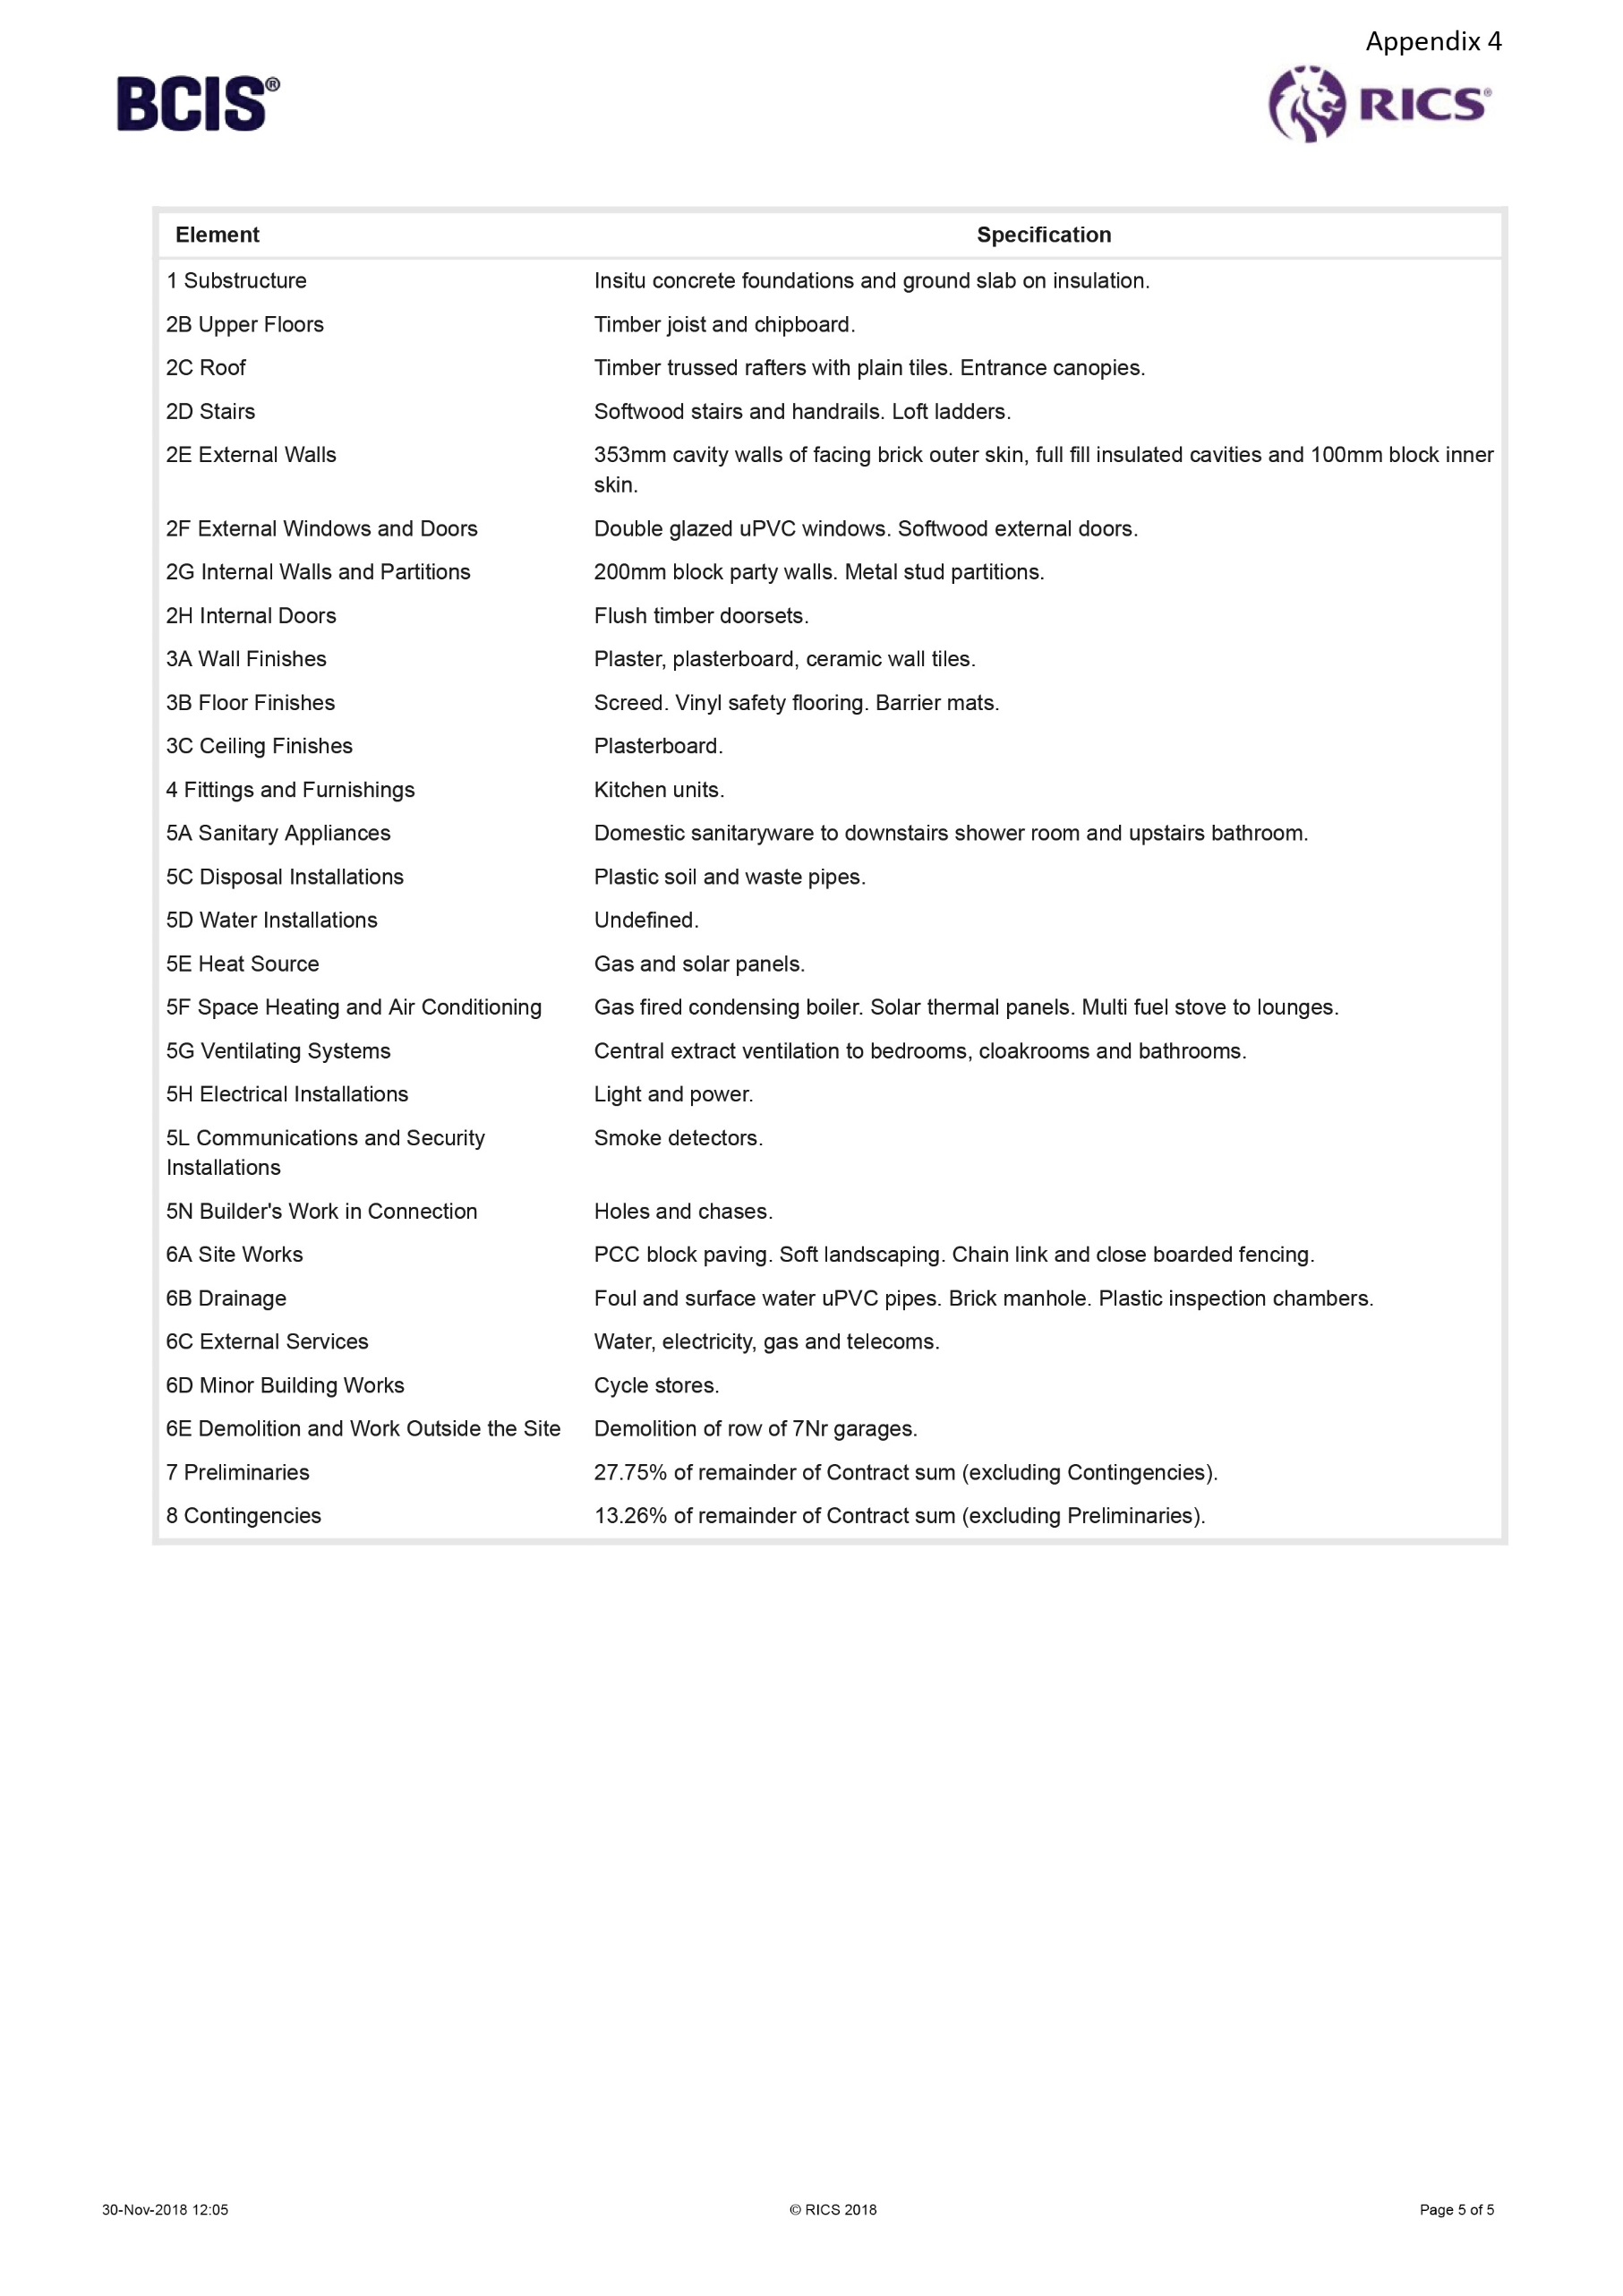
Appendix 5

The following costs in the spreadsheet have been taken from SPON’S (2019). The costs for bathroom fittings are from Victoria Plum (2018). The cost of the internal doors are from Howdens (2018).
The external works are based on the site size of 4500m², then subtracting the GIFA 2520m²= a total area of 1980m².
 | Element | GIFA or unit | Price per m² or unit | Sub Total | Total
1 | Substructure |  |  |  | £390,600
 | Strip foundations | 2520m² | £130 | £327,600
 | Insulation 100mm | 2520m² | £25 | £63,000
2 | Superstructure |  |  |  | £1,650,744
2.1 | Frame |  |  | 0
2.2 | Upper floors – softwood joists, plasterboard, skim & paint | 2520m² | £66 | £166,320
2.3 | Roof – timber trusses & clay tiles, insulation & rainwater goods | 2520m² | £185 | £466,200
2.4 | Stairs – softwood straight flight | 9 units | £1000 | £9,000
2.5 | External walls – brick cavity, insulation, plaster, skim & paint | 2520m² | £160 | £403,200
2.6 | Windows – uPVC 24mm | 2520m² | £210 | £529,200
 | External doors – uPVC | 18 units | £440 | £7,920
2.7 | Int partitions – timber stud | 2520m² | £24 | £60,480
 | Int doors - softwood | 69 Units | £110 | £7,590
 | Int fire doors - softwood | 6 units | £139 | £834
3 | Internal finishes |  |  |  | £90,216
3.1 | Wall finishes – 2 x plaster + paint | 2520m² | £14.30 | £36,036
3.2 | Floor finishes -chipboard | 2520m² | £16.90 | £42,588
3.3 | Ceiling finishes - paint | 2520m² | £4.60 | £11,592
4 | Fittings, furnishings & equip |  |  |  | £43,020
 | Kitchens – 3 bed house | 6 units | £3,800 | £22,800
 | Kitchens – 2 bed house | 3 units | £2,275 | £6,825
 | W.C.s & hand wash basins | 30 units | £299 | £8,970
 | Baths | 15 units | £295 | £4,425
5 | Services |  |  |  | £197,127
5.1 | Sanitary installations – w.c. | 30 units | £375 | £11,250
 | WHB | 30 units | £570 | £17,100
 | Baths | 15 units | £340 | £5,100
 | Kitchen sink | 9 units | £380 | £3,420
 | Showers | 3 units | £249 | £747
5.2 | Services equipment |  |  | 0
5.3 | Disposal equipment |  |  | 0
5.4 | Water installation | 2520m² | £53 | £133,560
5.5 | Heat source |  |  | 0
5.6 | Space heating & air con |  |  | 0
5.7 | Ventilation system |  |  | 0
5.8 | Electrical installation – lights | 105 units | £60 | £6,300
 | Consumer units | 9 units | £350 | £3,150
 | Sockets | 150 units | £110 | £16,500
5.9 | Fuel installation |  |  | 0
5.10 | Lift & conveyor installation |  |  | 0
5.11 | Fire & lighting protection |  |  | 0
5.12 | Comm, security & control |  |  | 0
5.13 | Specialist installation |  |  | 0
5.14 | Builders work in connection |  |  | 0
6 | Prefabricated builds & units |  |  |  | 0
7 | Work to existing buildings |  |  |  | 0
8 | External works |  |  |  | £379,767
8.1 | Site preparation |  |  | 0
8.2 | Roads paths, paving, surface – tarmacadam | 1980m² | £85 | £168,300
8.3 | Soft landscape - seeding | 1980m² | £2.30 | £4,554
 | Planting | 1980m² | £5.85 | £11,583
8.4 | Fencing - timber | 1980m² | £22 | £43,560
8.5 | External fixtures – road signs | 12 units | £130 | £1,560
8.6 | External drainage - uPVC | 1980m² | £52 | £102,960
 | Manholes (2 per property) | 18 units | £460 | £8,280
8.7 | External services – water supply | 9 units | £105 | £945
 | Water connection | 9 units | £520 | £4,680
 | Electricity mains supply | 9 units | £115 | £1,035
 | Electricity connection | 9 units | £2,375 | £21,375
 | Gas supply | 9 units | £300 | £2,700
 | Gas connection | 9 units | £310 | £2,790
 | Telephone - BT | 9 units | £345 | £3,105
 | Street lighting | 9 units | £260 | £2,340
8.8 | Minor building works |  |  | 0
9 | Main contractors prelims |  |  |  | £73,304
 | Office cabin | 104 weeks | £25.50 | £2,652
 | Toilets | 104 weeks | £41 | £4,264
 | Signs and notices | 104 weeks | £51 | £5,304
 | Fire extinguishers | 104 weeks | £8.50 | £884
 | Kitchen | 104 weeks | £150 | £15,600
 | Mechanical plant - power | 104 weeks | £10 | £1,040
 | Temporary works - road | 1980m² | £22 | £43,560
 |  |  |  | Sub-total | £2,824,778
10 | Main contractor o/h & profit |  |  | 24% | £677,946.72
11 | Project/design fees |  |  | 0 | 0
12 | Other development costs – insurance & fees |  |  | 4% | £112,991.12
13 | Risks |  |  | 5% | £141,238.90
14 | Inflation |  |  | 2.17% | £61,297.68
 |  |  |  | Total | £3,818,252.42

