Coursework Title
Module Name: Computer Architecture & OS
Module Code: ACCA4022
Student Name: Vincent Jackson
Student ID: 2520321
Lecturer Name: Dr Md Shantanu Islam

Submission date:

Contents
Introduction 4
Key functions of general Operating Systems 4
Task Management: 4
Application/Program Management: 4
File/Directory Management: 5
Device Management: 5
Security Management: 6
Use of Windows OS CLI commands 7
Example 1: 7
Example 2: 7
Example 3: 8
Example 4: 8
Example 5: 8
Example 6: 9
Example 7: 9
Example 8: 10
Example 9: 10
Example 10: 11
Use of Linux OS CLI commands 11
Example 1: 11
Example 2: 12
Example 3: 12
Example 4: 13
Example 5: 13
Example 6: 14
Example 7: 14
Example 8: 15
Example 9: 15
Example 10: 16
Use of Windows OS scripts 16
Example 1: 16
Example 2: 17
Use of Linux OS scripts 18
Example 1: 18
Example 2: 19
Conclusion 20
References 20
Appendices 21

Introduction
Computer architecture is the structure and design of a computer system. This encompasses the hardware components and the way they work together to execute instructions. It examines the communication between the central processing unit (CPU), memory, input/output devices and storage to ascertain the structure, functionality and performance of a computer. Learning about computer architecture can help you design efficient computer systems, improve performance and write software that makes the most of hardware resources. This assignment includes the key functions of general operating systems which enables the operating system to act as an intermediary between the computer’s hardware and application software, ensuring efficient, secure, and reliable operation.

Key functions of general Operating Systems
Windows operating system is a computer system software developed by Microsoft that manages the hardware and software resources of a computer and provide a user-friendly interface for the users. It is one of the most popular operating systems in the world and is running on millions of personal computers, laptops and business systems. Windows was first released in 1985 and has been through many changes, improving its performance, security and features to better meet the needs of users.

Task Management:
Windows task management is the monitoring and controlling of programs, processes, and system resources on your important. It gives users the tools to troubleshoot, optimise and manage applications successfully. Task management is important because it allows to find applications that use too many resources, close frozen programs, improve system performance, and diagnose software problems. Regular monitoring of system tasks enables users to keep a stable and efficient windows environment. In conclusion, Windows Task Manager is a very important tool that helps users to manage running applications and system resources effectively, which in turn helps to keep the computer running smoothly and efficiently.
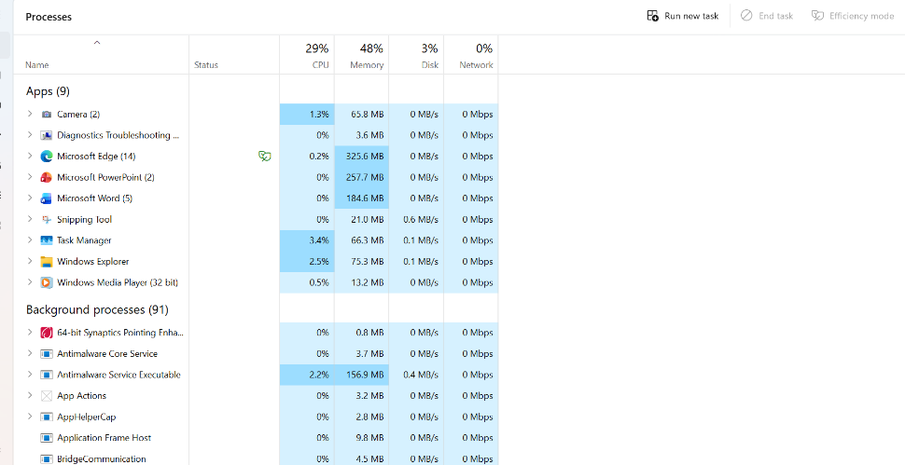
Figure 1: Description

Application/Program Management:
Windows application and program management is the process of installing, arranging, updating, supporting, and deleting software applications on a windows operating system. It guarantees programs work properly, securely and satisfy the requirements of users or organizations. In short, application and program management in windows involves the complete lifecycle of software, including installation, configuration, updating, monitoring, and removal. Proper management helps keep a windows environment secure, efficient and reliable for individual users and organisations alike.
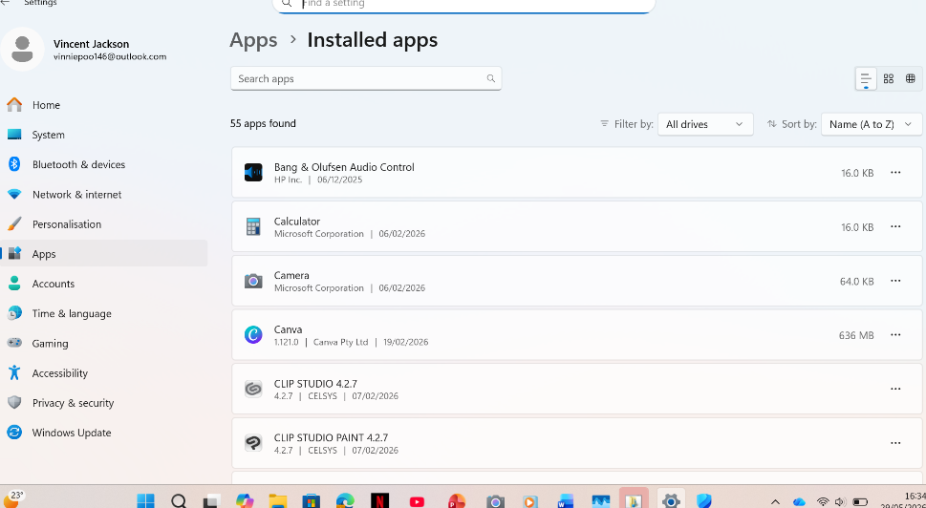
Figure 2: Description

File/Directory Management:
File and directory management in windows is the process of creating, organising, storing, accessing, modifying and deleting files and folders. Windows has tools like file explorer to help users organise data efficiently and keep a clean file system. Windows file and directory management is essential for the organization and maintenance of digital information. Using file explorer and following good organisational practices, users can manage files and folders efficiently, improve system performance, and ensure that important data is accessible and secure.

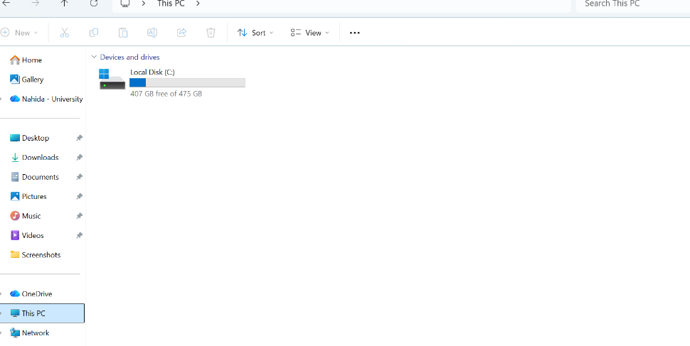
Figure 3: Description

Device Management:
Windows device management is the process of installing, configuring, monitoring and maintaining the hardware devices attached to a computer, It uses software called device drivers to make sure components such as printers, keyboards, monitors, network adapters, storage devices and graphics cards work properly. Device manager is a utility in windows that enables users and administrators to view and manage all the hardware devices installed on the system. It shows the state of the device, the drivers that are installed and any hardware problems.
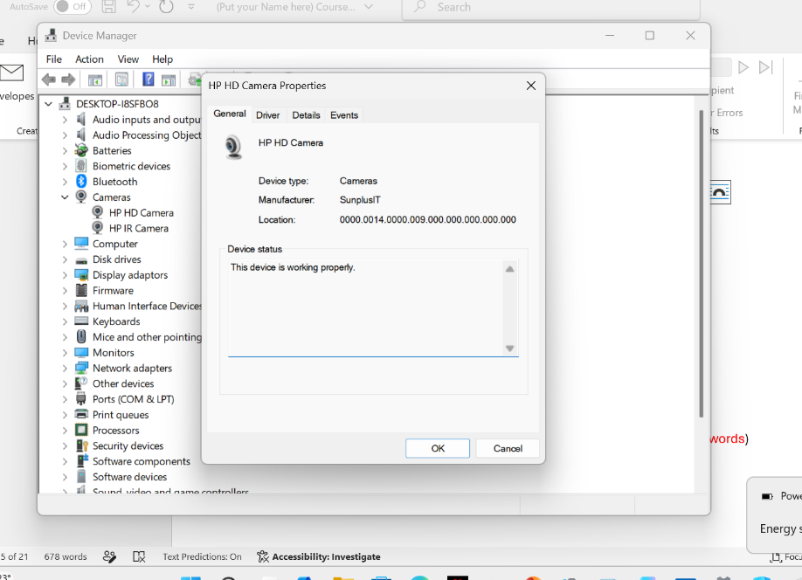
Figure 4: Description

Security Management:
Windows security management involves the tools, features, and policies that help secure a windows operating system, its users, data, and network resources against unauthorised access, malware, and cyber threats. It is an essential part of keeping a secure and reliable computing environment. Strong passwords should be used, multi-factor authentication where available, regular backups of important data, monitoring system logs, and educating users about safe computing practices are also part of effective windows security management. In summary, windows security management involves a combination of built-in security features, administrative controls, and the best practices to secure systems against threats. Correct configuration and regular maintenance are essential for the confidentiality, integrity and availability of data and resources.

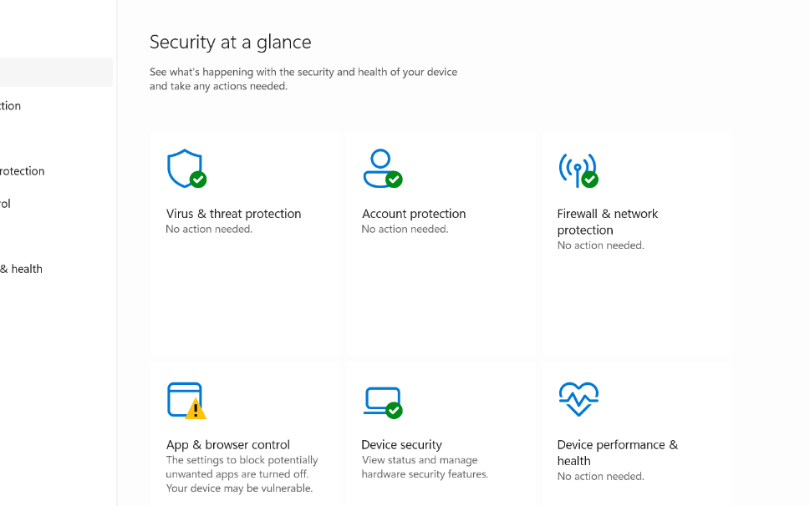
Figure 5: Description

Use of Windows OS CLI commands
The windows command line interface (CLI) is a text based environment that lets the user to interact with the operating system through the use of typed commands rather than a graphical interface.

Example 1:
The screenshot shows the windows command prompt after executing the Dir command. The command lists the contents of the c:\users\systems directory, displaying all available folders, their modification dates and times, and a summary showing the number of files, directories, and the amount of free disk space remaining on the drive.
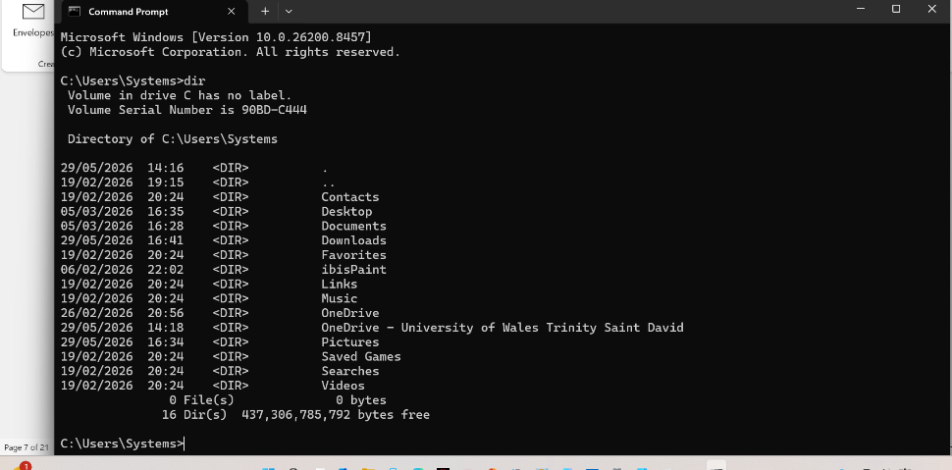
Figure 6: Description

Example 2:
The commands use cd to move between directories and dir to display folder contents. The output shows navigation from the root to users, lists available folders. Then enters systems and downloads successfully.
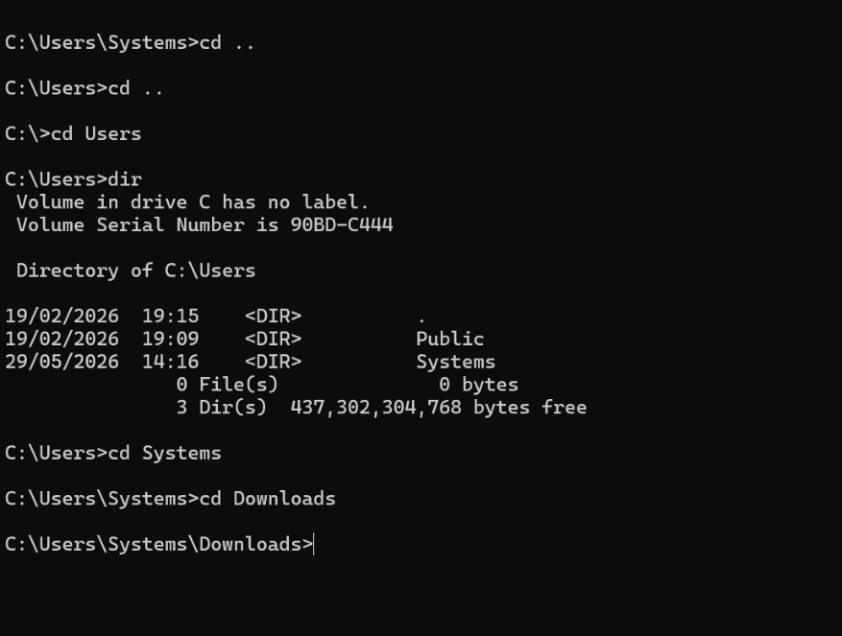
Figure 7: Description

Example 3:
The mkdir Vincent command creates a new folder named Vincent. The dir command displays the directory contents, confirming the new folder was successfully created in the current new directory.
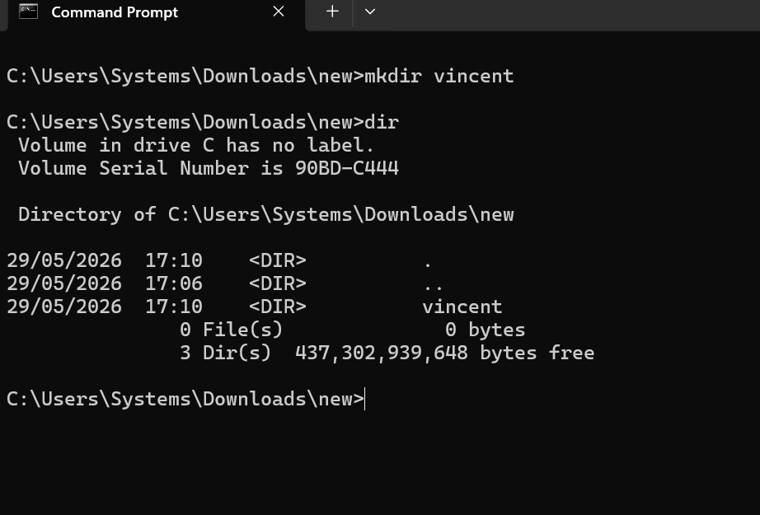
Figure 8: Description

Example 4:
The dir command displays the files and folders in the current directory. The output lists existing directories, including new. The rmdir new command removes the empty new folder successfully.
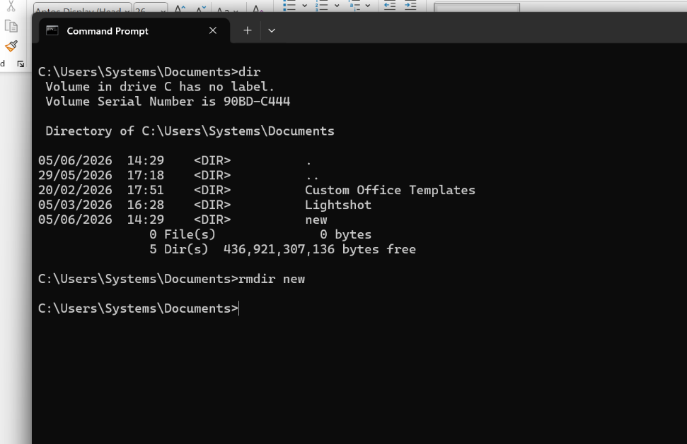
Figure 9: Description

Example 5:
The rename new newfolder command changes the folder name from new to newfolder. The dir command lists all files and folders, showing newfolder, confirming the rename was completed successfully.
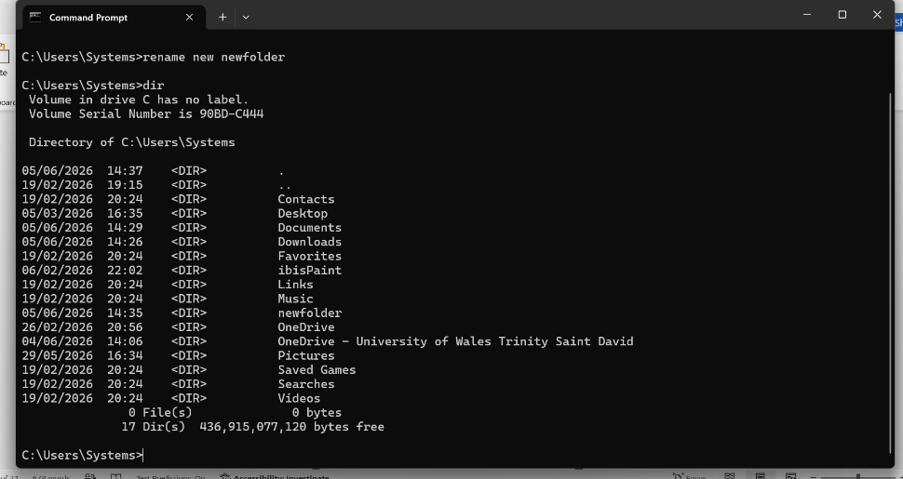
Figure 10: Description

Example 6:
The ipconfig command displays the computers network configuration. The output shows the wi-fi ip address, subnet mask, default gateway, and indicates that ethernet, Bluetooth, and other adapters are disconnected.
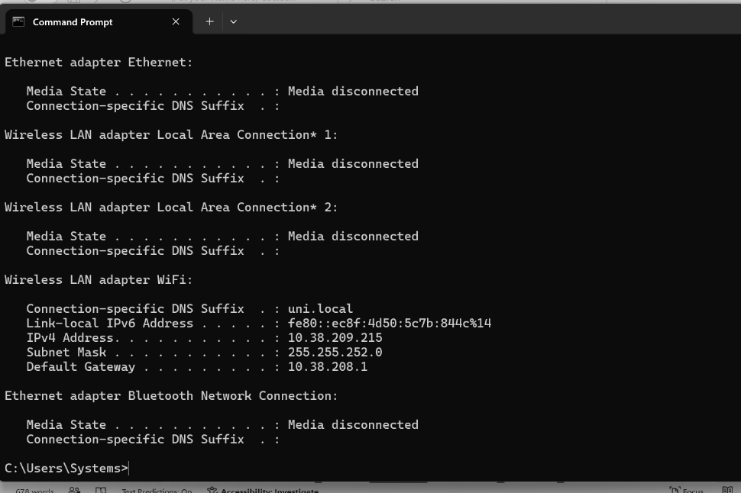
Figure 11: Description

Example 7:
The ping google.com command checks network connectivity by sending four ICMP echo requests to googles server. The output shows successful replies, response times, TTL values, 0% packet loss, and average latency.
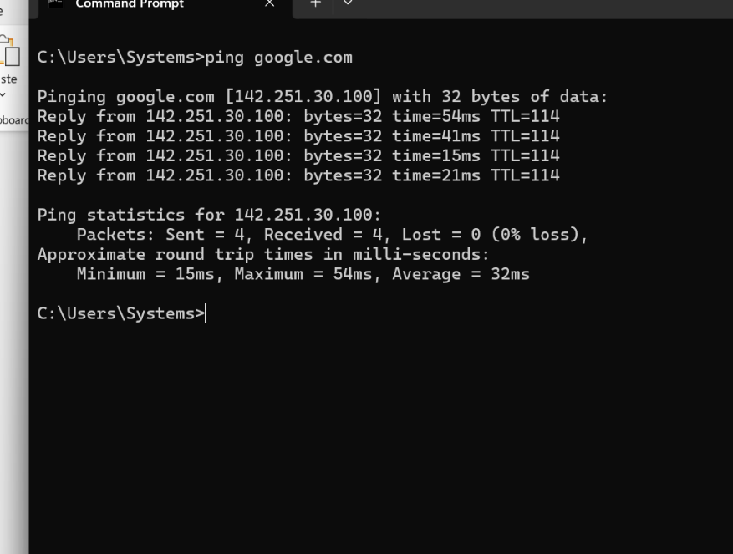
Figure 12: Description

Example 8:
The screenshot shows the netstat command run in windows command prompt. The netstat command displays active network connections and listening ports. The output shows TCP connections, local and remote IP addresses, connection states such as established and time_wait, helping diagnose network activity.
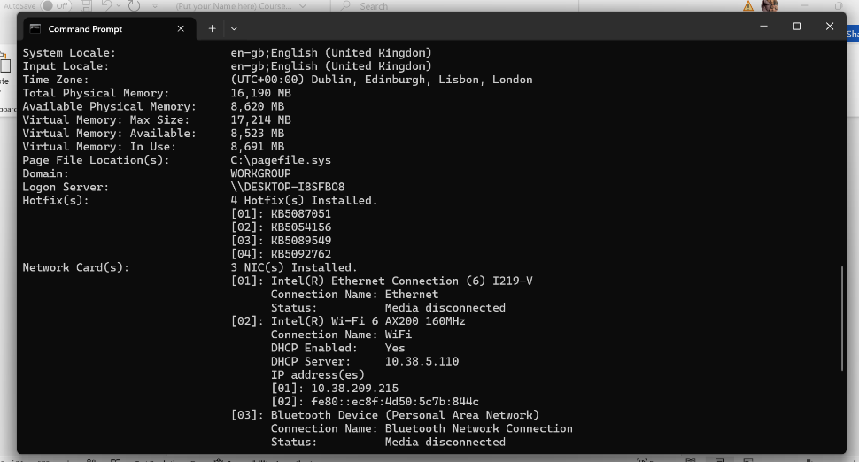
Figure 13: Description

Example 9:
The screenshot shows the tasklist command in windows command prompt. The tasklist command displays all currently running processes on a windows system. The output lists each process’s image name, process ID (PID), session name, session number, and memory usage, helping users monitor running applications and system resources.
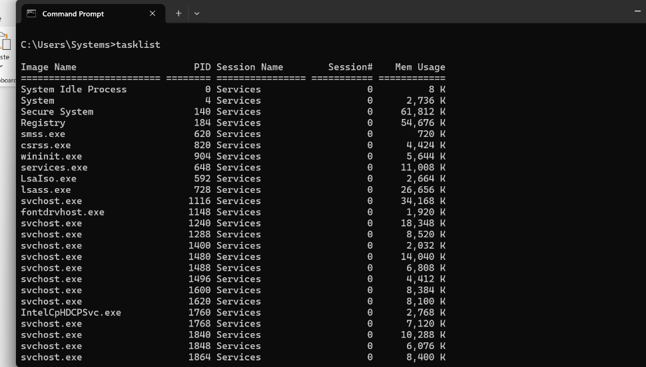
Figure 14: Description

Example 10:
Netstat displays active network connections and ports. The output shows local Ips, remote HTTPS addresses, and ESTABLISHED states, indicating ongoing TCP sessions between the computer and remote web servers connections.
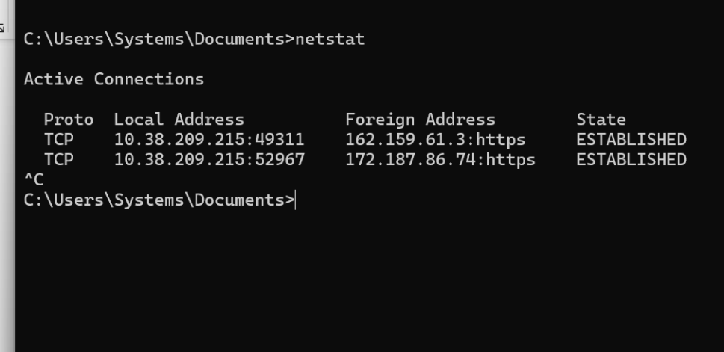
Figure 15: Description

Use of Linux OS CLI commands
Linux CLI (Command land interface) allows users to interact with the operating system by typing commands. It is used to manage files, install software, control processes, and administer the system efficiently. The CLI is widely used by system administrators, developers, and network engineers because it is fast, powerful, and supports automation through shell scripts.
References: the Linux command line, Linux documentation

Example 1:
The su command switches to another user, usually root. The first attempt fails because of an incorrect password. After entering the correct password, access is granted, then su sysadmin returns to the sysadmin user.
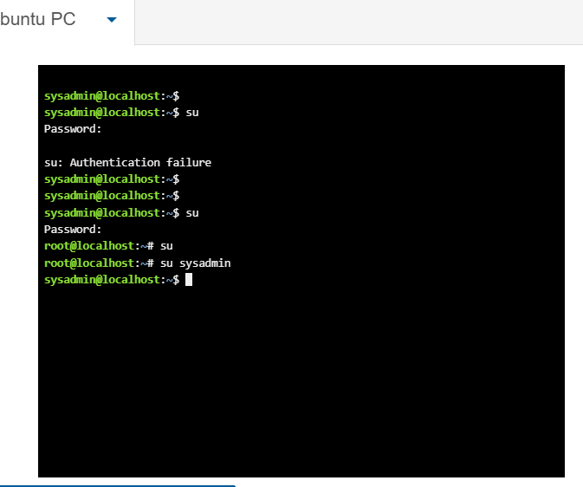
Figure 16: Description

Example 2:
The su command switches to another user account. The first password attempt fails, showing ‘authentication failure’. After entering the correct root password, the user successfully switches users and returns to the sysadmin account
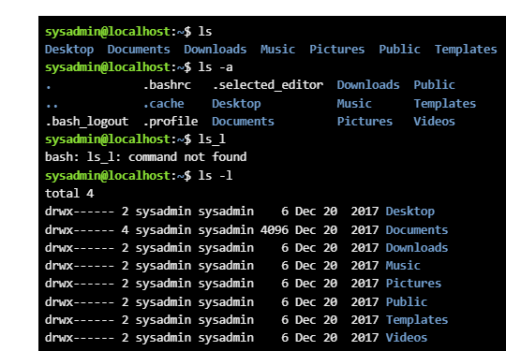
Figure 17: Description

Example 3:
The 1s command lists directory contents. 1s – a shows all files including hidden ones, 1s – 1 displays detailed information, while 1s_1 is incorrect, producing the “command not found” error.
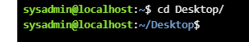
Figure 18: Description

Example 4:
The 1s command lists directory contents. 1s -a shows all files including hidden ones, 1s – 1 displays detailed information, while 1s_1 is incorrect, producing the “command not found” error.
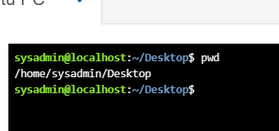
Figure 19: Description

Example 5:
The mkdir new command creates a new directory named new in the current location. The 1s command lists directory contents, confirming the new directory was successfully created.
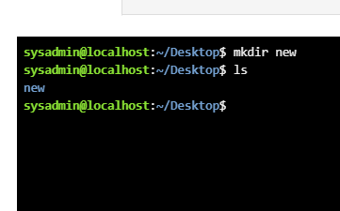
Figure 20: Description

Example 6:
The mkdir new command creates a directory named new on the desktop. The 1s command lists current directory contents, showing new, confirming the directory was created successfully.
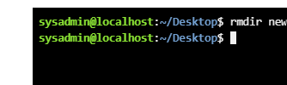
Figure 21: Description

Example 7:
The rmdir new command removes the empty directory named new. Since the directory is empty, it is deleted successfully. The terminal returns to the prompt without displaying any error message.
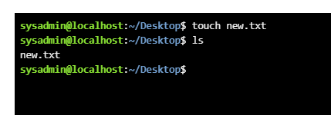
Figure 22: Description

Example 8:
The touch new.txt command creates an empty file named new.txt on the desktop. The 1s command lists files in the current directory, showing new.txt, confirming the file was created successfully.
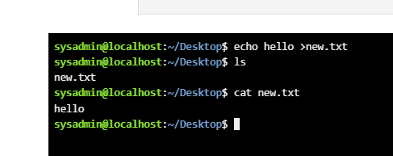
Figure 23: Description

Example 9:
The ifconfig command displays network interface configuration. The output shows ethernet (eth0) and loopback (1o) interfaces, including Ip addresses, MAC address, subnet mask, interface status, packet statistics, and transmitted/received data.
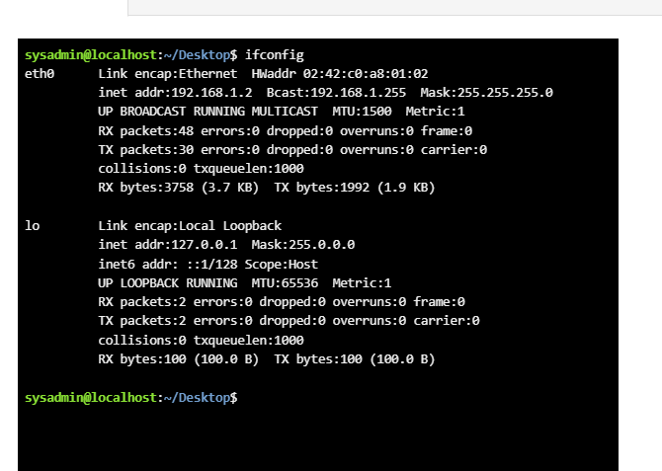
Figure 24: Description

Example 10:
The whoami command displays the current logged in username, which is sysadmin. The date command shows the systems current date and time, displaying Friday, June 12, 2026, 14:36:17 UTC,
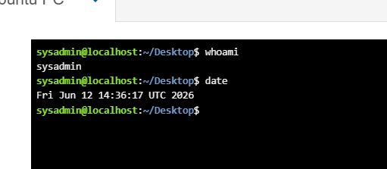
Figure 25: Description

Use of Windows OS scripts
Batch scripting is the process of writing scripts (usually .bat or .cmd files) to automate repetitive tasks in windows, such as file management, backups, software installation, and system administration. It improves efficiency and reduces manual effort. References: windows command- line administration instant reference ; Microsoft.

Example 1:
This batch script is written for the windows command prompt and performs a simple addition of two numbers entered by the user/ The @echo off command hides the execution of commands, making the output cleaner. The set/p num1= command prompts the user to enter the first number and stores it in the variable num1. Similarly, set/p num2= asks for the second number and stores it in num2. The command set /a total=num1+num2 performs an arithmetic calculation by adding the two values and saving the result in the variable total. The echo the sum is %total% command displays the calculated sum on the screen by printing the value stored in total. Finally, the pause command keeps the command prompt window open and displays “press any key to continue…” allowing the user to view the result before the program closes.
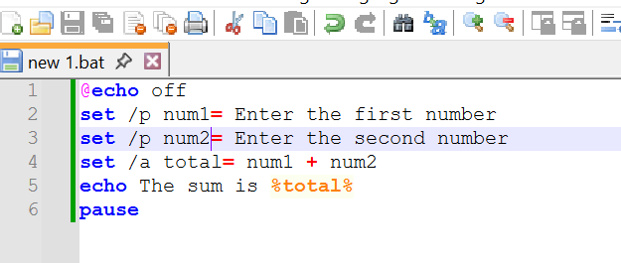
Figure 26: Description
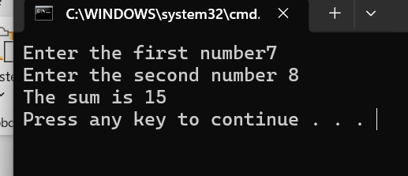
Figure 27: Description

Example 2:
The script is a simple program that demonstrates how to accept user input, perform an arithmetic operation, and display the result. First, it prompts the user to enter the first number, which is 7. It then asks for the second number, which is 8. These values are stored in variables. The program adds the two numbers together using the addition operator and stores the result in another variable, usually named sum or total. Finally, it prints the message “the sum is 15” to the screen. The output confirms that the addition was performed correctly because 7+8=15. The final line, “press any key to continue…”, appears because the program is executed in a command prompt window. This message keeps the console open so the user can read the output before the window closes. Overall, the program demonstrates basic concepts such as user input, variables, arithmetic operations, and displaying results.
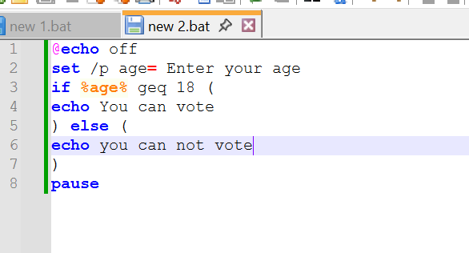
Figure 28: Description
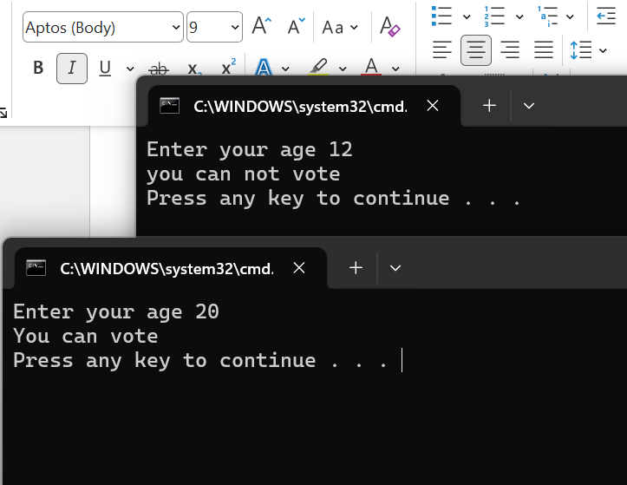
Figure 29: Description

Use of Linux OS scripts
Bash scripting is the practice of writing scripts using the Bourne again shell (bash) to automate tasks in Linux and unisex systems. It is used for file management, system administration, software installation, backups, and automation. Bash scripts combine commands, variables, loops, and conditions to improve efficiency and reduce manual effort.
This bash script takes two number from the user and prints their sum. First, the script displays a prompt using echo asking the user to enter the first number, and the read command stores it in the variable num1. It then prompts for the second number and stores it in num2. After both inputs are received, arithmetic expansion is used with total=$((num1+num2)) to add the two values. Finally, echo prints the result in a readable format as “The sum is $total”. When executed, the script waits for user input twice. For example, if the user eters 5 and 7, the output will display 12 as the sum. This demonstrates basic input/output handling, variable usage, arithmetic operations in Bash scripting. Sych scripts are useful for simple calculations and understanding how shell variables and user interaction work in Linux environments. It is a beginner friendly example for learning shell scripting basics.

Example 1:
The screenshot shows a simple Bash shell script and its execution in a Linux terminal. The script (script.sh) first prompts the user to enter two numbers using echo, then reads the inputs using read num1 and read num2. After collecting the values, it performs an arithmetic operation: total =$ ((num1+num2)), which adds the two numbers together, Finally, it displays the result using echo “the sum is $total”. In the terminal section, the user creates the file using nano script.sh, lists files ls, and then changes the script’s permissions using chmod +x script.sh to make it executable. After that, the script is run using ./script.sh. During execution, the user inputs 76 as the first number and 45 as the second number. The script calculates the sum as 121 and prints “the sum is 121” to the screen. This demonstrates basic shell scripting concepts: input handling, arithmetic expansion, file permissions, and script execution.
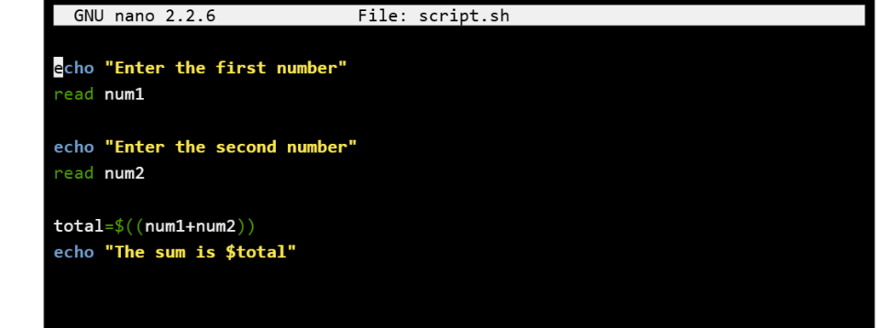
Figure 30: Description
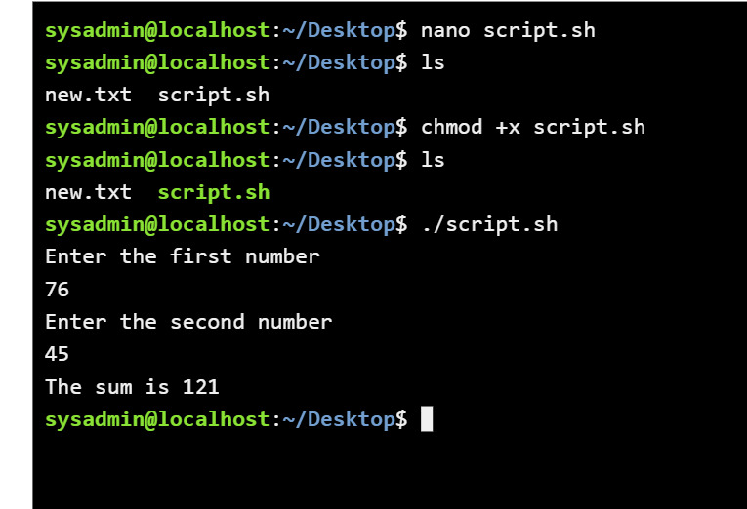
Figure 31: Description

Example 2:
The script is a simple bash shell program that asks the user for a number and then prints a sequence of numbers from 0 up to one less than that number. It first displays a prompt using echo asking how many times to count, then reads the user input into the variable count. A for loop is used: for ((i=0;<count;i++)) which initializes I at 0, checks if I is less than count, and increments I by 1 each iteration. Inside the loop, echo “$i” prints the current value of i. in the output example, when the user enters 9, the loop runs nine times and prints numbers 0 through 8. After editing and running again, the same behaviour is shown. This demonstrates basic input, iteration, and output in shell scripting using a counter – controlled loop. Overall it shows fundamental looping and user interaction concepts in Linux shell scripting clearly and concisely demonstrated.
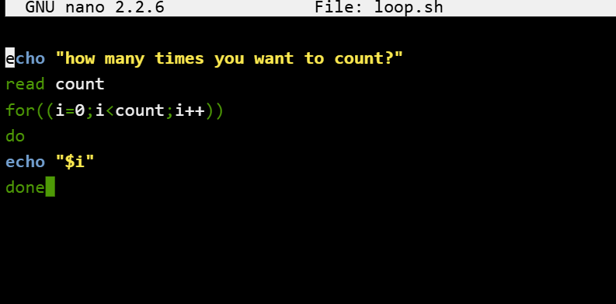
Figure 32: Description
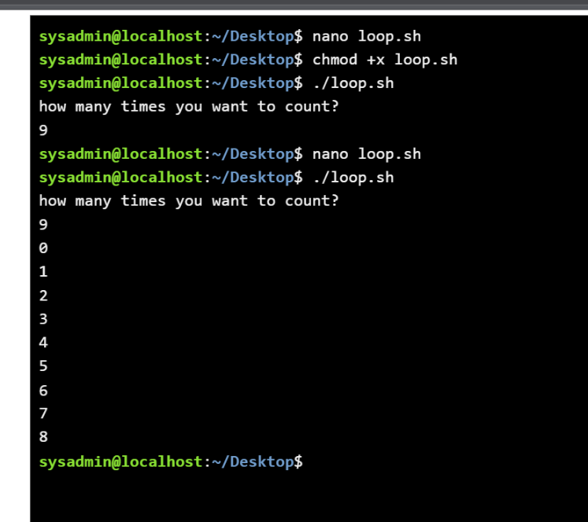
Figure 33: Description

Conclusion
Overall,, this report summarized the key tasks undertaken in the project, including analysis, implementation, and evaluation. The work demonstrated understanding of the concepts and practical application of methods. The findings highlight important outcomes and limitations, while supporting improved knowledge and skills gained throughout the process and future development opportunities overall.

References
References: the Linux command line, Linux documentation
References: windows command- line administration instant reference ; Microsoft.

Appendices
Online Course name:

Figure 34: Certificate of completion

