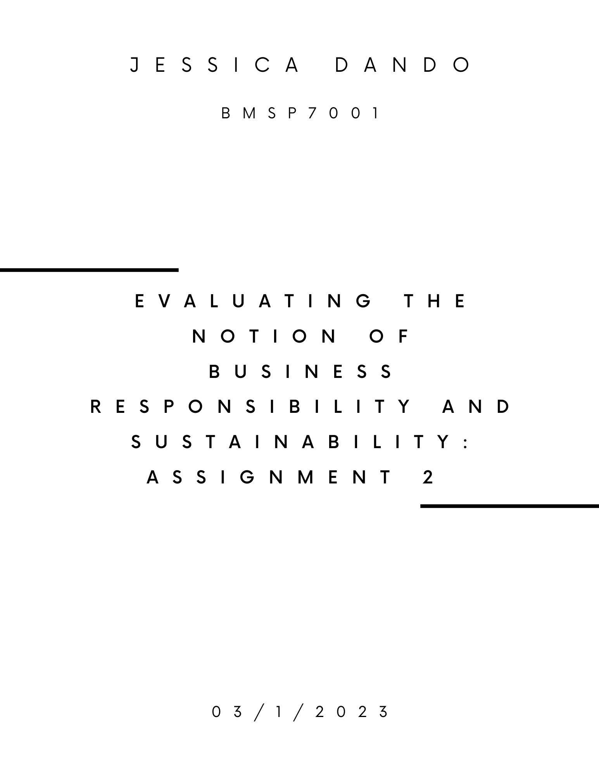

Sustainability and Responsibility.

Serious environmental issues such as the depletion of resources, air, water, and soil pollution; biodiversity; loss and overuse of land, are increasingly destroying the earth’s life-support system (Rockstrum et al, 1999; Meadows et al, 2004) Climate change is irrefutably the biggest global threat of the 21st Century. That includes the threat to global health caused by the change and increase in patterns of disease, water and food scarcity, population growth and extreme climactic events caused by climate change and migration (Costello et al, 2009)

The Living Planet Report (2016) highlighted a phenomenal rate of biodiversity decline in 2016, and that it has occurred exponentially during the industrial revolution (50% between 1970 and 2014) The latest publication shows global wildlife populations have plummeted by 69% on average since 1970 with biodiversity decline as much as 66% in Africa, and 94% in Latin America and The Caribbean. As countries continue to develop, unless huge changes occur this will continue to increase. The most notable development since the 70’s is the continued rise and increase of resource demand. The extraction of raw materials contribute considerably to carbon dioxide emissions. Where in the past, early warnings of resource depletion and overpopulation have been ignored, the evidence and signs of scarcity and damage has resulted in a growing interest in how resources are sourced and utilized, leading to a movement for change (Lacy & Rutquivist, 2015, p.21)

Tackling the challenges of climate change, world hunger and resource depletion certainly requires systematic changes related to business, government, and society. Business has the responsibility to focus on developing a new and sustainable culture, led by and motivate not only by consumer preferences but also increased acceptance and awareness of the situation our planet is in.

Michael Schramm opines that if we want to preserve out ecosystem,
‘Our social creativity must develop the ability to promote the ability and creativity of natural things to sustain themselves’ (Schramm, 2020)

Luckily, the number of successful organisations taking responsibility for the planet continues to rise, with many developing their business models on sustainability. Examples include Freitag; Ecosia; Patagonia; Ben & Jerry’s, to name a few. Former Governor for the Bank of England made a pertinent point when he said:

‘Companies and industries that are not moving towards zero-carbon emissions will be punished and go bankrupt’ (Carrington, 2019)

If the above examples are to be observed, then the opposite is also true, those who embrace sustainability will be profitable, this has certainly been proved so far, the case for a lot of B-corps and successful businesses who build their systems based on sustainability.

Ethics of course has an important role to play when considering Corporate and social responsibilities and sustainability. Future communities, eco-systems and non-human species are becoming key factors in business, spurred on not only as suggested earlier consumer pressure but also human health concerns such as increasing cancer rates, and climate change (DesJardins, 2005)

A good example of this pressure on organisations to. Have moral and ethical obligations to consumers, society and the environment is the Monsato-Glyphosphate case, where the organisation was held responsible for not labelling the herbicide roundup and its ingredient Glyphosphate as possibly carcinogenic. This case promotes the message to business that they will be held responsible for immoral actions, lack of fortitude and ignored risks (Reuters, 2019) The knowledge that culpability seems to be a mere click away tends to inspire more transparent and ethical business practice from organisations.

According to the Boston Consulting Group (BCG, 2017) organisations are more engaged now in the production of ethical products and offer products and services that have positive societal impacts) TSI: (Total Social Impact). Organisations such as the Fridays for the Future movement, have gained momentum by proposing that past and future businesses, and consumers have not acted against climate change as well as eco-systemic degradation and intergenerational injustice. It is of the utmost importance to consider why we do not take intergenerational equity/justice into account, because we are overconsuming resources, many of which their depletion will cause scarcity or catastrophic events for future generations. (Singh et al, 2020)

Aside from the obvious responsibilities faced by businesses while considering actions to take to become sustainable, businesses must also consider their own future resources. Organisations have been depending on resources such as wood; water and food for millennia and have always assumed an endless supply. Water and wood are effective examples of renewable sources overstretched as it leads us to explore a more sustainable model, based on long-term planning perspectives. Behind the idea of sustainability is the concept of intergenerational ethics, which already poses significant challenges when it comes to non-renewable sources which have been mined to the point of being rare or economically unviable to mine and when gone, will be unavailable for another million or so years (Sanchez et al, 2018)

One negative example of a company accused of overusing and deteriorating resources is Nestle, with its bottled water business, specifically the ‘pure life’ brand. The documentary ‘Bottled Life’ (Schnell, 2012) claims to reveal how Nestle in some cases had extracted water beyond the rate of renewal, which resulted in unsustainable environmental impacts and waning natural ecosystems. Among Nestle’s stakeholders in economically developing countries are local communities who, after Nestle began its operation, no longer have access to drinking water due to the sinking groundwater level. But for Nestle, this is a highly profitable business, because in some cases it purchases a tanker for ten dollars and sells the same volume of water for fifty thousand US dollars (Schnell, 2012) Another negative effect of this process is the amount of plastic produced and disposed of to bottle the water, especially in cases where the bottles cannot or are not recycled. This is an important example of a corporation with so much power, that they seem to demonstrate a disregard for the rules normally associated with moral and ethical organisations, people, and society, who have placed profits above people time and time again. Here, it is worth mentioning that without governmental policies and a complete refusal to tolerate these practices, companies like Nestle will no doubt continue to look at profit as being the number one priority, which is hardly suprirising considering the capitalist environment in which we live. However, the landscape is changing, and shifting so much so that there may be no more room for organisations like Nestle in the future, and if legislation is put in place to prevent businesses like Nestle from depleting natural resources and ignoring environmental ethics to make a profit, it is imperative that businesses work with governments and communities to maintain that organisations are not able to do this.

Whereas Nestle are a prime example of businesses consumed with the sole purpose of profit about people, Patagonia is an example of a highly successful business that has taken sustainability as its business model and philosophy. Caring for the environment and being responsible for future generations is at the core of the company’s ethos. It is a certified B corps, meaning a business legally required to analyse their impact on any kind of stakeholder, including the environment. We can learn here that by being sustainable and taking responsibility for the environment it automatically increases the profits, despite that not being the main motivation of the organisation – it naturally happens in most cases that with a sound business model based around sustainability and taking responsibility.
Environmental Ethics and Sustainable Development

The definition of sustainable development stems from the Bruntdland report entitled ‘Our common future (World Commission on Environment & Development, 1990) Development is seen as sustainable if it ‘Meets the needs of the present without compromising the ability of future generations to meet their own needs’ This report is named after Gro Harlem Brundtland, a former Prime Minister of Norway (1990-1996) however, this emphasizes needs, not wants – however, a lot of goods and services purchased in the so-called developed world go beyond what is essentially needed, many things are simply wanted and desired and this is continuing to grow.

In the context of discussing sustainability and responsibility, businesses talk about the triple bottom-line (People, Planet, Profit) (Szekely et al, 2017) unfortunately, as evidenced earlier when referring to Nestle many organisations have the order in reverse, and many neglect the other two considerations altogether. In recent years, the circle of sustainability has been developed, which bring together four sustainability spheres: Ecology; Culture; Politics and Economics (James, 2014)

Arguments against considering future generations and responding to sustainability goals

There are two arguments and most likely more that discount future generations’ needs. The first suggests that the further we try to guess the needs of future generations, the less we may predict them. This makes sense when you consider that previous generations may not have guessed that we would need the iPhone, tablets, and automated vehicles as well as AI. On the other side, it is evident that they would have known that we need clean air, clean water and resources that meet our needs. The second argument is that we may not even be sure whether future generations will exist, or whether extinction will happen due to various potential disasters.

The arguments here seem relatively weak, discounting future values is the economic result of being shortsighted in terms of accepting and acknowledging future values but is also explainable by a philosophic-anthropological condition that people have a preference for present positive values. We would prefer to have positive things now rather than some time in the future and vice vera. (Meinhold, 2014)

There are some powerful arguments for considering future generations of future communities moral standing and taking intergenerational justice, fairness, and responsibility seriously. The German philosopher Hans Jonas wrote in 1984 ‘The imperative of responsibility’ that along with the advancement of technology people also developed the potential to destroy the planet. With the potential of annihilation comes the automatic imperative of responsibility (Jonas, 1984) In his book The Idea of Justice Armartya Sen proposed that power connoted obligation, duty, and responsibility (Sen, 2011)

Environmental Ethics

Environmental ethics takes into consideration that most ethical theory in the past is concerned with human beings, neglecting the eco and non-human. Companies like Frietag and Patagonia are taking environmental ethical considerations into account, and it could be argued that CSR and moral management must also include the environment as a stakeholder, particularly due to the precarious position we are now in. (Rendtorff, 2009; 2018; Rendtorff & Kemp, 2000)

Ernest Callenbach, in his 1975 book Ectopia conceived the idea that businesses should consider sustainability and environmental ethics in everyday life and business dealings. (Callenbach, 2009)

Callenback (2009) suggested that we need comprehensive renewable energy production with tidal, wind and solar electricity production. Cars without combustion engines, free electric transport systems, such as electric high-speed trains and slow jump-on trams, combines with public bicycles as we can find them in some environmentally friendly cites and university campuses today. He imagined the de-concentration of living space in green cities where trees and water surfaces signify the cityscape (Meinhold & Stasi, 2021)

Employees at organisations agree that strategies relating to sustainability are essential in a competitive marketplace. They report that the advantages of addressing sustainability not only pertain to the environment and society but also to the companies themselves through reduced costs and enhanced reputation, as well as seen as ethical (Haanaes et al., 2012; Kron, et al, 2013; U.N. Global Compact & Accenture, 2010 & 2013).However, this does not translate to the balance of good and bad news when we look at how the planet is currently faring. Poverty has not been eradicated, inequity is growing, hunger and malnutrition still kills a child every 6 seconds, 1.8 billion people do not have access to clean drinking water and sanitation, 2.3 billion people do not have access to electricity, and a 4-degree warming scenario is now being accepted by international organisations like the World Bank and the International Energy Agency, (Gilding, 2011; WWF, 2022).
Adjusting the purpose of business to the common good may be too extreme for existing businesses, particularly corporations who have long established ways of doing things that are integrated into decades long systems and processes - but developments like Corporation 2020 and the emergence and broad support for social businesses and social entrepreneurship (European Commission, 2011) establish the need for new businesses with a clear social determination.
Peter Drucker has rightly opined that social and global issues are “business opportunities in disguise.” Making these changes will require massive systems upheaval and adjustments, but it is essentially responding to threats in the marketplace and adapting, like the impacts and ensuing changes brought about from globalization; technological and economic. Now the stakes are decidedly higher, but it is the responsibility of governments and business to work together.

An example of this necessity to respond to changes in the marketplace is the situation with global subsidies for fossil fuels which are still outnumbering those for renewable energies (International Energy Agency, 2011), and all attempts in changing this situation have been failing. It is difficult to understand why organisations keep holding on to unsustainable technology, restricting necessary and advantageous change where new more sustainable energy sources could be put in place, benefitting everyone. This highlights the difficulty a lot of organisations must face to make fundamental changes, and why it is imperative that the game is changed, and new systems and tools used to put in place more sustainable practices and business operations.

Of course, the big sustainability issues such as climate change, availability of water and loss of biodiversity cannot be resolved by business alone. Businesses also face the consequences of losing profits when they make big changes to their business models and attempt to address sustainability issues, as many high sugar beverage companies did when they searched for alternatives to combat obesity. There are many steps that need to be taken by organisations when taking responsibility for sustainability and these need to be considered, with rules and systems changed that may be long-winded and laborious, considering the dire circumstances that face the planet currently, it may be more pertinent to ask if it is too late rather than to consider whether it is ethical to leave these decisions for the future, the point is that the future is now when we face the fundamental issues we do currently. (Hoffman, 2018; Bakker, 2012)
One may ascertain that ecological modernisation is increasingly dominating policy responses and activities in the developed world, due to its promised convergence of new technologies and altering institutions (Barry et al, 2003; Barry and Doran, 2006) For instance, solar energy, hybrid vehicles, and wind turbines are all expected to enable us to maintain a good standard of living while leading somewhat different lifestyles. In fact, one could argue that due to rising concern over climate change, rising oil prices, and even peak oil, we are all now environmentalists. Recent discussions about the need for UK retailers like Marks & Spencer and Tesco to become carbon-neutral, emission labels on supermarket produce, Wal-announcement Mart's of a switch to organic products and recycled energy, the expansion of local food programmes, the move away from SUVs due to high oil prices, discussions over air travel, and other issues all seem to indicate that environmental issues have finally entered the mainstream of both popular and political concerns. Maybe now, for the first time, economic policies and behaviour will be significantly impacted by worries about climate change and resource scarcity. This could create chances for sustainable entrepreneurial endeavour to become more prevalent in economic development. (Dyllick & Muff, 2016)
A new area of study called "ecopreneurship" has emerged, primarily in management and business studies, and emphasises the crucial role that people and organisations play in fostering a move toward more sustainable practises.
Insofar as it deals with the relationship between organisations and nature and looks for ways to combine bioethics, environmental ethics, and business ethics; environmental ethics has an institutional character. It is suggested in this context that fundamental ethical principles be used to interpret the idea of sustainable development from the standpoint of triple bottom line management. The environmental ethics of organisations should consider the intrinsic value of nature and animals instead of just being conceived solely in terms of utility and enlightened self-interest. Development of compliance procedures for environmental protection is a key strategy to raise corporate responsibility for environmental protection and to effectively address the desire for environmental ethics.

SDG Sustainable Development Goals and future direction

No poverty, zero hunger, good health and wellbeing, quality education, gender equality, cleaner water and sanitation, affordable and clean energy, decent work and economic growth, industry innovation and infrastructure, reduced inequalities, sustainable cities and communities, responsible consumption and production, climate action, and life on earth are the 17 criteria that the United Nations Sustainable Development Goals (SDGs) have developed. (UN, 2016)

It is necessary to Integrate sustainability with corporate social responsibility (CSR) management, and leadership, as well as evaluation of the corporate organization's performance in terms of ethics and responsibility, which many B-corps do for themselves under much scrutiny to justify their status, and enjoy the benefits that come with it. It is crucial to incorporate sustainability considerations in leadership and management at all levels of the organisation to connect sustainability with business ethics and CSR management. (Lalani & Siziba, 2019) This concern for sustainability ought to be more than just a brand-washing language, or green/sustainability washing. The integration of CSR and business ethics into a new reality of organisational culture, leadership, and SDG management using CSR and business ethics offers the organisation a new purpose. (Brown et al, 2017)

With focus on sustainability, companies are entitled to create value for sustainability, business, and society as an integrated part of their strategy. To understand this value creation. The SDGs extend the considerations of the importance of the triple bottom line for business to be responsible for providing a general framework of strategic concern for people, planet, and profit with focus on important contemporary concerns like mitigating climate change and protecting human rights. In this context we can see the SDGs as a contribution to a new formulation of aim and purposes of corporate governance and citizenship in global society. (Camilleri, 2017) these future responsibilities, shared with governments and community as well as NGOs and charities.

Conclusion

With Climate Change and the effects of this being undeniably demonstrated in catastrophic weather events, affecting many underdeveloped nations, as well as crossing over into developed countries and being demonstrated in our weather; by the spread of diseases such as COVID-19 and the rise in health concerns worldwide - governmental; societal and business responsibility is to build and maintain a more sustainable future. This can be done by embracing intergenerational justice; accepting and embracing change, and essentially succumbing to common sense relating to the reduction and degradation of resources for the very near, and far future.

Even if it is not highlighted by an environmentally ethical perspective, the overwhelming evidence suggests that without sustainable business practices, organisations will not be competitive or to sustainable in the future without building new sustainable practices that offers benefits to wider society and the environment, as well as profits to stakholders.

To evaluate Lincoln’s statement. There is no evading or escaping the inevitable shift already happening from the old economic model, to the new sustainable one. How successful an organisation is, depends on the speed and effectiveness of embracing these necessary and inevitable changes, and whether they can look to utilize tools already available to make innovative changes which will inevitably see them as competitive and modern institutions doing what is necessary to advance their business. Business can’t make the changes necessary to combat climate change and resolve issues alone, but together with governments; society and communities, they can build a better future for all, considering their own organisations and that of future generations, and fulfil their responsibility to do so.

References

Achbar, M., & Abbott, J. (2004, June 4). The Corporation [Documentary; History]. Big Picture Media Corporation.

Aristotle. (2018). Nicomachean Ethics. The Internet Classics Archive. http://classics.mit.edu/Aristotle/nicomachaen.1.i.html

Bastin, J.-F., Finegold, Y., Garcia, C., Mollicone, D., Rezende, M., Routh, D., Zohner, C.M., & Crowther, T.W. (2019). The global tree restoration potential. Science, 365(6448), 76–79. https://doi.org/10.1126/science.aax0848

BCG. (2017). Total Societal Impact: A New Lens for Strategy. www.bcg.com/publications/2017/total-societal-impact-new-lens-strategy.aspx

BCG. (2019). How Companies – And CEOs – Can Increase TSI and TSR. www.bcg.com/publications/2017/corporate-development-finance-strategy-companies-ceos-increase-tsi-tsr.aspx

Bocken, N.M.P. and Short, S.W. (2021) “Unsustainable business models – recognising and resolving institutionalised social and environmental harm,” Journal of Cleaner Production, 312, p. 127828. Available at: https://doi.org/10.1016/j.jclepro.2021.127828.
Burtynsky, E. (2019). Watermark. www.edwardburtynsky.com/projects/films/watermark

Callenbach, E. (2009). Ecotopia. Random House Publishing Group.

Carrington, D. (2019, October 13). Firms ignoring climate crisis will go bankrupt, says Mark Carney. The Guardian. www.theguardian.com/environment/2019/oct/13/firms-ignoring-climate-crisis-bankrupt-mark-carney-bank-england-governor
Camilleri, M.A. (2017) “Corporate Sustainability and responsibility: Creating value for business, society and the environment,” Asian Journal of Sustainability and Social Responsibility, 2(1), pp. 59–74. Available at: https://doi.org/10.1186/s41180-017-0016-5.

Carroll, A.B., Brown, J., & Buchholtz, A.K. (2017). Business & Society: Ethics, Sustainability & Stakeholder Management (10th ed.). South-Western College Pub.
Chell, E. et al. (2014) “Social Entrepreneurship and Business Ethics: Does Social Equal Ethical?,” Journal of Business Ethics, 133(4), pp. 619–625. Available at: https://doi.org/10.1007/s10551-014-2439-6.

Cottier, T., Lalani, S., & Siziba, C. (2019). Intergenerational Equity: Environmental and Cultural Concerns. Brill.

Fjällräven. (2019). Sustainability. www.fjallraven.com/us/en-us/sustainability

Friedman, M. (1970, September 12). The social responsibility of business is to increase its profits. New York Magazine, 122–126.

Fjällräven. (2019). Sustainability. www.fjallraven.com/us/en-us/sustainability

Meinhold, R. (2009). Being in the matrix: An example of cinematic education in philosophy. Prajna Vihara, 10(1–2), 18.Meinhold, R. (2013). Ecotopia. In P.B. Thompson & D.M.

Meinhold, R., & Stasi, A. (2021). “Eco-polis”: Environmental sustainability in ecotopian cities. Interdisciplinary Studies in Literature and Environment. https://doi.org/10.1093/isle/isab002

Meinhold, R., & Stasi, A. (2021). “Eco-polis”: Environmental sustainability in ecotopian cities. Interdisciplinary Studies in Literature and Environment. https://doi.org/10.1093/isle/isab002

Meinhold, R. (2022) Business ethics and Sustainability. Routledge.
Naudé, M. (2011) “Sustainable development in companies: Theoretical dream or implementable reality?,” Corporate Ownership and Control, 8(4), pp. 352–364. Available at: https://doi.org/10.22495/cocv8i4c3art4.
Pennino, C.M. (2004) “Norman E. Bowie, Business Ethics, a Kantian perspective,” Journal of Business Ethics, 50(4), p. 415. Available at: https://doi.org/10.1023/b:busi.0000025100.48755.1d.
Rockström, Johan & Steffen, Will & Noone, Kevin & Persson, Åsa & Chapin III, F Stuart & Lambin, Eric & Lenton, Timothy & Scheffer, Marten & Folke, Carl & Schellnhuber, Hans & Nykvist, Björn & de Wit, Cynthia & Hughes, Terence & Van der Leeuw, Sander & Rodhe, Henning & Sörlin, Sverker & Snyder, Peter & Costanza, Robert & Svedin, Uno & Foley, Jonathan. (2009). Planetary Boundaries: Exploring the Safe Operating Space for Humanity. ECOLOGY AND SOCIETY. 14. https://10.5751/ES-03180-140232.

Sardá, R. and Pogutz, S. (2019) Corporate Sustainability in the 21st century: Increasing the resilience of social-ecological systems. London: Routledge, Taylor & Francis Group.
Singh, A. and Reji, E.M. (2021) Social Entrepreneurship and Sustainable Development. London: Routledge.
Schnell, U. (2012). Bottled Life. www.bottledlifefilm.com/homeSchramm,

Schramm, M. (2020). A Worldview for a Sustainable Bioeconomy. University Hohenheim.

Sen, A. (2011). The Idea of Justice (Reprint ed.). Belknap Press.Spash, C.L. (2017). Routledge Handbook of Ecological Economics: Nature and Society. Taylor & Francis.

Szekely, F., Dossa, Z., & Hollender, J. (2017). Beyond the Triple Bottom Line: Eight Steps Toward a Sustainable Business Model. MIT Press.

Velasquez, M. (2014). Business Ethics Concepts and Cases (7th ed.). Pearson Education Limited.

Zimbardo, P.G. (2007). The Lucifer Effect: Understanding How Good People Turn Evil. Random House.

