Architecture in your hometown.
History and Theory 1
M4X01975
Beate Mileiko
(1904388)
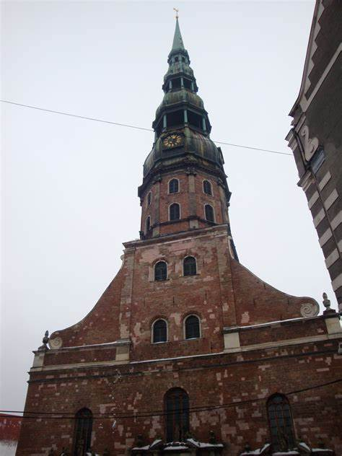
(Dhr Bhoon, 2020)
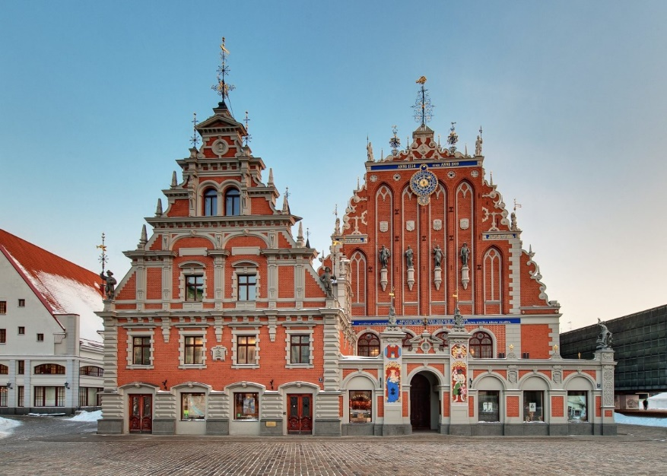
(Live Riga, 2020)

Context and Historical background.
The first building in this discussion will be the St. Peter’s Church situated in Riga, Latvia, in the old part of capital city centre. In 1977 was officially included in UNESCO world heritage sites and is one of the most valuable buildings of medieval architecture in Latvia (St Peter’s Church, 2020). The first plans of the building date back to 1209 but the architect is not mentioned. The first person to be associated with the construction of the building was building master Johannes Rumeschottel between 1408 - 1409 who supervised the construction and since then the church has had over 20 different architects and building masters as it has had to be reconstructed several times through its life (Ancient and medieval architecture, 2017).
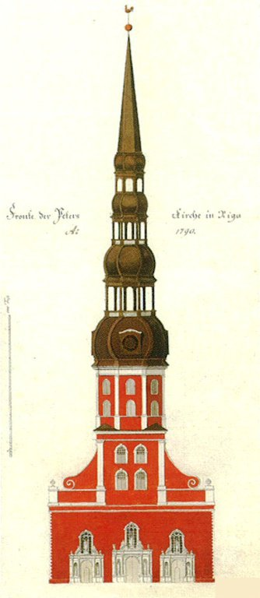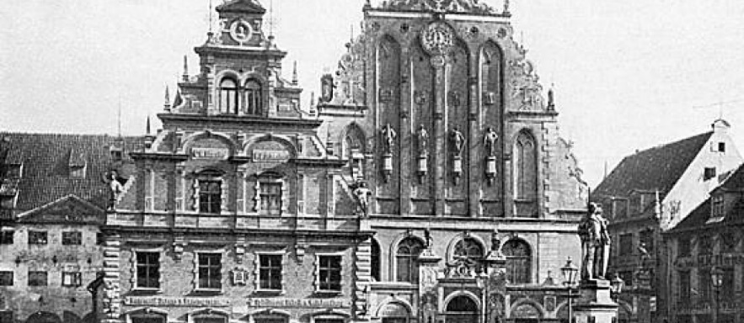
(Broce, 1790) (Melngalvju Nams, 2020)
The second to be discussed is The House of the Blackheads that sits one road ahead of St Peters Church was first built in 1334 by a guild of merchants. Building was destroyed during WW2 by Germans under a mission called “Barbarossa” but was rebuilt in 1999. Historically the buildings focus was to promote business, a place of gathering for shippers and traders. The brotherhood of the Blackheads was a group of young unmarried traders who also organised social events at the property. There is no mention of an architect but most of the detailing has been added periodically through its life up until it was demolished.

Plan and Section:
The St Peter’s church is comprised of three-nave basilica also housing polygonal chancel and an ambulatory. The façade facing west obtained a 136m high tower in 15th century however it collapsed in 1666 and re-erected second time in 1690 at 148m high (thought to at the time being the tallest wooden constructed tower in the world) (St Peter’s Church, 2020). The original tower was gothic style but since then the tower has collapsed several more times, due to a lightning strike, wars and sieges of the city and has undergone several design changes ending in baroque style. The nave and presbytery are wrapped from the outside with numeral buttresses and large pointed windows. The interior ceiling is covered in stellar vaults and painted star designs (Ancient and medieval architecture, 2017).
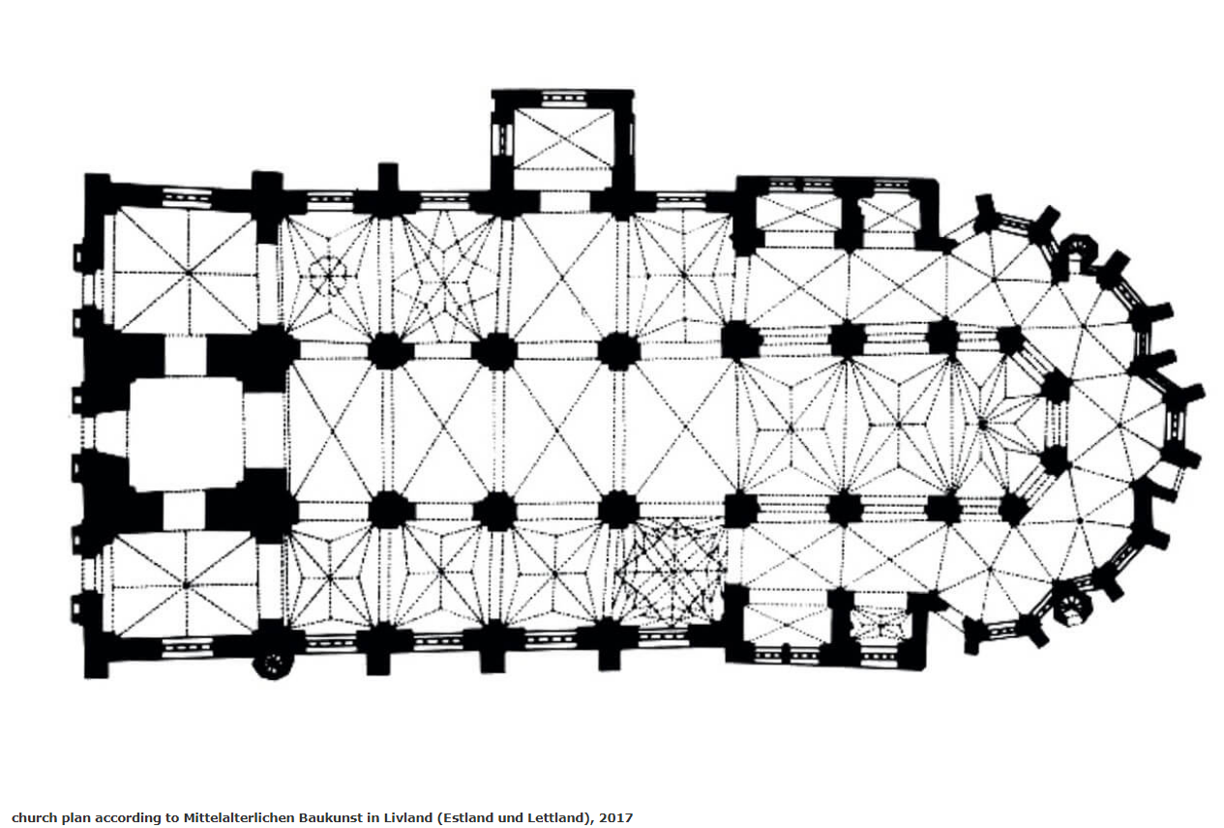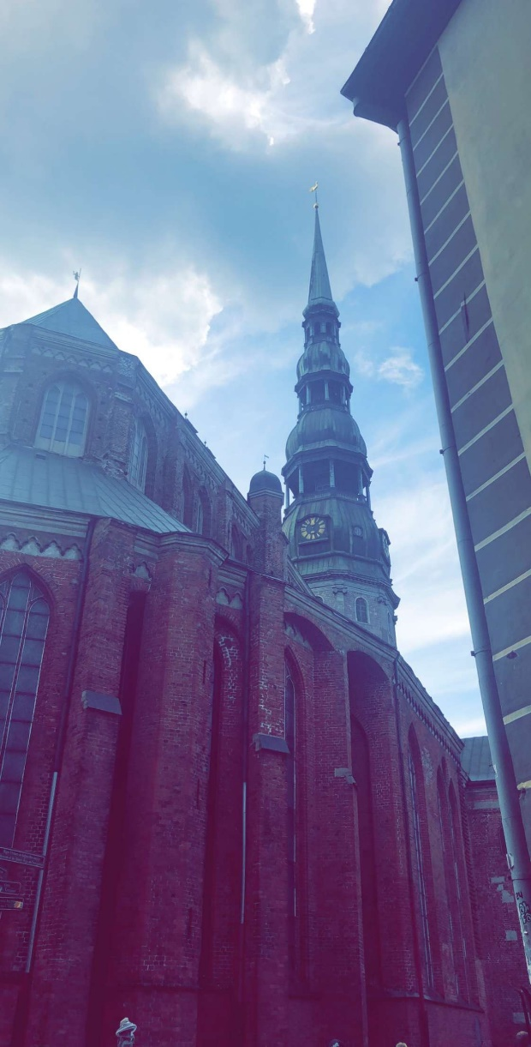
(Ancient and medieval architecture, 2017) My own picture of St Peter’s Church (2018)

The House of blackheads is set out plan wise in the manner of a palace, with grand ball rooms on the first floor and private chambers and offices on the ground floor. The building is facing and situated in the Riga old town central square and today stands opposite the main council building. In the basement there are links to the underground tunnels running under the whole of the city dating back to 14th century and is the only part of the building that stands original. The basement originally was used to house trading goods and warm air furnace. There does not seem to be much information regarding the physical plans of the building just the general purposes of the spaces inside.

Materials and Light:
The materials used in the construction of St Peter’s Church were timber, brick and stained-glass windows introduced in later years. During the 19th century the church underwent several construction and design changes. A new altar and marble pulpit was added as well as cast iron stoves and gas lighting introduced (St Peter’s Church, 2020). The glass windows were introduced on southern side of the building.
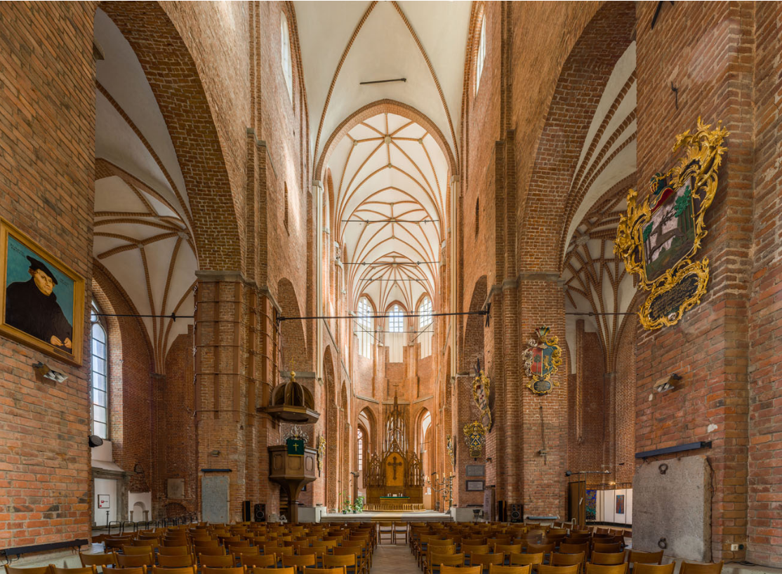
Central Nave St Peter’s Church (Ancient and medieval Architecture, 2017)
The materials used in the construction of the House of the Blackheads are modern since it is a reconstruction. It’s simple masonry embellished on the façade. The style of the building has gone through several stages of adding and combining different styles (Ancient and medieval architecture, 2020). In the original build mannerism was introduced in 17th century and developed further on to baroque and internally almost Rococo especially in the ballrooms and offices. Grand crystal chandeliers help with the light distribution across the space as the windows are in comparison small.
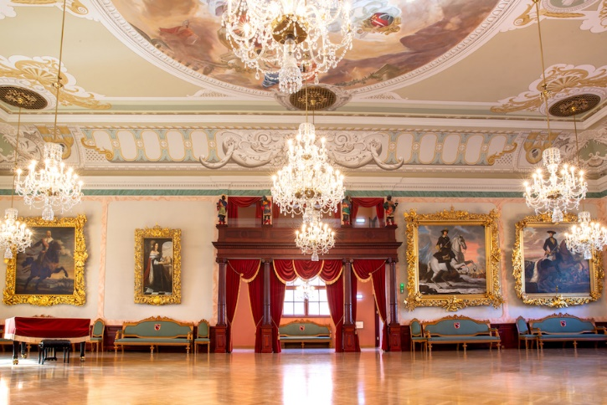
Interior of the House of The Blackheads (Live Riga, 2020)

Use:
St Peters Church has several uses besides being a church it also serves as an art gallery, information centre and a tourist attraction especially for the tower use (St Peter’s Church, 2020). Visitors can purchase tickets for tower visit at the entrance where an elevator takes you to the top of the tower from which you have 360-degree view of the whole city centre (Magnetic Latvia, 2020). The building also has a basement that facilitates public restrooms and a cloak room.
The House of the Blackheads previously used mainly for business and social events is now a museum and a gift shop. The museum tour only leads you through some of the building leaving the rest for private use and functions. During the reconstruction of the president’s castle between 2012 – 2016 it also served as presidents main offices and housing (Live Riga, 2020). Now the venue offers their space up for concerts, weddings, private events as well as greeting international political guests and people of importance to the state.

Conclusion:
To sum up I personally would say this task has taught me a lot regarding the surroundings I grew up in and assumed that school history lessons would have taught me enough. The relentness of Latvian culture / people regarding rebuilding the church over and over time again to the fact that I’ve never stopped to notice on the coats of arms for The House of Blackheads its two Egyptian men and an Egyptian male head. For 13th century highly religious country on continuous government changes to have a coat of arms with those features shows just how much of a port city it was and how much world trading had influenced the social norms. The guild was for single travelling men and yet it became so prestigious in church they would have their own highly decorated pews (Melngalvju Nams, 2020). Main reason for my selecting these two buildings was because of the proximity to each other and close age with one coming from a religious background and the other from social and both have ended up serving their original purpose still but with additional uses.
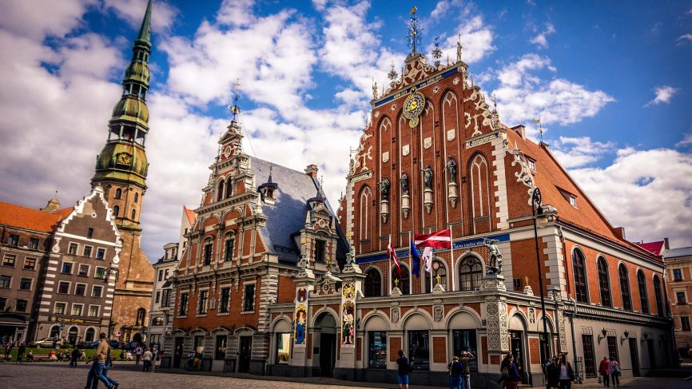
Both buildings in one picture above ( European chess Union, 2020)

Ancient and Medieval Architecture (2017) Riga – St Peter’s Church. Available at: https://medievalheritage.eu/en/main-page/heritage/latvia/riga-st-peters-church/ (Accessed: 25th January 2021)
Ancient and Medieval Architecture (2020) Riga – House of the Brotherhood of Blackheads. Available at: https://medievalheritage.eu/en/main-page/heritage/latvia/riga-house-of-the-brotherhood-of-the-blackheads-melngalvju-nams/ (Accessed: 25th January 2021)
Live Riga (2020) House of the Blackheads. Available at: https://www.liveriga.com/en/2023-House%20of%20the%20Black%20Heads/ (Accessed: 25th January 2021)
Magnetic Latvia (2020) Riga St Peter’s Church. Available at: https://www.latvia.travel/en/sight/riga-st-peters-church (Accessed: 25th January 2021)
Melngalvju Nams (2020) History. Available at: https://www.melngalvjunams.lv/lv/ekspozicija/vesture (Accessed: 25th January 2021)
St Peter’s Church (2020) History. Available at: https://peterbaznica.riga.lv/en/history-/ (Accessed: 25th January 2021)
Dhr Bhoon (2020), St Peter’s Church. Available at: http://archikey.com/building/read/2743/St-Peter-s-Church/494/ (Accessed 25th January 2021)
EuropeChess (2018), EUROPEAN YOUTH CHESS CHAMPIONSHIP 2018- Regulations. Available at: https://www.europechess.org/european-youth-chess-championship-2018-regulations/ (Accessed: 25th January 2021)

