University of Wales Trinity Saint David

555 Timer Circuit
ACDA 4018: Fundamentals of electrical and electronic systems

Name - Luke Brown (ID-2309075)
Course - Ordnance Munitions and Explosives (OME)
Tutor – Stalin Jacob
Submission Date – 22nd July 2024

Table of Contents:

Section 1 – Introduction

- Operation of the 555 timer IC……………………………………………….……..……………. (Page 3-5)
- Proteus design software……………………………………………….………………………………. (Page 6)
- Function of a breadboard……………..……….……………………………….……………………. (Page 6)
- 555 timer circuit schematic….………………..…………………………………….………………. (Page 7)

Section 2 – Theoretical model

- Proteus model…….…………………………………………...………………………………………….. (Page 8)
- Theoretical results…………………..………………………………..………………………………. (Page 8-9)

Section 3 – Experimental model

- Breadboard model…………..……………….………………………………………………….………. (Page 9)
- Experimental results……………………………………..……………………………………………. (Page 10)

Section 4 – Discussion

- Interpretation and comparison of results………………………………………….……….. (Page 11)

Section 5 – Conclusion

- Accuracy and future improvements……………………………………………………..…….. (Page 12)

Section 6 – References

- All referenced citations…………………………………………….……………….………..… (Page 12-13)

Table of figures

Figure 1 – 8 pin 555 Timer IC…………………………………..…………….…………………………………. (Page 3)

Figure 2 – Internal Circuitry of the 555 Timer IC…..………………………..…..……………………. (Page 5)

Figure 3 – Breadboard Connections………………………………………………………..……………….. (Page 6)

Figure 4 – 555 Timer Circuit Schematic….…………..…………………………………..……………….. (Page 7)

Figure 5 – Proteus Theoretical Model.……………………………………………………………………… (Page 8)

Figure 6 – Proteus Oscilloscope Results.……………………….………………………………..………… (Page 9)

Figure 7 - Breadboard 555 Timer Circuit...………………………………………………………………… (Page 9)

Figure 8 – Breadboard Oscilloscope Results...………………………………………………………… (Page 10)

Introduction:

Operation of the 555 timer IC:

The 555 timer is an 8 pin integrated circuit primarily used in timer/ oscillator circuits. It was first conceived in 1971 and is named after an original model containing 3, 5kΩ resistors, as explained by [1]. The integrated circuit works by utilising a regenerative feedback loop, changing its own internal state to alter the square wave output between two given responses. This is a useful function to withhold, along with its ‘low price, ease of use and stability’ [2], resulting in it still being widely used in circuits to date.

The 8 pins (Figure 1), detailed by [1] include:

- Ground – A safety measure to protect the circuit from a surge in the current.
- Trigger – Passes on voltage to start the timing operation.
- Output – Supplies voltage to the load device.
- Reset – Ends the timing operation.
- Control voltage – An optional pin that controls the circuit outside the main setup.
- Threshold – Determines the length of time the timer should output voltages for the cycle.
- Discharge – Typically connected to a capacitor, also influences the timing circuit.
- +$V_{cc}$ – Input voltage.

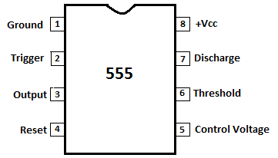
Figure 1 - 8 pin 555 Timer IC [2]

The internal circuitry of the 555 Timer IC (Figure 2), detailed by [3, p. 4-5] involves:

- Voltage divider – Provides a reference voltage at 1/3 and 2/3 of the supplied voltage across the comparators.
- Comparators – Compare two voltages at the input level, one is inverting (-) and the other non-inverting (+). If the non-inverting (+) voltage is higher, then the output is high. Likewise, if the non-inverting (-) is higher, then the output is low. This output is passed on to the flip/ flop.
- Flip/ Flop – A digital electronic device with memory. It has two stable states, 1 and 0. When S is high and R is low, Q is 1, when S is low and R is high, Q is 0, when both S and R are low the outputs don’t change, when both S and R are high, the state is invalid. This digital output is then passed onto the inverter.
- Inverter - After the digital signal leaves the Flip/ Flop through Q’ (which is the inverse of Q), it passes through an inverter. This effectively reverts the digital output back to the output seen at Q on the flip/ flop.

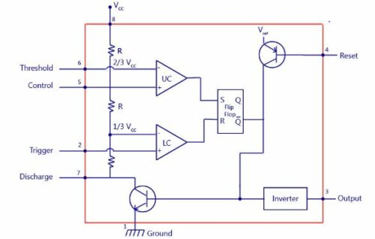
Figure 2 - Internal Circuitry of the 555 Timer IC [2]

555 timer IC operating modes, as explained by [3, p. 6]:

Monostable – There is one stable and one unstable state. It involves the 555 IC acting as a ‘one-shot’ pulse generator. An interruption may temporarily cause the IC to enter the unstable state, then once the interruption is removed, it will automatically revert to its original stable state.
Bistable – There are two stable states. The IC acts similar to a flip/ flop, as an interruption may cause the IC to switch states. It will then hold this state until the next interruption.
Astable – There are no stable states. The IC acts as an oscillator, as an interruption will cause the IC to swing back and forth in states. This is the type of 555 timer IC used later on in this essay due to its speciality in timer circuits.
Proteus design software:

Proteus is a circuit simulation design software. It is used to ‘design, test and debug your embedded projects’ [4]. It also has many other benefits, such as ‘completing embedded workflows, the Proteus VSM environment (microcontroller simulation) and measurement/ analysis’ [4]. This results in Proteus being a useful asset to test circuit ideas prior to creation, as well as providing accurate solutions using simulated measurements. Furthermore, Proteus removes ‘hardware restrictions’ [5, p. 1]. This is beneficial for electronic learners who are more economically challenged, allowing them to benefit from a cheaper education.
Proteus is used in this essay as a way to provide a theoretical model of a circuit prior to its experimental creation. This is utilised to predict the circuit’s performance and calculate electrical values using a vast array of digital measurement probes.

Function of a breadboard:

A breadboard provides a solderless base for electronic prototyping, as explained by [6]. It is simple and easy, providing holes to join electronic components for the creation of small circuits. Furthermore, the non-permanent connections allow for effortless changes of components. Additionally, in a world of ever-increasing simulation, physical experiments are very important in proving ‘if the laws posed by scientists like Ohm and Kirchhoff correspond with nature’ [7, p. 2]. This is vital in educating students, displaying the real-world application of certain models.
Inside the breadboard are ‘rows of tiny metal clips’ [8]. These clips grab hold of component leads, providing a connection. The connections then act in ‘rows, columns and buses’ [8]. As seen in Figure 3, the horizontal lines are columns and the vertical lines are rows. The buses include the yellow lines with + or – at the top. These buses describe the points of electrical power supply for the breadboard. A battery is to be connected across the columns with the correct arrangement of positive and negative terminals. Breadboards also typically feature a ravine in the middle. This splits up the breadboard into two halves and is typically used by larger ICs.

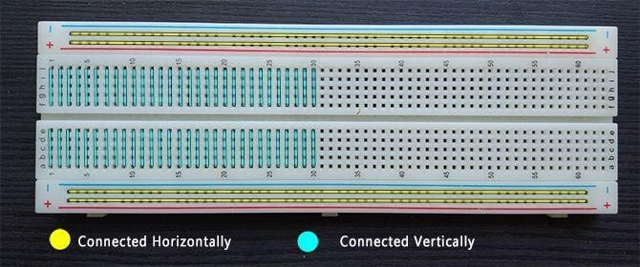
Figure 3 - Breadboard Connections [5]

555 timer circuit schematic:

The schematic discussed in this essay is shown in Figure 4. It features a 555 timer IC, 4 resistors, two capacitors, 2 LEDs, a power supply and a ground. The resistors and capacitors are set up in a way to cause correct current flow and timing operation. The values of these two components determine the period and frequency of the square wave output signals. This means that after changing the resistance and capacitance values of the timing components, the blink rate of the LEDs would alter. The equation ‘T = 0.69(R1+R2)*C1’ [9, p. 22] can be used to calculate the high state time period of the signal and the equation ‘T = 0.69(R2)*C1’ [9, p. 22] can be used to calculate the low state time period. Using the equations stated, it can be predicted that T = 0.69(1000+10000)*(0.0001) = 0.76s for the circuits on-time and T = 0.69(10000)*(0.0001) = 0.69 for the circuits off-time. This means the overall time period is expected to be 1.45s and the frequency is expected to be 0.69Hz. This is compared to our theoretical and experimental model signal time periods later on.
R3 and R4 have unknown resistance values. These values can be calculated using the equation$\frac{V_{cc}-V_{f}}{I_{f}}=R$. $V_{cc}$ = Voltage supply, $V_{f}$ = Forward voltage and $I_{f}$ = Forward current. This equation is used later on in the theoretical model in an attempt to calculate unknown resistance values.
It is also seen that pin 8 (+Vcc) is connected directly to the power supply and pin 1 (Ground) is connected directly to the ground. The other pins are connected to their allocated branches of the schematic, allowing the circuit to function correctly. This is seen as R1, R2 and C1 are the timing components and R3, R4, D1 and D2 are the load components.

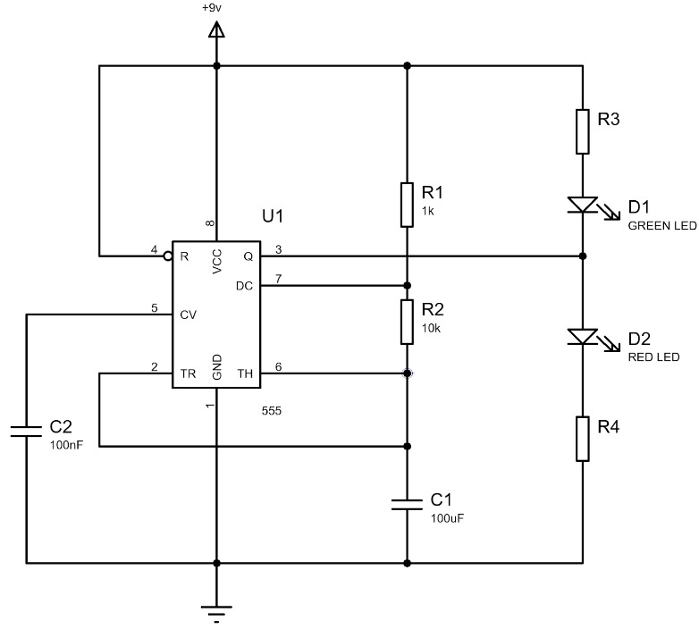
Figure 4 - 555 Timer Circuit Schematic
Theoretical model:

Proteus model:

The created Proteus theoretical model can be seen in Figure 5. This model is based directly off of Figure 4. However, it also contains an oscilloscope used to measure the square wave signal, as well as the (C1) capacitor charging and discharging signal.

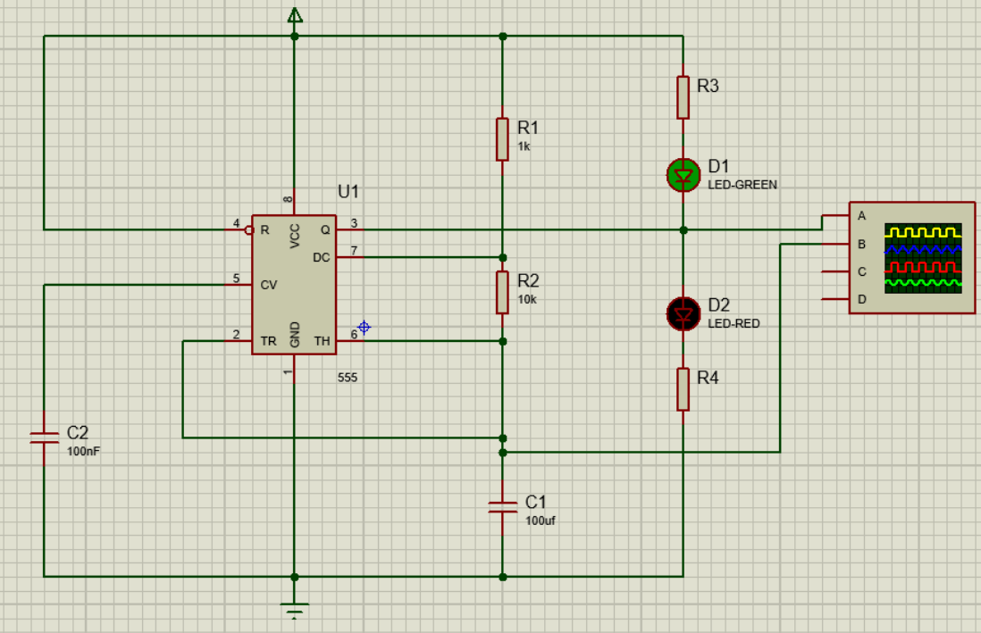
Figure 5 - Proteus Theoretical Model

Theoretical results:

Using the equation$\frac{V_{cc}-V_{f}}{I_{f}}=R$,$\frac{9-2.2}{20×{10}^{-3}} =340Ω$. This is the resistance of R3 and R4 based on the voltage and current values of the LEDs in the Proteus software.

Proteus square wave results table (from Figure 6):

On-time (s) | Off-time (s) | Period (s) | Frequency (Hz)
0.76 | 0.70 | 1.46 | 0.68

We can also see the blue signal in Figure 6 displaying the charging and discharging of the (C1) capacitor. This shows a precise rhythmic pattern of charging when the square pulse is high and discharging when the square pulse is low. There is also a stark difference in voltage between the square pulse and the capacitor signals.
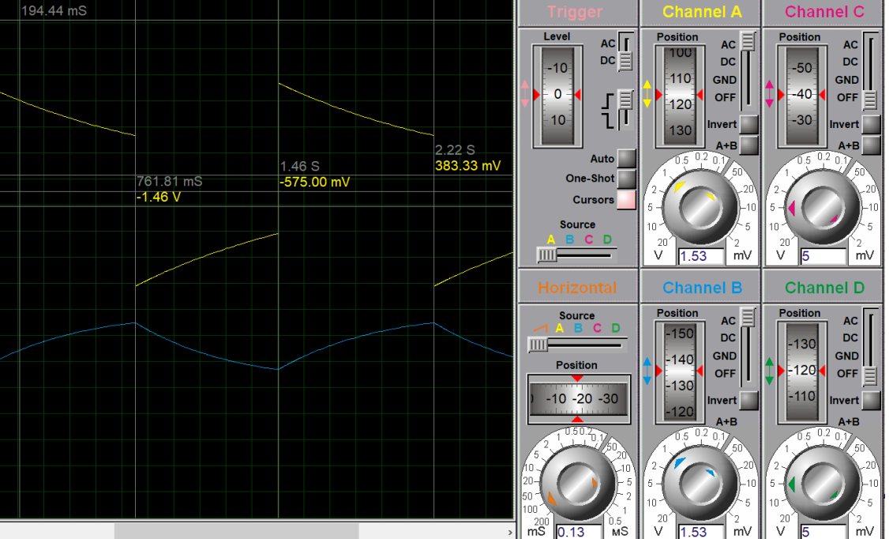
Figure 6 - Proteus Oscilloscope Results

Experimental model:

Breadboard model:
The breadboard experimental model created can be seen in Figure 7. This model is based directly off of Figure 4. However, it also contains an oscilloscope used to measure the square wave signal (Figure 8), as well as the capacitor charging and discharging signal.
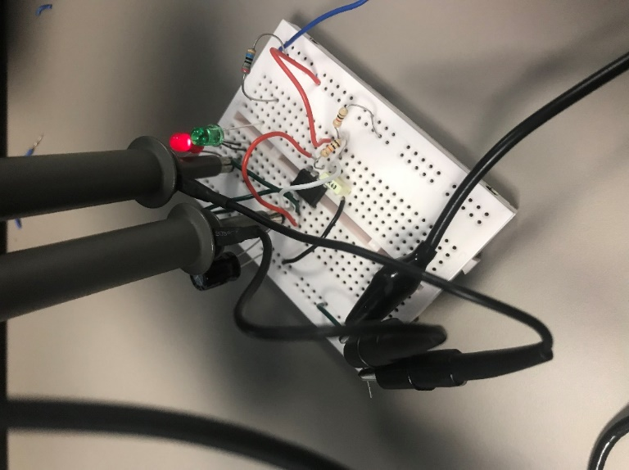
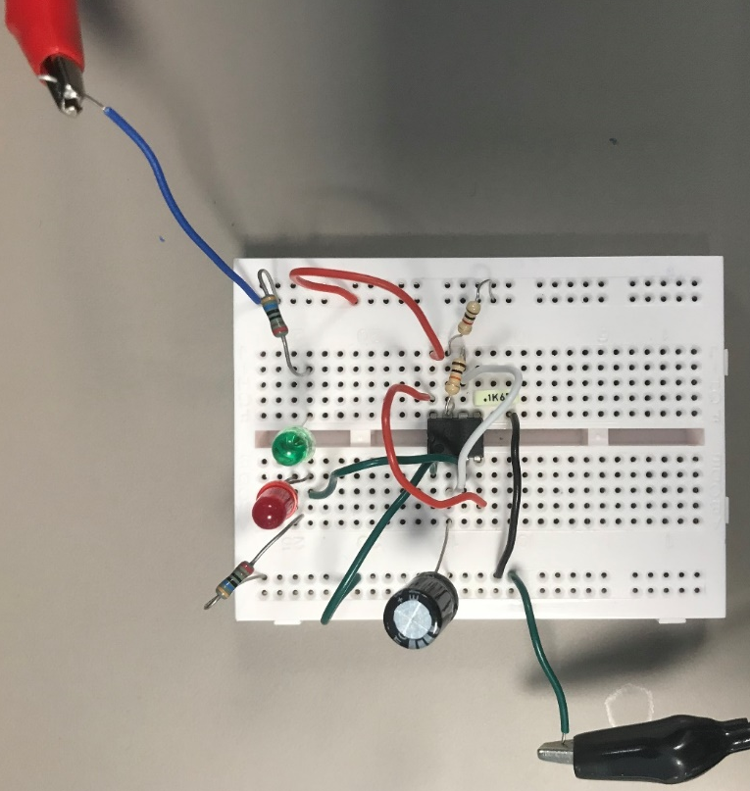
Figure 7 - Breadboard 555 Timer Circuit

Experimental results:

The resistors used with an unknown resistance value featured the following colour bands:

Band 1 – Red. Band 4 – Black.
Band 2 – Brown. Band 5 – Blue.
Band 3 – Black. Band 6 – Yellow.

Using a colour code calculator [10], the resistance calculated via the bands is 210$Ω, 0.25\%$, 25ppm.
In addition, a multimeter was used to measure the resistance across the resistor terminals, providing the following results:

R3 = 210$Ω$
R4 = 210 $Ω$

Breadboard square wave results table (from Figure 9):

On-time (s) | Off-time (s) | Period (s) | Frequency (Hz)
0.75 | 0.69 | 1.44 | 0.69

We can also see the yellow signal displaying the charging and discharging of the C1 capacitor. This shows a precise rhythmic pattern of charging when the square pulse is high and discharging when the square pulse is low. There is also a stark difference in voltage between the square pulse and the capacitor signals.

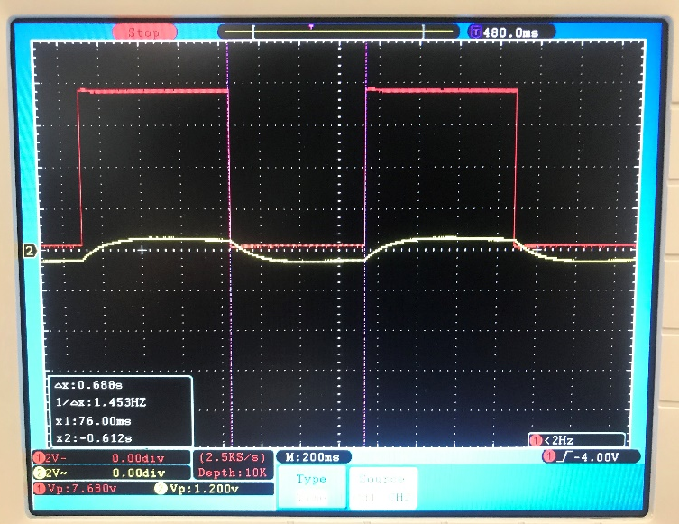
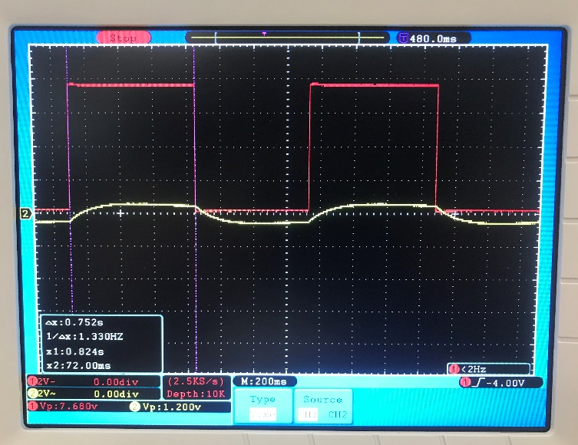
Figure 8 – Breadboard Oscilloscope Results
Discussion:

Interpretation and comparison of results:

It is seen that the results are similar in both theoretical and experimental models. However, there are some subtle differences. These include the resistance of the resistors R3 and R4 being 130$Ω$ apart. This difference will have a limited impact on the circuit as the resistors are only present to draw current through the LEDs. Therefore, a change in resistance would only alter the current and voltage flow. In addition, a change in resistance may also change other aspects, such as the time constant of the capacitor as explained later. Although this results in some slight changes to the circuit, there will be no effect on the time period or frequency.
The square wave results, from both models, show a very strong connection between on-time, off-time, period and frequency. Regarding on-time and off-time, the experimental results are just 0.01 seconds out from the theoretical results. For this reason, period is only 0.02 seconds different and frequency is just 0.01Hz different. This suggests the results produced from both models are valid and consolidates that the theoretical model accurately represents the experimental model. Furthermore, the results are backed up by the equations utilised in the 555 timer circuit schematic portion of this essay. It was predicted an overall time period of 1.45s, which is $± 0.01s$ of both models. Hence, the frequency is also closely related, meaning we can accurately determine that our results are correct with little uncertainty.
However, there is a difference in the square wave signal. In the theoretical model, the peak of the square has a drop of voltage over time. This voltage drop is similar in shape to the discharging of a capacitor. This drop is due to C1 charging as the IC changes states. This causes a potential difference drop across the LEDs and a potential difference rise within the capacitor. Surprisingly, in the experimental model, the pulse peak remains at a stationary voltage. This effect was not seen due to the square pulse maintaining a constant voltage supply from the 555 timer which is not accurately displayed via the theoretical model.
The C1 capacitor charging and discharging signals follow the same pattern of charging when the square wave is high and discharging when it is low. Despite this, the experimental model shows a signal profile with a lower time taken to charge to its maximum voltage. This suggests the capacitor experimental model time constant was lower than expected from the theoretical model. Using the equation ‘T = R*C’ [11], we know the time constant of a capacitor is related to resistance and capacitance. As capacitance and resistance of the timing components is the same in both models, there must be an alternate reason for the change in time constant. This difference is likely due to the difference in load current in both the models. As the theoretical model load resistance is 640$Ω$ and the voltage is 9V. Current is calculated as 0.014A using ohms law (V=IR). Whereas, in the experimental model, resistance is 420 $Ω$and the voltage is 9V. Therefore, current is calculated as 0.021A. This increase in load current in the experimental model is likely the reason for the difference in time constant. It is expected that as a higher current is present, the load voltage is drawn more quickly, resulting in a shorter time constant for the experimental model.

Conclusion:

Accuracy and future improvements:

The results produced are shown to be highly accurate due to the preciseness of results produced from both models and the equation used earlier. The only queries regarding accuracy involve the difference in pulse shape of the square wave and capacitor signal. To improve the experiment and validate these queries, I would use resistors in the experimental model that match the resistance of R3 and R4. After that I would repeat the experiment and compare the capacitor time constant to the theoretical model. Furthermore, I would investigate the square pulse in both models by taking extra oscilloscope measurements to better interpret the cause of the on state square wave voltage discrepancy.

References:

All referenced citations:

[1] – “ElectronicDesign,” (13/07/2024) the Origin, Explanation, and Applications of Triple-Five Timers, Available: The Origin, Explanation, and Applications of Triple-Five Timers | Electronic Design

[2] – “Electronicsforu” (13/07/2024) 555 Timer IC Pinout, Circuit, Working, and Datasheet, Available: 555 Timer IC Pin Diagram, Circuit, Working, Datasheet, Modes (electronicsforu.com)

[3] – Himani Goyal, (January, 2015) “Understanding of IC555 Timer and IC 555 Timer Tester,” International Journal of Inventive Engineering and Sciences (IJIES), vol. 3, no. 2, pp .4-6, Available: B0575013215 (psu.edu)

[4] – “Proteus” (14/07/2024) Circuit Simulation Software, Available: Circuit Simulation Software with SPICE (labcenter.com)

[5] – Katya Asparuhova, Daniela Shehova, Slavi Lyubomirov, (September 2018) “Using Proteus to Support Engineering Student Learning: Microcontroller-Driven Sensors Case Study” International Scientific Conference Electronics, pp. 1-4, Available: IEEE Xplore Full-Text PDF:

[6] – “Soldered” (15/07/2024) what is a breadboard and how to use it, Available: What is a breadboard and how to use it - Soldered Electronics

[7] – Ingvar Gustavsson, Thomas Olsson, Henrik Åkesson, Johan Zackrisson, Lars Håkansson, (2005) “A Remote Electronics Laboratory for Physical Experiments using Virtual Breadboards,” Department of Signal Processing, School of Engineering, pp. 10-80, Available: A REMOTE ELECTRONICS LABORATORY FOR PHYSICAL EXPERIMENTS USING VIRTUAL BREADBOARDS

[8] – “Sciencebuddies” (16/07/2024) How to Use a Breadboard for Electronics and Circuits, Available: How to Use a Breadboard (sciencebuddies.org)

[9] – Moyeed Abrar, (2017) “Design and implementation of astable multivibrator using 555 timer,” IOSR Journal of Electrical and Electronics Engineering, vol. 12, no. 1, pp. 22-29, Available: E1201022229-libre.pdf (d1wqtxts1xzle7.cloudfront.net)

[10] – “DigiKey” (17/07/2024) 6 band resistor color code calculator, Available: Resistor Color Code Calculator - 4 band, 5 band, 6 band | DigiKey Electronics

[11] – “Keysight” (17/07/2024) the art of calculating time constants in RC and RL circuits, Available: The Art of Calculating Time Constants in RC and RL Circuits - Used Keysight Equipment

