Evidence Based Practice

Sian Roberts – June 2024

Contents

The concept of Evidence Based Practice (AC 1.1) Page 3

Evaluation of analysis tools to support EBP (AC 1.2) Page 5

Principles of Critical Thinking (AC 1.3) Page 7

Decision Making Processes (AC 1.4) Page 7

Bibliographic Page 10

Introduction
In preparation for the upcoming senior management meeting, I have complied a report to provide an evaluation in all areas of Evidence Based Learning. The purpose of the report is to provide an understanding of what evidence practice is and the strategies that can be taken for effective critical thinking and decision-making.

AC 1.1
‘An evidence-based practice as an approach to decision-making is based on a combination of using critical thinking and the best available evidence’ (Young 2020). The concept of Evidence based practice is to make decisions and find solutions based on critical thinking and the use of data. This is done by assessing the decision against the best available data in order in to reach the most appropriate and desired outcome.
By following this approach, the hope is to ensure that HR decisions are not as influenced by factors such as personal experiences and personal opinions.
EBP employs several models to assist with this process. One of these models is the Rational decision-making model. This breaks down decision into 6 steps which are outlined in the below infographic.
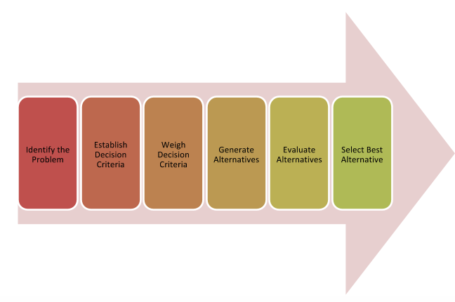

Figure 1: Rational Decision-Making Model (Lumemlearning.com, 2019)
In the table below you can see the people practice decision of implementing an employee benefits platform broken down into 6 stages.

Rational Decision-Making Model | Implementing a new benefits platform
- Identify the problem | The organisation needed a new benefits platform as part of a recruitment and retention strategy.
- Establish Decision Criteria | To establish the decision criteria – we sent out staff surveys so employees could list and rank factors in order of most important to least important.
- Weigh Decision Criteria | After sending out a survey on what employees what like included, criteria was ranked on factors such as wellbeing offers, discounts and inclusion extras such as Cycle to Work schemes.
- Generate Alternatives | We reached out to employee benefits providers and looked at their offerings.
- Evaluate Alternatives | We benchmarked the staff survey findings to the offerings of each to see which provider could fit into the criteria
- Determine Best Solution | After determining that one provider could offer all criteria plus additional services – we launched a platform with them.

Scott et al (1995) focused on thorough research and logical evaluations as main components for the rational decision-making model. The model supports making decisions by breaking down the process into compartmentalised steps, providing structure and discipline. By doing this, it allows the decision maker to focus on the relativity of the problem which in turn ensures only relevant data is used against the possible solution.
The model has further advantages such as reducing the risk of decisions being influenced by personal assumptions that are not based on factual data. It is suggested that the model can lead to better long-term decision then other models.
This model is best employed when there is a complicated decision with a variation of factors to consider. Uzonwanne (2016) who noted that the rational decision model would ‘apply to higher level decision making of a more serious nature’ therefore this model could assist in high-level business decisions such as restructures and change management.
The model however does have some limitations. It can be considered time consuming meaning it may not be helpful in a fast-moving situation. This is further supported by the fact it requires a lot of information/data to complete. This means the full process may not be efficient for some decisions, as well as not being necessary for decisions that can considered ‘smaller’. Hitt et al (1991) explained the use of the model is complicated and can have implications on future research and decision making.
Another model used within Evidence based practice is the Bounded Rationality Decision making model. This model’s strategy is to obtain a satisfactory result rather than the optimal solution. Banks et al (2014) noted that ‘bounded rationality is choosing the best solution, given the limitations of information and cognitive capacity’.
An advantage of this model is it takes less time and resources therefore it can be more efficient for fast moving situations and decisions. However, using this model may lead to decisions that are more effective in the short term and not as well suited to long term goals. This is since making the decision, there was not capacity to work out the long-term effects.
Within both models discussed as well as Evidence based practice, it is imperative to use the best available evidence. Barends et al (2014) define evidence as information, facts or data supporting a claim, hypothesis, or assumption.
Barends et al (2014) look at the four sources of evidence and while collating data from these four sources, it is imperative that as HR professional ensure the quality and integrity of the data. This can be done by through 6 steps which are detailed in the infographic.
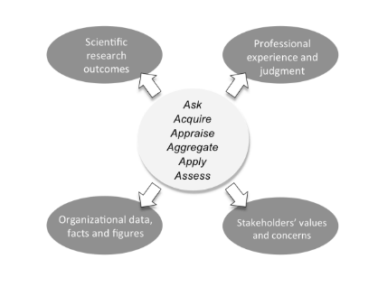

Figure 2: Four sources of Evidence Barends et al (2014)
AC 1.2
There are a range of tools to help support people practitioners diagnose or identify current/and or future challenges.
SWOT was developed by Albert Humphrey. The model looks at internal and external factors that could possibly impact the organisation. Strengths and Weaknesses focus more on internal factors whereas threats and opportunity focus more on the external factors. SWOT has ‘been extended beyond companies to countries and industries and is used in virtually every published business case for business analysis’ (Helms 2010).
Within my own organisation, I have used SWOT to analysis the way in which we recruit and retain apprentices.
To complete the analysis, I made comparisons with sector metrics and researched into other company offerings.
The table below outlines the findings of this analysis:
Strengths | - One of the most generous compensation packages for apprentices within the South Wales Area.  - A full support programme within the organisation for apprentices while studying – which includes an additional half day study leave to work on the qualification.
Weaknesses | - An online application that takes more than 15 minutes to fill out.  - Budget constraints which means no negotiation on salary or benefits.
Opportunities | - By hiring apprentices, we have access to a larger pool of candidates for each role.  - With the recent change to hybrid working – we may have a larger geographical to recruit from.
Threats | - A longer recruitment process than most other businesses in the area so a chance to lose potential candidates.  - Increased recruitment demands across the South Wales Area

This analysis tool has many positives. In comparison to other models, it is simple and can normally be applied to any organisational situation. Furthermore, the analysis allows you to see four different areas of a situation in one shot while integrating data for each area. This analysis is also low cost for many organisations as it doesn’t rely on specific software’s or data, rather it can be tailored to what is available in the given situation.
However, the SWOT analysis comes with its limitations. While the tool does simplify analysis, it does not outline priorities. Hill et al (1997) conducted research into the use of SWOT analysis within businesses and found there was a failure to prioritise after using the tool and that there was no attempt to verify any points within the analysis with data.
This would mean while the analysis can be used with data, it can also be subjective. The analysis is only as functional as the data used to complete it, meaning it may be clouded by personal opinions or lack of factual evidence.
To help support the analyse, we drew comparisons from sector metrics. Using this method allowed us to compare our own offering against other organisations and identify gaps within it. By doing this – it helped us focus on areas that needed addressing.
However, this method does have limitations. Some of the metrics may be inappropriate, for example a small business might not be comparable to a metrics of a larger company.

AC 1.3
The CIPD (2019) has defined critical thinking as ‘the ability to think well and reflect objectively on the ideas, opinions and arguments of other’.
Evidence based practice focused on asking relevant questions as discussed in AC 1.1 and this is a primary to critical thinking.
Critical thinking allows you to form a judgement by analysing and evaluating information rather than forming decisions influenced by factors such unconscious or conscious bias. It also allows you to question evidence sources and form well-reasoned and researched arguments. CIPD (2022) states that decisions made through critically appraised evidence yield more effective outcomes.
HR professionals need to be able to practice critical thinking to participate in the wider strategic conversations that may happen within organisations, as well as people practice issues.
In my own practice I have used critical thinking to help evaluate my decisions and be led by fact rather than opinion. An example of this, was implementing a new process for sending out new starter documentation. By using critical thinking, I was able to stream down the process, eliminating two steps. When appeal to history was argued I was able to demonstrate that the new process was more effective, separating opinion from fact.

AC 1.4
Decision making is a process of evaluating a solution/(s) to an identified problem.
This could be used to help assist in the implementation of the new employee benefits package as discussed in AC 1.2. There are various decision-making processes you could follow, however I have chosen to focus on the Six Thinking Hats (De Bono, 1985), Action Learning approaches and Best Fit
The Six Thinking Hats (De Bono, 1985) allows decision makers to compartmentalise 6 stages of the decision-making process with the idea that efforts are solely focused on one hat at a time. The below infographic outlines each of the six hats and their roles.
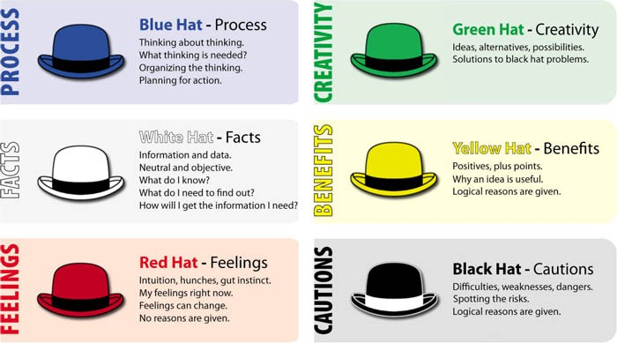

Figure 3: Six Thinking Hats (trickle.com)

This model would be effective in supporting the decision for a new employee benefits package because it would look at relevant categories within that decision. For example, the co-ordination element of setting up a programme (e.g., ensuring payroll is has capacity to carry out tasks relating to salary sacrifice, evaluating where the setup of a new starter on the programme sits in the on-boarding process) is not less throughout or dominated by ideas of what to include in the programme. By giving time to each component, it enables a comprehensive review of the entire implementation process and maximises productive collaboration.

The second decision making process which could support the implementation of the benefits package is using action learning approaches. (Hayden, 2021) describes action learning as a ‘form of collaborative learning where a small group of learners (an ‘action learning set’) meet regularly to reflect on real work issues’.
By using this process to look at the implementation – it will develop clarity on the exact nature of the problems with reflection and identification of solutions within a group dynamic. This will allow all relevant stakeholders to be present and participating but also to build a group dialogue about moving forward with the project. So, for example, we could include all the relevant departments in the decision-making process for the employee benefits scheme which could help explore new perspectives but also can help aid self-reflection for problem solving.
Lastly, the Best Fit approach could support in our decision for an employee benefits framework by allowing us to focus on what works best for our organisation needs. Best Fit practice focuses on the concept that there is ‘no universal way of doing things as what might work well in one place may be unsuccessful in another place’ (Adel, 2019).
As public body – we have different priorities and accountabilities than private sector business might. Therefore, when implementing a benefit package this process would work very well. Providers of employee benefits may work well with private businesses and could be considered best practice but may not align with our public sector organisation.

AC 1.5
CIPD (2023) define Ethical practice as ‘application of ethical values in organisational behaviour’. HR have a commitment to practice ethical and inclusive behaviours. Therefore, it is important for HR professionals to be aware of business ethics to ensure it can protect company reputation, retain a motivated, respected, and valued workforce and to apply and develop ethical values.
There are many Business ethic theories of which I would like to focus on two, Communitarianism and Utilitarianism.
Communitarianism focuses on the importance of community and wider society. Its core responsibility is to operate in a fair and socially responsible manner. It emphasizes the interests of the community over those of the individual. An organisation’s ethical view will be clear in their organisational culture. A communitarianism approach is suggested to be taken in a welfare-orientated organisation. Leeper (2002) suggested companies that place value in quality, social responsibility and stewardship fit within a communitarian approach.
My personal example of communitarianism decision making within an organisation is implementing a new policy that applies to all employees. A working from home policy was introduced to help with the cost-of-living crisis. By allowing employees to work from home, it eliminated their commuting costs.
However, this theory does not take into consideration individual views, beliefs, or personalities. So by implementing a working from home policy – we failed to identify that several employees may be productive within an office environment and therefore it may stunt their professional development.
Utilitarianism is an ethical theory that focuses on outcome. The theory makes decisions based on the greatest benefit for the biggest number of stakeholders, suggesting the most ethical approach is the one that will produce the greatest good. A utilitarianism approach is suggested to be mostly taken in profit-driven organisations. Micewski and Troy (2006) stated that utilitarian approach to merely to gain and maximize profit.
An example of utilitarianism decision making within an organisation is closing during Christmas. For example, if you were close a business down for 2 weeks during Christmas, employees of alternative faith groups may be forced to use mandatory annual leave to cover that time.
However, if much of the workforce celebrate and want to take leave during that time – then under a utilitarianism approach the policy is enforced and the company would close.
Ethical values of a company can impact the management and leadership styles. This can in turn impact on the organisational culture.
McGregor’s Theory X & Theory Y demonstrate the traits of a poor and good leader.
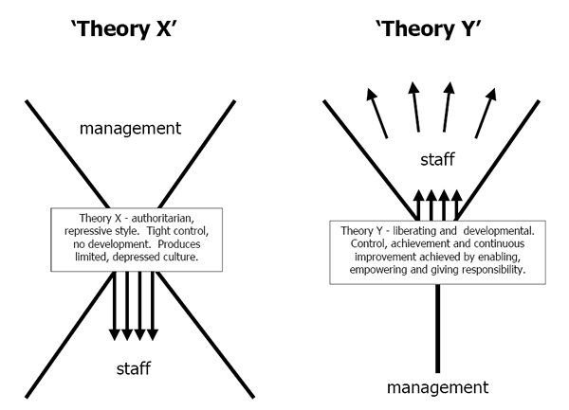

Figure 4: McGregors Theory of X & Y (Business Research Methodology)

An ethical leader is suggested to follow the traits and values set out in theory Y.
The impact this then has on the organisational culture is one of productivity, ethical practice, and high morale. It is also suggested that companies that follow an ethical approach are more profitability in the long term. According to a report published by the Institute of Business Ethics (2003) organisations that are explicit about business ethics out-perform in financial indicators in the long term against companies who do not have a code.
An example in recent times of poor ethical leadership was during the COIVD-19 pandemic. JD Wetherspoons faced negative press, criticism by industry leaders and suffered a damaged reputation for with-holding employee payments before the government had released the furlough support scheme. They also then only the statutory amount of sick pay if an employee was to contract COVID-19. CIPD HR-inform (2021) detailed that ‘organisations should consider the implications of employees feeling they cannot afford not to come into work despite potentially having the virus, and therefore spreading it amongst colleagues’

AC 3.1
Performance management can measured via financial methods and non-financial methods. Gifford (2020) stated that good performance management is essential for success within an organisation.
Financial KPI’s are metrics used to track and analyse the financial health of a company. KPI’s are important because they give you a value to compare against your current performance as well as being able to compare against previous performances. Implementing KPI’s means you can devise strategies for growth while evaluating performance.
Another financial measure is profit. Profit is the total expenditure minus the total revenue. Measuring profit is important in organisations because profitability determines and impacts if a company can expand it’s offering but also if it can attract investors and secure financing from a bank.
Organisations can also measure non-financial performance. (Ahrens and Champman, 2007) noted that non-financial consider different intangible assets and provide information on a range of operations effectiveness.
One approach is of non-financial performance looking at customer satisfaction. Customer satisfaction can be measured by reviews, surveys, and general feedback. The importance of measuring customer feedback is help identify product or survey problems, nurture consumer relations and manage reputation.
Another method would be to gather stakeholder feedback. Stakeholder feedback can be gathered by reports, staff surveys and questionnaires. Understanding stakeholders views and opinions can help improve the overall productivity and operation of the business.

AC 3.2
According to the Oxford English Dictionary the word value can be defined as the importance, worth or usefulness of something. Whereas the dictionary defines impact as an effect that something has on somebody or something.
It is important for people practice professionals to measure impact and value; it helps identify that objectives are being achieved, ensure useful people practice contribution and can help identify gaps in training, strategy or people practice activities.
By being able to measure all these aspects – it is suggested that it will help inform business decisions and help achieve desired outcomes.
The Kirkpatrick Model as seen on the infographic below demonstrates steps that can be taken to help evaluate value and impact.
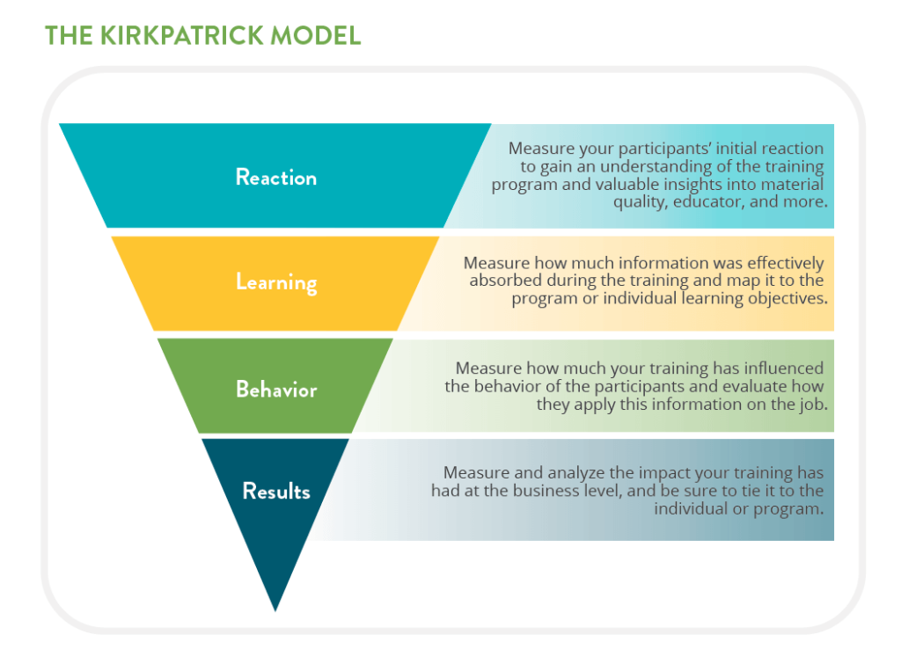

Figure 5: The Kirkpatrick Model (Linkedin 2002)

A people practice example where we can measure the added value and impact is in the delivery of wellbeing training and updated wellbeing policies. Due to an increase in employees on long term sick with stress-related symptoms – there was a lack of productivity across the organisation with services suffering and unable to deliver to stakeholders’ satisfaction. There was also a long-term financial impact with paying for absences and temporary staff to cover.
By expanding the Learning and Development team to include a Wellbeing Officer – who could deliver training internally to support employees to deal with stress, there was a marked improvement on the sickness absence rate per month and the financial cost associated with that. By adding that value, it was found to have a positive impact.
The evaluation method used was validation and a cost benefit analysis. The cost benefit analyses showed us that they additional salary and expenses paid were eventually off set by not paying temporary employees and a reduction in sickness absence throughout the organisation. The pre and post employee surveys helped us further validate these results by showing an increase in employees feeling supported in work and better abled to deal with stress.

Conclusion
To conclude, the use of evidence-based practice within people practice is the best practice. Decision making should not be led by opinion or received wisdom but on the best available, critically appraised evidence. It aids rational, logical, and ethical decision making by ensuring that evidence is correctly evaluated. This leads to the desired outcomes being achieved for the organisation.

Reference list

CIPD (2021) Coronavirus employer response – JD Wetherspoon. Hr-inform website, accessed 19th January 2023.

CIPD (2022). Evidence based practice for effective decision making https://1drv.ms/b/s!Aq07Iv7wrgpXgRWnvu_NKmJV_11Q?e=C3Ciph [PDF 111KB] Accessed 17th January 2023
CIPD (2023) Code of conduct and ethics https://www.cipd.co.uk/Images/cipd-code-of-conduct-and-ethics-v2_tcm18-112336.pdf [PDF 330KB] Accessed 11th January 2023

Gifford, J. (2020). Performance management | Factsheets. [online] CIPD. https://www.cipd.co.uk/knowledge/fundamentals/people/performance/factsheet#gref accessed 12th January 2023

Leeper, KA. (1996) ‘Public relations ethics and communitarianism: A preliminary investigation’, Elsevier, 22(2), pp. 163-179.

Micewski, ER. and Troy, C. (2006) ‘Business ethics – Deontologically revisited’ Journal of Business Ethics, 72, pp. 17-25. Available at https://link.springer.com/article/10.1007/s10551-006-9152-z Accessed 3rd January 2023.

Petrone, P. (2022). ‘The best way to use the Kirkpatrick model for evaluating L&D impact’, LinkedIn talent blog, March 18th 2022 [Blog]. Available at https://www.linkedin.com/business/talent/blog/learning-and-development/best-way-to-use-kirkpatrick-model Accessed 10 January 2023.

The Oxford English Dictionary. London: Oxford University Press.

Webley, S. and More, E. (2003) Does business ethics pay? Ethics and financial performance. London: Institute of business ethics.

