

MODULE: Digital Skills and Research Methods BMSW4003

TITLE: DSR Assessment 2 Individual Report

Module Leader: Amitave Banik
Rumen Emilov Milanov – 2030042
Date: 05-09-2021
Table of Contents
Introduction 3
Literature review 3
Methodology 5
Survey results and analysis 6
Conclusion 9
References 11
Appendix A – Survey questionnaire 12
Appendix B – Excerpts of survey results in Excel format 14

Introduction
The research report explores the applicability and impact of Virtual Learning Environment (VLE) – Moodle on the overall learning experience of students in the case of University of Wales Trinity Saint David London Campus. The report combines primary and secondary data in order to analyse previous findings in the studied fields, as well as the most contemporary evidence from students. More specifically, primary data are collected from a survey among students, whereas secondary data are extracted from previously conducted books, journal articles, statistical findings and other publications with a high level of credibility. Research findings are expected to deliver important information about the role of VLE in the process of learning, as well as possible recommendations for improvements in foreseeable future.

Literature review
This section of the report presents the secondary data findings. In general, the advancement in information and communication technologies (ICT) has also re-shaped the educational process, as suggested by Rahmany et al. (2014). The specific role of VLE is examined in more details, as a part of the discussion. Green et al. (2008) explain that VLE is considered as an online system comprising a variety of online-based tools designed to support and manage learning process. In this way, VLE aims at facilitating instructors’ ability to deliver parts or entire courses on the Internet (Green et al., 2008).
Moreover, teachers may utilise VLE as mechanism of using and delivering different learning resources; thereby, enriching the content of a course. In addition, teachers may combine and disseminate a variety of resources in an attempt to improve resource adaptation and interactivity – key factors for more efficient learning in accordance to individual preferences of learners (Dudeney and Hockly, 2007). Dudeney and Hockly (2007) also explain that VLE has the capacity of being information and content storage place.
VLE is also used as a tool for increasing the potential of enrolling distant students (Dudeney and Hockly, 2007). This feature of VLE has been particularly relevant during the pandemic period and imposed lockdown measures, as it has allowed effective access to students to the VLE regardless of their location. Namely, location independence is viewed as a main advantage of VLE, as explained by Puzhevich (2020). In addition, Masquera (2017) recognises the importance of VLE as a communication tool where information can be send between teachers and students, as well as conduct a real-time communication. This also contributes to achieving general improvements in the process of learning management, as online communication contributes to a clarification of contemporary issues and enhanced transparency (Puzhevich, 2020).
Considering the features of VLE, it is clear that the virtual spaces facilitate the process of presenting and sharing resources and activities between teachers and students (Masquera, 2017). As explained by Sneha and Nagaraja (2013), VLE is quite useful as a supporting tool for courses which require face-to-face attendance due to the opportunity to enrich the learning process with additional resources increase learners’ involvement in process. As a result, learners have access to a broader range of learning materials which cannot be otherwise accessed in traditional learning process (Puzhevich, 2020). Similarly, Barker and Gossman (2013) argue that VLE contributes to learners’ motivation and makes the overall learning process easier and more enriched. Thus, it is possible to achieve a generally higher level of engagement which has a positive impact on learning outcomes (Puzhevich, 2020).
The use of VLE has also been criticised for several key drawbacks. Godwin-Jones (2012) argues that VLE does not contribute to students’ engagement, as the latter do not perceive the system as attractive as the actual attendance-based learning process. In this relation, Puzhevich (2020) explains that online-based communication is impersonal and it has a lower level of effectiveness than traditional face-to-face one. Moreover, teachers often deliver delayed answers on students’ questions and requests on VLE which is another disadvantage with a negative impact on effectiveness (Puzhevich, 2020). Walker and White (2013) explain that teachers often lack technical skills or engagement in delivering high-quality resources and learning content on VLE. As a result, the quality of VLE-based learning is often lower in comparison to traditional one. In such a situation, Masquera (2017) explains that the resources, which are provided on VLE, do not add value to the learning process.
It is also important to note that the success of online-based learning strongly depends on individual experience with VLE and, most notably, the level of self-discipline (Puzhevich, 2020). This is important, as students often lack the commitment and concentration when occupied with the process of learning on the Internet. While traditional attendance-based learning imposes some standards for performance and behaviour in the classroom, online learning environment strongly weakens the mechanisms of formal control; thereby, relying on self-discipline of learners (Puzhevich, 2020). This key specific of VLE continues to be one of its major drawbacks.
The brief review of secondary data outlined some of the main specifics, advantages and drawbacks of VLE. Research findings are used as a basis of the questionnaire content which is used in the survey. The next chapter explains some of the main methodological specifics of the survey.

Methodology
The survey is a preferred strategy for collecting primary data due to the opportunity to access a relatively large sample of respondents in a time- and cost-efficient manner (Saunders et al., 2009). The inclusion of numerous respondents is of value for understanding developing trends. Surveys are also popular in practice and the experience and familiarity of respondents contributes to a higher response rate. In this case, a structured survey questionnaire is developed – a key factors for exercising strict control over the direction of the data collection process (Saunders et al., 2009).
An online survey is used in order to eliminate personal face-to-face contracts and protect respondents’ health and safety amid the pandemic. The selected online survey platform – Obsurvey – has a wide range of features facilitating the distribution of survey questionnaires, collection of data and its safe storage. The use of a 256 bit SSL connection support cyber safety and contributes to confidentiality and safe storage of primary data (Svoboda, 2020). The costs are also very insignificant (£8 in monthly subscription) which aligns with the restricted resources for the research project.
The sample size is 14 respondents – colleagues from university with experience in using VLE. The sample size is not exceptionally high but there are natural limitations related to the number of available respondents. A total 19 invitations for participation were sent; thereby, achieving participation rate of 73.7%.
Strict ethical standards are applied due to inclusion of humans in the primary data collection process. As mentioned, safety and health are top priorities in this regards. In addition to avoiding personal contacts, the survey does not ask for personal or sensitive information which may cause discomfort or harm. Moreover, the nature of participation is voluntary and based on free will. Another key priority in the field of ethics refers to maintaining confidentiality and anonymity of participation, as well as safety storage of primary data.

Survey results and analysis
A series of charts and graphs enrich the analysis of survey findings. Each of the five questions in the survey is visually presented as a part of the analysis. The first question aims at exploring the level of engagement with VLE during the distant learning period amid the pandemic. Survey findings show a relatively high level of engagement. In total, 57.2% of respondents were engaged, 21.4% express a neutral opinion, whereas only 21.4% consider themselves as relatively disengaged. The absence of strongly disengaged respondents and the relatively high level of engaged ones indicate that the sample is well-aware and experienced with the functionality of the university’s VLE. This is a prerequisite for objective and genuine opinions in relation to the studied areas.
Figure 1 – I was engaged with VLE during the pandemic
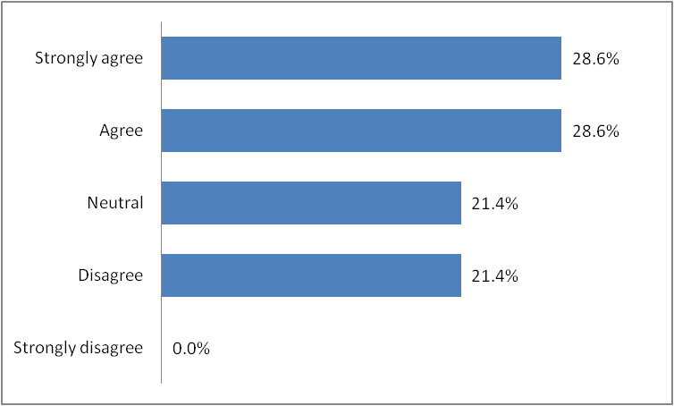
The next question explores students’ preferences for learning method by comparing VLE with traditional one. Despite the extensive use of VLE in the last 12-18 months, most respondents continue to prefer traditional face-to-face learning method where physical attendance is required. The majority of opinions confirm the viability of traditional learning, as indicated by the survey findings. Cumulatively, only 21.4% of respondents have preferences for VLE, whereas the same share of survey participants remain neutral and unable to distinguish a better method of learning. These results show that VLE continues to be mostly considered as an additional learning channel, rather than a main way of studying, despite the dependence on VLE during the pandemic period.
Figure 2 – I prefer VLE in comparison to traditional learning method
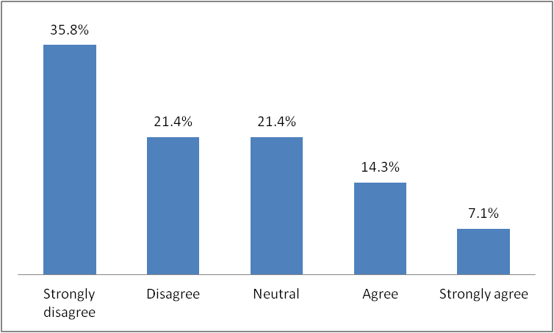
Considering the relatively limited preferences for VLE in comparison to traditional learning, it is important to examine the main benefits and drawbacks of VLE. Survey findings clearly see the recognition of VLE as a safe way of learning during the pandemic (57.1%). Perhaps, after the normalisation of the pandemic situation, the reliance on VLE will decrease proportionally. Half of participants recognise the wider access to learning resources as a main advantage of VLE which aligns with literature findings by Dudeney and Hockly (2007). Moreover, convenience is also recognised as a major advantage of VLE according to 35.7% of participants. This supports the previous results, as defined by Puzhevich (2020). It is important to note that all expressed advantages from the literature review, which are included in the survey, are recognised by 14.3% of respondents only. The same share of survey participants does not see any advantage in using VLE. Engagement, communication and interactivity are features with a marginal importance as individual factors, as shown below. In general, survey results indicate that only some of the initially stated benefits are experienced by the surveyed students. Hence, it is important o study the disadvantages preventing the achievement of a higher satisfaction rate with VLE.
Figure 3 – Benefits of VLE
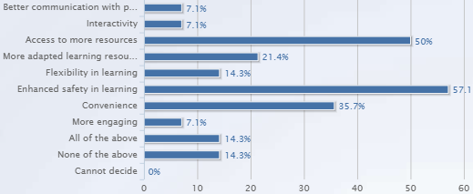
Considering the drawbacks of VLE, the lack of personal contact is seen as the most significant challenge by students (57.1%). In addition, the previously stated drawback related to self-discipline issues is recognised by half of participants. Surprisingly, technical issues are stated as a major individual limitation by 35.7% of survey participants. Only 7.1% of respondents do not face any drawbacks with VLE, whereas 21.4% of students recognise all of the below mentioned issues as relevant and important in their experience with VLE. Thus, survey findings largely confirm the secondary data propositions, as manly summarised by Walker and White (2013) and Puzhevich (2020).
Figure 4 – Drawbacks of VLE
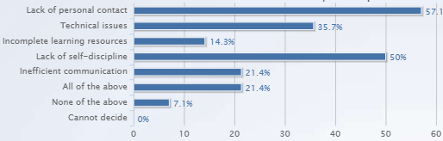
Since VLE already constitutes a very important way of learning in contemporary environment, the survey also explores students’ future intensions to engage with the technology. Overall, students remain sceptical, as only 14.3% express a high level of willingness to learn via VLE. Half of participants consider VLE as a possible way of learning which can be used to a certain extent. Interestingly, 28.6% of survey participants refuse to use VLE in the future which shows the negative impact of existing drawbacks of adoption rates. This relatively high level of resistance also indicates the previously discussed prevailing preferences for traditional attendance-based learning process.
Figure 5 – Future intentions to use VLE
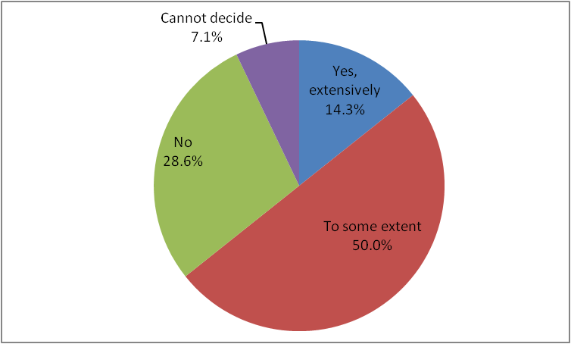
Survey results are indicative for the major trends in VLE use by university students at University of Wales Trinity Saint David London Campus. The combination of primary and secondary data findings strengthens the reliability of research findings and their actual validity in assessing VLE use.

Conclusion
In the light of research findings, VLE appears to be an effective addition to traditional learning; however, its long-term use as a main learning channel appears to be under question. VLE cannot replace actual face-to-face communication and poses management and technical issues to students. Survey findings indicate the existence of numerous advantages of VLE but they deliver value mainly as a supplement to traditional face-to-face learning. Considering this, VLE implementation requires considerable improvements in the future in order to become more widely accepted. Its use should be carefully dozed under normal circumstances. Despite the existing limitations, VLE is a key platform for learning in an environment of distant learning which demonstrates the plausibility of the technology in the particular domain of distant learning. It is important to conduct periodic studies among learners with different contexts in order to recognise the dynamic changes and possible areas of improvements and implementation.

References
Barker, J. and Gossman, P. (2013) The learning impact of a virtual learning environment: students' views, Teacher Education Advancement Network Journal, Vol. 5(2), pp. 19-38.
Dudeney, G. and Hockly, N. (2007) How to Teach English with Technology. England: Pearson Education Limited
Godwin-Jones, R. (2012) Emerging technologies: challenging hegemonies in online learning, Computer Assisted Language Learning, Vol. 16(2), pp. 4-13.
Green, T., Brown, A. and Robinson, L. (2008) Making the Most of the Web in your Classroom: A Teacher's Guide to Blogs, Podcasts, Wikis, Pages and Sites. Thousand Oaks: Corwin
Masquera, L. (2017) Impact of Implementing a Virtual Learning Environment (VLE) in the EFL Classroom, [online] Available: http://www.scielo.org.co/scielo.php?script=sci_arttext&pid=S0123-34322017000300479 [Accessed: 31 August 2021]
Puzhevich, V. (2020) The Use of Virtual Learning Environment in Education, [online] Available: https://scand.com/company/blog/the-use-of-virtual-learning-environment-in-education/ [Accessed: 30 August 2021]
Rahmany, R., Sadeghi, B. and Chegini, A. (2014) Normalization of CALL and TPACK: Discovering teachers' opportunities and challenges, Journal of Language Teaching and Research, Vol. 5(4), pp. 891-900.
Saunders, M., Lewis, P. and Thornhill, A. (2009) Research Methods for Business Students. 5th edition, Pearson, New York
Sneha, J. and Nagaraja, G. (2013) Virtual learning environments: a survey, International Journal of Computer Trends and Technology, Vol. 4(6), pp. 1705-1709.
Svoboda, T. (2020) Obsurvey - surveys made easy for iOS, [online] Available: https://download.cnet.com/Obsurvey-surveys-made-easy/3000-2064_4-76486749.html [Accessed: 2 September 2021]
Walker, A. and White, G. (2013) Technology Enhanced Language Learning. Connecting Theory and Practice. Oxford, UK: Oxford University Press

Appendix A – Survey questionnaire
1. Please, evaluate the following statement: “I was very engaged with VLE during the pandemic-imposed distant learning period.”
- Strongly disagree
- Disagree
- Neutral
- Agree
- Strongly agree
2. Please, evaluate the following statement: “I prefer VLE in comparison to traditional attendance-based learning”.
- Strongly disagree
- Disagree
- Neutral
- Agree
- Strongly agree
3. What are the main benefits of VLE based on your experience? (more than one answer possible)
- Better communication with peers and teachers
- Interactivity
- Access to more resources
- More adapted learning resources
- Flexibility in learning
- Enhanced safety in learning
- Convenience
- More engaging
- All of the above
- None
- Cannot decide
4. What are the main drawbacks of VLE based on your experience? (more than one answer possible)
- Lack of personal contact
- Technical issues
- Incomplete learning resources
- Lack of self-discipline
- Inefficient communication
- All of the above
- None of the above
- Cannot decide
5. Do you plan to use VLE in the future after the end of the pandemic?
- Yes, extensively
- To some extent
- No
- Cannot decide

Appendix B – Excerpts of survey results in Excel format


