ACMA6013

Major Project

Barrie John

1811176

Contents.
- Figures and Table list.......................................................................................................3
- Chapter 1 Introduction....................................................................................................4
- Why is it important to a business to reduce process defect?..........................................4
- What is the customers expectation of a supplier?..........................................................4
- History of Marelli Automotive Systems...........................................................................4
- Methodology...................................................................................................................6
- DMAIC Process................................................................................................................6
- Setting up the team.........................................................................................................7
- Chapter 2 Literature review………………………………………………………………………………….…....8
- Chapter 3 Define..............................................................................................................16
- Chapter 4 Measure.........................................................................................................24
- Chapter 5 Analyse...........................................................................................................29
- Chapter 6 Improve..........................................................................................................31
- Chapter 7 Control............................................................................................................37
- Chapter 8 Conclusions.....................................................................................................41
- References………………………………………………………………………………………………………………….42

Figures and Table list.
- Marelli profile.
- Marelli product and customer list.
- The DMAIC process.
- Marelli improvement team.
- Pareto of failure modes.
- A picture of a X52 core in the clinch machine.
- Picture of common area for clinch leaks.
- Example of a clinch leak.
- Definition of a faulty clinch
- Visual diagram of SMART objectives.
- Process flow for folded tube condenser.
- Process flow for the clinch machine.
- Picture of Clinch machine.
- Picture of a X52 Plate.
- Boxplot of plate measurement.
- Diagram of tank dimensions.
- Boxplot of tank measurement.
- Diagram of a tank assembly.
- Results of tank assemblies after division insertion.
- Sample pictures of clinch machine checks.
- Picture of tank check in the clinch.
- Ishikawa diagram of clinch leaks.
- Diagram of a payoff matrix.
- Graph of tank dimensions before modification.
- Cad image of tooling alterations made to correct tank dimensions.
- Graph of tank dimensions after modification.
- Accessory Clinch Improvement results.
- Graph showing the reduction in the bow of the tank.
- Pictures of the clinch machine improvements.
- Graph showing clinch leaks since improvement implementation.
- SPC Graph of tank dimensions.
- Graph showing the SPC points measured by the supplier of the tank component.
- Picture of the gauge introduced to monitor tank fitment.
- Updated standard operation sheets (SOS) introduced.
- Picture of the hourly output tracker introduced.
- New Clinch check list.

Chapter1: Introduction.
The X52 Folded Tube Condenser is a new design of product that Marelli Automotive Systems launched this year. This product has included a large amount of new technology and is significantly different to the other condenser variants previously manufactured across the organisation. This new product is a positive move for the organisation as it is incorporated in a new generation of vehicles with a key customer, however it is also accounts for the highest reason for process defects in the Llanelli Plant. The main failure mode for level of defects is clinch leaks, with the scrap rate running as high as 40%. Therefore, the aim of this study will involve taking an in-depth look at the manufacturing process of the X52 in the hope of identifying the main causal factors for the clinch leaks and potentially develop solutions to lower this high failure rate.
To achieve this, the DMAIC process will be followed. This approach will give a structured way to ensure all aspects of the problem are thoroughly analysed, with a view to produce a repeatable process and thus ensure that a sound process defect rate is achieved.

Why is it important to a business to reduce process defect?
Process defects are a problem for any manufacturing product or service. They are basically imperfections or flaws that makes the product or service fall short of achieving the customer's expectations. Process defects can occur during any stage of production and can be caused by a wide range of factors. These can include poor design, faulty equipment, poor training of operators, or even human error can result in defects being produced. Defects can result in serious consequences for a business, including lost sales, poor customer satisfaction, damage to the company’s reputation and increased costs such as overtime and express freight.
Eliminating process defects is the key to effective quality control. By managing to prevent defects from occurring in the first place, a business can ensure that it produces the highest standards of quality, which can lead to better customer satisfaction and winning repeat business. To effectively eliminate defects, it is important that we understand what they are, what causes them to occur, and how to best prevent them. (Faster Capitol, 2023)

History of Marelli Automotive Systems
Marelli Automotive Systems (MLUK) is automotive components manufacture who is based in Llanelli, South Wales. It has been in business since 1944 and traded under several different name including Morris Motors, Llanelli Radiators to Calsonic Kansei. The organisation employs over 250 people. MLUK supplies to a high-end OEM Customer base including Nissan, JLR, VW Audi and Stellantis.
MLUK produce a wide range of heat exchange products that include Radiators, Condensers, Low Temperature Radiators, and many more cooling components that are used in a wide range of vehicles.
MLUK have recently entered the Electric Vehicle (EV) market with the introduction of a Battery Cooling Plate production line which is seen as the future with the global change in car design.

Figure 1 shows the Marelli plant profile, while Figure 2 shows the Marelli product and customer list.

Figure 1.


Figure 2

Methodology
The study will use a range of that include quantitative data collection method and using process trial and errors. This will help determine the best process related improvement actions to achieve the lowest failure rate.
What quantitative data is?
Quantitative data is information that can be quantified. It can be measured or counted along with having a numerical value. These include distance such as meters or miles or a revenue value such as pounds. Quantitative data is great for statistical analysis as it is structured in nature. Quantitative data will allow you to find answers to questions such as how much or how often. (STEVENS, 2022)
To collate gain the required data for this process study several controlled trials will be carried out on the clinching methods along with measurements of the results.
Pros and cons of trial and error.
Trial and error is not a method for finding a solution first time but for working towards a solution, it is a problem-solving technique that is simply used to find a solution. A key advantage to this technique is that it does not require you to have a lot of knowledge. It will however require you to have large amounts of patience to be successful. (Exforsys, 2006)

Data Analysis
For a successful DMAIC process accurate and comprehensive data neds to be recorded. This will ensure that a structured process is followed thus ensuring that the best possible outcomes are achieved.
Production data, reject analysis, machine settings, and component measurement are all in scope.

The DMAIC Process.
What is the DMAIC process?
DMAIC is the acronym for Define, Measure, Analyse, Improve, and Control. These are five steps that represent an improvement cycle and greatly support the achievement of process improvement and best practices.
DMAIC is a data-driven technique and is a key tool of the Six Sigma methodology, however it can also be considered a standalone improvement method. It is also used to support other process improvement approaches such as Lean Methodologies.
This is a simple but powerful technique that brings a structure to follow when looking to make improvements to a process. it helps teams explore potential solutions, decide the best course of action, to implement process controls. (Brittany, 2021)

Figure 3 below shows the DMAIC process.
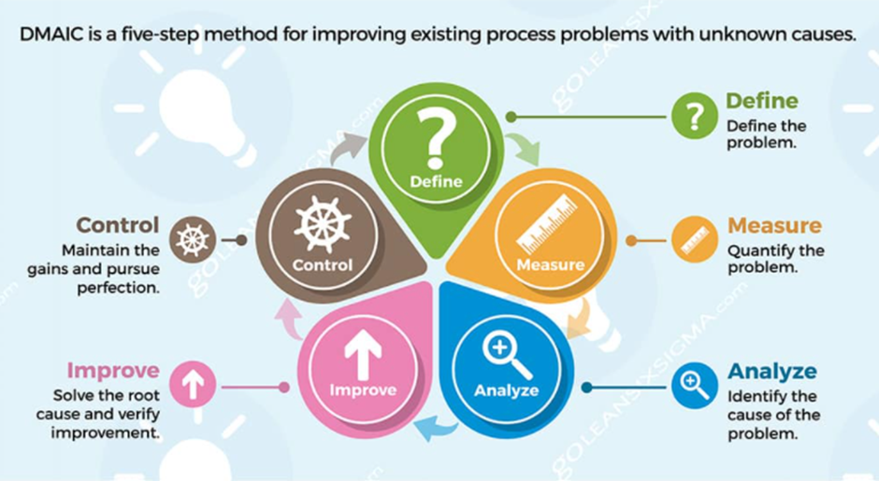
Figure 3. (GoLeanSixSigma, 2023)
Setting up the team.
To complete and achieve a successful outcome, a cross functional team was set up to include individuals from multiple departments with different levels expertise and knowledge. The team included Engineers, QA Engineers, Process Engineers, and Manufacturing Supervisors. All team members have many years’ experiences with making heat exchange products.
This team was led by Phil Mires (Plant Director) and Brandon Willams (Plant Manager) with me Barrie John (Manufacturing Section Leader) taking the day-to-day lead. It will also be supported by Adam Evans (QA Engineer), Hugh John (QA Manager), Colin Hogan (Senior Engineer), Mandy Kiely (Process Engineer) and Andrew Hughes (Engineering Manager) leading their functional teams.
Figure 4 below shows the improvement team that will work on this DMAIC activity.
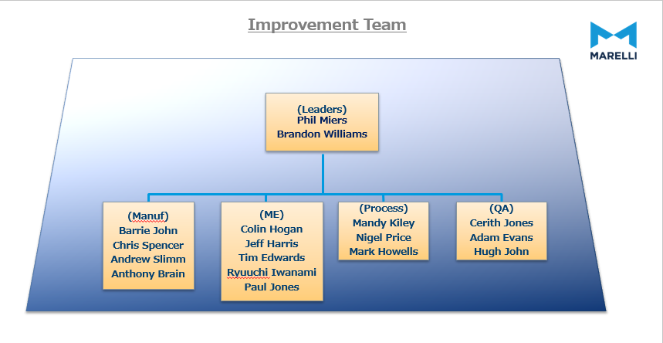
Figure 4.
Chapter 2: Literature review.
In this literature review we look at what can impact scrap and how it can be controlled. The cost of quality, quality control, total preventative maintenance, aluminium brazing, six sigma as a quality improvement tool and how to implement smart objectives along with data recording will all be reviewed.
The cost of quality.
Cost of Quality is a methodology that can be used to define and measure the amount of an organization’s properties needed for prevention activities to allow and maintain product quality as opposed to the costs that can result from product failures. Whether that be from internal issues (machines, processes etc) or external (supplier concerns). The Cost of Quality can be denoted by the total of two factors. The Cost of Good Quality and the Cost of Poor Quality equates to the Cost of Quality. (Quality One, 2024)

Taguchi Method of Quality Control
What Is the Taguchi Method of Quality Control?
The Taguchi method of quality control is a method to engineering that underlines the importance of research and development (R&D), the key factors is to reduce failures and limit defects in product design of manufactured goods.
A method, developed by Genichi Taguchi who was a Japanese statistician and engineer, looks at the importance of quality in a manufacturing process. One of the main aims is to try and remove production variances thus improving quality.
Critical elements:
The Taguchi method designed in the 1950’s focuses engineers to develop and design products that are both reliable and efficient.
Genichi Taguchi, believed that design was a vital part of quality control and could be used eliminate production variances even before they occur. He considered this to be more important than the manufacturing process itself.
By the 1980’s Taguchi’s principles have been adopted by many companies such as Ford, Boeing and even Toyota. (KENTON, 2021)

Total Quality Management (TQM)
What is TQM?
Total Quality Management (TQM) looks at a management system where all “employees continuously improve their ability to produce products that customers will find of great value.”
The principle of Total Quality Management can be found right in its name: That being “total” which implies that all employees in the corporation, from design through to production all buy into improving an operation. The “management” drives a methodology that is focused on effort to improve. Leadership looks at providing the training, staff and funds along with the goals to dynamically achieve a service and product of the highest quality continuously.
8 principles of Total Quality Management
It is widely agreed that TQM follows eight principles.
- A customer focus: The first of the Total Quality Management principles looks at the people who buy the products. This is designed to ensure that customers know they are buying a quality product that meets their needs and all the customers’ expectations.

- Total employee commitment: as part of Total Quality Management employee buy in is vital. Everyone needs to share the vision and goals of a company and they must be clearly communicated to allow for an efficient and productive process.

- A Process approach: Following a process is essential in quality management. Processes guarantee that the appropriate stages are followed on time to guarantee stability and increase the speed of production.

- An integrated system: It is common that in most business there are many departments, these all should follow Total Quality Management. In an integrated system, all departments need to have a clear understanding of policies, standards, objectives, and processes. Integrated systems allow a business to work towards continual improvement that will give a company the edge over the competition.

- A systematic and strategic approach: making an organisation efficient and effective requires managing, understanding, and identifying the key processes that allow for a company to achieve its objectives.
Numerous processes within a production sequence are managed as a system of processes to optimise efficiency.

- Continuous improvement: as part of Total Quality Management customer satisfaction is key. To do this a business needs to continually improve. A business must continually find ways to improve a process and modify a service or product. Total Quality Management principles are intended to help a business work toward continuous improvement.

- Using facts when decision-making: Data recording and analysis of available information allow for better decision making. Knowing your market and customers help a business to make informed decisions.

- Communication: a good communication plan allows for everyone in the business to understand the methods, plans, and strategies that will help achieve its goals. There is a significant risk of failure if a business does not have a good communication plan.
Implementing a successful Total Quality Management model will take time. TQM can often be seen as a change in the culture of a business and implementing these changes over time will reduce the impact. (Lucidchart, 2024)
Total preventative maintenance (TPM)
TPM (Total Productive Maintenance) is a complete approach to maintenance equipment that endeavours to reach perfect production, these include:

- Eliminating all Breakdowns.
- Removing defects.
- Improving runtime.
- Reducing H&S issues.
- Eliminating slow running.
TPM highlights proactive and preventative maintenance to optimise machine efficiency of equipment. A key part of TPM is to empower an operator to maintain and take ownership of their equipment.
The application of a TPM program can create a shared accountability for equipment and promote a greater involvement of shop floor workers. Under the right circumstances this can be a very effective way to improve productivity thus increasing machine up time, lowering cycle times, and removing defects. (Lean Production, 2024)

Aluminium Brazing.
Brazing is a process where metals are joined using a filler metal which is heated above its melting temperature but lower than the melting point of the metals being joined. The filler (clad) flows into the gap between the two surfaces. Ensuring the quality of the surfaces to be joined is of highest importance and the clearance linking the parts must be small (generally no more than 0.2 mm).
Conversely, the brazing of aluminium and its alloys demands precise temperature control since the brazing temperatures are usually close to the melting temperatures of the appropriate parent alloy. Aluminium alloys will usually melt in the range 560-660°C.
To aid the brazing process flux is used. Flux is a chemical compound applied to the joint surfaces before brazing. chloride fluxes have been a common use in manufacturing, more recently fluoride fluxes have been used.
Fluxes can be added as Liquid, paste or powder. Surplus flux must be typically removed as many aluminium fluxes (particularly chlorides) can lead to corrosion.
In the automotive industry an important use of aluminium brazing is in the manufacture of heat exchangers (radiators). In the early 1970´s, mechanically joined aluminium radiators were designed as a replacement for copper and brass radiators. In the 1980’s a flux-based controlled atmosphere brazing technique was developed.
A particular advantage is that a furnace brazing process is easy to automate. A key disadvantage of any brazing operation, is the difficulty of quality control of the resulting joints without destructive tests. (European Aluminium Association, 2015)

The importance of a brazing profile.
A brazing profile is a set of parameters that include the gas flow, nitrogen levels, furnace temperatures, and spacing between the products that dictate the required settings for the best possible braze of a product. Having a brazing profile is key to maintaining consistency when brazing for mass production such as in the automotive industry. Monitoring key factors such as heat, time over temperature and ensuring the correct levels of gas are all critical to achieving a good braze joint. (Kiley, 2024)

Six Sigma.
Six Sigma is a series of tools designed to aid problem-solving along with process improvement attempts. A Six Sigma specialist uses qualitative and quantitative techniques aimed at driving process improvements. The tools themselves may unique, but the way they are implemented and included as part of a system is. Common tools used in improvement projects are:

DMAIC: consists of five components, The define, measure, analyse, improve, and control process is a data-driven quality approach designed to improve a process. Seen as an integral part of Six Sigma, it can also be employed as a separate quality improvement procedure.
5S: 5’S is an approach that focuses on the workplace that is clean, uncluttered, safe, and well organized designed to enhance productivity. With a view of building a quality work location. The 5S thinking can be used for visual control and lean production.
The Visual workplace: A visual workplace exists to visually share information about administrative operations to improve both the human and machine performance.
The Voice of the customer: understanding the requirements of the customer is key, knowing the customer needs also known as Quality function deployment (QFD) is the first step. Then a voice of the customer table (VOCT) can be created Common sources that focus on sales, warranty claims are used. (American Society for Quality, 2024)

SMART Objectives.
What are SMART objectives?
SMART objectives are a tool designed to provide guidance when setting out objectives at the beginning of a project or activity.
A SMART objective means:
Specific:
Setting out exactly what you want to achieve.
- Who: consider who needs to be involved to achieve the results.
- What: be very detailed about what it is you want to accomplish.
- Where: think if the location of a project could have an effect of any result.
- When: ensure that you consider a time frame for the project.
- Why: it is important to outline the reasons for achieving the desired objectives.

Measurable:
Use micro-objectives to measure progress.
- Define how you know if the main objective has been achieved.
- Understand how you are tracking progress.
- Re-evaluate progress if necessary.
Achievable:
Be responsible and realistic when setting the objectives.
- Has this been done before?
- Are the skills available for the task?
- Are the resources available?
- Achieving the objectives needs to motivate, encourage, and challenge the team.
Realistic:
Set an objective that can be achieved in a timely manner.
- Can this really be achieved?
- Can the commitment be given to achieving the objective?
- Is the objective within the reach of the team?
Timely:
Have a start and finish time.
- Set a challenging yet realistic deadline.
- Map out timings for milestones in the project.
SMART objectives are effective in all aspects of a project and in day-to-day life.
(Secretariat of the Pacific Regional Environment Programme (SPREP), 2020)

Process flow.
Why is knowing a process flow important?
It is important in a manufacturing environment to know the process flow. This details each step of the process and develops an ideal sequence for the product manufacture.
Engineers can also find benefits in a process flow by organizing each part and allocating the resources needed.
A manufacturing process flow must be measurable to account for production timings, the management of inventory and develop improvement goals. (Flanigan, 2024)

Payoff matrix.
A Payoff Matrix is a tool used when decision-making and decision analysis. It uses a grid or table that is meant to help envisage and analyse all potential outcomes of different strategies or decisions involved in a situation. Especially useful when there are multiple options available to an outcome of a problem.
Payoff matrices work by listing strategies and decisions, assigning each one a payoff and outcome, and analysing the outcome.
Ultimately, a Payoff Matrix presents a structured way to analyse decision-making situations involving multiple options. Helping to understand all potential outcomes of different choices available to aid in selecting the most promising or best solution based on the objectives of the team involved. (Six Sigma, 2023)

Data Recording.
Data collection is critical when problem solving. It is important to know as much about the problem as possible: Knowing the history of a problem, what was the origin and cause of the problem, along with previous solutions that have failed or worked. Knowing the scope of the problem along with the impact is also key.
Gathering data about the problem starts with input from key stakeholders. These often include employees, customers, and other key members who may hold information regarding the problem in question. Gathering the information can come from customer complaints, production data, reject analysis. Nearly all problems will have a history of data. (Universal Class, 2024)

Data Analysis.
Words such as “data collection,” “quantitative data analysis,” and “pivot table” can sound confusing or even intimidating. Data analysis and data collection does not have to be complex. Easily put data collection is a tool that is useful to aid you in making business decisions and forming strategies.
Below are some key reasons as to why data collection and analysis is important to both an individual and a business when gathering information.
- Informed Decision making: Data is Intelligence. Having accurate data and assured results allow a business to come to an informed decision that can avoid wasted resources and inaccurate conclusions.
- Stops a problem from escalating: Data monitoring allows a business to monitor the progress of an important process within that business. Using accurate data to monitor a situation allows for a business to react and make changes before the problem develops into a crisis. Valuable data monitoring will allow a business to be proactive rather than reactive and will support a business to maintain best practices over time.
- Achieve the desired results: Good data collection and accurate analysis allows a business to monitor the success of a given plan: When plans are put into place to overcome a situation or problem, data collecting allows you to regulate how effective the solution is working and whether the method needs any adjustments.

- Problem solving: Data collection and analysis can help a business to establish the cause of a problem more effectively. Data allows businesses to understand the relationship between a process and the problem. Understanding at these data points at given intervals allows for more effective and accurate solutions to be developed.

- A Strategic approach: Data collection and analysis can increase problem solving efficiency. Efficient data collection and analysis will allow you to utilise resources where they can be most needed and effective. The issue could be related to staffing, training, poor machinery, or components. Using a strategic approach allows a business to decide what needs to take priority when solving a problem.

- Tracking your progress: Data collection and analysis allows for a business to measure the strengths and weaknesses across all areas. Data collection and analysis will support a business to identify the best performing areas so that they can be studied and used to develop plans that can help improve under-performing areas.

- Benchmarking: Accurate data collection and analysis allows for a business to establish a benchmark and set a baseline for its performance whether that be in quality, performance, or personnel. A baseline is what a definite situation may look like prior to the improvement plan being implemented. Benchmarking can allow a business to establish where to develop plans and set goals that allow for improvement and maintained success of both a process and the business itself.

- Value for money: businesses can use data collection and analysis to decide where funding should be allocated. Knowing that data-based outcomes can decide where funding is spent in a business can make decisions easier for management as this allows for an expected return to be calculated on the funding given. In modern business it’s vital to get value for money this can be in maximising people, machinery, to make a business profitable. Effective data analysis plays a key role in this.

- Maximizing resources: A business does not need to look far for data experts. In most businesses there are probably already the people needed to collect and analysis data effectively and efficiently. Most departments will already be collecting data that could be useful when problem solving. HR would be collecting training records of operators which would allow a business to track any development needs. Engineering will be tracking breakdowns, meantime to repair, and critical parts needed, while manufacturing would be tracking performance and process defect rates. All of this can be used for analysis and are tools that drive improvement in a business. (The Council on Quality and Leadership, 2024)

Managing Improvement activities.
There are Two process improvement methodologies that are most recognised in modern business. Firstly, PDCA (Plan, Do, Check, Act), this is commonly used in lean manufacturing methodology. Secondly is DMAIC (Define, Measure, Analyse, Improve, Control), this is widely associated with Six Sigma which considers following process control via a statistical approach.
Both improvement tools focus on understanding the issue along with following a structured approach to improvement. They consist of the following key factors:
- Understanding the problem.
- Having a robust improvement plan.
- Implementing the plan in a structured and controlled manner. This is considered key in both methodologies.
- Implementing control measures to sustain improvements.
- Tracking the success of the improvements. (Wright, 2022)

Controlling improvements.
Controlling a Process looks at following a set of manufacturing procedures aimed at ensuring all processes are carried out to the correct specification within a manufacturing facility.
Maintaining Process control is critical for any business. Process control systems allow a business to ensure the following:
- Ensure a high-quality product.
- Operate an efficient business.
- Control manufacturing costs.
- High levels of health and safety.
- Reduced process defects.
- Efficient and reliable machinery.
All these factors lead to profitable and sustainable business. ( Precognize, 2022)

Statistical process control (SPC)
Statistical Process Control (SPC) looks to eliminate variations in a process by following a statistical method of measuring, monitoring, and controlling a particular part of a manufacturing process. this systematic control method aims to eliminate variations in a process.
SPC has been around since the 1920’s but not until the 1980’s was it widely used in western manufacturing industry. These days SPC is commonly used worldwide in multiple manufacturing processes.
The benefits of a Statistical Process Control include:
- Reduction in rework and scrap.
- Productivity improvements.
- Better quality.
- Maintain the capability of product and process.
- Constantly maintain control of process via monitoring.
- Improved decision making.
- Modernize a process.
- A more reliable product.
- Lateral deployment of improvements throughout the business.
(Hessing, 2024)

The cost of conformance.
In a manufacturing process the monitoring quality nonconformance by capturing the issue, investigating the issue, and closing the nonconformance allows a business to successfully reduce the cost of poor quality.
Effectively identifying and managing a nonconforming product or process is essential to a business’s quality system. A non-conforming process, components, machinery, material, or operator can lead to excessive rework, defects and even possibly a product recall.
Poor quality can occur at any stage of the product lifespan, issues in production, engineering can all have a direct impact on the cost of quality. These issues can result in additional costs that can be incurred from any of the following: downtime of machinery, lost time analysing nonconforming parts or processes to determine the root causes; in addition, rework would then need to be retested which is an additional cost. Having to scrap defects will result in the additional costs to replace them. Following a collective approach to nonconformance management, you can prevent any variance in the equipment, process and parts that will allow for a flexible system for shop floor workforce that can manage ever-changing quality constraints. (Compliancequest, 2024)

Considering the Human Factor in Nonconformance Management: Why training, communication, and creating the right culture are all essential in managing nonconformances.
Modern businesses need to have clear policies and standard operating sheets (SOSs) to recognize, correct, prevent, and eliminate nonconformances. Bothe the policy and SOSs need to be communicated to all key stakeholders and ensure that best practices are applied. When best practices are applied a business will reduce nonconformance and the associated risks.
Operators are critical to a business when looking to maintain a high-quality standard and reduced nonconformance as they will be the first to see any issues and identify potential solutions. Creating a culture where they feel they can raise issues, make suggestions of improvement, and give valued feedback all allow for a better overall product and business. (Whitepaper, 2023)

Chapter 3: Define.

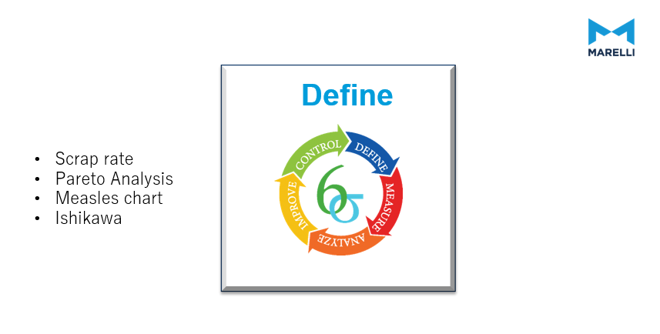
The first phase of the DMAIC is the define stage.

Why is it important to define the problem?
Define the problem allows the team to set out the improvement activity, look at the opportunity for improvement, set the project goals, and customer (internal and external) requirements.

Business case
To give validity to the project a defined Business Case was developed.

Scrap reduction is constant goal of the manufacturing team at MLUK. Weekly reports are produced and presented to the management team identifying the top concerns and the action plans for tackling these concerns. The clinch leak is currently one of the top scrap concerns with over £50,000 of scrap accounted for since the introduction of this product due to this failure mode. This is a key focus area for the management team and is also one of the top cost drivers for the business. This is a key reason for the undertaking of this project.

Manufacturing issues are monitored and graphically tracked on an ongoing basis.
Clinch Leaks were identified as a top concern for MLUK following a review of ongoing scrap data. The Pareto Chart below showed the impact of this failure mode on the manufacturing process.
Figure 5 below shows the pareto of the top failure modes.
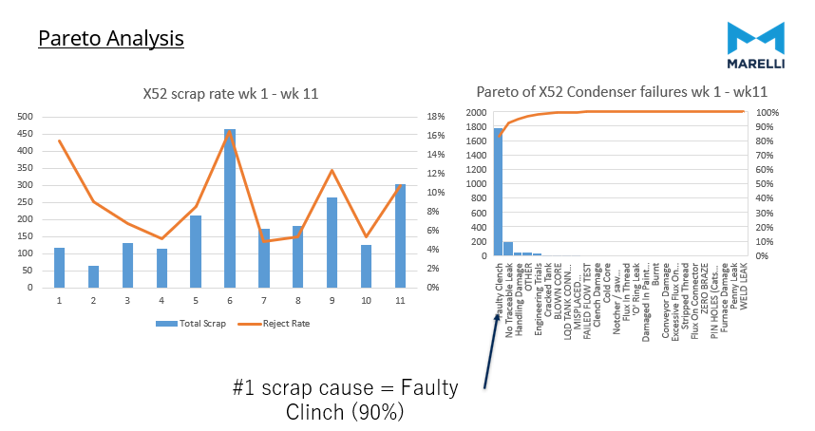
Figure 5.
Project Charter

: A Project charter is used to define the focus, scope, direction, and motivation needed by the improvement team. (American Society for Quality, 2023)
Below is the project charter for the clinch activity.

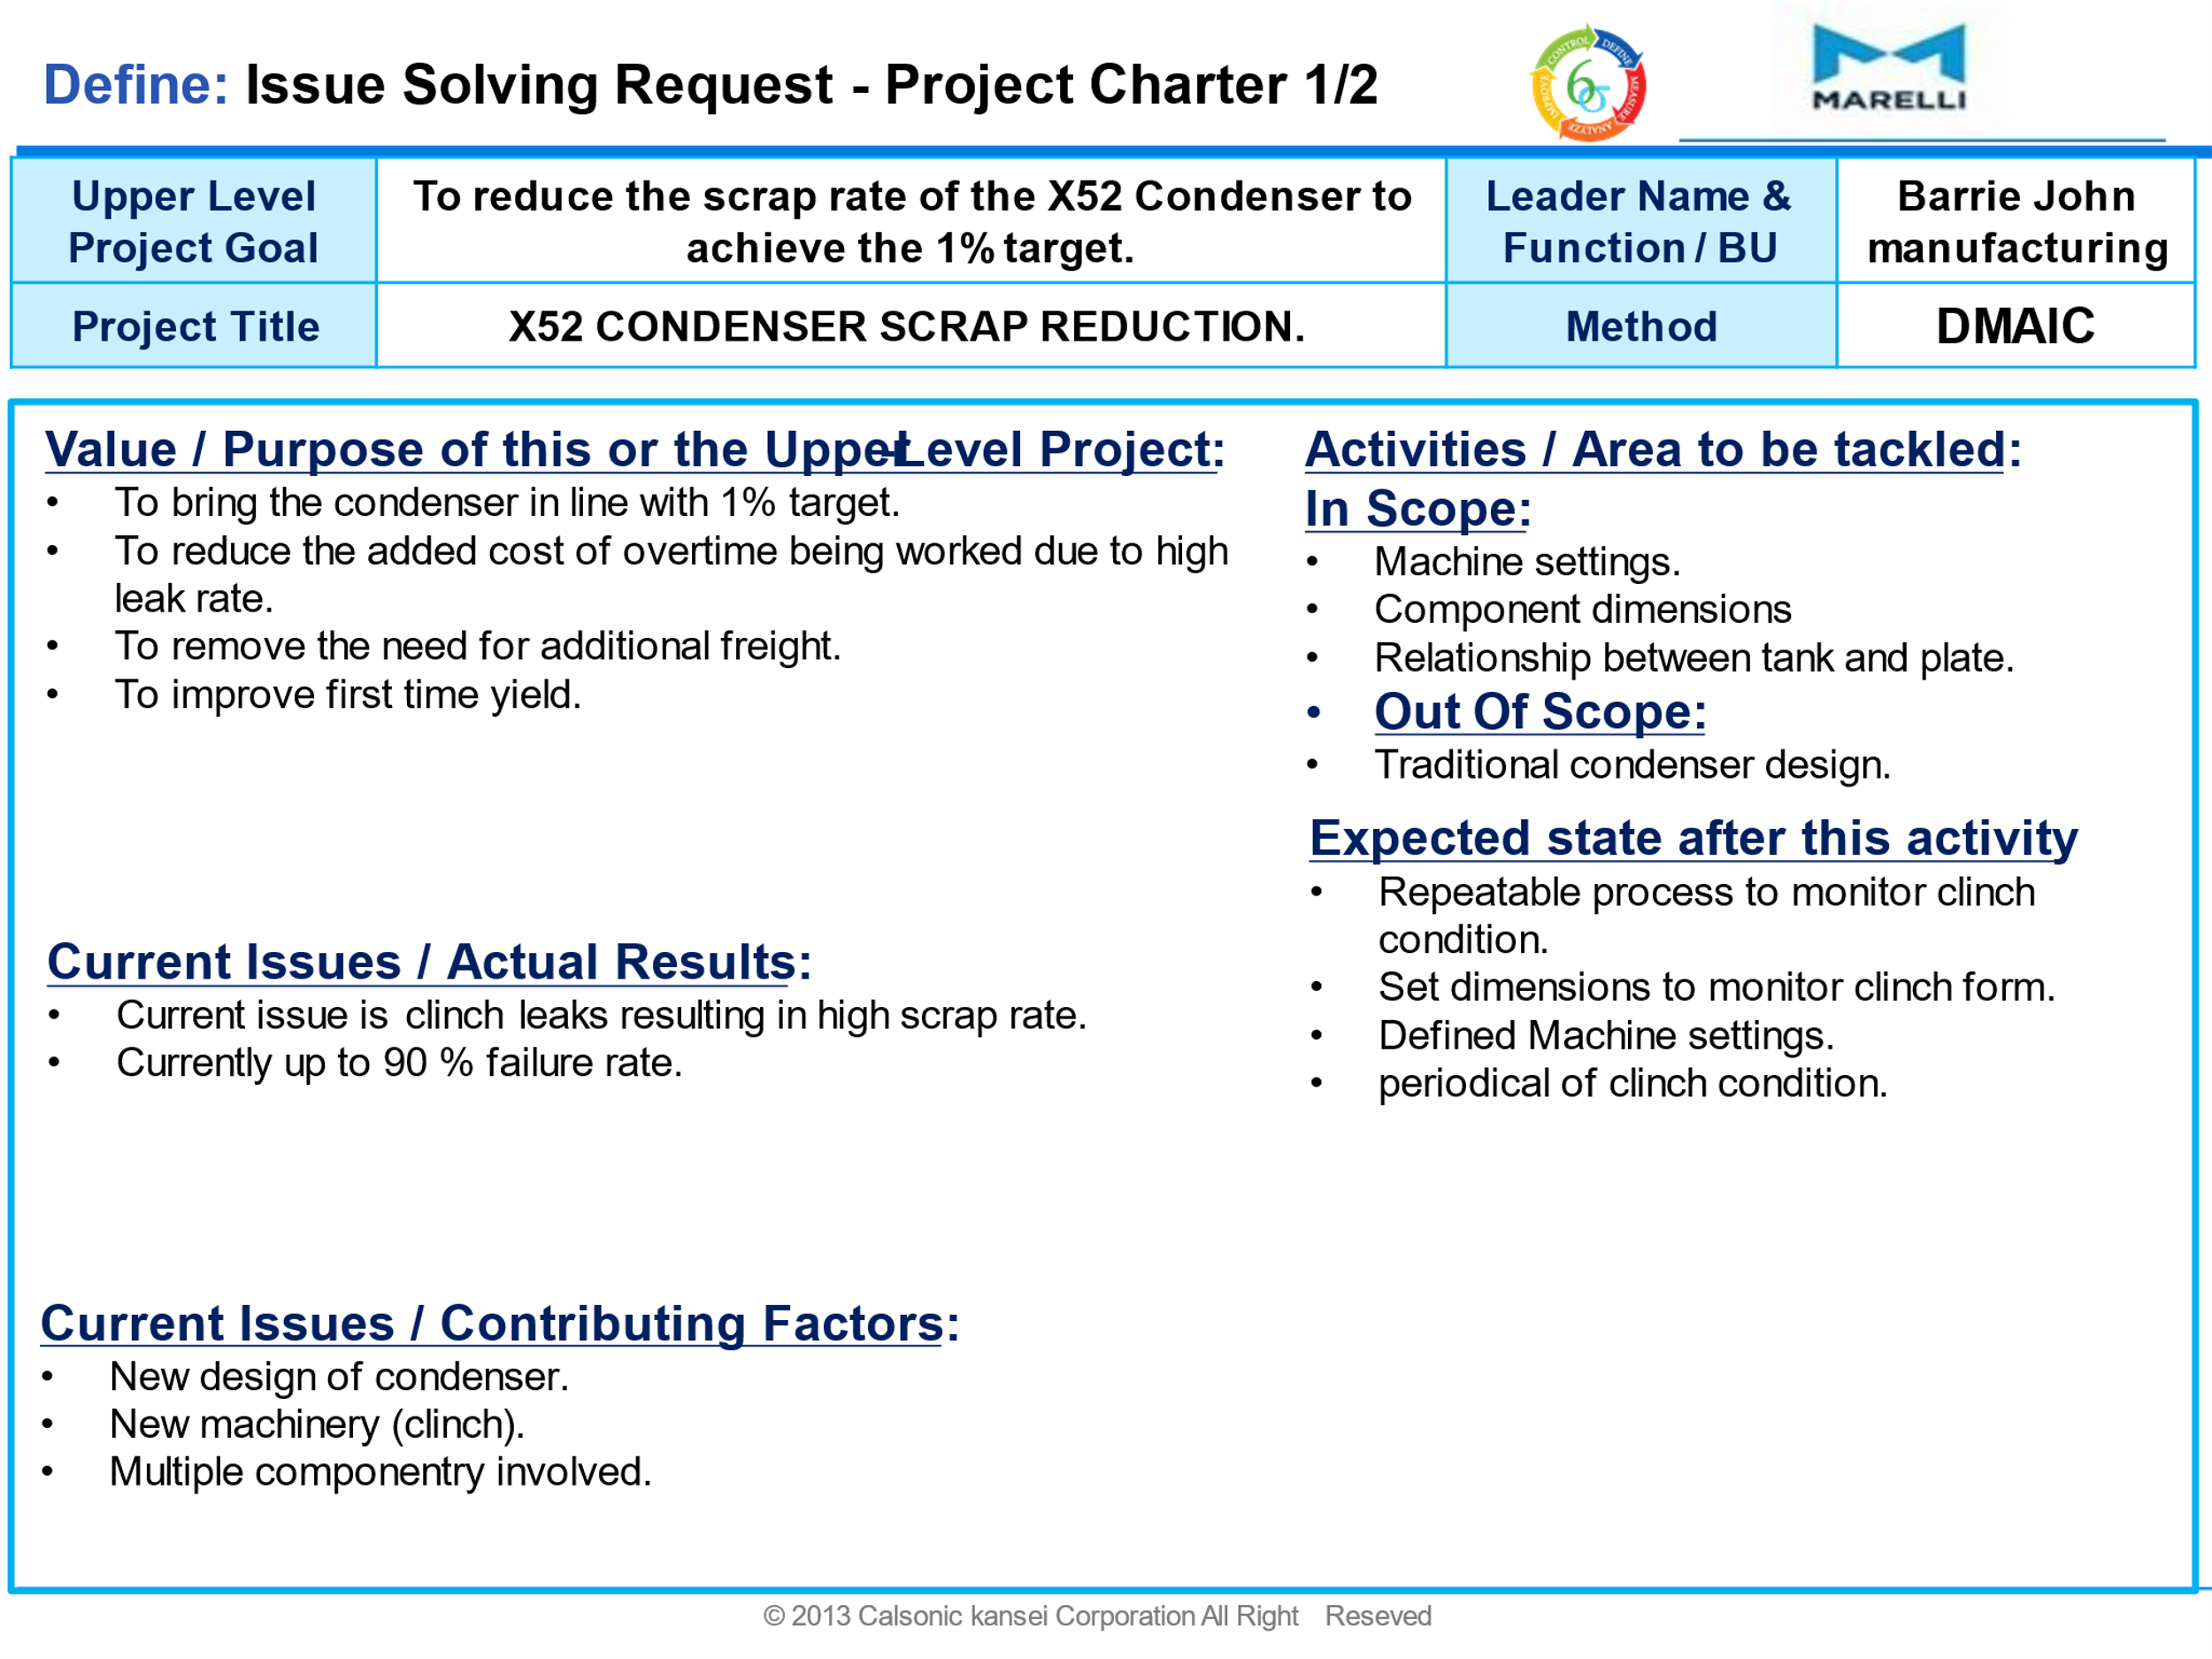
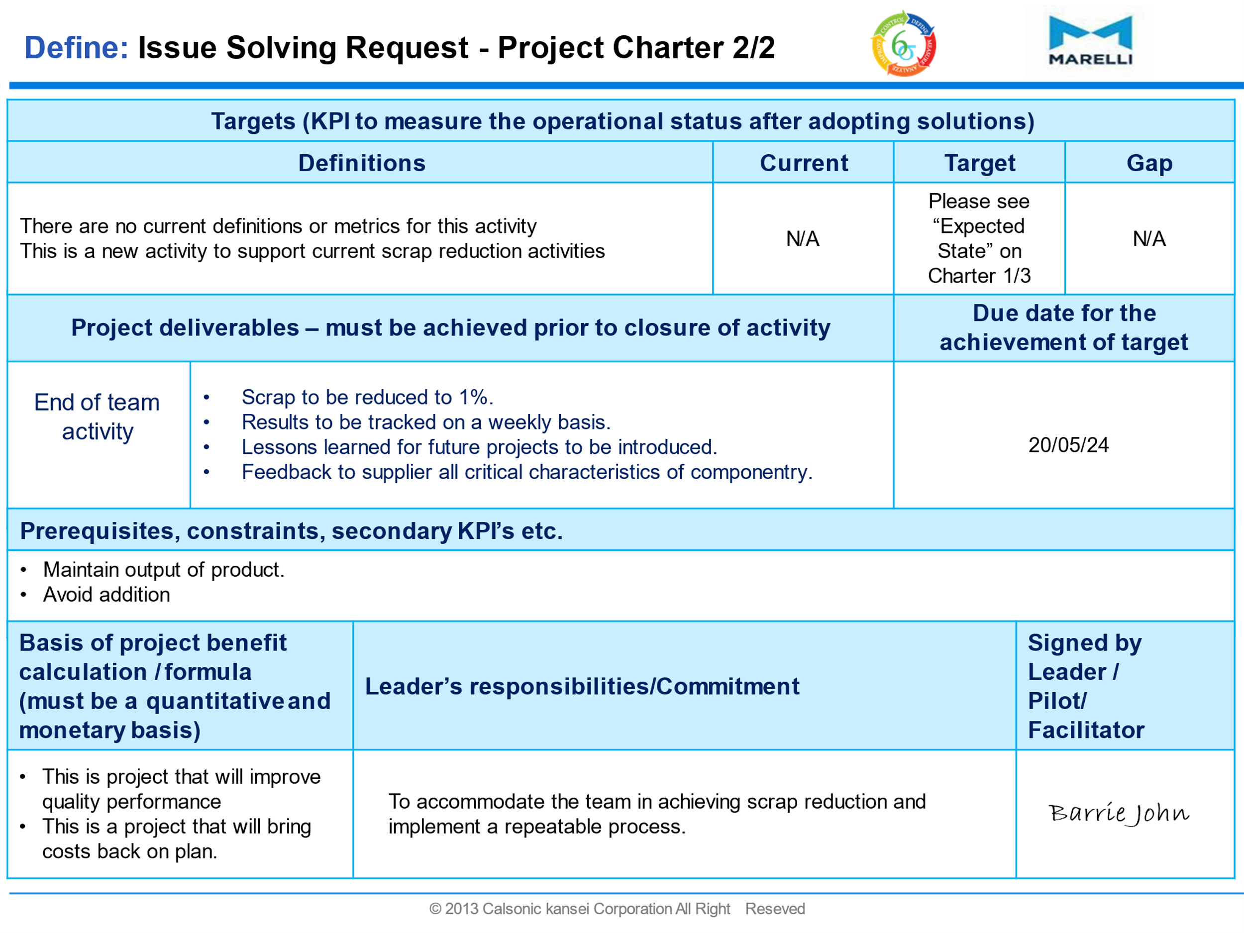

Below Figure 6 shows a core in the clinch machine.
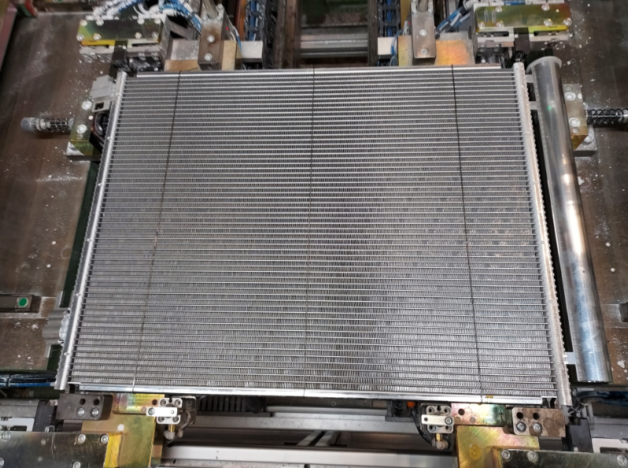
Figure 6.
Below Figure 7 shows the most common area for clinch leaks.
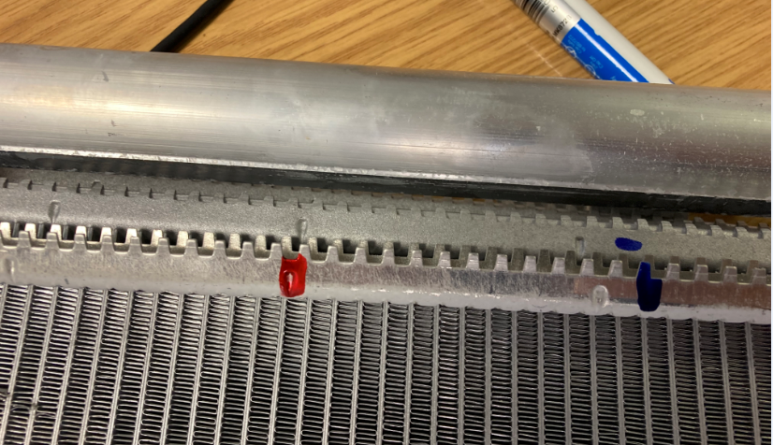
Figure 7.

Figure 8 below shows a typical example of a clinch leak. The highlighted area shows a leak path in the brazed joint.
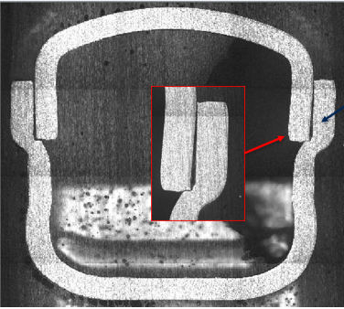
Figure 8.

Figure 9 shows the definition of a faulty clinch.
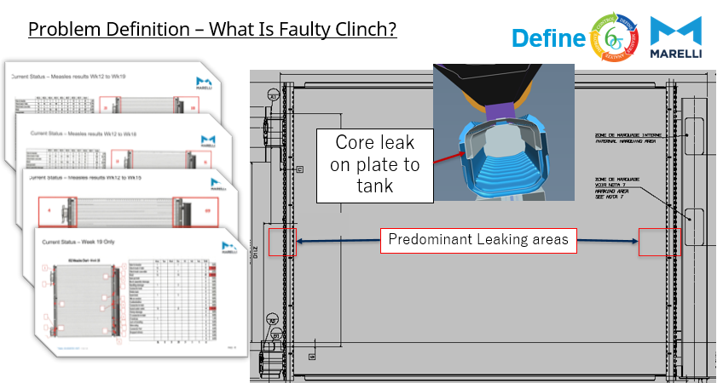
Figure 9.
This failure mode is detected at the final leak test cell of the manufacturing process at MLUK and therefore does not present a risk to the customer. However, a great deal of value has been added to the product prior to this leak testing operation being completed and due to the elevated scrap associated with this failure, it can add significant pressure on maintaining scheduled deliveries.
Project objective.
Using SMART objectives, the aim will be to reduce the reject rate to within the 1% target for all clinch leaks.
Below Figure 10 shows a visual diagram of SMART objectives.
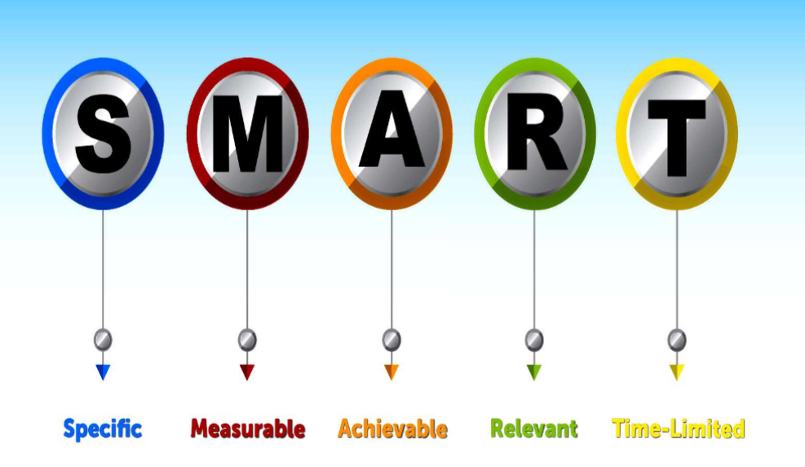
Figure 10. (Secretariat of the Pacific Regional Environment Programme (SPREP), 2020)
Key points.
There are several key points to take into consideration.
Quality. It is critical that a high-quality part is produced to be both competitive and to establish trust and a good reputation with your customers.
Why is Quality important.
Regardless of the industry, customers will look to choose a particular product largely based on the price, nevertheless often quality is still a key requirement. Some studies show customers are willing to pay a higher price for a product of a high-quality standard.
Competitive advantage
Companies want to gain competitiveness with a high-quality product, A distinctive product can be patented that prevent other companies from replicating it for almost 20 years. This would allow a company to sustain its competitive advantage for a long time.
Satisfaction of customers
Quality is essential to satisfy customers to retain their business. Quality products have a major impact on sales in the long term. Quality is what distinguishes a company in a competitive market.
(John Ruskin, 2024)

Productivity. In and ever competitive market it is important to make a component on time and right first time. This is the best way to be productive as it eliminates scrap thus reducing the need for re-work which is both time consuming and increases inventory.
Why productivity important?
To be an effective and successful business you must understand the importance of productivity in the workplace. Being productive ensures a company can maximise the capacity of the human resources it has. All successful and productive companies have a happy and healthy workforce, which are the basis of a successful company. (Andy Core, 2013)

Voice of the customer and QFD.
It is important to understand the customers’ requirements of the product being produced, both from a cost and performance perspective. One way to achieve this is through Quality Function Deployment (QDF).
QDF is a way of understanding the expectations of the customer. It begins with the design of the parts and maintains a focus all the way through to the finished product. This ensures that the customer receives a product that meets there every need.

Process flow.
What is process flow?
A flowchart is a picture of the separate steps of a process in sequential order. This is a tool which can be used for a variety of purposes, and can be used to describe various processes, one of the most common uses is to show the flow of a manufacturing process, or a project plan. (American society for quality, 2022)
To better understand where the issue could be occurring a process flow map was created to document all aspects of the production of the product.
Figure 11 below shows the current process flow for the Split header condenser.
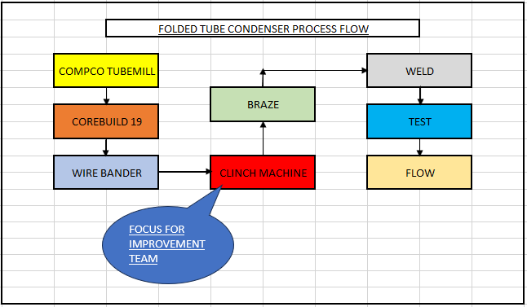
Figure 11.
Figure 12 below shows the current process flow for the clinch which was the focus of the activity.
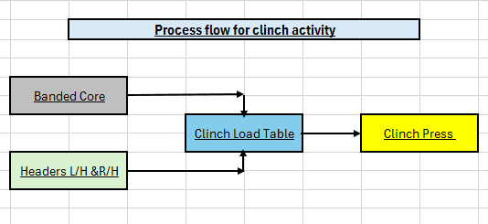
Figure 12.
Figure 13 below shows the clinch machine where the focus of the activity took place.

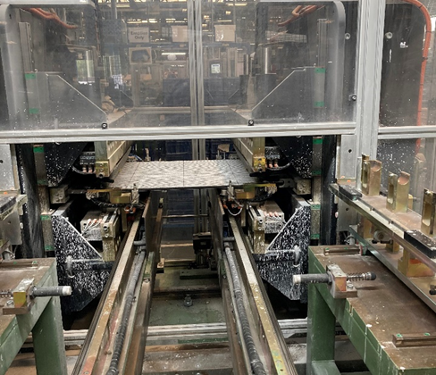
Figure 13.

Chapter 4: Measurement. 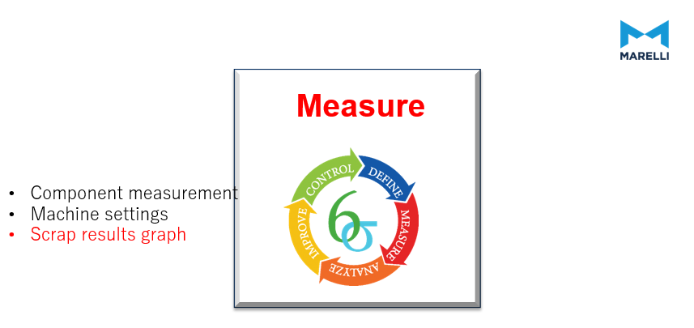

Measure process performance.
Why is it important to measure?
- A Process map allows for measuring the activities performed as part of a process.
- Capability analysis to assess the ability of a process to meet specifications.
(American Society for Quality, 2023)

As part of the measurement phase a data collection plan was developed, this included:
- Daily output trackers.
- Failure %.
- Process capability of componentry.
- Process capability of machinery.

It has been identified that all key components will be measured to confirm whether they were within specification. The following parts were deemed to be critical to clinch leaks.
- Plate.
- Tank.
- Tank assembly.

Plate.
The plate is a pressed aluminium component which is used to hold the tubes and airways in place during the braze process. measurement of the form of the plate is critical dimension of the part.
Figure 14 below shows a typical plate.

Figure 14.
The results from the measurement study of internal width shows the plate to be at its nominal value. The spec for the plate is 12.90 – 13.00mm in value.
Figure 15 below shows the results from the measurements of the plates.
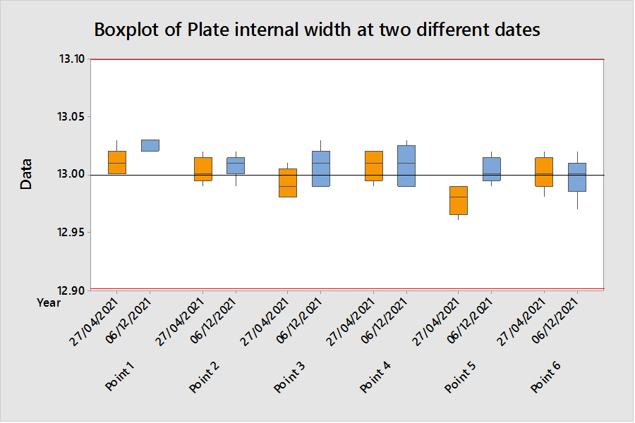
Figure 15.
Tank.
The tank is a pressed aluminium part which is assembled to the plate as part of the clinch process. The form of the of the tank is an area of investigation for the team.

Figure 16 below is a diagram of the plate and the key dimensions.
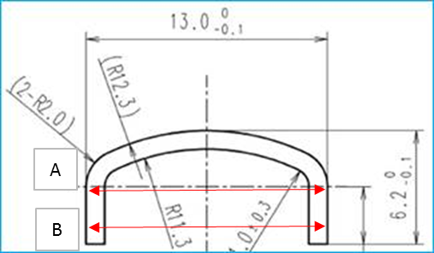
Figure 16.

The results of the tank measurements show that the tank walls are not straight and show narrowing as the tank fell below the minimum spec. the tank spec is 13mm +0 – 0.1mm. as you can see from figure 17 below at some points of measurement the tanks is up to 0.3mm below bottom spec.
Figure 17 below shows the results of the tank measurements.
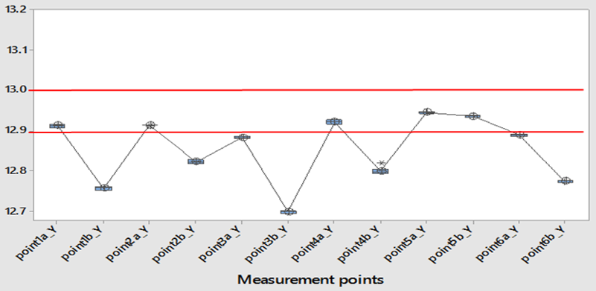
Figure 17.

Tank assembly.
Prior to assembly in the clinch the tank undergoes a sub-assembly process where divisions and connectors are fitted to the tank. This was checked to see if there were any changes to the tank.
Figure 18 below shows a diagram of the tank assembly.

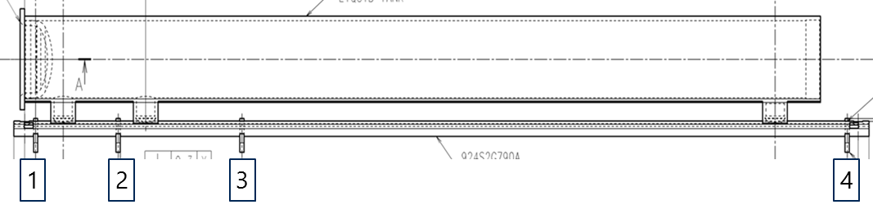
Figure 18.

From these measurements it was noted that there was significant difference in the tanks dimensions after the divisions were inserted. It can be seen below in figure 19 that after division insertion points 3 & 4 go out of spec. prior to the division being added the tank was undersized but afterwards the tank had gone oversized.
Figure 19 below shows the results of tank assemblies.

Figure 19.

Machine settings.
As well as checking the componentry against the required specification, the clinch machine was checked to ensure the settings were correct. These checks included.
- The pusher tooling settings (L/H &R/H sides).
- Comparison between the L/H & R/H settings.
- Differences between top and bottom of tooling (L/H & R/H sides).
- Dimensional checks along the tooling at pre-determined points.

Below figure 20 shows a sample of the clinch machine checks that were carried out.
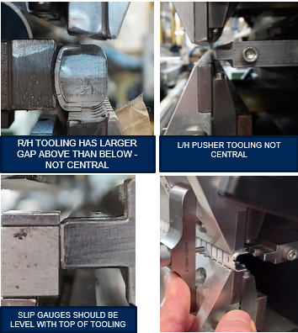
Multiple alignment issues found during clinch measurement activity.
Figure 20.
Below figure 21 shows the checks carried out on the clinch machine to measure that the tanks is aligned correctly.
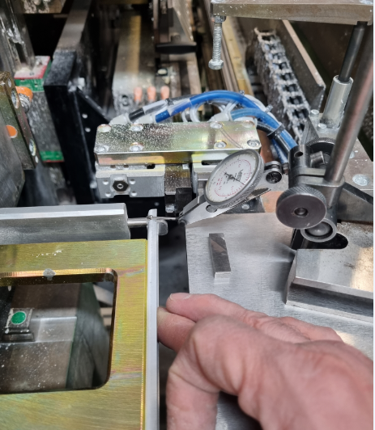
Figure 21.
Chapter 5: Analyse.
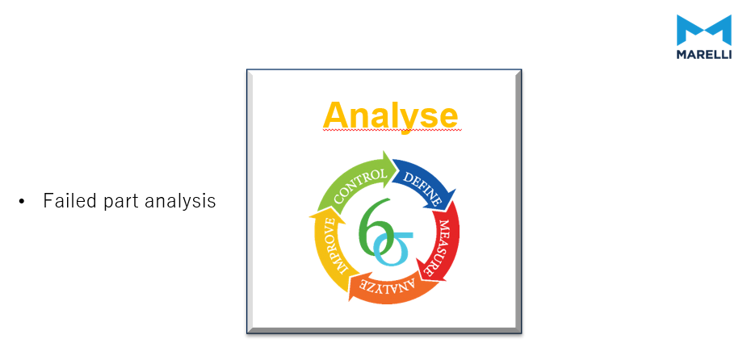

Ishikawa Diagram
As part of the analyse stage and fully understand the potential root causes of the failure mode an Ishikawa Diagram was created.
What is an Ishikawa Diagram?
An Ishikawa Diagram or Fishbone Diagram is designed to show the potential causes of a specific process or operation. It is commonly used as a brainstorming activity to outline the different steps within a given process. It can also help to determine whether quality control issues could arise.
The diagram is named after its creator, Kaoru Ishikawa. Visually, the diagram's structure resembles the skeleton of a fish and is commonly known as a fishbone diagram. The ribs represent the causes of an event, and the skeleton's head indicates the outcome. (Mind Manager, 2023)
Advantages and disadvantages of an Ishikawa Diagram.
An Ishikawa Diagram provides a creative approach to problem-solving within a business. The graphic illustration of the diagram can often lead to new insights. It is important to remember that the Ishikawa Diagram simplifies things a lot. At times the complexity of a business processes can be missed when problem solving. In addition, there is a risk of creating chaos if the complexity of the problem is illustrated comprehensively in a diagram. The aim of an Ishikawa Diagram is to create order and structure when problem solving. By sorting into different categories, the problem becomes more tangible and can be solved more systematically. To be most effective a disciplined approach needs to be followed.
Advantages | Disadvantages
✔ Encourages creativity when searching for the causes of a problem | ✘ Requires a structured approach to make the diagram useful
✔ Categorises possible causes | ✘ Predefined categories such as 4M can limit creative problem-solving avenues
✔ Teamwork allows for new perspectives | ✘ Complex correlations cannot be illustrated in the Ishikawa diagram
✔ fault causes are illustrated | ✘ Does not provide solutions, but only illustrates the potential causes
✔ Encourages all to contribute ideas
✔ Simplifies the problem
✔ Easy to use and easy to learn
(Ionos, 2023)

Figure 22 below shows the Ishikawa diagram that was completed for clinch leaks.
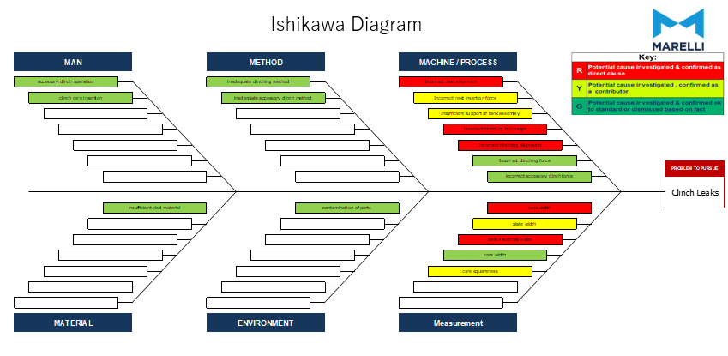
Figure 22.
Following a brainstorming session which included a detailed activity reviewing the Ishikawa Diagram as well as other problem-solving tools, it was concluded that the measurement of the components and machine settings were identified as critical areas.
These included the tank and plate measurements and the clinch machine tooling settings.

Chapter 6: Improve.
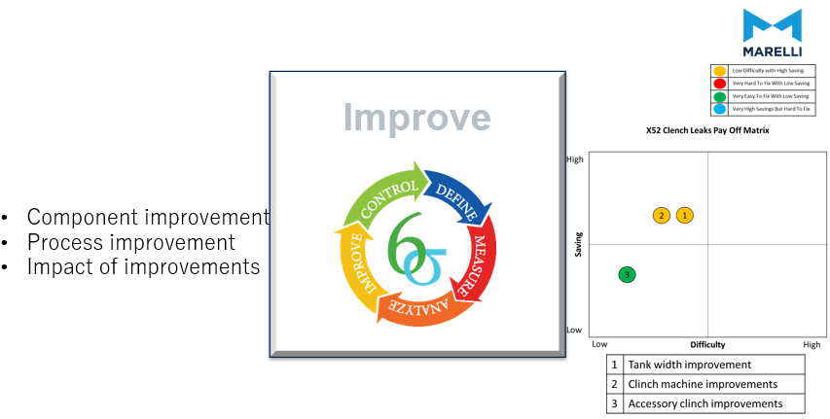
After completing a payoff matrix three key improvements were identified.
- Tank width improvements.
- Accessory Clinch improvements.
- Clinch machine improvements.

What is a payoff matrix?
A payoff matrix is a tool that is used to make it easier to prioritise improvement activities. This is based on considering the difficulty and payback of each improvement activity and then prioritising them accordingly.

Below figure 23 shows a payoff matrix.
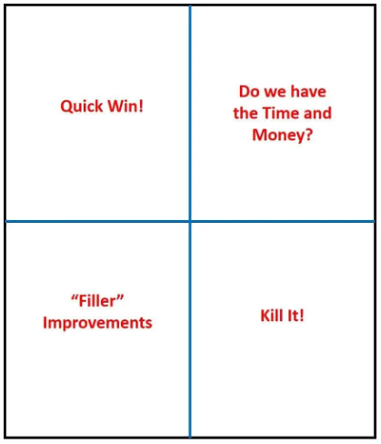
Figure 23.

Tank Width Improvement.
The first improvement was to the tank width. From the initial measurements it was found that the tanks walls were narrow with low points alone the tank.
Below figure 24 shows the tank dimensions before modification.
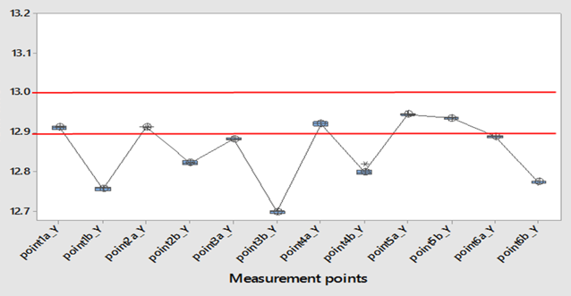
Figure 24.

Improvements were needed to the press tooling to correct tank dimensions.
Below Figure 25 shows a cad diagram of the correction to be completed on the tank tooling.
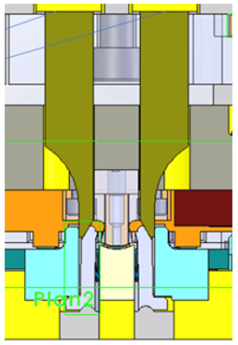
PRESS TOOLING MODIFIED TO CORRECT TANKS WIDTH
Figure 25.

After tool modifications the tanks width was much improved and within tolerances.
Below figure 26 shows the plate dimensions after modifications.
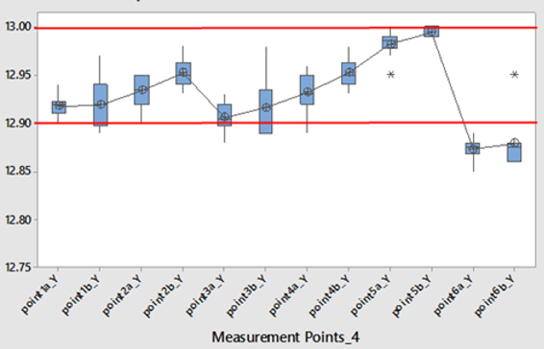
Figure 26.

Accessory Clinch improvements.
It was identified that during the accessory clinch process the tank was bulging when the division insertion was performed. As part of the improve phase the accessory tooling was re-aligned to improve the straightness of the tank and reducing the bulging of the assembly.
Also identified was the force which the accessory machine was using to fir the divisions into the tank. A reduction in this force was implemented as part of the improvements.
Below figure 27 shows the change in results of the tank bulging after the improvements to both the straightness of the tanks and the reduction of the force used in division insertion.
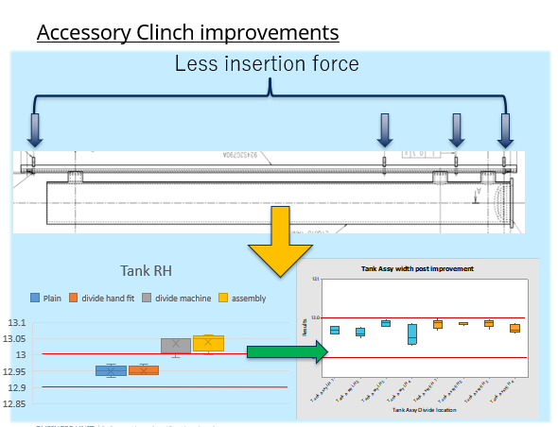
Figure 27.

Below figure 28 shows the bow in the tank after improvements had been made.
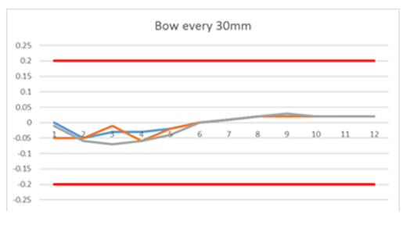
Figure 28.

Clinch machine improvements.
The final improvement identified was to the clinch machine.
Several adjustments were made to the clinch machine identified during the measurement phase.
They were:
- R/H tooling centralised.
- L/H pusher tooling centralised.
- Slip gauges on machine levelled with the top of the clinch tooling.
- Relief machined into the clinch bed to accommodate the banding wire.
- Improvement to the L/H liquid tanks tooling.

Below figure 29 shows the key improvements made to the clinch machine.
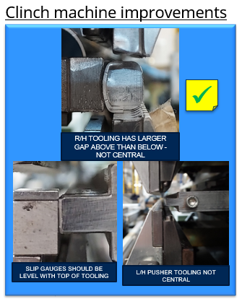
Figure 29.
All three of these improvements were vital in achieving a reduction in the scrap levels on the X52 condenser. While each individually resulted in a small improvement in the reject rate it is a combination of all that has produced a consistent result. Following these improvements being implemented a vast reduction in clinch leaks was achieved below the 1% target.
Figure 30 below shows the reduction in clinch leaks since the improvement activities.
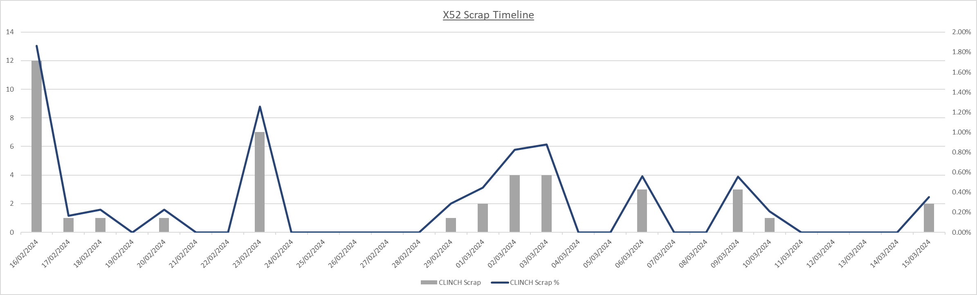
Completion of improvement activity.
Figure 30.
Chapter 7 Control.
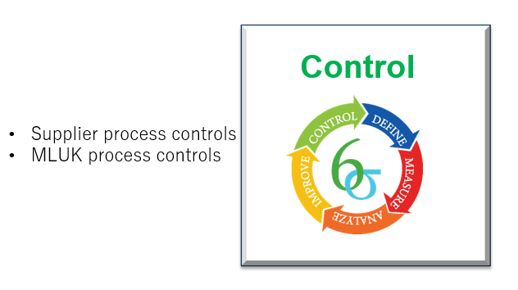
As part of this phase of the DMAIC activity controls have been implemented by both our parts supplier and MLUK to ensure a repeatable and sustainable process is achieved resulting in the continued scrap improvement of the X52 condenser.

Supplier process controls.
SPC has been implemented by the supplier to track and monitor the plate dimensions. This is designed to avoid any future narrowing of the plate dimensions.
What is SPC?
Statistical process control (SPC) is a commonly accepted methodology for process monitoring and control. SPC is originated in the distinct parts of a manufacturing process. The purpose of process control in the distinct parts of a manufacturing process is to produce parts with minimum variability. SPC aims to achieve this by identifying and removing exchangeable sources of variation from the process (Montgomery, 2007; Grant and Leavenworth, 2000). SPC assures process intervention by identifying when there is statistical proof that a process is out of control. (John, 2019)

Below figure 31 shows the SPC control implemented by the supplier.
Figure 31.
Figure 32 below shows the inspections points used for the SPC carried out by the supplier of the tank.
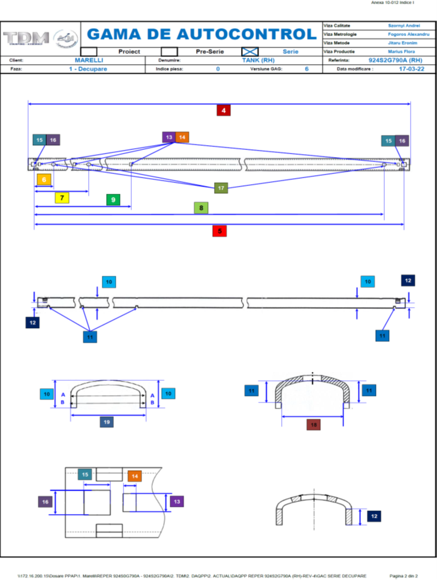
Figure 32.
MLUK Process controls.
As part of the control phase process controls have also been implemented to setup of the clinch.
These include:
- Setting instructions designed to maintain tooling positions.
- Hourly checking of the tank fitment using gauging by the operator.
- Daily cleaning of the clinch tooling
- Hourly tracking of output and rejects.
- Updated SOS to document new clinch process.
- Lateral deployment using a check sheet developed for new products (MLA & EV2020).
All the above are intended to lead to a stable and repeatable process.

Below figure 33 shows the gauge introduced to monitor tank fitment.
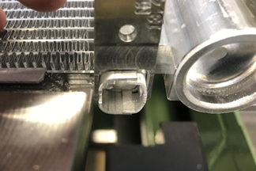
Figure 33.

Below figure 34 shows the updated standard operation sheets (SOS) introduced to ensure both correct setting of the clinch machine and the method by which the operator is required to check using new gauging that has been introduced.
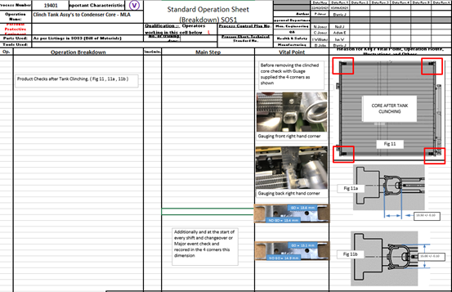
Figure 34.

Below figure 35 shows the hourly output tracker introduced to monitor both performance and quality of the clinch.
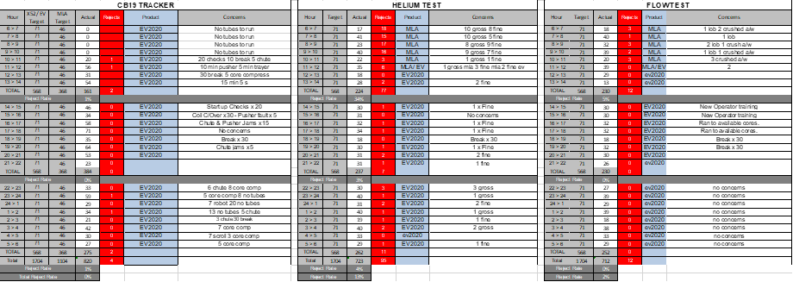
Figure 35.

Figure 36 below shows the clinch check sheet developed to ensure current controls are carried out at a set frequency. As part of the check list periodic checks by QA to validate the checks are being done is also planned.
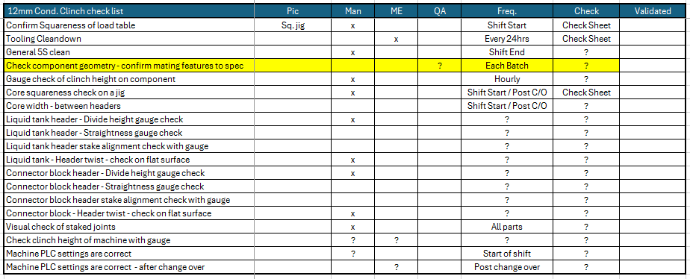
Figure 36.

Chapter 8 Conclusions.
In conclusion, using the DMAIC approach has allowed for a structured and systematic approach to improving the process and reducing the scrap of the X52 condenser. It has ensured key elements of both the process and part manufacturing by suppliers has the correct level of control in place.
This has allowed for the project objectives to be achieved as scrap levels have consistently been maintained below 1% as set out in the project charter. This improvement has also reduced additional freight, overtime, and re-work all of which have added to making this a profitable product.
The Define stage set out a business case for the project while the project charter stated all the key expected outcomes from the project.
The Measure stage used data collection, process flows and other key measurable characteristics of the componentry and machinery to identify any inconsistencies in machinery and componentry.
The Analysis stage used the measurement results to understand where the key issues might be. Problem solving tools such as Ishikawa Diagram and brainstorming sessions were carried out to set about identifying priorities for improvement.
The Improve phase used a payoff matrix to identify priorities of improvement. The Improve stage identified three key areas of improvement:
• Tank width improvements – narrowing of the plate was corrected by the supplier
• Accessory Clinch improvements – improvements to the set up were made by engineering.
• Clinch machine improvements - improvements to the set up were made by engineering along with periodical gauging checks were introduced.
The Control stage introduced process controls to both component manufacturers in the form of SPC and machinery controls by introducing setting sheets and work instructions (SOS).
All these actions have led to a successful project resulting in a stable, repeatable process that can be monitored and controlled.
Lessons learned from this activity have developed quality documentation, SOS and gauging that will be carried over to future projects (MLA & EV202) to ensure that the same issues don’t occur.
During the literature review key aspects of manufacturing, maintenance, process control, and quality improvement systems were reviewed along with industry standards of improvement activities. All of this allowed for an improvement activity which was thorough and comprehensive in its structure and approach.
In summary, a great effort from a cross-functional team made up from all MLUK key stakeholders all of whom made productive and effective contributions has resulted in the achievement of the project aim. This has led to a profitable product and efficient process with control measures in place for future projects.

References.
Precognize. (2022). What is Process Control in Manufacturing? Retrieved from precog.co: https://precog.co/glossary/process-control/
American Society for Quality. (2023). DMAIC Process. Retrieved from asq.org: https://asq.org/quality-resources/dmaic
American Society for Quality. (2024). SIX SIGMA TOOLS & TECHNIQUES. Retrieved from asq.org: https://asq.org/quality-resources/six-sigma/tools
Andy Core. (2013, May 02). The Importance of Productivity in the Workplace. Retrieved from andycore.com: https://andycore.com/importance-productivity-workplace/
Brittany, C. (2021, 03 18). An Overview of DMAIC for Beginners. Retrieved from BLOG.KAINEXUS.COM: https://blog.kainexus.com/improvement-disciplines/six-sigma/dmaic/the-complete-beginners-guide-to-dmaic
Compliancequest. (2024). Reduce Cost of Quality. Retrieved from compliancequest.com: https://www.compliancequest.com/nonconformance-and-cost-of-conformance/
European Aluminium Association. (2015). AAM>Aplications. Retrieved from aec.org: https://aec.org/sites/default/files/2022-05/6-Brazing_2015.pdf
Exforsys. (2006, July 20). exforsys. Retrieved from exforsys.com: http://www.exforsys.com/career-center/problem-solving/the-use-of-trial-and-error-to-solve-problems.html
Faster Capitol. (2023, December 22). Defects: Eliminating Defects: The Key to Effective Quality Control. Retrieved from fastercapital.com: https://fastercapital.com/content/Defects--Eliminating-Defects--The-Key-to-Effective-Quality-Control.html
Flanigan, R. (2024). What is a manufacturing flow management process? Retrieved from Method Me: https://www.method.me/blog/manufacturing-flow-management-process/
GoLeanSixSigma. (2023). DMAIC – The 5 Phases of Lean Six Sigma. Retrieved from goleansixsigma.com: https://goleansixsigma.com/dmaic-five-basic-phases-of-lean-six-sigma/
Hessing, T. (2024). Statistical Process Control (SPC). Retrieved from sixsigmastudyguide.com: https://sixsigmastudyguide.com/statistical-process-control-spc/
Ionos. (2023, 09 12). Fishbone diagram: Solving problems properly. Retrieved from ionos.co.uk: https://www.ionos.co.uk/startupguide/productivity/fishbone-diagram/
John Ruskin. (2024). Importance of Quality. Retrieved from studysmarter.co.uk: https://www.studysmarter.co.uk/explanations/business-studies/operational-management/importance-of-quality/
John, B. &. (2019). The International Journal of Quality & Reliability Management. Retrieved from An application of integrated EPC–SPC methodology for simultaneously monitoring multiple output characteristics: https://www.proquest.com/docview/2210975334?accountid=130472&sourcetype=Scholarly%20Journals
KENTON, W. (2021, September 21). Taguchi Method of Quality Control. Retrieved from investopedia.com: https://www.investopedia.com/terms/t/taguchi-method-of-quality-control.asp#:~:text=The%20Taguchi%20method%20of%20quality%20control%20is%20an%20approach%20to,and%20failures%20in%20manufactured%20goods.
Kiley, M. (2024, 04 12). Importance of a braze profile. (B. John, Interviewer)
Lean Production. (2024). Total Productive Maintenance. Retrieved from leanproduction.com: https://www.leanproduction.com/tpm/
Lucidchart. (2024). 8 Total Quality Management principles to improve processes. Retrieved from lucidchart.com: https://www.lucidchart.com/blog/8-total-quality-management-principles
Mind Manager. (2023). What is an Ishikawa diagram? Retrieved from mindmanager.com: https://www.mindmanager.com/en/features/ishikawa-diagram/
Quality One. (2024). Cost of Quality. Retrieved from quality-one.com: https://quality-one.com/coq/
Secretariat of the Pacific Regional Environment Programme (SPREP). (2020, April 1). FACTSHEET: A Guide to Developing “SMART” Objectives. Retrieved from jstor-org.ezproxy.uwtsd.ac.uk: https://www-jstor-org.ezproxy.uwtsd.ac.uk/stable/resrep46548?sid=primo&seq=3
Six Sigma. (2023, 12 21). How to Use a Payoff Matrix to Prioritize Solutions. Retrieved from sixsigmadsi.com: https://sixsigmadsi.com/payoff-matrix/
STEVENS, E. (2022, Aug 16). careerfoundry. Retrieved from careerfoundry.com: https://careerfoundry.com/en/blog/data-analytics/what-is-quantitative-data/
The Council on Quality and Leadership. (2024). Why Data Is Important. Retrieved from c-q-l.org: https://www.c-q-l.org/resources/guides/12-reasons-why-data-is-important/
Universal Class. (2024). Problem Solving Strategies. Retrieved from universalclass.com: https://www.universalclass.com/articles/business/problem-solving-strategies/problem-solving-strategies-research/gathering-data.htm
Whitepaper. (2023, July). The Human Factor in Nonconformance. Retrieved from compliancequest.com: https://www.compliancequest.com/whitepaper/human-factors-in-nonconformance-management/
Wright, M. (2022, April 14). How to Create and Implement a Process Improvement Plan. Retrieved from kainexus.com: https://blog.kainexus.com/continuous-improvement/process-improvement/how-to-create-and-implement-a-process-improvement-plan

