BMIH6007 INTERNATIONAL MEETINGS MANAGEMENT FOR THE HOTEL INDUSTRY
Assignment 1- Feasibility Plan for an International Meeting

Student ID: 2120534
Student Name:Frentusca Ana-Maria
Module code : BMIH6007
Module tutor : Kathryn Flynn

Introduction
Slide 1
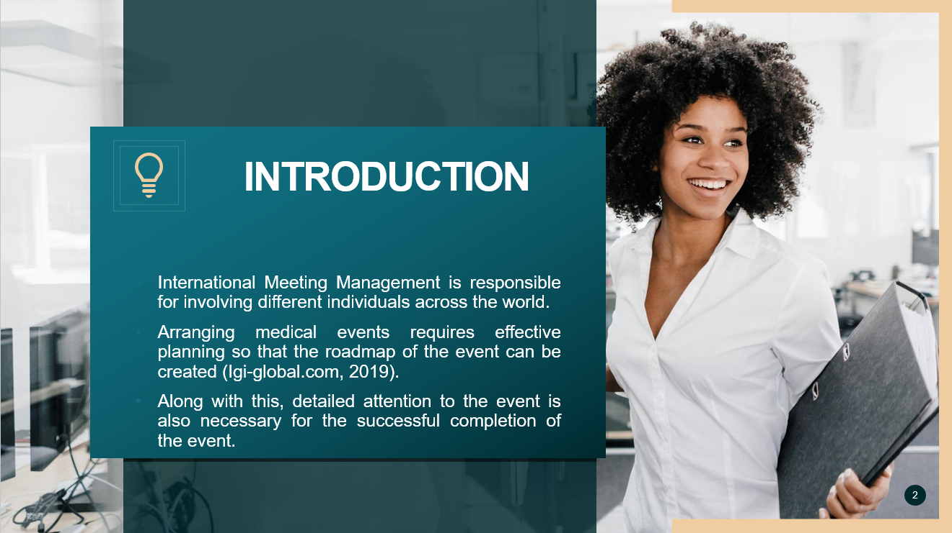
- International Meeting Management is responsible for involving different individuals across the world.
- Arranging medical events requires effective planning so that the roadmap of the event can be created (Igi-global.com, 2019).
- Along with this, detailed attention to the event is also necessary for the successful completion of the event.
Note for me :
For this reason, the venue selection is essential for the event planners to ensure the event’s effectiveness. According to Caswell (2023), Cardiff Marriot is one of the best choices to conduct such an event as the location of the hotel is attractive as well and the hotel's customer service quality is also high. The furnished meeting areas and huge conference rooms are perfect for the event's success based on the mental well-being of young adults (Marriott.com, 2024). Additionally, the technological advances within the workplace of the hotel are also lucrative for such events as the projection of those events can be effective enough. The workforce of the hotel is highly professional and can look after the event and the entire process very well.

Situational analysis and research
Slide 2
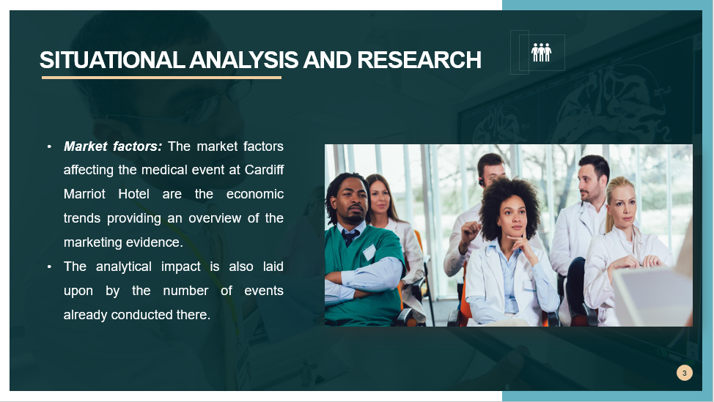
- Market factors: The market factors affecting the medical event at Cardiff Marriot Hotel are the economic trends providing an overview of the marketing evidence.
- The analytical impact is also laid upon by the number of events already conducted there.
Note for me :
The Cardiff Marriot Hotel faces intense competition in a saturated area with numerous hotels and conferences in a closed encumbrance (Marriott.com, 2024). The services provided by Cardiff Marriot Hotel are highly demanded because of the supreme location, undertaken events and prime relevance to other medical events.

Slide 3
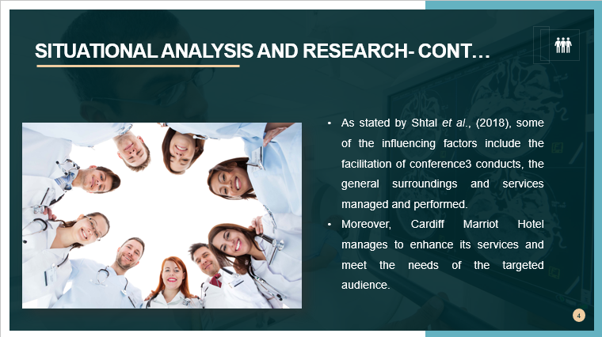
- As stated by Shtal et al., (2018), some of the influencing factors include the facilitation of conference3 conducts, the general surroundings and services managed and performed.
- Moreover, Cardiff Marriot Hotel manages to enhance its services and meet the needs of the targeted audience.
Note for me :
Operational factors: The operational factors which influence the medical event taking place at Cardiff Marriot Hotel is the capacity of the place to host such events (Marriott.com, 2024).
Slide 4
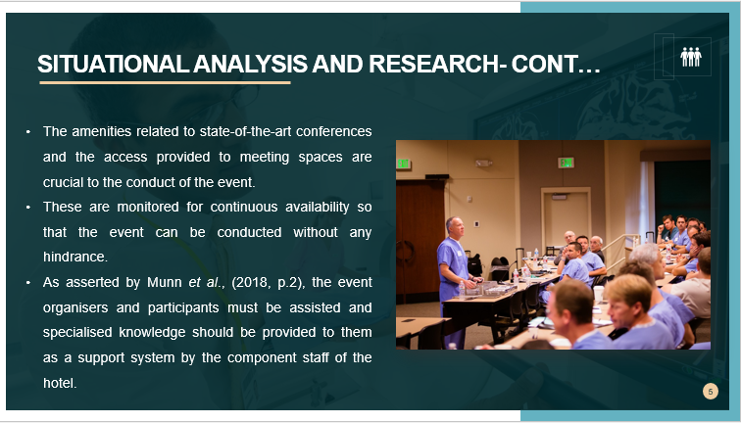

- The amenities related to state-of-the-art conferences and the access provided to meeting spaces are crucial to the conduct of the event.
- These are monitored for continuous availability so that the event can be conducted without any hindrance.
- As asserted by Munn et al., (2018, p.2), the event organisers and participants must be assisted and specialised knowledge should be provided to them as a support system by the component staff of the hotel.
Note for me :
The event management team plays an important role in this regard and shall look after the smooth conduct and regular facilitation of audio-visual equipment, culinary services and proper broadband.
Slide 5
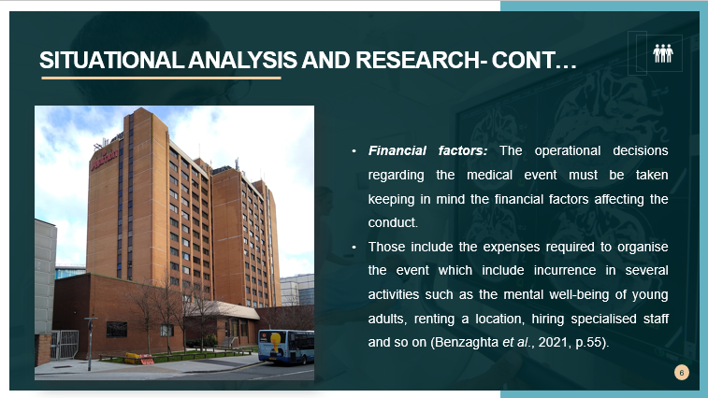
- Financial factors: The operational decisions regarding the medical event must be taken keeping in mind the financial factors affecting the conduct.
- Those include the expenses required to organise the event which include incurrence in several activities such as the mental well-being of young adults, renting a location, hiring specialised staff and so on (Benzaghta et al., 2021, p.55).
Note for me :
In addition to this, there should be contingency planning made to deal with the uncertain risks and complications. Some of them include any mishappening which makes a requirement for a new location. In that case, an alternative venue for the event must be kept as a backup and the rearrangement of schedule should be looked after by the event management team.

SWOT
Slide 6
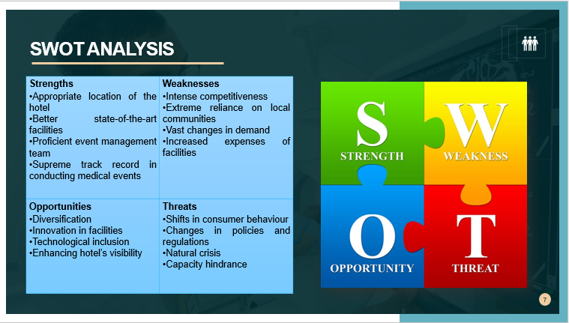
Strengths  - Appropriate location of the hotel  - Better state-of-the-art facilities  - Proficient event management team  - Supreme track record in conducting medical events | Weaknesses  - Intense competitiveness  - Extreme reliance on local communities  - Vast changes in demand  - Increased expenses of facilities
Opportunities  - Diversification  - Innovation in facilities  - Technological inclusion  - Enhancing hotel’s visibility | Threats  - Shifts in consumer behaviour  - Changes in policies and regulations  - Natural crisis  - Capacity hindrance
Note for me :
Analysis
The strengths of Cardiff Marriot Hotel which could impact the operational aspect of the medical event taking place include the best-suited location and the stature of art communities incorporated. The event management team of the hotel is involved in transacting duties efficiently and facilitates support to the event participants (Guilmette et al., 2019, p.9). Moreover, Cardiff Marriot Hotel is known for conducting successful medical events and this reputation could help in attracting an extended number of participants. There are certain weaknesses which are proven to be crucial such as the existence of intense competitiveness among the hotels and the extreme reliance on local communities which could further lead to failures. The demand aspect for the events keeps on changing and the expenses incurred could exceed, therefore a budget should be prepared. Opportunities such as diversification in the case of offerings could allure guests from many sectors. As opined by Jackson et al., (2021, p.2506), Innovation in facilities could be brought up with the inclusion of technologies. This could further improve the experience for the guests and add to the competitive landscape. Apart from all of the opportunities, there are certain threats including shifts in consumer behaviours potentially laying an impact on the demand aspect and the changes made in regulations like health and safety mandates. The natural crisis leading to hurdles for events like the pandemic could impact operations.

PESTLE
Slide 7
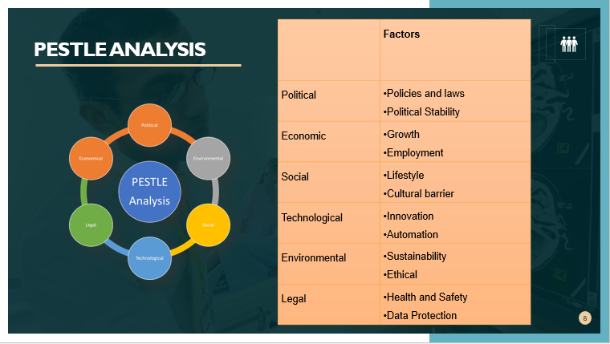
 | Factors | Analysis
Political | - Policies and laws  - Political Stability | Governmental laws and policies may create an immense impact on the business operations of Cardiff Marriot. It may have to change its laws and policies which will affect its marketing strategies (Gov.uk, 2024). The political instability of the UK may lead to the event of mental health well-being to acute failure as audiences may consider the country as an unsafe place.
Economic | - Growth  - Employment | The growth rate of the country’s economy will benefit the event by offering the best services to its audiences who will come from different corners of the globe (Cipd.org, 2023). Additionally, the employment opportunity will also be increased by this event.
Social | - Lifestyle  - Cultural barrier | The standard lifestyle of the citizens will help the event to attract more audiences. As stated by MOMIN (2023), the young adults of the country are also affected by several barriers due to their cultural differences. The event will get enough participants from the country.
Technological | - Innovation  - Automation | Cardiff Marriot has focused on innovative perspectives so it can upgrade technologies within the workplace (Getz and Page, 2019). Innovative technologies will improve the projection quality and provide a better visual experience to audiences (Great.gov.uk, 2024). Automation in the hotel’s premises depicts its class and standard in the competitive market which will justify the choice of the venue for the mental well-being of young adults event.
Environmental | - Sustainability  - Ethical | The sustainability of the environment may lead the event to arrange all steps successfully. In association with this, the ethical behaviour of the hotel staff within their workplace will certainly attract more audiences to this event (Openaccessgovernment.org, 2023). The hotel has to incorporate effective strategies so it can make the business operations sustainable so it can continue to offer such opportunities for upcoming events.
Legal | - Health and Safety  - Data Protection | The health and safety of audiences is the priority of the hotel’s authority. As the project will discuss the mental health and well-being of young adults, it will be necessary that they can provide the best service to audiences. The Data Protection Act 2018 will be followed by the hotel as they will never disclose the identity of the participants along with any of their personal information (Gov.uk, 2024).

Present evidence of why this event is feasible
Slide 8
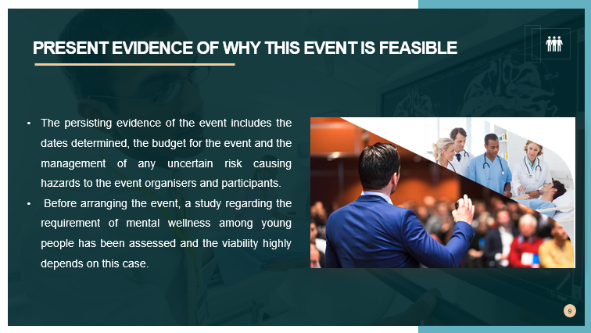
- The persisting evidence of the event includes the dates determined, the budget for the event and the management of any uncertain risk causing hazards to the event organisers and participants.
- Before arranging the event, a study regarding the requirement of mental wellness among young people has been assessed and the viability highly depends on this case.
Note for me :
Also, an assurance regarding the implementation of the formulated plan towards the event is made so that no anomalies are tolerated during the conduct (Shone and Parry, 2019). The supreme performance highly depends on the mission of the event and the targeted audience seeking mental health wellness support. A resilient backup of the event is also prepared to deal with the uncertain risk including a consideration of natural hazards and possible backlogs. Since the medical event would be focusing on the mental well-being of young adults, there exists a chance for endorsement and it is kept into account in the drafted schedule.

Slide 9
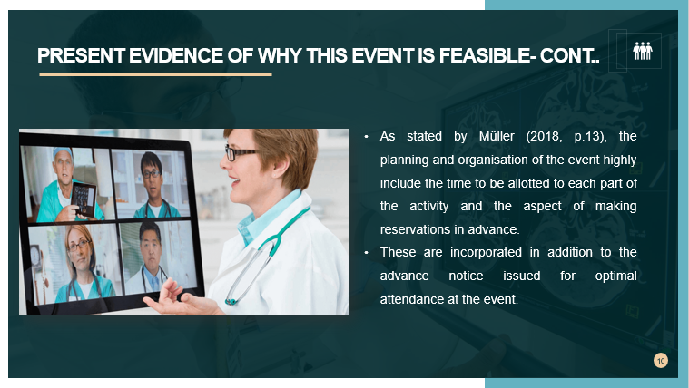
- As stated by Müller (2018, p.13), the planning and organisation of the event highly include the time to be allotted to each part of the activity and the aspect of making reservations in advance.
- These are incorporated in addition to the advance notice issued for optimal attendance at the event.
Note for me :
The financial results at the end would also be administered through a forecasted number of registrations and adequate identification of the cost involved. This shall further ensure the financial prosperity of the event with the creation of a budget and alignment with the ultimate motive.

Conclusion
Slide 10
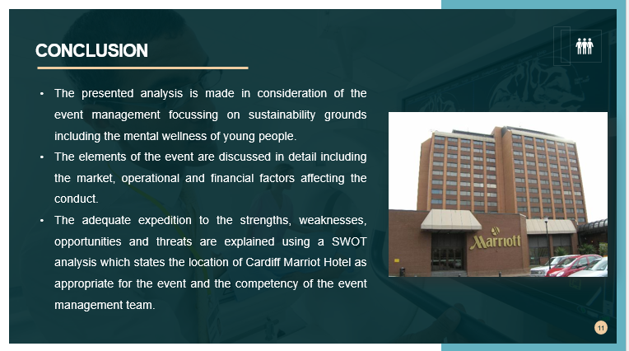
- The presented analysis is made in consideration of the event management focussing on sustainability grounds including the mental wellness of young people.
- The elements of the event are discussed in detail including the market, operational and financial factors affecting the conduct.
- The adequate expedition to the strengths, weaknesses, opportunities and threats are explained using a SWOT analysis which states the location of Cardiff Marriot Hotel as appropriate for the event and the competency of the event management team.
Note for me :
Thereafter, a PESTLE analysis is depicted stating the external factors affecting the operation of the event which includes a consideration of the political, economic, social, technological, legal and environmental factors. A statement regarding the present feasibility is provided to obtain a better understanding.

Link for Microsoft Teams Presentation :
https://uowtsd-my.sharepoint.com/:v:/g/personal/2120534_student_uwtsd_ac_uk/EawgarvIieBCjyUMJRiz5UYBjl_5h8Rr8b99NRGcADKX6w?referrer=Teams.TEAMS-ELECTRON&referrerScenario=MeetingChicletGetLink.view.view

References
Benzaghta, M.A., Elwalda, A., Mousa, M.M., Erkan, I. and Rahman, M., 2021. SWOT analysis applications: An integrative literature review. Journal of Global Business Insights, 6(1), pp.55-73. https://digitalcommons.usf.edu/globe/vol6/iss1/5/
Caswell, M., 2023. Cardiff Marriott Hotel unveils property-wide refurbishment. Available at: https://www.businesstraveller.com/business-travel/2023/02/27/cardiff-marriott-hotel-unveils-property-wide-refurbishment/
Cipd.org, 2023. ‘PESTLE analysis’. Available at: https://www.cipd.org/uk/knowledge/factsheets/pestle-analysis-factsheet/ [Accessed on- 23rd January 2024]
Getz, D. and Page, S.J., 2019. Event studies: Theory, research and policy for planned events. Routledge.
Gov.uk, 2024. ‘Data protection’. Available at: https://www.gov.uk/data-protection [Accessed on- 23rd January 2024]
Gov.uk, 2024. ‘PESTLE analysis’. Available at: https://assets.publishing.service.gov.uk/media/5a81b94fe5274a2e8ab55843/Tool_3.pdf [Accessed on- 23rd January 2024]
Great.gov.uk, 2024. ‘Technology’. Available at: https://www.great.gov.uk/international/content/investment/sectors/technology/ [Accessed on- 23rd January 2024]
Guilmette, M., Mulvihill, K., Villemaire-Krajden, R. and Barker, E.T., 2019. Past and present participation in extracurricular activities is associated with adaptive self-regulation of goals, academic success, and emotional wellbeing among university students. Learning and Individual Differences, 73, pp.8-15. https://doi.org/10.1016/j.lindif.2019.04.006
Igi-global.com, 2019. ‘International Meeting Management’. Available at: https://www.igi-global.com/chapter/international-meeting-management/209235 [Accessed on- 23rd January 2024]
Jackson, S.B., Stevenson, K.T., Larson, L.R., Peterson, M.N. and Seekamp, E., 2021. Outdoor activity participation improves adolescents’ mental health and well-being during the COVID-19 pandemic. International Journal of Environmental Research and Public Health, 18(5), p.2506. https://www.mdpi.com/1660-4601/18/5/2506
Marriott.com, 2024. ‘Cardiff Marriott Hotel’. Available at: https://www.marriott.com/en-us/hotels/cwldt-cardiff-marriott-hotel/overview/ [Accessed on- 23rd January 2024]
Marriott.com, 2024. Available at: https://www.marriott.com/en-gb/hotels/cwldt-cardiff-marriott-hotel/experiences/explore-cardiff/ [Accessed on- 23rd January 2024]
Marriott.com, 2024. Cardiff Marriott Hotel. Available at: https://www.marriott.com/en-us/hotels/cwldt-cardiff-marriott-hotel/events/ [Accessed on- 23rd January 2024]
MOMIN. A., 2023. ‘PESTLE Analysis of The United Kingdom: 6 Factors Affecting the UK’. Available at: https://pestleanalysis.com/united-kingdom-pestle-analysis/ [Accessed on- 23rd January 2024]
Müller, M., 2018. What makes an event a mega-event? Definitions and sizes. In Leveraging mega-event legacies (pp. 13-28). Routledge. https://www.taylorfrancis.com/chapters/edit/10.4324/9781315439846-8/makes-event-mega-event-definitions-sizes-martin-m%C3%BCller
Munn, Z., Stern, C., Aromataris, E., Lockwood, C. and Jordan, Z., 2018. What kind of systematic review should I conduct? A proposed typology and guidance for systematic reviewers in the medical and health sciences. BMC medical research methodology, 18(1), pp.1-9. https://bmcmedresmethodol.biomedcentral.com/articles/10.1186/s12874-017-0468-4\
Openaccessgovernment.org, 2023. ‘UK citizens’ interests towards sustainable practices on the rise’. Available at: https://www.openaccessgovernment.org/uk-citizens-interest-sustainability-sustainable-practices/152965/#:~:text=The%20United%20Kingdom%20was%20the,the%20UK%20economy%20by%202050. [Accessed on- 23rd January 2024]
Shone, A. and Parry, B., 2019. Successful event management: a practical handbook. Cengage learning.
Shtal, T.V., Buriak, M.M., Amirbekuly, Y., Ukubassova, G.S., Kaskin, T.T. and Toiboldinova, Z.G., 2018. Methods of analysis of the external environment of business activities. Revista Espacios, 39(12). https://ww.revistaespacios.com/a18v39n12/18391222.html

