Student Name……………………………………...Guile Danielle Virginie Fohe
Student Number………………………………….2128226
Module Title………………………………………………Introduction to Public Health
Module code…………………………………………………LCHS4004
Lecturer…………………………………………………………. Dr Fahad Khan
Assignment Title…………………………………………Major Health Issue

Contents Page

1.Introduction……………………………………………………………3

2.Public Health Measures…………………………………………...3-5

2.1. The key determinants/risk factors of Hepatitis B………………………………………5

2.2. Short- term public health consequences of Hepatitis B in a health and social care setting………………………………………………………………………………………………….6

2.3. Long -term public health consequences of Hepatitis B in a health and social care setting…………………………………………………………………………………………………6

3.Conclusion……………………………………………………………………...6

4.References…………………………………………………………………………………7

HEPATITIS B

1.Introduction
Hepatitis B is a viral and life-threatening infection that attacks the liver and can cause both acute and chronic disease. It is a vaccine-preventable liver infection caused by Hepatitis B virus (HBV). The virus is most often transmitted from mother to child during birth and delivery, through contact with blood or other body fluids during unprotected sex with an infected partner, unsafe injections or exposure to sharp or pointed instruments. The World Health Organization (WHO)estimates that 296 million people were living with chronic Hepatitis B in 2019 and counts 1.5 million new infections each year. In 2019, Hepatitis B caused approximately 820,000 deaths, mainly from cirrhosis or hepatocellular carcinoma (i.e., primary liver cancer). This is a major public health problem. According to WHO, there are 60 million people infected in the Eastern Mediterranean region ,18 million in the Southeast Asia region ,14 million in the European region and 5 million in the region of the Americas. There is a safe and effective vaccine, providing 98% protection against the disease. Preventing Hepatitis B to avoid complications like chronic form or liver cancer. In the UK, the prevalence of chronic hepatitis B is estimated to be 0,3% of approximately 180,000 people which is very low. “The incidence of Hepatitis B virus (HBV)infection in the UK is low. Since the infection can have serious sequelae, there is a continuing need to examine its epidemiology to inform control measures “. (Hahne et al.2004) What are the public health measures to control Hepatitis B for spreading? What are the risk factors? What are the short- and long-term public health consequences?

2.Public Health Measures
Hepatitis B is a virus that replicates in the liver and is present at very high levels in the blood of the infected person. The Hepatitis B virus (HBV) causes hepatitis which is the inflammation of the liver and can cause long term liver damage. It is a vaccine preventable disease. The virus is transmitted by contact with infected blood or body fluids contaminated by blood. It can be spread by: -Sharing or use of contaminated equipment ,from an infectious mother to her unborn baby ,by unprotected sexual contact , between individuals via a contact with an infected person , by infected blood transfusion, by needle stick or other sharps injuries sustained by hospital personnel, also by tattooing and body piercing . “Hepatitis B virus (HBV) continues to represent a major health problem and can lead to acute liver failure, acute hepatitis, chronic carriership, chronic hepatitis of HBV, liver cirrhosis, liver cancer, liver transplantation and death”. (Meireles et al., 2015)
The incubation period from infection to the appearance of symptoms is around 12 weeks. Hepatitis B diagnosis is based upon the presence of serological markers in plasma which indicate if the disease is acute or chronic or if the patient is immune or prone to infection. Once a case is confirmed, public health actions should be taken to control and prevent further cases. A risk assessment is completed to give a clearer picture as to where it will be important to focus public health efforts. The case should be counselled on the mode of transmission and preventive methods to limit onward transmission by health protection team. Information about protected sex, sharing needles, drug use injections, household hygiene like sharing razors, toothbrushes, towels should be documented. Identify close contacts. All adults’ cases must be signposted to clinic for a full sexual health screen.GP has to be informed of the diagnosis and be aware that the disease may be susceptible to progress to chronic hepatitis B. If the case is pregnant or newly delivered liaise with local midwifery for follow up.” Infants who are born to hepatitis B surface antigen (HbsAg)-positive women are at high risk for contracting perinatal hepatitis B virus (HBV)infection. When maternal status is known, postexposure prophylaxis (PEP)consisting of a birth dose of (HBV)vaccine and Hepatitis B Immune Globulin may be administered within 12 hours of birth to provide 90% protection”. (Libbus and Phillips ,2009). “All cases contacts should be immunized against Hepatitis B as soon as possible. Vaccination is effective in stimulating the production of antibodies against the virus and preventing the infection if administered shortly after exposure. Any sexual partner of individual with acute hepatitis B should be offered post exposure prophylaxis with the vaccine. The hepatitis vaccine is a part of the routine childhood immunization program since 2017.The main groups who should be offered pre-exposure vaccination are: .people who inject drugs .individuals who change sexual partners frequently , male and female sex workers and men who have sex with men .close family contacts of an individual with chronic hepatitis B infection .family adopting children from countries with high or intermediate prevalence of hepatitis B .patients with chronic liver disease .inmates of custodial institutions .individuals in residential accommodation for those with learning difficulties and staff .travellers to areas of high or intermediate prevalence who may be at risk whilst abroad .those with occupational risk healthcare workers , laboratory staff and other potentially high -risk occupations such as morticians and embalmers and prison staff Although immunization in high risk groups is evidence -based to protect individuals from the transmission of hepatitis B, universal precautions remain of the upmost importance and should not be neglected”.(Interim guidance on the public health management and control of acute hepatitis B, 2019) Vaccination is the best way to prevent hepatitis B. In the UK, the hepatitis B vaccine is given to babies as part of the 6-in-1 vaccine. Babies born to mothers with hepatitis B are given additional vaccinations at birth ,4 weeks and 1 year, to reduce the risk of them getting the infection. “Despite the existence of effective prevention and treatment interventions, hepatitis B virus (HBV) infection continues to cause nearly 1 million deaths each year. WHO aspires to global control and elimination of HBV infection. We aimed to evaluate the potential impact of public health interventions against HBV, propose targets for reducing incidence and mortality, and identify the key developments required to achieve them. We developed a stimulation model of global HBV epidemic, incorporating data on the natural history of HBV prevalence, mortality, vaccine coverage, treatment dynamics, and demographics. We estimate the impact of current interventions for prevention of infection and introducing wide-scale population screening and treatment interventions on the worldwide epidemic. Vaccinations of infants and neonates is already driving a large decrease in new infections; vaccination has already prevented 210 million new chronic infections by 2015 and will have averted 1.1 million deaths by 2030.However , without scale-up of existing interventions ,our model showed that there will be a cumulative 63 million new cases of chronic infection and 17 million HBV-related deaths between 2015 and 2030 because of ongoing transmission in some regions and poor access to treatment for people already infected .A target of a 90% reduction in new chronic infections and 65% reduction in mortality could be achieved by scaling up the coverage of infant vaccination (to 90%of infants), birth-dose vaccination(to 80% of neonates ),use of peripartum antivirals(to 80% of hepatitis B e antigen-positive mothers ),and populations -wide testing and treatment (to 80% of eligible people).These interventions would avert 7.3 million deaths between 2015 and 2030 , including 1.5 million cases of cancer deaths. An elimination threshold for incidence of new chronic infections would be reached by 2090 worldwide. The annual cost would peak at US $7.5 billion worldwide ($3.4 billion in low-income and lower -middle-income countries) but decrease rapidly and this would be accelerated if a cure is developed. Scale up of vaccination coverage innovations in scalable options for prevention of mother-to-child transmission, and ambitious population-wide testing and treatment are needed to eliminate HBV as a major public health threat. Achievement of these targets could make a major contribution to one of the Sustainable Development Goals of combating hepatitis”. (Nayagam et al ,2016)

Diagram of hepatitis B infection

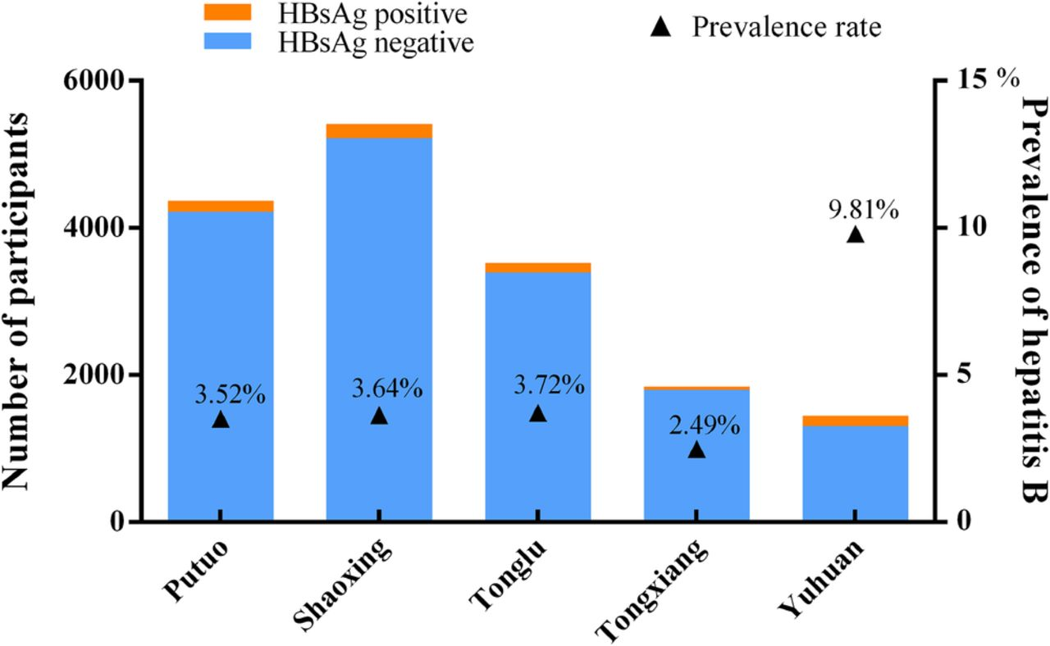

2.1. Key determinant/Risk factors of Hepatitis B
Hepatitis B is an infection of the liver caused by a virus. It is spread in blood and bodily fluids. It can be spread by having sex without protection and sharing needles, by birth from mother to her baby, sharing items such as toothbrushes, razors or medical equipment with an infected person.” The risks of hepatitis B increase if you: .travel to countries with high infection rates of HBV such as Asia , Pacific Islands , Africa and Eastern Europe. . have a job that exposes you to human blood. .men who have sex with other men. .have unprotected sex with multiples sex partners or with someone who is infected with HBV”.(Mayo Clinic,2022).According to Thomas ‘et AL’(1993),healthcare personnel are at increased risk of occupational acquisition of hepatitis B virus(HBV)infection.

2.2.Short term public health consequences of hepatitis B
There is no specific treatment for acute hepatitis B(short term).Care is aimed at maintaining comfort and adequate nutritional balance, including replacement of fluids lost from vomiting and diarrhea. Avoiding unnecessary medications.

2.3 Long term public health consequences of hepatitis B
Chronic hepatitis B infection can be treated with medicines , including oral antiviral agents. The treatment can reduce the progression of cirrhosis , lower the incidence of liver cancer and improve long term survival.

3.Conclusion
“Hepatitis B is a leading cause of death in the world and the first cause of hepatic cirrhosis and HCC. The chronic form of hepatitis B infection is a significant public health problem. The history of chronic hepatitis B infection is determined by the extended level of HBV replication , as reflected in circulating levels of HBV DNA serum. Some evidence indicates that control of hepatitis B replication with antiviral therapy lower the incidence of complications .People with chronic hepatitis B require to be monitored for viral activity , viral load reduction , drug resistance and the progression of the disease. A better understanding of viral , host and environmental factors that influence disease progression will improve efficiently the management of patients with chronic HBV infection. The best prevention against hepatitis B is through global vaccination programs and routinely applied neonatal and primary adulthood prophylaxis should be pursued”.(Rustgi et al.,2010).
“In conclusion, although we are still some ways from eradicating or curing chronic hepatitis B, the advent of lamivudine allows new population to benefit from therapy and helps to address the global public health problem of hepatitis B”.(Maddrey, 2001).
There is no cure for hepatitis B and the infected persons require management for the rest of their lives.

4.Refrences
.EA SL(European association for the study of the liver)
EASL clinical practice guidelines: Management of chronic hepatitis B virus infection ,Journal of hepatology 2012,57(1):167-185
.David L Thomas, Stephanie H Factor, Gabor D Kelen, Antonio S Washington, Eric Taylor, Thomas C Quinn; archives of internal medicine 193(14),1705-1712,1993
.Martha Kay Libbus, Lynelle M Phillips, Public health nursing 26(4),353-361,2009
. Maddrey, W C,(2001) 47(1-2),51-55
.Susan Hahne, Mary Ramsay, journal of clinical virology29(4)211-220, 2004
.https://www.who.int/news-room/fact-sheets/detail/hepatitis-b
.https;//www.mayoclinic.org/diseases-conditions/hepatitis-b/symptoms-causes/syc-20366102
.https://doi.org/10.1016/S1473-3099(16)30204-3
.https://www.gov.uk/guidance/hepatitis-b-clinical-and-public-health-management
.
.

