Lonye Browne (2114209)
UWTSD
ACBA 5009
WORK BASED

Table of Contents
Name of Student 2
Student ID 2
Name of Award 2
Mode 2
Title 2
Abstract 2
The Introduction and the Background 2
Aim 3
Objectives 3
Literature Review 4
Introduction and Background of Gabion Baskets 4
What happens to a river, and why Gabion Basket Walls are used? 5
Methodology 8
Results 8
Case Study One 9
Case Study Two 9
Case Study Three 10
Case Study Four 10
Case Study Five 11
The Caratal River, Georgetown, St. Vincent and the Grenadines 12
Conclusion 16
Reflection 17
Bibliography 20
Appendices 23

Name of Student: Lonyé Browne

Student ID: 2114209

Name of Award: BSc Civil Engineering

Mode: Full Time

Title
The Use of Gabion Baskets at the Caratal River, Georgetown, St.Vincent and the Grenadines

Abstract
This research paper seeks to understand how gabion baskets work and why they were implemented at the Caratal River, Georgetown, St. Vincent. The paper gives a background to the topic, with the aims and objectives of the research project. There is a literature review which defines gabion baskets, how they work and what they are used for. The methodology of this paper is to seek the results by researching similar cases where gabion baskets were implemented. This paper analyses five different case studies to measure the success rate of gabion basket structures. That success rate is then used to determine if gabion baskets were a good choice for resolving the issues faced by the Caratal River. Lastly, there is a reflective piece by the author stating their mistakes, and improvements for further research.

The Introduction and the Background
The Researcher grew up in St. Vincent and the Grenadines, an island in the Caribbean and is currently studying Civil Engineering; so, this research is focused on issues faced by St. Vincent and the Grenadines.

GISGeography (2022) Describes the topography of St. Vincent as “rugged and very mountainous”. The highest peak is the active volcano La Soufriѐre at 1234 metres. With that, there are also many waterfalls and rivers.

St. Vincent and the Grenadines is subject to two seasons, the dry season (November to May) and the wet/hurricane season (June to October). During the dry season, there are trough systems which cause flash flooding, heavy rain, rising river levels and landslides.

In December 2013, an unseasonal trough system and accompanying torrential rain resulted in considerable river flooding, landslides, slope failures, and debris flows to St. Vincent (mainland). There was also extensive damage to roads, bridges, river defences and residential housing. The island suffered nine fatalities, and thirty-four injuries were reported. (Refer to Appendix A)

As part of the rehabilitation and reconstruction after this tragic event, and to reduce the effects that trough systems and the hurricane season have on the island, gabion baskets have been engineered at the Caratal River in Georgetown.

Aim
- This research aims to identify if the use of Gabion Baskets were the correct choice for the Caratal River, Georgetown, St. Vincent and the Grenadines.

Objectives
- What are gabion baskets, their uses, and their advantages?
- What is the nature of St. Vincent, and how did it contribute to the problems that created the need/use of gabion baskets at Caratal River? (Get information from the terms of reference TOR/Appendix A)
- Using the drawings, what size stones were used in the gabion baskets?
- Why is stone size important in engineering gabion baskets?
- What research is available on other rivers that have implemented gabion baskets to resolve similar issues as Caratal River?
- Based on that research, will the use of gabion baskets at Caratal River be successful?

Literature Review

Introduction and Background of Gabion Baskets
A Gabion basket is a square or rectangular wire cage that is filled with stones. The stones that are used must be durable, of a high specific weight(dense), and have a good resistance to the elements (water, wind, snow). The wires/mesh of the cage are double-twisted into hexagonal shapes, as opposed to the original square, simple-twist cage. Depending on the environment the gabions will be placed, the wires can be coated with zinc or PVC.

Gabion baskets were introduced to the world since ancient Egypt as a method to make different environments habitable but still aesthetically pleasing. They used gabion structures along the banks of the Nile River to protect their crops. (Civil Engineering Magazine, 2018)

Today, gabion baskets are used to stabilise shorelines, stream banks, slopes against erosion, retaining walls, temporary flood walls, silt filtration from runoff, small dams, river training, and channel lining. The use of gabions is much more predominant in today’s society as global warming has caused severe climate change resulting in floods and droughts. Flash floods result in a number of issues, including mass erosion of river banks, which gabions can be engineered to resolve. (AARSLEFF, 2022)

Gabions are prefabricated, and the flattened units are sent on site, where the boxy shape is achieved by fastening the different elements together. All gabion baskets must be laced to each other, both horizontally (those next to each other) and vertically (those on top of each other). Before the gabions are placed, a layer of geotextile must be put down on the soil surface. The geotextile is a semi-permeable membrane which prevents the loss of fine soils (from behind/under the gabions) but still allows water to pass through. Failure to use the geotextile will decrease the integrity of the structure. (Refer to Appendix B)

The lattice shape of the gabion allows even distribution of the imposed forces. The wire netting increases the tension on the structure, which will enable it to take any other loads which may not have been calculated when it was designed. Though the structure of a gabion may deform, it will not fail because it is still applying the same load to the soil; this is particularly advantageous when the land beneath the gabion is uneven or where deposition of soils may occur.

Gabion baskets are permeable because of the empty spaces between the stone fill, which allows fluid movement. This makes gabion baskets the optimal choice for hydraulic systems as they are not highly affected by the pressure exerted on them, and they allow water to flow in both directions, thus remaining efficient. Also, installing gabion baskets does not require a change in the usual flow of hydraulic systems.

What happens to a river, and why Gabion Basket Walls are used?

A river is an active natural body of water that can change the pattern in which it flows. When the pattern of a river changes, it can destabilise the bank because the bank absorbs energy from the water. Erosion of a river bank takes place naturally as the water flow wears it away. The bank of a river can also erode due to floods, heavy rainfalls, strong currents of the river, deforestation, and housing near banking. Erosion can occur in two forms: bank scours and mass failure. In bank scours, the bank is eroded by the flowing water removing and carrying the sediment, while mass failure occurs when the bank slides and falls into the water. River bank erosion has severe socio-economic impacts, such as loss of homes, loss of land, and death; thus, it is important to create and implement solutions for an eroded/eroding river bank. (Adidti, 2020)

When a gabion basket is utilized as a solution for stabilising an eroded/eroding river bank, it acts as a retaining wall. The Oxford Dictionary defines a retaining wall as “a wall that holds back earth or water on one side of it”. Retaining walls are designed to withstand lateral pressure of soil or to hold back the soil materials, liquid pressure and/or sand (The Constructor, 2021).

Gabion walls can be designed using two different analysis methods: serviceability limit state design or ultimate limit state design; whichever design method is adopted, there are key factors that must be considered which would influence the stability of the existing bank or what may affect the gabion wall (Guan-Chyun and Cheng-Yung, 2011).

Determining the equilibrium of the wall is done in two parts.
- External Stability, which includes analysis for sliding, overturning, and bearing capacity.
- Internal Stability, which is the analysis of shear failure slope.
(Peerdawood and Mawlood, 2010)

As a gabion wall is a retaining wall, there are certain forces with are calculated for.
- The forces acting on the wall: the principal forces acting on the wall are due to the weight of the wall itself (acting vertically), and lateral earth pressure. Other loads such as vehicular and seismic loads must be considered if applicable.
- Sliding Check: this refers to the ability of the active earth pressure to cause the wall to slide. The structure must be designed in a manner that is able to oppose that force using frictional resistance at its base.
- Overturning Moment Check: The active soil pressure forces tend to overturn the wall, the forces must be counteracted and create balance by the resisting moment caused by the weight of the wall and other forces.
(Peerdawood and Mawlood, 2010)

The design of a gabion wall must also consider the size of the stones used for various reasons like stability, drainage, durability, and aesthetics. Therefore, it is important to consider stone size in the design of a gabion structure for it to be effective.

- Structural Stability: The structural stability of the construction is influenced by the size of the stones used in the gabion basket. The stones must be substantial enough to support the wire mesh container adequately and keep it from tipping over under the weight of the materials. The ideal size of the stones used in gabion baskets should be between 100 mm and 200 mm to maintain structural stability, according to a study by M.K. Hossain and M.A. Hossain (Hossain & Hossain, 2014). Therefore, for gabion baskets to be structurally stable, the use of stones of the proper size is crucial.
- Drainage: The gabion basket's ability to drain water is also determined by the size of the stones used in it. The stones must be large enough to prevent obstructions from occurring and permit water to flow freely through the structure. The size of the stones used in gabion baskets should be between 75 mm and 300 mm, according to a study by K. Beckett and S. Srinivasan (Beckett & Srinivasan, 2009). Thus, the use of stones proper stone size is crucial in gabion baskets for efficient drainage.
- Durability: The durability of the structure is also impacted by the size of the stones used in the gabion basket. The stones must be big enough to withstand erosion brought on by water flow or other environmental factors. The size of the stones used in gabion baskets should be between 100 mm and 300 mm, according to a study by C. Thewes and J. Kirchner (Thewes & Kirchner, 2012). To ensure long-term endurance, gabion baskets must contain stones of the proper size.
- Aesthetics: The gabion basket's aesthetics are governed by the size of the stones used in its structure. To create a pleasing appearance, the stones should be uniform in size and colour. The size of the stones used in gabion baskets should be between 100 mm and 200 mm, according to a study by A. Watanabe and K. Kawamoto (Watanabe & Kawamoto, 2010). Therefore, for gabion baskets to seem appealing, the use of stones of the proper size is crucial.

While gabions act as a retaining wall, they can simultaneously be used to widen a river channel. Widening or deepening a river to increase the volume of water that can flow in a section is known as channelization. Channelization helps water to move more efficiently and at a higher volume in times of a flood, which decreases bank erosion (Alberta Water Portal Society, 2013). Increasing the width of a river also decreases the chances of the river overflowing or reaching the height of the bank and its surrounding areas, which can have different effects based on what is in the surrounding areas.

Methodology
Research on how gabion baskets aid in slope stabilization and widening river channels by lining and supporting the riverbank will be obtained from (e)books and (e)journals.

St. Vincent does not have much research available online or to the public regarding projects; therefore, information specific to the use of gabion baskets at the Caratal River will be obtained by having targeted, semi-structured interviews over the next few months with the Civil Technician who worked on-site. The existing drawings and proposed drawings will also be used to deduce information on the river and how engineering gabion baskets are expected to make changes.

The research from books/journals will be used to make assumptions on whether using gabion baskets at Caratal River was a good choice by analysing the results of similar case studies.

Studying the behaviour of the river in the occurrences of high rainfall is also another way to tell if the gabions have succeeded. This information will be obtained by contacting the relevant ministries and persons living close to Caratal River. Through the timeline of this assignment, if a trough system approaches the island or if there is heavy rainfall, it would be perfect to examine the behaviour of Caratal River, through video evidence from persons living close by.

Start linking things from the literature review with the Caratal River to justify using gabion baskets and analyse whether it was the correct choice. For example, using drawings and aerial photos to show that houses are near the bank, which in the literature review is stated as a contributor to erosion.

Results

The general success rate of implementing gabion baskets to stabilise riverbanks and mitigate erosion is considered to be high. The success of a gabion basket project may vary depending on the site and is influenced by factors such as the soil characteristics, the slope and the water flow. The success is also dependent on the quality of the construction of the baskets, the size and shape of the baskets, and the material used. Therefore, importance is stressed on considering the site-specific conditions for a successful implementation of gabion basket walls and structures (Rani et al., 2017).

The following are five case studies from around the world that investigate the use of gabion baskets in rivers. After gabion baskets are installed, the site is revisited to investigate whether the structure successfully fulfilled its purpose. Each case study would state if the implementation of the gabion structures served their purpose or not.

Case Study One
Gabion baskets were used to stabilise a streambank along the Washita River in Oklahoma, USA. They were implemented because the banks suffered extreme erosion due to high flows and an unstable bank. This issue was causing a threat to nearby infrastructure and creating environmental hazards. The gabion baskets were installed along the stream bank, and they were backfilled with soil. Additionally, vegetation was planted to provide more stability and for aesthetics; the vegetation matched the surrounding landscape, thus making the gabions look more natural. Researchers monitored this project and concluded that the gabions stabilised that stream bank and reduced the erosion. The vegetation also became overgrown, which provided even more stability. This application of gabions was considered to be a success for stabilizing and preventing further erosion to the stream bank. However, a major flood occurred causing some of the gabions to be displaced, but the gabions were easily repaired (Janjua et al., 2015).

Case Study Two
In this case study research was carried out on the Zealand River, New Hampshire in the US. The gabion baskets were initially installed in 1960-1963 to stabilise the stream. The researchers conducted their study in 2014, which is 54-51 years later after the initial installation. Their research concluded that almost all the gabions had failed 25 years after they had been installed and that they were “completely ineffective” by 2014. The gabion baskets were severely damaged at the time the study was conducted, however, they still maintained control of the channel width and its direction. The gabions would topple into the channel because pools of water would form at the ends of the walls in the downstream direction. The researchers say that the gabion baskets are conflicting with the natural channel adjustments of the river and that it will cause disruption to vegetation if any attempt is made to remove the remaining gabions. The final opinion was that gabion baskets are not recommended for river stabilization as they pose long-term problems associated with their failure (Thompson et al., 2016).

Case Study Three
This case is based on the Jhelum River, Kashmir, India which implemented gabion baskets for flood mitigation. It is a major river that is situated in the Himalayan region of Kashmir, and it is subject to flooding due to high rainfall and snowmelt from the surrounding mountains. These floods contribute significantly to socio-economic issues such as damage to properties, infrastructure, and livelihoods in the region. The government of India, therefore, had to create solutions to these problems, one being implementing gabion baskets. The gabions were installed to stabilise the river banks, control erosion, and protect nearby infrastructure such as roads and bridges. Gabion baskets were chosen as a solution because they are cost effective, durable and are able to blend in with the natural environment. The gabion baskets were effective and successful as a measure for flood mitigation as they reduced the river bank erosions and protected the infrastructure during other times of flooding. Other advantages of this project are that it improved the nature of the river, providing a better habitat for the wildlife which promoted biodiversity. This project was also able to provide employment to the persons of the community during the construction of the gabion structure and for maintaining it (Dar and Ahmad, 2017).

Case Study Four
The Arare River in Switzerland employed gabion baskets for river training and protecting the river bank. The river was subject to significant erosion due to high flows and unstable banks, which posed threats to the surrounding infrastructure and the environment. The gabion baskets were installed along the river bank on a layer of geotextile to prevent the loss of fine materials. The objective of the gabion basket structure was to widen the river channel and stabilise the river bank to prevent further erosion of it. The gabion basket structure also provided a more suitable habitat for aquatic life. In this application of gabion baskets, there was an issue with the structure being placed too close to the edge of the river which caused instability and deformation of the baskets. This problem was resolved by repositioning the baskets further from the edge of the bank. The gabion structure was designed to be flexible and to adjust to changes in the flow, allowing it to maintain stability during the event of high flow. The application of gabion baskets at this river was successful in achieving the aim of stabilising the river bank and widening the channel; with an added advantage of improving ecological life. This project also highlights the importance of the planning and designing stage of a gabion project to ensure long-term stability (Holzer et al., 2004).

Case Study Five
This case study is based on the use of gabion baskets at Rakaia River, Canterbury, New Zealand. This is a large, braided river that suffers from erosion and sedimentation which creates issues with surrounding infrastructure, water management, and the ecological health of the river. Using locally sourced stones, the baskets were filled up. Then, baskets were placed along the river banks and in certain areas of the riverbed, which created a stable and permeable structure that would resist the forces created by the water flow. The gabion basket structure was effective for reducing sedimentation, improving water management, and bettering the ecological health of the river by restoring the habitat. This project benefited the local community by creating jobs in constructing and maintaining the structure (Hamilton et al., 2019)

These five case studies prove that gabion baskets usually serve their purpose when utilised to stabilise river banks and widen river channels. Gabion basket structures are successful in flood mitigation and resolving issues with sediment settlement in a river channel. Implementing gabion basket structures in rivers also has additional advantages such as bettering the habitat for wildlife and ecology; these projects also create job opportunities for persons of the communities. Though there were many successes, there was one case where the gabions had failed after twenty-five years of installation and the researcher added that gabions are not a good investment in the long run. However, it is fair to say that a gabion basket structure would have a service life like any other infrastructure and that after twenty-five years, it would have served its purpose.

The Caratal River, Georgetown, St. Vincent and the Grenadines

Georgetown is a town in St. Vincent and the Grenadines located on the Windward side of the island. Though St. Vincent is mountainous, Georgetown is flat with little to no elevation. However, the Caratal River runs from the mountains, down and through the town. The river meanders around houses and crops that are situated on its embankment. Gabion baskets were installed along the river’s banks to widen the channel and stabilise the banks.

The literature review speaks about reasons that may cause erosion to a river bank such as floods, heavy rainfall and housing near the bank; these are all factors which describe the circumstances that the Caratal River is under. The trough system that occurred in December 2013 brought heavy rainfall and flooding, resulting in the failure of the bank, and endangering the persons living nearby. The failure of the bank also caused damage to the nearby infrastructure, crops, and livestock.

From the five case studies, it can be deduced that gabion basket walls are normally used to resolve the issues that were faced by the Caratal River, and successfully too. Therefore, it is no surprise that the engineers and relevant bodies resorted to gabion baskets as the solution. Not only are gabion basket structures effective, but they are also one of the cheaper solutions which must be considered for large scale government projects.

The main objective of installing gabion baskets at the Caratal River was to stabilise the river banks and widen the river channel. It is imperative for the bank to be stabilised to ensure that it would not fail and collapse in the future. A collapse in the bank of the Caratal River could cause fatalities, and loss of homes, land, and livestock. The river channel must be widened to allow for a high volume of water to flow without the water level reaching the height of the surrounding houses. If the water level reaches that height of the houses, it could result in flooded houses and loss of valuable items.

The case studies stressed the importance of properly planning and designing a gabion basket structure. This is an important stage of the construction as it could make the difference of whether it is effective and successful or a complete failure. The implementation of gabion structures at the Caratal River involved designing the gabions by producing different drawings and choosing which is most suited for the river based on other calculations. The planning process involves choosing a company to source the gabions from which was Maccaferri.

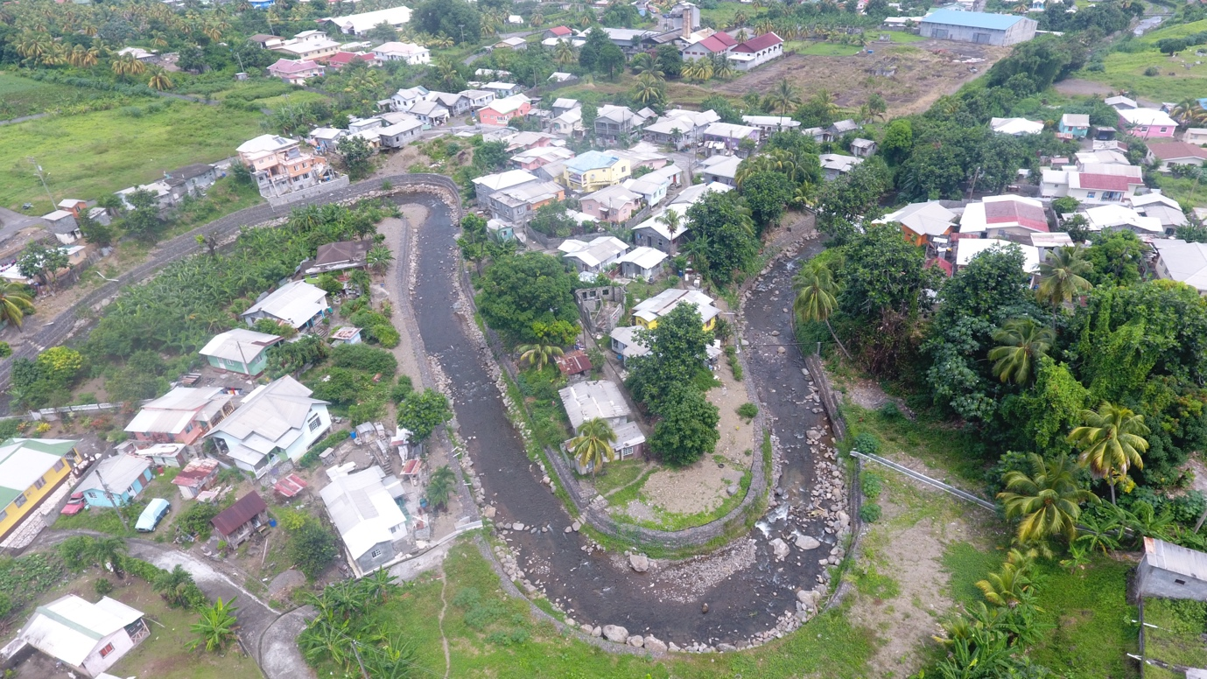
Fig 1 Showing an aerial view of the site.
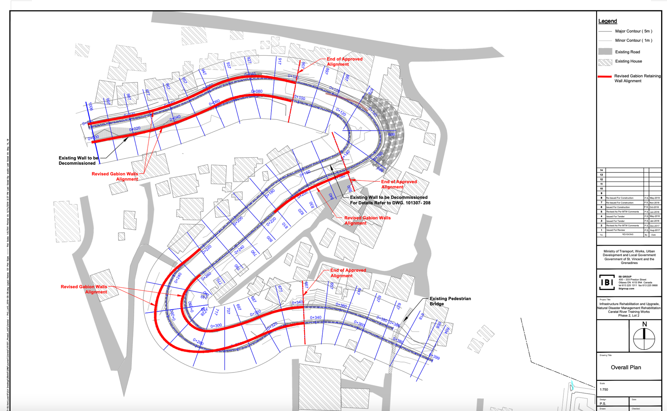
Fig 2 Showing the proposed plan in red, for the positioning of the gabion baskets which would widen the river channel.

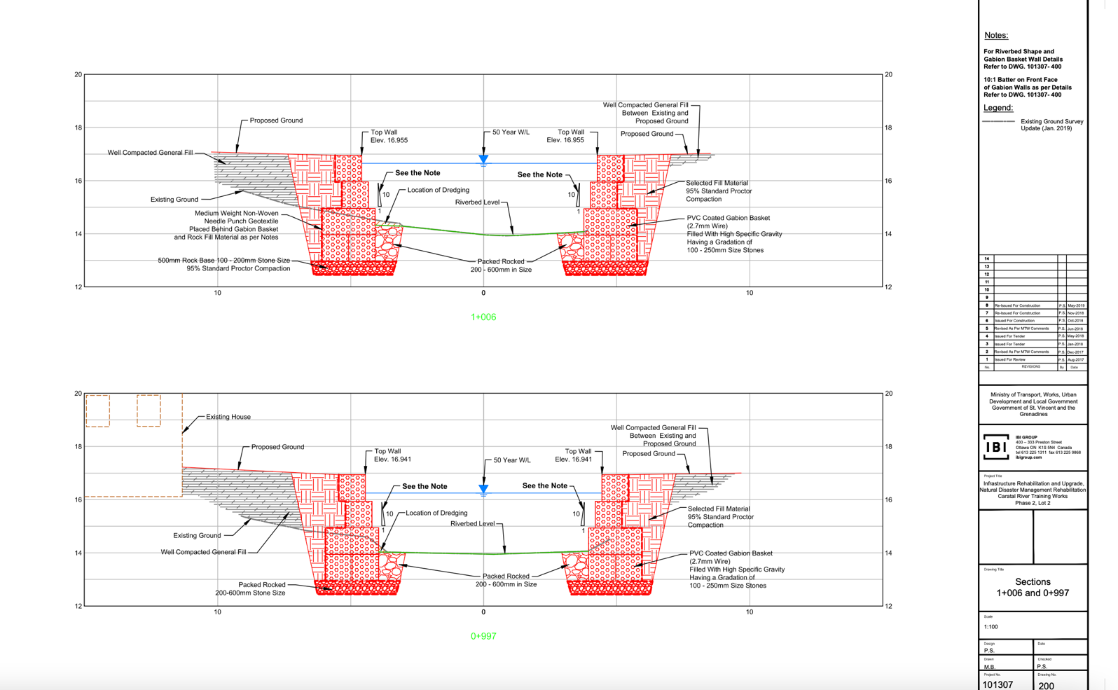
Fig 3 Showing a proposed plan for the gabion baskets.

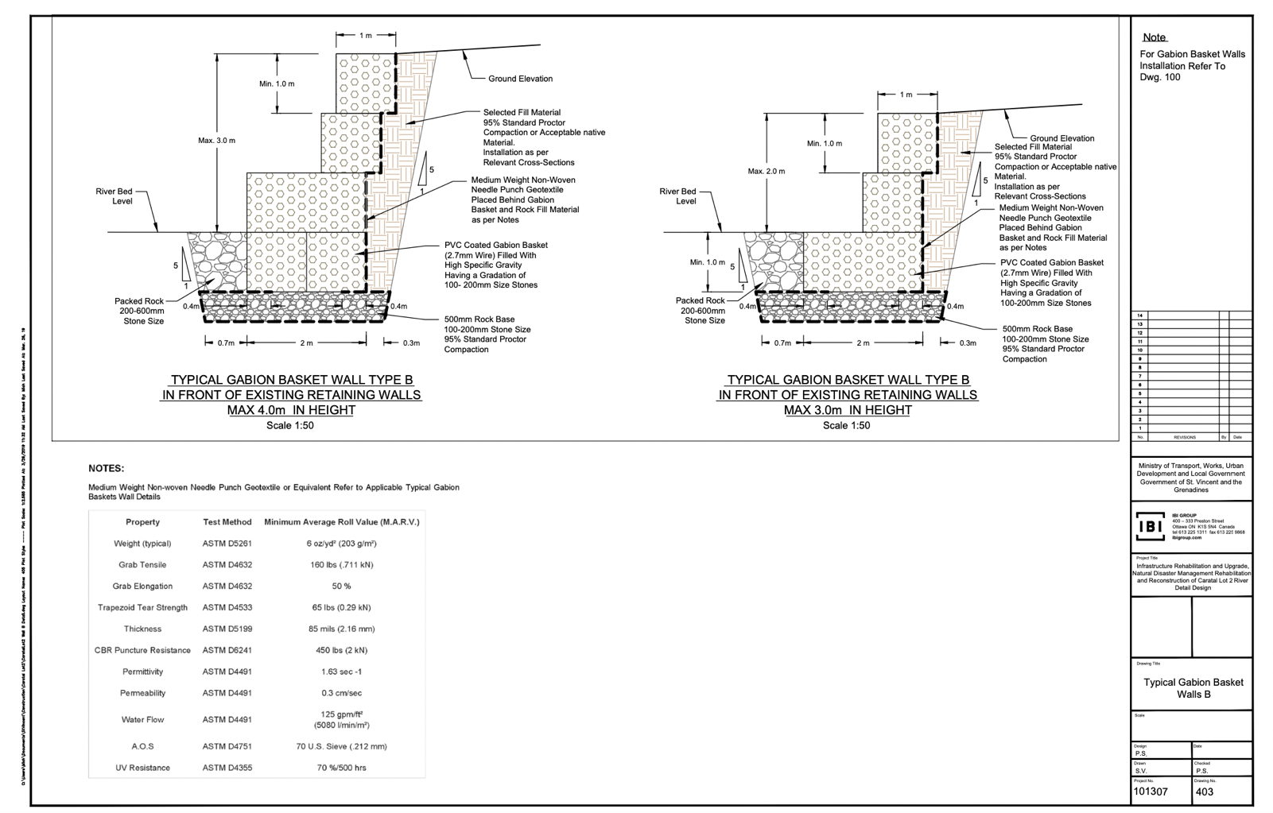
Fig 4 Showing a typical design for a gabion basket.

This was used as a reference for designing the baskets for the Caratal River.

Conclusion
Gabion baskets are structural elements made of wire cages that are filled with stones. They require similar design considerations as a retaining wall for them to be effective and achieve their purpose. They have many applications, especially for stabilising hydraulic systems. They are very commonly applied in rivers for stabilizing their banks, widening the channel and they create benefits for ecology and natural habitats. A gabion project can also impact socioeconomics as it provides jobs to the people in the communities for the construction and maintenance of the project. The application of gabion basket structures in rivers has a generally high success rate. The five case studies looked at problems that were similar to those faced by the Caratal River. These case studies were successful, therefore the use of gabion baskets at the Caratal River was a good choice. However, it is important to note that every site is different, and results and an effective structure vary based on the site conditions and how well the gabion structure was constructed.

Reflection

I chose the topic “The Use of Gabion Baskets at the Caratal River, Georgetown, St.Vincent and the Grenadines” because I grew up in St. Vincent and I often went to rivers for outings and I grew fond of them. I am now studying Civil Engineering because I have an interest in understanding how everyday infrastructure that may be taken for granted aid in bettering lives. I have always seen gabion baskets around my country and wondered what they are for, and when I would ask people around me, they would not be able to answer. Over the summer, I had the opportunity to work with a versed Civil Technician who worked on the Caratal River project. I was able to learn about how these structures can have an immense impact on rivers, and the way they work. For me, it felt like my two worlds met, my academic interests and my hobbies. I thought it would be fun for me to research this topic and gain an even greater understanding of my surroundings and how it functions.

The aim of this research project was to decipher if the use of gabion baskets were the correct choice for the Caratal River, with the objectives of defining gabion baskets, their uses, the considerations when designing them, and their success rate in river applications. Through research, I was able to answer the aim and meet some of the objectives. Though the aim was answered through research, I believe that for a project so specific, generalised information from other case studies was not the best way to evaluate the correct solution for the problems faced at the Caratal River. I think it is imperative for more site-specific information and data to be studied to accurately make a decision. However, this information was not available to me for several reasons such as:
- Basic site survey data was not available to me, because St. Vincent does not carry out that type of work or recognise the importance and benefits of having that information available.
- This project was outsourced to a foreign company which took all of its research and work with them after the project was completed.

In addition, determining the success of the structure would involve an in-depth and comprehensive site walkthrough around the two-year mark post-completion of the project to assess the nature of the structure; check if the wires were damaged or if any of the baskets had fallen. This was not done, therefore, determining if the gabion structure is successful would mean waiting for the next disaster to hit and observing if the structure retains its stability by assessing the damage made to the surroundings. This was stated in the method as a way of determining the structure’s success, however, no heavy rainfalls or flooding has been reported for the duration of this research project.

Using the drawing plans that were passed on to me by the Civil Technician, I was able to see that the channel was widened, which in theory should reduce erosion. I was supposed to conduct a targeted, semi-structured interview with the Civil Technician to gain a better understanding of how things worked on-site, including if they followed the Maccaferri instructions list when building up the baskets, how they did the calculations for the stone sizes, and what stone sizes were used. However, unforeseen circumstances prohibited me from conducting the interview; and as stated before, this information is not readily available.

Researching this topic was fun and informative, however, I sometimes encountered pieces of work that I could not understand because it was a very high degree of mathematics. I do believe if I was able to understand that level of maths, I would have been able to gain a better understanding of how exactly water flow and the velocity of water can affect the design process and the effectiveness of a gabion structure when applied in a river. I would say that the research is vague because I was not able to comprehend the higher-level information and use it to gain a better understanding of how gabion structures are able to be applied in hydraulic environments and withstand various forces. Gaining an understanding of the water flow equations would also help to further explain why stone size is important for the drainage of the structures. Conducting research on an area with limited information and sources available was not wise when trying to obtain a definite answer. There are many missing factors, unanswered questions and gaps in the research where it specifically relates to St. Vincent.

As we know, this module was a trial run for my bigger, and more important dissertation for my final year. Taking from this experience, I can confidently say that I want to conduct a practical in the next academic year. I think it would be rewarding to do research and conduct my own experiment which can give me a definite answer to my aim; whether my experiment agrees with existing literature or contradicts it. I think that I would have much more to talk about and that I would have an easier time meeting the word count, which is something I struggled with due to my lack of understanding of the complex research that is available, and the lack of research available on St. Vincent. Though I am reluctant to choose a topic (for my dissertation) that has been overused, I can see the benefits of researching a topic with countless pieces of literature already published. I understand that in some cases conducting interviews with persons who are well-informed on a subject area can provide an invaluable opinion on things, and help one to better understand their work, but it requires planning ahead of time and you also become dependent on someone, which brings me back to the point of choosing a topic that has countless publications. I am grateful that we were able to do this module this year, though it is half the work, I gained an insight of the workload I will be handling next year, and how I should proceed if I am to be successful.

Bibliography

CURRIE, A., 2022. The vital role of retaining wall structures. Civil Engineering: Magazine of the South African Institution of Civil Engineering, 30(6), pp. 24-25. [Nov 21, 2022].
GABIONS TO THE RESCUE. 2018. Civil Engineering: Magazine of the South African Institution of Civil Engineering, 26(6), pp. 59-60. [Oct 26, 2022].
PEERDAWOOD CIYAMAND, T. and MALWOOD YOUSIF, I., 2010. Analytical Study for Stability of Gabion Walls. Journal of Pure and Applied Sciences, 22(10), pp. 21-34. [Feb 16, 2023].
Retaining Wall Types, Materials, Economy, and Applications2021-last update. Available: https://theconstructor.org/geotechnical/retaining-wall-types-use/24566/ [Feb 26, 2023].
SHIAH GUAN-CHYUN and TSENG CHENG-YUNG, 2011. The major design considerations of gabion wall for stream bank, - 2011 International Conference on Materials for Renewable Energy & Environment 2011, pp. 1885-1888. [Feb 26, 2023].
The use of gabions in hydraulic applications: water engineering. 2012. Civil engineering (Johannesburg, South Africa), 2012(5), pp. 37-39. [Nov 9, 2022].
THOMPSON, D.M., PUKLIN, L.S. and MARSHALL, A.E., 2016. The long-term impact of channel stabilization using gabion structures on Zealand River, New Hampshire. Ecological Engineering, 95, pp. 779-792. [Nov 11, 2022].
BECKETT, K. and SRINIVASAN, S., 2009. Hydraulic Conductivity of Large Stone-filled Gabions. Journal of Hydraulic Engineering, 135(11), pp. 960-963. [April 4, 2023]
BHAT, M.S., ALAM, A., AHMAD, B., KOTLIA, B.S., FAROOQ, H., TALOOR, A.K. and AHMAD, S., 2017. Mitigating Flood Disasters in the Jhelum River Basin of Kashmir Himalaya using Soft Engineering Approaches . Journal of Environmental Management, 204, pp. 619-629. [May 5, 2023]
DI PIETRO, P., MAHAJAN, R.R. and ZEUGIN, G., 2004. Gabions: A Solution for River Training and Bank Protection. Journal of Hydraulic Engineering, , pp. 71-94.
DOKALA, C., KARIM, M. and IBRAHIM, M., 2015. Gabion Structure for Streambank Stabilization and Erosion Control: A Case Study from Oklahoma. Journal of Soil and Water Conservation. [April 30, 2023]
EVANS, K., 2019. Improved River Habitat through Co-Design: The Rakaia River, New Zealand . River and Research Applications, 35, pp. 209-222. [May 6, 2023]
HOSSAIN, M.K. and HOSSAIN, M.A., 2014. Stability of Gabion Structures: A Review. Journal of Geotechnical Engineering, 8(2), pp. 192-200. [April 30, 2023]
KYLEFORS, K., ANDREAS, L. and LAGERKVIST, A., 2003. Comparison of the Mechanical Behaviour of Small and Large Scale Gabion Baskets. Geomechanics and Engineering, 4(2), pp. 131-150. [May 1, 2023]
NAYONO, S.E., PRABOWO, Y.B., WIBOWO, D.E. and PURWANTORO, D., 2017. A Review of Gabion Design and Construction for Riverbank Stabilization. Environmental Earth Sciences, 76(12), pp. 12064. [May 2, 2023]
WATANABE, A. and KAWAMOTO, K., 2010. Evaluation of Aesthetic Design of Gabion Structures. Journal of Architecture and Planning, 75(650), pp. 1365-1373. [May 7, 2023]
Flood Mitigation: Channelization Nov 29, 2013-last update. Available: https://albertawater.com/flood-mitigation/channelization/#:~:text=Channelization%20is%20a%20method%20of,in%20less%20damage%20to%20banks. [Feb 4, 2023].
AIRD JANER, May 30, 2017-last update, Preventing erosion with riprap and gabion walls. Available: https://www.stormh2o.com/erosion-control/article/13029946/preventing-erosion-with-riprap-and-gabion-walls [Feb 26, 2023].
ADIDTI UNMONA, Sep 27, 2020-last update, River Bank Erosion | Causes | River Bank Erosion Control Methods in Detail. Available: https://civildigital.com/river-bank-erosion-causes-river-bank-erosion-control-methods-in-detail/ [March 4, 2023].
St. Vincent and the Grenadines Map. Oct 29, 2022-last update. Available: https://gisgeography.com/st-vincent-and-grenadines-map/#:~:text=The%20main%20island%20of%20St,and%20in%20the%20whole%20country. [Nov 11, 2022].

Appendices

Appendix A

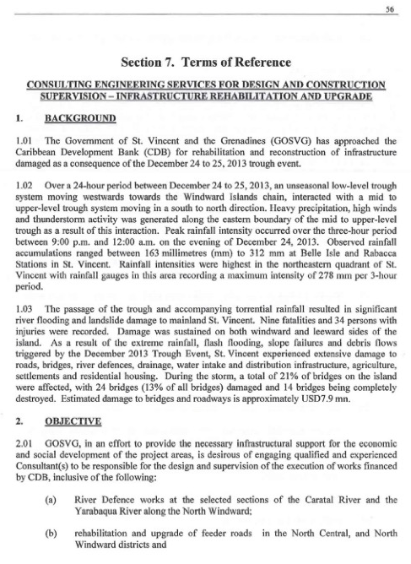

Appendix B1
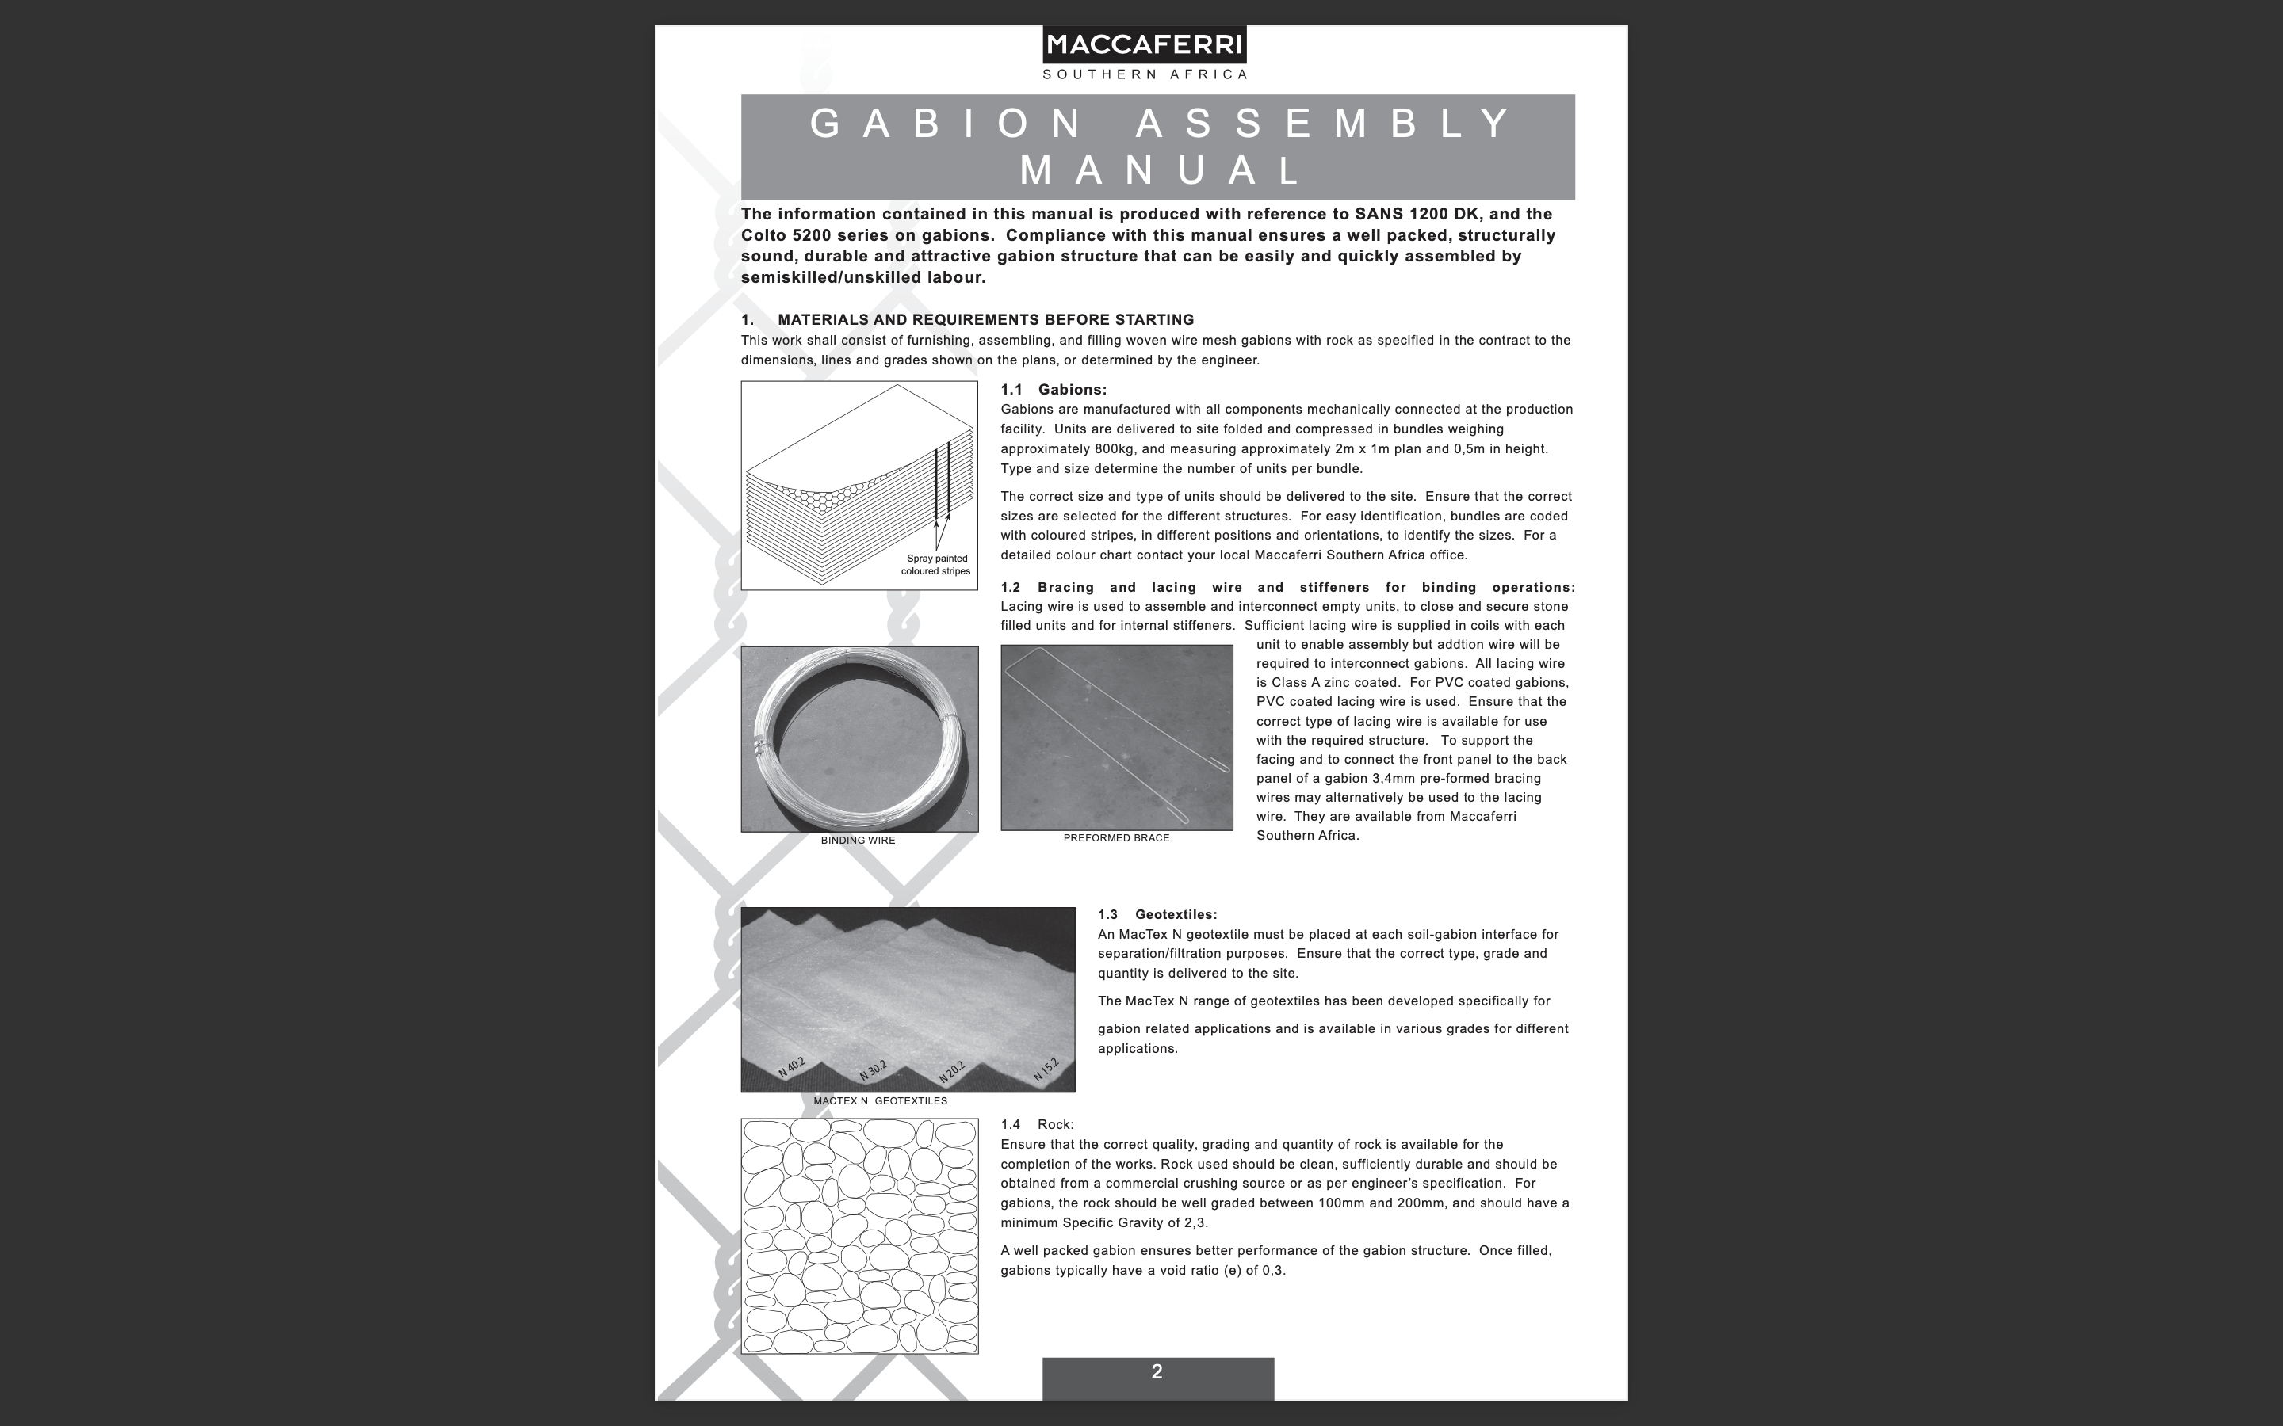

Appendix B2
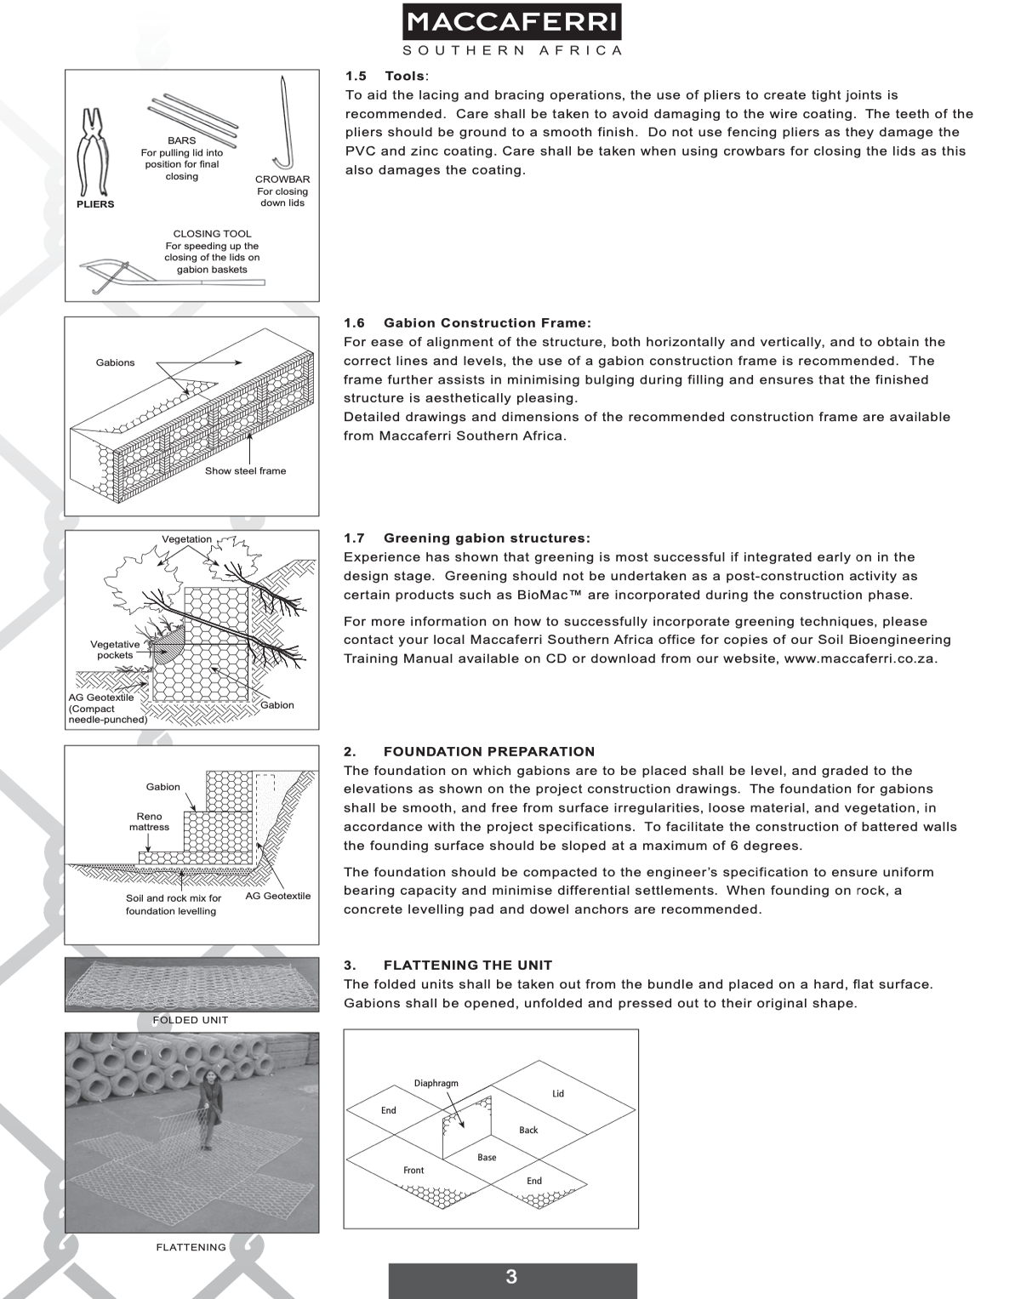

Appendix B3
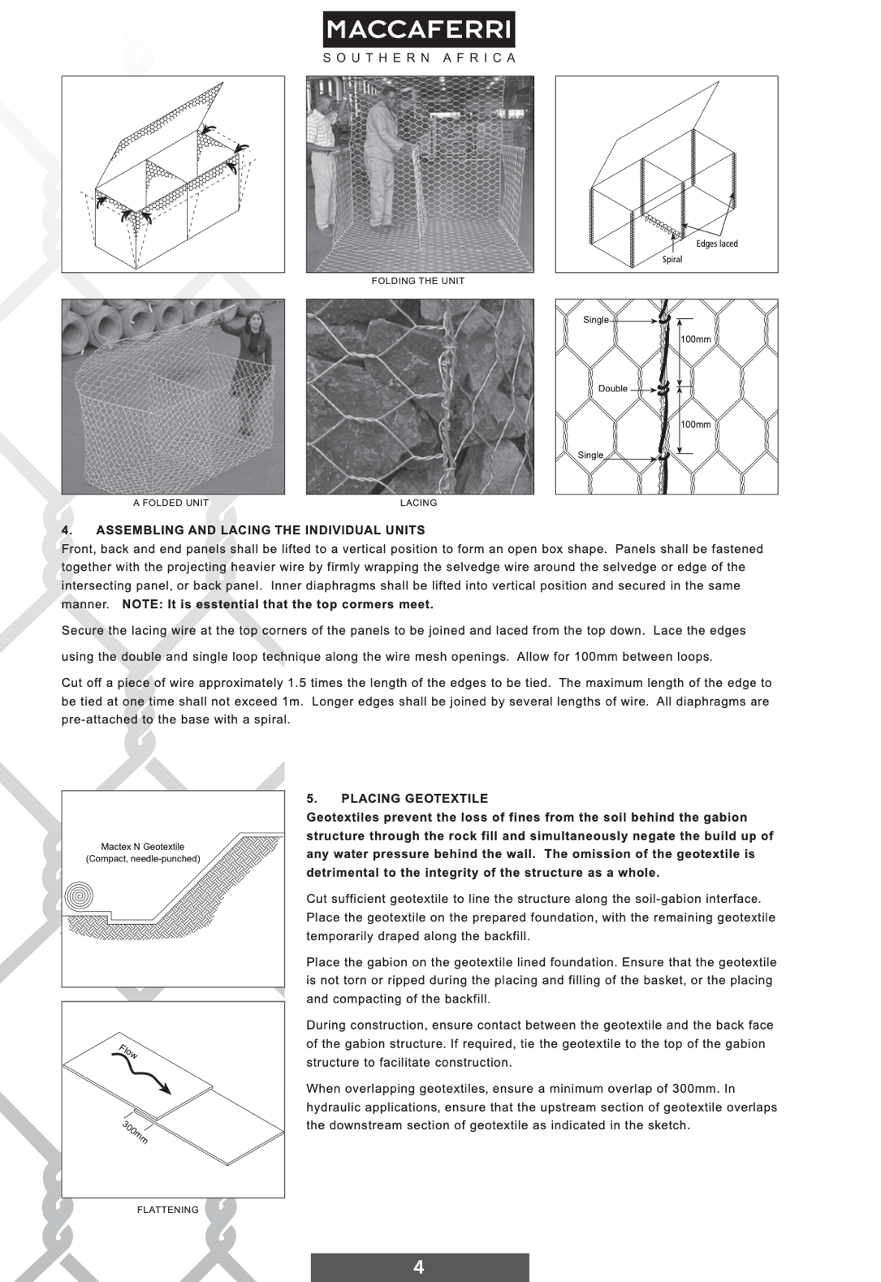

Appendix B4
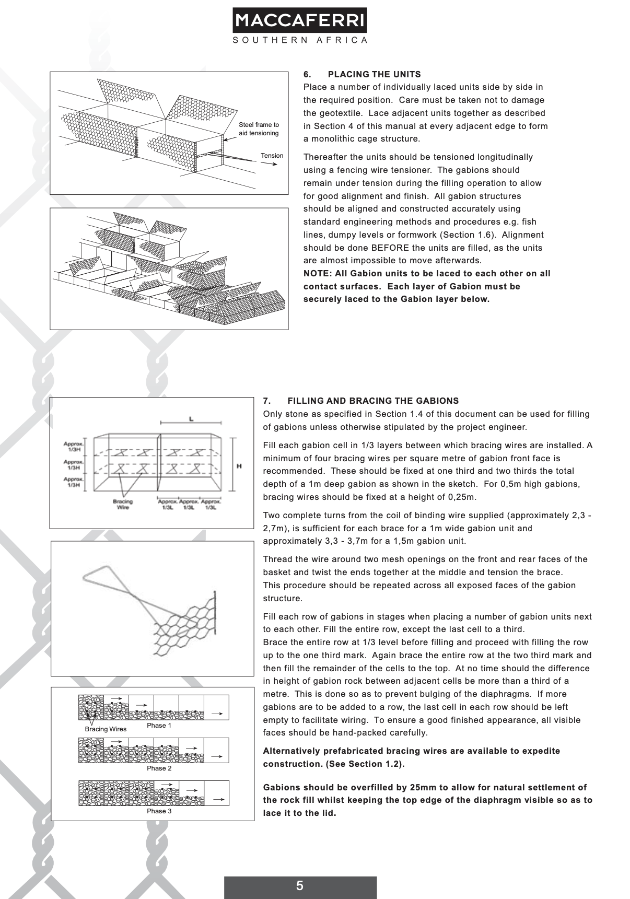

Appendix B5


