
Student name: MOHAMMEDAADIL RANA
Student id: 2530040
Module Name: Marketing Management
Module code:LCMB7024
Lecturer’s Name: Laila Maazouz & Dian Mayasari
Work Count: 2643

Term-1

Table of Contents

1. Introduction 3
2. Task 1: Critical Analysis of the Macro Marketing Environment 4
2.1 Macro Marketing Environment 4
2.1.1 PESTLE Framework as a Tool for Analysing Macro-Environmental Forces 4
2.1.2 Justification for Selecting the Two Specific Macro Factors 4
2.1.3 Strategic Significance of These Factors in the EV Industry 4
2.2 Analysis of Macro Factor 1 6
2.2.1 Impact on the Pioneer Organisation 6
2.2.2 Impact on the Follower Organisation 7
2.3 Analysis of Macro Factor 2 8
2.3.1 Impact on the Pioneer Organisation 8
2.3.2 Impact on the Follower Organisation 10
3. Task 2: Strategic Responses of Pioneering and Follower Organisations 11
3.1 Pioneering Organisation’s Strategic Responses – Tesla 11
3.1.1 Response to External Challenges and Opportunities 11
3.1.2 Application of Porter’s Generic Strategies 12
3.1.3 Industry Examples Supporting Tesla’s Strategy 13
3.2 Follower Organisation’s Strategic Responses – BYD 14
3.2.1 Response to External Challenges and Opportunities 14
3.2.2 Application of Ansoff Matrix Framework 15
3.2.3 Industry Examples Supporting BYD’s Strategy 17
4. Conclusion 18
Reference 19

Introduction
Strategic marketing management is important in ensuring that organisations compete well in the competitive and dynamic markets. It entails the examination of internal strengths as well as the external environmental factors to develop strategies that will lead to the achievement of long-term growth and sustainability (Career Advice, 2025). The report aims to discuss the influence of the macro-environmental forces on the organisational strategies of Tesla, Inc. and BYD Company as disruptor and follower organisations in the electric vehicle market, respectively.
Overview of industry
Over the past few years, the world electric vehicle (EV) market has been growing rapidly because of growing environmental issues. The competitive nature of the industry is denoted by innovative EV makers and old car manufacturers that are shifting to electrification (Saltik and Tuydes-Yama, 2025). In such a competitive environment, Tesla, Inc. is also well known as an innovator that has redefined the EV market through technological advancement and high-brand positioning, and BYD Company has grown fast to be a leading competitor with its cost efficiency and high domestic market share.
Importance of analysing the macro marketing environment
The Strategic marketing management involves the analysis of the macro marketing environment, as it allows the organisations to determine the external opportunities and threats that can affect business performance. The PESTLE analysis and other tools assist companies in analysing political, economic, social, technological, legal, and environmental conditions that define the situation in the industry.
Structure and scope of the report
The following report takes a critical analysis of two major macro-environmental factors affecting the electric vehicle industry and evaluates how they would affect Tesla and BYD. Moreover, it evaluates the business reaction of each organisation to these environmental forces in a strategic manner by using the appropriate marketing models, such as the Generic Strategies formulated by Porter and the Growth Matrix developed by Ansoff.

2. Task 1: Critical Analysis of the Macro Marketing Environment

2.1 Macro Marketing Environment

2.1.1 PESTLE Framework as a Tool for Analysing Macro-Environmental Forces
The macro marketing environment is defined as the external forces that affect organisational performance in a broad way, though the organisational performance is not under the direct control of firms. The PESTLE framework is one of the most effective instruments for analysing these forces as it studies factors that influence industries and organisations and concern politics, economics, social, technological, legal, and environmental issues (CIPD, 2025).
The effect of macro-environmental forces is not specific to the industry of electric vehicles. As an example, Apple in the technology sector have to constantly react to regulatory policies regarding data privacy and international trade regulations. On the same note, in the retail industry, retailers such as Walmart change their approaches to suit the economic environment such as inflation and fluctuations in consumer buying power.

2.1.2 Justification for Selecting the Two Specific Macro Factors
Government policies and environmental regulations (political/legal factors) and technological innovation (technological factor) are two among various PESTLE factors that have the greatest impact on the global EV industry development. Governments in the world are enacting stringent emission policies and providing subsidies to facilitate the use of electric vehicles to curtail the amount of carbon emitted (IBEF, 2025).

2.1.3 Strategic Significance of These Factors in the EV Industry
The significance of these aspects is witnessed by the high rate of EV market development. Electric vehicle adoption continued to expand in 2024, with global EV sales exceeding 17 million units and representing more than 20% of all new cars sold worldwide (Editorial Board, 2025).
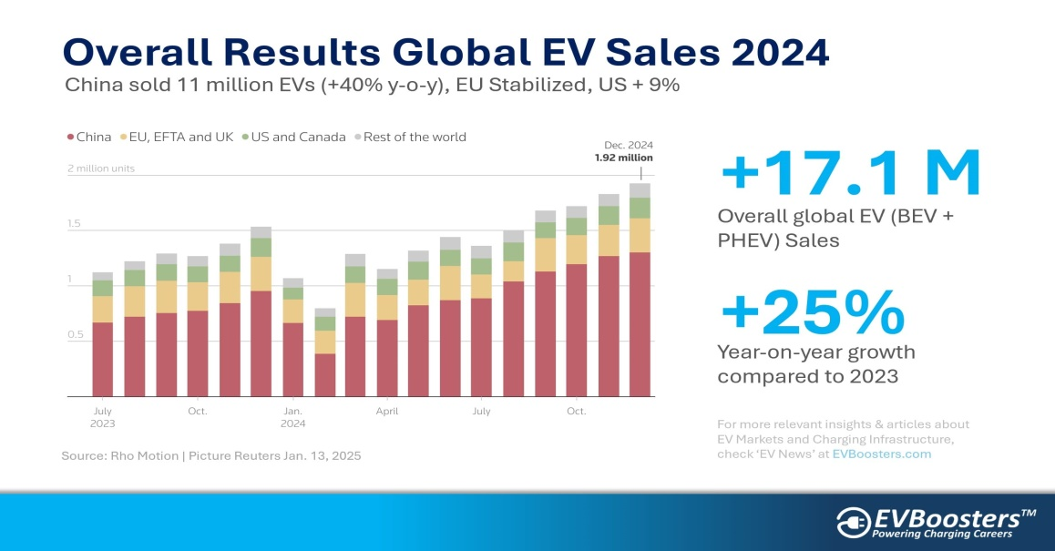
Figure 1 Global EV Sales 2024
(Source: Editorial Board, 2025)
Tesla, Inc. and BYD Company, the two most prominent manufacturers in this rapidly growing market, have taken the position of the dominant players, with a total of over 35 per cent controlling the global EV market (HT Auto Dusk, 2024).
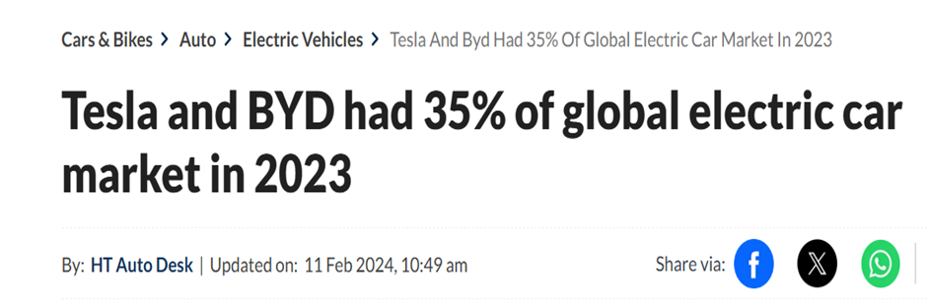
Figure 2: Tesla and BYD Dominating Electric car Market
(Source: HT Auto Dusk, 2024)
They are companies that are in the same macro-environmental situation but react in different ways to external forces depending on their resources, capabilities, and strategic position.

2.2 Analysis of Macro Factor 1
Government Policies and Environmental Regulations

2.2.1 Impact on the Pioneer Organisation

2.2.1.1 Identification of Opportunity and/or Threat
The adoption of clean energy and the decrease of emissions by the government is a significant opportunity for Tesla, Inc. Governments have implemented various incentives, including tax credits, subsidies, and increased carbon emission regulations, to help in the shift towards electric vehicles over the internal combustion engine-powered vehicles (IBEF, 2025).

2.2.1.2 Evidence from Industry Data
These regulatory changes have been a major standard gain for Tesla as it enters the EV market early. Tesla remained one of the leading pure electric vehicle manufacturers globally, delivering 1,789,226 vehicles in 2024, although this represented a slight decline compared with 2023 due to increasing competition and changing market dynamics in the electric vehicle industry (Tesla, 2025).
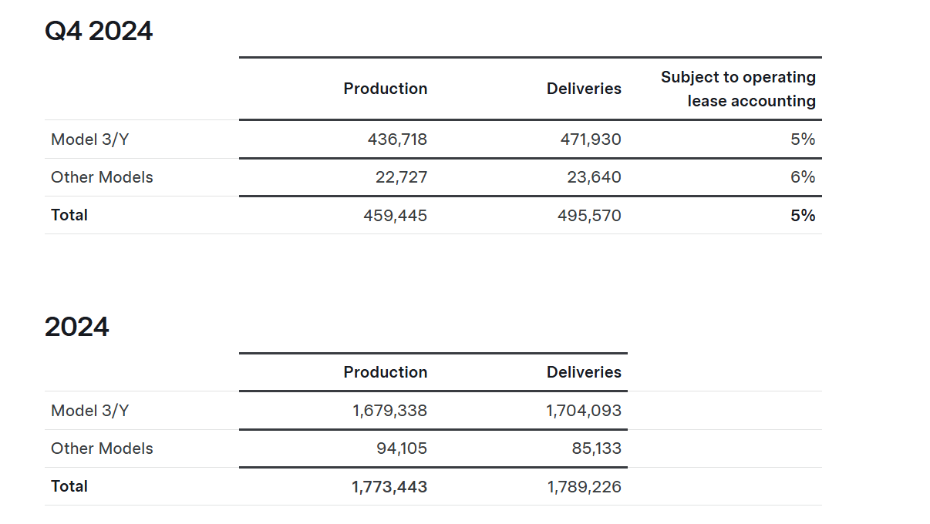
Figure 2: Tesla Inc. vehicle production and deliveries in 2024
(Source: Tesla, 2025)

2.2.1.3 Implications for Competitive Advantage
Strategically, such environmental policies strengthen the competitive advantage of Tesla because they drive the demand for products and the sustainability of the company as an innovative and sustainable mobility brand. These risks do not inherently negate the fact that Tesla has a solid brand positioning and first-mover advantage in the market that allows the firm to exploit positive environmental policy more than most of its competitors can.

2.2.2 Impact on the Follower Organisation

2.2.2.1 Identification of Opportunity and/or Threat
BYD Company also has a great chance with government policies and environmental regulations, though there is a certain slight difference in these impacts, caused by the strategic positioning and geographic focus of the company. China has also established a high level of government support for electric vehicles in terms of subsidies, investment in the charging infrastructure, and national plans for promoting new energy vehicles (Feng Wang, 2025).

2.2.2.2 Evidence from Industry Data
BYD has been enjoying high growth in this policy environment. As of 2023, the company sold over 3 million new energy vehicles, both battery electric and plug-in hybrid vehicles, which is a significant improvement compared to the past years. Moreover, BYD sold about 1.57 million battery electric cars, which made it one of the closest competitors to Tesla in the world market (Jennifer, 2026).
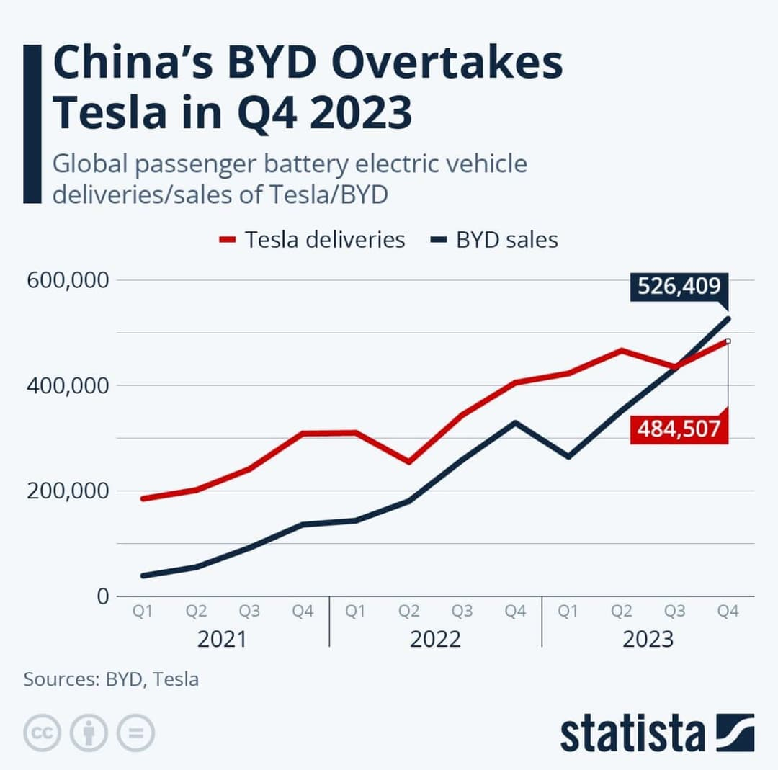
Figure 3 BYD Overtakes Tesla
(Source: Zecar, 2024)

2.2.2.3 Implications for Competitive Advantage
China has a favourable policy environment, which has assisted BYD to increase the capacity of production, reduce the cost of manufacturing and scale its operations at a very fast rate. BYD might be less susceptible to the policy uncertainty in the Chinese market as compared to Tesla due to the presence of good domestic supply chains and government support.

2.3 Analysis of Macro Factor 2
Technological Innovation in Battery and EV Technology

2.3.1 Impact on the Pioneer Organisation

2.3.1.1.Identification of Opportunity and/or Threat
One of the most significant aspects that determines competition in the electric vehicle industry is technological innovation (Owen and Hayes, 2025). There are ongoing advances in battery, charging infrastructure and car software efficiency, which greatly impact the performance of the vehicle, driving range and customer experience.

2.3.1.2 Evidence from Industry Data
Tesla has established itself as a competitor that is technologically advanced. The company spends a lot of money on research and development so as to enhance battery performance, autonomous driving systems, and energy storage systems. Tesla Gigafactories allow the company to produce batteries in large quantities, which lowers the cost of the manufacturing process and enhances the rate of production. This technology has assisted Tesla to remain competitive in the EV market globally, and in 2023, it controlled 19.1% of the worldwide battery electric vehicles (Statista, 2025a).
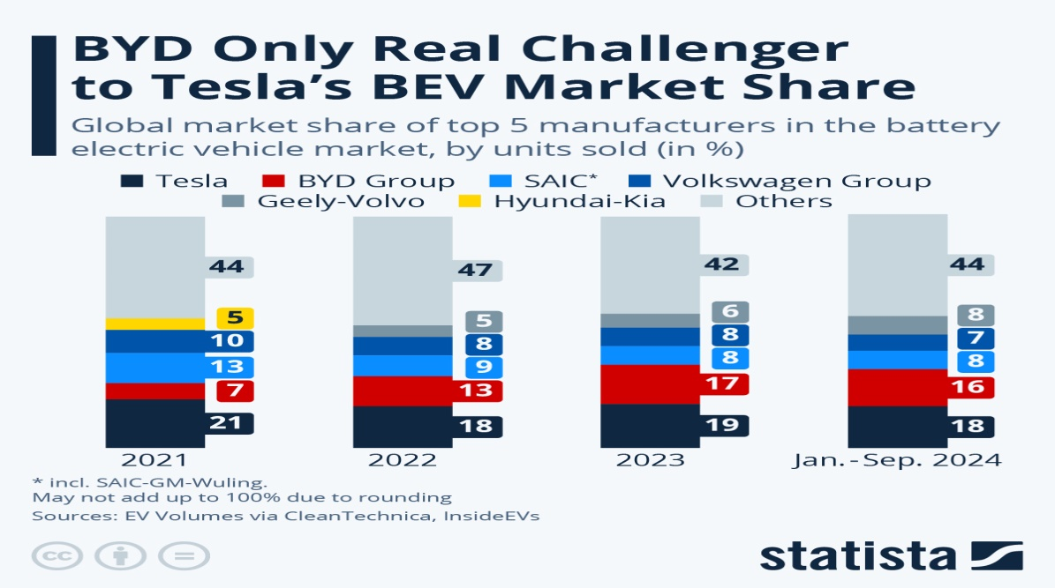
Figure 4 Global BEV Market Share
(Source: Statista, 2025a)

2.3.1.3 Implications for Competitive Advantage
The constant technological progress demands a significant amount of money to be given to research and development, which can raise the cost of operation and the risk of losing money. Nonetheless, Tesla has been able to create a strong emphasis on innovation to enable it to preserve differentiation and reaffirm its image as a technology-oriented automotive manufacturer.

2.3.2 Impact on the Follower Organisation

2.3.2.1 Identification of Opportunity and/or Threat
Technological innovation also avails significant opportunities to BYD Company, especially in battery development and manufacturing efficiency. In contrast to most car manufacturers, BYD adheres to the vertically integrated business model, manufacturing the main elements of its work, including batteries and semiconductors, in-house.

2.3.2.2 Evidence from Industry Data
Blade Battery is one of the most significant technological inventions of BYD, since it is safer, more enduring, and cost-efficient than conventional lithium-ion batteries. The growing market importance of this technology is illustrated in Figure 5, which shows the rapid expansion of the Blade Battery market from 2024 to 2034 (Snehal Paste, 2025).
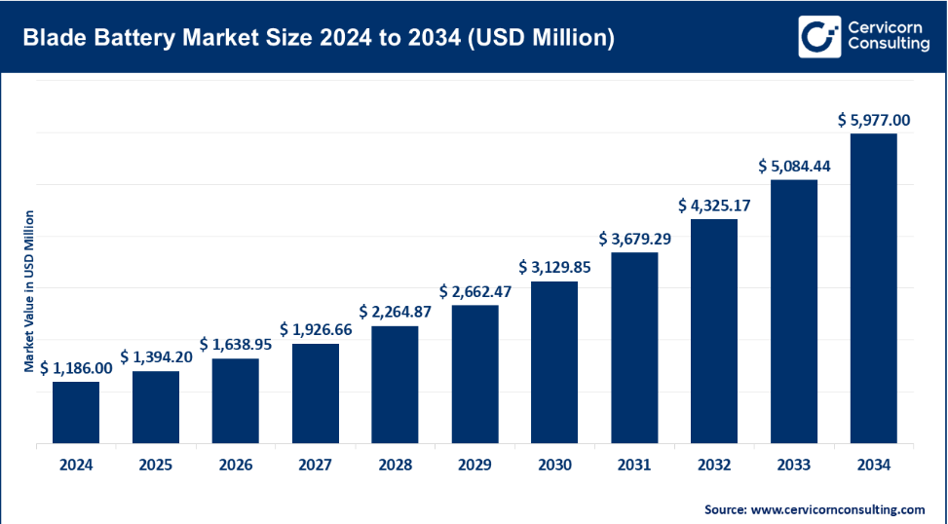
Figure 5 Blade Battery Market Size and Growth
(Source: Snehal Paste, 2025)

2.3.2.3 Implications for Competitive Advantage
With this technological development, BYD can provide competitive electric vehicles at affordable prices and still have acceptable performance.

3. Task 2: Strategic Responses of Pioneering and Follower Organisations

3.1 Pioneering Organisation’s Strategic Responses – Tesla

3.1.1 Response to External Challenges and Opportunities
Tesla, Inc. is considered one of the most innovative organisations in the worldwide market of electric vehicles (EV) because of its early investment in battery, autonomous driving application, and charging infrastructure (Tesla Inc, 2025). The company has taken a significant part in increasing the shift to electric mobility by replacing internal combustion vehicles. As of 2024, Tesla has delivered 1,789,226 cars worldwide, and despite a growing number of competitors in China, it is still the largest seller of battery-electric vehicles (BEVs) (Statista, 2025b).
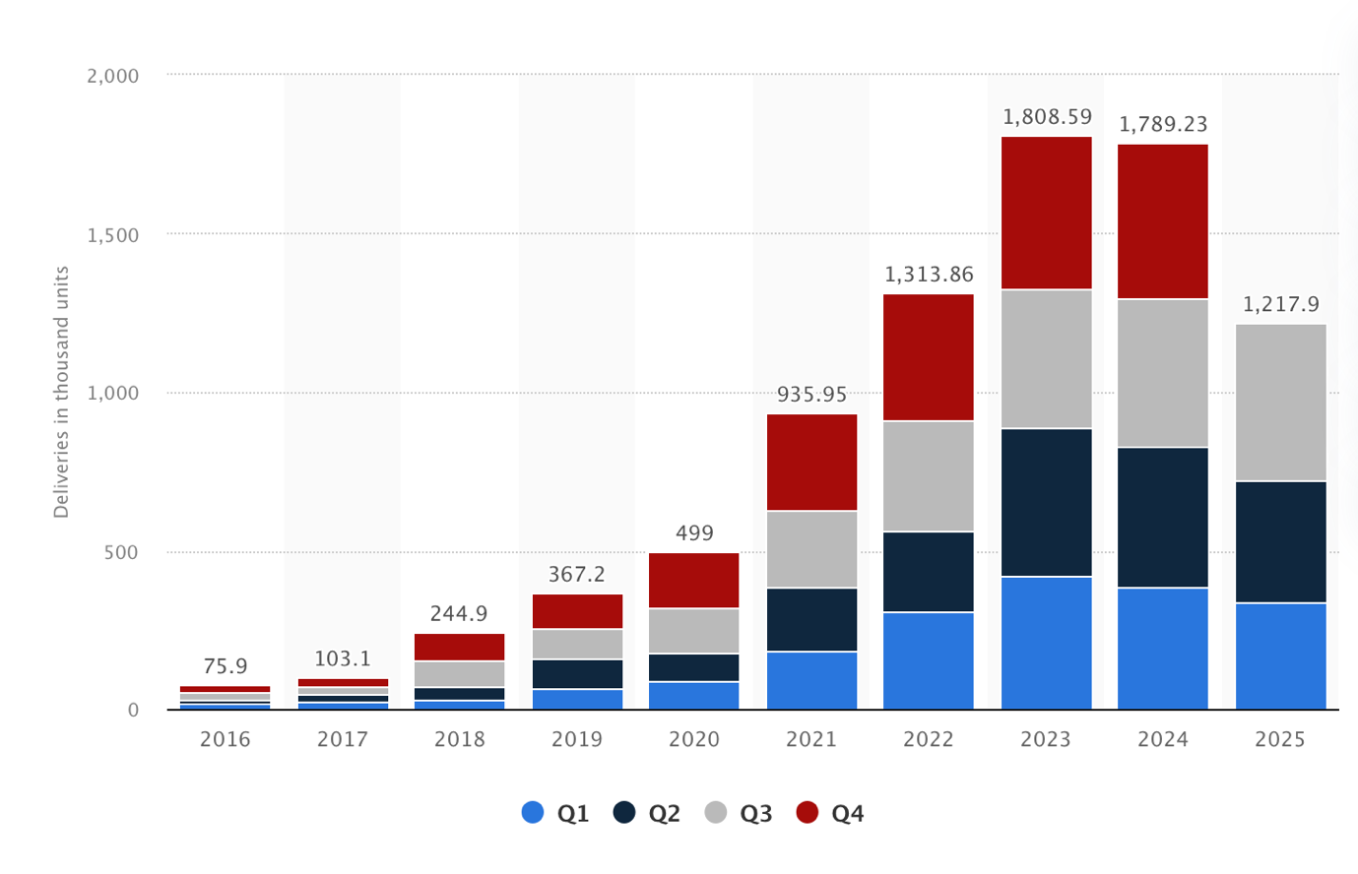
Figure 6: Tesla Sales Worldwide from 1st quarter 2016 to 3rd quarter 2025
(Source: Statista, 2025b)
Tesla has continued to embrace various strategic initiatives in order to address the emerging external challenges like increased competition, regulatory pressure and consumer preferences.

3.1.2 Application of Porter’s Generic Strategies
A useful framework to examine the response of Tesla is Porter's Generic Strategies, which outlines how companies attain competitive advantage by being cost leaders, differentiating or focusing (D Shyamadanthi, 2025).
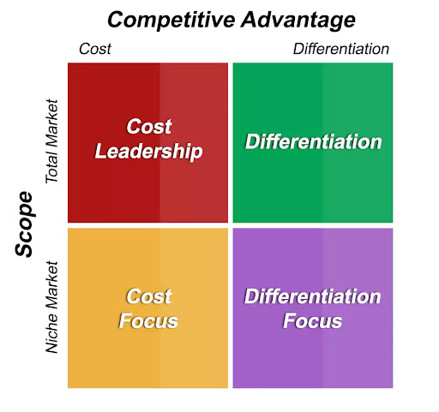
Figure 7 Porter's Generic Strategies
(Source: D Shyamadanthi, 2025)
To begin with, the concept of differentiation is highly focused on by Tesla. The firm enjoys significant investments in technological innovations and modern technologies like self-driving, artificial intelligence, and over-the-air updates. Such technologies as Autopilot by Tesla and the provided digital ecosystem make the vehicles unique compared to others (Olorunfemi, 2024).
Second, Tesla is slowly gaining strength in its cost leadership strategy. The external threats, including the price wars that Tesla will face with the Chinese EV manufacturers, have compelled Tesla to lower its production expenses. Discounts on such models as Model 3 or Model Y indicate that Tesla employs cost-effectiveness as a means of remaining competitive in an already booming EV market (Junaid Shah, 2025).
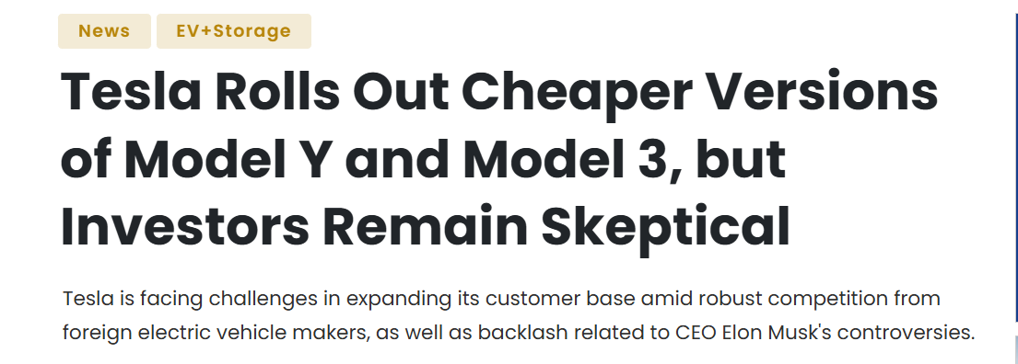
Figure 8 Tesla's Model 3 and Model Y Cost-Effectiveness Strategy
(Source: Junaid Shah, 2025)

3.1.3 Industry Examples Supporting Tesla’s Strategy
The other strategic reaction is the market expansion and ecosystem development. Tesla has also increased the number of Superchargers across the world in order to facilitate the use of EVs and minimise range anxiety among consumers (Nikhil Chaudhary, 2025). The infrastructure of charging is an essential condition of the development of the EV market, and Tesla is well-positioned with an effective network of charging points, which builds customer loyalty and puts competitors at a disadvantage.
Tesla also reacts to the environmental guidelines and sustainability requirements by putting emphasis on renewable energy solutions. In addition to the manufacturing of EVs, the corporation also creates battery storage and solar energy items, which support its long-term goal of sustainable energy transition.
Nevertheless, Tesla is experiencing an increasing level of competition, especially with the Chinese EV producers who are able to sell cheaper vehicles (Reuters, 2025).
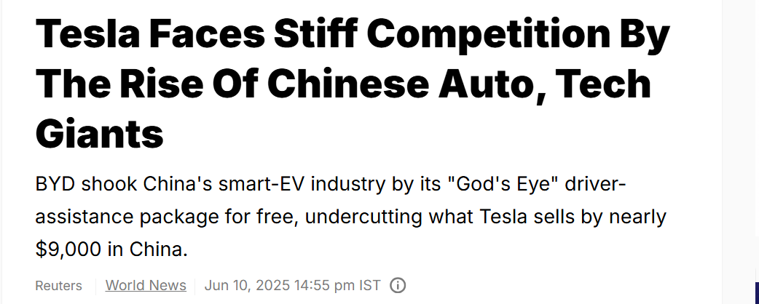
Figure 9: Tesla Facing Stiff Competitions
(Source: Reuters, 2025)
On the whole, the strategic reactions of Tesla can demonstrate that innovative companies should be constantly developing to remain competitive. By combining differentiation, cost leadership, technological innovation and global expansion, Tesla has been able to respond to the external threats and leverage the fast-growing EV market.

3.2 Follower Organisation’s Strategic Responses – BYD

3.2.1 Response to External Challenges and Opportunities
BYD Company Ltd. is a good example of a follower company that has managed to adjust its strategy to compete with such pioneers as Tesla. Despite the fact that Tesla is the earlier entrant in the EV market, BYD has grown its business very quickly due to aggressive pricing, mass production, and government subsidies in China (BYD, 2025).
The Growth Matrix of Ansoff may be used to analyse the strategies of BYD and how companies grow through penetration of the market, product development, market development and diversification.

3.2.2 Application of Ansoff Matrix Framework
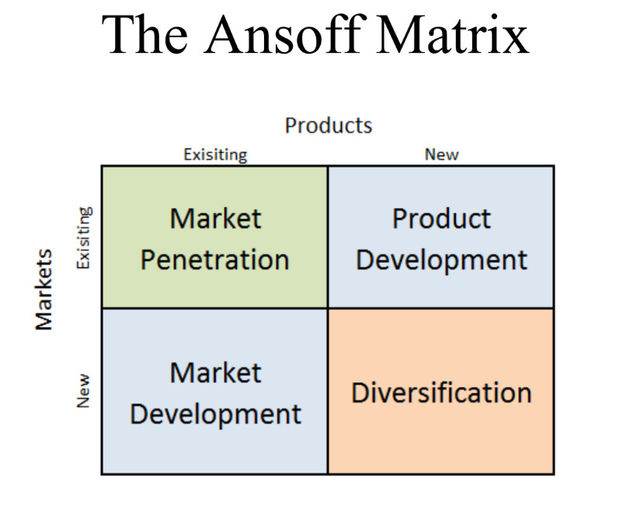
Figure 10: Ansoff Matrix
(Source: Lecture Materials)
Market Penetration: First, BYD has chosen an aggressive market penetration approach, which consists of providing cheap electric cars in various market segments. As of 2024, BYD was able to sell 1,764,992 fully electric cars as compared to 1.79 million cars delivered by Tesla. The minimal disparity underscores the ability of BYD to dominate the EV market in the world despite its late entry (Reuters, 2026).
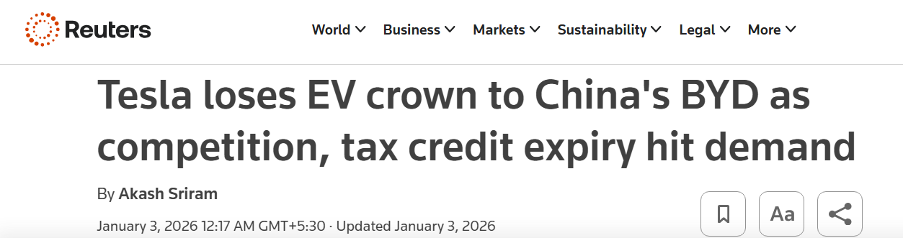
Figure 11 BYD Dominating Tesla
(Reuters, 2026)
Product Development: Second, BYD possesses high product development strengths. The firm spends heavily on battery technology, especially its own proprietary technology of the Blade Battery, which enhances safety, longevity, and sensitivity in terms of cost (Kavya Aggarwal, 2025).
Market Development: Third, BYD is undertaking the development of the market by fast expansion internationally. The company has done more exports to other parts of the world, such as Europe, Southeast Asia, and Latin America. International sales increased in the year 2024, and the firm achieved exports of over 417,000 vehicles all over the world, which shows how the firm has extended its global presence (Riz Akhtar, 2026).
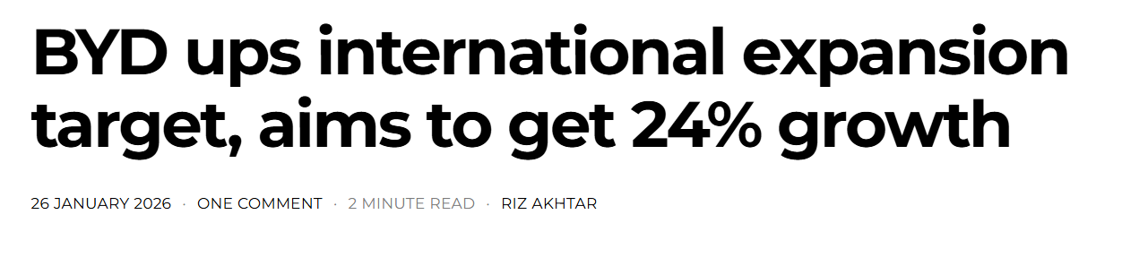
Figure 12 BYD's International Expansion
(Source: Riz Akhtar, 2026)
Diversification: The other strategic factor is diversification in the electric mobility ecosystem. However, BYD does manufacture battery electric vehicles (BEVs) and plug-in hybrid electric vehicles (PHEVs), unlike Tesla. In 2024, the company sold more than 4.27 million new energy vehicles, including both BEV and PHEV in aggregate, which is a notable improvement over prior years (Jonathan James Tan, 2025).
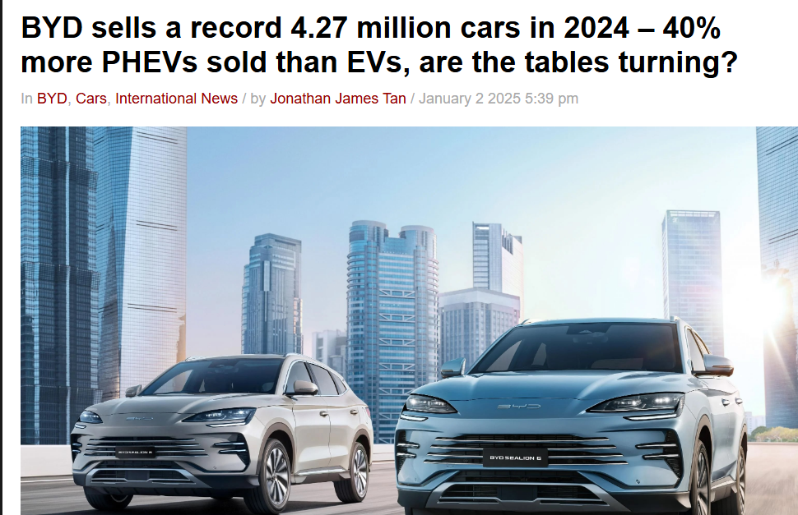
Figure 13 BYD NEV Sales
(Source: Jonathan James Tan, 2025)

3.2.3 Industry Examples Supporting BYD’s Strategy
However, BYD has some weaknesses, including stiff competition in China, variances in demand and regulatory threats in the global markets. To overcome these challenges, the firm is making further investment into research and development, new battery technologies, and international alliances.
In summary, BYD shows how some of the follower organisations can effectively compete with the innovative companies through the application of adaptive growth strategies.

4. Conclusion
Summary of Key Findings from Both Tasks
This report has discussed the significance of appreciating the macro marketing environment in organisations that are in a very dynamic environment, like the electric vehicle (EV) market. The research investigated the way in which two leading organisations, namely Tesla, Inc., as an innovative organisation and BYD Company Limited, as a copycat organisation, react to external macro-environmental forces that influence strategic marketing decisions.
The results of Task 1 prove that political and technological issues play a great role in the EV industry. Simultaneously, the competition is brought about by the fast technological changes in battery innovations, charging networks, and vehicle software. As Tesla enjoys the advantage of its technological advantage and global charging infrastructure, BYD has used its advantageous battery technology and cost-effective manufacturing capacity to grow fast, especially in China and other global markets.
Task 2 looked into the responses of these companies to these external forces in terms of their strategic response. Tesla uses differentiation and technological innovations as the main basis of its competitive edge, but BYD uses cost efficiency, diversification of products, and market expansion approaches.
Strategic Importance of Environmental Scanning and Adaptive Marketing
On the whole, the report stresses that the ongoing environmental scanning and dynamic marketing approaches are the key to remaining competitive and successful in the highly dynamic EV market. Companies that effectively monitor macro-environmental trends and respond through innovation, cost efficiency or market expansion are more likely to sustain long-term competitiveness in the global EV industry.

Reference
BYD, 2025. BYD Concludes 2023 with Record 3 Million Annual Sales, Leading Global NEV Market. Available at: https://www.byd.com/us/news-list/BYD-Concludes-2023-with-Record-3-Million-Annual-Sales-Leading-Global-NEV-Market.html#:~:text=BYD%20Annual%20Sales%20Exceeds%203,surge%20from%20the%20previous%20year.
Career Advice, 2025. The Role of Strategic Marketing in an Organisation. Available at: https://www.berlinsbi.com/blog/the-role-of-strategic-marketing-in-an-organisation.
CIPD, 2025. PESTEL Analysis. Available at: https://www.cipd.org/en/knowledge/factsheets/pestle-analysis-factsheet/.
D Shyamadanthi, 2025. Michael Porter’s 3 Generic Strategies Model. Available at: http://www.creantho.com/michael-porters-generic-strategies.php.
Editorial Board, 2025. EV market growth and global adoption trends. EVBoosters, 15 January. Available at: https://evboosters.com/ev-charging-news/overall-results-global-ev-sales-2024/.
Feng Wang, 2025. The Development of China’s New Energy Vehicle Charging and Swapping Industry: Review and Prospects. https://www.mdpi.com/1996-1073/18/17/4548.
IBEF, 2025. The Role of Government Initiatives in Shaping India's Electric Vehicle Landscape. Available at: https://www.ibef.org/blogs/sustainable-mobility-the-role-of-government-initiatives-in-shaping-india-s-electric-vehicle-landscape.
Jennifer L, 2026. BYD Overtakes Tesla as World’s Biggest EV Seller in 2025. Available at: https://carboncredits.com/byd-overtakes-tesla-as-worlds-biggest-ev-seller-in-2025/.
Jonathan James Tan, 2025. BYD sells a record 4.27 million cars in 2024 – 40% more PHEVs sold than EVs, are the tables turning? Available at: https://paultan.org/2025/01/02/byd-sells-a-record-4-27-million-cars-in-2024-40-more-phevs-sold-than-evs-are-the-tables-turning/.
Junaid Shah, 2025. Tesla Rolls Out Cheaper Versions of Model Y and Model 3, but Investors Remain Skeptical. Available at: http://saurenergy.com/solar-energy-news/tesla-rolls-out-cheaper-versions-of-model-y-and-model-3-but-investors-remain-skeptical-10540992.
Kavya Aggarwal, 2025. What Makes BYD’s Blade Battery Technology so Different? Available at: https://www.evfy.in/blogs/what-makes-byds-blade-battery-technology-so-different.
Nikhil Chaudhary, 2025. Tesla Superchargers - All you need to know. Available at: https://www.expwithevs.in/p/tesla-superchargers.
Olorunfemi, B., 2024. The innovations driving Tesla's success: Disruptions, competition, business model, customer transformation, and entrepreneurial strategies. Qeios. https://www.researchgate.net/publication/379555334_The_Innovations_Driving_Tesla's_Success_Disruptions_Competition_Business_Model_Customer_Transformation_and_Entrepreneurial_Strategies#:~:text=Key%20to%20Tesla's%20success%20w,addressed%20the%20issue%20of.
Owen, A. and Hayes, D., 2025. Technological Innovations in EV Manufacturing. IU International University of Applied Sciences. Available at: https://www.researchgate.net/publication/390329113_Technological_Innovations_in_EV_Manufacturing.
Reuters, 2025. Tesla Faces Stiff Competition by The Rise Of Chinese Auto, Tech Giants. Available at: https://www.ndtv.com/world-news/tesla-faces-stiff-competition-by-the-rise-of-chinese-auto-tech-giants-8631023.
Reuters, 2026. Tesla loses EV crown to China's BYD as competition, tax credit expiry hit demand. Available at: https://www.reuters.com/business/autos-transportation/teslas-quarterly-deliveries-fall-more-than-expected-lower-ev-demand-2026-01-02/.
Riz Akhtar, 2026. BYD ups international expansion target, aims to get 24% growth. Available at: https://thedriven.io/2026/01/26/byd-ups-international-expansion-target-aims-to-get-24-growth/.
Saltik, E.C. and Tuydes-Yaman, H., 2025. Electric vehicle (ev) market penetration in countries with rising motorization rates. International Journal of Civil Engineering, 23(3), pp.461-480.
Snehal Paste, 2025. Blade Battery Market Size, Share, Growth, Report 2025 to 2034. Available at: https://www.cervicornconsulting.com/blade-battery-market.
Statista, 2025. Tesla and BYD Claim a Third of the Global BEV Market. Available at: https://www.statista.com/chart/27733/battery-electric-vehicles-manufacturers/?srsltid=AfmBOor9Yo84wUD14lwjiGGqL8i9Ir0ogLzSLv2juLtZK_FiVZhdyLaa.
Statista, 2025b. Tesla's vehicle sales by quarter YTD Q3 2025. Available at: https://www.statista.com/statistics/502208/tesla-quarterly-vehicle-deliveries/?srsltid=AfmBOorI0_Dd_IDLyvXhKrlF5qFderdYWhtpv9VREOp1N32Yt1A5H_Lq.
Tesla Inc., 2025. The Future is Sustainable. Available at: https://www.tesla.com/en_in/about.
Tesla, 2025. Tesla fourth quarter 2024 production, deliveries and deployments. Available at: http://ir.tesla.com/press-release/tesla-fourth-quarter-2024-production-deliveries-and-deployments.
The strategy Institute, 2024. The Ansoff Matrix: A Powerful Tool for Business Strategy and Growth. Available at: https://www.thestrategyinstitute.org/insights/the-ansoff-matrix-a-powerful-tool-for-business-strategy-and-growth.

