Establishing a music performance space on the UWTSD Carmarthen Campus
By Heather Hawkins
The idea
As a musician and a creative student here on Carmarthen campus, I feel that it is important to have an accessible and well-equipped room for myself and other musicians to use. In addition, as a student on the acting course we study modules that are musical theatre orientated so having rooms and areas where we could rehearse without disturbing anyone would be very beneficial to our course. However, I was saddened to learn that there were no such spaces on Carmarthen campus. The only exception being the ABC room in the old school building, also seen as an old church hall that we makeshift as a rehearsal room. Unfortunately, there is no technical equipment apart from an old grand piano that is somewhat out of tune and there are not many plug sockets even if you wanted to bring in equipment. All the rehearsal spaces around the university’s campus, such as the Parry rooms and the Llwyfan, are designed for physical activity and are unable to create the environment needed for practising instruments or recording music. Therefore, I propose that the university should establish rehearsal spaces to be specifically designed for music practice. I feel that as a university that treasures the arts, spaces for people to rehearse should be more accessible. So, I decided to take it upon myself to explore creating one for these spaces for musicians to rehearse in any time they please. Over the course of this model, I will conduct primary and secondary research to see how many students would benefit from a music room such as this. I will do this by sending out a survey for students to fill out. I will also perform secondary research to reinforce my proposal. For example, getting in touch with people across the community such as `James Music` in Carmarthen town and the Swansea UWTSD (BA) Creative Music Technology lecture Simon Kilshaw.
My experience
I consider myself a musician. I am currently improving and learning both electric Guitar and acoustic, the Bass Guitar, Ukulele, Clarinet, and Piano. I am also an inspiring singer and before coming to University I have been a part of many musical theatre productions such as Madagascar, Into the woods and The Little Mermaid. Furthermore, last summer I auditioned for National Youth Theatre of Wales and was successful. Therefore, I performed their summer production of Under Milk Wood, at the Sherman in Cardiff. During this production I played the guitar and sang. It was a fun but nerve-racking because it was the first time ever played the electric guitar in front of people let alone a live before. This was the first ever youth, bilingual, female narrator version of Under Milk Wood. During the rehearsal process I was in fact located on Carmarthen campus. In my opinion, there needed to be more music friendly rooms available, making the rehearsal process easier. I feel strongly that it would help students like me and those who would like to get more involved with music side of the creative arts. These rooms would be soundproof to therefore keeping the rehearsal private and not disturbing other people on campus. I often struggle to find a suitable place to rehearse, especially with my guitar. I find myself rehearsing in my room quietly, not to disturb my flatmates. Additionally, I am a part of a band, consisting of me and my classmates. We try to rehearse as much as we can but are often faced with obstacles such as rooms not being available. Therefore, a music rehearsal space would really help us to improve ourselves as a band.

Possible locations
While studying at the university I have come to realise that there are many under utilised rehearsal rooms. These consist of Parry 5, which is a quarter full of old furniture and props. Also, the Parry 3 backrooms which are small but are easily accessible and would make great recording spaces. In addition, some rehearsal spaces are in desperate need of renovation therefore why not adapt them to be music friendly. Especially the smaller, less used rooms. Having these spaces nearby on campus would make a huge difference to the students at the university. Including students on less creative courses that just have a passion for music. Having students be aware of spaces like there might influence and encourage them to learn an instrument and explore music as a hobby.
How music can benefit your mental health
Coming from a personal level I think music is a very good tool for helping with your mental health. From my experiences I found music to be a comforting hobby as it allows me to express my emotions freely. For example, when I am having a low day or feeling down, it a really nice feeling at the end of the day to just whip my guitar out and play on it. Mental health is a real struggle for a lot of people, but if you find something that will make your day just that bit better, that’s one of the best feelings ever. I feel like this room would bring people together. It is a lovely new way to meet new people and make music together. Whether you are a beginner or you have been playing your instruments for years. Getting to know people who have similar interests as you could go great in the long run. You never know what to expect, could make some lifelong friends. Also talking about things you love will increase your dopamine levels, which is known as the happy hormone. Which would help with your mental health. “Music has healing power. It has the ability to take people out of themselves for a few hours.” (Elton John)

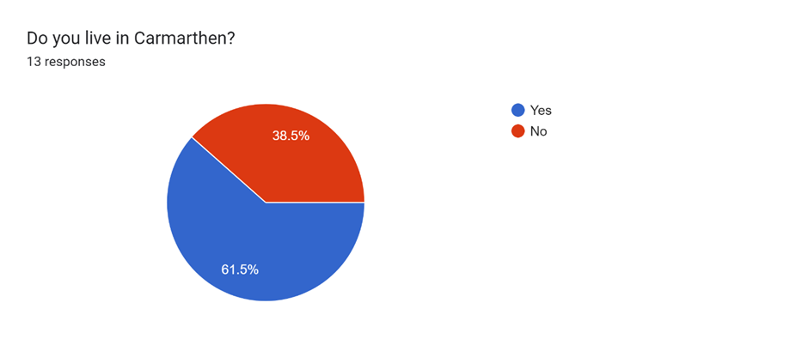
I thought that this was a perfect opening question! Quick and easy to answer. ‘Do you live in Carmarthen?’. At the beginning I was a little bit confused with the amount of people that replied with no they do not live in Carmarthen or on UWTSD Carmarthen campus. Then I realised that not everyone one dose. So personal I think I should have refreased this sentence differently. For example, `do you live near Carmarthen? ` or added another question such as ‘do you live on UWTSD Carmarthen campus?’.
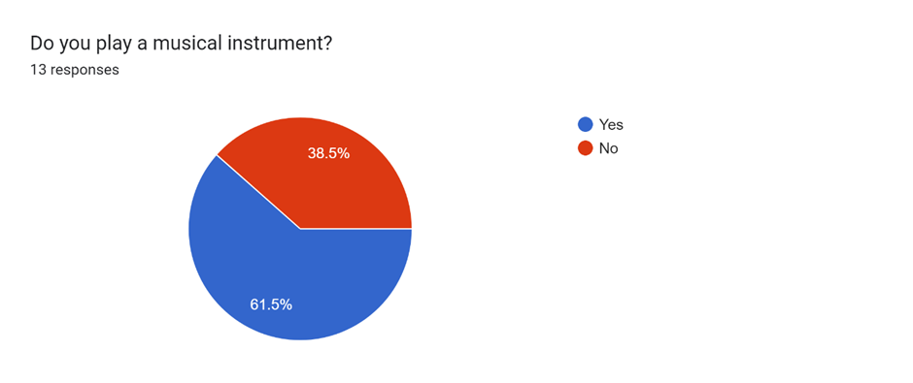
For the rout I was going for, I thought that this was the next best question. ‘Do you play a musical instrument?’. Personally, I thought what the chances of the same percentage being that living Carmarthen would be the same as if people played musical instruments. These statistics made me really happy that more than 50% of people that took my survey places a musical instrument. And who knows by doing this survey anyone could be interested in learning an instrument.
If Yes, what do you play?9 responses
Piano
Ukulele
N/A
Guitar
Guitar, electric and acoustic
Bass guitar
I play the cello!
Electric guitar
Guitar
Then brought out this iconic that every survey would have, the if yes what one. ‘If yes, what do you play?’. Having 9 responses when 13 people took this survey personally is brilliant. As you can see there are a lot of people that play the guitar. In my own opinion guitarists, bassets, drummers, and singers will benefit this room more than others, because they will get the opportunity to be loud. Unlike sometimes having to hide in your room and try to be quiet. But that does not mean another musician would not be able/ aloud to use it. Just with the amount of guitarist that answered I felt like this could an achievable thing.

What kind of music do you listen to?12 responses
Everything
A bit of Michael Jackson, as well as Little Wales
All sorts
Mixture, mostly indie, comedy-rock and metal. But also musicals and American pop.
Everything apart from rap and jazz
Rock, Easy, Classical, Country, Folk, Acoustic
Bit of anything really
Rock, metal, indie
rock mostly

In my opinion it is the question everyone is waiting for. ‘What kind of music do you listen to?’. As this a is a great open question it gave a good understanding what kind of people would we are working with, and to see what people will be using the room for. The reason for the question was to find out and understand what kind of music people listen to.
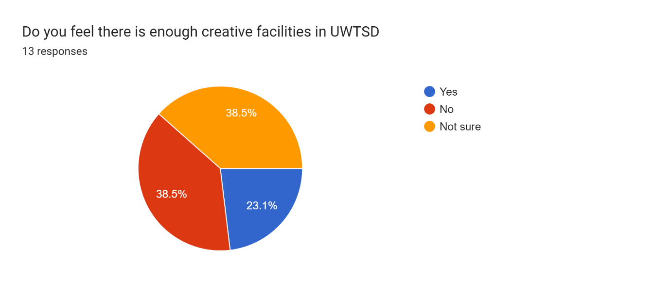
Now it is time for the nitty gritty! ‘Do you feel there is enough creative facilities in UWTSD’. It is a nice start to a rhythm of closed questions.

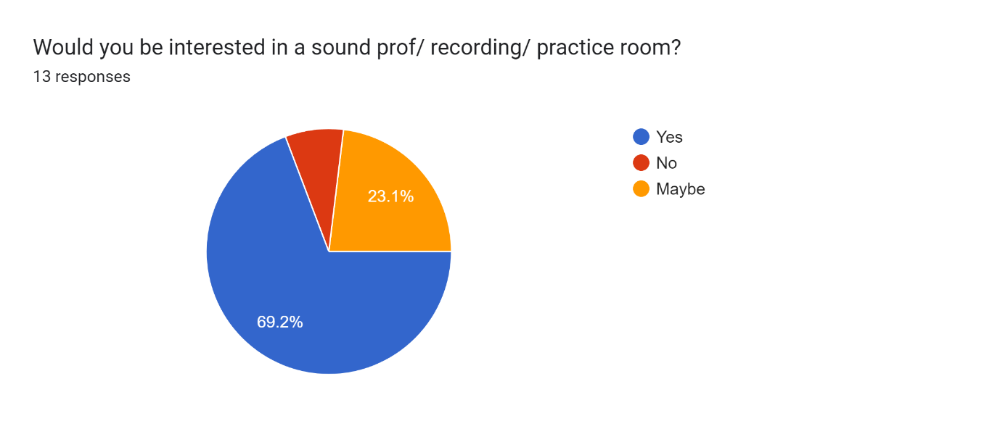
This was the question I was hoping to get the biggest reaction to, and I think I was able to achieve that with the records that I got. The no was a bit upsetting but we move past that. ‘Would you be interested in a soundproof/ recording/ practice room?’ Why would someone say no? I do not know. Maybe in their personal opinion they have no interest in it what so ever.

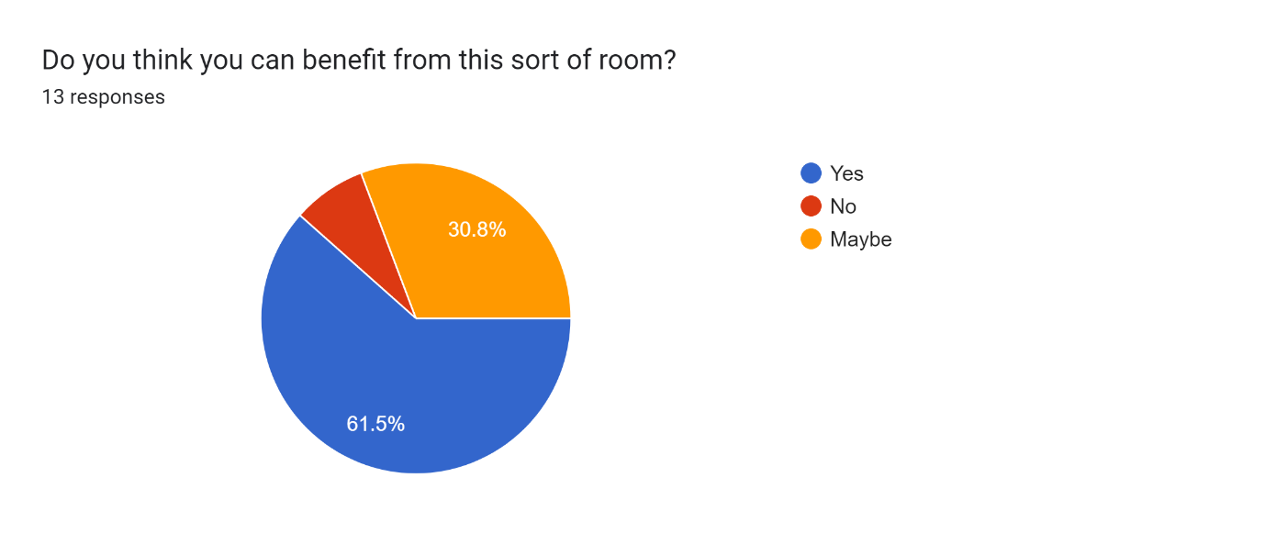
And finally, the question to top it all off. ‘Do you think you can benefit from this sort of room?’.
Again, with the no.

Something I have found interesting while doing my research was Music therapy. I think it is a really nice way to spend a day. It is in loads of different settings, the elderly, adults to children. one thing it benefits in my opinion is people with mental health problems. In my own personal experience in the summer of 2021 me and a friend invented a club called L.W.C.T (little Wales comedy therapy). It was a group for loads of different people aged 10 to 40 coming together and putting together a piece of theatre. and in that time people laughed and enjoyed themselves a lot. Times filled with innovation and thinking on the spot. There was a bunch for people that when they first came, they were nervous but by the end they were taking part in everything. But there is one thing I think about when I look back on that experience, it would have been great if we have some aspect of playing musical instruments.

Some universities I found that had this type of rooms were
UWTSD Swansea
University of Southampton

Personally I think it will be appropriate that in this sound proof /recording/ practice room that we would be able to provide everyone with the equipment that they need.

What I sent to the student union
Hey, my name is Heather Hawkins, and I am just emailing to ask about what do you know about the other trinity campuses other than Carmarthen? Do you know if they have any specific aeras where musicians can practise and record stuff with professional equipment? If you could just let me know that will be great!
Many thanks,
Heather

Email I got back
Hello Heather,

UWTSD has a music technology course in Swansea (Swansea College of Art).

The Students’ Union is not involved in the running or accessing of their facilities, so you would need to speak with course tutors and workshop technicians accordingly.

Course details, including tutors, can be found at https://www.uwtsd.ac.uk/ba-music-technology/.

All the best, Matt.

Email I sent the course lecture of Creative Music Technology Simon Kilshaw
Hello, I hope your well. My name is Heather Hawkins, and I am doing the BA Acting course in Carmarthen. I am currently on my change makers project looking at Establishing a music performance space on the UWTSD Carmarthen campus. I was wondering if you will be able to provide me with some information your practice rooms. What music rooms do you have available for students? When are they available to be used? Is it specific times or 24/7? What equipment is there for students to use? And are students from different UWTSD campuses able to it?
Hope to here form you soon.
Many thanks,
Heather Hawkins (2205072)

Email I sent to `James music` a shop in Carmarthen town
Hello, I hope you are well. My name is Heather Hawkins, and I am doing the BA Acting course in Carmarthen. I am currently on my changemakers project looking at Establishing a music performance space on the UWTSD Carmarthen campus.
I was wondering if you will be able to share this poster with anyone that loves music and lives in Carmarthen?
Hope to hear from you soon.
Many thanks,
Heather Hawkins (student and UWTSD)

(Double tap to open)

15 Inspirational Quotes About The Power Of Music | uDiscover (udiscovermusic.com)

https://www.james-music.co.uk/ (music shop in town)

(Other unis with soundproof rooms)
https://www.southampton.ac.uk/study/facilities/music-practice-rooms-rehearsal-spaces#information
https://www.southampton.ac.uk/study/facilities/music-production-recording-studios

https://www.port.ac.uk/about-us/our-facilities/teaching-and-learning-spaces/music-and-sound-recording-studios (equipment that they have)

https://www.ipr.edu/blogs/author/cbuehler/ (blogger)

https://www.bamt.org/music-therapy/what-is-music-therapy (music therapy)

College students can use music and noise for stress management – The Oakland Post (oaklandpostonline.com)

College students can use music and noise for stress management – The Oakland Post (oaklandpostonline.com)

IJERPH | Free Full-Text | An Eight-Week Zen Meditation and Music Programme for Mindfulness and Happiness: Qualitative Content Analysis (mdpi.com)??/

Full article: Higher education student motivations for extracurricular activities: evidence from UK universities (tandfonline.com)

Power-of-Music-Report-Final-Pages.pdf (ukmusic.org)

(PDF) Building Resilience in Students: Managed and Minimised Stress in Students (researchgate.net)
Creative Music Technology (BA) | UWTSD

