Josh Archer
2011907@student.uwtsd.ac.uk
2011907

Network Operating Systems and Services
Component 2
Josh Archer

Table of Contents
1. Report Overview 3
1.1 Abstract 3
1.2 Introduction 4
2. Team Evaluation 5
2.1 Team Members 5
2.2 Team Evaluation 6
3. Task 1: Managing and maintain network resources using network policy and security practices. 7
3.1 Creation of Share_ACCA5023 7
3.2 Error & Solution when Searching for Admin Log In 8
3.3 Successful user addition to group 9
3.4 Permission Granted to 2 users. 10
3.5 Local & Remote Path to Shared Folder 11
3.6 Map of Shared Network Drive 12
4. Configuring User Environment and Computer Environment, ‘Network Group Policy Objects’ 13
4.1 GPO 1: Moderating Access to the Control Panel 13
4.2 New User Creation 14
4.3 Group Policy Object & Group Policy Management 15
4.4 Prohibit Access to Control Panel & PC Settings 16
4.5 User Denied Access to Control Panel 17
5. GPO 2: Removing Access to the Command Prompt 18
5.1 Creation of New GPO to Prevent Access to Command Prompt 18
5.2 Access Removed from User for Command Prompt 19
6. GPO 3: Restricting Access to Removable Media Drives 20
6.1 Creation of GPO to Restrict Access to Removable Media Devices 20
6.2 Access to Denied to Removeable Media Device 21
7. GPO 4: Restricting Software Installs 22
7.1 Relocation of Client Computer 22
7.2 Policy Creation to Stop Users Performing Installations 23
8. GPO 5: Enforcing Password Policy in the ‘accatask.msft’ Domain 24
8.1 Edited Version of Password Policy 24
8.2 Password Policy Updated 25
9. Task 2: Routing & Packet Filtering Within Core TCP/IP Services & Critical Failover/Redundancy Policies 26
9.1 Command Prompt ‘ARP-A’ 26
9.2 Command Prompt ‘Route Print’ 27
9.3 FTP Server Configuration 28
9.4 Ftpuser23 and password Creation 29
9.5 Edit of SSL Settings 30
9.6 FTP Message 31
9.7 Ftpuser23 Addition to ftproot User Group 32
9.8 ftp 172.16.2.1 Command and Login 33
9.9 Folder ‘myftpile2upload.txt’ Folder Creation 34
9.10 Installation of roles and Features 35
9.11 ‘RIP’ Listing on New Routing Protocol 36
9.12 Pinging PublicNet Ip for Server2 from Server 1 37
9.13 Unsuccessful Ping From Client 1 to Client 2 38
9.14 Inbound Filter for PrivateNet1 39
9.15 Unsuccessful Ping to PrivateNet1 40
9.16 Outbound Filter on Server1 41
9.17 Blocked Connection to ‘FTP 172.16.1.1’ 42
9.18 Set Inbound Rule 43
10. Task 3: Individual Observation 44
10.1 Security Enhancement of a SOHO (Small Office/Home Office) Network. 44
10.2 Group Policy Management Consoles (GPMC) 44
10.3 Group Policy Objects 44
10.4 Failover Cluster 45
10.5 Hyper V Role in Windows OS 45
10.6 Network Policy for an Enterprise Network 49
11. Reflection 51
12. References 52

Report Overview

Abstract

The purpose of this assignment was to work within a team of three other students to Manage and maintain network resources using network policy and security practices while configuring User Environment and Computer Environment using ‘Network Group Policy Objects’. Within this team each student had tasks delegated to them which had to be completed. These were set out in a worksheet. These tasks were to then be evaluated by the other group members and if needed troubleshooting to make sure each steps of the task work together.
Finally, an individual report was to be carried out that covered security policies on a small office or home office. Failover clustering will also be covered as well as its configuration and best role suitable. Finally, a draft of a network policy was to be constructed by the individual.

Introduction

When managing and maintaining Network resources numerous practices are carried out. These practices will be covered below in greater detail but consist of creating NTFS permissions and outlining the use of sharing permissions in regards to network deployed access control. A comparison and investigation will take place discussing the differences in deploying local files to shared. Research into Group Policy Objects and how these are to be implemented will also be shown as well as Group policy management consoles. Detailing this is a vital part in network policies.

The ability to construct a network policy is a vital skill to have. A draft will be set out comprising the topology, teams needed such as security, threat analysis and other policies that are needed in place to ensure that a network is working efficiently and any threats are mitigated.

Team Evaluation

Team Members

Name of the Team: Team Coffee
Student Name | Student ID
mARK WILLIAMS | 2022279
ASHLEY REES | 2009258
TIRION WALL | 2023509
JOSH archer | 2011907

Team Evaluation

Team Evaluation
 | Mark | Ashley |  | Tirion |  | Josh
Mark | 5 |  | 5 |  | 5 |  | 5
Ashley | 5 |  | 5 |  | 5 |  | 5
Tirion | 5 |  | 5 |  | 5 |  | 5
Josh | 5 |  | 5 |  | 5 |  | 5
Team’s Contribution with a scale of 1 to 5 (1 No Contribution and 5 Excellent Contribution)
Mark: Our team once again worked extremely well together each brining in their own unique skills and abilities to this assignment, for example I went through the Worksheet with help from Ashley while Tirion and Josh took screen shots and wrote the descriptions of what each of the stages was. Our team have grown close and worked exceptionally hard to make sure the work is to the highest quality possible.
Tirion: By collaborating closely, our team worked really well. Mark and Ashley (who study Cyber Security, and therefore have a better understanding on the topic) troubleshooted the issues we came across as we went through the worksheet, and Josh and I provided the screenshots and detailed descriptions. Our ability to communicate well as a team helped us complete the work to a high standard.
Ashley: Once again our team worked very well together, Mark and I went through the worksheet together and Tyrion and Josh took screenshots, then went away and wrote the descriptions of each step. The team has grown closer much closer this time, I believe it has helped us to complete the work to an excellent standard.
Josh: As before the team worked well together. With Mark and Ashley providing valuable support to myself and Tirion. I found personally, this assignment more difficult however with Mark and Ashley supporting me throughout I was able to fully understand the fundamentals of what the assignment was trying to get us to understand.

Task 1: Managing and maintain network resources using network policy and security practices.

Creation of Share_ACCA5023
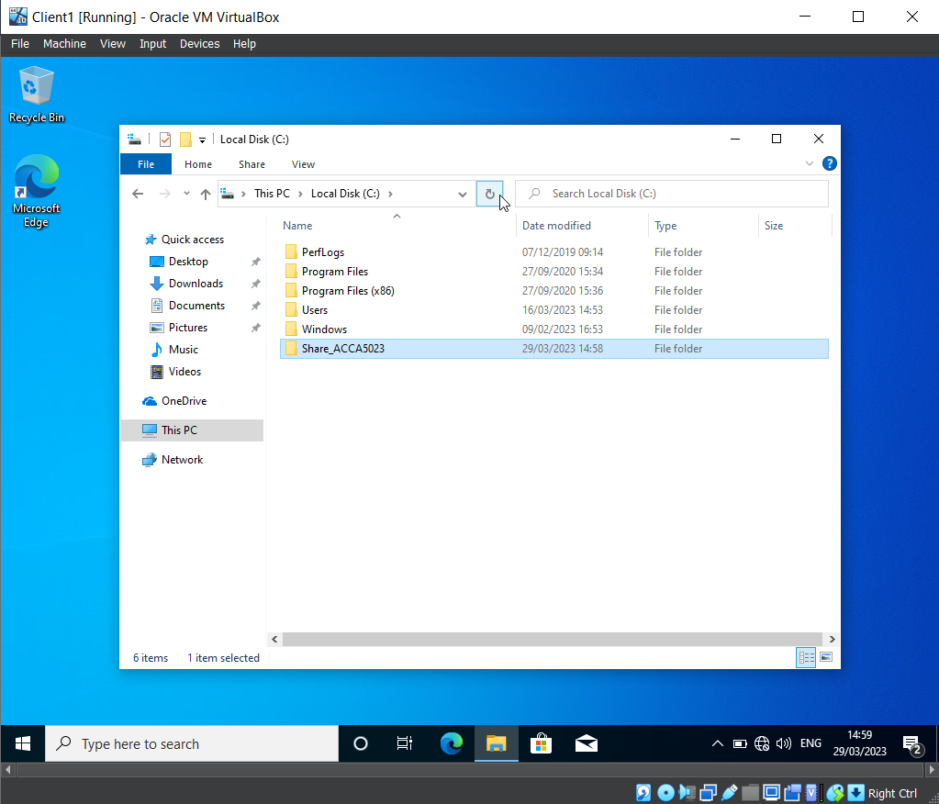

A file has been created within the Local C drive called ‘Share_ACCA5023’. NTFS (local) permissions have been set so that the network user has Full Control permissions, and the other network users have read only access. This helps protect the contents of the file.

Error & Solution when Searching for Admin Log In

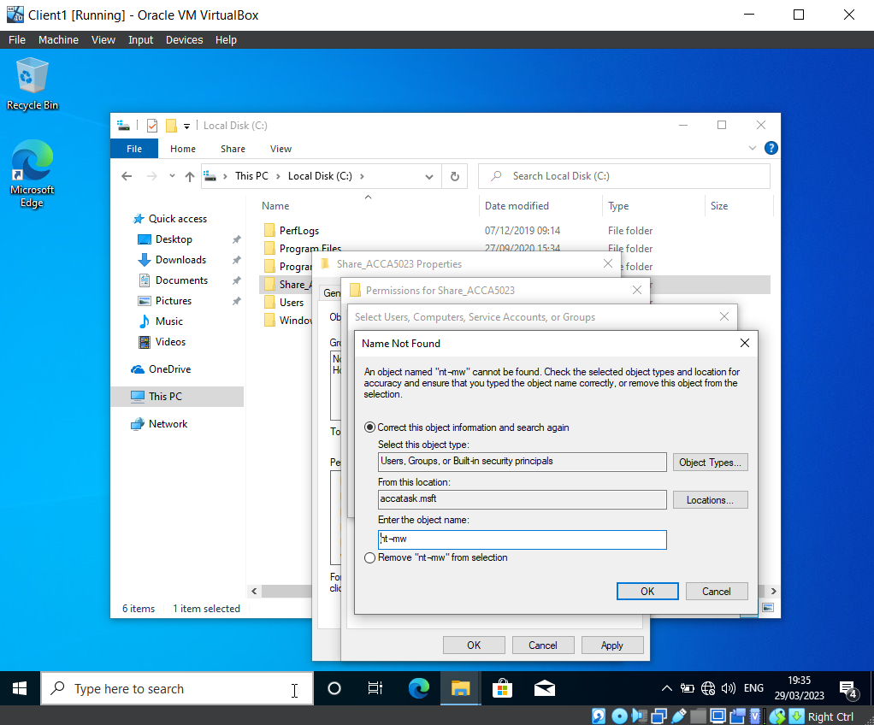
When using the username ‘nt-mw’ to search for the admin login for ‘Mark Williams’, the group encountered the error message in the screenshot above, which indicated that the account could not be found. To resolve this issue, the group retraced their steps, repeating the previous actions. This resolved the problem, as depicted in the next screenshot.

Successful user addition to group

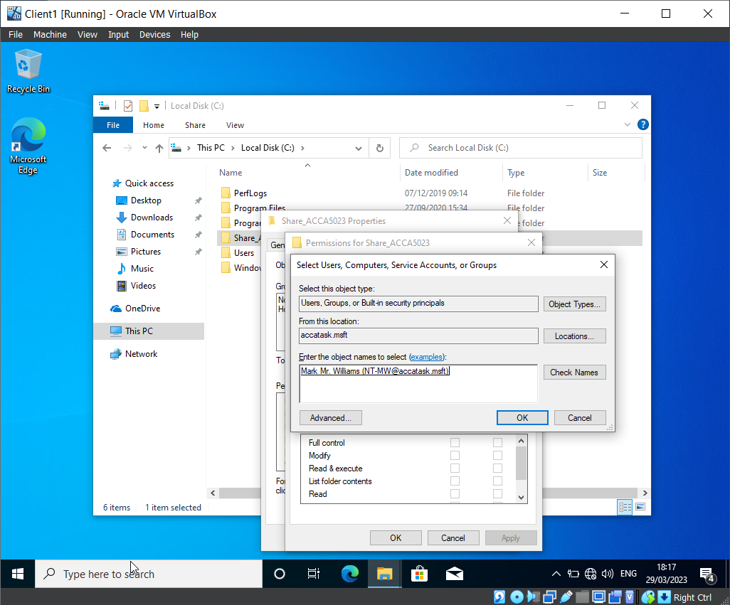

The username has successfully been added to the group, which allows the team to modify the permissions of this user’s access within the file ‘Share_ACCA5023’.

Permission Granted to 2 users.

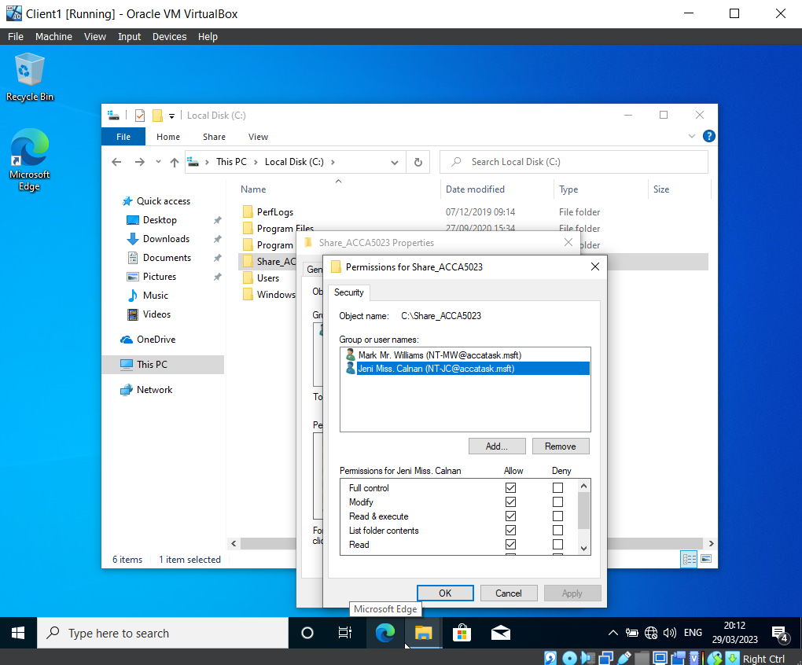

Two users were added to the permissions group for the folder ‘Share_ACCA5023’.

Local & Remote Path to Shared Folder

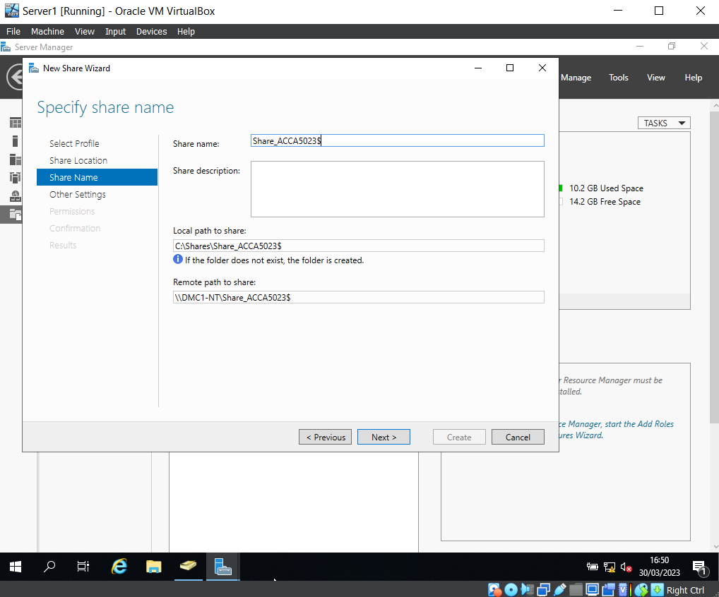

A folder share has been created on the ‘Share_ACCA5023’ server. This shows the local path to share, and the remote path to share. These options have been noted for later use, as they will be needed when the group access the files over the network from a different machine. Additionally, they will be needed to map a network drive to the file server.

Map of Shared Network Drive

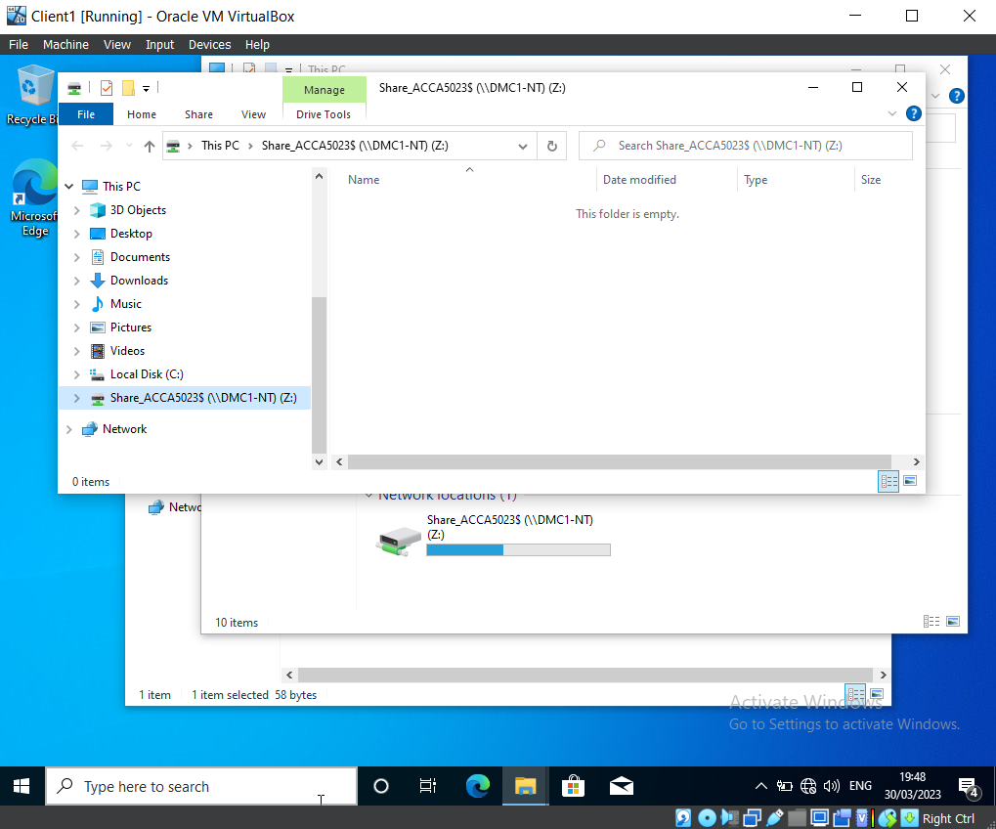
This screenshot shows that the mapped shared network drive is set to drive Z.

Configuring User Environment and Computer Environment, ‘Network Group Policy Objects’

GPO 1: Moderating Access to the Control Panel

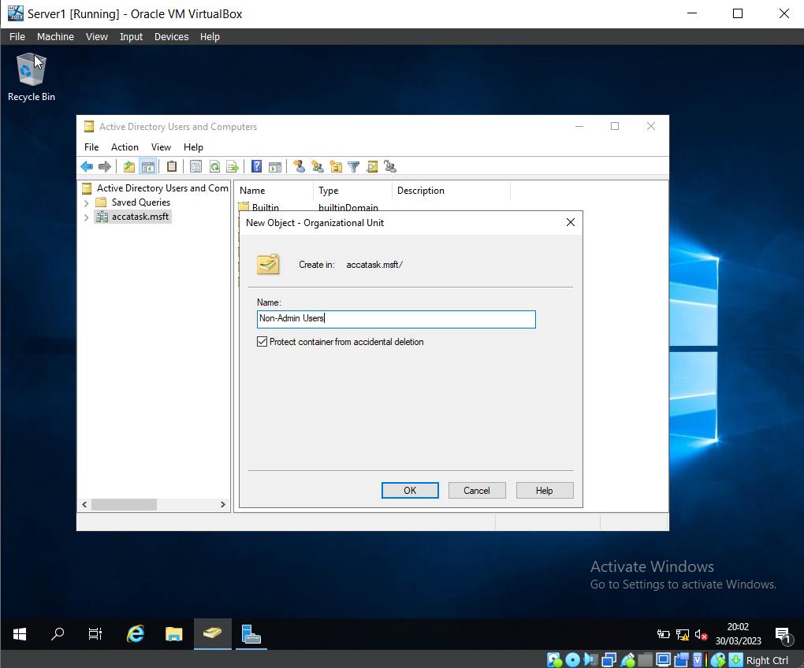

A new Organisation Unit has been created on Virtual Machine Server 1, named ‘Non-Admin Users’.

New User Creation

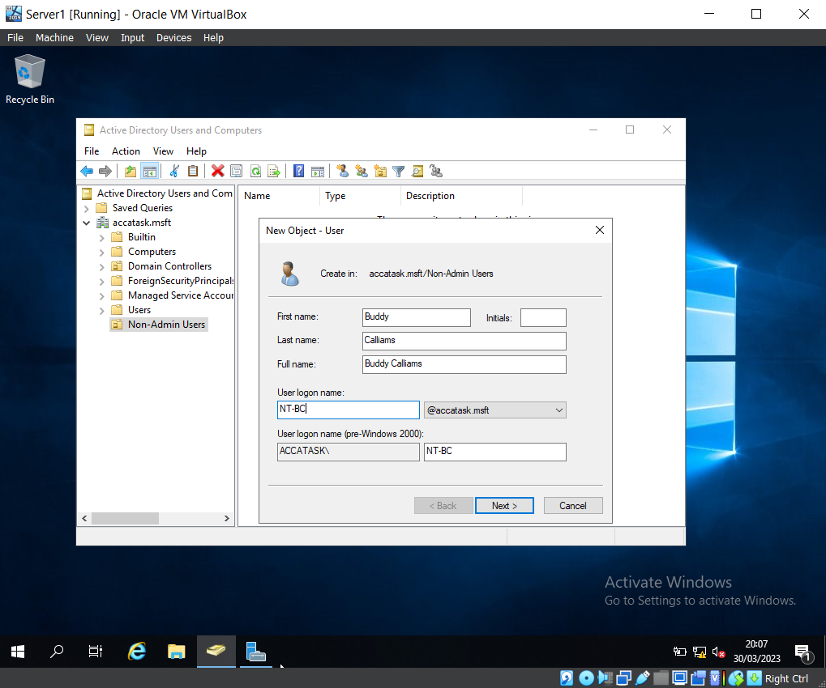

Using Active Directory Users and Computers, a new user has been created within the Non-Admin Users OU. (New user: ‘Buddy Callams’)

Group Policy Object & Group Policy Management

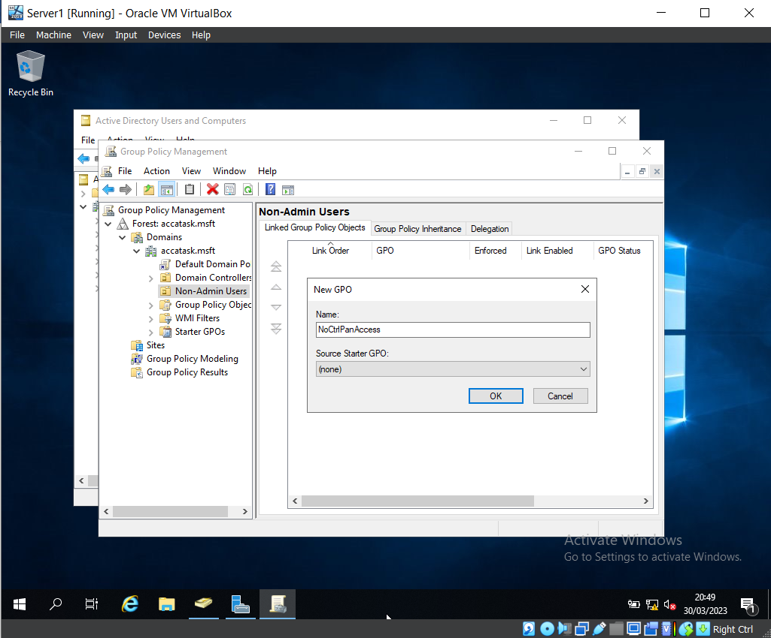

The Group Policy Management Console program was loaded to create a Group Policy Object (GPO). This GPO was named ‘NoCtrlPanAccess’.

Prohibit Access to Control Panel & PC Settings

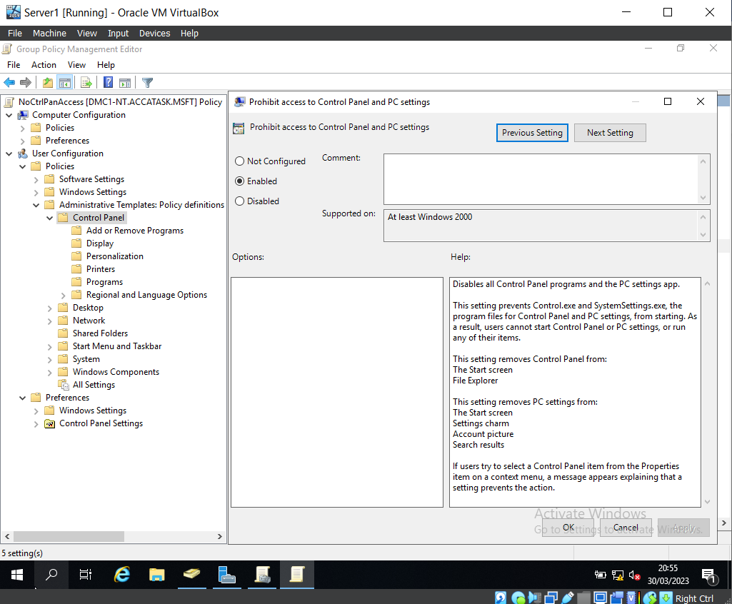

Here you can see that the ‘Prohibit access to Control Panel and PC settings’ policy has been enabled.

User Denied Access to Control Panel

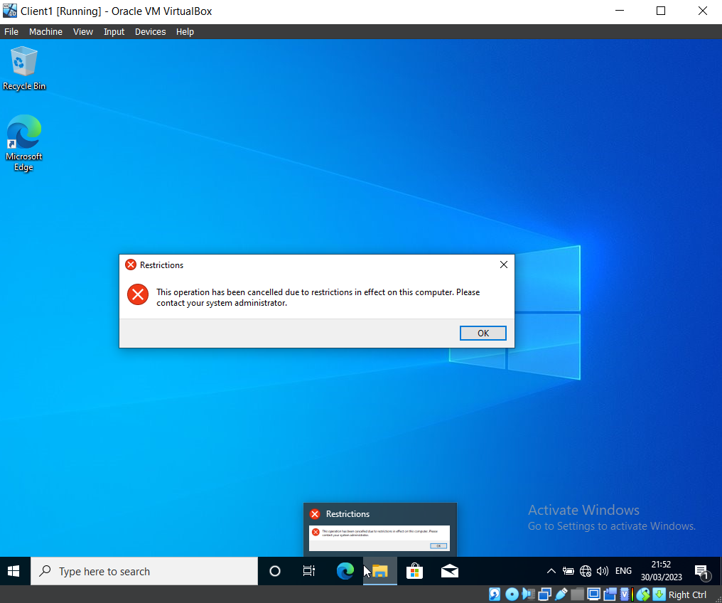

Once logged into Buddy Callams’ account (which was intentionally created with no access to the Control Panel), the group verified that the account could not access the Control Panel.

GPO 2: Removing Access to the Command Prompt

Creation of New GPO to Prevent Access to Command Prompt

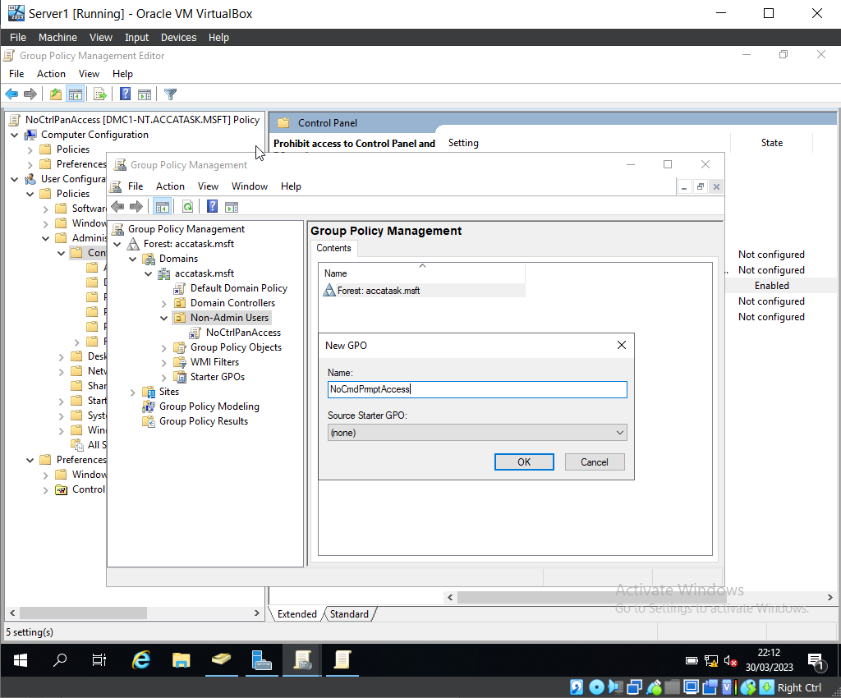

After loading the Group Policy Management Console program, expanding the domain and finding the Non-Admin Users OU, the team created a new GPO named ‘NoCmdPromptAccess’.
The team then edited the GPO to prevent Buddy Callams from access to the Command Prompt.

Access Removed from User for Command Prompt

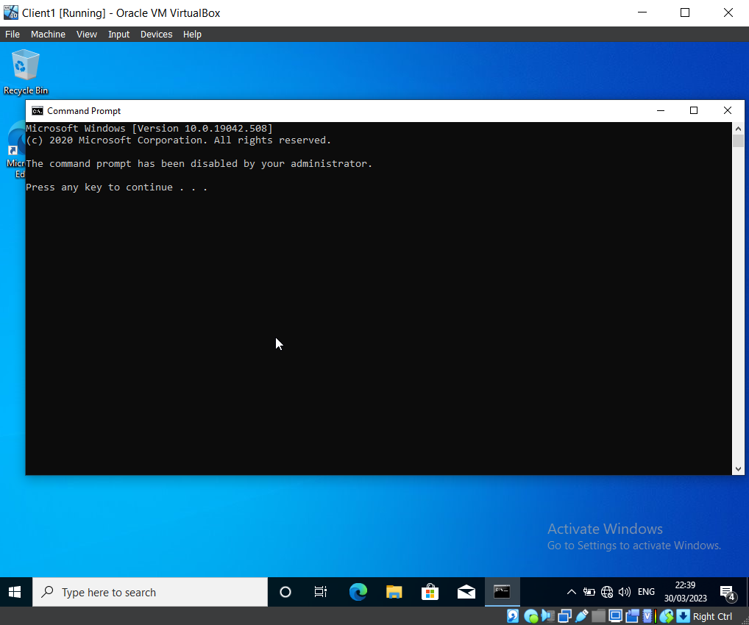

Using Buddy Callam’s account, the team tested that the Command Prompt could not be accessed. This screenshot confirms that the policy created in the GPO is working as expected.

GPO 3: Restricting Access to Removable Media Drives

Creation of GPO to Restrict Access to Removable Media Devices

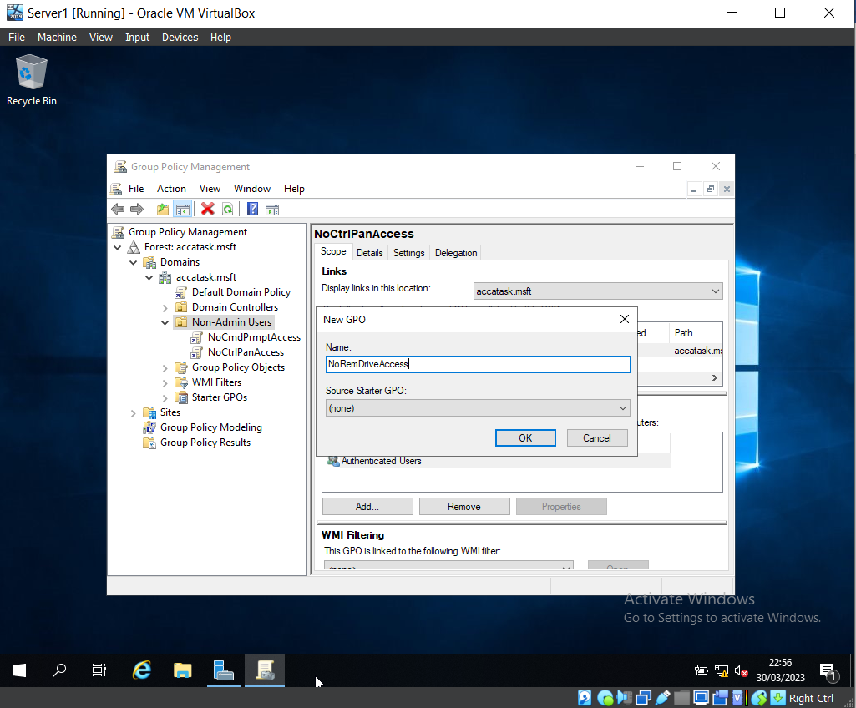

Another Group Policy Object has been created within the Non-Admin Users OU, named ‘NoRemDriveAccess’.

Access to Denied to Removeable Media Device

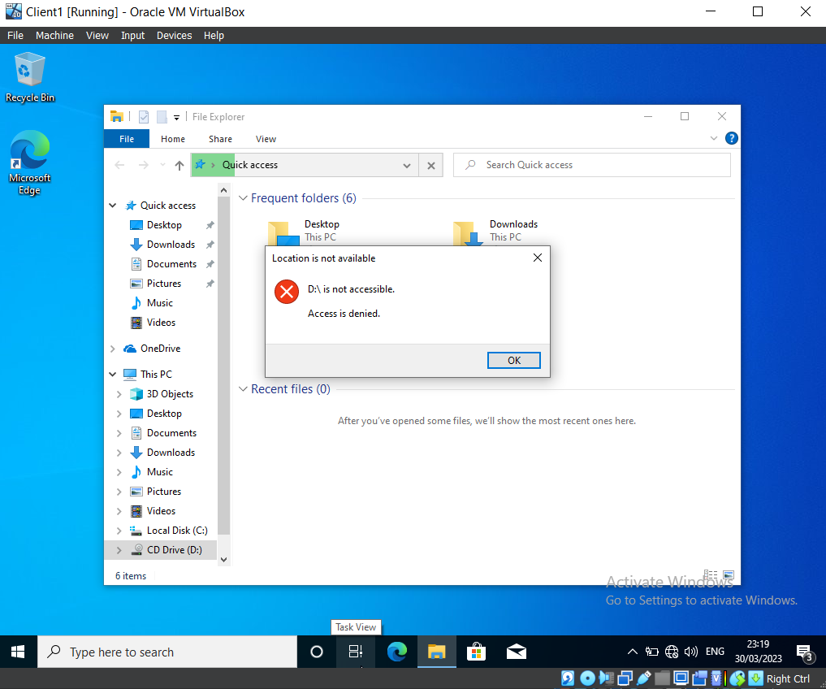

A USB has been attached to the Virtual Machine. This screenshot demonstrates that due to the policies now in place (i.e., access to Removable Storage is disabled), the USB is not accessible, and the error message is displayed to inform the user.

GPO 4: Restricting Software Installs

Relocation of Client Computer

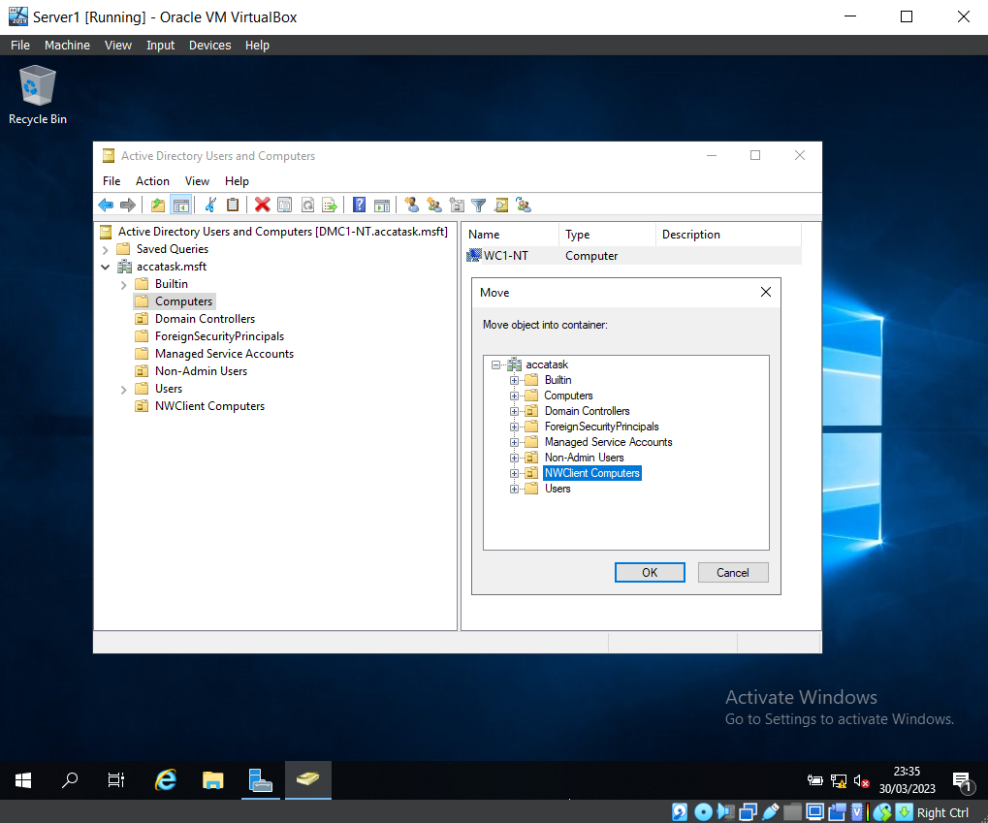

This screenshot displays the relocation of the client computer from the ‘Computers’ folder to ‘NWClient Computers’, enabling the policies specifically designed for computers within that particular Active Directory.

Policy Creation to Stop Users Performing Installations

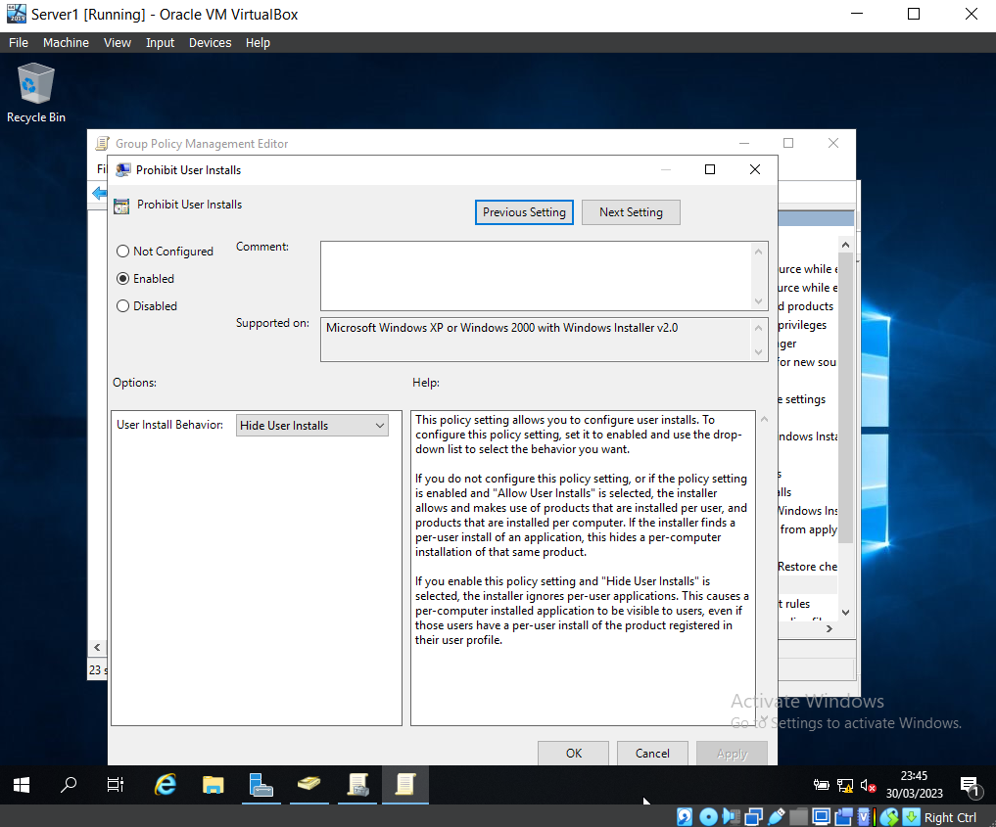

A policy has been created to stop users from performing installation on the client computer.

There’s a problem with the steps just after this one - I can’t prove the policy is in place because my client and server aren’t connected to the internet, so I can’t download anything to prove the policy is in effect.

GPO 5: Enforcing Password Policy in the ‘accatask.msft’ Domain

Edited Version of Password Policy

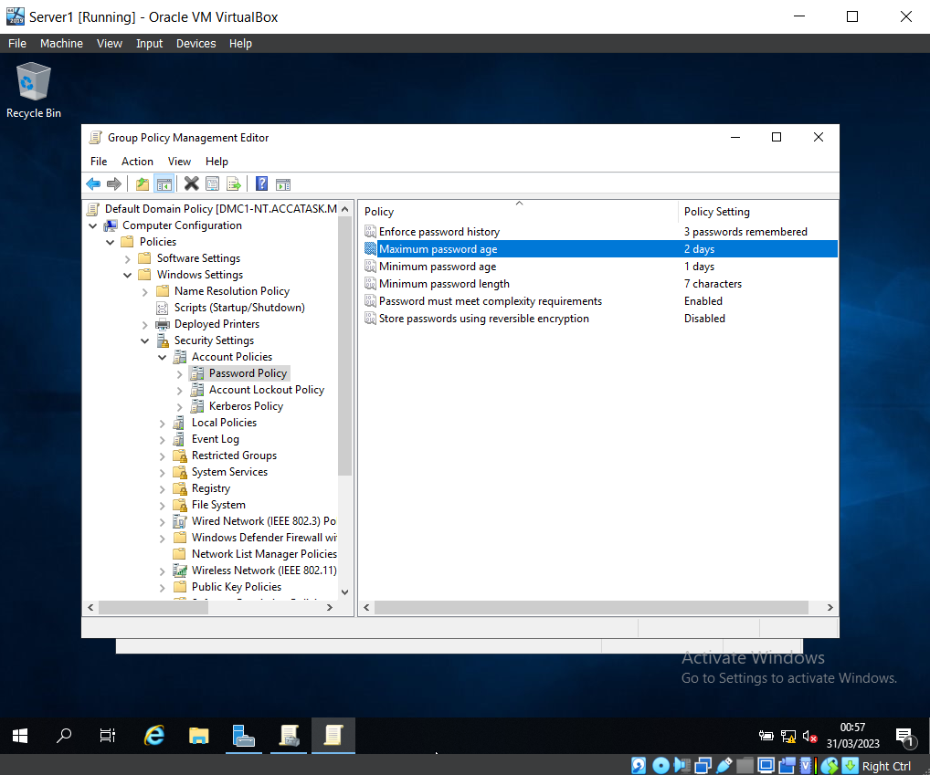

The password policy has been edited to fit the new requirements (e.g., the password must be a minimum of seven characters, and passwords using reversible encryption have been disabled).

Password Policy Updated

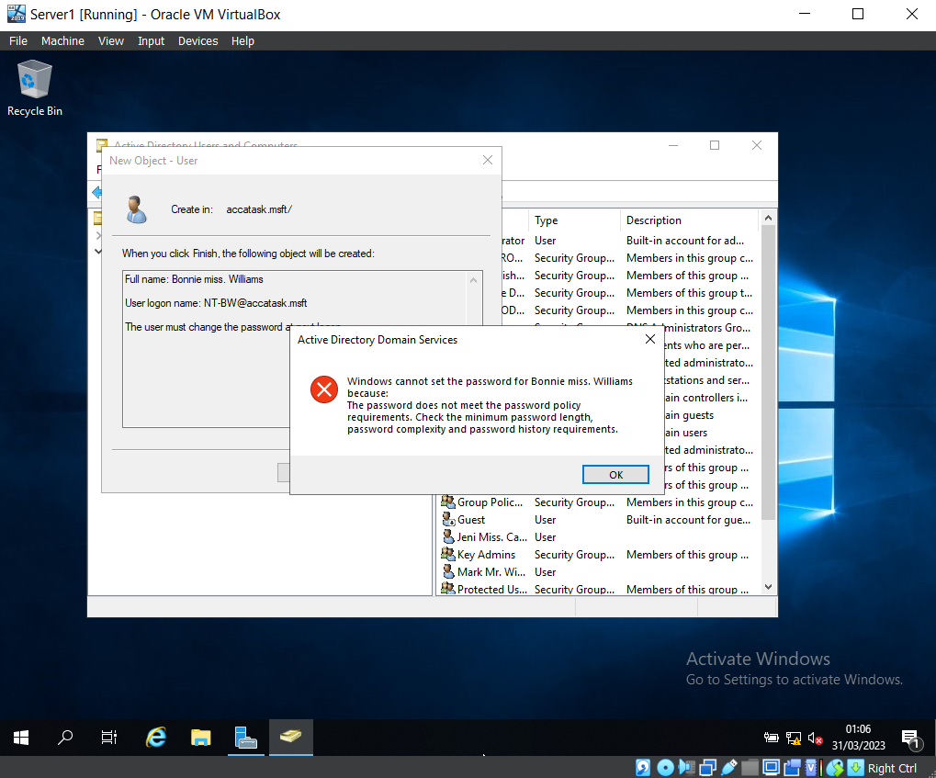

Here is evidence that the password policy is working as expected.
The team set a user’s password that was only four characters long, as this did not meet the criteria of the Password Policy, the password was not updated and an error message appeared.

Task 2: Routing & Packet Filtering Within Core TCP/IP Services & Critical Failover/Redundancy Policies

Command Prompt ‘ARP-A’

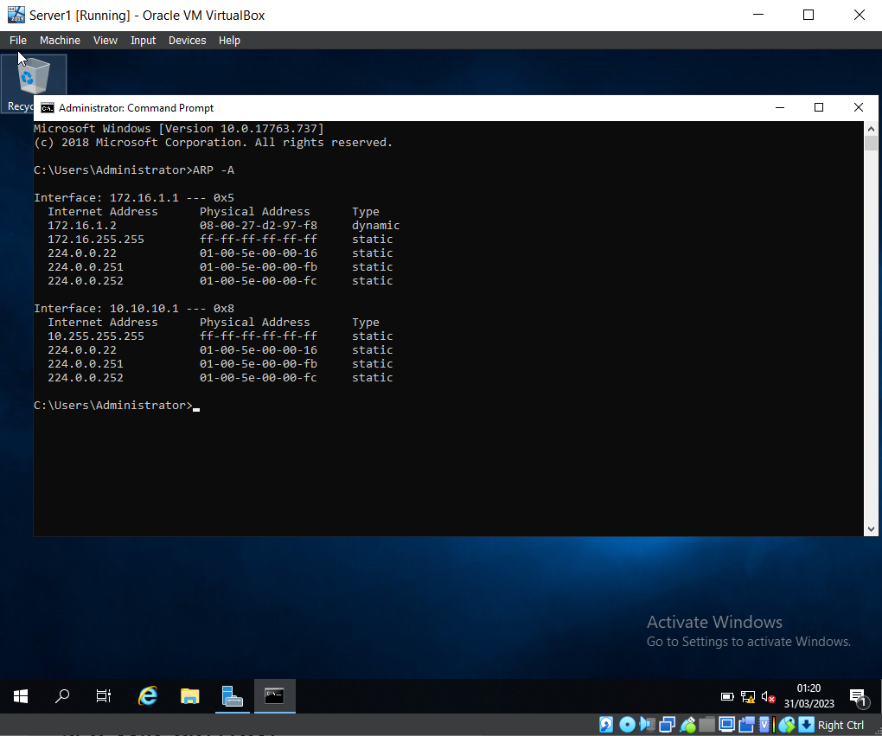

‘ARP – A’ has been entered into the Command Prompt, this shows the Interface (NIC’s), the Physical (MAC) address, and internet address of this NIC.

Command Prompt ‘Route Print’

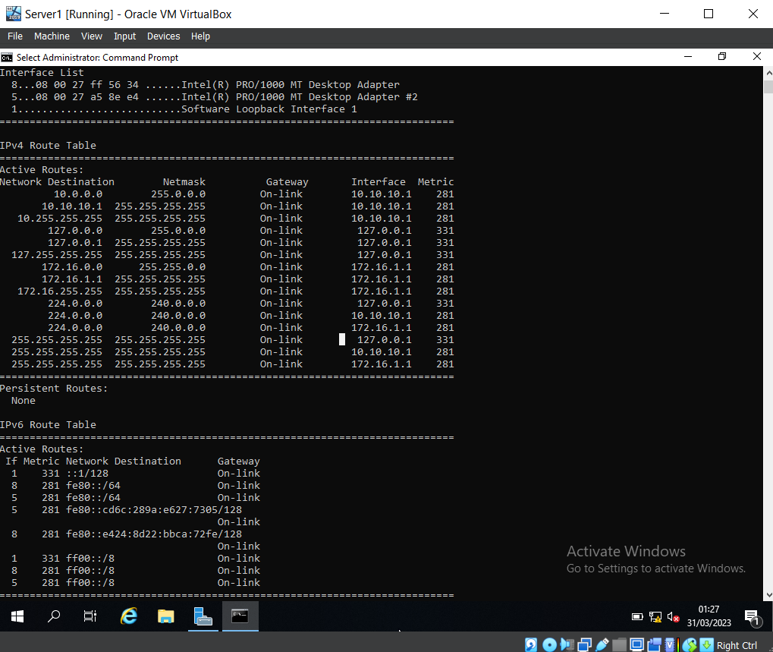

‘route print’ was entered into the Command Prompt to show the current IP routing table, which displays the following information: Netmask, Gateway, Interface, and Metric.

FTP Server Configuration

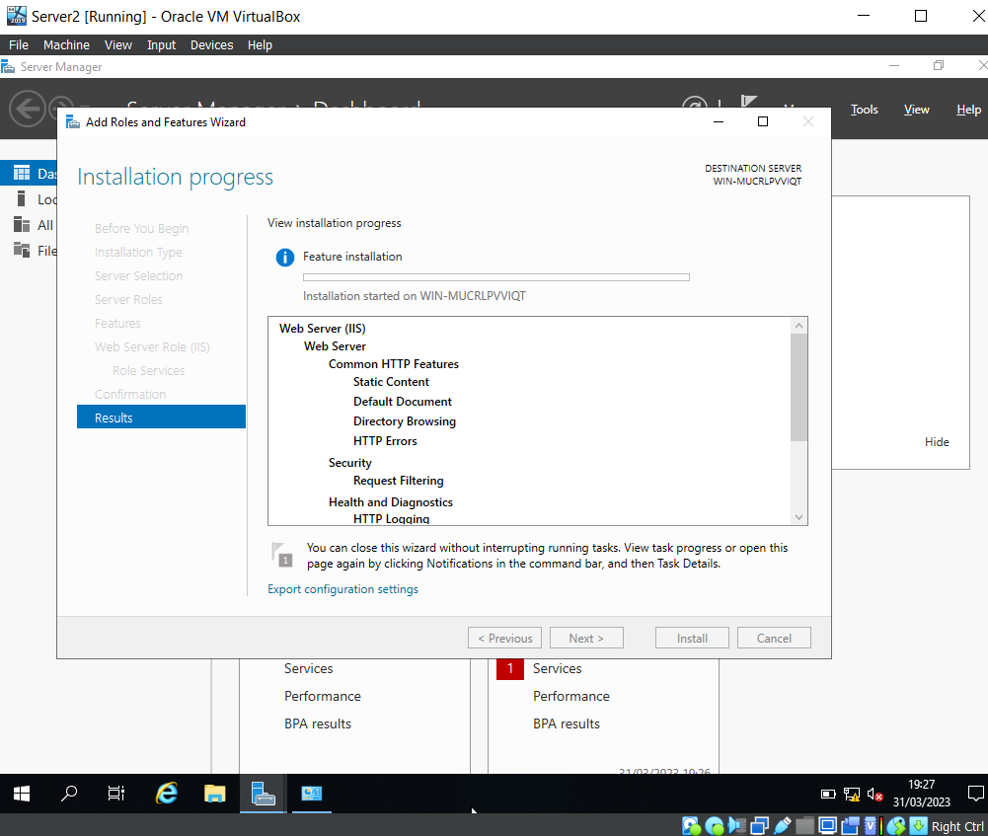

After launching the Server Manager, the FTP Server (IIS) Role has been configured and the FTP User Account has been created.

Ftpuser23 and password Creation

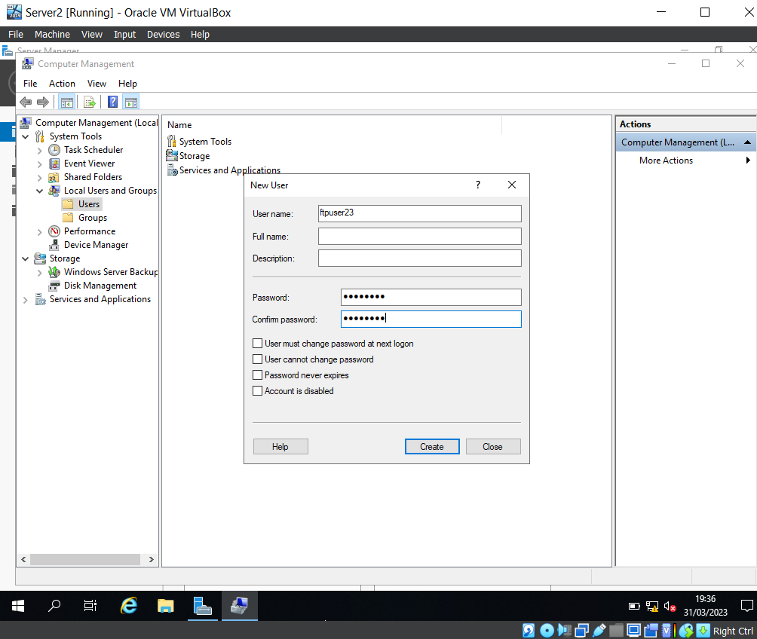

A new user was created, the username was set to ‘ftpuser23’ and the password ‘P@55word’.
The team manually unticked ‘User must change password at next logon’ before creating the user.

Edit of SSL Settings
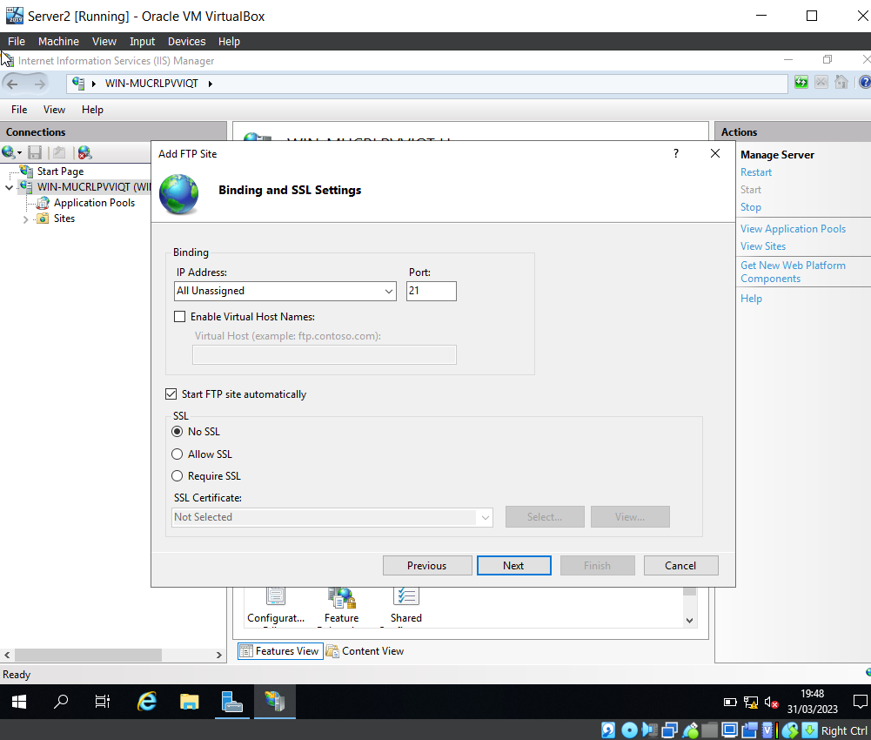

The team then opened the IIS Manager within the Sever Manager Tools and changed the binding and SSL settings to ‘No SSL’, and made a note of the Port Number (21), as this is the port used for FTP (File Transfer Protocol).

FTP Message

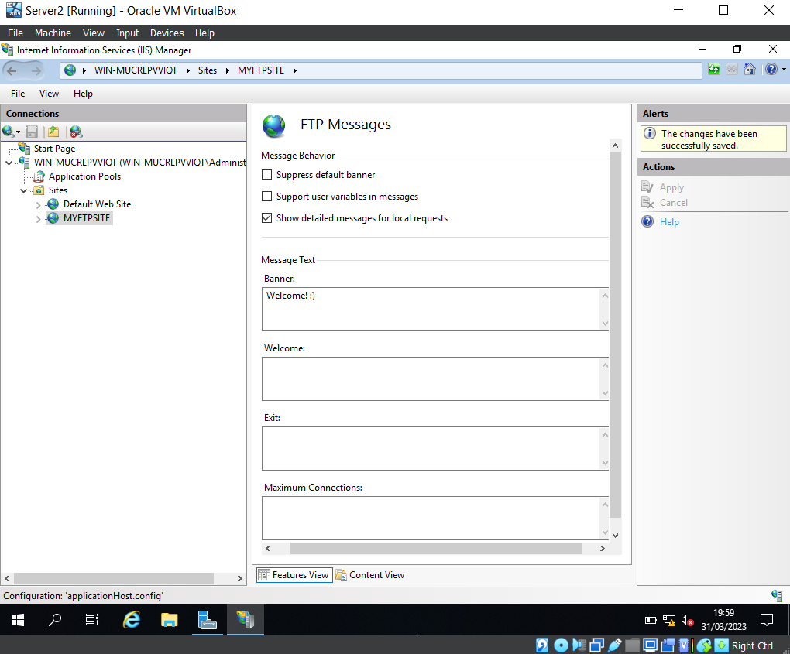

This screenshot displays the set-up of a banner message within the ‘MYFTPSITE’ site.

Ftpuser23 Addition to ftproot User Group

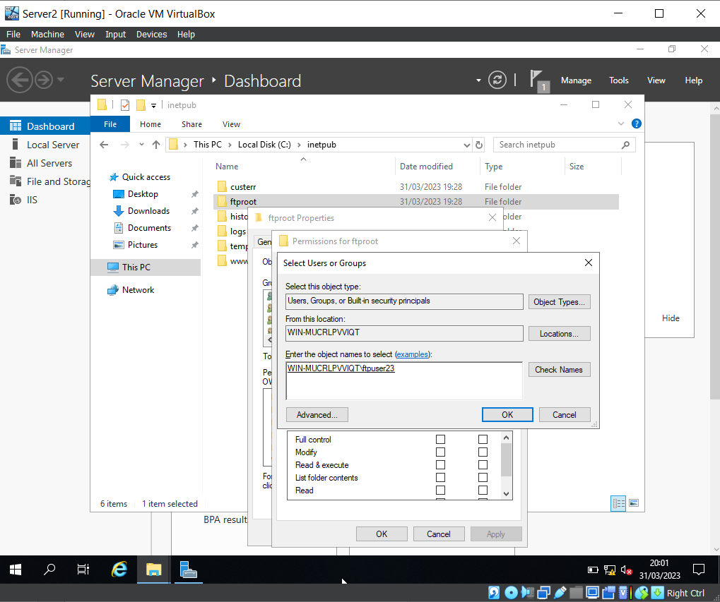

The newly created user, ‘ftpuser23’, has been added to ‘ftproot’ users group.
To confirm that the new user could be found, the team entered ‘ftpuser23’ and clicked ‘Check names’. The account is underlined, confirming that is has been found.

ftp 172.16.2.1 Command and Login

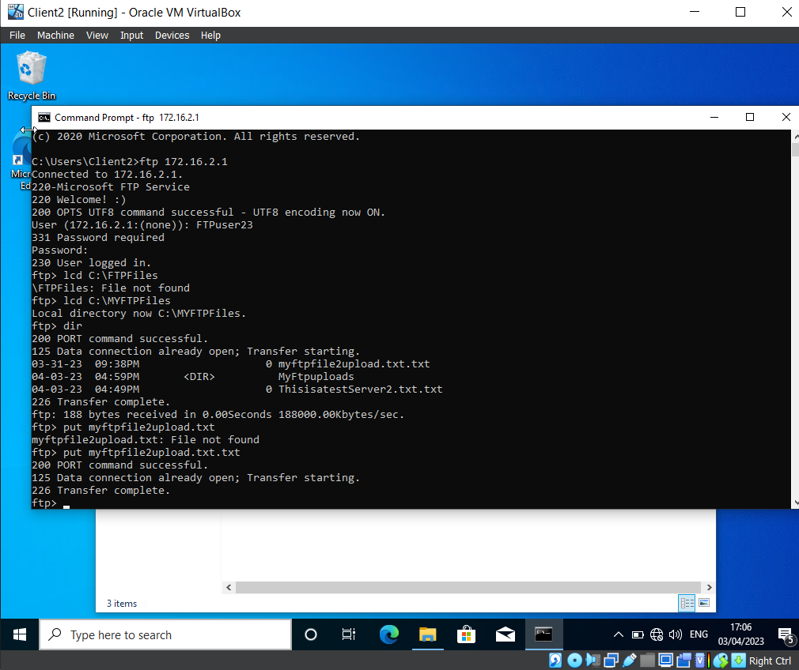

Using the command ‘ftp 172.16.2.1’ granted access to the FTP Service and prompted the ‘Welcome :)’ banner that was set up previously in the desk. This then prompted a login which was for the ‘Ftpuser23’ account. After the successful login, the command ‘lcd C:\MYFTPFiles’ proceeds to the directory of ‘C:\MYFTPFiles’. The command ‘dir’ brings up the files within the directory and the command ‘put myftpfile2upload.txt.txt’ transfers the document within ‘C:\MYFTPFiles’.

Folder ‘myftpile2upload.txt’ Folder Creation

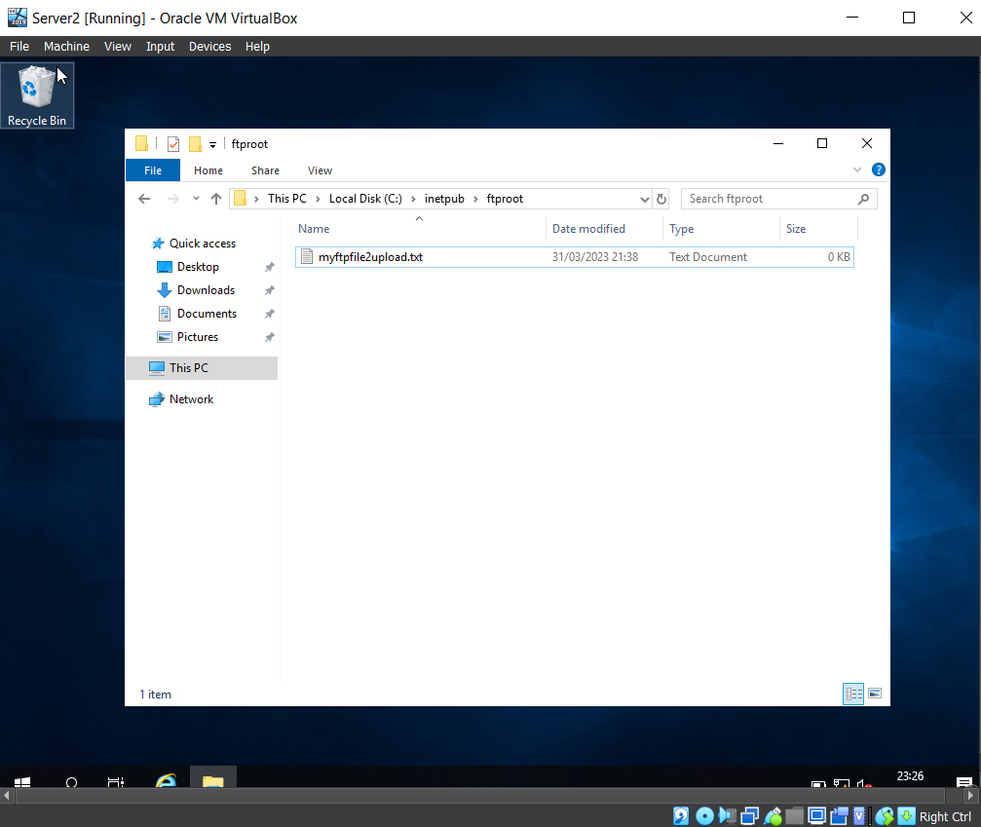
In the C:\directory of Client 2, the team created a new folder, and within this folder, a text file was created, named ‘myftpile2upload.txt’.
Prior to this, the team logged in as a domain administrator level account, and confirmed that the firewall on the Windows 10 client machine was disabled.

Installation of roles and Features

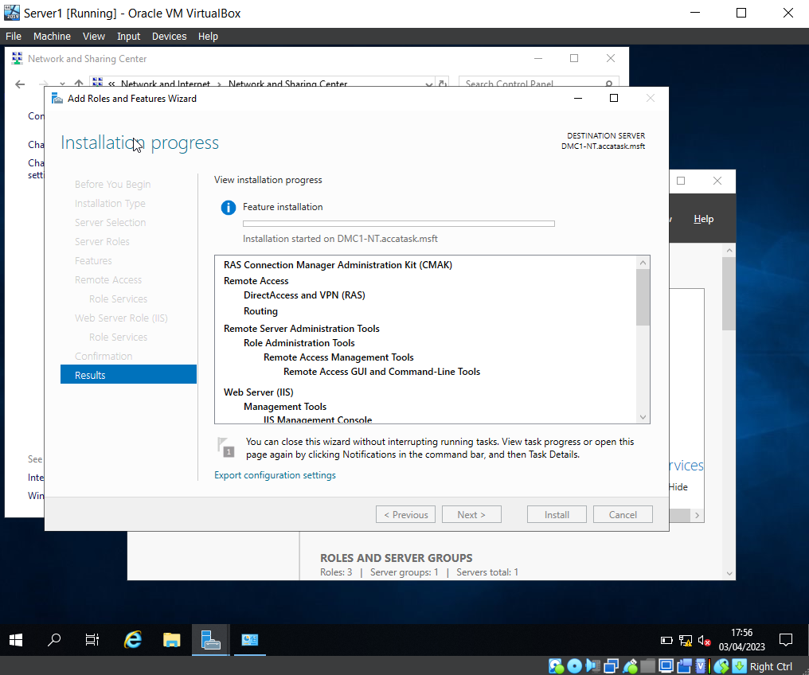

This screenshot displays the installation stage of adding roles and features for DirectAccess, VPN, and Routing Services.

‘RIP’ Listing on New Routing Protocol

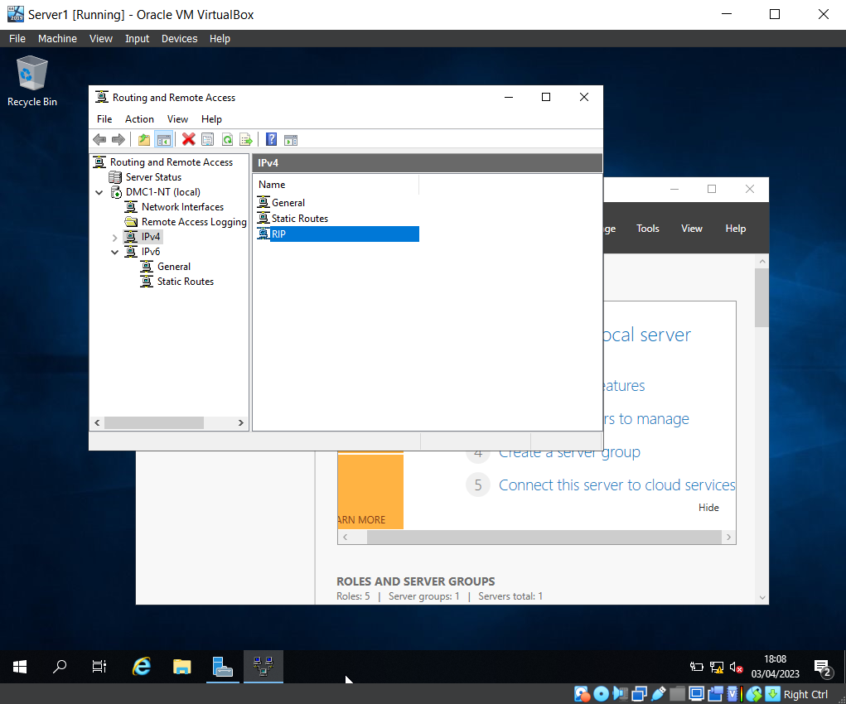

The team opened Routing and Remote Access and selected ‘RIP V2’ as the IPv4’s New Routing Protocol.
As you can see, ‘RIP’ is listed as an available protocol on the IPV4 stack.

Pinging PublicNet Ip for Server2 from Server 1

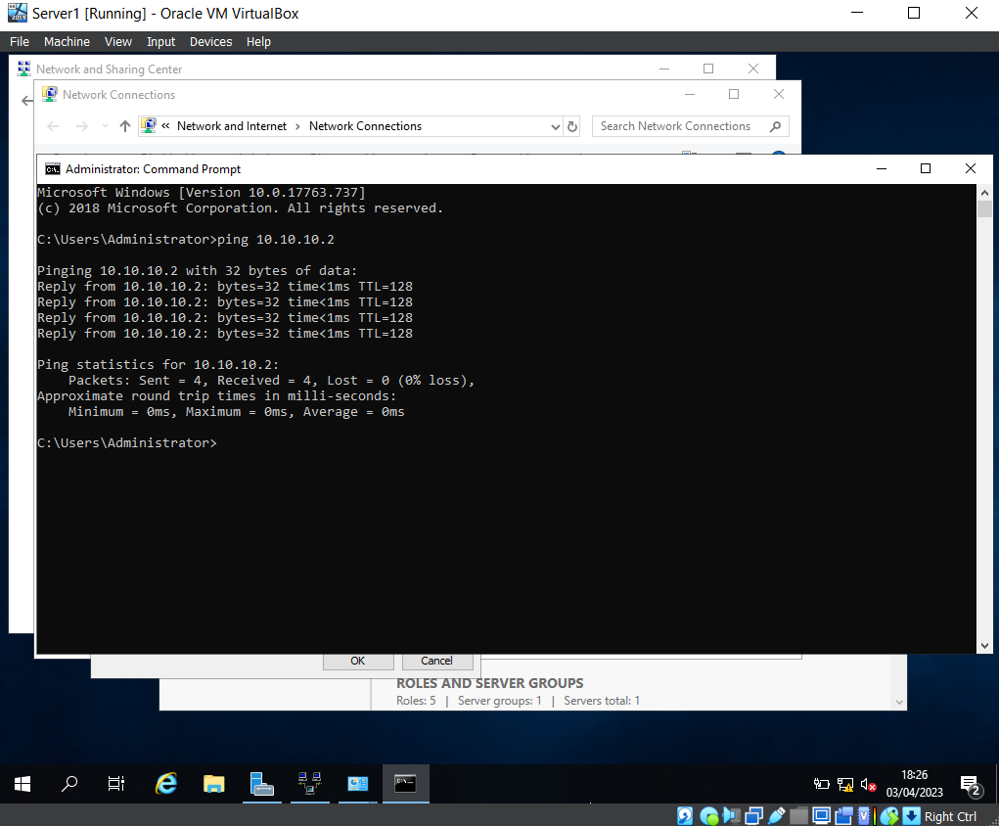

Pinging the PublicNet IP address for Server 2 from Server 1 and receiving a response.

Unsuccessful Ping From Client 1 to Client 2

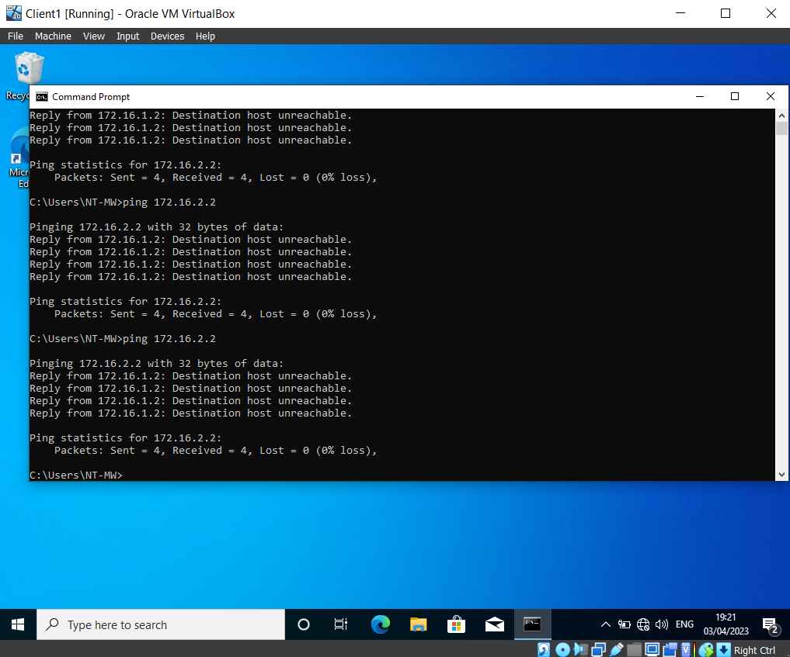

Here you can see the team are unable to ping Client 2 from Client 1.

Inbound Filter for PrivateNet1

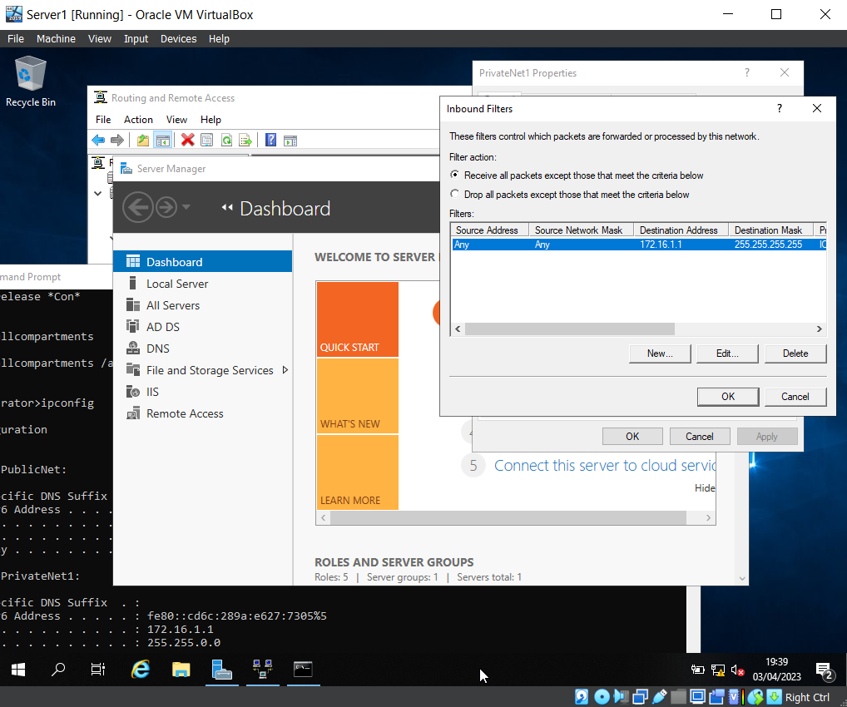
The Inbound filter for PrivateNet1 within Server1.

Unsuccessful Ping to PrivateNet1

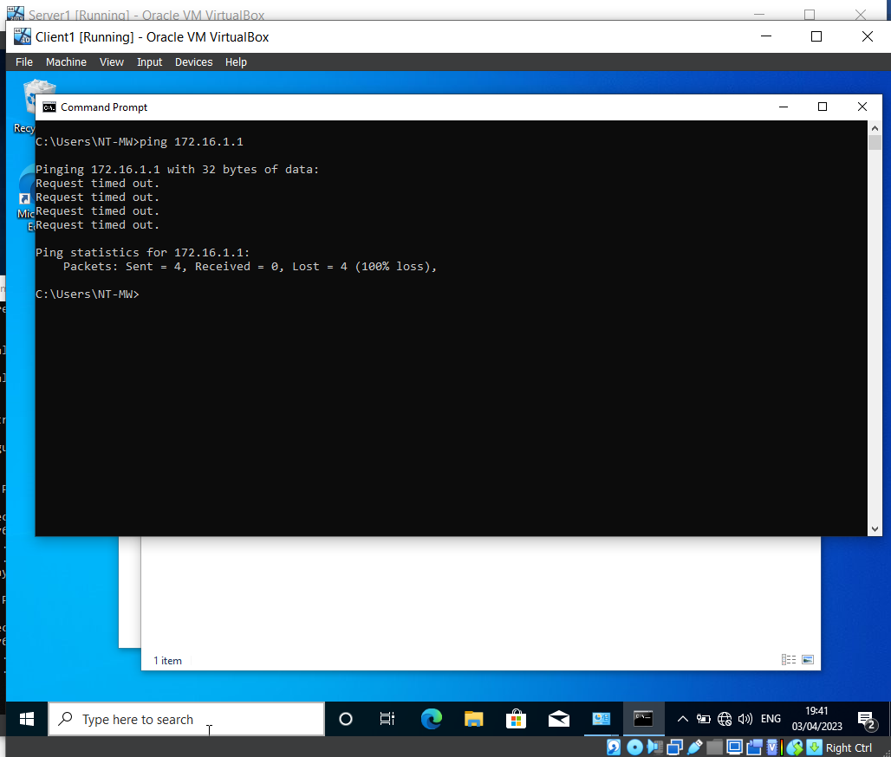
Here the team have attempted to send a ‘ping’ to PrivateNet1 from the Client, this currently results in a timeout error, as the new inbound filter is blocking ping requests.

Outbound Filter on Server1

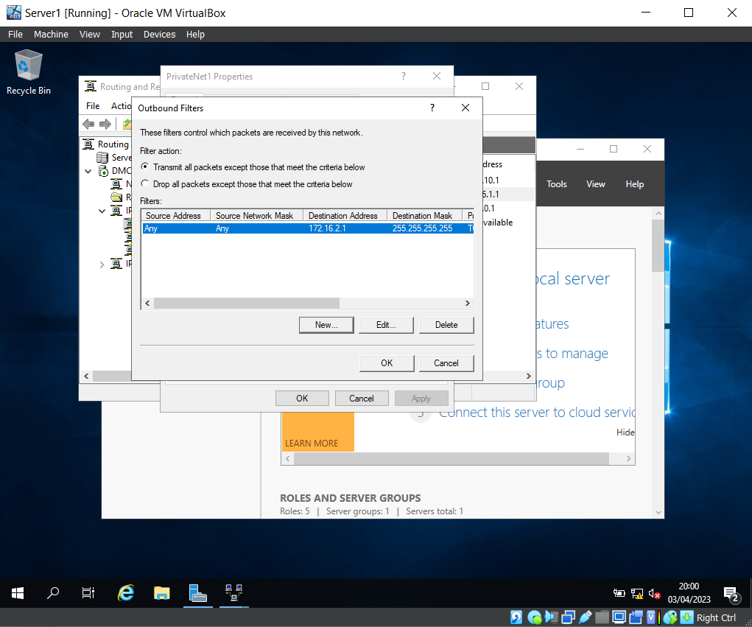

The outbound filter on Server 1 for PrivateNet1 is configured to restrict access from PrivateNet1 to the FTP running on Server 2.

Blocked Connection to ‘FTP 172.16.1.1’

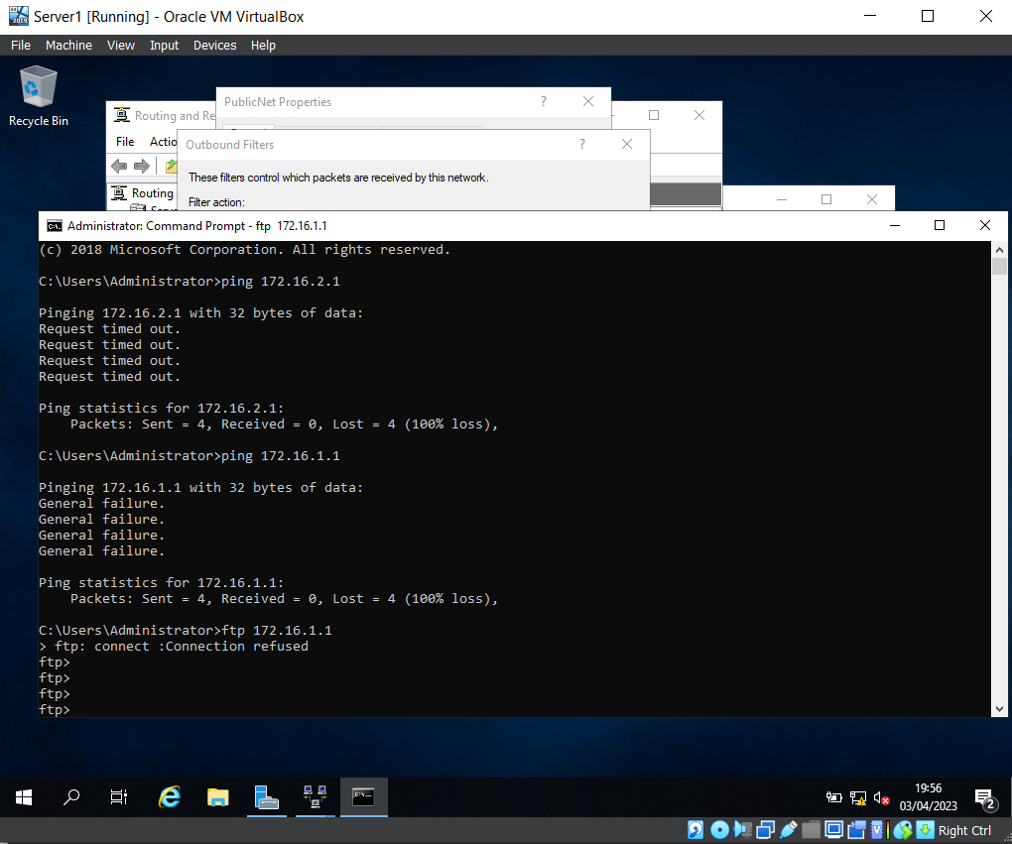

This screenshots shows the connection to ‘FTP 172.16.1.1’ has been blocked, due to the filter.

Set Inbound Rule

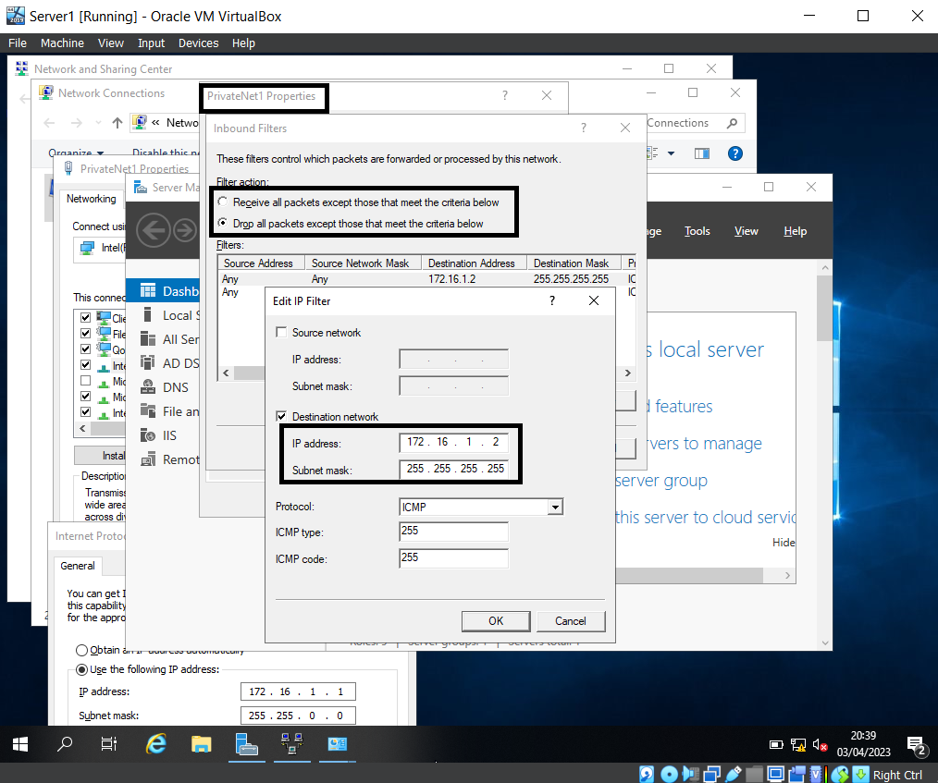
The set inbound rule above shows that the IP is set for Client1, and the middle box shows the filter action ‘Drop all packets except those that meet the criteria below’, which means Client 1 will have FTP access, but all other IP addresses will be denied access.

Task 3: Individual Observation

Security Enhancement of a SOHO (Small Office/Home Office) Network.

When wanting to enhance the security for a SOHO network there are numerous ways to achieve this. These could range from encryptions, whether your IP address is Dynamic or Static or just by evaluating your exposure to the Internet. However, this report will discuss Group Policy Objects (GPO) & Group Policy Management Consoles (GPMC).

Group Policy Management Consoles (GPMC)

GPMCs unites all group policy management across a network. By using these consoles, administrators can reduce the number of tools they would need to use to organise these management policies such as Active Directories or Services snap ins. GPMCs incorporates the functions involving the group policies from these existing tools into a central consol. These consoles now come with new functions also. These include:
- User interfaces that make it easier to manage GPOs.
- The ability to back up and restore GPOs and to also import and copy GPOs.
- Data that reports GPO settings and Resultant Set of Policy.
- Programmatic access to be able programme the GPOs. This cannot be done within the GPOs themselves [1].
It’s important to remember that GPMCs do not replace the existing tools that were needed for policy management. It simply allows for better Group Policy admin. Whereas the existing tools such as Active Directories are used for directory admin [2].

Group Policy Objects

GPOs are essentially a digital collection of the different policy settings. These settings basically define what a system will behave and look like for a pre-defined group of users. There are 3 different types of GPOs, Local, Non-Local and Starter.
- Local – this group Policy will only apply settings to the local computer and to anyone trying to access it. Microsoft have this type of GPO as a default on there computers as these are needed when a policy setting is needed for a single computer or user. When talking about a home office where there will only be one potential user and computer. This type of policy will be acceptable.
- Non Local – This applies to more than one user or computer that is accessing the network. These policies will apply to users when they access the Active Directories Objects. These objects could include any sites or domains that could be visited. This policy would be acceptable to a bigger set up such as a small office.
- Starter – This is a template for Group Policy settings. This gives an administrator a foundation to build future policies on. These come with pre-configured settings [3].
Some settings within these objects will help secure the Home or small office network. Some of these settings include Regulating access to the control panel. By accessing a control panel resources such as data can be obtained. Restricting access will stop unauthorised users gaining access via the control panel. Another measure could be to disable the command prompt. Command prompts can be used to bypass restrictions implemented on the system already. This could be essential to securing the systems resources. Finally creating a GPO that disables software installations will stop any unauthorised users installing any software, malware or viruses that could compromise the security and integrity of the network and system [3].

Failover Cluster

Failover Clusters are a group of computers working together to ensure availability and scalability of clustered roles are increased. The services from clusters are known as nodes are connected by hardware such as cables and also by software. If one of these nodes are to fail, other nodes will then provide a different service, this is what is known as Failover [4]. Failovers clustering are vital as they allow administrators to provide patching and maintenance on said nodes without compromising or shutting down the network or database. This type of mechanism can also provide a service ensuring that any databases that fail can be stopped in order to ensure the safety of the active nodes. Finally using failover clustering can provide automated recovery of data if and when failure occurs. Some of the main concepts and features of Fail over clustering includes:
- Scalability – scaling this mechanism is made easier as the clustering operates on a group of clusters. Making it easier to add new clusters to said groups.
- Stability – if a node fails, whether this is from external circumstances or not, the surviving nodes can still provide a service using the failover mechanism.
- Real time monitoring – the nodes are constantly being monitored. Any that are functioning properly are able to be restarted or moved.
- Cluster Shared Volume – This allows for nodes to be used on a shared storage by giving a consistent namespace. This ensures that there is minimal disruption to server applications [5].

Hyper V Role in Windows OS

The requirements for Failover Clustering on a Windows OS are the server should be able to ping the DNS and NTP servers. The administration credentials need to be set up in away in which they can create the Cluster Computer Objects. Also, RDM disks added the servers, need to be accessible. All servers that the clusters are added to must be running off the same version and are connected by the same active directory. Once these prerequisites are checked and met you can begin to deploy the failover cluster. A role within the Windows OS environment that can provide the requirements stated above would be the Hyper V Cluster. First you must install the Failover cluster feature. This is done through first accessing the Server manager and accessing the ‘add roles and features’.

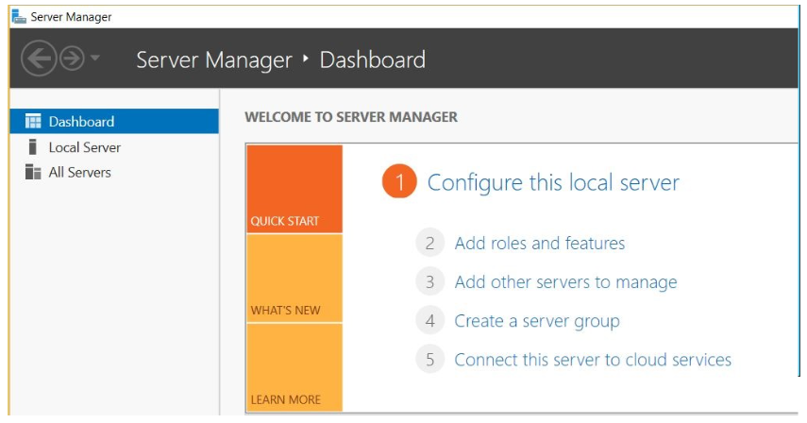
Next the administrator must select the Role based or the feature based installation.

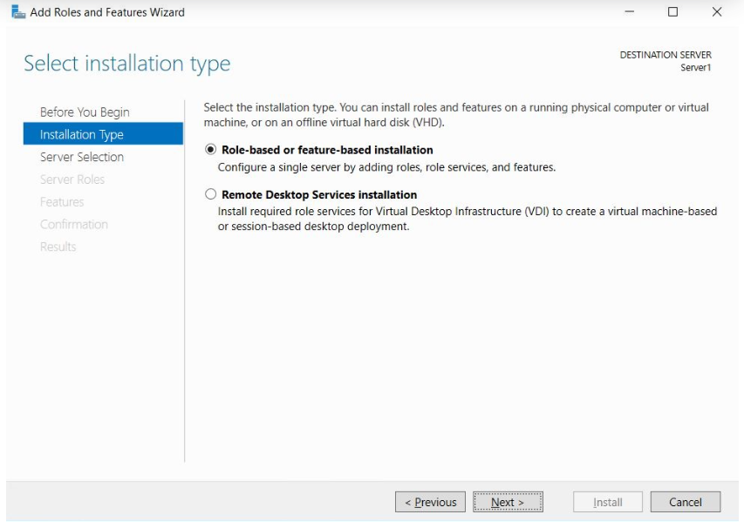 [6]

The administrator can then select the server that is the destination that you would like to instal that feature on then move onto selecting the server roles and the features. Once this is then done, the administrator can then install the management tool by selecting Add Features.
The administrator can then begin to create a failover cluster by accessing the Windows Administrator tools and launching the Failover Cluster Manager.
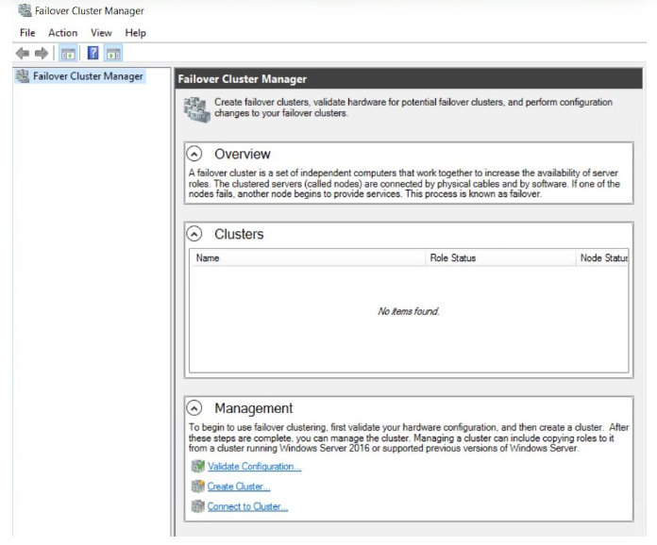

[6]

A Virtual machine can then be created by right clicking the Roles and selecting New Virtual Machine and choosing the Hyper V host.

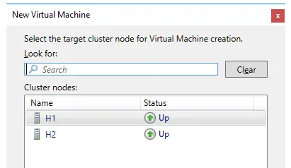 [7]

The administrator must then provide the Virtual machine with a name and location. The next step would then be to ensure the virtual machine is created in the shared volume of the Hyper V role.

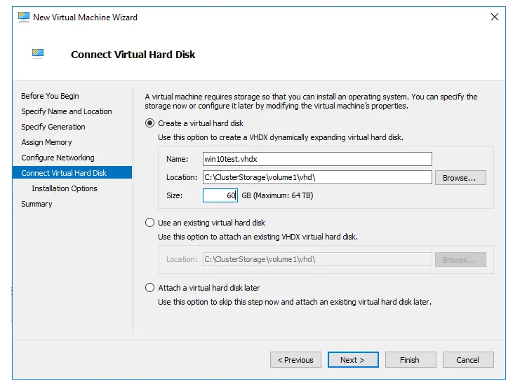[7]
Once completing these steps a summary will then be given in which the administrator will then simply finish.
By finally implementing these failover clusters, the networks will be provided will a better defence against technological failures, whilst also providing automated recovery methods if such failures occur [8]. The Hyper V role is vital as it will reduce any downtime on the Virtual machines [7]

Network Policy for an Enterprise Network

To be able to construct a network policy, the administrator must first know the constraints of what they are constructing it for. An enterprise network that has both physical and virtual networks and protocols that are there to connect users and systems that are connected on a Local area network [9]. The first thing to consider would be the topology of the network that would look something like the image below.
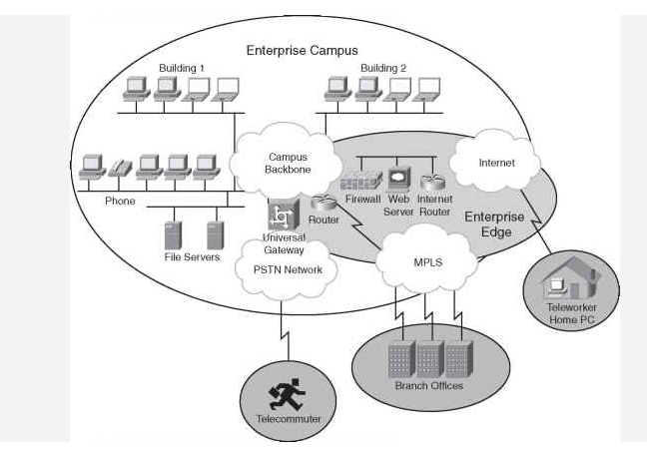 [10]

As shown, there are multiple connections made. This means that the administrator should first divide the network into appropriate areas. The Enterprise campus will include any devices or connections within the main area of business. Outside the edges of this area would be any connections that are made remote access. These could include additional branches in multiple locations or any remote data locations [10]. The use of Dynamic Host Configuration Protocols will be essential so that the default IP address is configured properly.
Regulating who can access said network is vital. With this being said a recommendation would be to instal a network policy server (NPS). This would allow for multiple network policies to be configured. The NPS will then verify whether any connections then meets the rules and policies of which the NPS has set out. A way of verify a users credentials would to then deploy a Remote authentication Dial in User service [11].
Ensuring that a security team is employed will mitigate some risks against said network. These could be Network Security Teams, these would deal with cyber attacks. They will identify systems and protocols to handle these attacks, whether these be through malware or viruses. These Network Engineers would also monitor the network for any activity deemed suspicious. These could then provide a cyber attack analysis. The engineers would simulate attacks and conduct testing on the penetration of the network. From this, patterns and any possibilities of vulnerability can then be identified [12].
Enforcing said security polices can come in many ways, some of which include:
- Password policy – Ensuring that there is a standard in which to create strong passwords, the frequency of password changes.
- Account management – setting out standards for the administration of accounts. This could range from the creation to the rights of access given to the removal of accounts.
- Emails – ensuring that the company has a way of receiving and sending emails in a secure way. Give the employees ways in which to report any suspicious emails.
- Clean Desks – Ensure any confidential information or information that could corrupt the network is protected from anyone with malicious intent.
- VPN acceptability – create standards to which anyone that is trying to connect to the Network must adhere to. This can be done via network policy servers and authentication protocols.
- Monitor and audit system – this will allow the administrator to determine whether and inappropriate or malicious activities have taken place [13]
Analysing the security risks will help ensure that the networks security is one step ahead of any attacks or defects. First the administrator must Determine the value of the information available. An assumption here would be that the company are dealing with highly confidential customer information. Identifying any cyber threats would then ensure you can pre-empt any problems. These may not just be from cyber attacks but natural disaster, failures of systems or human error. Next would be to identify any vulnerabilities, this would consist of knowing the threats the network might face, ensuring a high level of training has occurred to reduce human error and reducing accessibility to things such as command prompts, control panels and any software installations.
Analysing the controls will then reduce the threat of attack. Using encryption and detection methods will ensure this is carried out. Finally calculating and prioritizing the risks can then be done one the cost and value if the network is corrupted. Ensuring these areas are then properly protected [14].

Reflection
On reflection to the tasks completed, again as before working in a team that contained people from multiple disciplines really helped enforce the lessons that were being taught. Having 2 Students on the team from a Network Operating background ensured that any trouble shooting to get through the work sheet was completed. They were also able to explain why it was important to do certain things and why we were getting errors when carrying out certain tasks.
Being able to successfully configure user environments and managing and network resources has ensured I have been left with an extensive knowledge in the subject. Finally learning about the security of said networks has opened my eyes to the threats on networks and how to mitigate said threats.

References

[1] | Microsoft, “Group Policy Management Console,” 31 05 2018. [Online]. Available: https://learn.microsoft.com/en-us/previous-versions/windows/desktop/gpmc/group-policy-management-console-portal. [Accessed 02 05 2023].
[2] | Microsoft, “About the Group Policy Management Console,” 31 05 2018. [Online]. Available: https://learn.microsoft.com/en-us/previous-versions/windows/desktop/gpmc/about-the-group-policy-management-console. [Accessed 03 05 2023].
[3] | A. K. Linda Rosencrance, “Group Policy Object (GPO),” TechTarget, 2022. [Online]. Available: https://www.techtarget.com/searchwindowsserver/definition/Group-Policy-Object. [Accessed 03 05 2023].
[4] | Microsoft, “Failover Clustering in Windows Server and Azure Stack HCI,” 02 11 2022. [Online]. Available: https://learn.microsoft.com/en-us/windows-server/failover-clustering/failover-clustering-overview. [Accessed 03 05 2023].
[5] | A. Chola, “Understanding Failover Clustering: 6 Important Aspects,” 19 05 2022. [Online]. Available: https://hevodata.com/learn/failover-clustering/. [Accessed 03 05 2023].
[6] | Paper Cut, “Microsoft Failover Cluster Manager (MSFCM) on Windows server 2012/2016,” Paper Cut, 2022. [Online]. Available: https://www.papercut.com/help/manuals/ng-mf/common/cluster-server-2012-2016/. [Accessed 03 05 2023].
[7] | Nakivo, “Hyper-V Cluster Setup on Windows Server Machines: A Step-by-Step Guide,” Nakivo, 20 06 2022. [Online]. Available: https://www.nakivo.com/blog/hyper-v-cluster-setup. [Accessed 03 05 2023].
[8] | T. G. Mesevage, “What Is Failover?,” Datto, 26 06 2019. [Online]. Available: https://www.datto.com/blog/what-is-failover. [Accessed 03 05 2023].
[9] | VMware, “What is enterprise networking?,” VMWare, [Online]. Available: https://www.vmware.com/topics/glossary/content/enterprise-networking.html. [Accessed 03 05 2023].
[10] | Cisco, “Guidelines for Creating an Enterprise Network,” 11 12 2022. [Online]. Available: https://www.ccexpert.us/network-design/guidelines-for-creating-an-enterprise-network.html. [Accessed 03 05 2023].
[11] | Microsoft, “Network Policies,” 29 07 2021. [Online]. Available: https://learn.microsoft.com/en-us/windows-server/networking/technologies/nps/nps-np-overview. [Accessed 03 05 2023].
[12] | S. Taher, “Network Security Roles and Responsibilities,” 28 02 2023. [Online]. Available: https://shorelight.com/student-stories/network-security-roles-and-responsibilities/. [Accessed 03 05 2023].
[13] | M. Prokopets, “The Ultimate Manual for Network Security Policy,” 2022. [Online]. Available: https://nira.com/network-security-policy/. [Accessed 03 05 2023].
[14] | Data Flair, “Cyber Security Risk Analysis and Assessment,” [Online]. Available: https://data-flair.training/blogs/cyber-security-risk-analysis/. [Accessed 03 05 2023].

