

UNDERGRADUATE DISSERTATION
RESEARCH PROPOSAL FORM

Please complete the following research proposal and submit it to Turnitin.
Please get rid of the red writing for your final submission.

NAME: Geraint Lewis | STUDENT ID No.: 1922424
RESEARCH TITLE QUESTION:

“How road related deaths and serious injuries are caused in Wales between 2020 - 2022 and the impact it has on the Police and Ambulance service attending”.

INTRODUCTION:

Front line officers have first–hand experience of the large impact that road-related serious injuries and deaths have on the communities, the police, and the ambulance service attending. It is important to raise awareness of incidents and by doing so, proactively reduce the number of road-related deaths and serious injuries in Wales.

Research from (Sats Wales, 2022) shows that during the year 2020, 26 people were killed and 106 persons were seriously injured on South Wales roads. These statistics can be seen on the graph which has been provided by (Stats Wales, 2022). See appendix A.

Despite these figures further research from (UK Parliament, 2022) shows that during 2020 there was a thirty five percent decline in the number of car occupants killed or seriously injured on the roads of South Wales when compared to 2019. However when compared to the number of cyclists killed or seriously injured there was an increase of six percent. See chart - Appendix B.

A recent article by (Dowrick, 2022) states that a male and female who were both 19 years of age have been killed in a road traffic collision in Swansea, South Wales. (Dowrick, 2022) also states that the other two passengers within the vehicle were taken to hospital with what has been described as serious injuries. Following this incident, a recent article from (Dowrick, 2022) highlighted the negative impact this incident had on the communities stating that a minute of silence had been held in the memory of those who were killed in the incident. Councillor Lyndon Jones stated how the incident had shocked both himself and the local communities.

A further article from (Police Federation, 2020) stated how roads policing officers were suffering from mental health as a result of dealing with such incidents.

This shows road related serious injuries and deaths have a significant impact on communities and the emergency services. This research will show the main causes for serious and fatal traffic accidents in the South Wales area, and if the current approach taken by South Wales police for example working with multi agencies, is proactively reducing statistics and saving lives on the roads of South Wales.

From this research the aim is to raise the readers awareness of the severity of the number of the causes of road related injuries and deaths that have occurred in Wales between 2020 – 2022. This will be implemented by gathering analytical data whilst providing suggestions on how we can take a further proactive approach to reducing the number of serious injuries and deaths caused on the roads of South Wales.

SUMMARY OF RESEARCH OBJECTIVES:

The authors objectives are to raise the readers awareness of the causes of road related injuries and deaths that have occurred in the South Wales area between 2020 - 2022.

To identify the importance of working closely with multi-agencies to reduce the number of serious injuries and deaths on the roads of South Wales.

To identify further ways of reducing road related serious injuries or deaths on the roads of South Wales.

Clarify the information you want to collect on your research topic in the form of two, three or four key objectives.

The key objectives of the research are to gather analytical data relating to the amount of road related serious injuries and deaths that have occurred between 2020 – 2022 within the South Wales area.

The gathering of further research through the study of books, online journals and articles.

To gather data regarding the impact such incidents have on the police and the ambulance employees attending. This will be done by providing a questionnaire to the employees of South Wales Police and partner agencies such as The Welsh Ambulance Service.

LITERATURE REVIEW:

From carrying out research of online articles, media articles, and journals, a study was carried out during March 2010 by (Clarke, Ward, Bartle, and Truman, 2010, p. 167). The purpose of this study was to examine statistics of fatal road traffic collisions. The statistics in this report was limited as it only covered road related fatalities and not serious injuries or its effects on the emergency services attending.
The research concluded that young drivers aged 20 years or younger were almost twelve times more likely to be involved in a fatal accident than that of an older driver. The risk continued to decline with the increase of age until the driver reached an age of sixty five where the risk began to increase.
However further research by (Rolison, 2020, p.1 ) shows the importance of police statistical data when recording the number of road traffic collisions and its causes within the UK. The research also identified there to be some discrepancies in the statistical data provided by police which in turn can result in inaccurate figures.
The research being carried out aims to gather up-to-date statistics of road traffic collisions in Wales that have resulted in serious injury, or fatality. To date the statistics for the year 2022 have not been released. This is where the gap is for the current research as it does not yet exist. Once these statistics have been gathered it will be compared against the statistics over the past two years. This will evidence if there has been an increase or decrease in the number of fatal or serious road traffic collisions in Wales, and if any factors played a significant part in the cause of the incident. This will show who are the most vulnerable on the roads of Wales, what age group are most likely to be involved in a serious or fatal collision, and if drink or drug driving plays a significant factor in this. It also aims to show the impact such incidents have on the emergency services attending such as post traumatic stress disorder (PTSD) and resource management.

SUMMARY OF RESEARCH –SURVEY METHOD:

The author will gather analytical data from the roads policing unit and serious collision investigation unit within Wales. This will assist the author in the collection of accurate data on the number of road related fatalities and serious injuries in Wales between 2020 - 2022.

Further research through online journals and articles will assist the research with an academic approach. Whilst further gathering of data by the means of submitting a questionnaire to employees of South Wales Police and multi-agencies such as employees of the Welsh Ambulance Service. This will assist the research and allow a comparison of data collected.

SUMMARY OF SAMPLING FRAMEWORK:

To conduct the research the author will be seeking input and speaking with experts based in the Roads Policing Unit and Collisions Investigations Unit within South Wales Police. This will be the best approach as they will be experts in the area that will be able to provide analytical data.

Questionnaires will be sent to employees within South Wales Police and partnership agencies to gather perspectives of the impact such incidents have on the emergency services such as levels of resourcing and long-term conditions such as Post Traumatic Stress Disorder (PTSD).

ETHICAL ISSUES:

There are potential ethical issues surrounding this piece of research. This could include the accuracy of the data that is collected. Also if the researcher was to ask for expert opinions this could have a contradictory outlook on the other data that has been collected. There is also the risk of causing some distress when asking questions around PTSD, as if there is a person with this condition it might be difficult subject for them to talk about openly.

TIME SCALE:

Proposal form to be completed and submitted by 15/08/2022
Ethics Form to be completed and submitted by 15/08/2022
Literature Review to be completed and submitted by 24/10/2022
Research methods chapter to be completed and submitted by 05/12/2022
Analysis of results chapter to be completed and submitted by 23/01/2023
Findings chapter to be completed and submitted by 27/02/2023
Final Dissertation to be completed and submitted by 27/03/2023

REFERENCE LIST:

Clarke, D. Ward, P. Bartle, C. Truman, W. (2010) ‘Killer crashes: Fatal road traffic accidents in the UK’, Accident Analysis and Prevention, 42 (2), pp. 764 – 770. Available at: https://www-sciencedirect-com.ezproxy.uwtsd.ac.uk/science/article/pii/S0001457509003091 (Accessed: 15 July 2022).
Dowrick, M. (2022) ‘Beautiful floral tributes laid after two people died in crash’, Wales Online, 2nd June 2022. Available at: https://www.walesonline.co.uk/news/wales-news/floral-tributes-laid-after-crash-24131979 (Accessed: 15 July 2022).
Dowrick, M. (2022) ‘Two 19 – year – olds killed and two more rushed to hospital after car crashes into petrol station’, Wales Online, 1st June 2022. Available at: https://www.walesonline.co.uk/news/wales-news/two-19-year-olds-killed-24119208 (Accessed: 15 July 2022).
Police Federation (2020) Trauma Build Up Can Destroy Officers. Available at: https://www.polfed.org/news/latest-news/2020/blog-trauma-build-up-can-destroy-roads-officers/ (Accessed: 14 July 2022).
Rolison, J. (2020) ‘Identifying the cause of road traffic collisions: Using police officers’ expertise to improve the reporting of contributory factors data’, Accident Analysis and Prevention, 42 (2), pp. 1. Available at: https://www-sciencedirect-com.ezproxy.uwtsd.ac.uk/science/article/pii/S0001457519311650 (Accessed: 15 July 2022).
Stats Wales (2022) Record road accidents by severity and area. Available at: https://statswales.gov.wales/Catalogue/Transport/Roads/Road-Accidents/accidents/roadaccidents-by-severity-area (Accessed: 15 July 2022).
UK Parliament (2022) How were road accidents and traffic affected by lockdowns in 2020? Available at: https://commonslibrary.parliament.uk/how-were-road-accidents-and-traffic-affected-by-lockdowns-in-2020/ (Accessed 15 July 2022).

Appendices

Appendix A

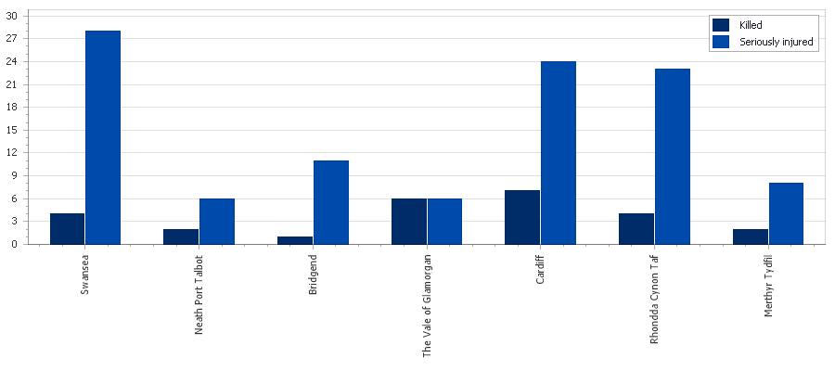

Appendix B



