
Wifi penetration testing
WEP, WPA, WPA2

Project submitted as part of the requirements for the award of BSc (Hons) Cloud Computing
Supervisor: Paul Willin.
November 8, 2017
mASROOR KHAN
UNIVERSITY OF WALES TRINITY SAINT DAVID

Declaration of Originality

I, Masroor khan declare that I am the sole author of this project; that all references cited have been consulted; that I have conducted all work of which this is a record, and that the finished work lies within the prescribed word limits.

This work has not previously been accepted as part of any other degree submission.

Signed: .....Masroor Khan.........

Date: .....08/11/2017..................

Form Of Consent

I, Masroor khan hereby consent that my Project, submitted in candidature for the B.Sc.(Hons) Cloud computing degree, if successful, may be made available for inter-library loan or photocopying (subject to the law of copyright), and that the title and abstract may be made available to outside organisations.

Signed: ......Masroor Khan...........

Date: .....08/11/2017............

Acknowledgements

I would like to give glory to God for the gift of life to complete this work and thanks to those who have supported me during these three years of study I’d like to thank my family and friends for all the encouragement during this time. Without them, I would not have made it this far.

I would like to thank my fellow students who have pushed me to my best over the past three years. Finally, I would like to thank my teachers for the support and guidance during my time of the study.

Copyright Acknowledgement

I acknowledge that the copyright of this project report, and any product developed as part of the project, belong to University of Wales Trinity Saint David, London.

Abstract:
This project is about the exploring and testing the vulnerabilities in wireless networks that are being used in the modern age to connect the wireless devices. The WPA/WPA2 security standard are investigated to reveal the weak points in network security. The WPA pre-shared key system offers a possible weakness to attack the system. Dictionary attack on WPA/WPA2 protocol and comparison with a more complex password, cracking the password hashes using the GPU’s and CPU’s, the practical chapter contain the screenshot of the process for better understanding. The summary of previously completed projects on this topic by other students from different universities is the part of this report for better understanding of this project. The cyber-attacks and how its related to Wi-Fi networks also explanied. At the end, the findings of this project practical work clearly stated that even making the small changes of the characters will add hours and hours into cracking process. Wi-Fi is radio signal and radio signal can be received in the given radius with using right equipment’s and tools, which make the question mark on Wi-Fi security but implementing the right security measure and regular update always give user a peace of mind.

Chapters Briefing

- Chapter 1:
Contains the brief introduction of Wi-Fi and the project aims and goals
- Chapter 2:
In the second chapter, the detail literature review of wireless protocols and existing work of this topic is been discussed.
- Chapter 3:
Under the chapter 3, the practical work carried out all experiment and results are explained with screenshots.
- Chapter 4:
Contains the summery of work, final wording and the evaluation.

Contents
Declaration of Originality 1
Form Of Consent 1
Acknowledgements 2
Copyright Acknowledgement 2
Abstract: 3
Chapters Briefing 4
Figure Table 6
Chapter 1 7
Overview: 7
Introduction: 7
Aims and Goals: 7
Time plan: 8
Project Type: 8
Introduction of IEEE 802.11 8
Chapter 2 9
Literature review 9
WEP 9
WEP Cons: 9
WEP Pros: 9
WEP attacks: 9
The FMS Attack: 9
Chop Chop Attack: 9
The PTW attack: 10
WPA: 10
WPA Weaknesses: 10
Data integrity attacks: 10
Pre-shared Key Attacks: 10
Rivest Cipher 4 Attack (RC4): 11
The Hole196 vulnerability: 11
WPA DoS: 11
De-authentication flooding: 11
RF Jamming: 11
WPA2: 12
WPA2 Attacks: 12
DoS on WPA2: 12
Weaknesses: 12
Portable Wi-Fi Jamming Device: 12
How it works: 13
Network Protection Tools: 13
Wi-spy Dbox: 13
Cisco Wireless Control System Planning Tool: 13
Cyber-attack: 13
How its related to Wi-Fi: 13
Existing work : 15
Chapter 3 16
Case study: 16
Practical: 16
WPS attack: 16
How the reaver works: 16
WPA/WPA2 handshake attack (GPU): 20
How it works: 20
WPA Handshake (CPU) 23
Recommendations: 25
Chapter 4: 26
Evaluation 26
Future works: 27
Conclusion: 27
References 28
Appendix: 30

Figure Table

Figure 1 Router Settings 9
Figure 2 WPS setup 9
Figure 3 ifconfig 10
Figure 4 Monitor mode enabled 10
Figure 5 wash scanning WPS 11
Figure 6 reaver started 11
Figure 7 reaver response 11

Chapter 1

Overview:
Wi-Fi is the easy and reliable way to communicate with other devices and connect with internet access point wirelessly within the signal range. Usually, Wi-Fi devices have some authentication methods to avoid unauthorized access unless it's turned off by the administrator. Authentication methods include a pre-shared key or login details etc. Wi-Fi enabled hosts to convert energy into waves to transfer the packet to connected devices or broadcast SSID if the hosts are connected to the internet the connected devices (clients) start using internet thorough connected host. Since the radio waves travel in open air so a hacker can easily see that and break the key, making wireless network secure is much important. Penetration testing of wireless protocols can reveal the security flaws and let admin know the weaknesses of their network.

Introduction:
The first wireless product was invented in 1991 by NCR Corporation with AT&T corporation named as WaveLan, WaveLan were intended to use in cashier system. This system considers as a precursor of WI-FI protocols. In 1997, the first official version of 802.11 was released and the user can get a max transfer rate of 2Mbit/s. After 2 years, this was upgraded with new protocol 802.11b that’s give 11Mbit/s with the secure connection as compared to previous one and get popular among users. [1] Wi-Fi alliance formed a trade association and holds the trademark of Wi-Fi in 1999. Australia engineer took credit to invent this game-changing product. [2]

Aims and Goals:
The main aim of this project is to test and measure famous Wi-Fi protocols and the critical evaluation of available security measures for implementation. The attacks will be carried in lab in the safe environment
The goals are:
- To set up a lab which able to carry out tests in a safe environment.
- To test the Wi-Fi encryption techniques and identify relevant exposures. The attacks will try carry outs are:
- WPA/WPA2 key crack
- Brute force attack
- DoS (deauth packets)
- To compare the encryption level of the above tests and list out the suitable one (base on project outcome).

Methodology:
The working methodology for this project is the literature review and the personally collecting data from solo practical is being discussed and used.
The waterfall model of work was implemented to complete the task one by one and avoid any confusion, below is the time plan which help to understand the waterfall model as well.

Time plan:
This is certain that every successful project has a proper time plan and working order, to make sure this project finish on time the time plan is below.
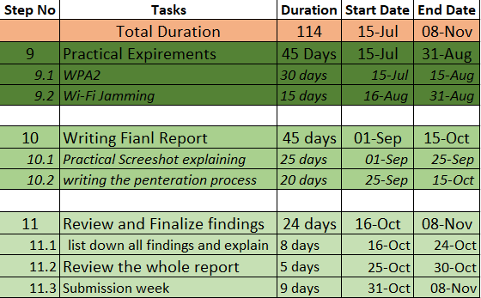
Figure 1 Time Plan

Project Type:
This is an experimental based project, no ethics research is been done.

Introduction to IEEE 802.11
“IEEE 802.11 is a set of media access control (MAC) and physical layer (PHY) specifications for implementing wireless local area network (WLAN) computer communication in the 900 MHz and 2.4, 3.6, 5, and 60 GHz frequency bands”. [3]
After that, there were many other standards announced by IEEE, for defining the communication between two wireless-enabled devices the name of the standard is IEEE 802.11x.

Chapter 2

Literature review

WEP
WEP stands for Wired Equivalent Privacy. WEP is a security protocol that specified by IEEE as Wi-Fi standard 802.11. It's designed to provide secured Wi-Fi LAN as wired LAN. [4] WEP built on RC4 Encryption algorithm based on 10 hexadecimal that’s 64-bit or 26 hexadecimal that’s 128-bit. [5]. IEEE 802.11 standard gain popularity due to its cost-effectiveness and easy deployment, people start using the hotspot in many public places as well as residential and offices. IEEE 802.11became one of the world largest deploy wireless network.

WEP Cons:
This algorithm has many weaknesses which make WEP an insecure way to connect to the network. In sense of some major disadvantage of using WEP, this algorithm is bit old these days weakness of WEP allows attacker to crack his keys in minutes using readily software’s like “WEP-Attack” and “Fern-WIFI” because WEP use shared key authentication and keep sending his keys with data packets, so every data packet contains the pre-shared key of the network. [6]
Another big disadvantage of using WEP is its big headache for network admin after changing master key it will have to be changed manually on all connected devices.

WEP Pros:
Well after every cons there are some pros as well which make WEP famous and useful back in years. Using WEP security protocol when users see the key requirement its discourage them to connect to the network, this tells the user he’s not authorized on this network unless until he provided the key. [6]
Every wireless device supports the basic encryption of WEP, this can be handy if you try to connect any old device with Wi-Fi.

WEP attacks:

The FMS Attack:
WEP attacks all start with IV’s, after getting about 60 IVs attacker can redirect the packets to get full key successfully.
The FMS attack released in 2001 by Fluhrer Mantin and Shamir, [7] it’s a statistical attack that uses the RC4 weaknesses. The attacker first gets the IV, IV is three bytes of the key per packet. If four our more than four conditions match manipulation of RC4 allows the system to guess the byte of the key. Using vote system, the full key can be guessed and test against the authentication system, [8] if it’s not correct another key can be guessed and this continues. The packet requirement for this attack is 6,000,000 to achieve 50 percent of success [7]

Chop Chop Attack:
The chop attack focuses on design flaws in WEP protocol. The weakness of crc32 and checksum and the replay protection. using chop chop method attacker can access the packet without knowing the key, its decrypt the packet after eavesdropping then modify the packet and inject the packet back into the network to generate more traffic and get more information from the network to attack full key recovery attack. Chop chop attack flips the value of CRC32 packet into text and flip back again to keep the validity of packet and then guess the last byte of the packet. This is an ARP type attack. [8]

The PTW attack:
In 2007, PTW practical attack was launched by Tews, Weinmann and Pyshkin. [9] This method of attack has two new concepts in attacking strategy.
- “All previous correlations used required 2-4 values in S not to change during the remaining RC4-KSA.” [9]
There are many other conditions should be freeze to use this connection, not every packet used to vote for certain key byte. [10]

- Secondly, attack structure has been changed before key recovery attacks had a tree-based structure which decides and fixes byte per byte. [9] [10]

WPA:
WPA stands for Wi-Fi Protected Access. In 2003 Wi-Fi alliance bring the new security protocol named as WPA (Wi-Fi Protected Access). This is a big development in Wi-Fi security system it's basically invented to tackle the serious weaknesses in WEP protocol. WPA system refers to IEEE 802.11. [11]

WPA Weaknesses:
According to Guillaume Lehembre, WPA/WPA2 has minor weaknesses in their system although these are not very serious. [12] The question is that statement make WPA faultless and unbreakable?
We will exam the security protocol of WPA and WPA 2 using real-world scenario to check if users really can rely on wireless networks.
WPA mainly focus on two mods how payload can protect during transmission and temporal key integrity protocol. [9] TKIP was designed by IEEE802.11i protocol.

Data integrity attacks:
Data integrity attacks have extreme risk and revelation in many real-world environments, this attack can go undetected and open the confidential data through without leaving footprints. Attackers used passive monitoring and dictionary attack against pre-shared key mode. Rivest Cipher 4 algorithm for packet encryption can be attacked. [13]

Pre-shared Key Attacks:
Organizations often use pre-shared keys for authentication, despite using strong encryption techniques. PSKs passphrase usually recommended for home networks or the organizational guest networks. [14] The risk involved in this method is as name resembling its shared secret and one or more users already known. This risk can be handled if passphrase changing set periodically, but its require man force, with this authentication method both client and access point try to verify the PSK without revealing the passphrase information. This process named 4-way handshake. Both client and AP compute PMK (Pairwise-master-key) from the PSK passphrase and the access point SSID, which is then used as a basis to figure the rest of key exchange data. [14]
Another attack on WPA was known as a pre-shared key dictionary attack, this attack used to determine the pre-shared key using common passphrase list. On the users who have their network passphrase form dictionary words and using less than 20 characters this type of attack might succeed. Actually, in this attack, attacker run the long list of words using a known algorithm to generate the pairwise-master-key, then its combine the passphrase SSID length into a string that has been hashed 4096 times. This key usually based on the 256-bit number or a pass-phrase 8 to 63 bytes long. [12]

Rivest Cipher 4 Attack (RC4):
RC4 was originally designed by Ron Rivest in 1987 Security and known as Ron’s Code while he’s working for RSA. [15] In the field of cipher writing rivest cipher 4 also named as ARC4 or ARCFOUR. RC4 is a stream cipher. RC4 known for its simple programming and the swiftness. There are vulnerabilities found in this protocol which lead this cipher towards insecurity. [16]. One of the vulnerability is at the start of the output keystream is not cast-off, or when random keys are not being used. Grim uses of RC4 ran towards very insecure protocol like WEP. [17]. Fluhrer, Mantin and Shamir exam the RC4 and found that the first few bytes of keystream based on patterns which allow detecting the information about the key that been used for encryption. [16] In WPA algorithm increased the Iv for RC4 to 48-bit, and randomly generate the new key for each packet that sent, and cut-off the initial bytes of keystream before using it. [13]. Later some new version of RC4 being announced with more strong encryption method named as RC4 A, and RC4B [15]. Although later version came with add security but using same basic method for encryption so RC4 attacks still useable.

The Hole196 vulnerability:
This vulnerability found by Sohail Ahmed in 2010. Mention on page 196 of the standard paper about 802.11 protocols. This is not really a key recovery attack but it allows the user to bypass the security method and directly connected to a network and became an unauthorised user of the network. Basically, the first attacker forces the connected clients to update their ARP tables by sending ARP request with Mac-address and the IP-address of the access point. So legit clients start sending packets to attackers mac address, attacker receive the packet decrypt them and again encrypt them into own key and forward them to access point, this is kind of man-in-the-middle attack as well because of attacker able to read the packet data as well. This method normally works because of fake packets in shared group key GTK. This vulnerability exploits the WPA2 systems as well. [18] [7]

WPA DoS:
Denial of service attack is a famous attack on the services where certain services or the whole system being unavailable to legit users. This can be possible by many ways, for example jamming wireless signal or sending wireless router authentication request with spoof packets. [19]

De-authentication flooding:
WPA has a vulnerability to shut its self-down whenever its detect two packet forgeries from client to access point within the one-second window. [13] In the self-shutdown process the access point disconnect all the users and delete encryption keys, wait for some seconds and then try to reconnect the clients this allow an attacker to get entry into the network and start sending forging packets to access point. If the attacker increases the rate of recurrence of these packets the access point became unavailable for the clients. This attack is known as De-authentication flooding attack.
This attack can be defeated up to a certain extent if WPA routers configured with access control list (ACL), this allows the access point to connect only valid clients, again this solution admin work to add mac address into access control list.

RF Jamming:
Radio Frequency (RF) jamming is an old-fashioned denial of services attack, in world war 2 this method been used to disturb the wireless communication between aeroplanes. [20] Wi-Fi routers use radio frequency band to communicate between devices and its open band so using radio signal jamming devices Wi-Fi signals can be disrupted.
Although this is not possible in all situations, for example, open area networks like a train station or coffee shops this attack can be prevented if the perimeter of the service area is secured. [13]
There are many other attacks which can be performed on WPA network like eavesdropping where attacker listen to the packets on the network (using different tools like Wireshark). Impersonation attack as well where access point force to send false routing information to the clients. [21]

WPA2:
WPA2 is updated version of WPA stands for Wireless Protected access 2. WPA2 is also referring to 802.11i standard. WPA2 has new encryption scheme called AES (advanced encryption standard) which operate on 128-bit cipher which is more secure then rivest cipher 4 because it encrypts the packets using 128, 192 or 256 bits. [13] [11]
In WPA2 there are some extra security checks added which include CCMP, CCMP has had a programme to rotate the key and take care of message integrity checks (MIC). To keep WPA2 security and encryption level more secure CCMP calculate the MIC on each packet using the algorithm called “cipher Block Chaining Message Authentication Code” (CBC-MAC) [13]. Using a different key for each packet and signal bit produce different MIC making WPA2 stronger than previous protocols.
WPA2 operate on two modes enterprise and personal, in personal mode is required to use the pre-shared key method to authenticate a user and does not require every user to authenticate separately. The enterprise mode operates on an 802.11x authenticating method which requires every user to authenticate separately.

WPA2 Attacks:
Just configuring the WPA2 on the system is not making the unbreakable there is still weakness in WPA2 which can be exploited. Exploiting the weak passphrase is a most common attack on the WPA2 system. This attack can be performed offline after capturing the handshake packets and decrypt them against dictionary attack or making a combination of words and characters, although this requires plenty of time and processing resources. [7] [18]

DoS on WPA2:
Unfortunately, WPA denial of service attacks also works on WPA2 networks, for example, RF jamming and data flooding etc it’s because all Wi-Fi standards work on layer 2 or above, dealing with access point failure is not incapability of Wi-Fi standards. [22]

Weaknesses:
Management frames are not protected, these frames report about network topology and client behaviour, so the attacker can guess the layout of the network and perform DoS more efficiently. Packets Deauthentication can be performed which force user to re-authenticate with the access point.
As compare to WPA, WPA2 has one more disadvantage its need more processing power to secure the network. This mostly affects the older access point.
IEEE 802.1w developed in March 2005 and its responsibility is to protect the management frames in wireless networks. This ability to spot the spoofed management frames and drop them from the network.

Portable Wi-Fi Jamming Device:
As per UK law jamming any radio signal is illegal and producing and using such kind of device is not permitted as well until unless authorized by Ofcom. [23]
The purpose of developing a raspberry pi portable Wi-Fi jamming device is to DE authenticate the unauthorized Wi-Fi users, for example, overloaded coffee shop Wi-Fi users or your home Wi-Fi unauthorized users.

How it works:
Raspberry Pi is a credit card size computer motherboard which can be configured for many things. In this project, raspberry pi will be used as a Wi-Fi jamming device.
After powering up the raspberry pi with attaching screen and a Wi-Fi dongle. Write an autorun script which sends deauthentication packets to target access point and make it unusable for the users.
This device can be configured as a remote link for desktop pc, for example capturing the handshake packets from a remote location and crack them on desktop pc.

Network Protection Tools:
Below are some tools which can help to secure and manage the Wi-Fi network more easily or after infected Wi-Fi network how to trace the weak part of the network.

Wi-spy Dbox:
Wi-spy is a device which can help to build the secure network as well as help to find the blind spots in the coverage area to improve the network efficiency. This device exam the RF and using its own designated application shows the results. [24]

Cisco Wireless Control System Planning Tool:
This tool help to plan and deploy the successful Wi-Fi network, this system has built-in tools to reduces the operational costs, provides the GUI interface to improve the efficiency of the network. This system uses the Cisco Clean Air technology to protect the performance of 802.11n. [25] There are some other network protection tools available in the market to avoid being a victim of Wi-Fi crack.

Cyber-attack:
Cyber-attack is an attempt by an attacker to damage and destroy the computer system and aim to steal personal information. These days computer systems are one of the major parts of our lives the modern business can’t imagine their survival without having the running computer system and they spend a fortune to keep the system alive, this is because of we human ever more dependent on the electronic information. It has made our system to vulnerable for cyber-attack. [26]

How its related to Wi-Fi:
Cyber-attack could be possible through Wi-Fi eavesdropping over an insecure network, or attacker can hack the someone’s Wi-Fi first and then use victim network to attack other computers remotely.
In case of corporate Wi-Fi network, compromise attacker can deploy RAT(remote access tool) in the servers and later can access the server remotely and make zombie computer to launch cyber-attack on another corporate network.
Wi-Fi network is like an entry point to a secure network protection of the Wi-Fi network make sure that attacker has not easily got access to a network.

Existing work :
In the Turku university, applied sciences student Gbolahan Ola did penetration testing on a wireless network in 2013. [27] In his thesis the starting is form basic testing level of Wi-Fi network, which include installation of required application and hardware system and then move to testing phrase where author able to capture network packets and analyse through Wireshark, capturing packets make secure network a bit weak because after de-encryption of the packets the data can be revealed. While it’s come to actual WPA handshake and cracking key to gain full access to wireless network MR. Gbolahan use dictionary words to crack the passphrase using aircrack-ng. This was a successful attempt to break the Wi-Fi security but limited to dictionary words. [27]
The same kind of project completed by Martin Daniel at Aalborg University Institute for Electronic Systems as Master thesis, Martin was successful to attack WPA/WPA2 protocols and decrypt the key form handshake, Martin mainly focuses on combining the PPU power and that was a simple processing and dictionary word. [28]
The student named L’ubom´ır ˇZa´k from the Comenius University, Bratislava test the WPS on different organizations and in the local lab back in 2012, in the result table the author successfully wrote the minutes it took him to be successful in WPS attack. [29] after attempting the successful attack on WPS vulnerability the author considers it a small threat to the organization because there are different AP having a solo connection to the internet.

Chapter 3

Case study:
To set up to a lab which has a victim access point with Wi-Fi communication 2.4Ghz and an attacker computer having a Linux installed, with GPU card to use for hashcat. The access point should support WPS in order to crack WPS key. After attacking the access point taking the screenshot and explaining the working methodology. Listed all results of practical labs and recommend the security measures.

Practical:
This section contains the information about different attacks being performed on a wireless network, and their vulnerabilities.

WPS attack:
Wi-Fi protected setup was introduced in 2006 by Wi-Fi alliance to help protect and connect the network more securely without entering long passphrases but later in 2011 one vulnerability was point out in WPS single code system which can be exploited within hours using a tool like “reaver” and “pixie dust”.

How the reaver works:
Reaver try many hard pins against the WPS pin and brute force the attack, after exploiting the sequence of the pin reaver revel the WPA/WPA2 passphrase, this attack is not very common these days because although routers still supports WPS they set to broadcast when physical button on the router is pressed, or routers locked WPS remote connection if two or more wrong pins tried. Router stetted up for WPS attack using WPA/WPA2 TKIP/AES encryption.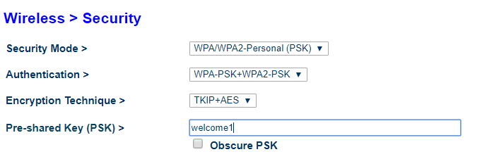
Figure 2 Router Settings
At first, try to reveal the WPA passphrase using WPS pin cracking method via reaver, this is a live attack. The WPA2 passphrase is set to a common word from dictionary “welcome1”. Above in figure 1 is the screenshot of router security settings. The router in use here is “Belkin double N+”. The Wi-Fi card attaches to the terminal is TP-LINK TL-WN722N that supports up to 150 MBPS. WPS is enabled on the particular router and enable the WPS hardware button and allow users to connect to the network using this method. and ESSID is Belkin_N+_34D7D3 which is related to BSSID 00:22:75:34:D7:D3.
Figure 2 is the screens shot of WPS setup 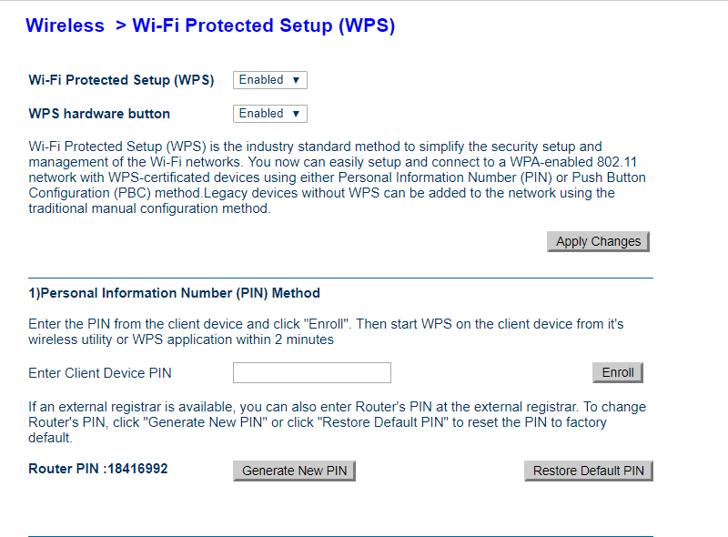
Figure 3 WPS setup
since terminal, Wi-Fi card is can be verified using “ifconfig” command as you can see in figure 3

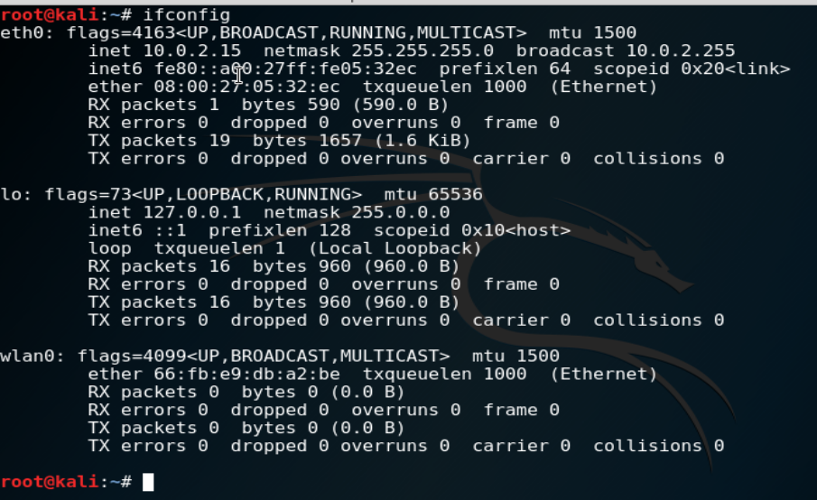
Figure 4 ifconfig
The wireless interface is named as wlan0. For seeking the available networks and make our Wi-Fi card to inject the packets interface should be transferred into monitor mode. This can be possible by using airmon-ng.
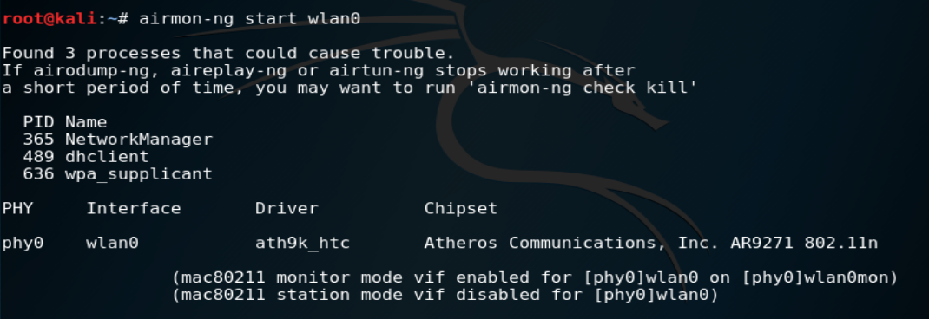
Figure 5 Monitor mode enabled
Airmon-ng start wlan0 command used to start the monitor mode, as it's shown in figure 4. Wlan0 now named as wlan0mon.
There are some services running in the background which might cause a problem in future, these services can be killed using “kill <PID number>”. This can kill all the process, DHCP client refuses to be killed which leave it as it is.

Once Wi-Fi card in monitor mode its ability to scan the WPS networks in range, the command being used to start scanning is in figure 5 below. Wash is a WPS scanning tool.
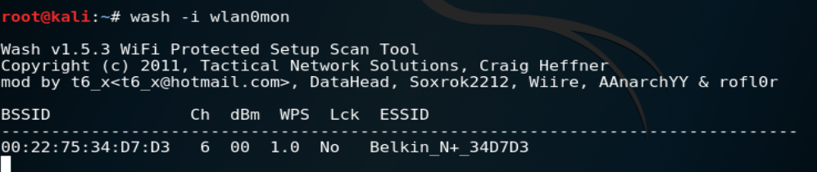
Figure 6 wash scanning WPS
As seen in figure 5 we have one available WPS network as it’s our own private lab. This network is operating on channel 6 and WPS is not locked.
At this point target access point broadcast enough information to carried out the attack. Reaver is started to attack the AP.
Figure 7 reaver started
-i = interface
-b mac address access point
-d delay in seconds before trying the next pin
-vv verbose

After press the enter its start communicating with access point shown in figure 7.
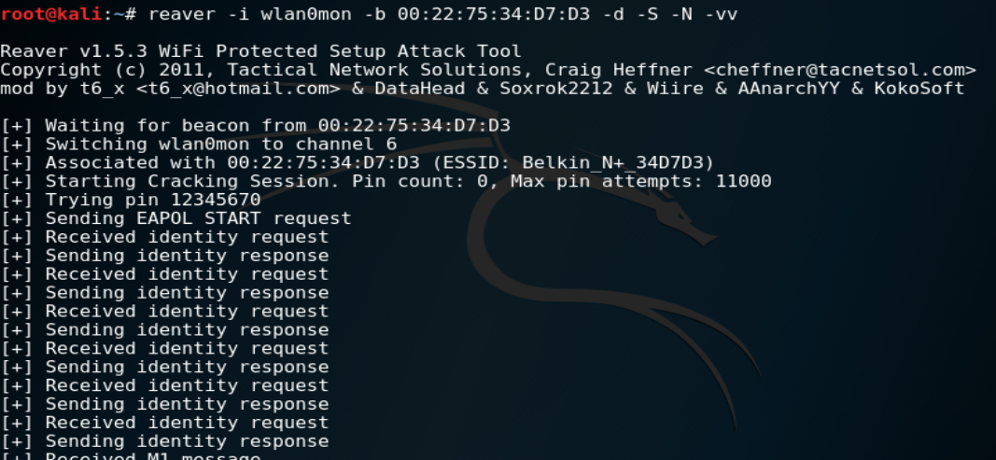
Figure 8 reaver response
After trying first sequence router blocked the WPS and refuse to identify the request. With this method, I consider this is a failed attack to reveal the pin.

WPA/WPA2 handshake attack (GPU):
To carry out further attacks the next attack in our list is handshake packets capturing.

How it works:
A dictionary attack is one of the most famous and easy attacks that can be performed on poorly design passwords of wireless networks, the success rate in a real-world environment is less. It depends on computing power and the dictionary. If this attack is successful in one area of the world probably that dictionary has zero success rate in any other language speaking zone.
In this lab, I set a common word as a network password “welcome1” . in this attack the handshake packets between the router and the already connected client will be captured and then decrypt the packets to reveal the pre-shared key. This attack will be only success full if the targeted router already has at least one connected client.
The Same lab is being utilised using same Wi-Fi cards and wireless router as mention above. To start searching for WPA/WPA2 networks.
Figure 9 airodump-ng starts

Airodump-ng search for available networks and wlan0mon is wireless interface card in monitor mode. Using this command the Wi-Fi card start capturing the available information in surroundings networks, and the screen appears similar to figure 9.

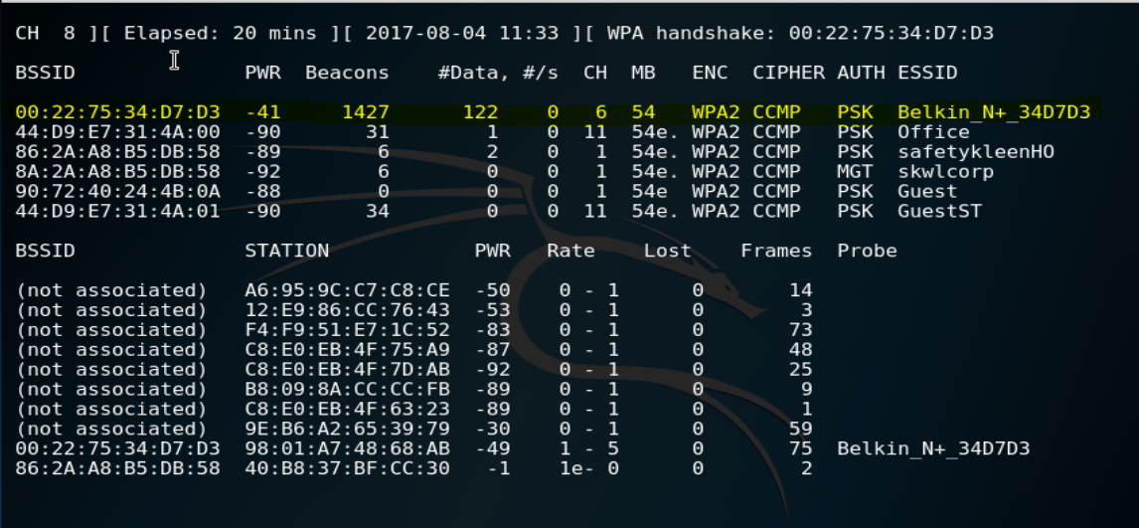
Figure 10 available wireless networks
Our targeted network is highlighted as yellow. BSSID 00:22:75:34:D7:D3 operating on channel 6, ESSID Belkin_N+_34D7D3.
Before moving to next step give airodump-ng enough time to collect beacons and data to support the process otherwise, it won't communicate. The time elapsed is 20 min and collected nearly 1400 beacons and 122 data. Beacons are the frames that periodically advertise the presence of the network.
Issuing the following command will start capturing the handshake packets.
Figure 11 handshake capturing request
-c =channel number
-w = instruction to write the local file named any
--bssid = bssid of targeted network
At the end mentioned the Wi-Fi interface name.

Now airodump will start to wait for handshake packet on given bssid either wait for any client to reconnect by itself with access point or force them to reauthenticate their passphrase with router, to speed up the process and avoid any suspicious behaviour I did reauthenticate only one client despite the fact that for testing purpose I have only one client connected with router.
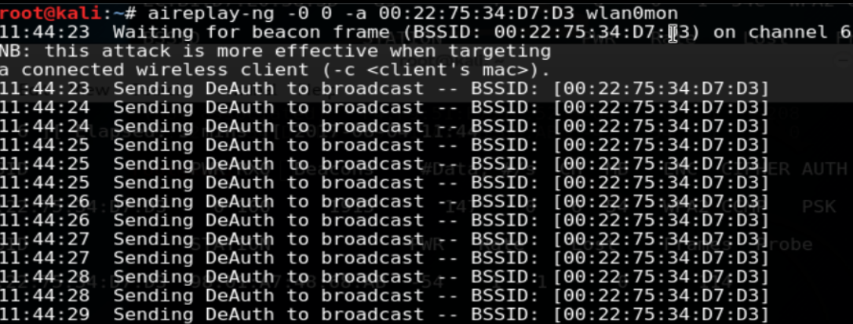
Figure 12 Deauth packets

Most routers don’t verify the Deauthentication packets, after receiving the request the access point honours it as legit packets which leave the attacker with exploitation point
After wait for few minutes, the Deauthentication attack successfully deauthenticate the client and the client reauthenticate his self with the access point, to exploit that weakness the airodump-ng process with the file name WifiMajorPro has been started.
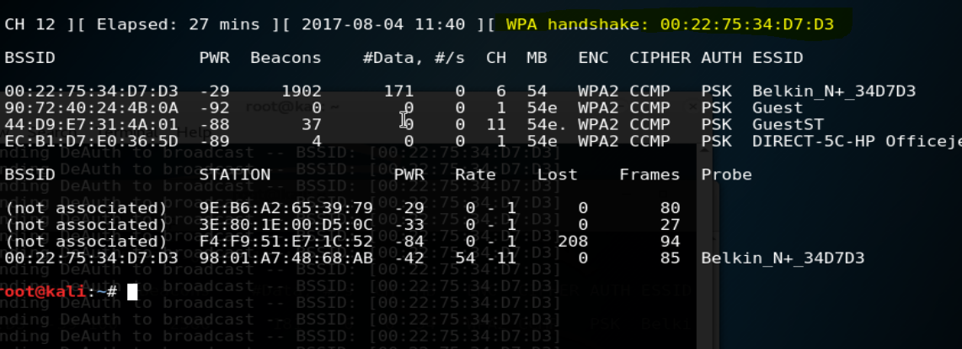
Figure 13 successfully handshake captured
With the WPA2 configuration, it took 27 mins to capture the handshake file.

Cracking the handshake file to reveal the Wi-Fi passphrase is the stressful process for the processor as it requires a lot of processing power to finish the task on time. In the modern day's computer, there are powerful video graphic cards to support up to date video requirement, the GPU is a lot faster as compared to CPU, so to crack this file the GPU is being utilized through “hashcat”.
After downloading and installation of hashcat on windows client 
Figure 14 hashcat versions

The hashcat is intelligent enough to decide to use the most powerful processor in or more than one sync for the same process from the given processors in the system. To start hashcat process below is the sequence of commands was initiated in cmd.
Figure 15 the hashcat intiating
In testing lab, windows host has a GPU processor so it's better to run this tool on cmd. The GPU was GTX 1060. After few minutes the hashcat was successful to found the key.
The running process of hashcat is below
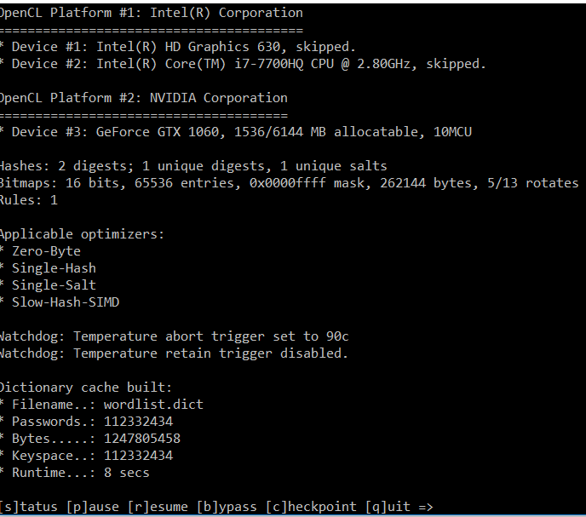
Figure 16 the hashcat started

As it's above it took only a few minutes to find the key for the captured handshake file from the given dictionary.
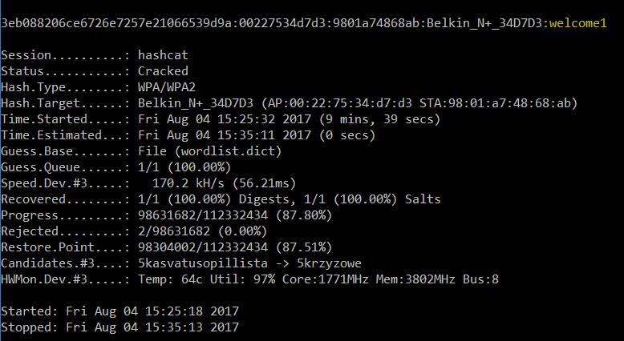
At the right corner of above picture, the captured password is highlighted with yellow.
The hashcat was run for 9 mins and 39 seconds and scan the 98304002 keys. The experiment took less than half an hour to crack the key having the simple dictionary 8 letter character, again this kind of attack is a relay on the dictionary the more vast the dictionary is the more chances to get successful and depends on different areas of the world speaking different languages.

WPA Handshake (CPU)
The changes were made in passphrase is just the rearrange the alphabet order using the same word. The passphrase is “ecoclew1”.

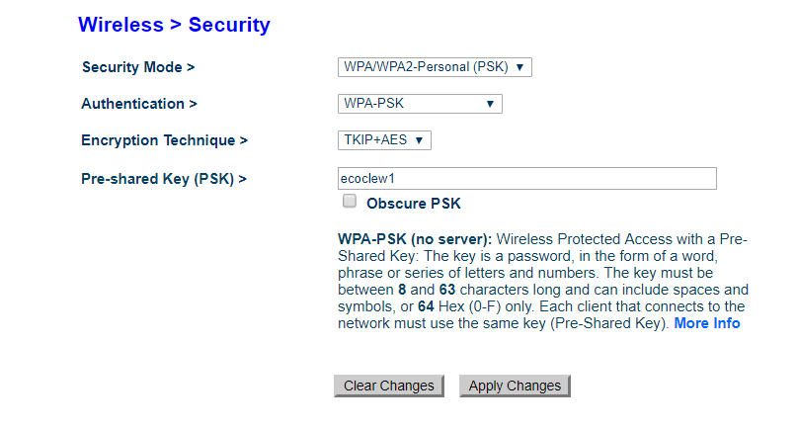
Figure 17 changing the pre-shared key

After making the changes in pre-shared key. Using the same method the handshake packets was captured and named as “wpahandshake2-01”.

Now the next is two option one is to create own powerful dictionary using crunch and then later do the dictionary attack, below is the screenshot of crunch dictionary, using mask system and keep the processing time low the matching characters with the pre-shared key is being set to create the dictionary.
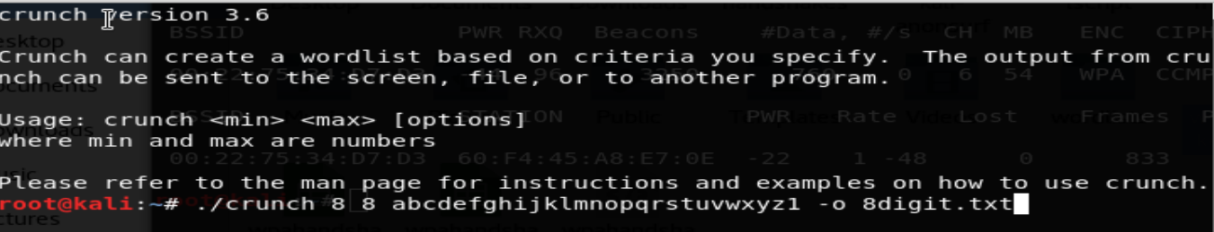
Figure 18 start crunch to create the wordlist
After hitting the enter button its start creating the huge number of words and the storage space required is around 2 TB.

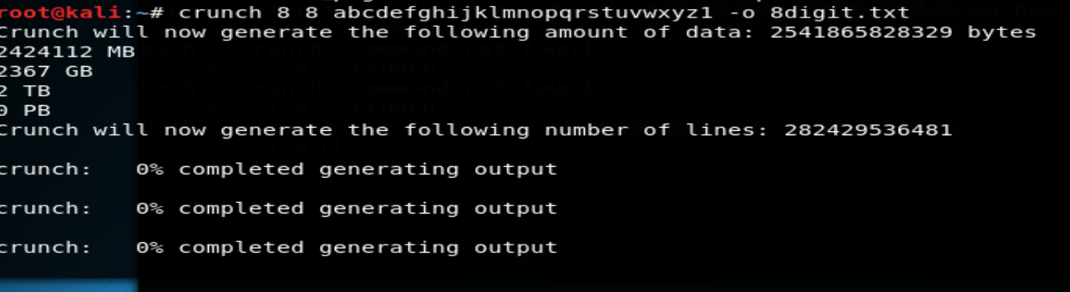
Figure 19 Crunch Process
As you can see in figure 19 The number of lines is “282429536481”. And expected required space is 2367 MB. This process needs a long time to complete and after that, the dictionary attack will take huge time to process the long word list.
The solution was to merge both tools to work together, this can save the storage requirements.
To pipe both programme “crunch” and “aircrack-ng” used the “|” symbol, this allows them to create the word and try against the handshake packet at the same time.
After starting the process expecting completion time was 4 days, this time is much longer than that if all possible characters where included in crunch process but to keep it simple the only small letters of English is used for the process.

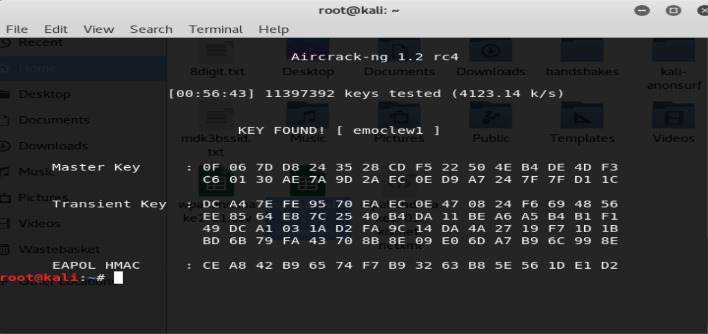
Figure 20 crunch and aircrack result
Luckily after 56 mins and 43 seconds of the processing system found the key. This time is variable depends on system speed and the crunch process order. This process was done by 2core CPU i7, with 4gb ram. The key testing speed was 4123.14 k/s.

Recommendations:
The protection of Wi-Fi network is necessary as the Wi-Fi itself, as you can see in above experiment making the small changes in passphrase lead the break-in process very difficult and lengthy, it’s really necessary to have a strong and complex password.
To keep the Wi-Fi network secure try to use the unfamiliar SSID this can help to prevent ease of identification of network because hackers always try to use the network as a target which is easily identifiable.
The SSID can be set to hidden mode if only a few devices using the Wi-Fi network connect them manually and set SSID broadcast to no. Hidden SSID take longer to identify as compared to visible one, but still using right tools the hidden networks can also be exploited. Using the complex password take longer to crack, which is one step towards demotivation of the attacker.
Physical security is very important for a network, mostly AP have the reset button at the back after pressing that button AP went back to the factory settings where it’s easy for an attacker to crack the passphrase. Try to use vendor physical locking system to prevent the access to AP ports and buttons, and always mount the access point out of easy reach.
For companies, Wi-Fi network always uses WPA/WPA2 enterprise mode this allows every individual user to authenticate with the network using their own username and password. Later if the employee left the company or for any reason revoke individual access to the network is easily possible for network admin.
802.1x settings have vulnerability where attacker can make a rough AP and sitting near to the corporate office when user tries to connect to rough AP using their username and password the attacker can steal that information and then connect with original network using the same personal details this issue can be solved if server verification is implemented, before sharing the login credential the client verifies the server using their unique identification system.
If the IEEE make rules which stated that using better security features is necessary or having a strong password is compulsory for closed networks, this can help people to be victim of an attack
Recently a new vulnerability in Wi-Fi network is popup known as KRACK, using this vulnerability attacker cannot access to Wi-Fi key but the unencrypted data can be read, and using packet injection the attacker can get a hold on the information [30]. To avoid this attack try to encrypt data with https or using any VPN services.
In companies, Wi-Fi jammers can be installed on the walls and door which not allowed signals to travel outside the building and installed physical filtration so only authorised person can come inside the building. The home users instead of using one long range router at home which makes signal travellers outside the house for miles use multiple short-range access point in every room and try to design the location of the access point to keep the signal inside the house. This method is not hundred percent works against hacker but still, this avoids to give your network identification to one who just passing by your house, and also limiting the number of devices on the Wi-Fi connection and set up router as sticky mac address will prevent a new users to make connection, this method is bit hassle when require to add the new device.

Chapter 4:

Evaluation
Before the start of this project there was the main problem known as The overachiever problem which I faced too, selecting the topic and the understanding of the subject was the difficult task to do, selecting the topic that unrealistically large for solo project so keep it low profile to complete in timely manners, work on this topic already be done by different students from around the world,( the details in the report above) having different approach towards the same topic and giving the results in timely manners was one of the major issue, after finalizing the topic once I started the study about it, at that point I had lack of motivation because that topic is so vast and its really easy to get distracted from the topic, with the consultancy of my supervisor I made the work plan and limitation of topic to work on, thanks to my teachers and fellow students for motivation to complete and work.
The given topic is for to test the WPA security measure and show the importance of having complex passwords, In today modern age more devices use wireless connectivity to as compare to a few years back, according to Wi-fi.org by the end of 2016, 16 billion devices were ships around the world having Wi-Fi alliance logo. [31] The reason behind the popularity of wireless communication is its more convenient and hassle of wires can be avoided easily. A large number of devices means more people use and security of their data is a necessity to break into a wireless network is easy as compared to the wired network for the wired network physical access to network wires is necessary but for the wireless network, the signal can be captured form well away using powerful antenna etc. The importance of having better and secure authentication method with a strong password is the basic outcome of this project.
Another challenge is to have the system which has reasonable processing speed to support the process, setting up and buying the equipment for the minilab to work in safe environment.
The “Do It Tomorrow” Problem was also a big challenge at the start of this project it looks like there is huge time to complete the task but after discussion with project supervisor, I did follow the time plan to complete the project timely.
The Gant chart for this project is one of the important aspects of work structure, The start date of this project is 15 July and the end date is 08 of November the total days of 114 was given to this project, the first 45 days from 15 July to 31 Aug was allocated to practical work to do some experiment and collect the results, the reason to do this at first is the whole project report based on practical work. The next task is to write the final report including literature review and explained the attacks, last 24 days are allocated to review and finalize the project findings and submit for final marking.
While doing this project the things I learned will definitely help me in my future, for example project management skills and making the time plan for small and big tasks and completing those tasks according to time plan. This help to rectify my own mistakes as well, and during this project I failed at my first task which give me the motivation of doing it again in better way. Also by writing this report the writing skills is being utilised and improved. The new software and tools learned for example hashcat, aircrack-ng, crunch and the use of Linux operating system will help me in the future to have better understanding of command line interface based tools. The understanding of Linux operating system give positive mark on my qualification. Parallel with this degree I been doing cisco CCNA exams as well which will a lot helpful during my studies and later in the job market.

Future works:
In the future, I want to attack an enterprise level network (safe lab) and list out the possible attack methods and vulnerabilities. Making the WPA authentication method better to overcome the handshake captured vulnerability. The KRAcK vulnerability [30] is also under consideration for future work which can be tackled if all packets on Wi-Fi network encrypted in end-to-end encryption.

Conclusion:
At the end, the whole project reflects that how important is to have better security measures implemented. Wireless networking is a most valuable aspect of information technology sector most of the newer devices use Wi-Fi to communicate with other devices. Numerous methods to compromise the wireless network are spreading around on daily basis, this is because of people interest in wireless hacking etc, people should adobe encryption techniques like VPN etc while they connected with open network because it’s easy for an attacker to do man-in-the-middle attack to steal the information, network owner should change their passphrase occasionally to get rid of unwanted users. This work in only for educational purpose and not meant to be a guide to attack real network. In an ideal world having iron proof security which cannot allow any kind of break in and lock down the network and give access only to authorised users, but the issue is we are not living in that world, there is always a security loophole and it can be protected by continuously research work and updating system.
In the practical chapter of this report, it clearly shows it’s not a very difficult task to hack the wireless system if proper security measures did not take place even just scrambled the same password add an extra hour to crack it. Using right tools and powerful system against secure network make them vulnerable.
WPS attack wasn’t successful because the today's routers are intelligent after few wrong tries the router auto stop any more request from that mac address.
The attack on WPA protocol was successful and I was able to crack the key in an hours the dictionary attack took less time because the hashcat use the GPU to process the request, and the air crack-ng method was successful too but its require more human intelligence to work properly the passwords made by human and human nature mostly goes for easy way to their designed passwords, these methods looks unrealistic against lengthy and well-designed passwords which include characters from alphabetical, symbol, figures which took a long time and more processing power to crack.
As I mention in my future work my aim to develop an algorithm to revoke the handshake capturing process and make users change their passwords regularly.

References

[1] | B. R. Jahanzeb Farooq, “An Overview of Wireless LAN Standards IEEE 802.11 and IEEE 802.11e,” Umeå University, Sweden, 2006.
[2] | BY AG STAFF, “20 Australian inventions that changed the world,” Australian Geographic, 18 June 2010. [Online]. Available: http://www.australiangeographic.com.au/topics/history-culture/2010/06/australian-inventions-that-changed-the-world/. [Accessed 08 04 2017].
[3] | I. The Institute of Electrical and Electronics Engineers, “Part 11: Wireless LAN Medium Access Control (MAC) and Physical Layer (PHY) Specifications,” IEEE Computer Society, NewYork, 2012.
[4] | S. Wong, “The evolution of wireless security in 802.11,” 2003.
[5] | I. G. Nikita Borisov, “Security of the WEP algorithm,” [Online]. Available: http://www.isaac.cs.berkeley.edu/isaac/wep-faq.html. [Accessed 08 04 2017].
[6] | E. Misel, “Advantages/Disadvantages: WEP/WPA Network Security,” Bright Hub, 19 07 2010. [Online]. Available: http://www.brighthub.com/computing/smb-security/articles/78216.aspx. [Accessed 09 04 2017].
[7] | M. C. J.-L. Gilis, “Attacks against the WiFi protocols,” 2010.
[8] | E. Tews, “Attacks on the WEP protocol,” Informatik, 2007.
[9] | E. T. Martin Beck, “Practical attacks against WEP and WPA,” Germany, 2008.
[10] | M. B. Lazar Stošić, “RC4 stream cipher and possible attacks on WEP,” International Journal of Advanced Computer Science and Applications, , vol. 3, no. 3, p. 114, 2012.
[11] | J. HOWE, “WEP, WPA, WPA2 and Home Security,” 10 July 2011. [Online]. Available: http://blog.privatewifi.com/wep-wpa-wpa2-and-home-security/. [Accessed 23 April 2017].
[12] | G. Lehembre, “Wi-Fi security – WEP, WPA and WPA2,” hakin9.org, 2005.
[13] | H. Cosand, “Wi-Fi Protected Access (WPA) Security and Exploits,” 2006.
[14] | “Understanding WPA/WPA2 Pre-Shared-Key Cracking,” 27 Dec 2015. [Online]. Available: https://www.ins1gn1a.com/understanding-wpa-psk-cracking/. [Accessed 06 06 2017].
[15] | M. E. McKague, “Design and Analysis of RC4-like Stream,” University of Waterloo , Waterloo, Ontario, 2005.
[16] | Y. L. J. Katz, Introduction to Modern Cryptography, Chapman and Hall, 2014, p. 77.
[17] | L. C. B. L. Constantin, “Microsoft continues RC4 encryption phase-out plan with .NET security updates,” Computerworld, 14 May 2014. [Online]. Available: http://www.computerworld.com/article/2489395/encryption/microsoft-continues-rc4-encryption-phase-out-plan-with--net-security-updates.html. [Accessed 13 06 2017].
[18] | J. Wexler, “WPA2 vulnerability found,” Network World, 03 JUL 2010. [Online]. Available: http://www.networkworld.com/article/2214616/wireless/wpa2-vulnerability-found.html. [Accessed 17 06 2017].
[19] | M. Hangargi, “Denial of Service Attacks in Wireless Networks,” Northeastern University .
[20] | V. Lehtoranta, Jamming or deliberate interfferance against radio broadcasting stations, finlad: Radiomaailma Magazine 8/99, 1999.
[21] | P. Parihar, “Attacks in Wireless Networks,” Institute of Technology & Management, , Bhilwara, 2011.
[22] | P. Arana, “Benefits and Vulnerabilities of Wi-Fi Protected Access 2 (WPA2),” Fall 2006 .
[23] | “Phone jammers,” Ofcom, [Online]. Available: https://www.ofcom.org.uk/spectrum/radio-spectrum-and-the-law/jammers. [Accessed 07 07 2017].
[24] | Metageek, Dual Band Versatility.
[25] | Cisco, Cisco CleanAir Technology, Cisco Systems, Inc, 2011.
[26] | P. Day, Cyber Attack, Carlton Books, Limited, 2014, 2014.
[27] | G. Ola, “PENETRATION TESTING ON A WIRELESS NETWORK -- USING BACKTRACK 5,” TURKU UNIVERSITY OF APPLIED SCIENCE, BACHELOR’S THESIS , 2013.
[28] | M. Daneil, “WPA password cracking Parallel Processing on the Cell BE,” Aalborg University , Aalbrog, 2009.
[29] | L. ’. ˇZa´k, “Security of Wi-Fi Networks,” Comenius University, Bratislava, June 2012.
[30] | R. D. Natasha Lomas, “Here’s what you can do to protect yourself from the KRACK WiFi vulnerability,” techcrunch, 16 OCT 2017. [Online]. Available: https://techcrunch.com/2017/10/16/heres-what-you-can-do-to-protect-yourself-from-the-krack-wifi-vulnerability/. [Accessed 08 11 2017].
[31] | E. Suthers, “Wi-Fi® device shipments to surpass 15 billion by end of 2016,” Highwire PR for Wi-Fi Alliance, [Online]. Available: https://www.wi-fi.org/news-events/newsroom/wi-fi-device-shipments-to-surpass-15-billion-by-end-of-2016. [Accessed 08 11 2017].
[32] | Fraunhofer Heinrich-Hertz Institute, “Novel integration technologies for disruptive capacity upgrade in data center systems,” Berlin, 2016.
[33] | C. B. &. P. Teuwen, “802.11 Security Inaccessible star?,” EADS, 2006.

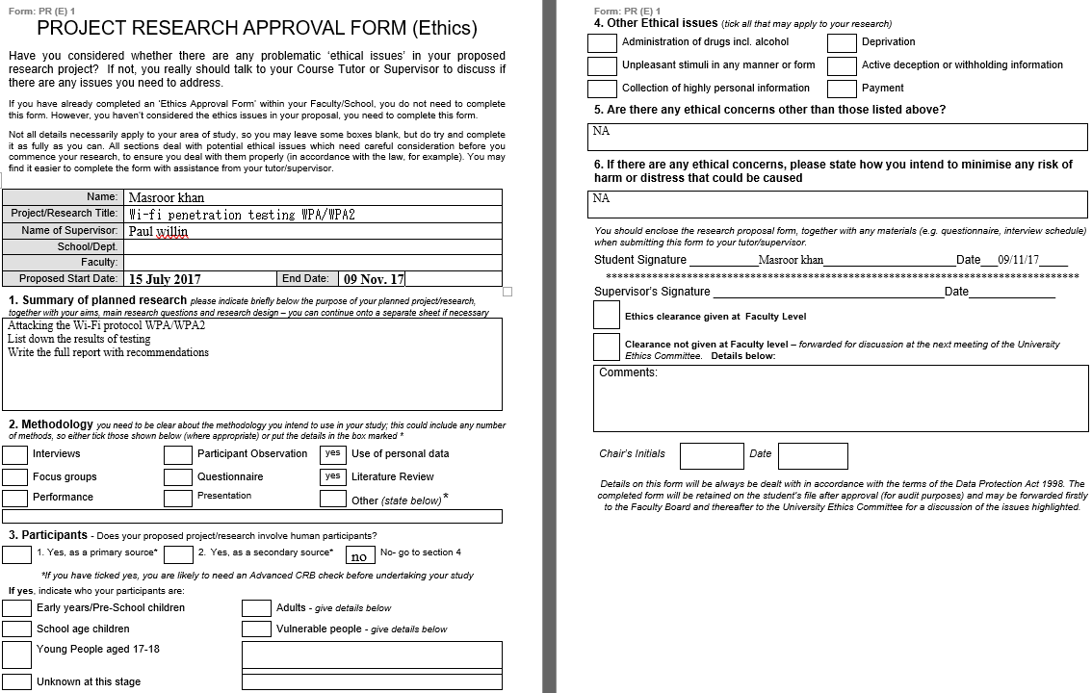
Appendix:



