Bachelor of Arts Business Management
Introducing the Modern Workplace
Student Name – DEMIR DEMIROV
Student ID - 2127256

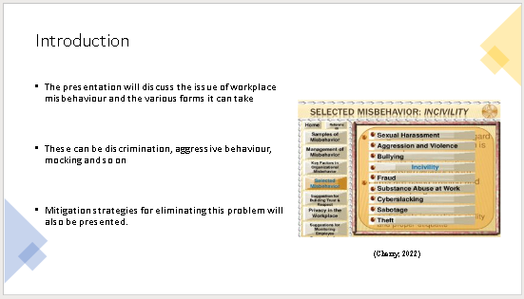

Introduction
The presentation will discuss the issue of workplace misbehaviour and the various forms it can take. These can be discrimination, aggressive behaviour, mocking and so on. These issues can have serious effects on the performance of an organisation and diminish employee performance. All of these perspectives will be discussed in here. The behavioural theory of BF Skinner, and the Hertzberg’s two-factor theory will be used to analyse the ways in which people conduct themselves in the workplace. Mitigation strategies for eliminating this problem will also be presented.
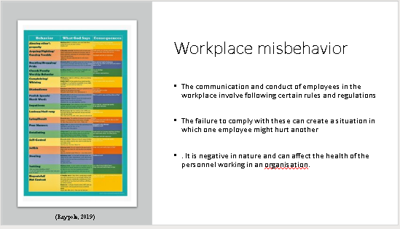

Work place misbehavior
The communication and conduct of employees in the workplace involve following certain rules and regulations. The failure to comply with these can create a situation in which one employee might hurt another in a physical, mental, or emotional way, this is known as workplace misbehavior (Vpapat, 2022). It is negative in nature and can affect the health of the personnel working in an organisation.

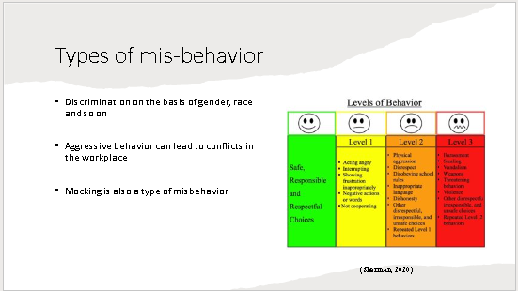
Types of misbehavior
The misbehavior in workplace can be catagorised further according to their characteristic and effects
Discrimination
Discrimination in the workplace involves the inequal treatment of workers based on their race, gender, skin colour and so on (Cooks-Campbell, 2021). This can happen between two employees or can be due to bad management established by the organisation. Although these practices are illegal and there are laws to prohibit them, still these practices can be found in various corporations
Aggressive behavior
The communication between personnel can involve the act of behaving rudely or aggressively which can lead to conflict in the workplace. According to survey, 2 million people suffer from non-fatal violence in the workplace annually (Sherman, 2020). This can happen due to various reasons like stress, bad attitude and so on. If not handled, this can lead to reduction in employee morale and motivation.
Mocking
The most common type of misbehavior in the workplace can be mocking other people by using their weakness. This is a form of bullying and can lead to employees feeling cornered and unsatisfied in their job. It has to be understood that providing constructive criticism cannot be always considered as mocking or bullying as it is necessary for performance evaluation (Raypole, 2019).

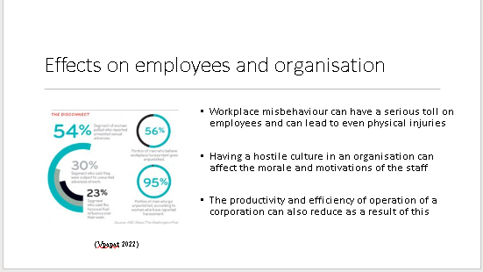

Effect on employees and organisation
Workplace misbehaviour can have a serious toll on employees and can lead to even physical injuries. Having a hostile culture in an organisation can affect the morale and motivations of the staff. This can lead to talent drain and lack of employee retention as nobody wants to work in these types of atmospheres. Another major impact can be on customer service, as if the culture of a company operates like this, then it will definitely affect the way in which they communicate with their customers. The productivity and efficiency of operation of a corporation can also reduce as a result of this. Other areas in which the negative impacts will spread can be product quality, HR management, relationship with suppliers and so on.
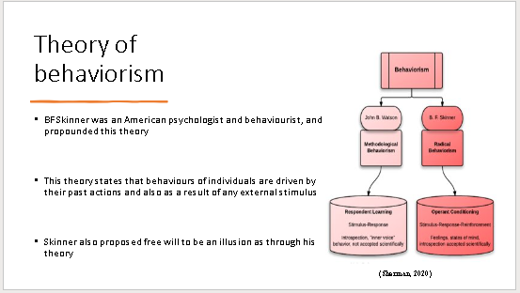

Theories of workplace misbehavior
Theory of behaviourism
BF Skinner was an American psychologist and behaviourist, and propounded this theory. It is also sometimes called as radical behaviourism. This theory states that behaviours of individuals are driven by their past actions and also as a result of any external stimulus. Skinner called these as respondent and operant behaviour. Skinner also proposed free will to be an illusion as through his theory, he proved the derivation of present actions based on past experiences (Cherry, 2022). This theory can be used to explain workplace misbehaviour. It shows that these kinds of actions are a result of bad attitude choices of a person which conditions the individual towards the path of misbehaviour.

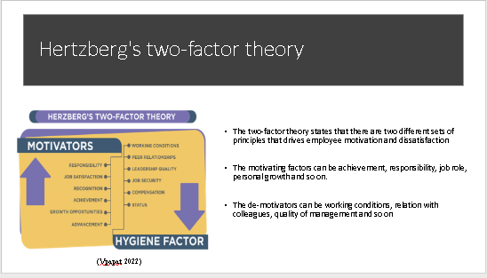
Herzberg’s two factor theory
The two-factor theory states that there are two different sets of principles that drives employee motivation and dissatisfaction (Gordon, 2022). The motivating factors can be achievement, responsibility, job role, personal growth and so on. The de-motivators can be working conditions, relation with colleagues, quality of management and so on. This clearly shows that workplace misbehaviour can lead to demotivation of employees. The source of that can be colleagues, supervisors, management and so on.

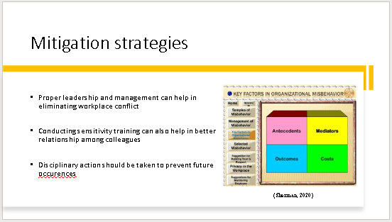

Mitigation strategies
The problem of bad attitude or misbehaviour at work can be mitigated by taking certain steps that can lead to better relation among employees and a healthy work environment.
Proper leadership and management
The management of an organisation can influence employee behaviour in the workplace. Having a transformative and inspirational leadership can help foster a climate of wellbeing and cooperation. A strong leadership can also help in taking decisive and quick action in handling these issues.
Sensitivity training
Sensitivity training is a group activity that helps in making workers more conscious of their attitudes and actions. It teaches personnel the values of empathy and being understanding towards the relationship with each other. Having these kinds of trainings periodically can help maintain the atmosphere of empathy in the workplace that will lead to reduction or elimination in workplace conflicts (Toll, 2022).
Disciplinary actions
The occurrence of misbehaviour in the workplaces should be dealt with in an efficient manner and the guilty person should be made aware of their mistake. Actions should also be taken to make sure that these do not get repeated in the future. For this reason, taking disciplinary actions is important as it acts as a deterrent which prevents the continuation of these actions
Proper workplace culture
The culture of a workplace also has a lot to do with the way employees behave with each other (Schuneman, 2019). Setting standards for communication and code of conduct in the workplace can help in the mitigation of these issues.

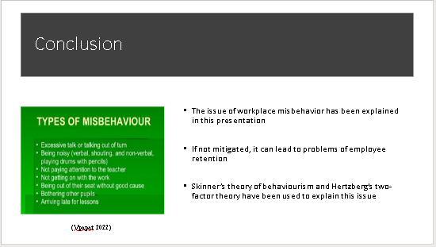

Conclusion
The issue of workplace misbehavior has been explained in this presentation. The different forms of it like mocking, aggressive behavior, and discrimination have also been evaluated. If not mitigated, it can lead to problems of employee retention, loss of productivity, poor customer service and so on. Skinner’s theory of behaviourism and Hertzberg’s two-factor theory have been used to explain the ways in which people behave with each other in the workplace. This can also be mitigated through the implementation of proper leadership, workplace culture, disciplinary action, and sensitivity training. All of these have been explained in this presentation.
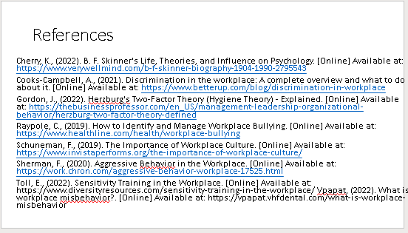

References
Cherry, K., (2022). B. F. Skinner's Life, Theories, and Influence on Psychology. [Online] Available at: https://www.verywellmind.com/b-f-skinner-biography-1904-1990-2795543
Cooks-Campbell, A., (2021). Discrimination in the workplace: A complete overview and what to do about it. [Online] Available at: https://www.betterup.com/blog/discrimination-in-workplace
Gordon, J., (2022). Herzburg's Two-Factor Theory (Hygiene Theory) - Explained. [Online] Available at: https://thebusinessprofessor.com/en_US/management-leadership-organizational-behavior/herzburg-two-factor-theory-defined
Raypole, C., (2019). How to Identify and Manage Workplace Bullying. [Online] Available at: https://www.healthline.com/health/workplace-bullying
Schuneman, F., (2019). The Importance of Workplace Culture. [Online] Available at: https://www.invistaperforms.org/the-importance-of-workplace-culture/
Sherman, F., (2020). Aggressive Behavior in the Workplace. [Online] Available at: https://work.chron.com/aggressive-behavior-workplace-17525.html
Toll, E., (2022). Sensitivity Training in the Workplace. [Online] Available at: https://www.diversityresources.com/sensitivity-training-in-the-workplace/
Vpapat, (2022). What is workplace misbehavior?. [Online] Available at: https://vpapat.vhfdental.com/what-is-workplace-misbehavior

