
Skills for the Workplace
Module Assignment Submission
Student Name: | Amanda Napier
Student Number: | 2007696
Module No: | BMSK4008
Module Title: | Academic and Research Skills

Statement of Confirmation of Authenticity
By the act of making this submission, the student declares that this is the work of the student named above. The work has not, in whole or in part, been knowingly presented elsewhere for assessment, or where assessment has been built on a previous assessment, this has been identified. Where materials have been used from other sources it has been properly acknowledged. If this statement is untrue, the student acknowledges that an assessment offence has been committed.
Attention is drawn to the plagiarism and unfair practice policies of both the University and of ILM.
Permission for ILM to use this script
ILM uses learners’ submissions – on an anonymous basis – for assessment standardisation. By submitting, both the centre and the learner agree that ILM may use this script on condition that identifying information is removed. However, if you are unwilling to allow ILM use this script, please refuse by ticking the box: □

Table of Contents
Managing Remotely: Is it the Way Forward? 3
Part 1 3
1.1 Introduction 3
1.2 Research 3
1.3 Findings 3
1.4 Conclusion 4
Part 2 4
Personal Reflection on Managing Remotely 4
2.1 Description 5
2.2 Feelings 5
2.3 Evaluation 5
2.4 Analysis 5
2.5 Conclusion 6
References 7
Appendix 1 8
Appendix 2 9

Managing Remotely: Is it the Way Forward?

Part 1

1.1 Introduction

Managing remotely is a way in which individuals work alone, often in different environments for example, the home, a coffee shop or even while travelling. It’s a way in which work load can be achieved in your own time and what time and place is best for you and your family, giving you that work-life balance. It may be that you’re an early riser and find that working before the kids get up will benefit you as a family as you are then able to take them to school, do the shopping etc.
In March 2020 a global pandemic meant that more people were forced to work from home in order to keep the world as safe as possible. A year on and more and more people are seeing it as the future of work.
School children have also had to turn to digital technology and work from home through the pandemic. This has proved to be quite challenging as not all children have use of a pc or laptop. Teachers have had to conduct class sessions through online chat rooms for example zoom and teams which have been quite distracting for all on the meeting. Class work is sent online and children have been able to contact their teachers via email while at home.
I have also had to work from home as a result of the pandemic. This brought up many challenges and a year on we are slowly adapting to a more online way of working. As the majority of my work involves physically seeing small children face to face, we as a team had to come up with a plan to keep the children stimulated at home during lockdown. We were able to conduct team meetings via Microsoft Teams which then enabled us to plan ahead what we were going to do for the children and their families. We have a messaging system at work called Class Dojo. This enables staff and parents to send messages, pictures, videos etc. and keep in touch with each other. Staff were able to upload fun activities for parents to engage with their children. We also sent videos of staff reading stories and singing songs that the children were familiar with. Together as a team we put together activity learning packs for our children and some staff were able to deliver these to doorsteps. This hopefully gave the children and parents some sort of routine and kept them physically and mentally stimulated.
We found that during these challenging times, Class Dojo has been a great way to keep in touch with our children as it is an instant messaging service so we were able to respond very quickly. We found that some parents were struggling with finances and their mental health but were able to contact us and we could then refer them to the relevant help that they need. For example, food parcels were sent out as a result of one family struggling with their five children. The parents contacted us via Class Dojo and the help was sought immediately. This is a great way of communicating and doesn’t cost, you just need internet connection.

1.2 Research
According to an article by Business info there are many advantages and disadvantages to managing remotely.
Advantages
- Increased productivity – there are many distractions and interruptions in an office environment and by working from home you may find that you are more focussed due to a quieter environment. This along with the extra time saved commuting to and from work will enable the employer to complete more work than if they were office based.
- Increased staff motivation – by working from home employees may feel a lot happier in completing their work as they are able to get on with it without being monitored by their employer. They may feel more trusted that they can do the work, therefore more motivated in doing it.
- Improved staff health and wellbeing – employees may feel less stressed with having to commute back and fore work every day. With more time saved by working from home employees are able to get a little more sleep, spend more time with the family, exercise more and also prepare food for the family. Employees may find it easier with collecting children from school and feel a lot more loyal to their company that they are able to do this.
- Flexibility – with the flexibility of completing your work from home, in your own time employees may be more willing to work later in the day or even at weekends. This may benefit certain businesses for example companies trading at different time zones.
- Better work/life balance – working from home can give employees the flexibility to do things around the home, do the shopping etc. and still complete the same amount of (if not more) work they would do in an office. This would then enable them to spend more time with their family or catch up on a hobby.
- Financial benefits – employers will save money on office space, utility bills, office supplies and other facilities. Employees may also benefit from a working from home tax relief.
- Convenience – the internet makes it possible for staff to connect to their workplace wherever they may be. Communication via email, skype, teams etc. makes work life more flexible.
- Less sickness absence and a need for holidays – by working from home staff may feel like they are spending less time at work, therefore happier in themselves and less stressed so their health may benefit meaning less sickness absence. They may also feel that by being at home more often that they don’t need a break away therefore don’t feel a need to take holidays.

Disadvantages

- Working from home doesn’t suit everybody – with different personalities and abilities working from home doesn’t suit everybody. Some employees may prefer the structure and routine of work life and may also not have the space to work from home. Some employees may have a disability and rely on work life to be their social interaction. Children may also be an interruption where parents may feel less distracted at work and able to fulfil their daily tasks.
- Feeling isolated – some employees may feel isolated which could then possibly lead to mental health issues if they are not interacting with others. For some individuals work may be their only communication with the outside world and they may enjoy the work environment as they know there is nobody at home to talk to. By conducting regular team meetings this may avoid the issues with feeling isolated and help with mental health.
- Home distractions – if an employee doesn’t have the physical space to work from home, then there could be many distractions. These may be children making noise, background noise for example the tv, washing machine etc.
- Difficulty managing performance – managers may struggle with monitoring staff performance while working from home. This can be resolved by setting goals and targets via an online team meeting.

- Cost of working from home – staff will need equipment in order to carry out their work from home. This may be costly to the company if they haven’t already got it. Employees may find that they are using more gas and electric while working from home and some families may not be able to afford extra bills.
- Information security risk – with laptops etc. being used at home there is a risk of confidential information being leaked. Staff must ensure that all technology is equipped with the latest software in order to avoid this happening. Employers also need to look at staff broadband speeds where they live. Not all areas have good connection and staff may need to be connected for most of the day therefore needing a good internet connection.

A report published by Office reality (December 2020) stated that the increase in Wi-Fi and cloud software systems has contributed to making working from home more accessible for anyone not involved in manual labour.

Monster.com wrote an article which stated that working from home, for the right people, can increase productivity and decrease stress. They also suggested that companies that encourage and support a work from home protocol save money in the long run.

1.3 Findings
A report published by Wiserd 2020 found that working from home rose dramatically from 5.7% in January/February 2020 to 43.1% in April 2020 and even though it had fallen in June 2020, it still remained high at 36.5%. This surge in homeworking was triggered by the 2020 coronavirus pandemic where the world was put in lockdown in order to protect life.
The report found that two thirds of employees (65.5%) reported that they were able to produce much more work while working at home and would prefer to work from home in the future. In comparison, only 6.4% of employees who did not want to work from home in the future said that their work was much higher when they worked from home.
By looking at the figures we can clearly see that more people would prefer to work from home. With social distance measures put in place this may be the case for the near futre.
The office for National statistics stated that in April 2020 46.6% of employed people worked from home. Of those who worked from home, 86% did so as a result of the coronavirus pandemic.
A report by Apollo Technical stated that productivity while working remotely from home is better than working in an office setting. On average, those who worked from home spend 10 minutes less a day being unproductive, work one more day a week, and are 47% more productive.

1.4 Conclusion
In conclusion to my research into working remotely my findings show that figures soared during the ongoing pandemic. They clearly show that working from home can be achieved in many jobs although this not the case some. There were many advantages and disadvantages found to working from home. Some employees have reported that they prefer working from home as it gives them the flexibility to manage their everyday life. Others say that they prefer the routine of office-based work as they do not have the space at home and are unable to concentrate due to distractions from noise, children etc and also enjoy the socialisation of physically communicating with others.
Figures show that both employers and employees seem to have benefited from working remotely with less costs and more quality time spent with family and friends. This seems to be a new way of working for many in the near future.

Part 2

Personal Reflection on Managing Remotely


Gibbs (1988)

2.1 Description
During the 2020 coronavirus pandemic many businesses were forced into lockdown which meant employees having to work as best they could from home in order to keep everybody safe.
Although my job role includes physically caring for young children, I was able to complete some of my work at home. Regular virtual meetings were conducted via Microsoft Teams where the plan for the week ahead was discussed and staff knew what was expected of them. Various learning activities were put onto our class dojo (a picture/messaging app) by staff for parents and children to carry out. This was a great way for both staff and parents to communicate when there was no physical way to do so.
Staff training was up to date as we were able to take up courses online and print out certificates. Many staff members also took up free courses relevant to our job roles with the open university. This gave staff a wider knowledge and understanding of child development which we were then able to bring to our setting to help the children.

2.2 Feelings
At the beginning of the pandemic, while still at work and exposed to the virus every day I found myself to be very worried and anxious. The world was slowly going into lockdown yet we were still at work trying to keep the children in our care as safe as possible, while worrying greatly about taking the nasty virus home to our families. Schools started to shut down which meant staff were put on a rota system for children of key workers and also vulnerable children. I started to feel less anxious as I was in less contact with others due to working from home some of the time. With lockdown in place, we started getting into a routine of regular virtual meetings. These meetings were a lovely way of connecting with my work colleagues as we were unable to see each other every day. The more meetings and online work we did, the more I got into a routine and started to enjoy my new work life.

2.3 Evaluation
While working from home I found many advantages. These being I was able to look after my children as I was home from work and they didn’t need to go into childcare, therefore protecting them from the coronavirus and keeping them safe. Another advantage was the extra time that I could spend with my husband and children due to not having to commute to and from work every day.
There were also some disadvantages. These being that my children did make some noise while on team meetings, although my colleagues were in a similar situation so it wasn’t a big issue. Initially I found it really strange and hard to conduct my duties from a laptop. This was quickly resolved as we were forced to work from home and had to come up with a solution to the problem. Even though we were unable to meet face to face, technology made this possible and made our work lives a lot easier.

2.4 Analysis
Initially, for my job role, working from home seemed impossible. By working together with my colleagues, we were able to come up with a plan which worked for the children in our care and their families. With the help of Microsoft Teams to keep everybody connected we were able to put in place a plan going forward which worked for everybody.

2.5 Conclusion
In conclusion to my personal reflection on working remotely I have found that even though we are still in the pandemic a year on and back to physically being in work, for me, working from home was only possible for some of my job role. The use of modern technology certainly made work life a lot easier in order to communicate with each other although we still needed that face to face, physical contact in order to fulfil our roles.
We have shown that online courses can be achieved on a laptop so we are looking at this for the future as its less time consuming and can be achieved anywhere.

References

Gibbs, G. (1988) Learning by doing; A guide to teaching and learning methods. London: FEU
Business info (2020) Employees working from home.
Available at: http://www.nibusinessinfo.co.uk
Accessed on 7/3/2021.

Wiserd 2020 Homeworking in the UK.
Available at: - http://www.wiserd.ac.uk
Accessed on 7/3/2021

Office for national statistics (2020)
Available at:- http://www.ons.gov.uk
Accessed on 7/3/2021

Apollo Technical (2021)
Available at :- http://www.apollotechnical.com
Accessed on 7/3/2021

Flexjobs (2007-2021)
Available at :- http://www.flexjobs.com
Accessed on 17/03/2021

Office reality (2020)
Available at :- http://www.officereality.co.uk
Accesed on 17/03/2021

Monster.com (2020)
Available at :- http//www.monster.com
Accessed on 17/03/2021

The Muse (2020)
Available at :- http//www.themuse.com
Accessed on 17/03/2021

We work (2020)
Available at :- http//www.wework.com
Accessed on 17/03/2021

Employment studies (2020)
Available at :- http//www.employment-studies.co.uk
Accessed on 17/03/2021

Appendix 1
https://docs.google.com/forms/d/e/1FAIpQLSe7Ct_rOzC9IjStmgToHrqVqu0XHHe6I1WNVNgPOYWIpLGv0A/viewform?usp=sf_link
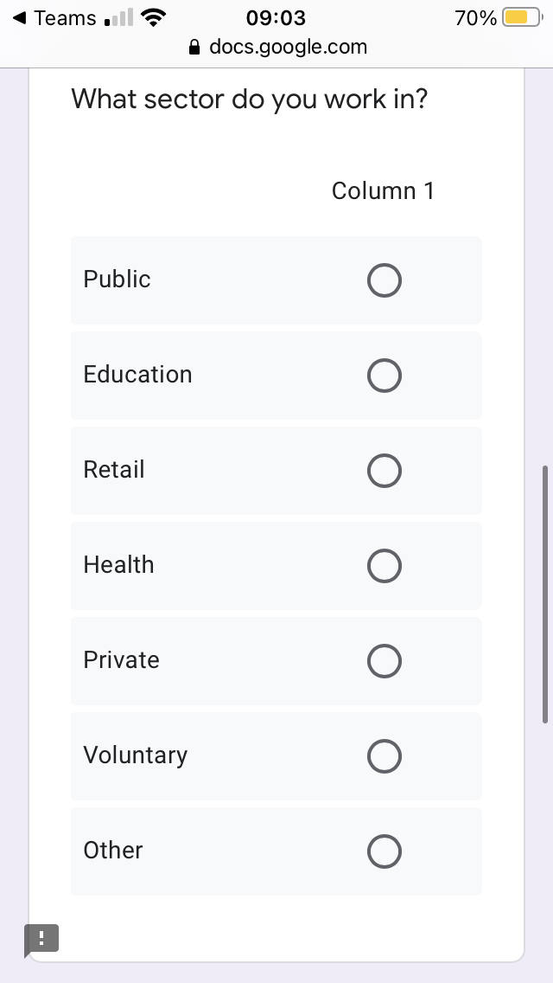
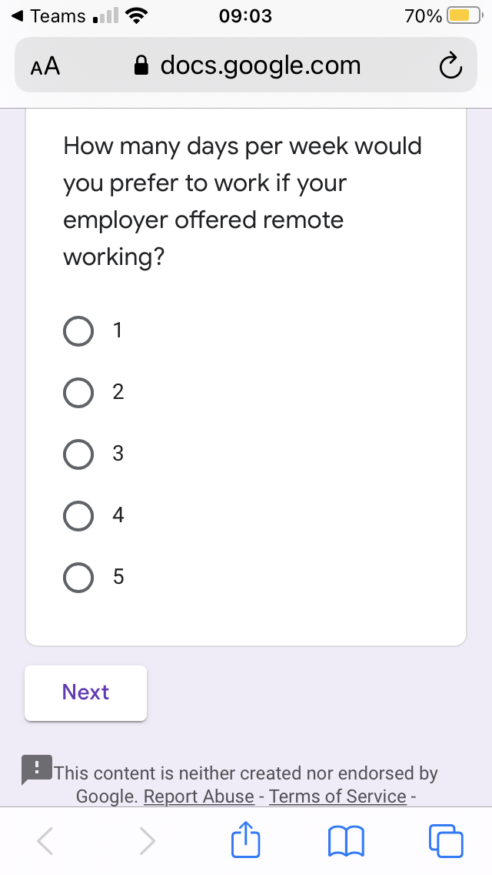
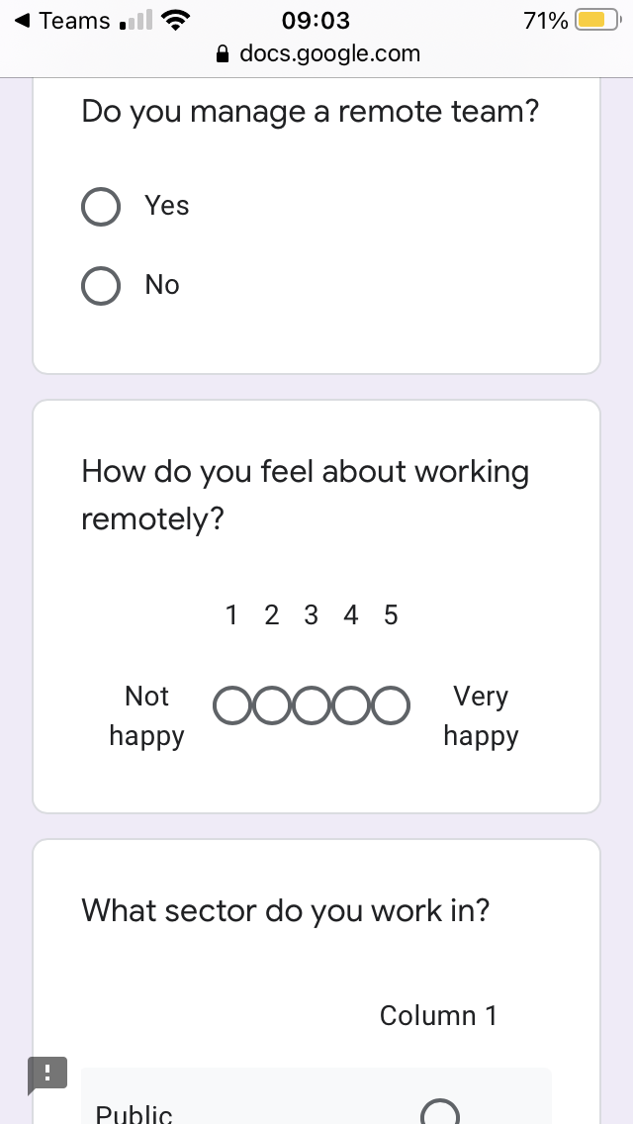
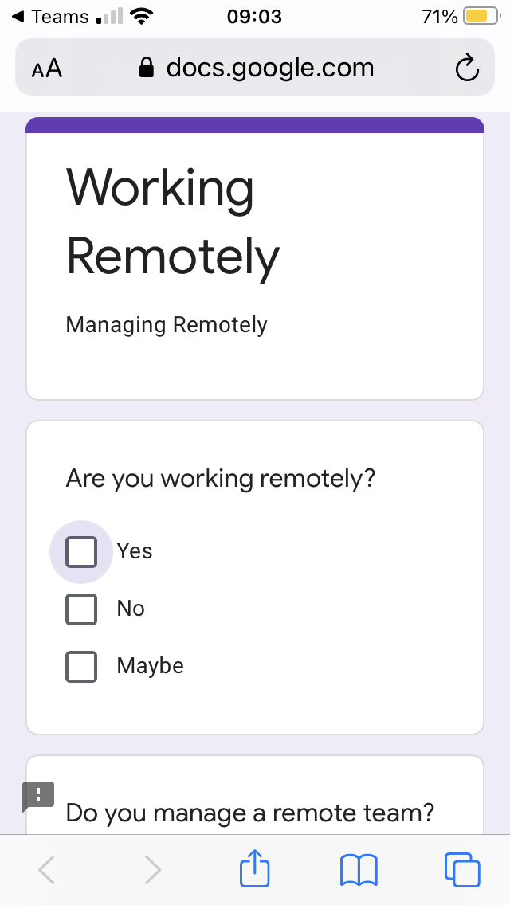

Appendix 2

