Student ID: 2246151
Student name: Florentina Raluca Iamandi
Lecturer: Ka Po Chong
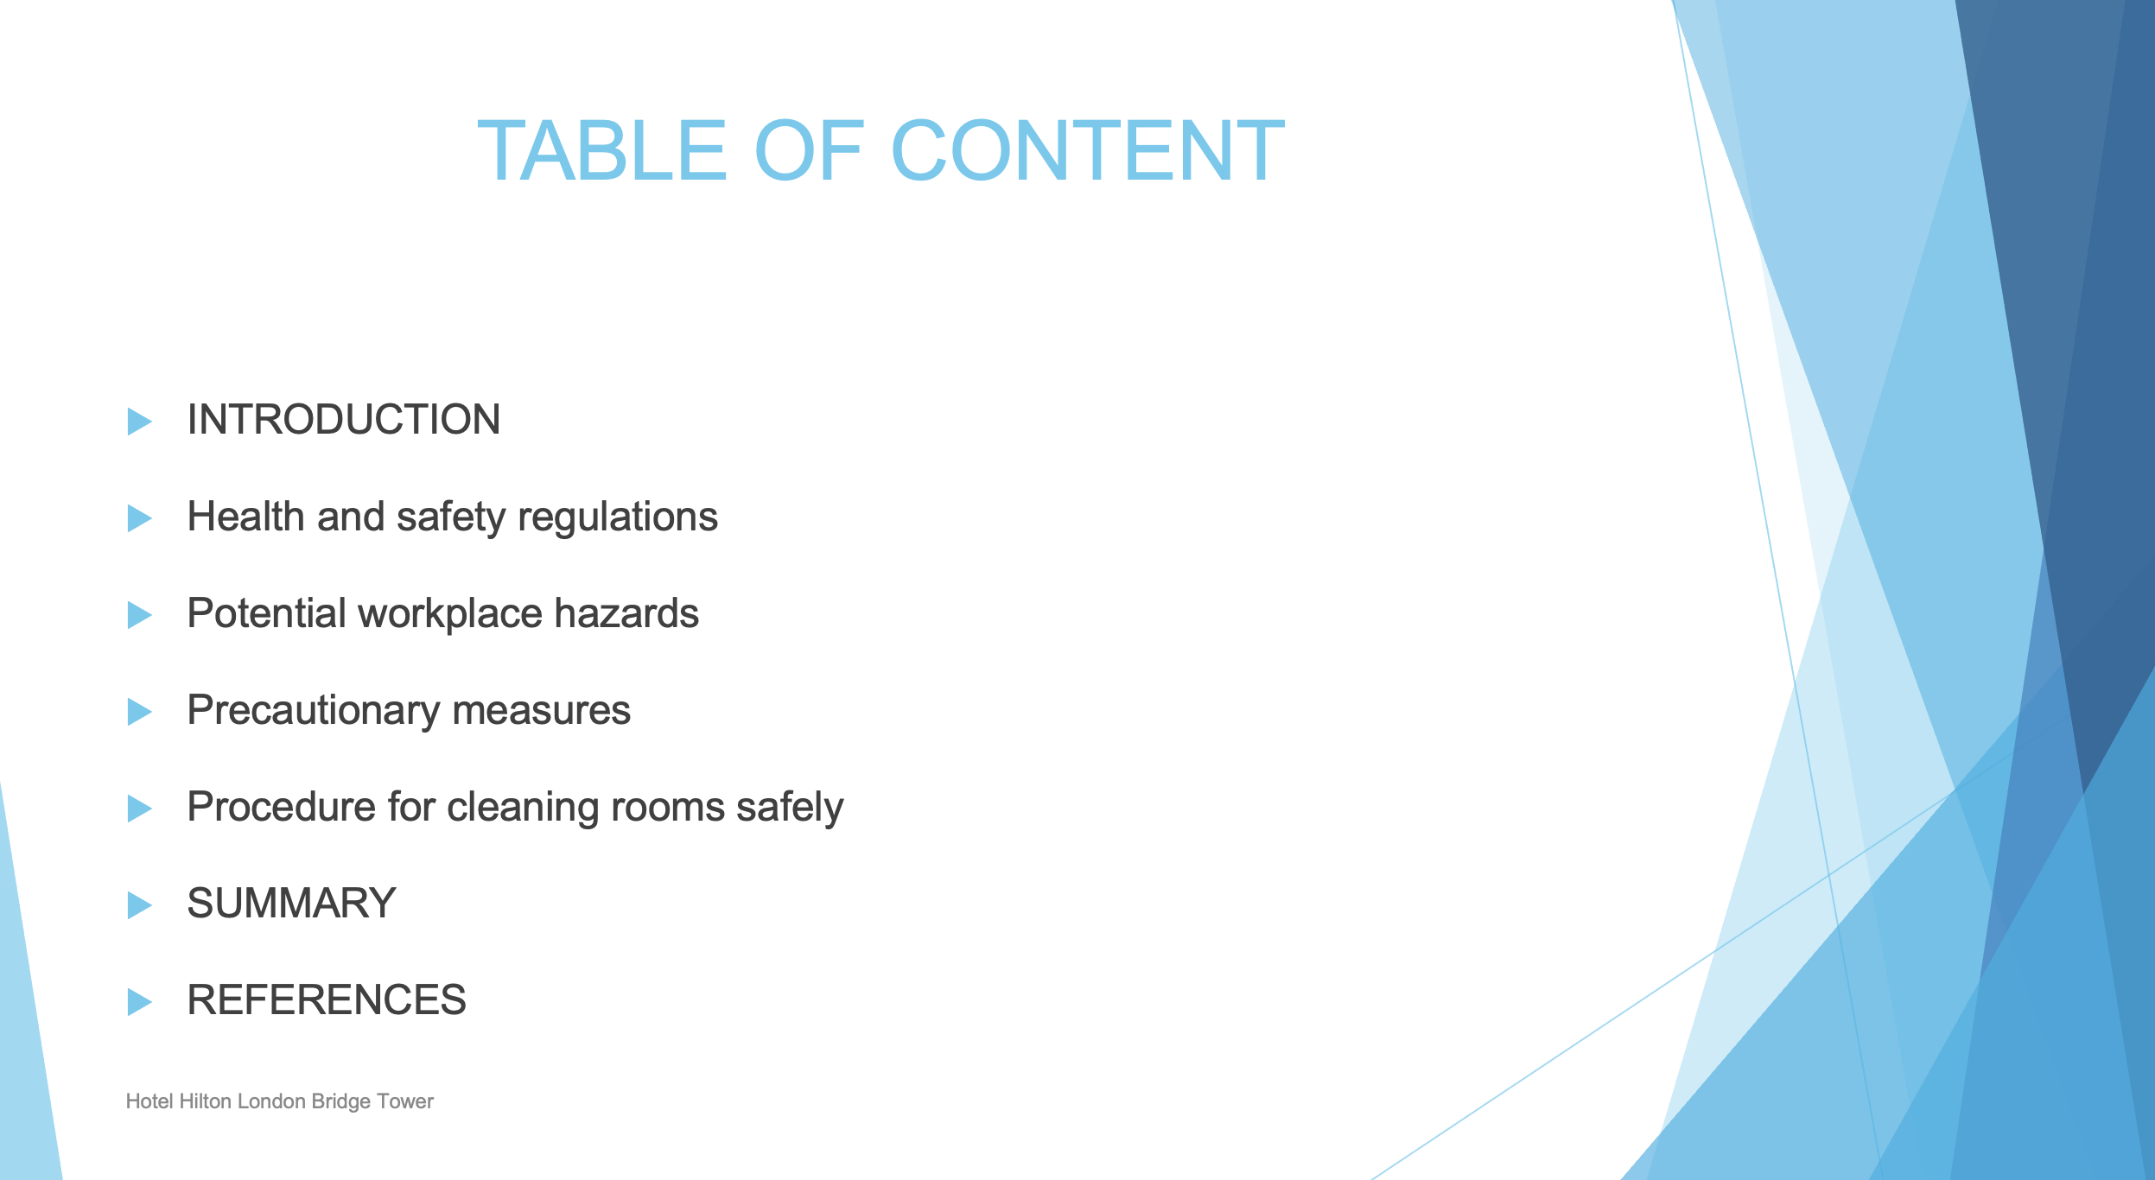

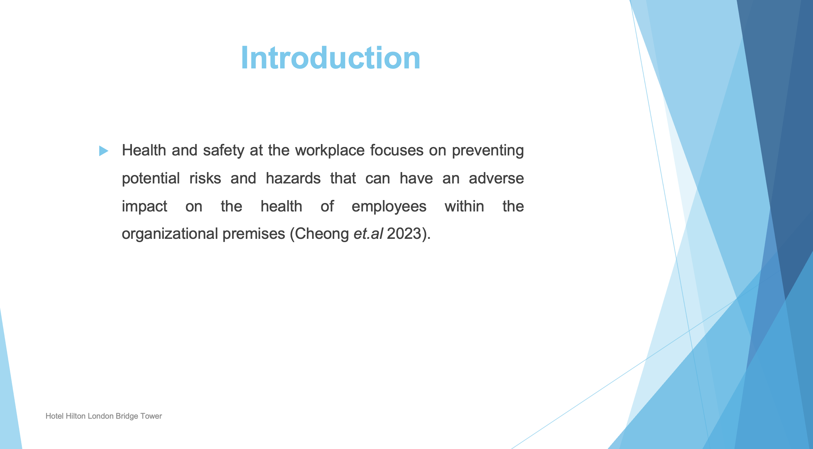

Hence, this presentation will outline key considerations for the housekeeping department of Hotel Hilton London Tower Bridge to carry out their job roles in a safe way.

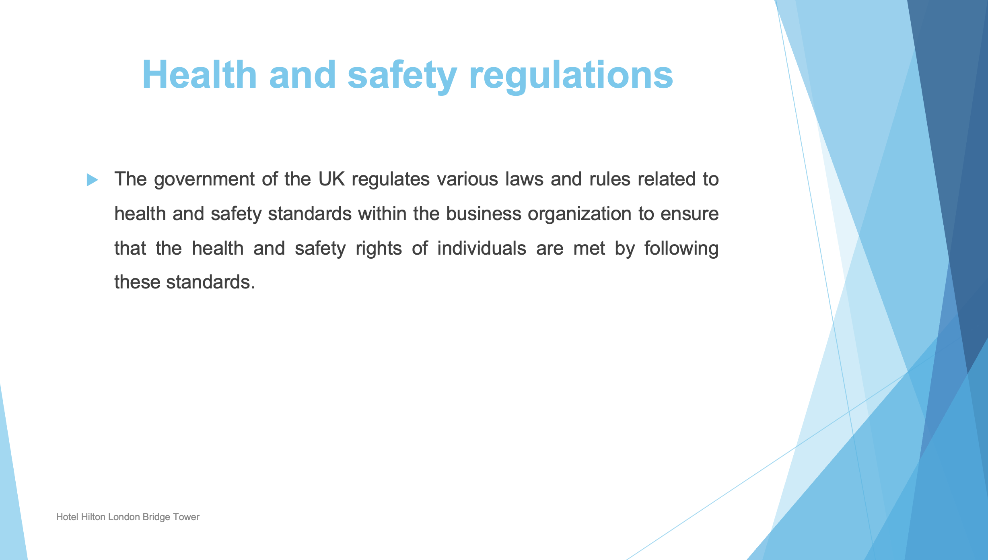

Some of the health and safety regulations followed by the hotel are as follows:

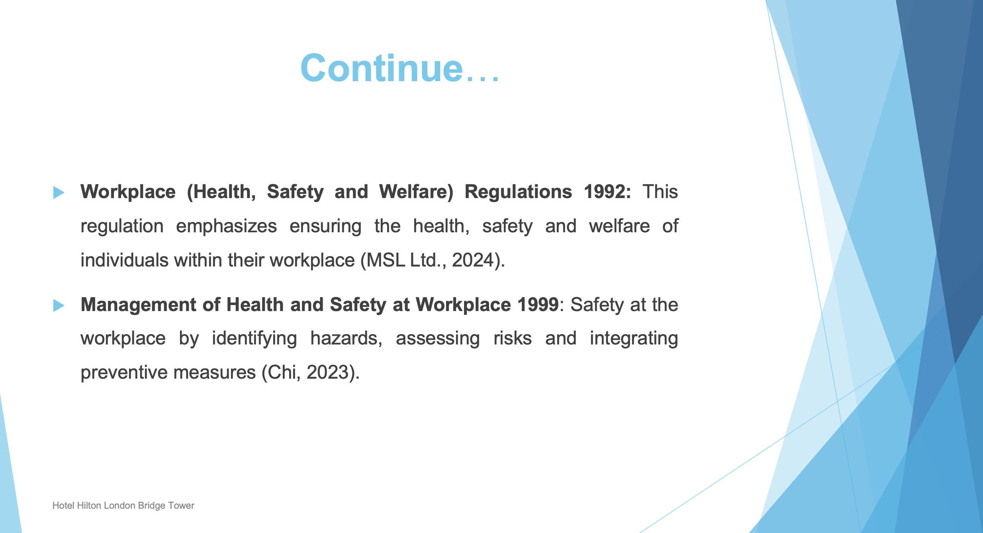

This regulation directs employers to manage health and safety.

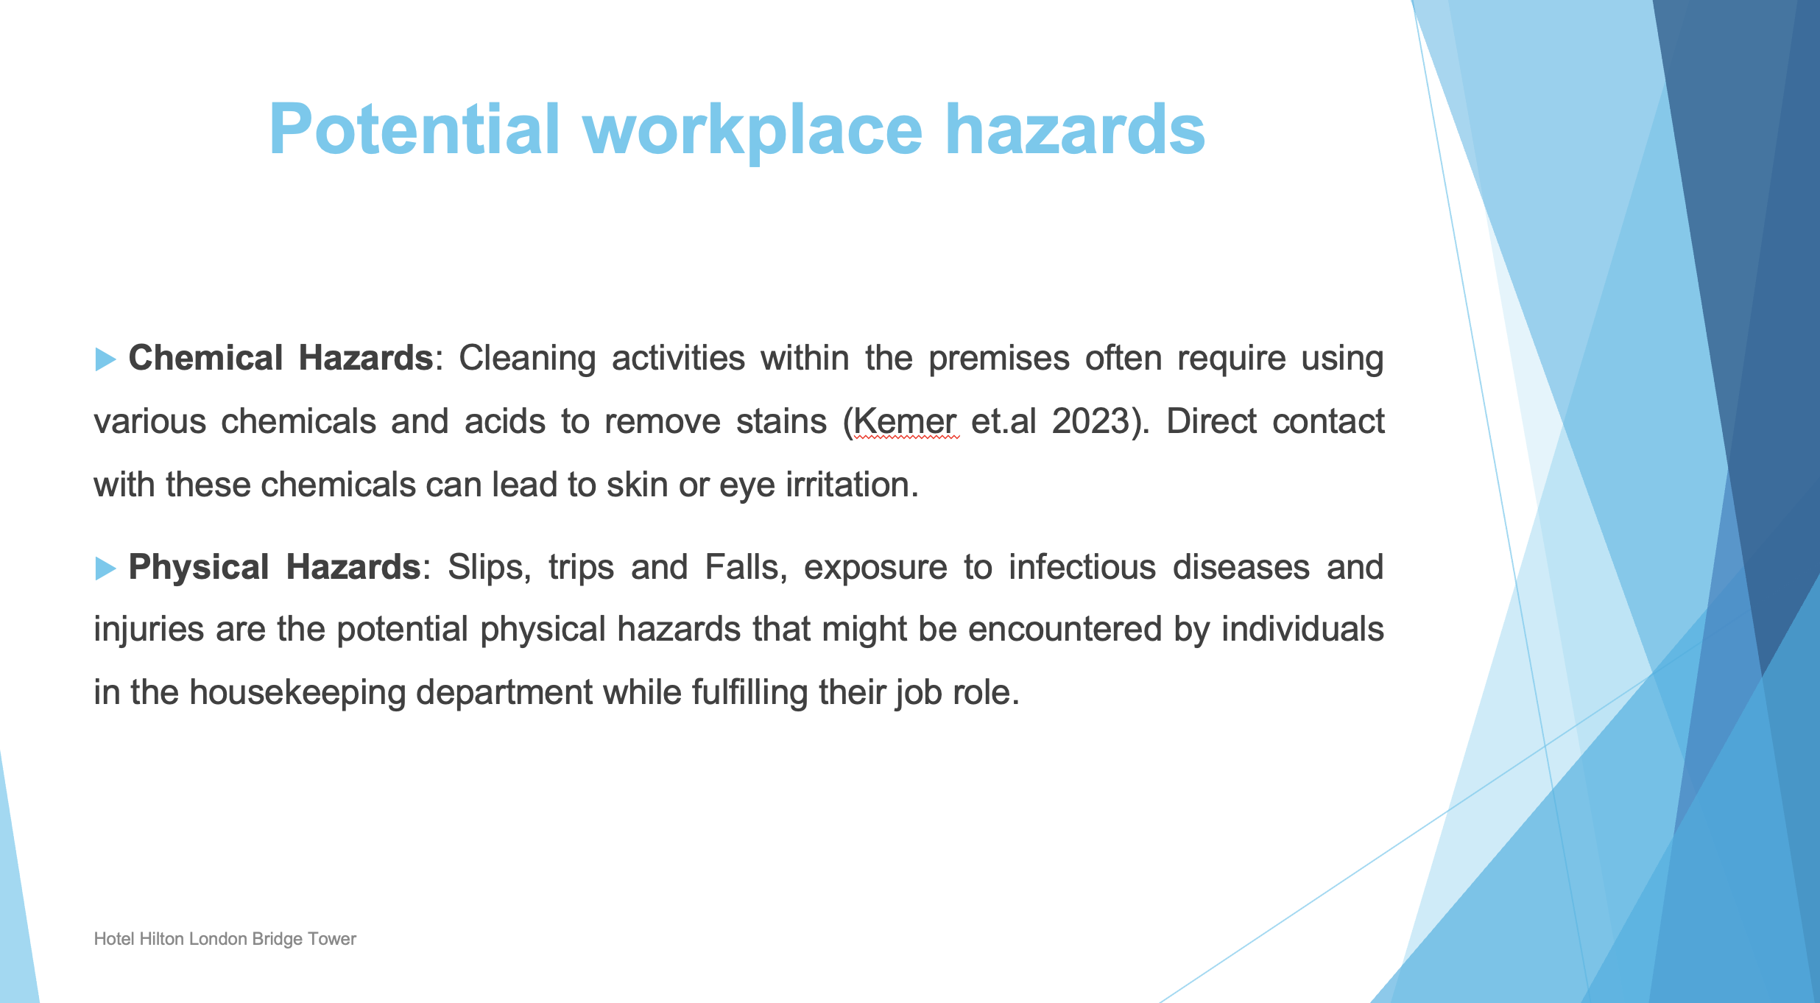

Other hazards: Fire and electrical hazards can also arise due to improper maintenance.

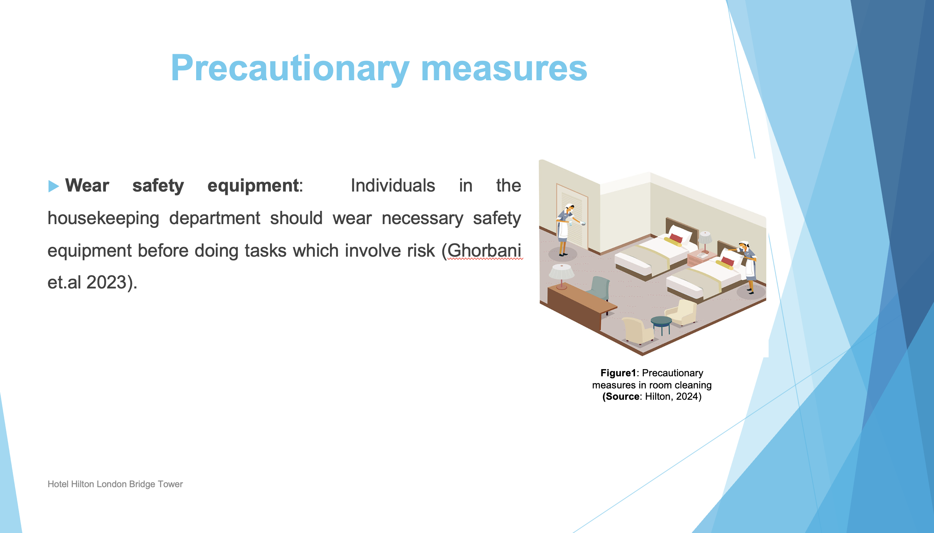

For example: safety gloves and goggles should be worn by individuals before using chemicals in cleaning bathrooms to avoid skin infection

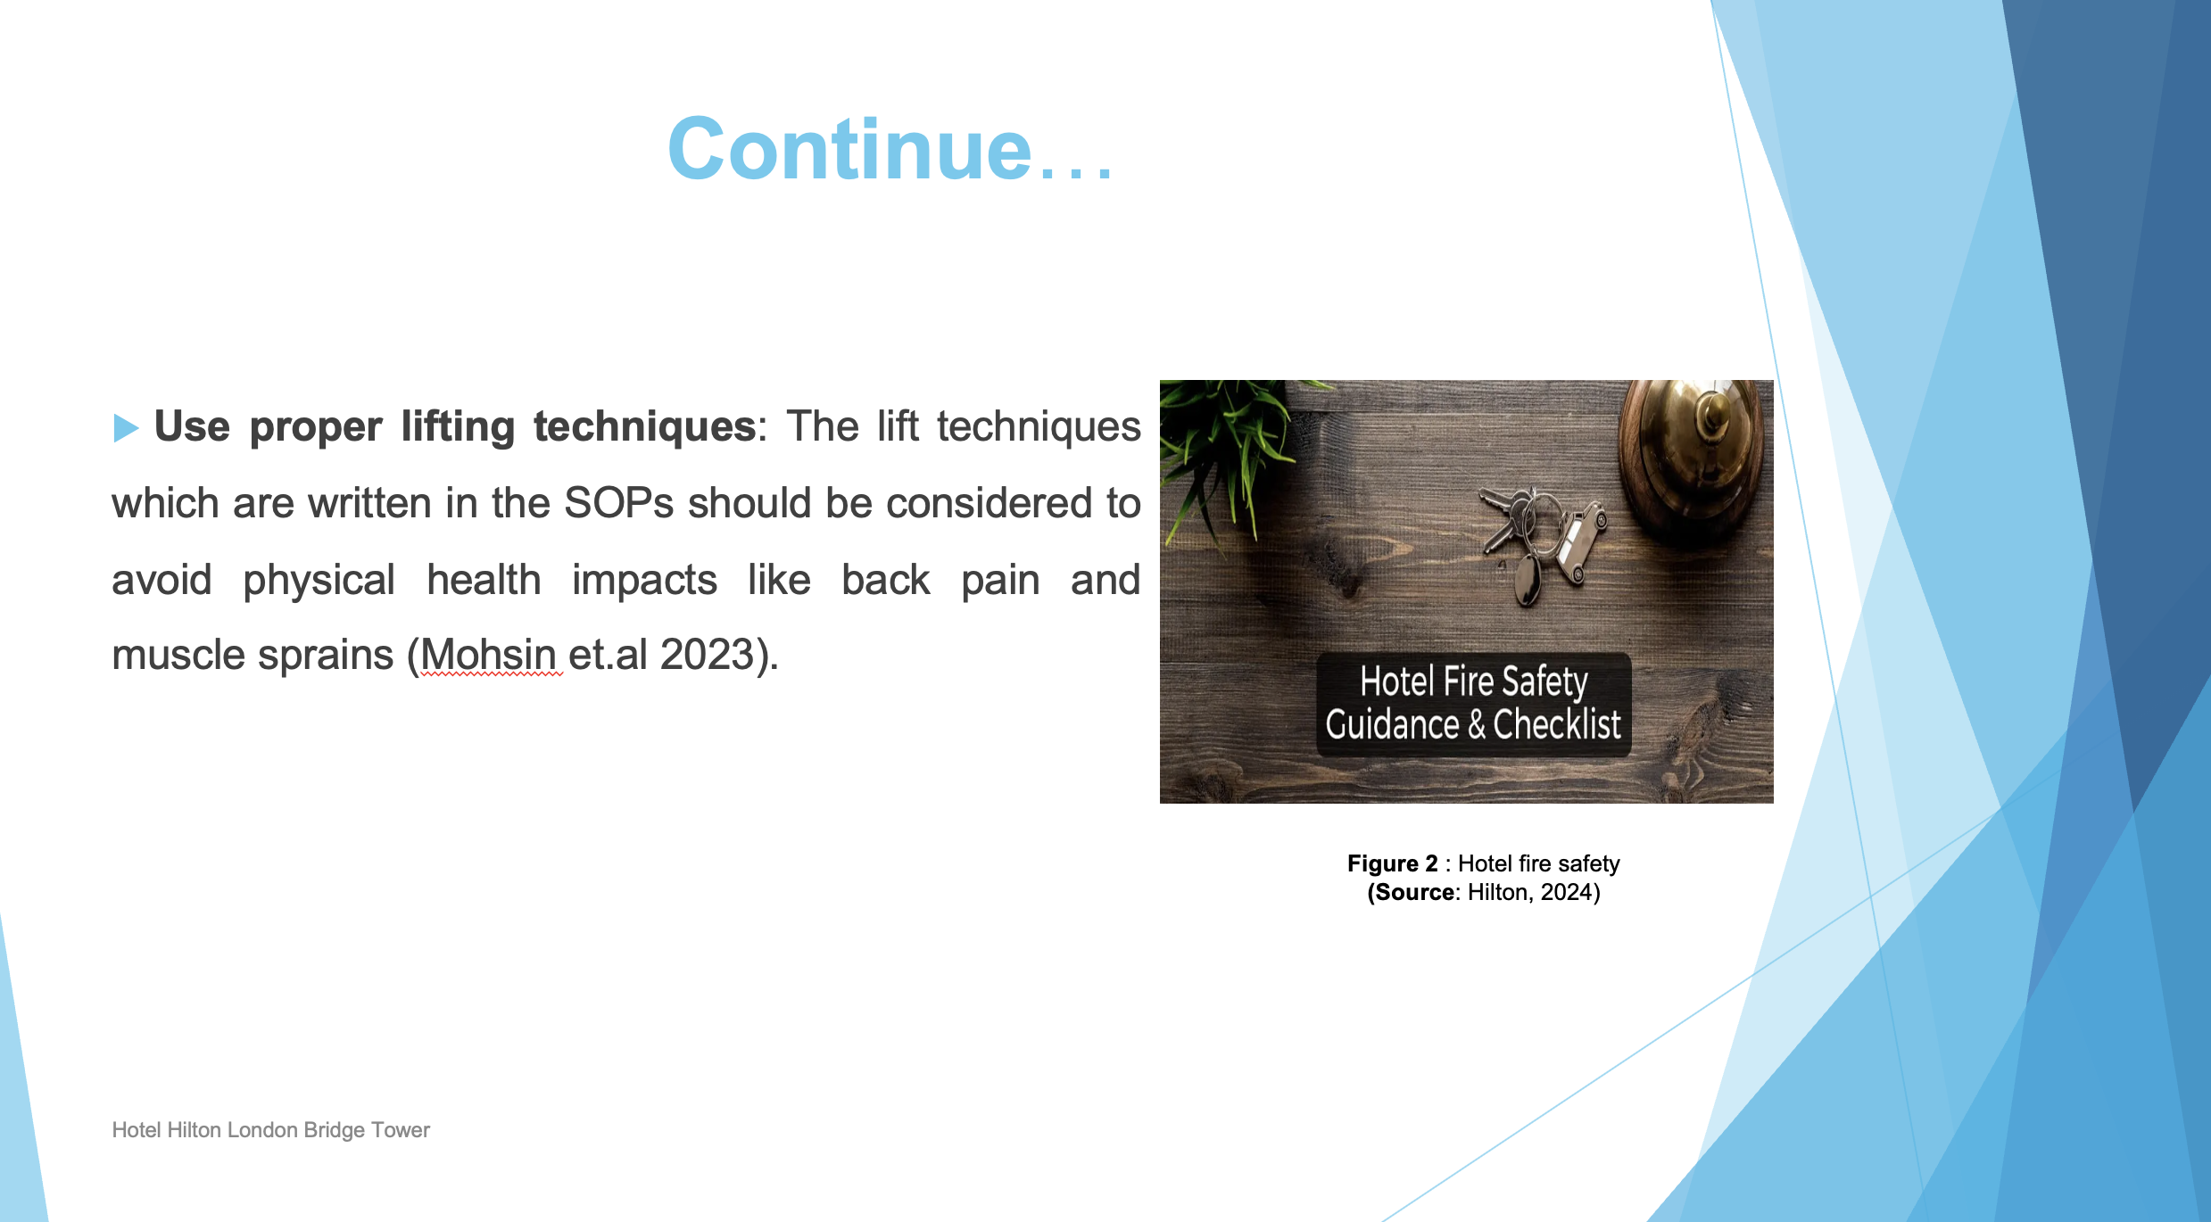

Follow safety procedures: Safety protocols and steps should be followed properly before using electrical equipment to avoid physical health risks.

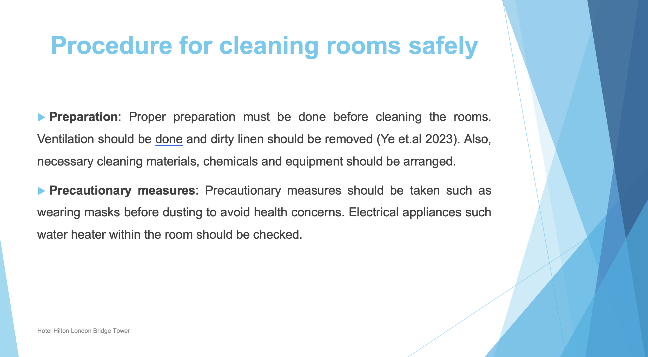

One of the main duties of the housekeeping department is to clean the rooms after check-outs to make them ready for the next bookings. Therefore, a systematic procedure should be followed to address this duty more safely.

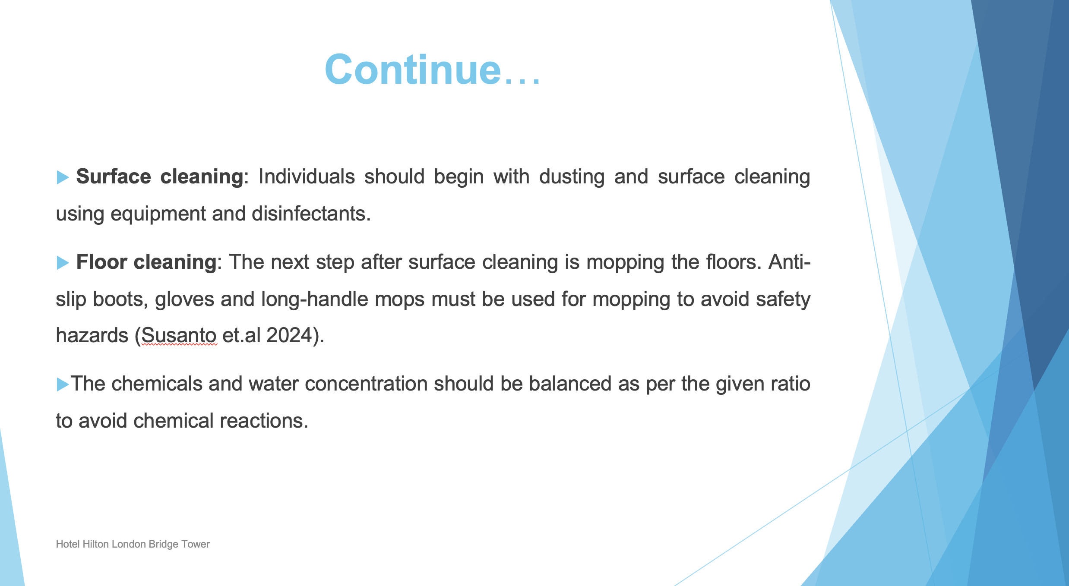

Floor cleaning: After cleaning, the floor should be left to dry and the signage board must be placed on the wet floor to avoid the risk of slips, trips and falls.

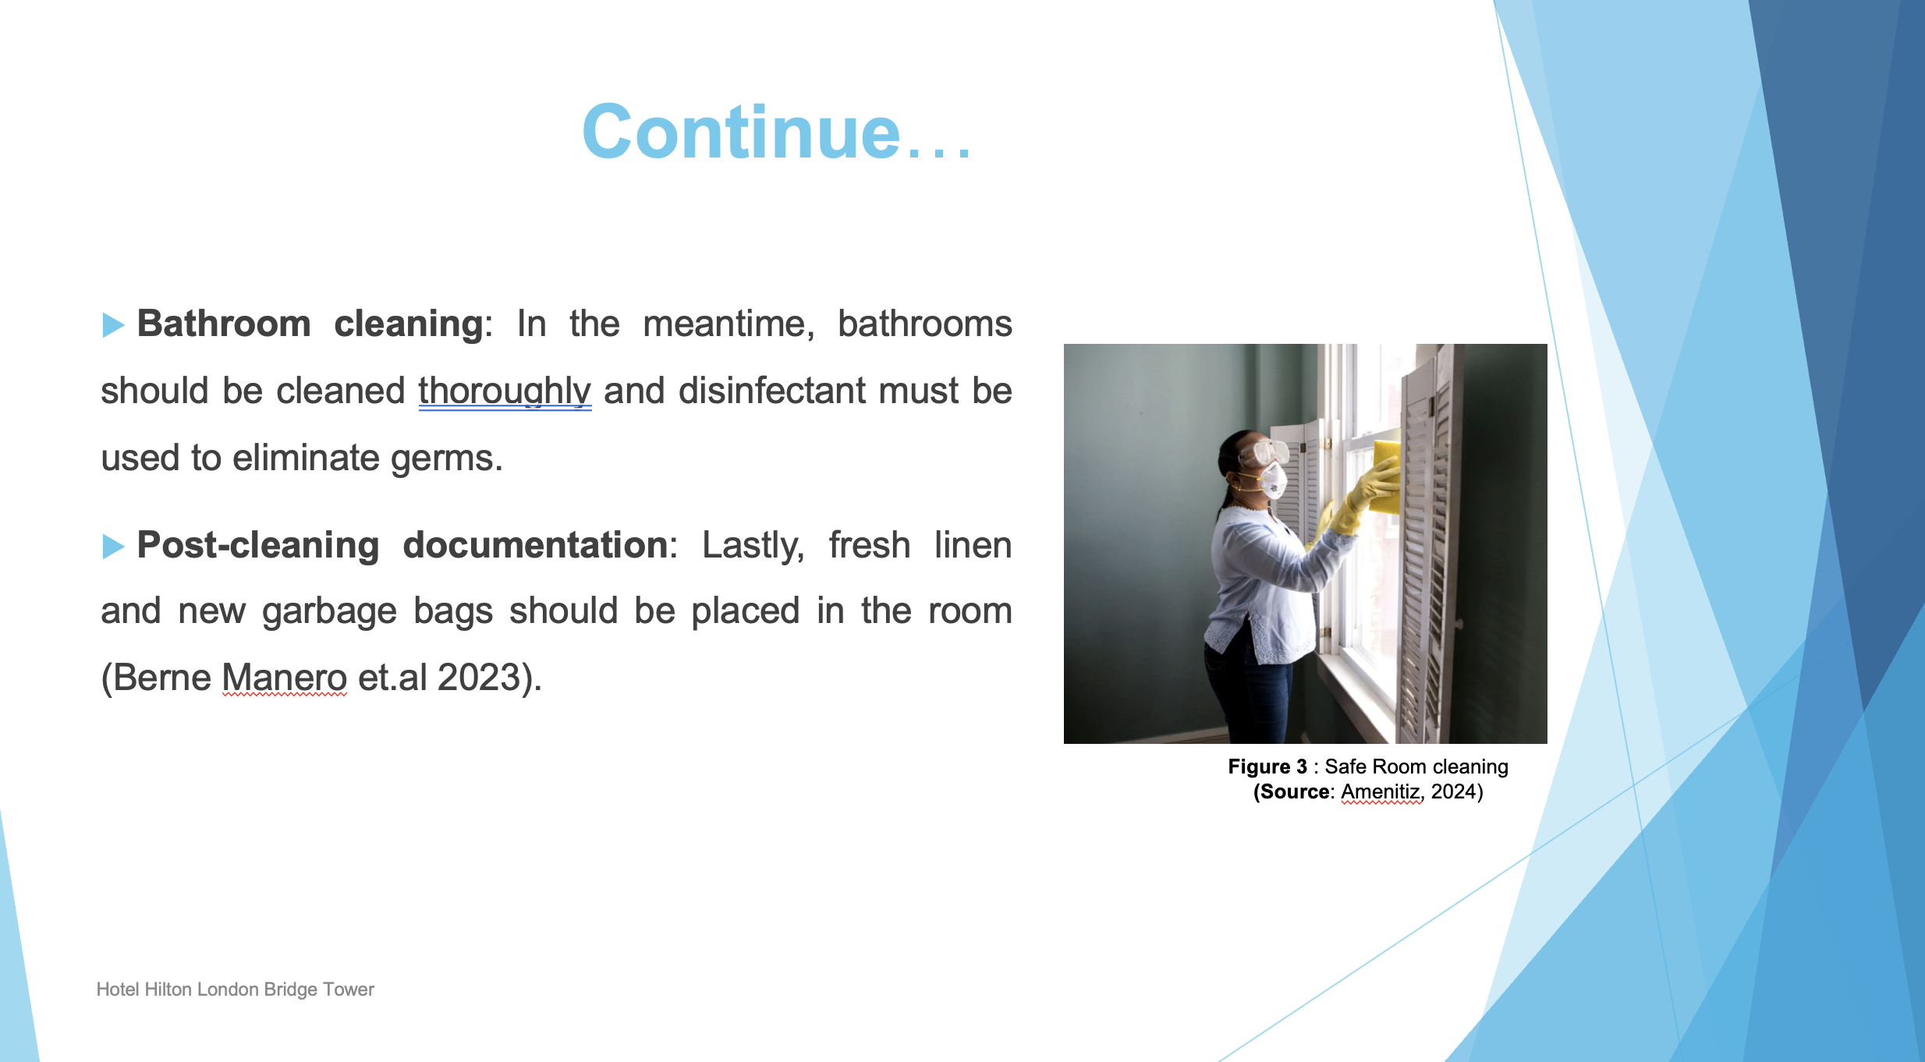

Post-cleaning documentation: Individuals must fill out the checklist at this last step of room cleaning to ensure that every requirement is fulfilled.

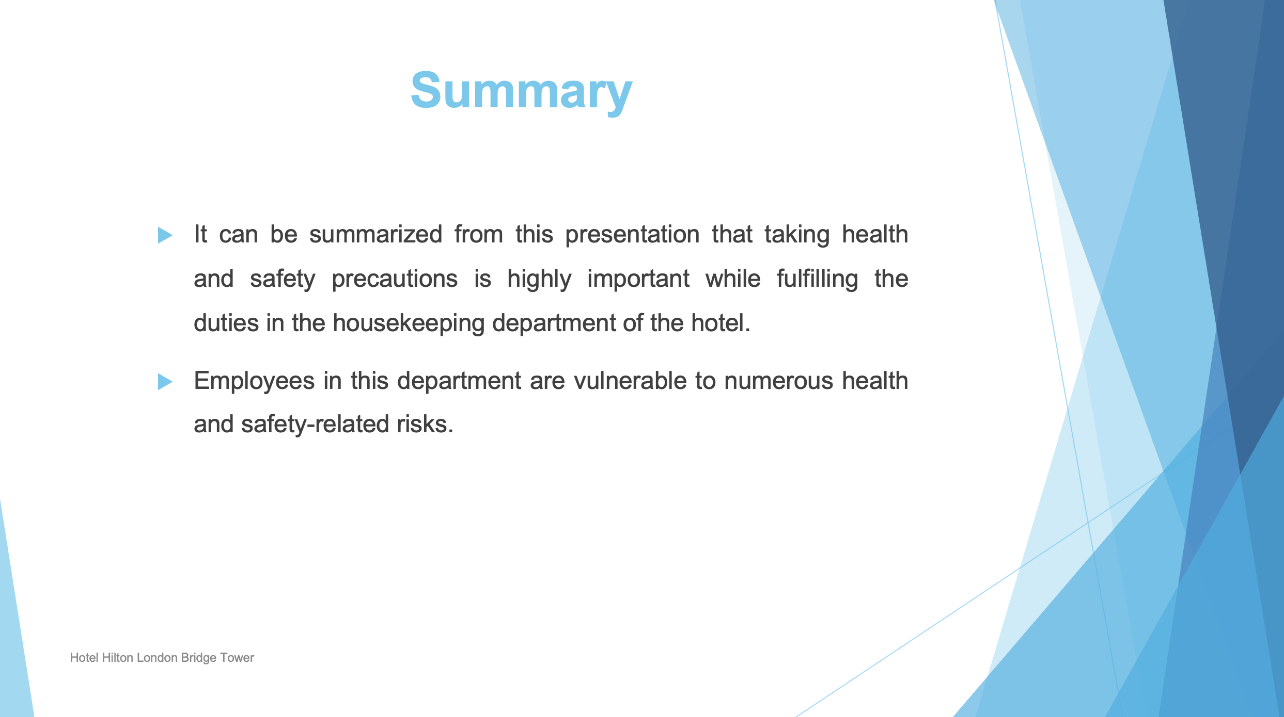

Therefore, various precautionary measures and best practices must be followed to avoid health issues.

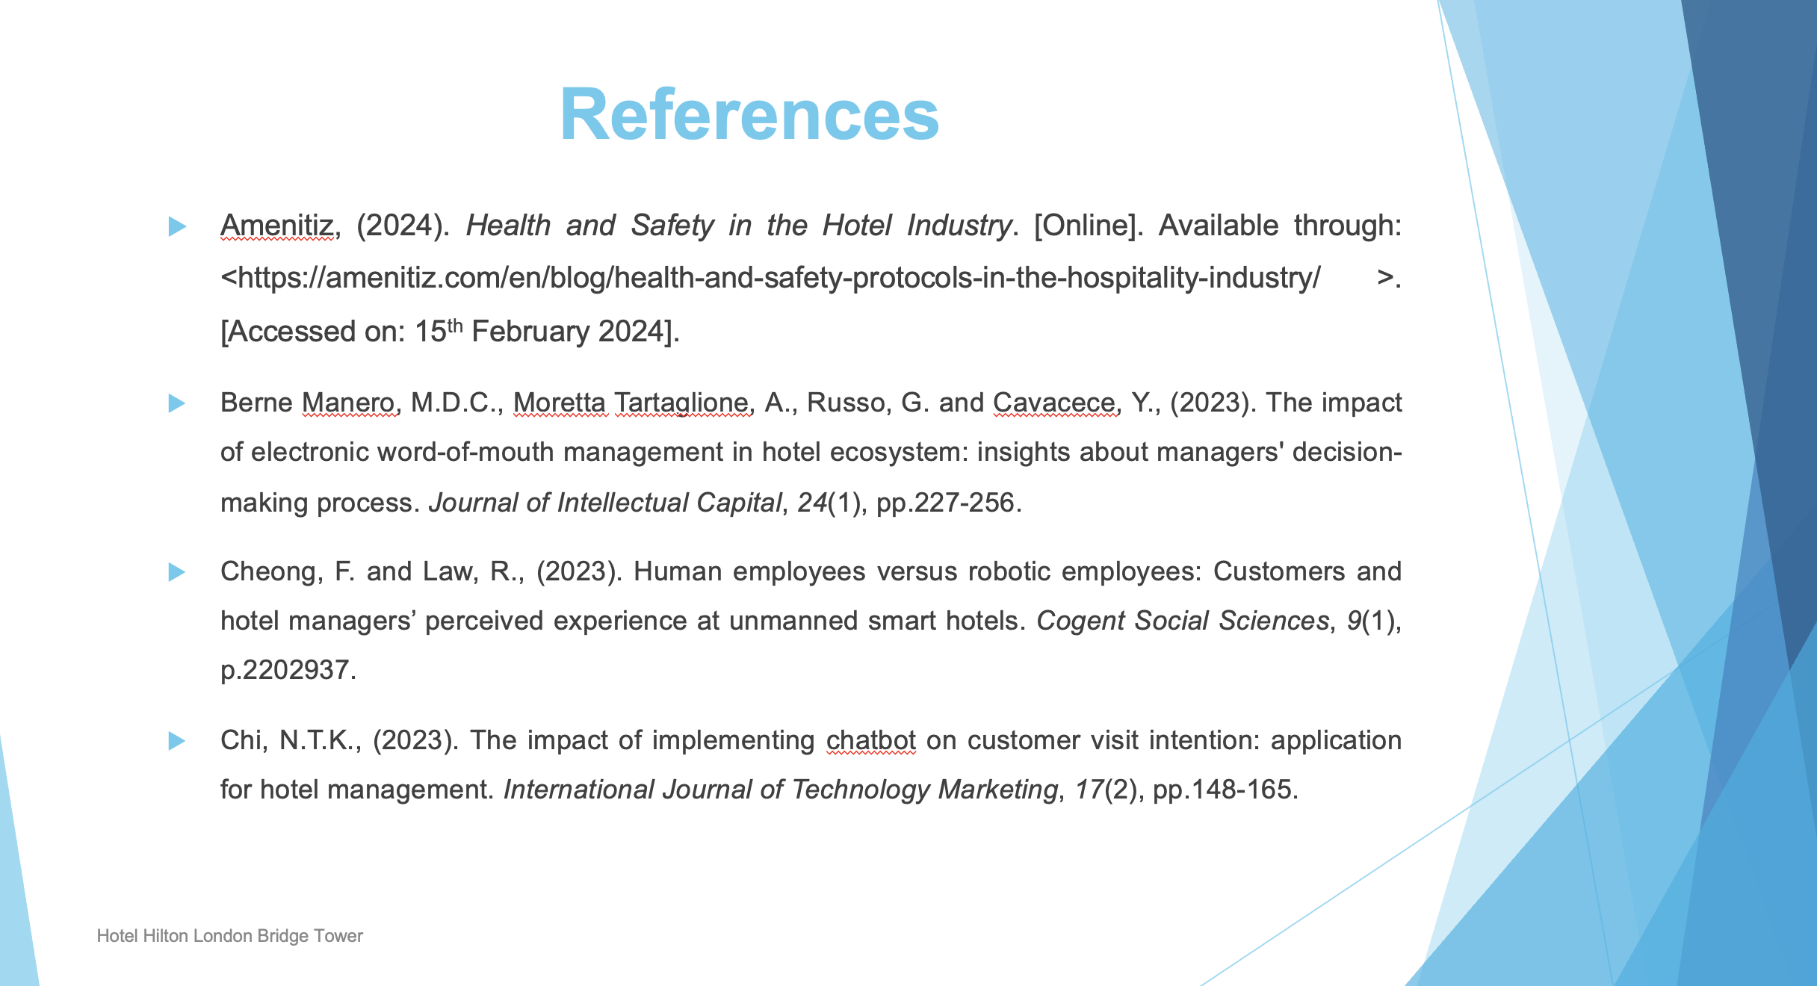

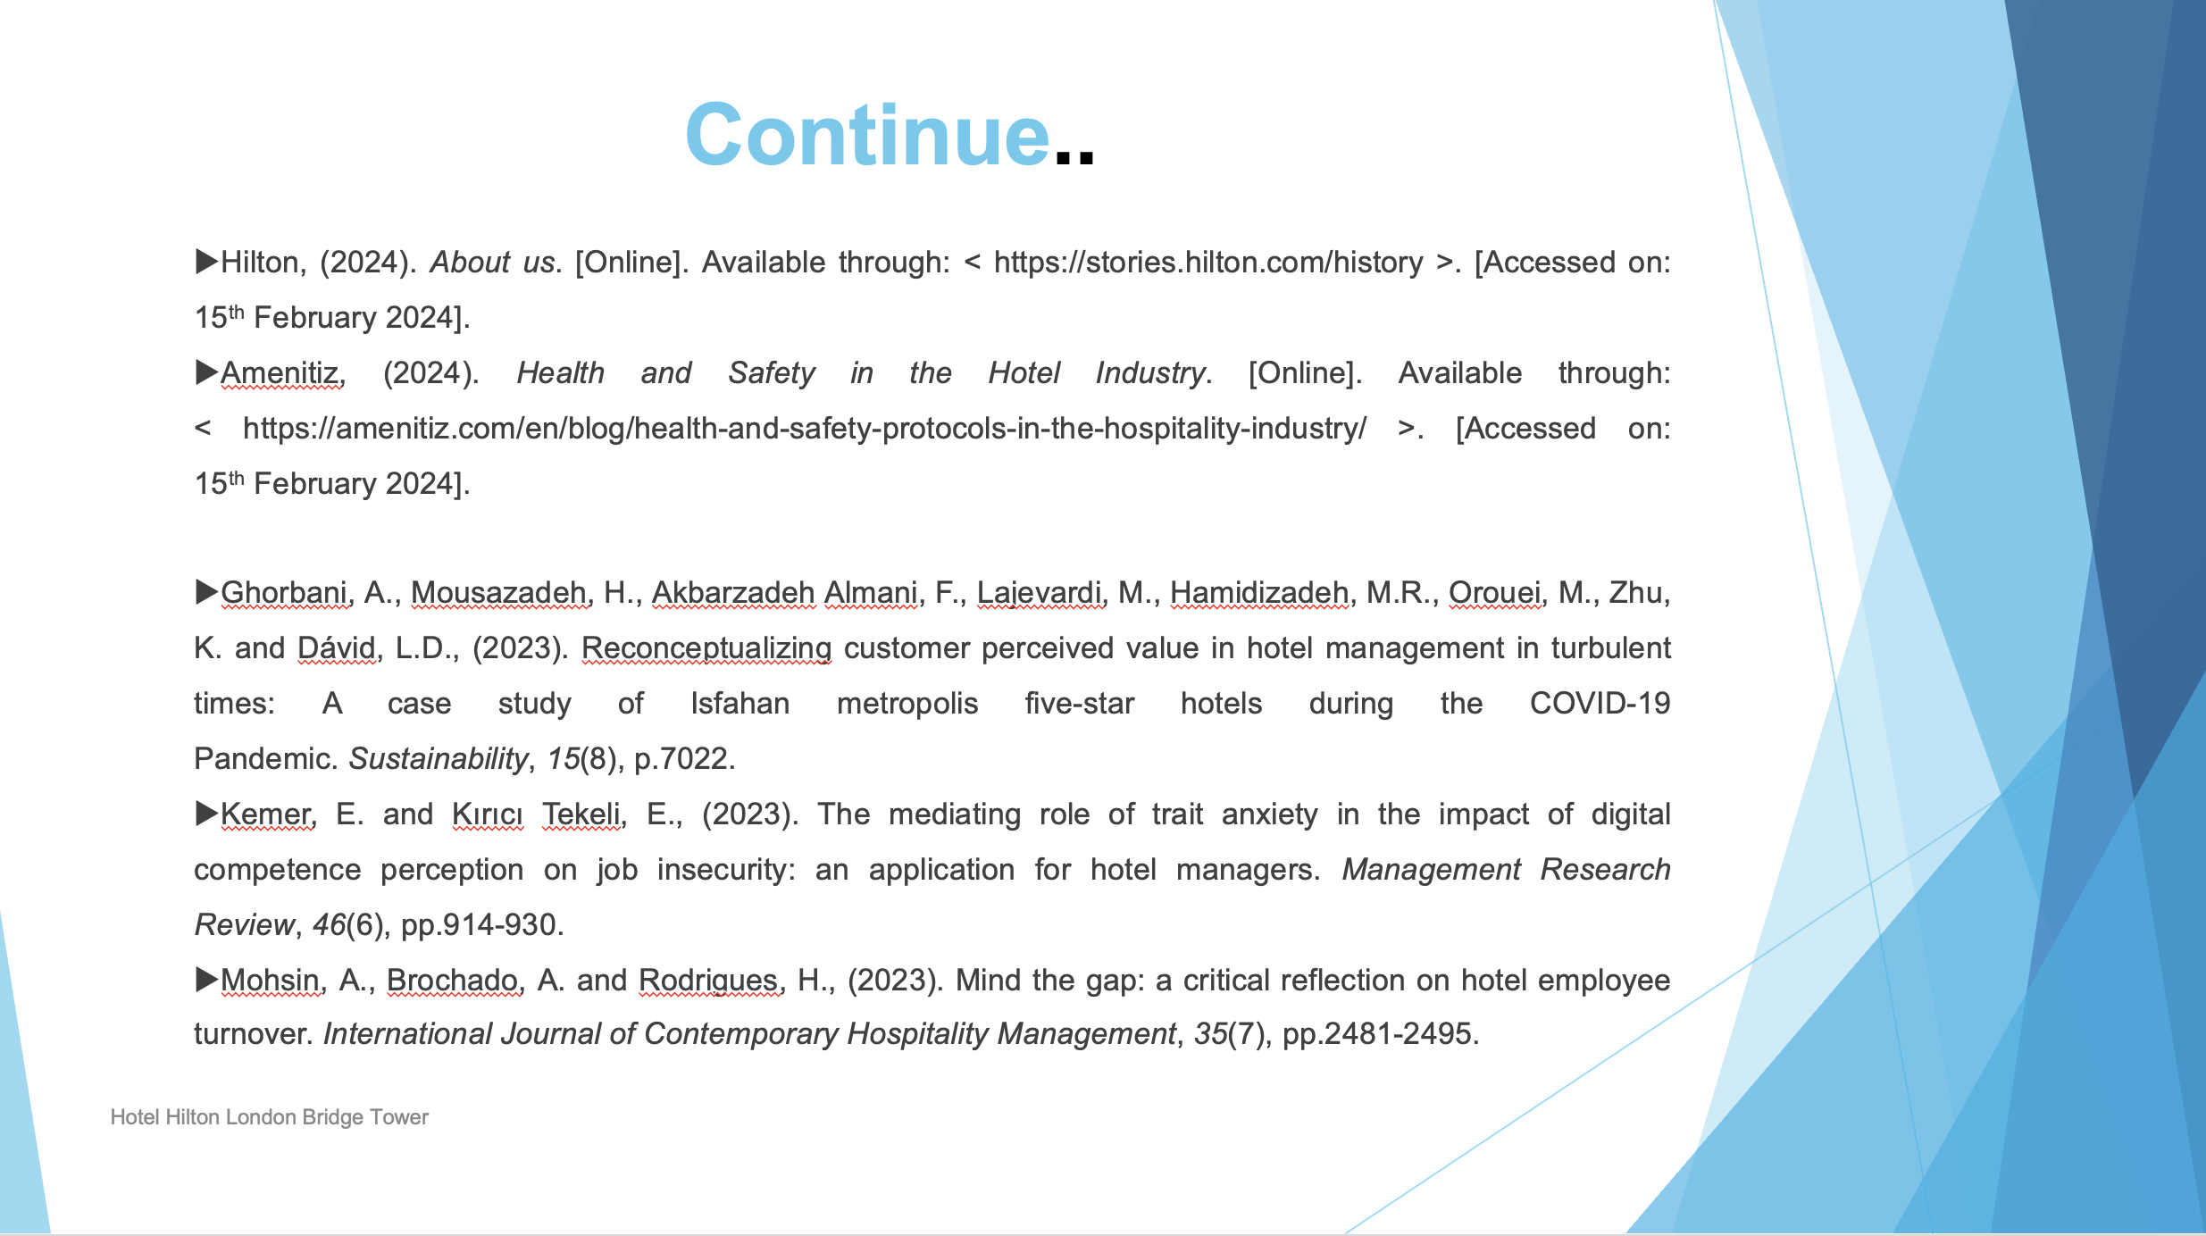
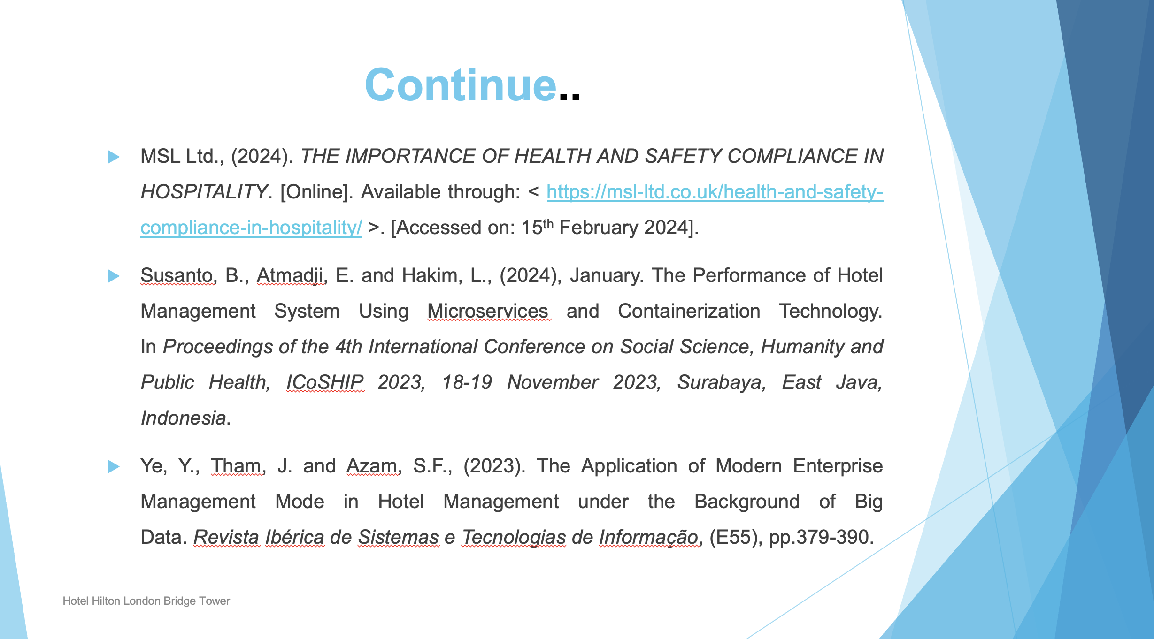

- Amenitiz, (2024). Health and Safety in the Hotel Industry. [Online]. Available through: <https://amenitiz.com/en/blog/health-and-safety-protocols-in-the-hospitality-industry/ >. [Accessed on: 15th February 2024].
- Berne Manero, M.D.C., Moretta Tartaglione, A., Russo, G. and Cavacece, Y., (2023). The impact of electronic word-of-mouth management in hotel ecosystem: insights about managers' decision-making process. Journal of Intellectual Capital, 24(1), pp.227-256.
- Cheong, F. and Law, R., (2023). Human employees versus robotic employees: Customers and hotel managers’ perceived experience at unmanned smart hotels. Cogent Social Sciences, 9(1), p.2202937.
- Chi, N.T.K., (2023). The impact of implementing chatbot on customer visit intention: application for hotel management. International Journal of Technology Marketing, 17(2), pp.148-165.

- Hilton, (2024). About us. [Online]. Available through: < https://stories.hilton.com/history >. [Accessed on: 15th February 2024].
- Amenitiz, (2024). Health and Safety in the Hotel Industry. [Online]. Available through: < https://amenitiz.com/en/blog/health-and-safety-protocols-in-the-hospitality-industry/ >. [Accessed on: 15th February 2024].
- Ghorbani, A., Mousazadeh, H., Akbarzadeh Almani, F., Lajevardi, M., Hamidizadeh, M.R., Orouei, M., Zhu, K. and Dávid, L.D., (2023). Reconceptualizing customer perceived value in hotel management in turbulent times: A case study of Isfahan metropolis five-star hotels during the COVID-19 Pandemic. Sustainability, 15(8), p.7022.
- Kemer, E. and Kırıcı Tekeli, E., (2023). The mediating role of trait anxiety in the impact of digital competence perception on job insecurity: an application for hotel managers. Management Research Review, 46(6), pp.914-930.
- Mohsin, A., Brochado, A. and Rodrigues, H., (2023). Mind the gap: a critical reflection on hotel employee turnover. International Journal of Contemporary Hospitality Management, 35(7), pp.2481-2495.
- MSL Ltd., (2024). THE IMPORTANCE OF HEALTH AND SAFETY COMPLIANCE IN HOSPITALITY. [Online]. Available through: < https://msl-ltd.co.uk/health-and-safety-compliance-in-hospitality/ >. [Accessed on: 15th February 2024].
- Susanto, B., Atmadji, E. and Hakim, L., (2024), January. The Performance of Hotel Management System Using Microservices and Containerization Technology. In Proceedings of the 4th International Conference on Social Science, Humanity and Public Health, ICoSHIP 2023, 18-19 November 2023, Surabaya, East Java, Indonesia.
- Ye, Y., Tham, J. and Azam, S.F., (2023). The Application of Modern Enterprise Management Mode in Hotel Management under the Background of Big Data. Revista Ibérica de Sistemas e Tecnologias de Informação, (E55), pp.379-390.

