 | Targed/Target | Yr hyn yr wyf wedi’i wneud yn yr aseiniad hwn….  What I have done in this assignment….
Targed/Target 1 | Rely less on description in my literature review and use more peer-reviewed literature. | I have reflected more on sources and tried to rely less heavily on description and provide some analysis of them.
Targed/Target 2 | Use accurate punctuation so my work is grammatically correct. | I have looked at the grammatical guides that were suggested and tried to use punctuation correctly throughout this essay.
Targed/Target 3 | Try not to use sources in isolation to one another, link them together using key ideas. | I have tried to link sources together and review them in order of key concepts that follow on from one another.
Critically reflect on your progress in planning, preparing and teaching lessons that incorporate specific pedagogical principles. Identify one of these pedagogical principles as an area for development and justify the next steps in your development.

ECAD6008 Assignment: Part 1

Professional Experience Template 1
Pedagogy Standard | Assessment for learning
What did you do and why? | Over the course of a week students had been reading a story called ‘Pippety Skycap’. In the penultimate lesson about the story students had to re-write the story either from memory or using prompts (depending on ability). After writing their story students were given marking labels for them to firstly assess their own work, checking off if they have included things such as capital letters, full stops, and paragraphs. If there was anything on the label they had not included they should add in corrections to their story using a purple pen. Then students asked the person next to them to assess their work using the marking label and adding in any improvements to the story in purple. Then finally, the teacher would look at the students’ work and use the marking label to check for key points, making any final corrections before students write their final draft in the next lesson. I used this technique as I had read different articles that promoted the use and development of self-assessment skills (Towler and Broadfoot, 1994, Panadero et al, 2013). It gives students an opportunity to reflect on their own work as well as their peers’, which can help them to understand critiques of their work more deeply. If they see improvements that could be made in other students’ work it helps them to understand where they could make improvements in their own work also. It also helps create more independent learners who can take pride in their work knowing they have tried their best and made improvements to it.
What have you learned? | Through this experience I have learnt that students enjoy taking responsibility for their work and working independently in some respects. Students enjoyed being given the responsibility of assessing their peers’ work and it made them feel like their opinions were important and being listened to. I have further learnt that while most of the students engaged well with the activity, some would have benefitted from additional supervision. Some students tried to complete the marking as quickly as they could and did not give their peers an appropriate amount of feedback.
What next? | If I were to repeat this activity in the future, I would change the layout of my marking labels to make them look more appealing to the students. I would include less points for students to look for and focus in on the most important ones. I would also consider changing the ability levels of the pairs marking each other’s work. Mixed ability groups would be helpful for marking as the higher ability students would be able to give more advice to lower ability students. To help with this in the future I will continue reading articles about self and peer assessment and the best method of accomplishing it. I have also taken on advice from out bridging experience where many student teachers spoke about this topic and I will use their experiences to help inform my future practice.

Professional Experience Template 2
Pedagogy Standard | Blended learning experiences
What did you do and why? | Many of the lessons I taught worked on a carousel basis so over the course of a lesson or day students would rotate and try different activities. For example, when teaching a mathematics and numeracy lesson one group of students would work at the front table with myself on the interactive whiteboard completing sums and going through a powerpoint presentation. Another group would work with a teaching assistant playing a game such as maths bingo, where a number was called out and students had to work out if their sum resulted in that number. Then first one to check them all off wins. Finally, the third group would work independently either on laptops or doing an activity such as maths colouring in. Where students had to work out the answer to questions then look at the colour key and colour in the square the required colour to eventually reveal what the picture is.
What have you learned? | I have learnt that blended learning experiences help to keep student engaged, especially if there is a whole day focused on one topic. However, it is also important to make note of which activities students found less enjoyable so in future I could revise them or use a different activity. There was often one activity that students looked forward to the most, for example, the maths bingo. So students would look forward to this and work hard in their other activities so they could participate in their favourite one. Although, if their favourite activity was the first one they did this could sometimes have s negative impact as they weren’t as engaged with the rest of the day’s activities then.
What next? | Moving forward I will continue to use blended learning experiences as I found they were very useful to keep students engaged with the lesson. I will continue to reflect on the methods and activities I use to ensure I choose ones which will keep students interested. I will read more journal articles to improve my knowledge of which teaching methods are best blended together and complement each other the most.

Professional Experience Template 3
Pedagogy Standard | Real life authentic contexts
What did you do and why? | An example of when I incorporated real life authentic contexts into teaching is when I was teaching a maths lesson and related it to the real-life situation of buying items in a shop. The focus of the lesson was practicing multiplication and times tables. To begin with the class sang a multiplication song that they knew and had been practising for quite some time. Following this we went over some questions as a group that would lead into our main activity. They were questions such as ‘I would like to buy 6 apples for 10p each, how much does this cost?’. As a class we discussed that we can break this down into 6x10=60 and repeated this for different amounts and items. I then asked the students to work with the person next to them and role play working in a shop/buying an item. Students had plastic coins they can use and whiteboards with pens to help them work out difficult sums. They also had a list of questions that was differentiated for each group. One student would ask the other a question such ‘Can I buy 12 bananas for 20p each please?’ and the other student would have to work out how much this would cost. Students would swap roles after each question so that everyone had a chance to play each role. I used this technique because the use of multiplication and maths tied in nicely with the real-life situation of going to a shop and buying things. Students had previously asked me why they had to learn their times tables, and this was a perfect example of why it is very important to know them.
What have you learned? | This experience highlighted for me the importance of students enjoying and having fun in lessons. Instead of writing out sums in their books students were able to act it out and they all seemed to really enjoy the lesson. After the success of this lesson I have looked more at Glasser’s choice theory (1997) and the importance of meeting students’ needs, such as having fun, in order for them to get the most possible out of a lesson.
What next? | If I were to repeat this activity then I would try to use more props to make it more realistic. Students enjoyed using the plastic money and it helped to further relate the skills they were learning to how they would use them outside of school. Using more props such as plastic fruits or other food and drink items would have allowed for even more student engagement in the activity. I would also make some of the questions more open ended for the higher ability students. I would allow them to choose their own items that they wanted to buy and work out the price it would come to. This freedom would mean they can push themselves if they feel able to and try adding up a variety of multiplication sums. Further to this, with the lower ability students if they were struggling I would suggest we work as a group initially with myself as the customer and they can work together as the shopkeeper. Once they were more confident they could branch out and work in smaller groups or pairs.

Professional Experience Template 4
Pedagogy Standard | Cross-curricular themes
What did you do and why? | When learning stories in the classroom we would first read the story as a group, then individually. After this students would undertake different activities that incorporated cross-curricular themes throughout the week to help them the story. Students would creative story maps of key events, drawing illustrations to visually remind them. They would also act out their favourite scene from the story in small groups, which helped them remember which characters said what. Thirdly, they would also create actions that they would use alongside reading the story to help them remember it. So if a student was struggling to recall what happened next I would advise them to go through their actions and this would often lead them to remembering.
What have you learned? | I learnt that the students were much more engaged with the activities that incorporated cross-curricular themes as the lessons did not feel so repetitive to them then. Students particularly enjoyed acting out their favourite scenes from the story as expressive arts was an area of learning that they did not get to practise as much as some other areas like language, literacy and communication.
What next? | Moving forward I will try to incorporate cross-curricular themes into all of my lessons where possible. It allows students the opportunity to practise skills across all areas instead of just one. It also helped keep them more engaged as it made lessons more exciting when they were doing different activities to what they would normally be doing.

Word count: Approximately 2,000
ECAD6008 Assignment: Part 2
The pedagogical principle identified for further development throughout this essay is assessment for learning (AfL). There are many different AfL strategies, but AfL as a whole can be broadly defined as activities where the priority is promoting student learning rather than specific goals or targets. It is “assessment that is for learning, as opposed to merely of learning” (Florez and Sammons/CfBT Education Trust, 2013, p.2). This principle has been chosen as the focus for development as it is one I have employed often in my own teaching, meaning classroom experiences can be drawn off as well as experiences from the second bridging presentation. Peer and self-assessment will be the primary focus of investigation although AfL strategies as a whole and how best to conduct them are also considered.
I employed peer and self-assessment whilst teaching through the use of marking labels which students used after they had completed writing a story either from memory or with prompts (dependent on ability). We had been focusing on the story for the week prior so students knew it well, and whilst they were trying to rewrite it as best they could, the main objective was being able to recognise and correct any mistakes in their work rather than perfectly retell the story first time around. Students could first use the marking label to check for key points such as correct spelling and punctuation in their own work, writing in any improvements they noted in a different coloured pen. Then students swapped work with their peers for assessment using the same marking label and criteria. Their peers would also write in any possible improvements in a coloured pen. Lastly the work was also reviewed by the teacher.
Self-assessment is a form of assessment where students take the lead in reflecting on and evaluating their own work, as well as what they have learnt through the process of its creation. It is most effective when students can judge their work against a clearly stated success criteria or goals/targets which allows them to recognise where the strengths and weaknesses in their work lie (Andrade and Du, 2007). This then leads onto students being able to edit their own work and developing the skills necessary to effectively reflect on where improvements can be made. Peer assessment is a similar process, except students are providing feedback about the work of their peers, directly to them, instead of their own work. A success criteria of some kind is also regularly used to give students something to compare work to. This ensures they are focusing on the intended aspects of the work, for example, spelling or punctuation. Peer assessment can sometimes include the allocation of a mark or grade by students to their peers, but writers such as Boud and Falchikov (2007) have argued this aspect of peer assessment can create difficulties. Students are not used to providing grades for pieces of work so can find it a daunting undertaking and may provide grades that are not reflective of the grade a teacher would have provided.
Peer and self-assessment are important AfL techniques because they hand part of the responsibility of assessment back to the students. Students are used to producing work which is then marked by teachers and returned to them. Allowing and encouraging students to be involved in both sides of the process can help them to develop and entrench new skills such as self-awareness and reflection. Spiller (2012, p.2) argues that “assessment processes in which the teacher holds all the power and makes all the choices limit the potential for learner development”. The importance of teachers being reflective practitioners is outlined in Donaldson’s (2015) report and is highlighted as a necessary skill for teachers to develop in order to improve their future practice. Many of the reasons why teachers are encouraged to be more reflective are true for students too. Reflection upon one’s work and progress can help teachers identify areas for development in their practice. This is often done through peer assessment in the form of observations from other teachers/staff members. As well as through self-assessment such as reflecting on the outcome of lessons and whether students achieved the intended goals. These are the same skills that AfL techniques aim to develop in students, namely the ability to recognise where improvements can be made in a positive manner.
This leads onto the next point regarding peer and self-assessment, that in order for it to be as effective as possible teachers should model it through their classroom behaviour. If students see their classroom teacher receiving critiques of their work or practice from their colleagues, in a positive manner, then this sets an illustrative example for students of how they too should take corrections suggested by their peers. Moreover, it is important for teachers to set and illustrate guidelines for student behaviour when giving and receiving assessment. The most successful way to do this is when students are involved in the creation of guidelines and thus already implicitly agree with them (Williams et al, 2004). In particular for students who are not used to peer assessment it can be essential to stress the need to be kind to each other and not be unnecessarily critical. Similarly, it may be helpful to speak to students about how best to accept constructive criticism and not take it personally. Having a marking criteria also lessens the chance of unconstructive criticism as there are specific points to look for and mark to (Ibid). Whilst student involvement in the process of creating success criteria has been noted as a positive, depending on the age of students this process may need to be primarily teacher-led to ensure all the key points are adequately addressed.
Following on from the importance of modelling good methods of peer and self-assessment, during the second bridging presentation for student teachers many of the presentations focused on this topic. This in itself acted as a catalyst for peer and self-assessment of how we were implementing this technique within our classrooms. After listening to the presentations of my peers, many of whom had used marking labels also, I was able to self-assess my own implementation of them more effectively and take on board advice from my peers. Due to this I conducted further research into how to make AfL more fun for students to engage with, as this was something my peers suggested and had incorporated into their own lessons. This research has illuminated the importance of relating lessons to subjects that students already had a prior interest in. For example, if students are writing stories and peer assessing them with marking labels, students are likely to be more engaged in the process if they are writing a story about a topic they find interesting. Thus, they should be more interested in reading each other’s stories (Perry, 2012). This helps build their skills further as students will take different approaches to tasks, and they will be able to learn from each other’s different perspectives.
The importance of AfL techniques such as peer and self-assessment are further highlighted through Donaldson’s 12 pedagogical principles. Peer and self-assessment incorporate many of the principles, particularly, encouraging collaboration, supporting social and emotional development and positive relationships, use of assessment for learning to accelerate progress, and sustained pupil effort to reach high but achievable targets (Impact Wales, 2018). Moreover, using such methods could also easily meet the principle of reinforcing cross curricular responsibilities – literacy, numeracy, and digital competence. Peer and self-assessment is often used in literacy based lessons but this could incorporate digital competence by students being involved in the creation of marking labels on laptops, or writing their tasks on laptops and having them be marked on there.
It has been argued by To and Panadero (2019) that engaging in peer-assessment can aid in the development self-assessment skills by furthering their reflective skills. Objective feedback from a student’s peers can give them a fresh perspective on their work as they may approach feedback in a different manner to how a teacher would. Suggesting that peer-assessment should be engaged in before self-assessment to allow students to develop the necessary skills to adequately reflect on their own work. Additionally, they argue that the influence of peer assessment can be reduced depending on the students in question. If there is mistrust between students or tensions of some kind this can impact how effective the peer assessment is (To and Panadero, 2019). There may be unconscious biases at play when assessing another student’s work, or a student may be hesitant to take advice from a fellow student they do not fully trust. It should also be noted that To and Panadero’s (2019) argument is based around data received from first year university students, so will likely have some different conclusions drawn compared to if it was primary age students. Nevertheless, there is still some evidence to suggest that effective peer self-assessment skills breeds more effective self-assessment skills.
AfL techniques such as peer and self-assessment can sometimes tend to be associated with slightly older students, such as those in key stage two or in secondary school. However, there is evidence from authors such as Towler and Broadfoot (2006) that peer assessment can be effectively introduced into early years settings and can in fact be very beneficial. Introducing such concepts very early on can be beneficial because they are techniques often used later in education, like secondary school or in higher education settings. Students who are more experienced in peer and self-assessment often gain more from the experience as they are able to take constructive criticism from it and apply it to their future work without taking on board any negative feelings surrounding their work needing improvements (McDonald and Boud, 2010). Similarly, students who have spent more time assessing the work of their peers are more able to give high quality feedback and focus in on the more important aspects, for instance correcting spelling mistakes rather than focusing too much on handwriting style. Whilst it is beneficial to introduce these techniques early on the students, it will also require a lot of scaffolding to ensure that students are employing it effectively and not simply writing positive remarks about their friends and less positive reviews of those they are not as friendly with.
The introduction of self-assessment skills early in the education of students can also be advantageous during the current climate of Covid-19. Some students have spent lots of time at home either isolating or when schools could not open and being able to effectively reflect on their own work during this time would be hugely helpful to their development (Margevica-Grinberga and Vitola, 2021). Introducing self-assessment tasks can help students develop their understanding of their own skills, learning which tasks they struggle with or excel at, and why. This can help them plan their own time when learning from home, as there may other distractions present making learning during typical school hours more difficult. Moreover, this kind of self-assessment can also allow teachers a greater insight into how their students are approaching tasks and how well they feel they are doing (Ibid). This can aid teachers in tailoring future tasks and lessons to best fit their class. Although, to gain this kind of understanding it is likely more detailed means of self-assessment than marking labels would be necessary, and it would require students to fully engage with the process.
There is also evidence that whilst self-assessment and self-regulated learning has been beneficial to some students whilst learning from home, this has not been the case for all students (Cai et al, 2020). COVID-19 caused disruptions to the typical learning day for many students at one point or another and some found these disruptions more impactful than others. Some students when learning alone at home instead of a busy classroom did not engage with self-assessment as fully as they could have and would have benefitted from more direct assessment from their teachers. If teachers wish to employ self-assessment techniques when students are learning from home, it is suggested by Cai et al (2020) that they are sure this is something their students feel confident in and they are clearly shown how to do it effectively. Additionally, issues with peer-assessment may arise if trying to do this online rather than in person, as sometimes words do not translate as well over text or even video, as they do in person. It can be easily for something to be misinterpreted and to be taken more negatively than was intended.
A final approach examined is Glasser’s (1999) choice theory and his argument that there are five key basic needs: love/belonging, power, survival, freedom, and fun. Glasser argues that if these needs are fulfilled then students will be much more likely to behave, and hence, gain the most they can from a lesson. Research has shown that implementing his theory into to classroom can help foster skill such as creativity, a positive self-image, and a cooperative approach to tasks (Naderi et al, 2019; Olutayo 2012). These are tools that can then be utilised in peer and self-assessment. For example, having a positive self-image of oneself can a student take constructive criticism in the manner intended, and not focus solely on the negative aspects of their work. Moreover, a cooperative approach can assist in peer assessment as students would be more likely to work together effectively to improve each other’s work. However, for this approach to be effective all five needs would have to be fulfilled which may not always be plausible in larger classes, particularly where there are children with additional learning needs.
When reflecting on my own use of peer and self-assessment techniques there are several ways in which I would change my use of them in the future. Primarily I would place a lot more importance on the role of reflection in the assessment process. Donaldson’s (2015) report highlights the critical role of reflection in teachers improving their practice and I believe this can be applied to students as well. When using marking labels, I would encourage students to take more time completing them and to think about not just what could be improved, but how it can be improved and why it should be. I would change the format of my marking labels (see appendix) to include more space for student reflections and would use reflective question prompts to encourage students to engage with reflection. I would also
After considering input from my fellow student-teachers at our bridging presentation, in future I will adapt my marking labels to make them more interesting to students. I could due this by changing the design of them so they look more attractive, but also by ensuring the lesson they are using them in is centred around a topic they are interested in. This also links to the basic need of fun in Glasser’s (1999) choice theory, and whilst I feel that it would be difficult to fulfil of the needs he suggests, all of the time. Going forward I will strive to make sure lesson plans incorporate fun and innovative ideas so that students stay engaged with the topic. When I used my marking labels, I found that some students became disengaged after a while and were trying to complete them as fast as they could, not giving theirs or their peers work the level of attention it deserved. Further to this I would spend more time at the beginning of the lesson explaining the purpose of the labels and how students should aim to give as much feedback as possible to their peers. Stressing the point that while it is acceptable to point areas that could be improved in others’ work, it is not acceptable to do so in an unkind way.
Overall, I believe that the use of peer and self-assessment through marking labels is a good AfL technique and teach students to become more reflective about their work and how they can improve it, rather than always relying on teacher input. Particularly in COVID-19 times this is beneficial as there may be a time where they are remote learning again and whilst they would still have input from teachers, having reflective self-assessment skills would be an invaluable tool. This type of AfL is a technique I would employ in foundation phase in future teaching experiences, however, I would adapt the labels to make them clearer and have less points to focus on. Peer and self- assessment may be a skill often associated with older students but it is a technique often implemented in secondary schools and higher education settings, so starting to use it a young age will be very helpful for students.

Talk abouot which parts of the marking labels didn’t work and why they didn’t. any iterature that backs up why they didn’t work and how to try and avoid this in the future.
Be more critically reflective of my teaching in the last part, reflect on how I would plan them differently, how I would teach them differently/what was good, and how I felt about them after. Try to link to some kind of theory.
Mrking labels, say students like some independence, makes them feel good to mark their own work and to mark other students work. Say that I made it clear that they should be nice and not make fun of each other. Can talk about bridging experience and hwo that helped me choose to focus on this one. Say that seeing other peples presentations gave me extra ideas. Like how to make the marking labels moore visually appealing etc.
Be reflective in the lit review, write about a point how it relates to what I did, pros/cons etc anyone who disagrees then reflect on it and say how I will use it or why I Wont going forward.
In this section, provide an assessment and summary of the approach you have taken and identify your next steps. It is important that you link your approach to the role of the reflective practitioner in Wales and the new Professional Standards for Teaching and Leadership. Justify specific actions you will take in future teaching experiences. These should derive from the critical discussion.

Word count:

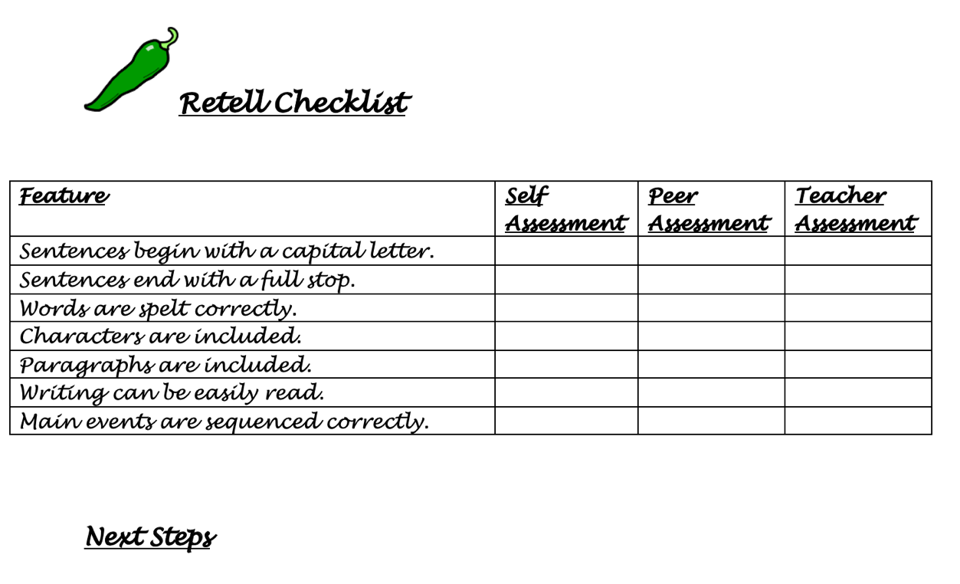
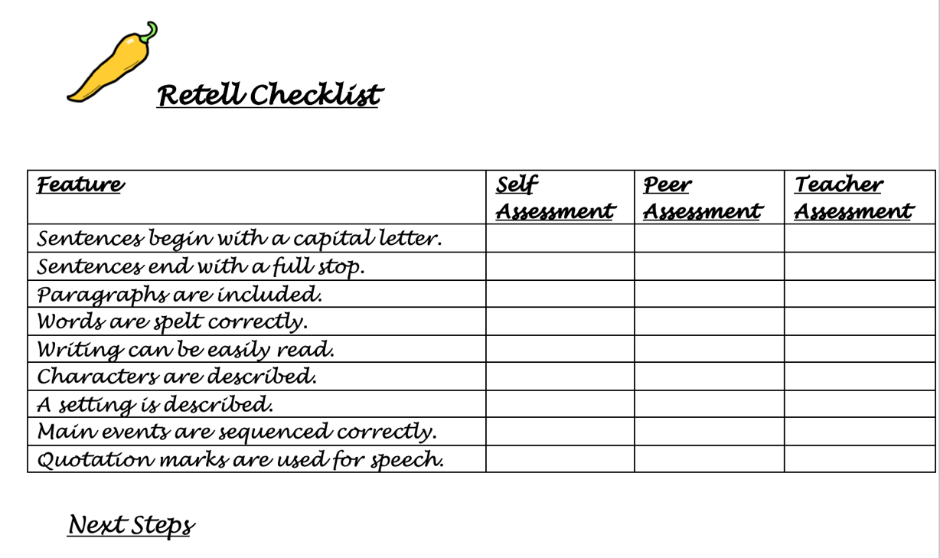
Appendix

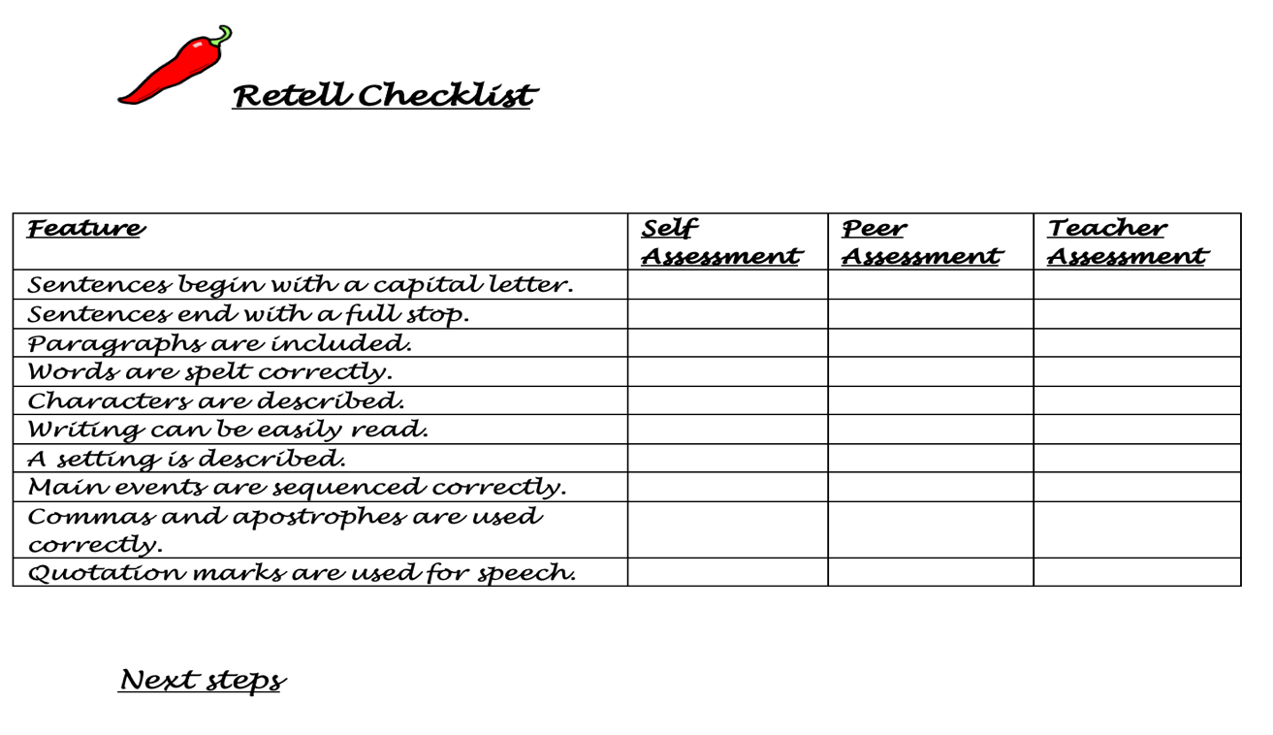

References
Andrade, H, and Du, Y. (2007). ‘Student responses to criteria-referenced self-assessment’. Assessment and Evaluation in Higher Education. 32 (2). 159-181.
Boud, D, and Falchikov, N. (2007). Rethinking assessment in higher education. London: Kogan Page.
Cai, R, et al. (2020). ‘Effectiveness of Students’ Self-Regulated Learning during the COVID- 19 Pandemic’. Sci Insight. 34(1). pp.175-182.
Donaldson, G. (2015). Successful Futures: Independent Review of Curriculum and Assessment Arrangements in Wales. Available at: https://gov.wales/sites/default/files/publications/2018-03/successful-futures.pdf [Accessed: 30/12/2021].
Florez, M, T, and Sammons, P/CfBT Education Trust. (2013). Assessment for learning: effects and impacts. Available at: https://www.educationdevelopmenttrust.com/EducationDevelopmentTrust/files /5a/5a6d6203-ec49-4d33-9c5d-42c188184807.pdf [Accessed: 02/01/2022].
Glasser, W. 1999. Choice theory: A new psychology of personal freedom. USA: Harper Perennial.
Impact Wales. (2018). Donaldson’s 12 Pedagogical Principles. Available at: https://www.impact.wales/wp-content/uploads/2018/01/12-Pedagogical- Principles- 1.pdf [Accessed: 03/01/2022].
Margevica-Grinberga, I and Vitola, K. (2021). ‘Teacher Education Students’ Self- assessment in COVID-19 Crisis’. Psychology and Education. 58(3). pp.2874- 2883.
McDonald, B and Boud, D. (2003). ‘The Impact of Self-assessment on Achievement: The effects of self-assessment training on performance in external examinations’. Assessment in Education: Principles, Policy & Practice. 10(2). pp.209-220.
Naderi, H, et al. (2019). Effectiveness of quality education based on Glasser’s choice theory and the student’s academic self-efficacy. Iran: University of Mazandaran.
Olutayo, B, G. (2012). ‘Using Glasser’s Choice Theory to Foster Creativity’. International Journal of Choice Theory and Reality Therapy. 32(1). pp.22-26.
Perry, D, L. (2012). What Makes Learning Fun? Principles for the Design of Intrinsically Motivating Museum Exhibits. USA: Rowman Altamira
Spiller, D. (2012). Assessment Matters: Self-Assessment and Peer Assessment. New Zealand: The University of Waikato.
To, J and Panadero, E. (2019). ‘Peer assessment effects on the self-assessment process of first-year undergraduates’. Assessment & Evaluation in Higher Education. 44(6). pp.920-932.
Towler, L, and Broadfoot, P. (2006). ‘Self-assessment in the Primary School’. Educational Review. 44(2). pp.137-151.
Williams, D, et al. (2004). ‘Teachers developing assessment for learning: impact on student achievement’. Assessment in Education: Principles, Policy & Practice. 11(1), pp.49-65.

