

MODULE CODE: ECPT6006

ASSESSMENT COMPONENT: A Critical Evaluation of the Role of Digital Innovation in Professional Practice

STUDENT NAME: Daniel Ashby

STUDENT NUMBER: 2114240

Use of Generative AI in Assessment

(Lecturer to indicate Yes or No against each element)

RESEARCH | For this assessment, you can use Generative AI to support you in research, including searching for bibliography, using tools to summarise, compare and interrogate materials. | Yes ☒  No ☐
STRUCTURE | For this assessment, you can use Generative AI to support you in structuring your submission, including creating a draft argument structure, identifying parts and headings, etc. | Yes ☒  No ☐
PROOFREADING | For this assessment, you can use Generative AI to check your own text/creation for grammatical and syntactical mistakes, including rephrasing of your own work within specific standards. | Yes ☒  No ☐
WRITING | For this assessment, you can use Generative AI to create text for submission. | Yes ☐  No ☒
CREATIVE | For this assessment, you can use Generative AI to create creative materials, such as images. | Yes ☒  No ☐
PROGRAMING | For this assessment, you can use Generative AI to create and check code. | Yes ☐  No ☒
NONE | For this assessment, you are not allowed to use any type of Generative AI support. This includes research support, structure support, writing/proofreading support and creative support. | Yes ☐  No ☒

AI Acknowledgement
I confirm that I have not used any AI tools in the research and creation of this assignment.
I confirm that I have not presented any AI generated materials as my own work.
I confirm that I have copies of my drafts, notes, and other resources I used, which I may be asked to provide in evidence.

A Critical Evaluation of the Role of Digital Innovation in Professional Practice

Introduction 230 words
Fowler and Leonard (2024) argue that digital innovation holds significant potential to enrich and improve learning outcomes in modern education settings. Derrick, Laurillard and Doel (2016) highlight that digital innovation has become increasingly central to professional practice in the post-16 sector, leading to a shift in the way that educators design learning, assess progress and develop their own professional and digital skills. Furthermore, they also note that the further education (FE) workforce is now expected to implement and integrate more digital tools into their everyday pedagogical approaches and work more confidently with emerging technologies, mirroring those that are used in modern workplaces.

Whilst considering these viewpoints, this assignment will critically evaluate the role of digital innovation in professional teaching practice. It will also explore the benefits of digital innovation in post-16 education, as well as exploring some of the potential drawbacks. To connect theory with practice, the writer will be examining the use of Mentimeter as a formative assessment tool in the classroom. The analysis of this tool will examine how Mentimeter can contribute to professional practice and how it can be implemented effectively to potentially improve learners’ academic outcomes.

The discussion will be structured into four key sections: firstly, a literature review, a justification for the chosen digital tool, an outline of its practical application in the classroom, and a critical reflection of its impact on teaching and learning.

Literature Review – 1917 words
Hund et al. (2021) state that although the term digital innovation has become an increasingly prominent theme, its conceptual boundaries remain much contested. However, they suggest more recent work places a definition on digital innovation as developing or taking up new and useful products, services, or ways of working that rely on digital technology. The focus on this definition, therefore, should be based on the usefulness of technology depending on the needs of the user. A study by Henderson et al. (2017) gives a clear indication of this, arguing that students value digital technology that helps to support the practical demands of their studies, such as organising deadlines, being able to access information, tools that save time, and ways of accessing recorded materials. As a result, they say that this contrasts with institutional narratives from settings such as universities and colleges around digital innovation being a means of improving, transforming or modernising learning. These narratives often emphasise innovation, effectiveness and futureproofing that can overlook the practical applications that Henderson et al. (2017) argue are more important to students. Additionally, Selwyn (2016) identifies 4 key downsides to digital technology, namely distraction, disruption, difficulty and detriment. These can range from technology failures in the classroom to diminished learning experiences because of using digital technology. Together, these studies show that digital innovation can be both supportive and potentially hinder learning, placing a higher emphasis on usefulness, and something being useful cannot always be assumed, and any use of digital technology should be meaningful. This balance is relevant in the post-16/FE sector, where a diverse range of student needs can shape how digital innovation is experienced.

Digital innovation within the post-16 and FE sector is influenced by contextual conditions in a way that potentially differs from other elements of education, particularly as both staff and learners engage with digital tools in learning environments that have uneven access or restricted resources. According to the Joint Information Systems Committee (Jisc, 2025a), 45% of learners in further education do not have access to a suitable device for learning, with 9% of learners relying solely on the use of a smartphone, whilst 27% of learners were using a loaned device to study. These figures illustrate how inequalities can have a significant effect on how learners engage with digital tools. Jisc (2025a) also highlighted connectivity issues, which undermined learner engagement, with 59% of learners experiencing wi-fi connectivity issues with 48% struggling to access the systems that they needed. These obstacles are not just limited to FE learners, with the Joint Information Systems Committee (Jisc, 2025b) also highlighting that FE staff also described issues with a lack of devices, connectivity issues and inability to access essential systems, all of which undermined and hindered lesson planning, delivery and assessment. Beyond access issues, Jisc (2025b) also found that there were substantial issues with professional development around digital competence, with only 46% of staff reporting that they had received the guidance required for digital skills, only 29% of staff having the time to explore and experiment with new tools and 21% of staff receiving recognition for their digital expertise. Together, the issues reported by both learners and staff highlight a persistent gap between institutional policy expectations around the use of digital innovation and the realities experienced in the settings. This reinforces that digital innovation must align with the conditions in which it is being used. This is a fundamental foundation before examining the role of digital technology in formative assessment.

What is Formative Assessment?
When considering how effectively digital technology can be implemented in classroom formative assessment practices, the writer feels that it would be beneficial to examine the concept of formative assessment. Black and Wiliam (1998) describe formative assessment as all the activities undertaken by an educator which provide live information which can be used to modify approaches to teaching and learning, including students assessing themselves. Additionally, Wiliam (2009) argues that formative assessment should help educators formulate a picture of where a student is now in their learning, where they need to go next and how they are going to get there. Black (2007) suggests that there are four critical components to assessment for learning, these include sharing success criteria, questioning, feedback, and finally self and peer assessment. Wiliam (2009) also advocates for the use of formative assessment in education by arguing that its use can have a significant effect on learning outcomes for learners, adding the equivalent of as much as eight months of additional learning per year and is highly cost-effective when compared against other strategies such as reduced class sizes. Whilst not entirely relevant to post-16 education, it is worth noting that formative assessment is embedded into Welsh educational policy in compulsory school education, with the Welsh Government (2024) stating that assessment is intrinsic to teaching and learning whilst also including a requirement for teaching staff to utilise formative assessment methods, signalling the new curriculum in Wales has embraced formative assessment and moved away from more traditional summative assessment practices such as the use of end of teaching testing.

Despite the positives surrounding formative assessment and the widening implementation of it in education as an approach to assessment, it is also worth noting that formative assessment is not without critics. An example of this critique includes Brown (2019), who claims that formative assessment is not a true form of assessment and in fact claims that the in the moment judgements on which it relies are not formed with verifiable data which he feels are prerequisites of quality assessment practices, adding that formative assessment should be seen more as a pedagogical approach as opposed to assessment. Additionally, Schildkamp et al. (2020) also believe that for formative assessment to be truly effective there are a set of prerequisites for a teacher to possess, these include data literacy, high quality feedback skills, a positive attitude and supportive psychological and social conditions, which they argue are not always frequently in place in classrooms reducing how effectively formative assessment can be implemented. In higher education Morris et al. (2021) also questions the credibility of formative assessment stating that the evidence base on which claims are made is limited and inconsistent, they do note however that some benefits were noted in some aspects such as low stakes quizzes, however found that aspects such as feedback timing, grading and technology lacked any basis for the generalised claims about formative assessment across varying contexts

Digital tools for formative assessment?
Audience response systems (ARS) are widely recognised tools that enable learners to submit responses in real-time and receive immediate feedback, which is an important element in formative assessment as outlined by Black (2007). Picardo et al (2021) define Mentimeter as an instant online audience response system, with Mayhew et al. (2020) also describing it as a new generation web-based ARS system which is used to support interaction in large group teaching. These definitions firmly place Mentimeter within this genre of system and therefore provide the writer with the contextual basis of assessing it as a formative assessment tool. Kay and LeSage (2009) highlight that audience response systems generally increase learner participation and motivation, as well as providing opportunities to bring any misconceptions to the surface. However, they also say that much of the evidence for these claims is perception-based rather than measured through improved learning outcomes, which casts some doubt over the credibility of such claims and the research that has previously been completed on the effectiveness of ARS, and therefore, its value cannot be assumed. Whilst it may be possible to establish the effectiveness of the tool, the generation of meaningful evidence on learning outcomes that educators can act upon in a formative way is essential.

Han and Finklestein (2013) further strengthen this argument by arguing that audience response systems produce greater results when used for formative rather than summative assessment. Their finding also show that engagement and perceptions of learning increased when educators use ARS to initiate discussions, probe reasoning which can be used to adjust explanations, whereas the use of ARS for summative assessment actually offers minimal pedagogical value, which enforces a critical foundation that ARS only has a benefit on learning outcomes when it is used to support pedagogical decisions rather than merely a metho of recording answers. This is expanded further by Krumsvik and Ludvigsen (2013), who introduce the term moments of contingency, which they explain are shifts in teaching approach based on real-time responses, very much in line with the thoughts of Black and Wiliam (2009) around using assessment to progress learning. The work of Krumsvik and Ludvigsen (2013) also shows that while using ARS can reduce the gap between intended and achieved learning, they also warn that having correct responses may mask wider misconceptions, especially if the questions asked only require a basic recall of information. Therefore, poorly designed questions within these systems risk reinforcing surface-level learning rather than measuring conceptual understanding, therefore raising an issue that the skill of the educator rather than the technology itself determines its effectiveness in formative assessment. Papadopoulos et al. (2021) agree with this view and feel that feedback generated from its use can become superficial rather than beneficial to learning outcomes without a detailed construction of questions looking to assessment conceptualisation.

Whilst the literature so far has discussed the broader view of audience response systems, Mayhew et al. (2020) discuss that Mentimeter specifically can enhance inclusive participation of learners, increase attention in class, and allow quieter students the opportunity to have a voice behind the system's anonymity. They also stated that whilst students enjoyed the interactive nature of its approach, staff did highlight difficulties around cognitive load and pacing, whilst also warning that there was a risk that activities using Mentimeter may inadvertently drift towards being entertaining rather than true engagement, again highlighting the importance of specific pedagogical reasoning for using the software rather than just using it with no criticality in the decision making for doing so. Picardo et al (2021) also found that Mentimeter’ combination of data inputs such as polls, ranking tasks, word clouds and open-ended responses provides educators with richer insights into student learning that can be used to inform real-time teaching decisions, again showing that Mentimeter is potentially compatible with the viewpoints of Black and Wiliam (2009) on what effective formative assessment looks like. However, Picardo et al. (2021) also echo previous concerns around how these features can be used to distinguish whether true learning has taken place, which depends on educator expertise as well as the capabilities of the technology.

Critical perspectives across the literature studied all appear to reach a consensus in that audience response systems in general and Mentimeter specifically do have the potential to offer meaningful opportunities for real-time diagnosis, leading to responsive teaching practices and inclusive participation for students; however, their benefits are far from automatic. Examples of this are provided by Krumsvik and Ludvigsen (2013), explaining that question design can be limited by time constraints, especially in larger lectures, which may then reinforce narrower assessment practices by using lower-level questioning. Additionally, Han and Finkelstein (2023) discuss that for ARS such as Mentimeter to be truly effective, it requires post-response discussion; however, they also warn that often teachers lack the time to facilitate deeper discussions, highlighting external factors such as organisational pressures and workload can affect formative assessment quality. They also highlighted other practical limitations, such as a reliance on a stable internet connection and varying levels of digital competency between learners pose challenges in FE settings, especially where access to technology is uneven.

Selection and Justification of appropriate teaching tool(s)/resources - 1015 words
As previously discussed, when selecting an appropriate digital tool to support formative assessment within my lesson in the post-16 sector, I chose to implement the use of Mentimeter, again as previously discussed, a web-based audience response system (ARS) which allows learners to engage by submitting answers, ideas and reflections in real-time. When selecting this tool, it was not my intention to merely use technology for the sake of using it; instead, I wanted the digital tool to enhance engagement and generate an immediate insight into learner understanding and spark appropriate discussion through this formative assessment approach. This approach aligns closely with the views of Estyn (2023) and their review of digital learning in the FE sector in Wales, their report highlights that FE settings are not focused on embedding digital technology that support and enhance classroom delivery and moving away from larger scale remote learning systems, which is important to consider when looking at the wider developing national policy context in Wales, with the Welsh Government (2025) recently introducing the Digital Inclusion Wales Grant that has the aim to help develop people in Wales to become more confident digital users to increase meaningful engagement with technology in the workplace and in learning. I believe that this wider policy context reinforces the need for practitioners to select appropriate digital tools that are not only accessible but also used to allow learners to build confidence and have an active participation role in their lessons. Research from Mayhew et al. (2020) demonstrates that my choice to use Mentimeter aligns with these aims, as they found that Mentimeter had an impact on learners by increasing student enjoyment, interaction and confidence. Additionally, Ayandibu (2025) highlights the value of Mentimeter for visualising conceptual understanding, whilst enabling low-pressure and anonymous participation. Together, matched with the wider context, I feel these features make Mentimeter a purposeful and relevant choice as a digital tool for formative assessment in further education.

I also feel that Mentimeter design aligns strongly with wider evidence from Kay and LeSage (2009) on the use of audience response systems, which have found that an increase in learner participation and the ability to provide a rapid insight into learner understanding. They also state that ARS tools promote more equitable involvement due to requiring input from all learners, not only the most confident. This is particularly important in FE settings, where my experiences from professional practice have shown me that groups can often include learners with varying levels of confidence and/or educational background. Research from Padadopoulous et al. (2018) also reinforces my use of Mentimeter to enhance formative assessment, stating that its instant visualisation of responses helps educators to quickly identify misconceptions and adjust teaching in response as a direct action to this. This ability is a key principle of responsive teaching in diverse FE classrooms, again justifying my use of Mentimeter as an appropriate digital tool supported by research of the established pedagogical strengths of ARS.

My pedagogical rationale for selecting Mentimeter is strongly embedded in the principles of formative assessment. Black and Wiliam (1998) emphasise the importance of gathering real-time evidence of learning, as well as providing timely feedback to learners and adapting teaching accordingly. Mentimeter supports this approach by enabling educators to pose questions for diagnostic purposes, or to gather whole class responses instantly, designed to facilitate discussions to draw out misconceptions of learning with a formative approach, which was the objective within the context of the lesson, with the world cloud produced creating a shared reference point that encouraged reflection, comparison and peer collaboration. This aligns with the views of both Beatty and Gerace (2009) and Kaya-Capocci, O’Leary, and Costello (2022) that argue effective digital formative assessment requires questioning, feedback and reflection, all of which I felt Mentimeter afforded. Estyn (2023) also reports that FE educators are using digital technology to promote student collaboration and interactive questioning, which reinforces the relevance of Mentimeter for current practice.

To ensure that my decision was grounded in recognised digital pedagogy frameworks, I drew upon the Technological, Pedagogical and Content Knowledge (TPACK) framework. Daniela (2020) states that TPACK describes the integrated knowledge required for effective technology use, which emphasises that teachers must balance technological (TK), pedagogical (PK) and content knowledge (CK). Yeh, Chan and Hsu (2021) state that TPACK mandates that technology must be selected in relation to subject matter, instructional goals and contextual conditions. My selection of Mentimeter strongly aligns with the pedagogical intent behind my teaching, especially regarding questioning, retrieval practice and response feedback, with its technological functions enhancing rather than driving pedagogy, further strengthening the technological-pedagogical (TPK) aspect of TPACK. This is important in FE settings, where Estyn (2023) highlighted that staff often experimented with digital tools; however, the reasoning for choosing one tool over another was not always clear. Alternatively, I could have used the SAMR model to justify my choice of digital tool; however, I decided to use the TPACK model. The reason for this is due to research showing significant limitations of the SAMR model. Hamilton, Rosenberg and Akcaoglu (2016) argue that the SAMR model is often misinterpreted as a hierarchy and only offers a surface-level description of the technology use rather than supporting informed pedagogical decisions. Given the views from Estyn (2023) that the FE sector is placing an emphasis on purposeful, context-driven digital practice as well as the limitations discussed leading me to decide that TPACK offered a more robust framework to use, as it considers how technology, pedagogy and content must align to enhance learning.

Therefore, Mentimeter is a theoretically grounded and appropriate tool for supporting formative assessment in further education teaching. Its alignment with ARS research, formative assessment theory and digital pedagogical frameworks such as TPACK further demonstrates that it is a pedagogically purposeful choice. Estyn (2023) and Welsh Government (2025) policies further emphasise the value of accessible, confidence-building digital tools in FE. My selection of Mentimeter, therefore, reflects a deliberate professional judgement in its suitability for my teaching objectives and ensured that I used technology to meaningfully enhance my formative assessment practices within my lesson.

Application of the chosen learning tool(s) 1000 words

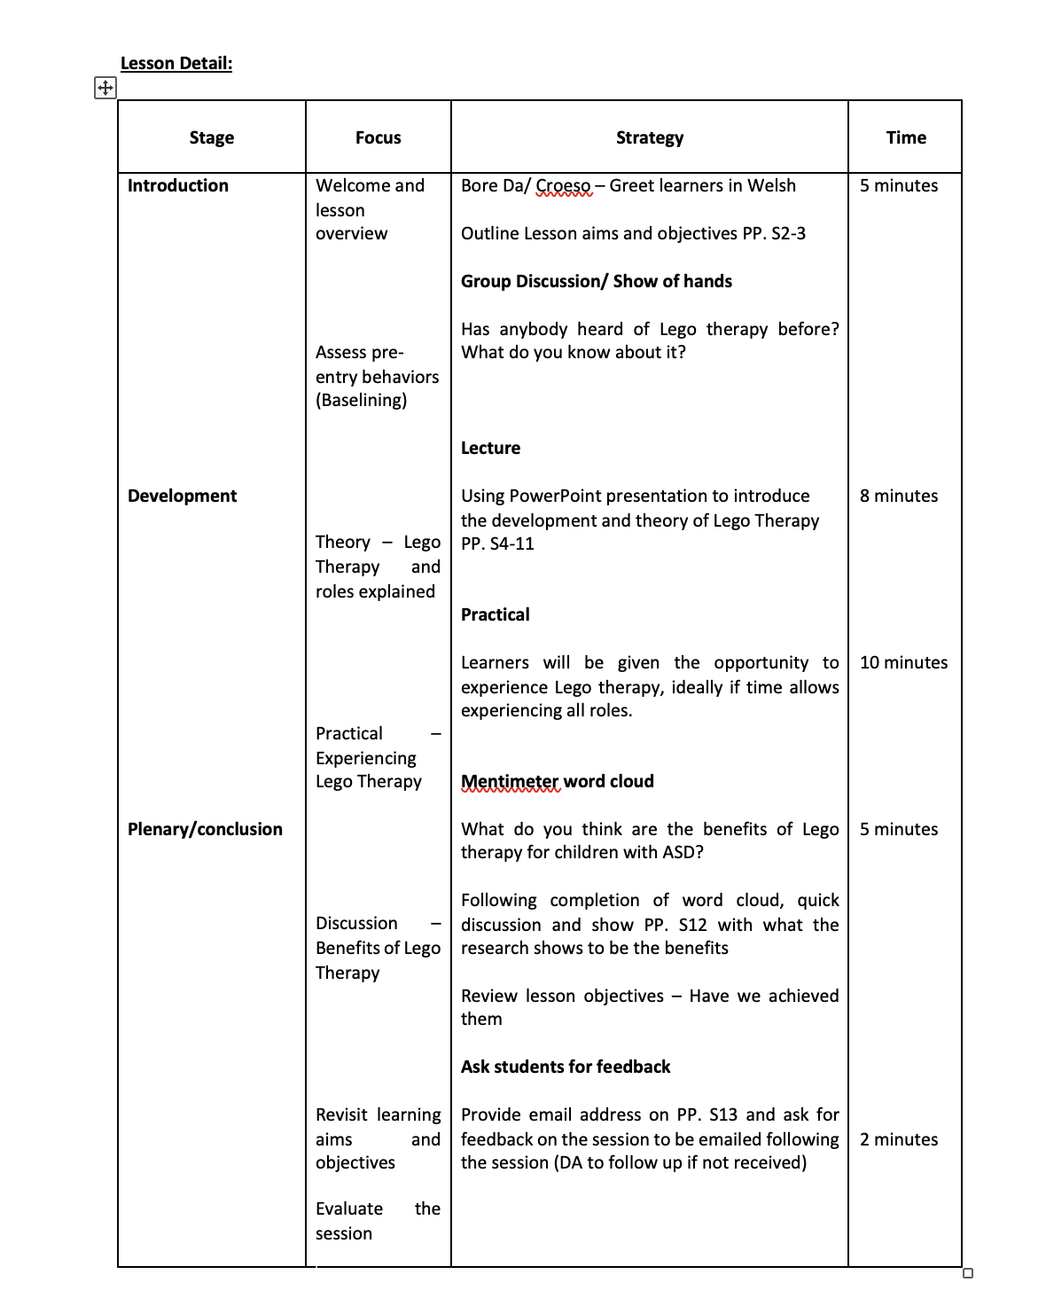
Mentimeter was used towards the end of the lesson as part of the plenary to ascertain how well learners had interacted with the practical activity to facilitate a discussion as part of my formative assessment of the session, while this lesson was used for my microteach and therefore I had limited time, the data collected here would have informed whether aspects needed to be revisited, either during the session or as part of a follow up session, and would have had a direct impact on my questioning.

The setup of Mentimeter and the creation of resources to be used in teaching and learning are straightforward to implement. Below is a step-by-step guide on how to set up Mentimeter for use in the classroom as a formative assessment tool

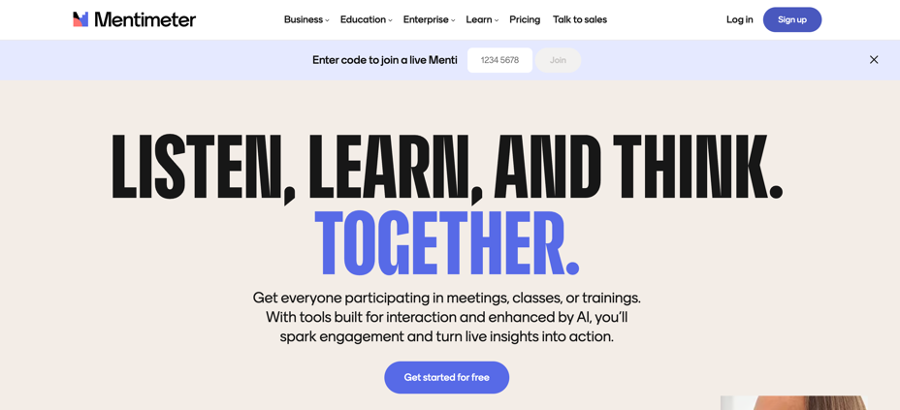
Visiting www.mentimeter.com
Click on sign up button to create an account

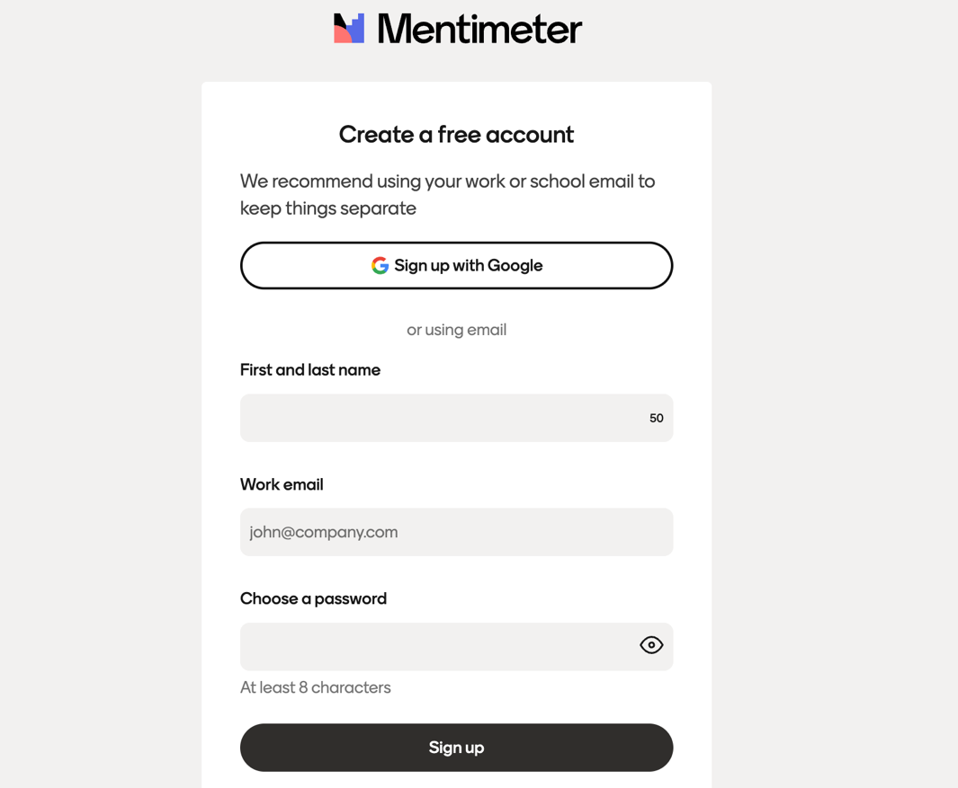
One-click registration if using a google account to sign up
Details needed for manual sign up include name, email address and creation of a password

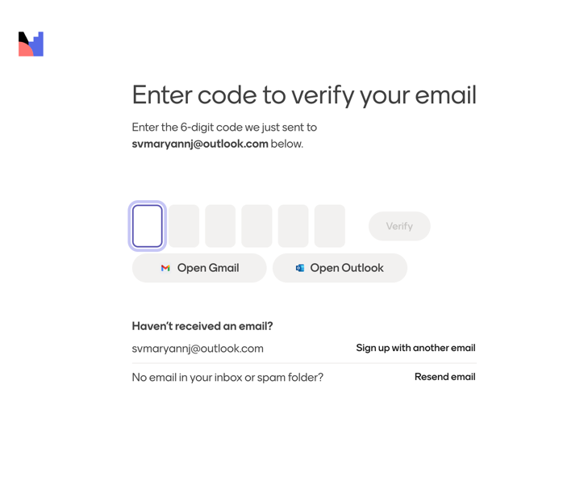
Verification code will be sent to registered email address and will need to be confirmed to activate account.

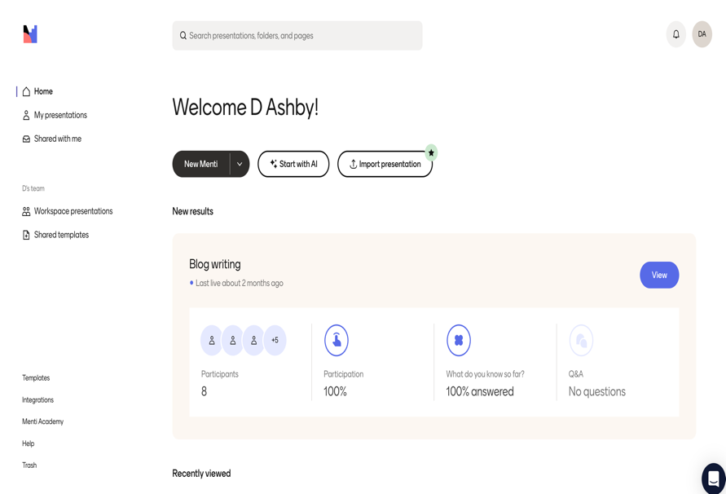
Generative AI is also embedded within Mentimeter to assist with the creation of resources
To get started, click on New Menti button which will open up next steps to create resource

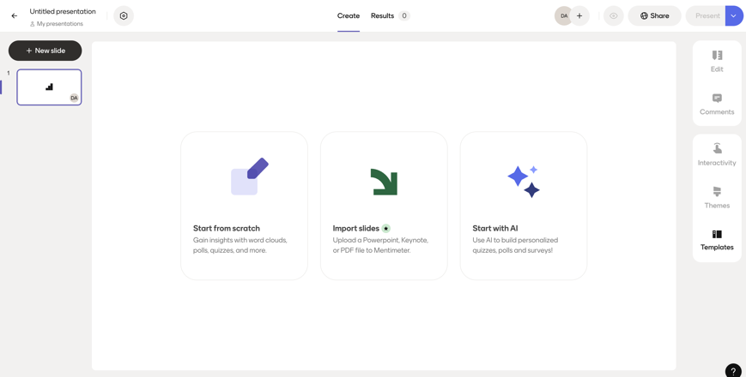
Again, several options will be presented including starting from scratch on your Menti, importing existing slides and using generative AI features to help create your resource

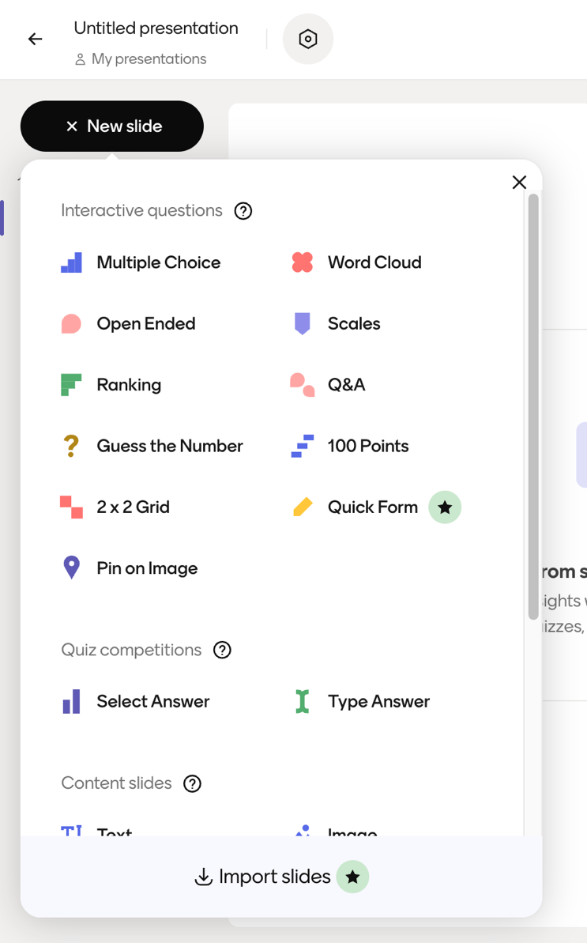
There are several options for using Mentimeter, for my digital tool I decided to use the word cloud feature, as this allowed learners to add their own thoughts without restrictions, in my opinion increasing the quality of responses received

Resource creation is very straightforward, in the case of my digital tool, I used the word cloud feature. A question is posed for students to engage with
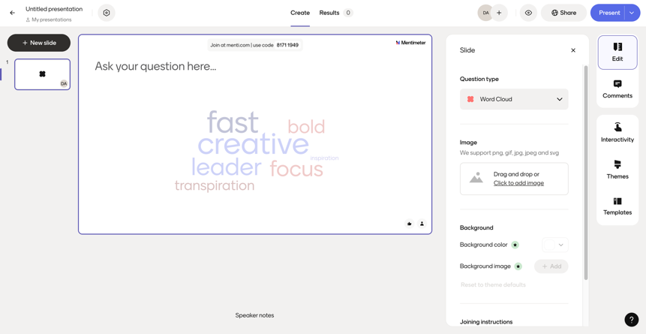
Make use of share button to generate a shareable link or QR code
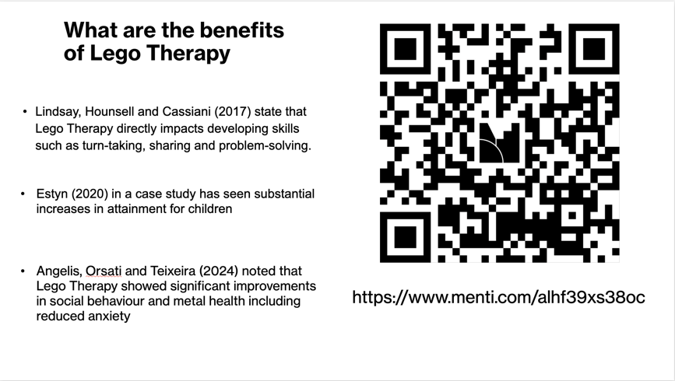
This image shows where QR code and link shared on session PowerPoint slides
Both the QR code and link were shared with the link acting as a failsafe if QR code failed to load

This image shows completed Mentimeter world cloud by students, these responses were used to facilitate discussion and shaped questioning as part of my formative assessment approach
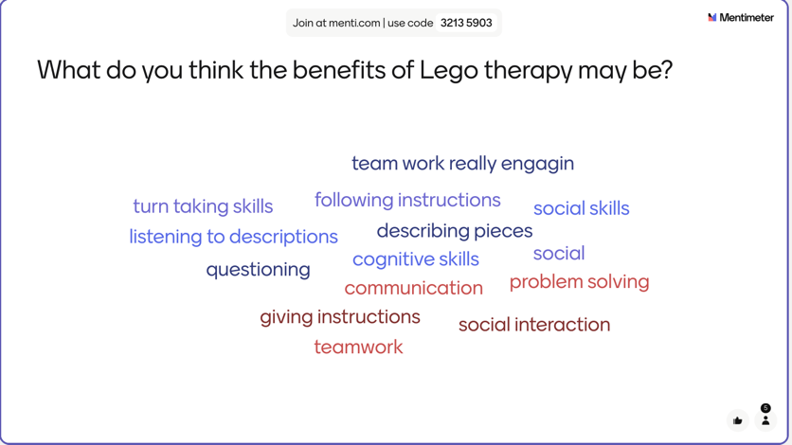

Evaluation and Reflection - 1085 words
Implementing Mentimeter into my lesson provided a valuable opportunity to consider and evaluate how the use of a digital tool could further support formative assessment, which is a personal area of interest in education within the context of the FE sector. The lesson introduced learners to the principles of Lego therapy with the specific aim to explore the roles involved in Lego therapy and the benefits of this intervention for children with additional learning needs, specifically those with learners with autism. The lesson followed a clear and planned structure, which culminated in a Mentimeter word cloud plenary activity being deployed to elicit responses from learners to assess contextual understanding after having a hands-on experience of the intervention, as well as having the aim to encourage discussion on the topic. Reflecting on the session through a combination of received feedback, my own thoughts and feelings in the session as well as the professional standards for FE educators as outlined by the Welsh Government (2025) has allowed me to critically evaluate both the impact of the digital tool as well as my own developing practice, especially around the use of technology to enhance teaching and learning.

Early in the session, I assessed baseline knowledge of Lego Therapy through direct questioning, not integrating any form of digital technology. Whilst I accept the dynamics and experiences of the group may have meant that prior knowledge was limited, there were only two learners who responded and gave any input. However, when I introduced the Mentimeter activity, the quantity of responses increased significantly. Lesson feedback from the learners highlighted that they enjoyed the anonymity that using Mentimeter provided and felt more confident in answering to feeling under less pressure. This feedback closely aligns with the research by Henderson et al. (2017) and Ayandibu (2025), who stated that learners value digital tools that reduce anxiety, which leads to increased participation, which correlates with what was observed in my lesson. Additionally, I feel that this also aligns well with the professional standard by the Welsh Government (2025) of demonstrating a commitment to learners learning, safety and well-being, this is demonstrated through my use of Mentimeter in my lesson through the creation of a psychologically safe space as the anonymous format enabled learners that were potentially feeling less confident to participate without fear of judgement or embarrassment without exposing their confidence levels publicly.

The answers generated for the word cloud allowed me, as the educator, to evidence that there had been learning in the lesson; additionally, the system also told me how many participants had entered answers, which showed that all learners had answered. These answers were also central in my lecture, therefore suggesting that the learning objective to identify the benefits of Lego therapy had been met successfully. This approach also allowed me to meet the Welsh Government (2025b) professional standard of planning and delivering effective learning, teaching and assessment, which also aligns with the works of Black and Wiliam (1998) and the principles of formative assessment through eliciting evidence that could be used to adjust teaching or revisit learning if required. Using Mentimeter towards the end of the lesson for this purpose not only allowed me to gauge learner understanding but also demonstrated further to me how digital tools can support responsive, adaptive teaching

However, despite the positives, challenges did arise with the implementation of Mentimeter that aligned with concerns raised in my literature review. An issue that did arise centred around accessibility and connectivity, with one of my learners having an issue logging in using the QR code that had been generated. While the reason for this is unknown, it may have been a compatibility issue with the learner’s device. I had, however, planned for this eventuality and had also prepared a short link which the learner was able to use instead to log in; however, the delay caused reflected well with the findings of JISC (2025a) that inconsistent device access and connectivity issues are common barriers within the FE context. This challenge did highlight to me the need for robust contingency planning to ensure that any gap that may arise accessing digital tools can be addressed and dealt with effectively, if the setting allowed this may include arranging to have spare devices available that could be loaned by learners during sessions but I also appreciate this would be very dependent on the educational setting and the infrastructure in place. By attempting to address these barriers, I feel that I met the Welsh Government (2025) professional standard of valuing and promoting diversity, equality of opportunity and inclusion by ensuring that no learner was disadvantaged by digital access or device issues.

The session also contributed strongly to my development in relation to digital pedagogy. Using Mentimeter in my lesson allowed me to utilise the TPACK framework effectively. The tool used aligned with my content and how I wanted to use it, complemented my pedagogical approach and functioned well within my environment. This also reinforces to me the importance of selecting digital tools based on having a pedagogical justification rather than just using technology with no planned intent or purpose.

As I move forward in my career as a post-compulsory educator, this evaluation has led me towards several tangible changes I would make to my practice. Although successful in the context of my lesson, I also feel that Mentimeter could be used earlier in a lesson to measure pre-entry knowledge, as well as potentially using it again towards the end to further evidence the scale of learning that has taken place. Moving forward, I would also like to further explore ways that I can hide the word cloud responses to eliminate the possibility that learners may simply use the responses of others to form their responses, although I found no literature to support this drawback, I do believe that this could be a possibility. However, overall, Mentimeter proved to be an effective and inclusive tool for formative assessment within my lesson and is a tool that I will certainly look to refine and develop its application as I continue my placement activities and as I enter the post-compulsory teaching workforce. Its use increased participation of learners, supported adaptive, flexible teaching approaches, allowed me to demonstrate my commitment to my professional standards, as well as increasing my confidence with using digital innovation in a meaningful manner and will continue to shape how I integrate digital tools into my teaching practice.

Reference List
Ayandibu, A. (2025) ‘A comparative analysis of interactive tools in higher education’s teaching and learning: The strengths and weaknesses of Mentimeter, Google forms, Socrative, and Kahoot for playful learning’, International journal of research in business and social science, 14(5), pp. 411–419. Available at: https://doi.org/10.20525/ijrbs.v14i5.3821.

Beatty, I.D. and Gerace, W.J. (2009) ‘Technology-Enhanced Formative Assessment: A Research-Based Pedagogy for Teaching Science with Classroom Response Technology’, Journal of science education and technology, 18(2), pp. 146–162. Available at: https://doi.org/10.1007/s10956-008-9140-4.

Black, P., Wiliam, D. (1998) Inside the black box: raising standards through classroom assessment. London: GL Assessment.

Brown, G.T.L. (2019) ‘Is Assessment for Learning Really Assessment?’, Frontiers in education (Lausanne), 4. Available at: https://doi.org/10.3389/feduc.2019.00064.

Daniela, L. (2020) Pedagogies of digital learning in higher education. 1st edn. Routledge.

Derrick, J., Laurillard, D. and Doel, M. (2016) Building digital skills in the Further Education Sector. Foresight, Government Office for Science.

Estyn (2023) Digital and online learning in further education colleges: autumn 2022 insights. Available at: https://www.estyn.gov.wales/system/files/2023-02/Digital%20and%20online%20learning%20in%20further%20education%20colleges%20-%20autumn%202022%20insights_0.pdf. (Accessed: 25th November 2025)

Fowler, S. and Leonard, S.N. (2024) ‘Using design-based research to shift perspectives: a model for sustainable professional development for the innovative use of digital tools’, Professional development in education, 50(1), pp. 192–204. Available at: https://doi.org/10.1080/19415257.2021.1955732.

Hamilton, E.R., Rosenberg, J.M. and Akcaoglu, M. (2016) ‘The Substitution Augmentation Modification Redefinition (SAMR) Model: a Critical Review and Suggestions for its Use’, TechTrends, 60(5), pp. 433–441. Available at: https://doi.org/10.1007/s11528-016-0091-y.

Han, J.H. and Finkelstein, A. (2013) ‘Understanding the effects of professors’ pedagogical development with Clicker Assessment and Feedback technologies and the impact on students’ engagement and learning in higher education’, Computers and education, 65, pp. 64–76. Available at: https://doi.org/10.1016/j.compedu.2013.02.002.

Henderson, M., Selwyn, N. and Aston, R. (2017) ‘What works and why? Student perceptions of “useful” digital technology in university teaching and learning’, Studies in higher education (Dorchester-on-Thames), 42(8), pp. 1567–1579. Available at: https://doi.org/10.1080/03075079.2015.1007946.

Hund, A. et al. (2021) ‘Digital innovation: Review and novel perspective’, The journal of strategic information systems, 30(4). Available at: https://doi.org/10.1016/j.jsis.2021.101695.

Joint Information Systems Committee (2025a) 2024/25 UK further education learners digital experience insights survey findings. Available at: https://digitalinsights.jisc.ac.uk/reports-and-briefings/our-reports/2024-25-uk-further-education-learners-digital-experience-insights-survey-findings/. (Accessed: 20th November 2025)

Joint Information Systems Committee (2025b) 2024/25 UK further education teaching staff digital experience insights survey findings. Available at: https://digitalinsights.jisc.ac.uk/reports-and-briefings/our-reports/2024-25-uk-further-education-teaching-staff-digital-experience-insights-survey-findings/. (Accessed: 20th November 2025)

Kay, R.H. and LeSage, A. (2009) ‘A strategic assessment of audience response systems used in higher education’, Australasian Journal of Educational Technology, 25(2), pp. 235–249. Available at: https://doi.org/10.14742/ajet.1152.

Kaya-Capocci, S., O’Leary, M. and Costello, E. (2022) ‘Towards a Framework to Support the Implementation of Digital Formative Assessment in Higher Education’, Education sciences, 12(11), p. 823. Available at: https://doi.org/10.3390/educsci12110823.

Rune Johan Krumsvik and Kristine Ludvigsen (2012) ‘Formative E-Assessment in Plenary Lectures’, Nordic journal of digital literacy, 7, pp. 36–54. Available at: https://doi.org/10.18261/ISSN1891-943X-2012-01-04.

Mayhew, E. et al. (2020) ‘The impact of audience response platform Mentimeter on the student and staff learning experience’, Research in learning technology, 28, pp. 1–16. Available at: https://doi.org/10.25304/rlt.v28.2397.

Morris, R., Perry, T. and Wardle, L. (2021) ‘Formative assessment and feedback for learning in higher education: A systematic review’, Review of education (Oxford), 9(3). Available at: https://doi.org/10.1002/rev3.3292.

Pichardo, J.I. et al. (2021) ‘Students and Teachers Using Mentimeter: Technological Innovation to Face the Challenges of the COVID-19 Pandemic and Post-Pandemic in Higher Education’, Education sciences, 11(11), p. 667. Available at: https://doi.org/10.3390/educsci11110667.

Papadopoulos, P.M. et al. (2019) ‘Enriching feedback in audience response systems: Analysis and implications of objective and subjective metrics on students’ performance and attitudes’, Journal of computer assisted learning, 35(2), pp. 305–316. Available at: https://doi.org/10.1111/jcal.12332.

Schildkamp, K. et al. (2020) ‘Formative assessment: A systematic review of critical teacher prerequisites for classroom practice’, International journal of educational research, 103. Available at: https://doi.org/10.1016/j.ijer.2020.101602.

Selwyn, N. (2016) ‘Digital downsides: exploring university students’ negative engagements with digital technology’, Teaching in higher education, 21(8), pp. 1006–1021. Available at: https://doi.org/10.1080/13562517.2016.1213229.

Welsh Government (2024) Supporting learner progression: assessment guidance. Available at: https://hwb.gov.wales/curriculum-for-wales/assessment-arrangements/supporting-learner-progression-assessment-guidance. (Accessed: 19th November 2025)

Welsh Government (2025a) New grants to help people become confident in using digital technology. Available at: https://www.gov.wales/new-grants-help-people-become-confident-using-digital-technology. (Accessed: 25th November 2025)

Welsh Government (2025b) Professional standards for FE teachers, WBL practitioners and AL practitioners in Wales. Available at: https://educators.wales/professional-standards-FE-WBL-AL-practitioners. (Accessed: 26th November 2025)

Wiliam, D. (2009) Assessment for learning: why, what and how? London: Institute of Education, University of London.

Yeh, Y.-F., Chan, K.K.H. and Hsu, Y.-S. (2021) ‘Toward a framework that connects individual TPACK and collective TPACK: A systematic review of TPACK studies investigating teacher collaborative discourse in the learning by design process’, Computers and education, 171. Available at: https://doi.org/10.1016/j.compedu.2021.104238.

