Module: Geographical Information Systems

Module code: ACCA5027

Assignment Title: Geodemographic analysis using GIS software

Student Name: Ashleigh Simons
Student ID Number: 2003948

Task 1
(Please zoom in to any images to make the clear to understand if needed.)
Collecting of Welsh Census Output Areas
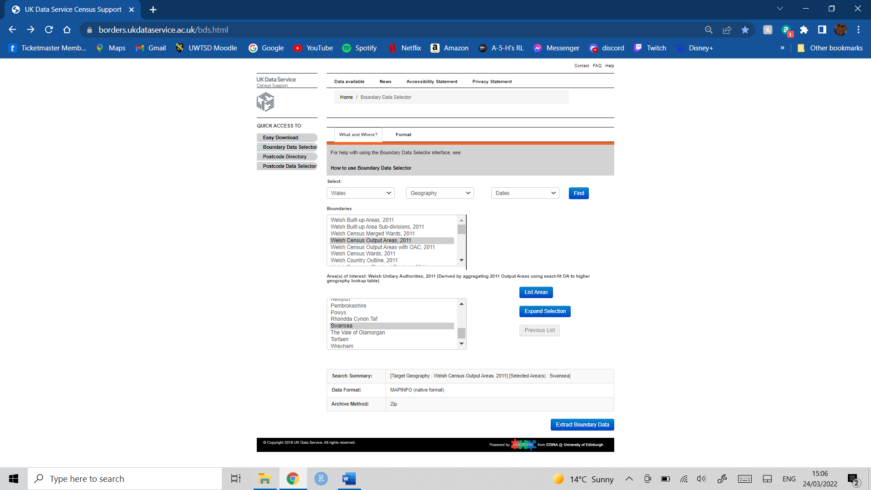
Above shows the first collection of data. The selection is the Welsh Census Output Areas, 2011 for Swansea. This is going to be used within the GIS workspace for the case study. The file type is a MAPINFO (native format) as this will allow the map to be able to be viewed and used within MapInfo Pro 2021, which is the software that is going to be used within this case study. We will be able to use this map to show themes of data within the area.

Storage of Documents and Downloads
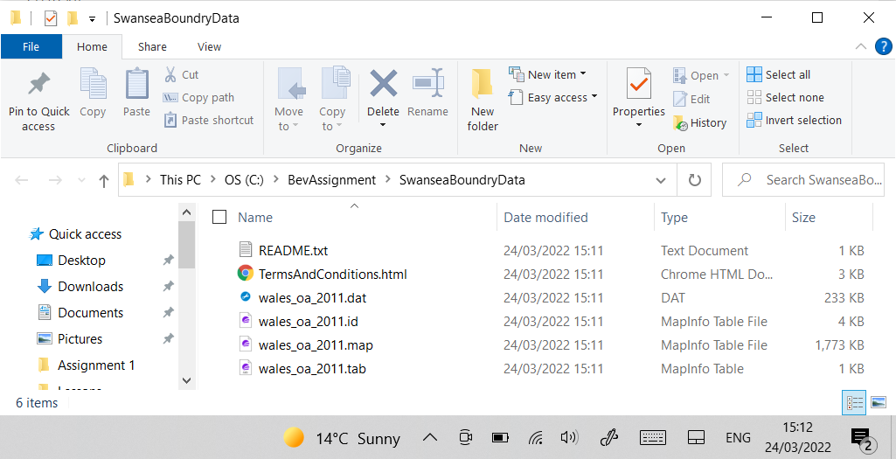
Now we have downloaded the Swansea boundary data we shall store it in a file on the devices (C:) drive, this is so that the software can access and use the downloaded data.

Collection of Data
The following are just some of the many pieces of data that have been collected.
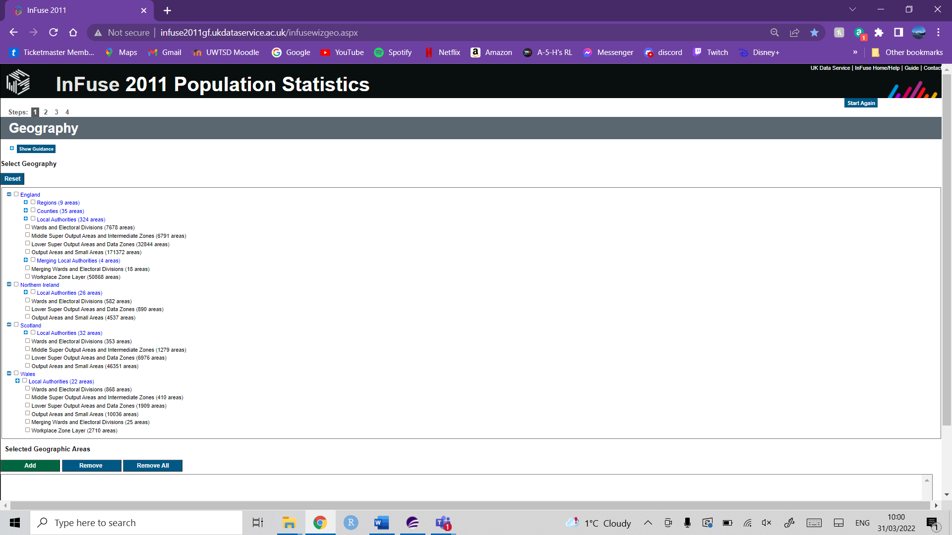
This is where we can collect topic data about age, sex, deprivation, cars or van access, occupation and many more topics that have data collected for the areas. Above shows the selection of what area you would like to collect data from.
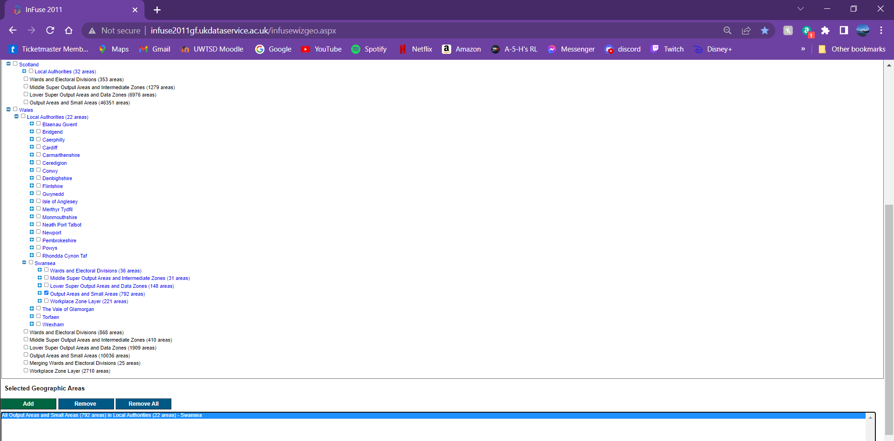
Swansea is the Local Authority which has been chosen and the Output Areas and Small Areas (792 areas), now the topic data within this selection can be selected.
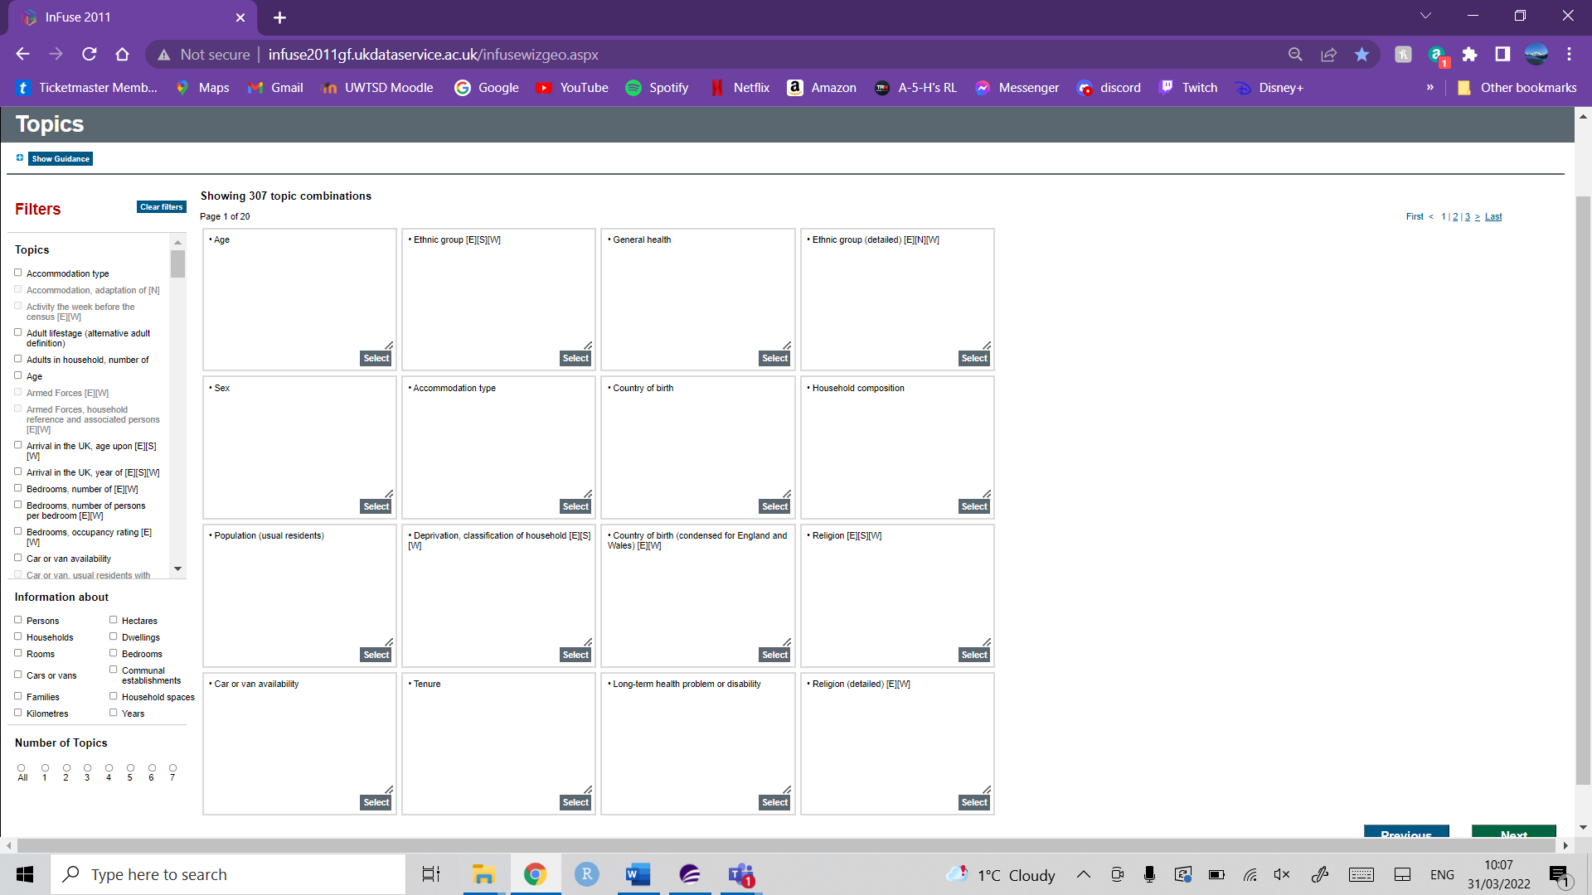
This is where the topics are selected and above ‘Deprivation, classification of household [E] [S] [W] will be selected.
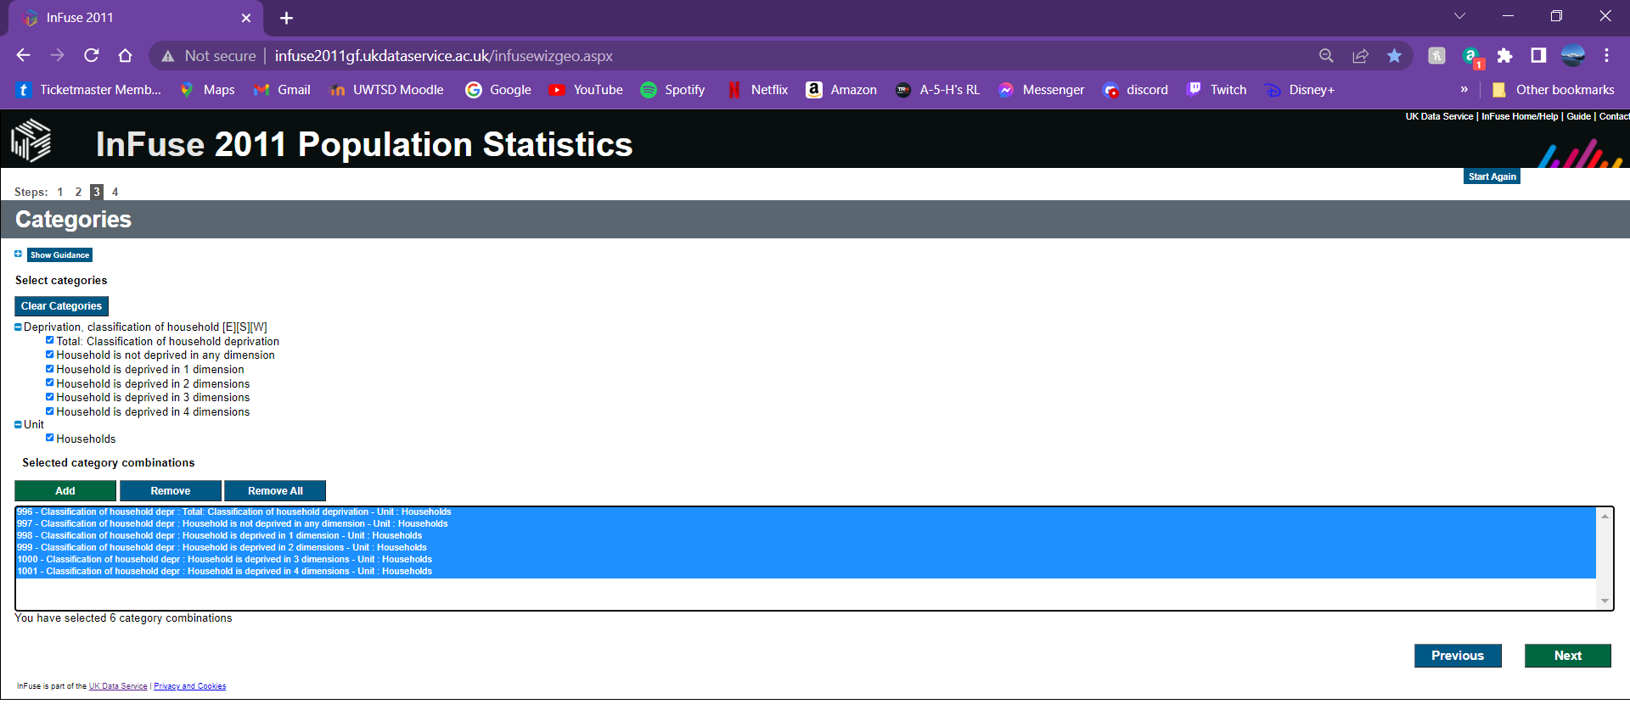
These are all the categories that have been selected. They now need to be downloaded so that the data can be used.
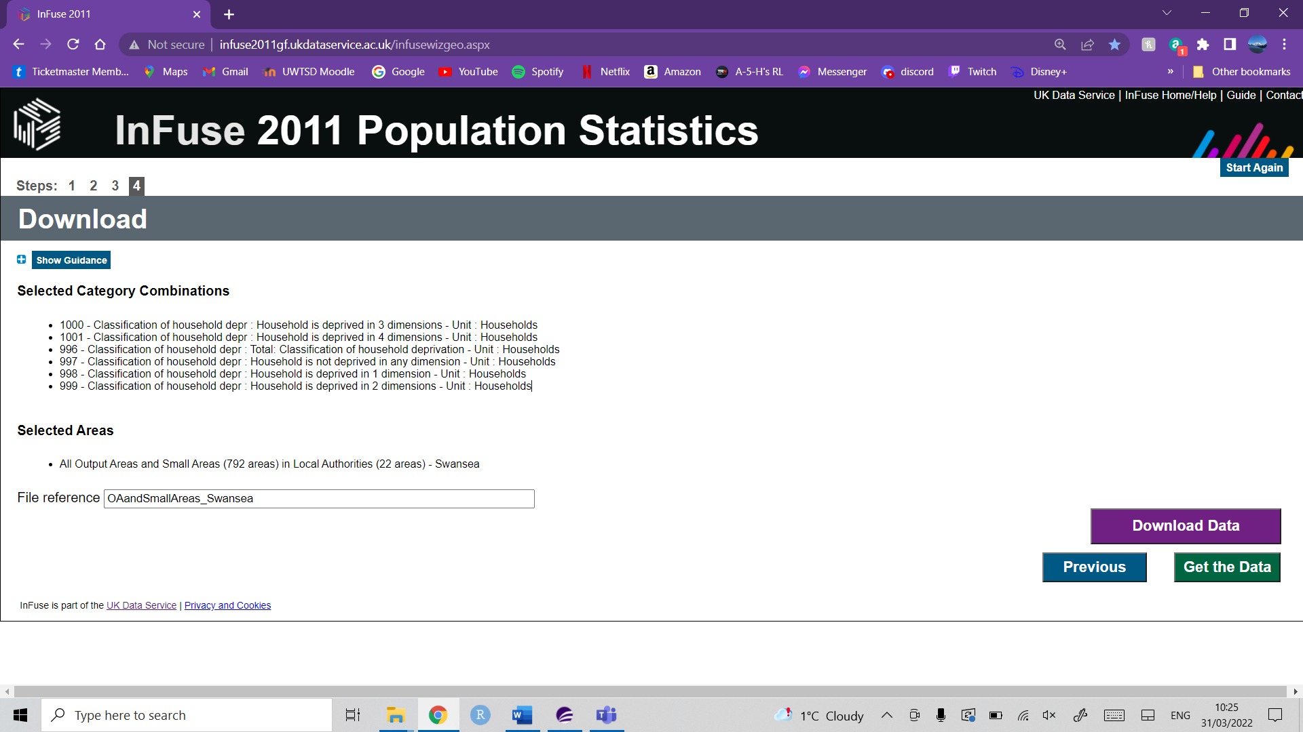
Now the data can be downloaded, then extracted from the .zip file and stored in our dedicated folders so that the data is easy to access and reduces the chance of future errors. This process will now be repeated to get all the information that we would like to use.

Manipulation of Data
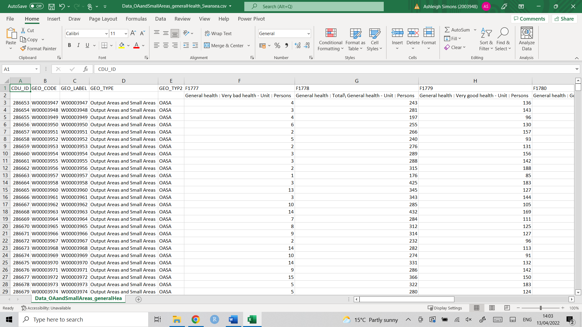
Now that we have access to the data we need we can manipulate it so that its able to be used within MapInfo Pro 2021. We can give the headings more suitable and understandable names and delete some cells that we will no longer require.
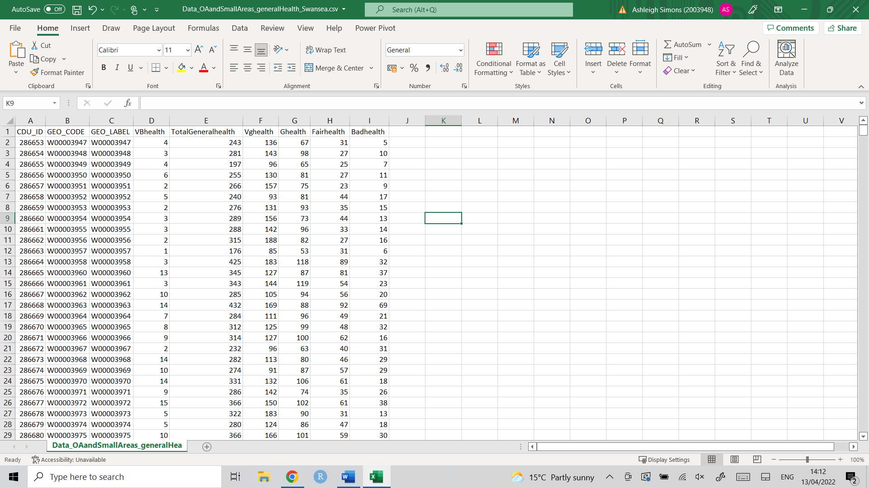
This is the data now it is more useful. This process will be done for most of the data that is going to be used. Then the files will be saved as Excel 97-2003 Workbook (*.xls) files so that the data can be used.

Opening Boundary Data in MapInfo Pro
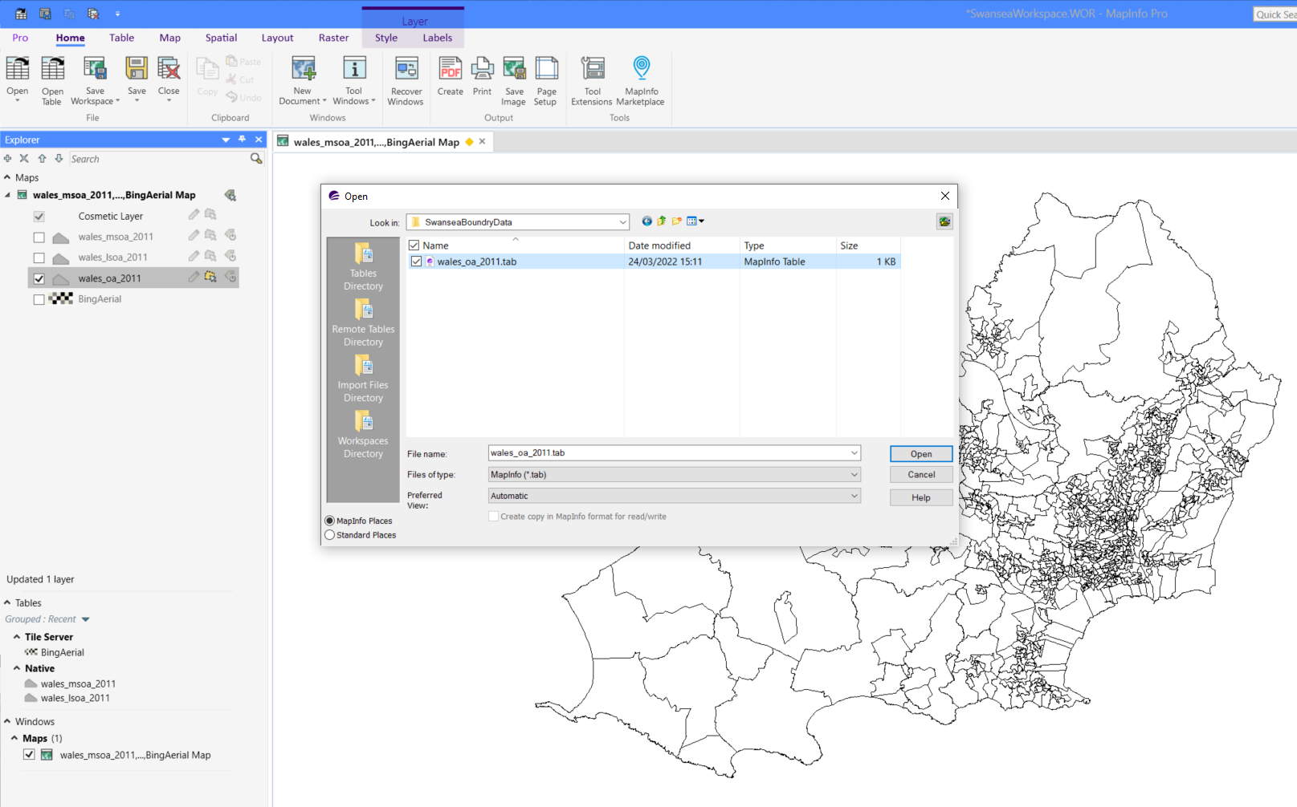
Now that the maps and data are ready, the creation of the workspace can be started. The first thing that is useful to do is load in the maps that will be used. These are the .tab files as they are MapInfo Tables, using these will show us the imagine you see within the workspace behind. There can then be use to present themes and spatial analysis.

Opening Table Data in MapInfo Pro
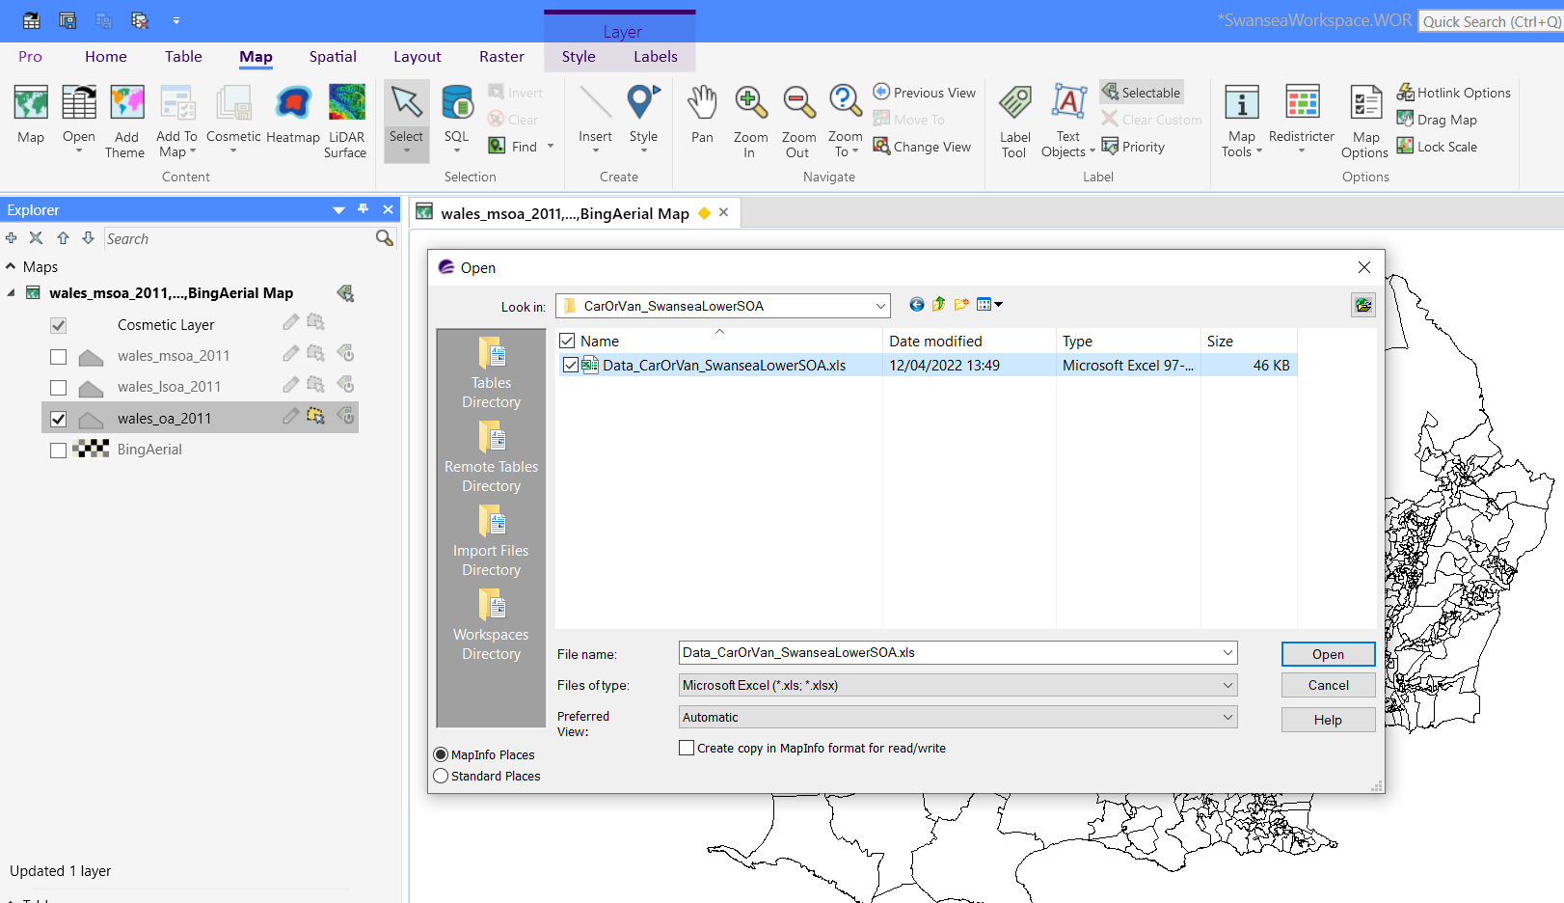
Now for use to put the data we have collected onto the MapInfo Workspace. To do this it requires a similar step to the .tab files. However, this time we require the .xls files as these are the Microsoft Excel 97-2003 Worksheets that we have edited and prepared to be brought into the workspace.

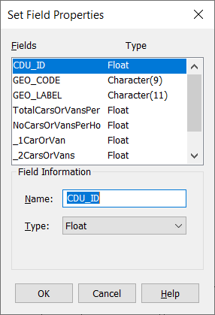
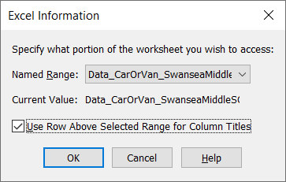

Once we have clicked open on the previous step it will require us to enter if the first row is currently used for headings, which in this case it is. So, this can be ticked as shown. Additionally, on the next imagine ‘Set Field Properties’ It allows us to make sure the type of the data is correct for each of the fields within the .xls files.
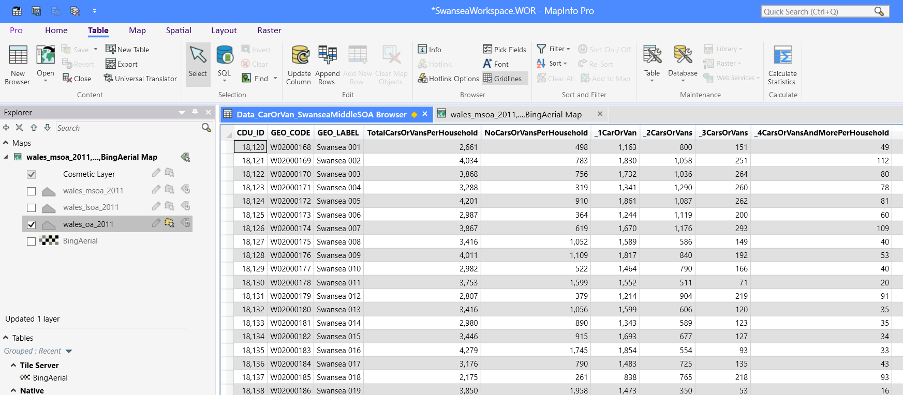
Now that we have brought the table into MapInfo, the table opens and can be found within the explorer on the left-hand side. We need to repeat this process of selecting open table on the table menu, then navigating to the correct one, and checking the headings and field types are what we require ones until all of them are within the workspace.
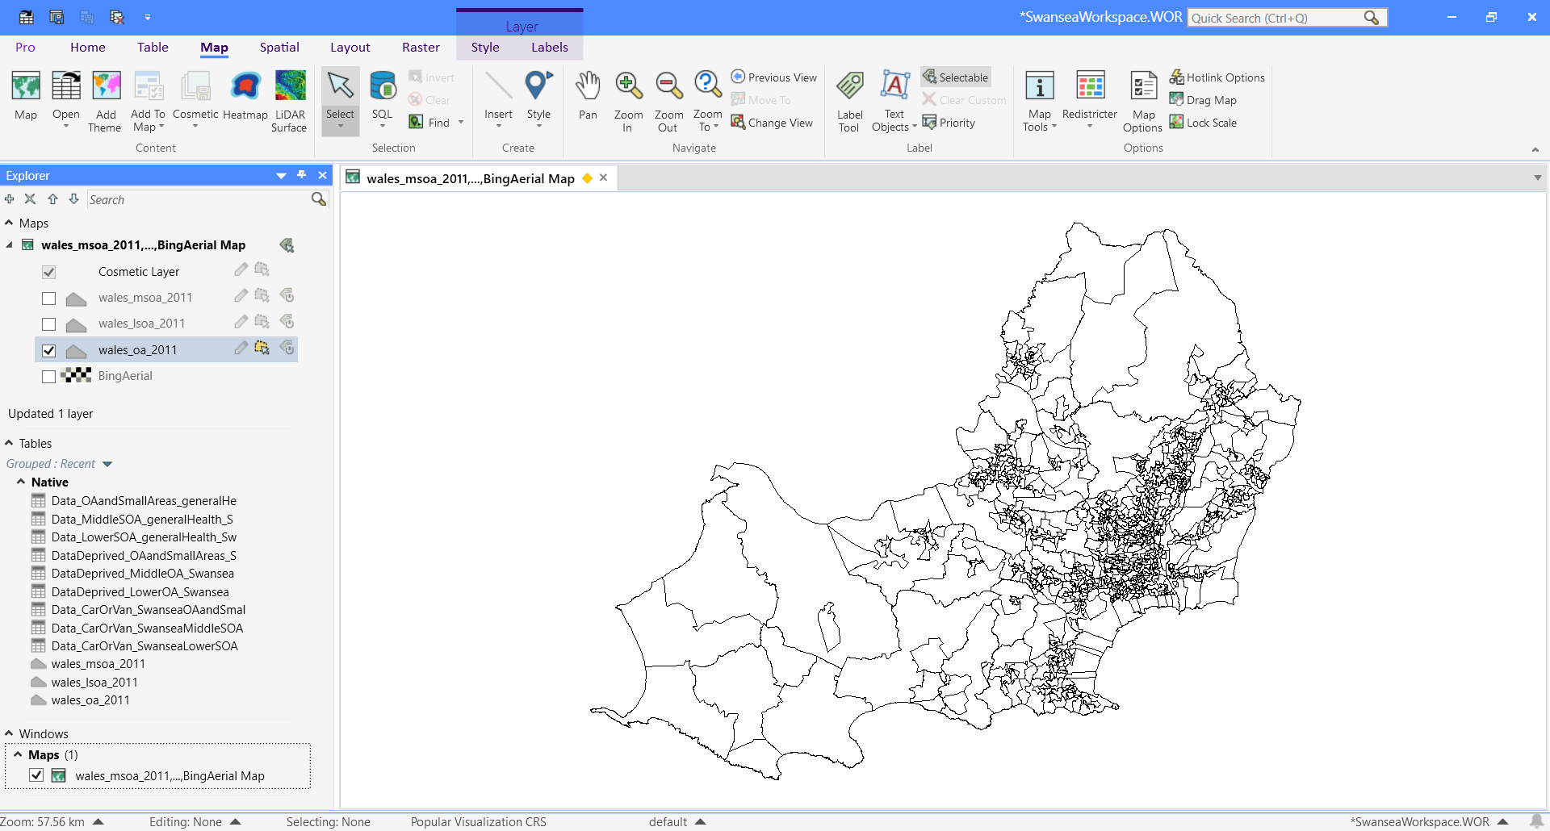
Within the ‘Explorer’ window on the left-hand side you can see Native, below this all the tables have been brought in that contain data that was collected online earlier. We can now use this data to create themes.

Creation of Geocodes
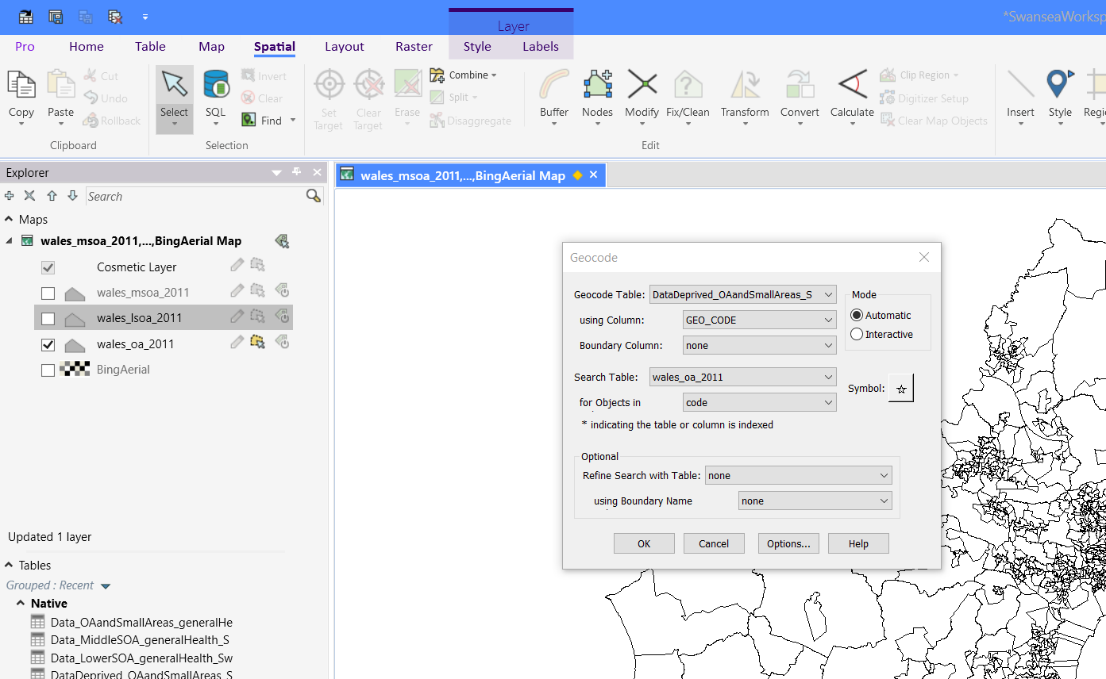
Now that all the data has been opened into the workspace, we are able to geocode the data so that it is able to be used with the maps also opened. This requires each of the tables being linked to a map using the above method. The column that is being used is the same corresponding to what the maps data includes. This means that when the codes match one another the data from one table can be presented on the other.
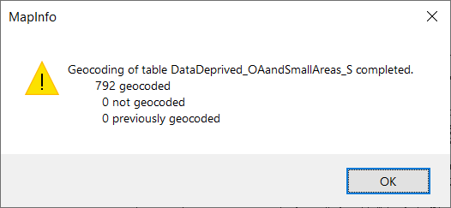

Above confirms that all of the data has been used and geocoded to the codes of the map.

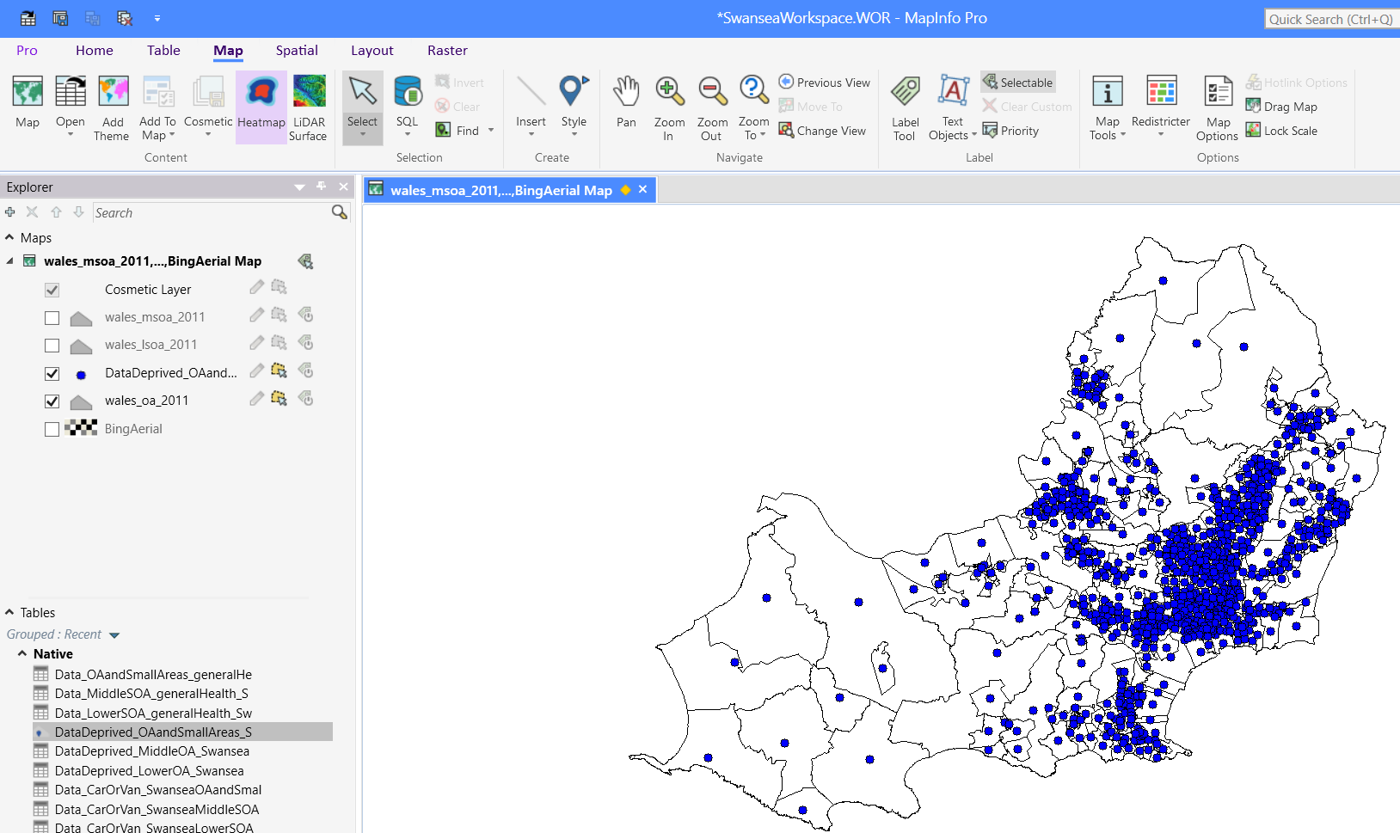
This is what the map looks like after adding one of the geocoded tables to the map. The individual blue dots represent a piece of data for the geocoded location within that output area.
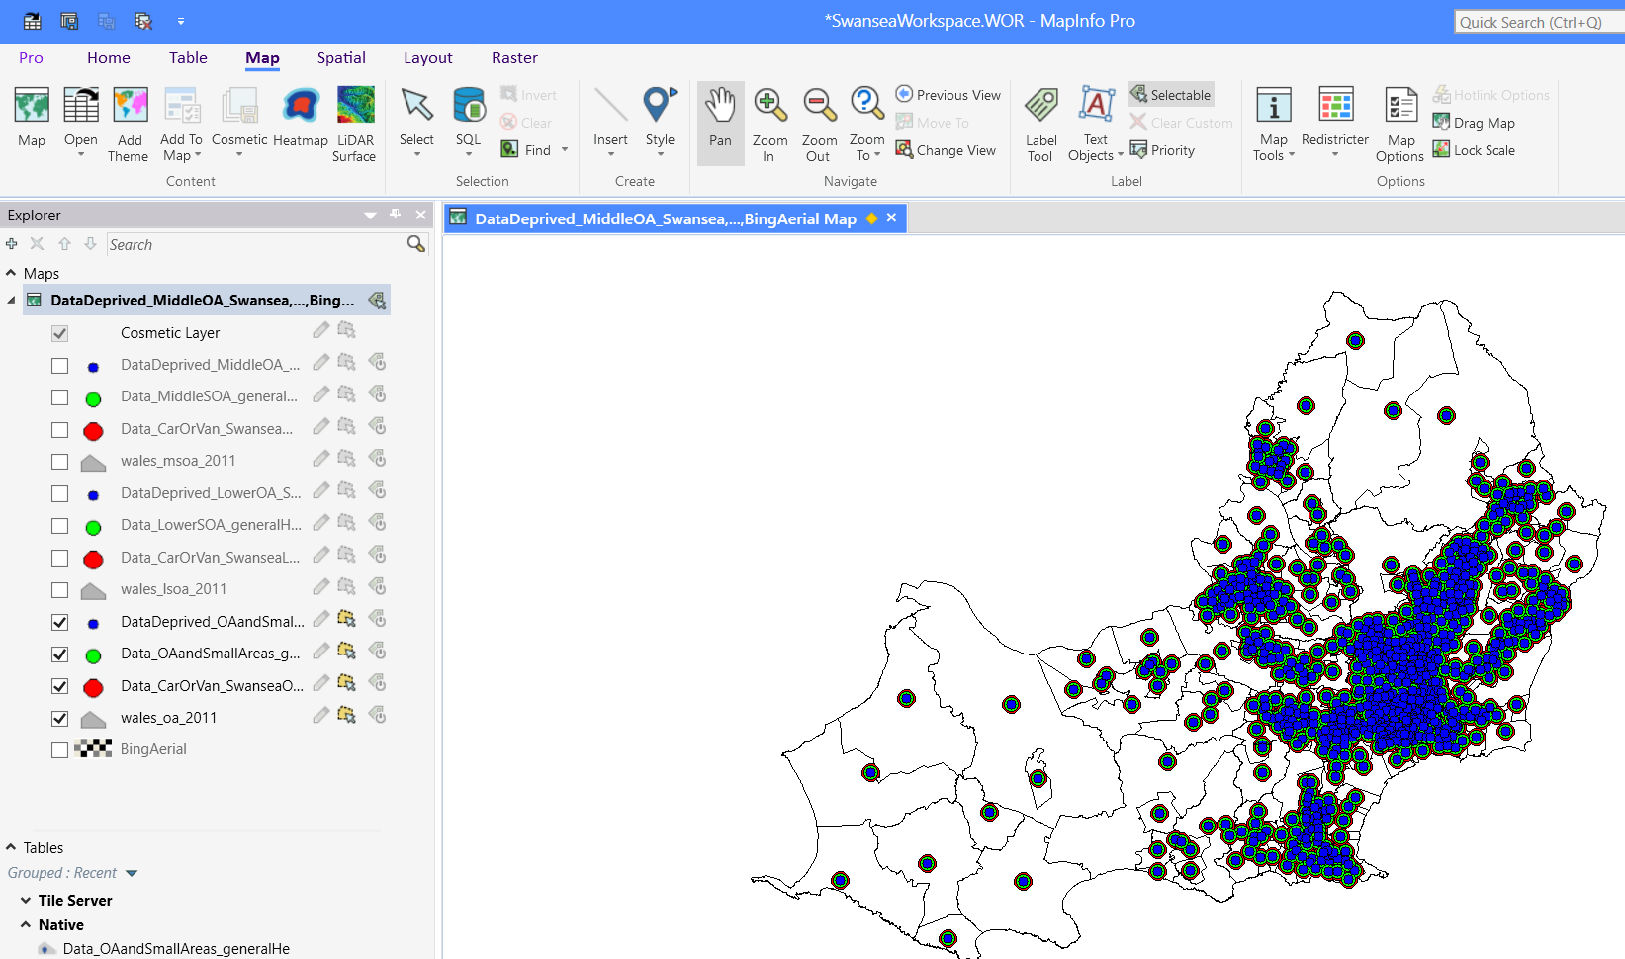
This is now the map with all the geocoded tables added to it. There are 3 versions of this map for the data in Swansea. The Output Areas and Small Areas being one (OAandSA), Lower Super Output Areas being the second (LSOA), and finally Middle Super Output Areas (MSOA).
Creation of Themes
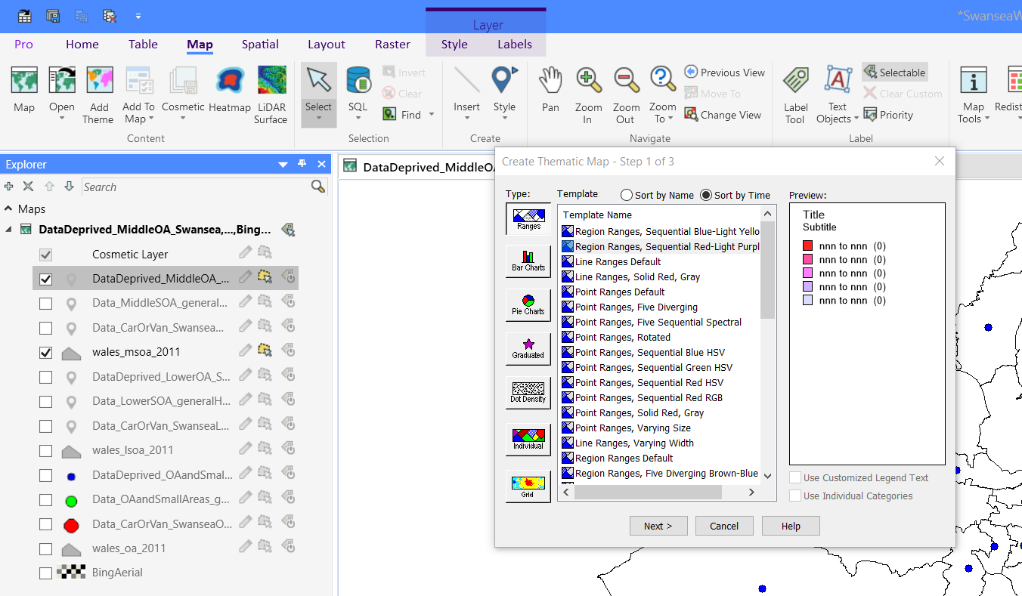
To create a theme for our geocoded data we first need to go to the ‘Map’ tools, then click ‘Add Theme’ button. This will bring up several types of data presentation options that can be selected. There options can be selected to create the desired theme design.
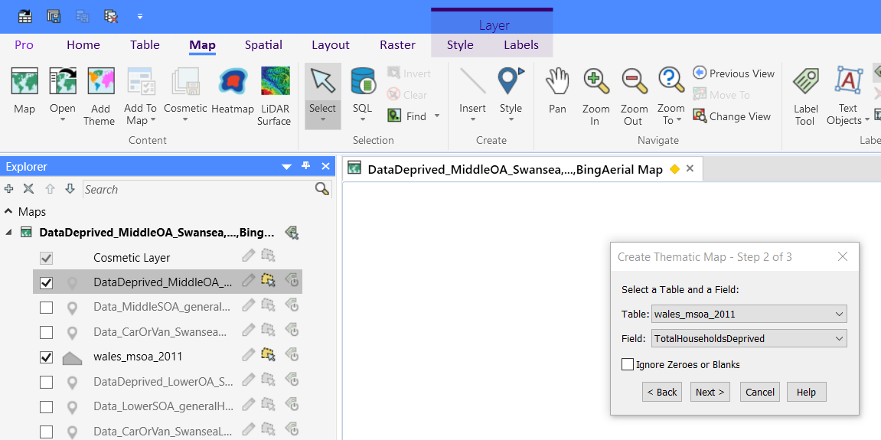
For this example, the data we are looking to add to the wales_msoa_2011 map (Swansea MSOA) is the Total households deprived. The shades of colours will be darker for the higher values found within the databases for the ranges set in this theme.
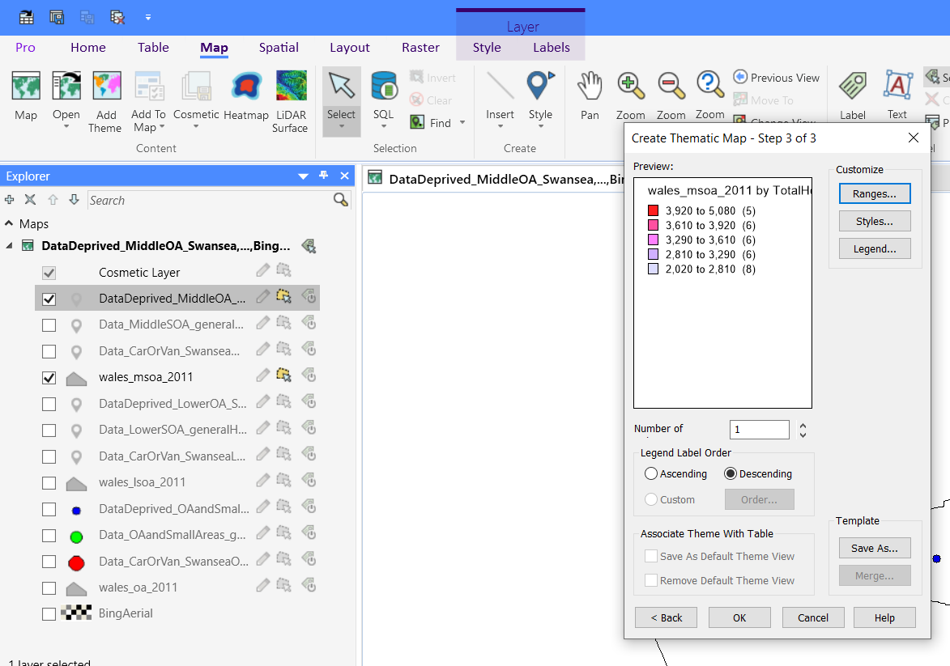
These are the ranges that have been selected for the data and the colours that will be representing them. These can be changed and sorted into ascending or descending to show the data in a way that is simpler for non-experienced users to understand.
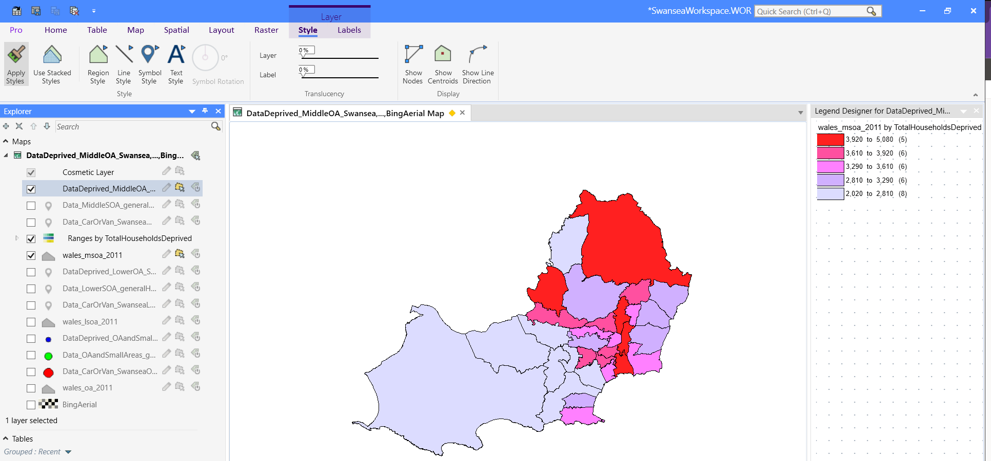
This is what the above data is now presented on the map. This can now be used to show users or people to convey the data that has been collected simpler than reading a database.

Plotting Vaccination and Booster Centers
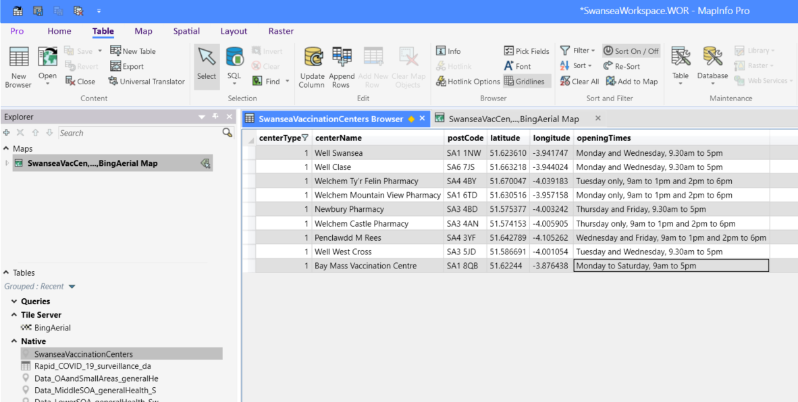
Now that we have the maps and themes created in MapInfo, we can plot the locations of the known Vaccination Centers and Booster Centers. This will allow us to make assumptions and educated conclusions as to understanding the data that can be seen within the themes created. The table above has been created using Microsoft excel and then brought into MapInfo like the process seen earlier on Task 1. The table contains locations and some information to give context on the type of center, this information was found using the ‘sbuhb.nhs.wales’ [1] website.
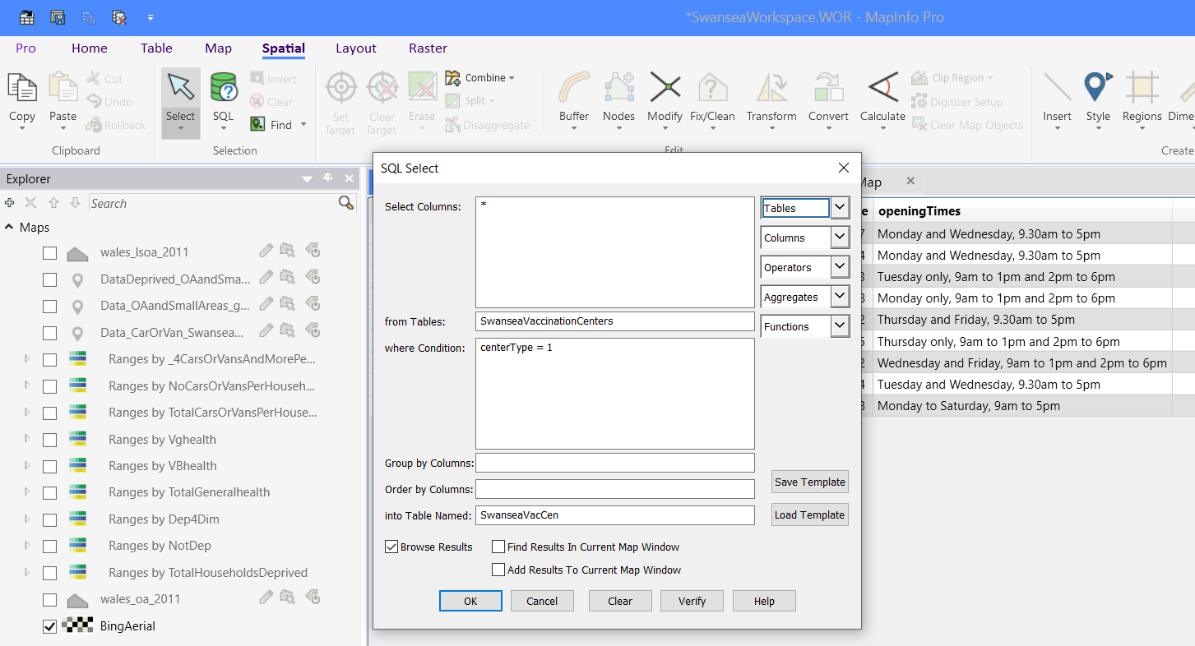
Now that we have the data we are able use a SQL Select to look through the table to select what we require. For this select we are looking for all the centers that have a centerType valued ‘1’. This will bring all of the centers into the query and put them into a new table. This table can then be brought over to the map environment, so that the data can be used. Whilst the data is brought into the environment the latitude and longitude values place points where the co-ordinates are located on the map.

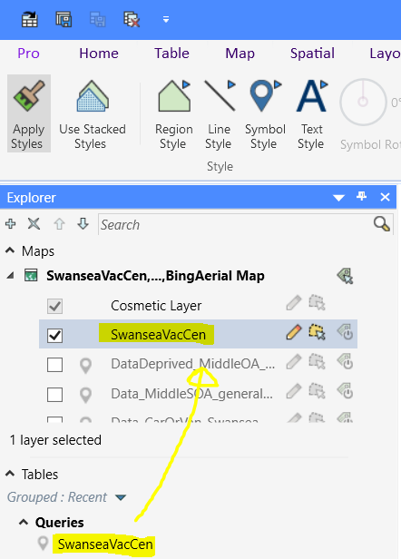
Now that the query is brought into the map environment we can add some design so that we can represent the data. These different options can be accessed by clicking on the blank space between the tick box and the name of the data.

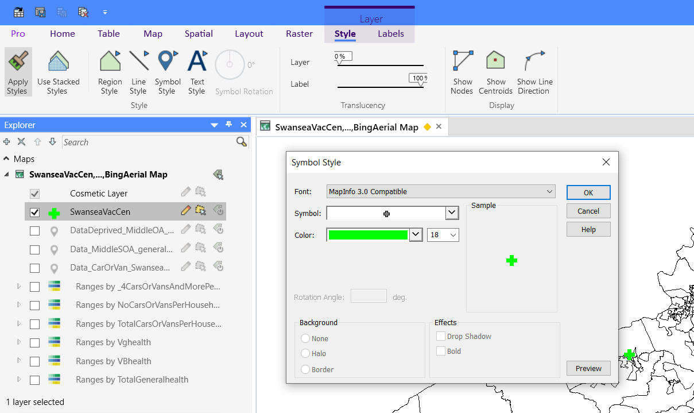
As you can see above there is options to select ‘Font:’. This is not related to words like familiarly used on popular software. This in this case is the packs of symbols that you can use to represent the data. There are many different fonts that can be used, however for this data we can use the suggested font which is ‘MapInfo 3.0 Compatible’. This gives us access to a few symbols including the one chosen to represent this data, which you can see is an addition sign and in the colour green. This has been decided as it is different to any of the colours used within the themes that have been created. Additionally, this colour is contrasting to the other colours used when making the themes, so the infographics presented later can be more accessible for more people. In cases for example where visual impairments are an issue to individuals, this attempted has been made to be countered this potential problem.
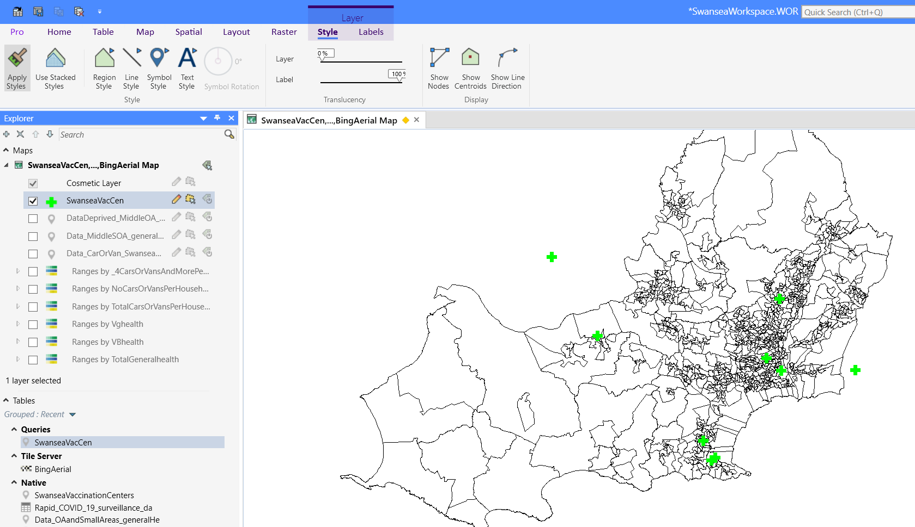
This is now what the data is represented like on the output areas map of Swansea. As you can see there are two marked centers outside of the Swansea mapped location (to the north and to the east of the mapped area). This is because some locations within the area have individuals that have used these centers. There could be reasoning for this and in task two this will be looked at.

Task 2

Within this task it will aim to discuss the results found in task one. ‘COVID_Vaccination_data_ download_Wales_latest’ (VDDW) and ‘Rapid COVID-19 surveillance data’ (RC19S) will both be used within this task to help inform health care professionals of the uptake of the vaccination programs that have taken place.
Firstly, we can look at the data recorded to get an idea of what is happening within the area of Swansea. From the VDDW table we can see the health boards of residence within Wales. After selecting Swansea and the Wales totals we can see the amount of people Immunized in Dose1, Dose2, Dose3, and the booster. Although this data is not 100% accurate as it states the information should be ‘interpreted with caution’. This suggests that the values may not be completely representative of the results, but it still gives a good approximate for results.
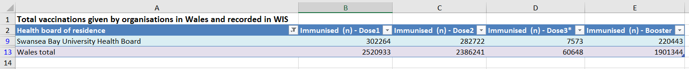
The table above shows the number of people that have had a vaccine and number of people that have had a booster vaccination. As you can see there is a great deal of people that have had all three doses and a booster for Wales. Furthermore, specifically looking at Swansea we can see this follows the same type of trend with the lowering and rising of statistics. We can use this information to inform healthcare professionals while in conjunction with looking at infographics [2] created with themes and trends. We will be able to see an understanding about aspects of individuals lives within Wales and specifically looking at Swansea for this task. Additionally, looking at the results from task one could give us reasons for why results that have been collected, have the conclusion that it does.
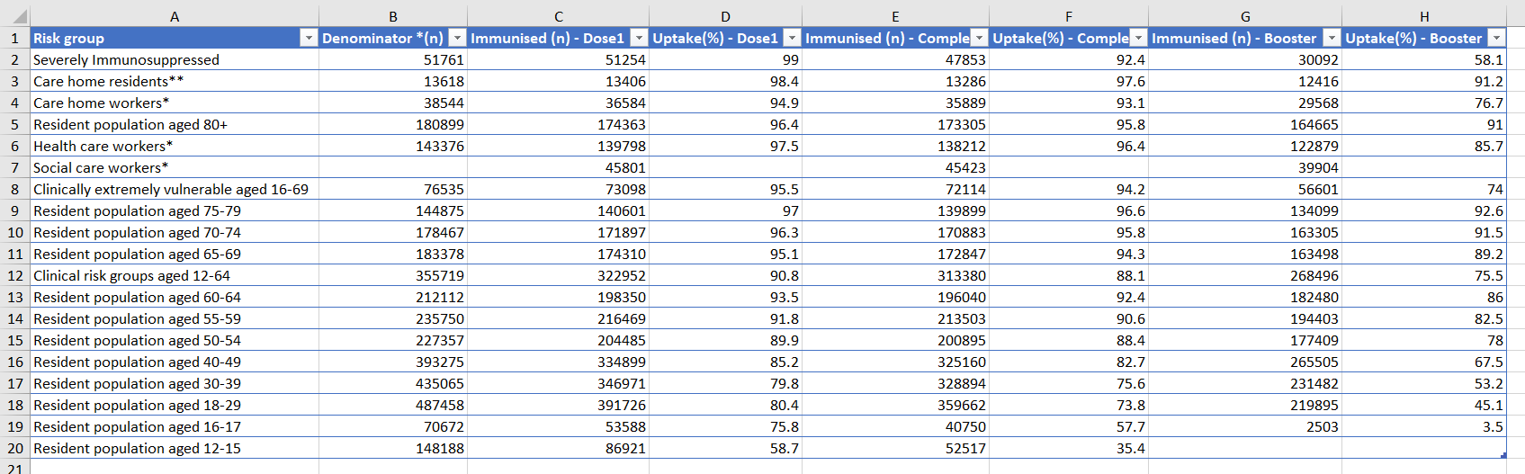
Also, we can see from this VDDW table above that the ages of people getting the vaccination and booster are from the ages of 12-80+. This table also shows the amount of people that are able to get a vaccination in Wales and how many people have. Furthermore, those who have gone for a second and uptake dose plus a booster and the uptake of the booster vaccination. Some of the reasons for the uptake percentages could be down to reasons such as the five Cs. These five Cs are labeled “Confidence, Complacency, Calculation, Constraints (or convenient), and Collective responsibility” [3]. We can use these to look for trends within the data to see if they could possibly hinder the results that have been collected.
Having confidence in a vaccination or booster could be a reason as to why there is not a high percentage of people not up taking the dosage. The trust and feeling [4] in the effectiveness of the vaccine could be caused by deprivation in areas within Swansea, Wales. We can see by looking at the two themes below the areas of Swansea that have four levels of deprivation and then where there is no deprivation.
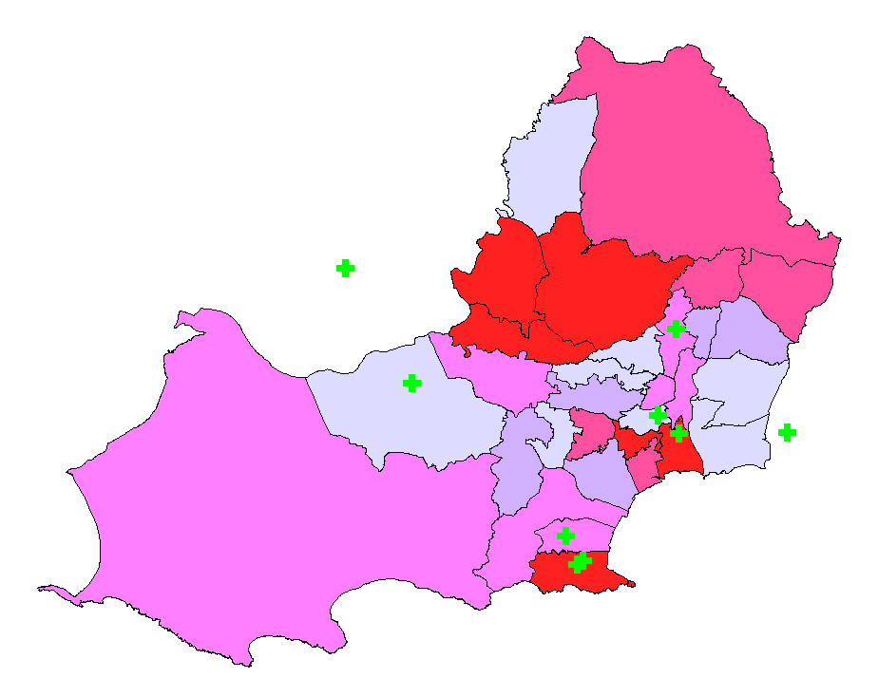
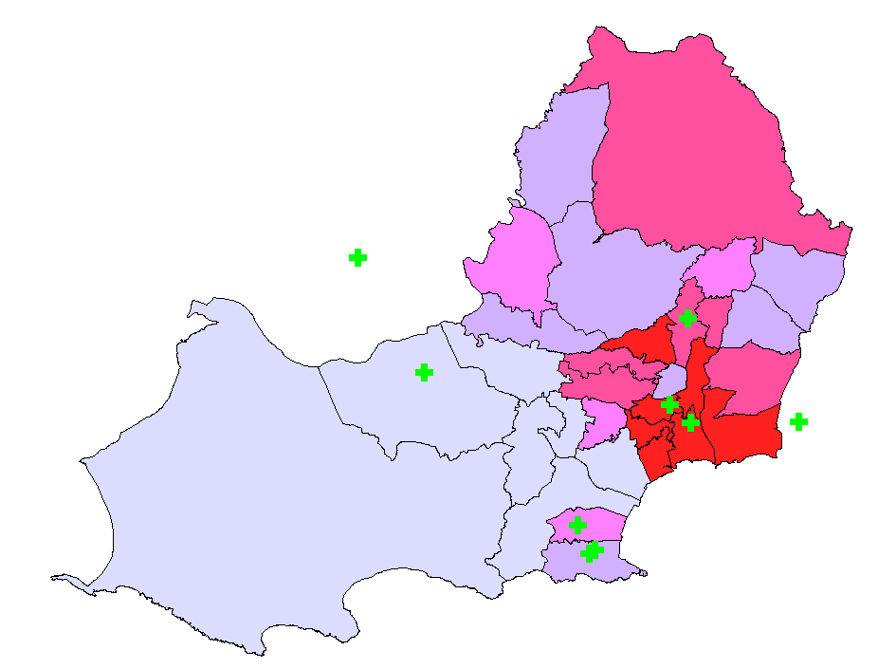
Four Levels of Deprivation No Levels of Deprivation

These maps both represent the Medium Super Output Areas within Swansea. The green markers are the vaccination centers and the colours go from light to dark in the number of households with the levels of deprivation in their titles.
The first map suggested that there are more houses with four levels of deprivation towards the city center of Swansea and less when going further away from the center. In the second we can see that on the outskirts of the city center there is more households with no levels of deprivation. Both maps have some areas where there are many households both with high deprivation and none. This could be a reason as to why the uptake % of the vaccines are lower as areas around Swansea could be more deprived. To get a more detailed version of this map we can look at the same levels of deprivation but for the Lower Super Output Areas (LSOA) and All Output Areas in Swansea. These maps could give us more of an idea where the deprived locations are and if this could make a difference to the percentage of people getting the vaccines and up taking the vaccine with multiple dosages, as recommended to give you “long term protection against the virus” [5].
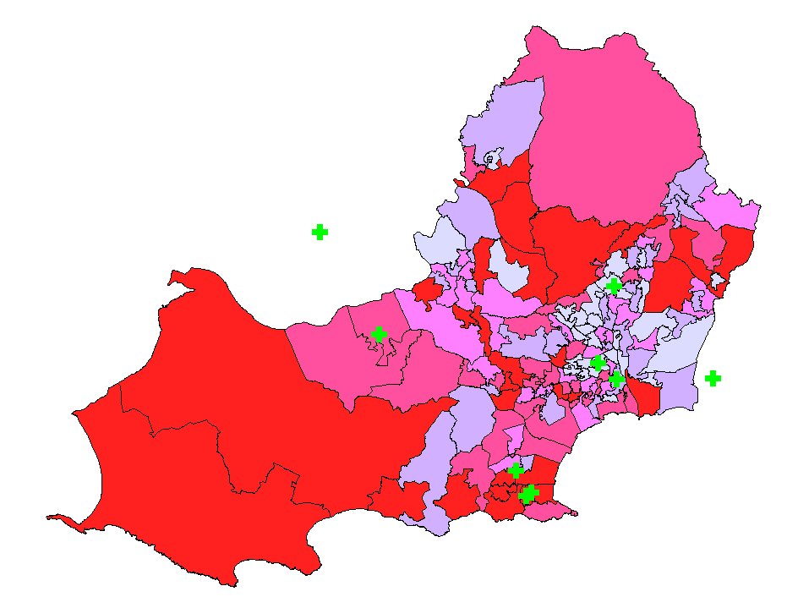
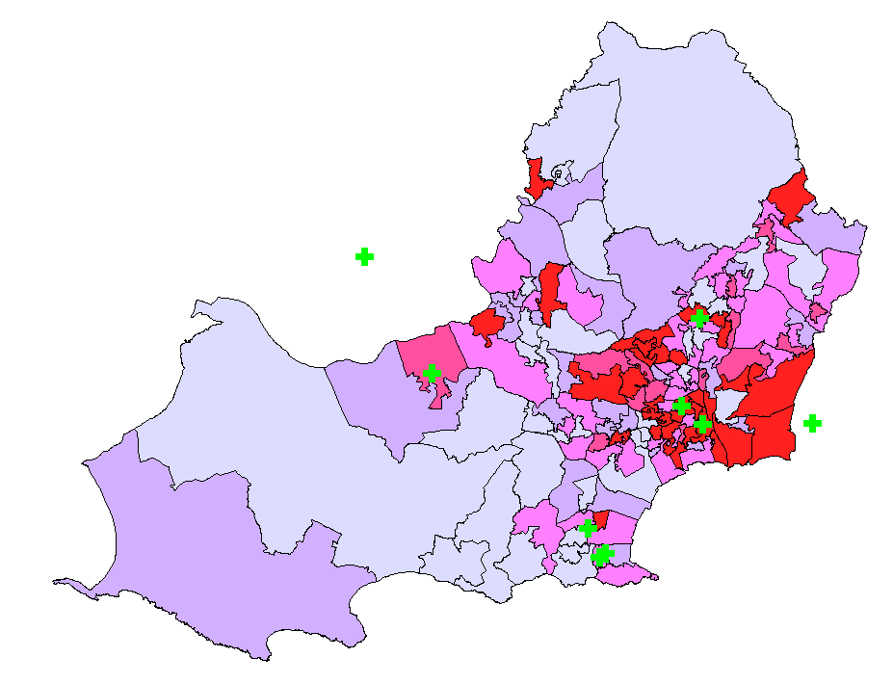
Four Levels of Deprivation No Levels of Deprivation
On the previous page you can see the LSOA map with the theme to show the levels of deprovision. This more detailed map shows that areas are substantially more deprived than others, many of the places highlighted in red are where there are vaccination centers. This suggests that the selection of these centers could be to accommodate people who might not have the resources others have to be able to gain access to a vaccination or booster. Additionally, from the second map we can see that the places with the most households in no deprivation are further away from these centers generally, suggesting that these households would be able to get to a vaccination with more ease than others. To get an even clearer idea of the areas that are deprived we can look at all the Output Areas and small areas, this could then outline some areas that could possibly require a closer vaccination center to attain a higher chance of herd immunity [6], because of the vaccine and boosters being more accessible.
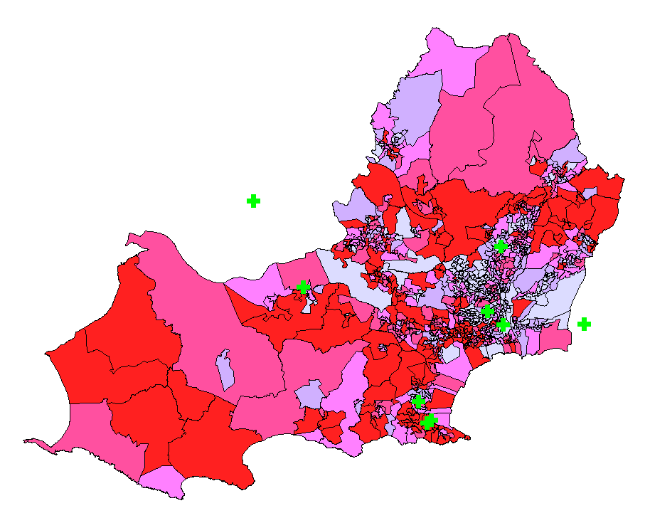
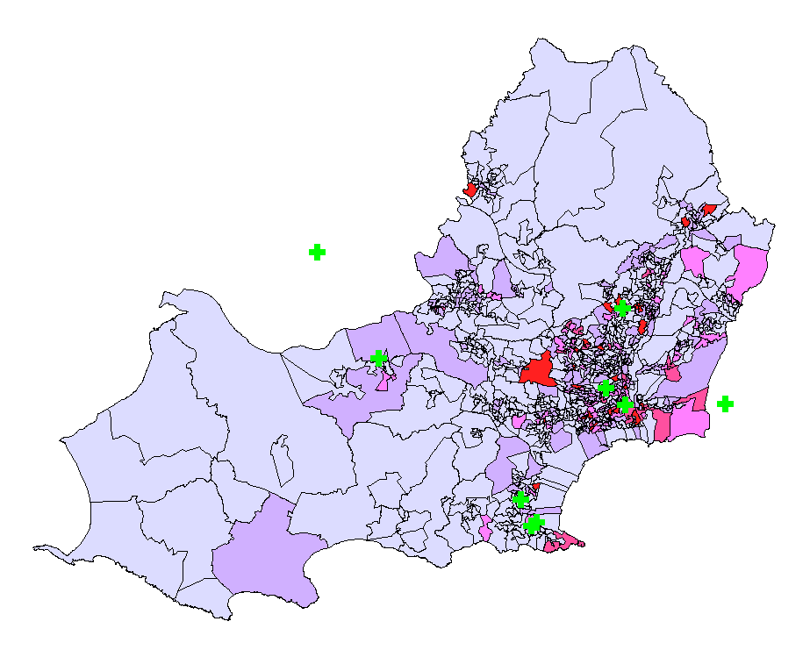
Four Levels of Deprivation No Levels of Deprivation

Now we have the most accurate maps and locations of deprivation and no levels of deprivation we can see that the majority of Swansea has small areas with high levels of deprivation. However, we can also see that there are lots of areas that have a high number of households that are not deprived. This could explain to some degree how the percentage of people for getting the vaccine doses and boosters have not stayed consistently high. As some of the high deprived areas are further away from the vaccination centers this could be an understanding reason for this. If the target was to get a fully vaccinated population in Swansea then additional centers could be opened in these areas to make it more accommodating.
Another issue that could result in the vaccinations and boosters not being as successfully carried out across individuals in Swansea could be because of constraints such as travel. To be able to see if this could be a reason we can look at the vehicles per households in Swansea. These vehicles would be focusing on cars or vans that people could use to travel to the centers to receive the first does, and following doses required after to make sure that the vaccine is effective for keeping people safe [7].

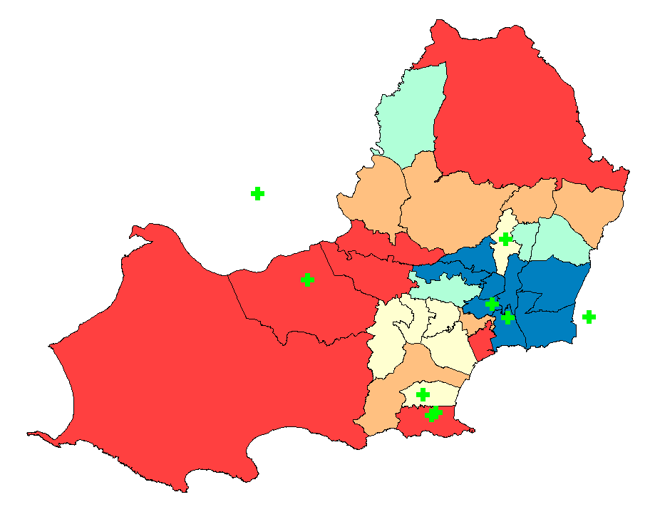
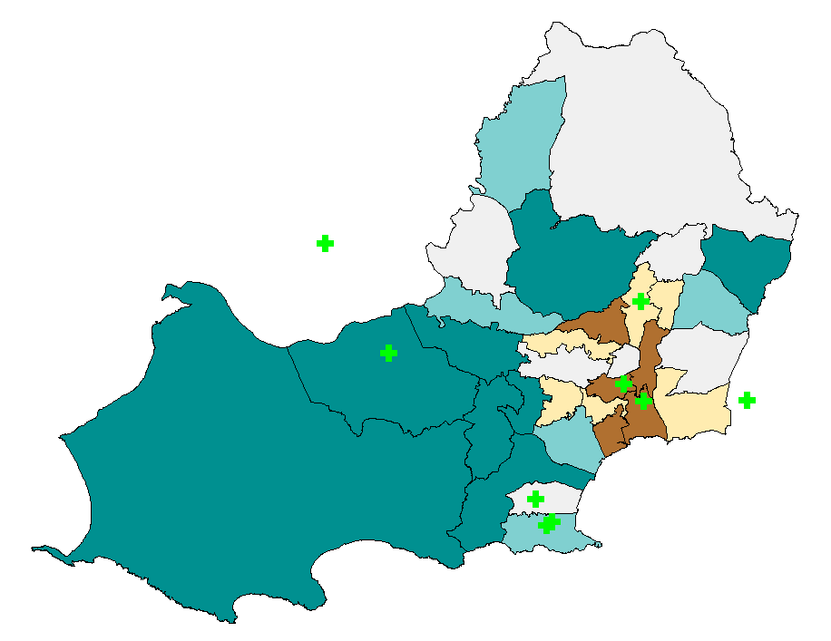
No Vehicles per Household Four or More Vehicles per household
These are the two maps presenting the thematic data for vehicles per household. On the left you can see there is a theme of no vehicles, the brown is areas where there is lots of households and going towards the white then lighter and darker blue showing the lease number of households. Alternately, the map on the right presents the data of households with 4 or more vehicles (cars and vans). The red colored areas represent the areas with most households that have this number of households with vehicles going to white and blue and dart blue where there are less households. We can see on both themes that there is a higher number of people without a lot of vehicles within the city center and the areas surrounding. There is also a similarity in the number of households with vehicles on the further out areas around the city center. This data could show that the people living further away from the vaccination centers might still be able to travel to get a vaccine and suggest maybe there is a different reason why the number of people getting a vaccine and booster is less as time goes on. We will now look at the data presented on the LSOA and then further on with the OA and Small Areas.
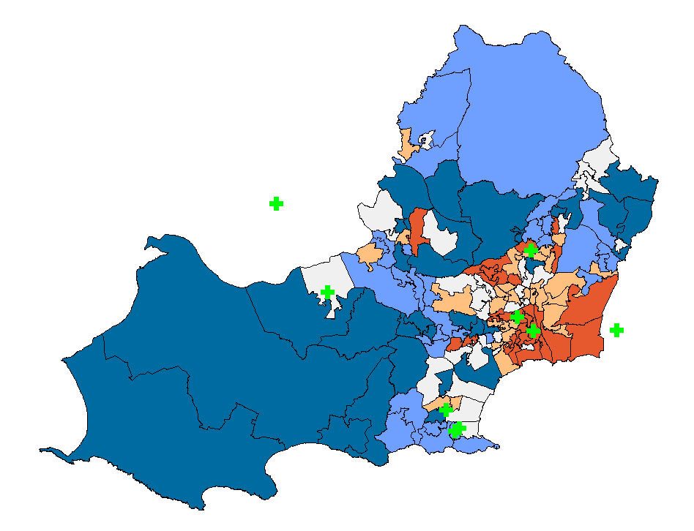
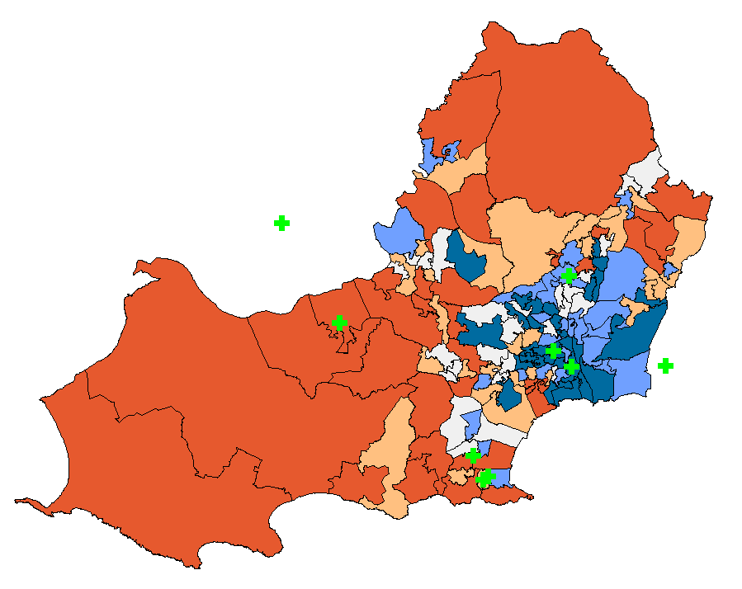
No Vehicles per Household Four or More Vehicles per household
Above is a similar version of the set of maps however now we can see there is a lot more variation in the lower super output areas. We can see that within the areas that before that suggested there were no vehicles and more than 4 vehicles per household, there are places that are more dominant to the themes. With this higher level of detail, we can now suggest that vehicles could be more of an impact to the percentage of uptake than once thought. This implies that travelling to a vaccination center could have been an issue for a larger number of people. This could also mean that more people were dependent on public transport such as busses, and even options like taxis which could have posed more of a risk to an individual trying to get to a vaccination center for a vaccine or booster. This could have affected the number of people willing to leave the house which would affect the percentages and risks of not achieving herd immunity.
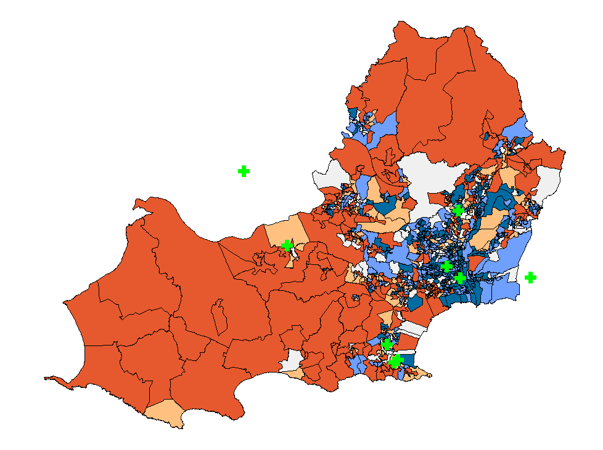
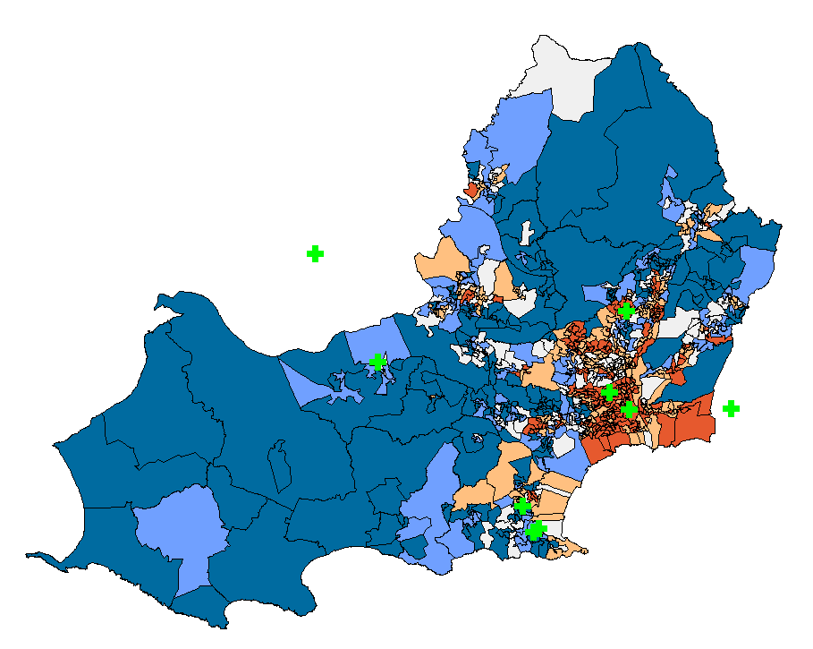
No Vehicles per Household Four or More Vehicles per household

This is now the most detailed version of the Swansea output areas and small areas. We can see from these two themes that there is a large amount of OA and small areas with no vehicles and on the contrary, lots of households with four or more vehicles. Generally, the areas that have higher amounts of households without vehicles are nearest the vaccination centers, which presents that the locations have been thought about to accommodate a lot of people. There are however some areas that are exceptions to this meaning there is still a risk of not having everyone in Swansea receiving the vaccinations and boosters that they are suggested to have. We know that this is an issue as the VDDW & RC19S data present statistics that show the statistics are not as what is desired for Swansea and other areas within Wales and for households that do not have any vehicles it could be a reason along with other potential factors as to why the statistics are not.
One of these other potential factors could be people’s health. If they are of certain ages being old or young and if they are in good or bad health, these could be aspects that can be considered as to why the % of uptake injections have not been high or consistent shown at the beginning of this task 2. To get an idea of what the general health is like within Swansea we can look at the themes below.
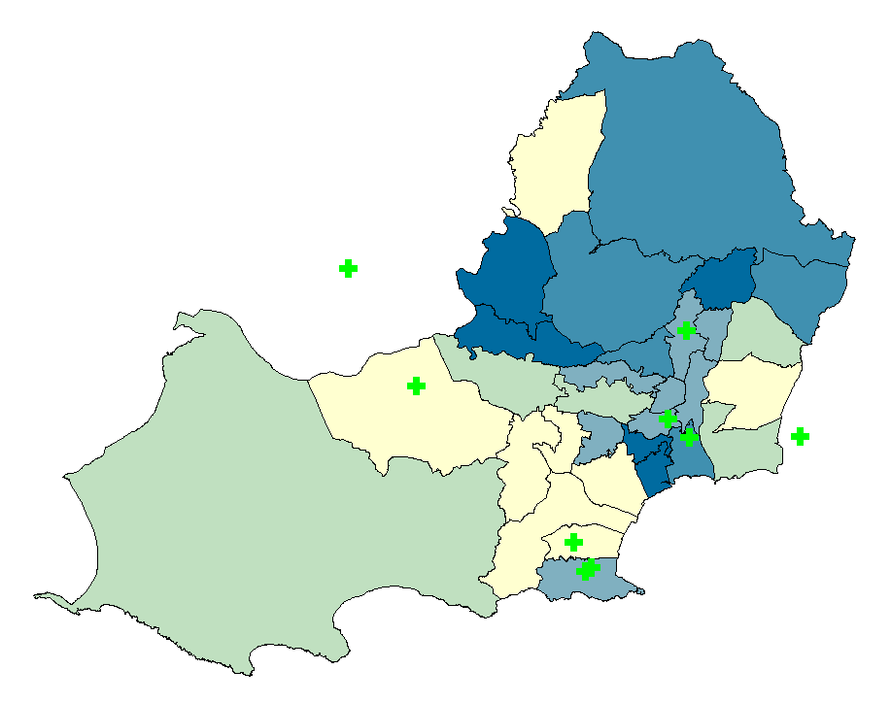
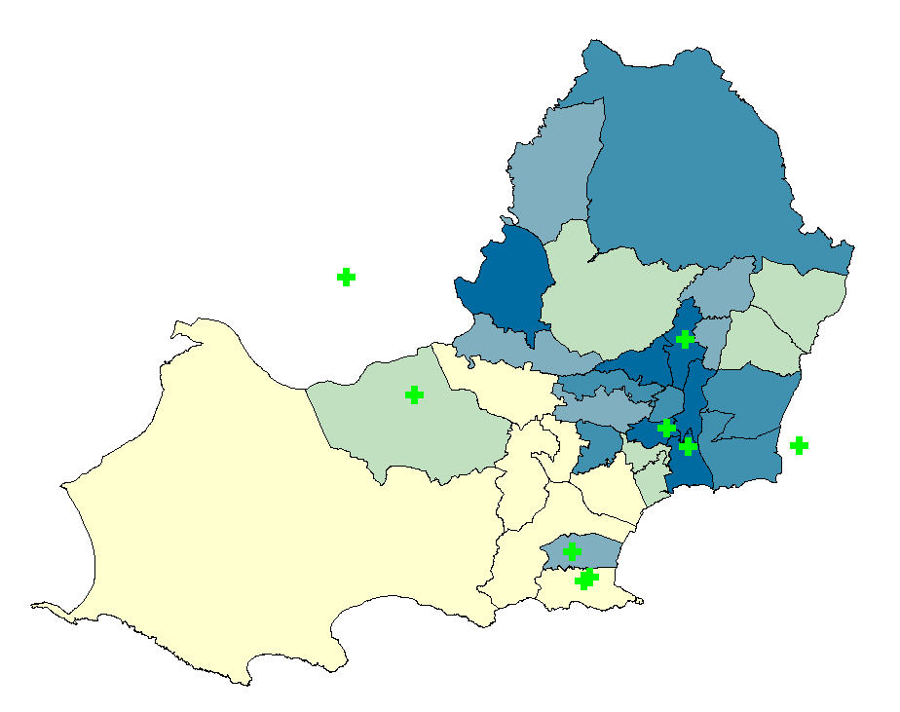
Very Bad Health Very Good Health

From these two themes we can see the output areas with the highest numbers of people which have very good and very bad health. The darker the areas show the places where the number of people is higher within the theme. We can see to the west of the Swansea city center that there is generally good health. Around the main city center is a mix with the health of people and could even have people with very bad health than good. To the north and east of the city center we can see there is also a mix in both very bad and very good healthy people. This data could show some reasoning as to why people have not attempted to go and receive a second and booster doses making the statistics how they can be seen in the VDDW & RC19S data.
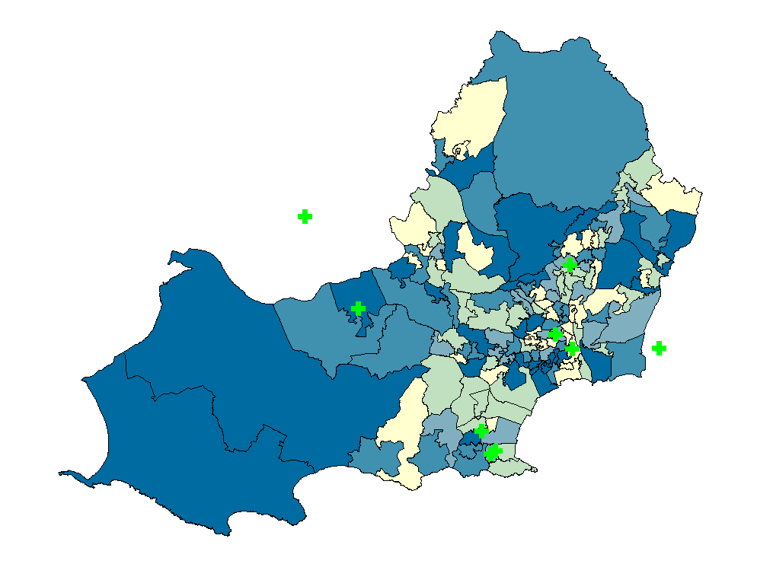
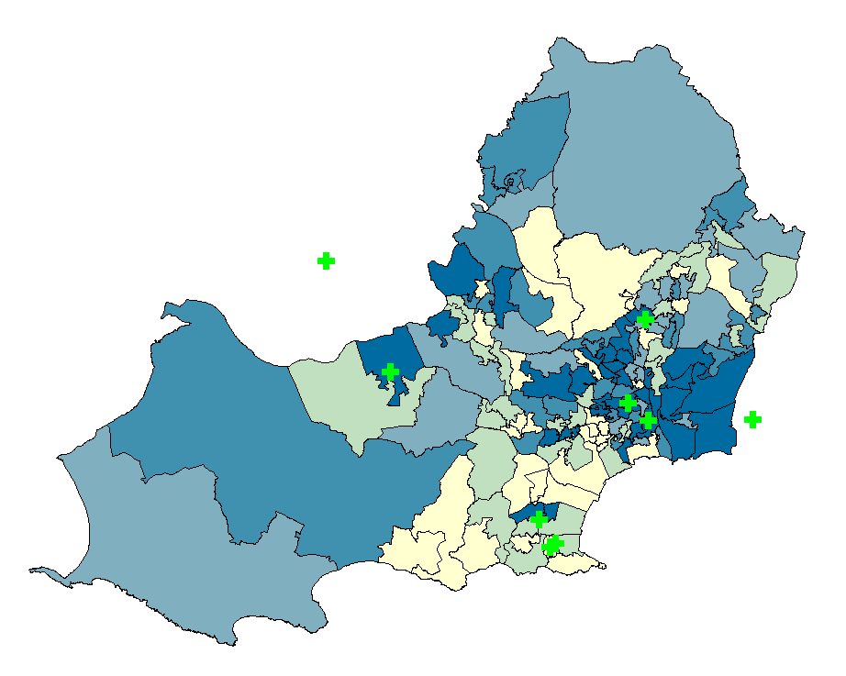
Very Bad Health Very Good Health

From the two themes presented above we can again see the same data presented however this time within the LSOA of Swansea. These maps look very different in comparison to the previous maps shown before. They suggest that there is a higher number of people both with very good and very bad health in more areas than shown before suggesting that there is a lot of people throughout Swansea that have good and bad health. Furthermore, when comparing these maps to the deprivation levels within these LSOA we can see a similar presentation of areas highlighted when looking at very good health and no levels of deprivation. Additionally, where very bad health and 4 or more levels of deprivation and seen. These two maps showing similar themes could be an insight into why many people have not got more doses and booster vaccinations, as they might not have the resources nor health to receive the vaccine. With constrains potentially being high and confidence in the vaccine being low it could present the reasoning why the uptake is much lower on the latter doses.
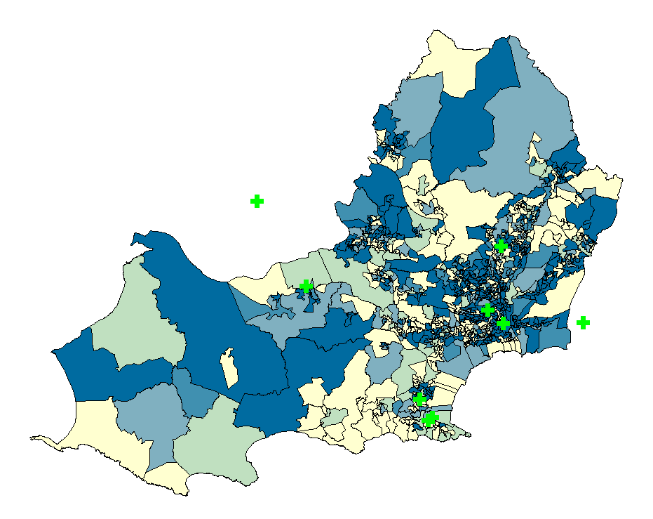
Very Bad Health Very Good Health
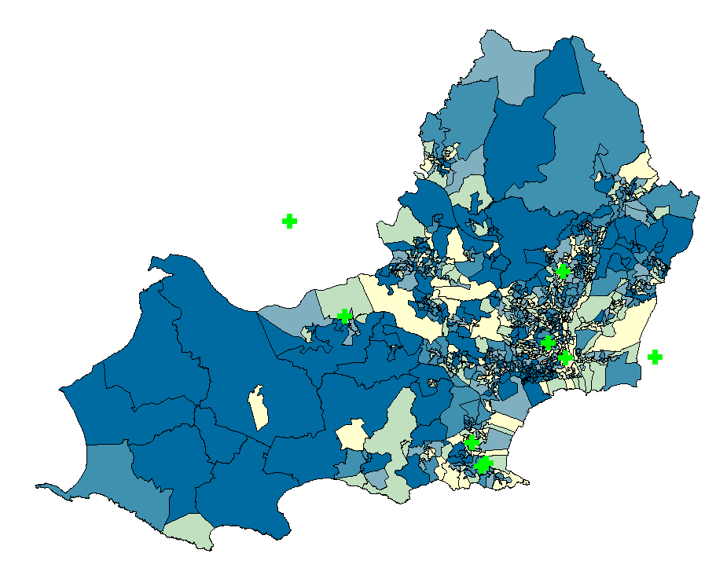
From the OA and Small Areas maps and themes on the bottom of the previous page we can now see the most detailed versions of the data presented. These maps both show the areas like before that have the best and worst health. From these themes there is not many areas that are fully good nor bad which is understandable for people in the areas. Knowing this gives us an idea of how effective the vaccine could be for these areas. If the people with very bad health received a vaccine it could result in them being protected and being able to fight off the vaccine, the very good healthy individuals should still get the vaccine regardless of how well their body would be able to fight off COVID 19 without the vaccine. The vaccination doses and boosters would also help these people to become less transmissive [8] meaning that more people could be protected, and the virus could be prevented from affecting a higher number of people.

Conclusion
Within the first task, data acquisition and designing of infographics was demonstrated, leading to the creation of a workspace with maps, tables, and themes presenting data about the vaccination programs and uptake. This documentation shows how software such as ‘MapInfo Pro’ can be used and what the final results can be used for. Within task two, there is analysis of the created infographics and how this can be used to understand the results that have been collected and why they could be as they are. This project hopefully succeeds with the aims to shows the process and reasonings of building a workspace and a discussion on findings as a result of the creations made.
References
[1] SBUHB, "COVID vaccine in Swansea and Neath Port Talbot", Swansea Bay University Health Board, 2022. [Online]. Available: https://sbuhb.nhs.wales/coronavirus-covid-19/information/vaccine-in-swansea-and-npt/. [Accessed: 28- April- 2022].
[2] M. Sheikh, "What is an Infographic? (Examples, Tips and Templates)", Visme Blog, 2020. [Online]. Available: https://visme.co/blog/what-is-an-infographic/#:~:text=Generally%2C%20infographics%20are%20used%20for,of%20illustrations%20and%20visual%20cues. [Accessed: 1- May- 2022].
[3] D. Robson, "Why some people don't want a Covid-19 vaccine", Bbc.com, 2021. [Online]. Available: https://www.bbc.com/future/article/20210720-the-complexities-of-vaccine-hesitancy. [Accessed: 3- May- 2022].
[4] "confidence", Dictionary.cambridge.org. [Online]. Available: https://dictionary.cambridge.org/dictionary/english/confidence. [Accessed: 7- May- 2022].
[5] NHS Inform, "Coronavirus (COVID-19) booster vaccination", Nhsinform.scot, 2022. [Online]. Available: https://www.nhsinform.scot/covid-19-vaccine/the-vaccines/coronavirus-covid-19-booster-vaccination#:~:text=Why%20the%20booster%20dose%20is,give%20you%20longer%2Dterm%20protection. [Accessed: 12- May- 2022].
[6] Mayo Clinic Staff, "Herd immunity and COVID-19: What you need to know", Mayo Clinic, 2022. [Online]. Available: https://www.mayoclinic.org/diseases-conditions/coronavirus/in-depth/herd-immunity-and-coronavirus/art-20486808#:~:text=Herd%20immunity%20also%20can%20be,causing%20illness%20or%20resulting%20complications. [Accessed: 16- May- 2022].
[7] NHS, "Coronavirus (COVID-19) vaccine", nhs.uk, 2022. [Online]. Available: https://www.nhs.uk/conditions/coronavirus-covid-19/coronavirus-vaccination/coronavirus-vaccine/. [Accessed: 23- May- 2022].
[8] N. Rura, "Vaccinated who get breakthrough infections less contagious", Harvard Gazette, 2021. [Online]. Available: https://news.harvard.edu/gazette/story/2021/12/vaccinated-who-get-breakthrough-infections-less-contagious/. [Accessed: 31- May- 2022].

