

University of Wales Trinity Saint David

Master of Business Administration (MBA)

Module: International Marketing: Principles and Practices

Comparative Analysis of CHANEL in Romania and Japan

Module Code: LCMB7026_LON

Student Name: Georgiana-Ioana Chirita

Student ID: 2120500

Lecturer: Dr. Amir Homayounfard.

Submission Deadline: 13.08.2026 BY 2PM.

Words: 5393

Term 2

1.AI Use Acknowledgement
I acknowledge the use of AI tools between 01 July 2026 and 09 August 2026 to support the research, proofreading, paraphrasing and preparation of my Strategic Management assignment on BMW Motorrad (BMW Group) and the proposed UK manufacturing facility.
The following AI tools were used:

1. QuillBot (https://quillbot.com/)
Used to improve sentence structure, paraphrase selected text, and enhance academic writing while keeping the original meaning.
Example prompts:
• Paraphrase this paragraph in an academic style.
• Improve the clarity and flow of this section.

2. ChatGPT (OpenAI) (https://chatgpt.com/)
Used to explain strategic management theories, help organise the report, create graphics and chart ideas, develop framework layouts (PESTEL, VRIO, SWOT, Balanced Scorecard), and support the reflection section.
Example prompts:
• Create a PESTEL analysis for BMW Motorrad in the UK.
• Design a Balanced Scorecard with KPIs.
• Create a SWOT matrix and implementation timeline.

3. Grammarly (https://www.grammarly.com/)
Used to check grammar, spelling, punctuation, clarity and Harvard referencing consistency.
Example prompts:
• Check this text for grammar and clarity.
• Review Harvard referencing and citation formatting.

Declaration
I confirm that I have not presented AI-generated text as my own work. I used these AI tools only to support my research, proofreading, visual materials and academic writing. The final analysis, discussion, recommendations and conclusions are my own work.

Table of Content

1. AI Use Acknowledgement……………………………………………….. 2
2. Introduction………………………………………………………………….4
3. Company overview…………………………………………………………5
3.1. Strategic Sources of Chanel’s Sustainable Competitive Advantage……………………………………………………………………5-6
4. Comparative Market Analysis…………………………………………..6-7
PESTEL ANALYSIS……………………………………………….…...7
4.1. Political analysis…...………………………………………………7
4.2. Economic analysis………………………………………………7-8
4.3. Social analysis………………………………………………..…8-9
4.4. Technological analysis………………………………………..9-10
4.5. Environmental analysis……………………………………...10-11
4.6. Legal analysis………………………………………………..11-12
5. Hofstede’s Cultural Dimensions Analysis………………………….12-14
6. STP Analysis………………………………………………………………14
6.1 Segmentation strategy……………………………………….14-15
6.2 Targeting strategy………………………………………………..15
6.3 Positioning strategy ………………………………………….15-16
7. Marketing Mix (7Ps)…………………………………………………..16-17
7.1 Product strategy………………………………………………17-18
7.2 Pricing strategy………………………………………………..18-19
7.3 Place strategy…………………………………………………….19
7.4 Promotion strategy……………………………………………19-21
7.5 People strategy……………………………………………….21-22
7.6 Process strategy………………………………………………….22
7.7 Physical evidence strategy…………………………………..22-25
8. Evaluation of Chanel’s Market Entry Strategy into Japan………..25-26
9. Ethical issues in Chanel’s International Marketing………………..27-28
10. Recommendations…………………………………………………..28-29
11. Conclusion……………………………………………………………29-30

2. Introduction
International marketing compels companies to strike a balance between globally coordinating brand image and adapting to local market conditions and consumer behaviour to be successful (Kotler, Keller and Chernev, 2022). For luxury brands like Chanel, this means that achieving the desired level of exclusivity and constant adjustment to the specifics of different markets is crucial for the company.
This report investigates the international marketing strategy of the Switzerland-based luxury brand Chanel by comparing the markets of Romania and Japan. The rationale behind the comparison is that Japan as a country has developed luxury markets whereas the market of Romania is growing.
To achieve this purpose, the author of this report applies the PESTEL analysis as well as Hofstede's cultural dimensions theory to assess the external atmosphere of the countries where Chanel operates. After that, the company Segmentation, Targeting and Positioning (STP) strategy as well as its 7P's marketing mix are analysed. Along with that, the author also discusses how the company enters the Japanese market and discusses the important ethical issues that are present in international marketing and provides recommendations in order to improve the competitiveness of the company in the international arena (Kotler, Keller and Chernev, 2022; Kapferer and Bastien, 2012).

Source: The Culture Factor/ Country- Comparison-tools

3.Company Overview

3.1. Strategic Sources of Chanel's Sustainable Competitive Advantage
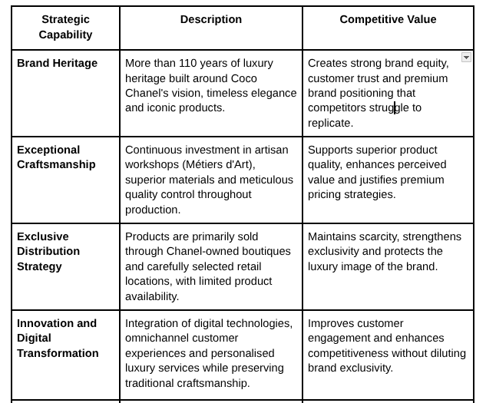

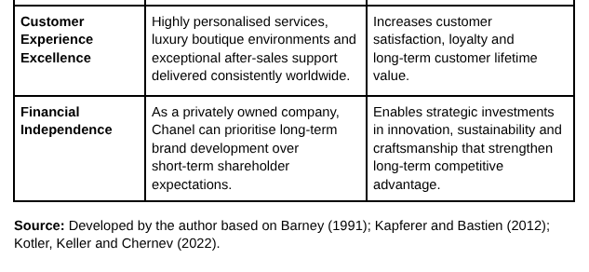
Important discussion
The table indicates that Chanel’s competitive advantage is a combination of both tangible and intangible strategic resources as opposed to a single capability. According to the Resource-Based View (RBV), these resources provide the grounds for sustainable competitive advantage since they are valuable, rare, hard for competitors to imitate, and at the same time well-supported by organizational strategic capabilities (Barney, 1991). Therefore, Chanel can keep premium pricing, improve customer loyalty, and maintain its position as a leader in the luxury fashion industry regardless of increasing competition from companies like Louis Vuitton, Hermès, Dior, and Gucci (Kapferer and Bastien, 2012).

4. Comparative Market Analysis
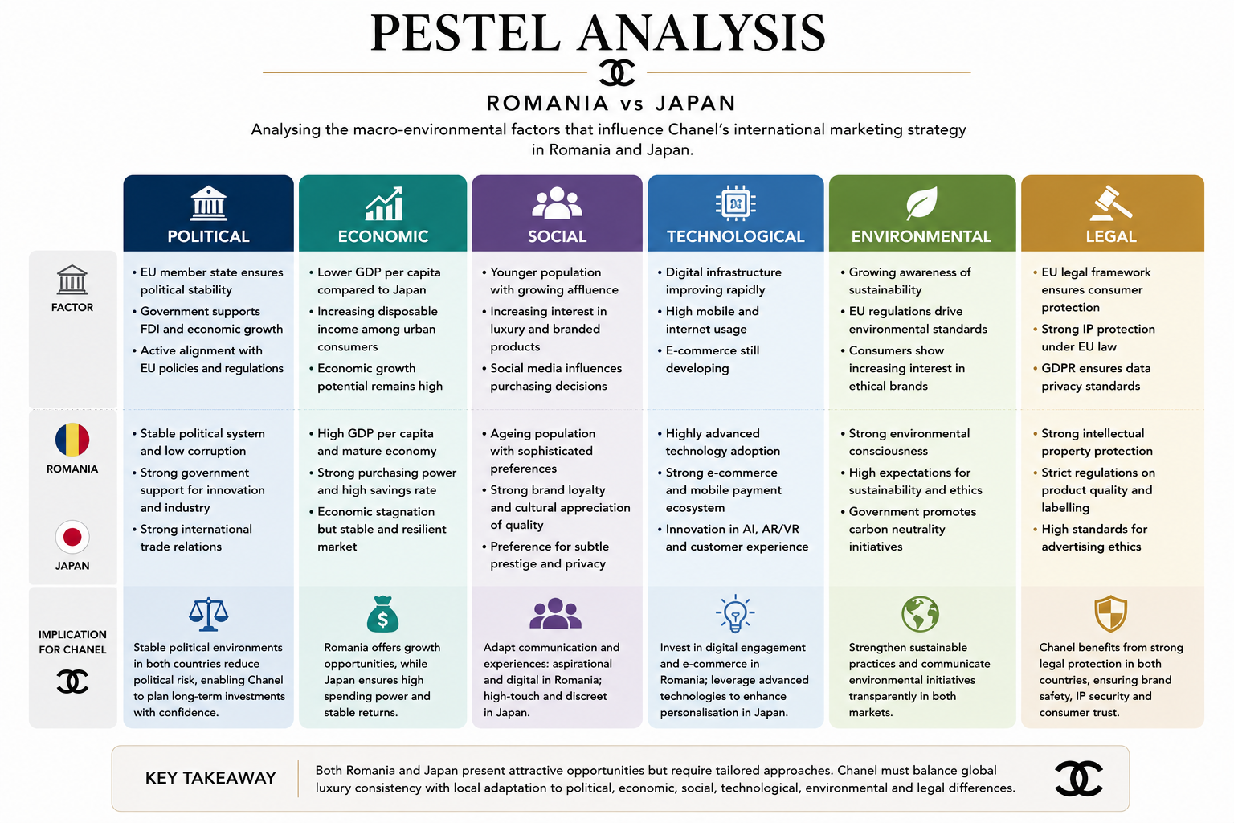
Chanel in Romania &Japan presents a comparative PESTEL analysis of Romania and Japan, highlighting the key macro-environmental factors that influence Chanel’s international marketing strategy. The analysis shows that both markets offer attractive opportunities but differ significantly in their economic, social and technological environments.
Japan represents a mature luxury market with high purchasing power, advanced digital infrastructure and strong consumer demand for premium brands. Romanian consumers, on the other hand, are younger and benefit from a growing economy, creating opportunities for market expansion and increasing luxury consumption. While both countries provide stable political and legal environments through strong regulatory frameworks, Chanel must adapt its marketing strategy to local consumer behaviour, cultural preferences and market conditions.
Overall, the comparison suggests that Chanel should adopt a standardised global luxury positioning while tailoring its product offering, communication and customer experience to the specific characteristics of each market. This balance between global brand consistency and local responsiveness will support sustainable growth and strengthen Chanel's competitive advantage in both Romania and Japan.

PESTEL Analysis
4.1. Political Environment
The stability of the political situation in the country can influence such aspects as investment decisions, adherence to regulations and long-term planning in business. Romania is a member of the EU, which guarantees standard regulations and protection of intellectual property. However, there are fiscal reforms and changes in policies every now and then when it comes to the Europeans (European Commission, 2025). Japan, on the contrary, is a country with stable politics and regulations which makes long-term investment and premium retail expansion possible (World Bank, 2025).
This means that the business environment Japan offers Chanel is predictable, which leads to a low strategic risk level and makes it easy to invest into flagship boutiques and offer premium experience to their clients. Romania is still a country, where Chanel is going to expand in the future, but it needs to become more flexible when it comes to the operations since the market and legislation is changing quite frequently.

4.2 Economic Environment
Purchasing power and luxury consumption are affected by the economic environment. Japan is one of the leading markets in terms of luxury consumption and is characterized by high incomes and the strong brand awareness of many premium products (OECD, 2025). Romania is a smaller and somewhat more sensitive market but can show continued growth and the increasing number of affluent consumers (Euromonitor International, 2025).
Such differences in markets would lead to different marketing approaches. In the case of marketing Chanel in Japan, the focus could be on building customer loyalty. In Romania, in turn, the company must think of the creation of a customer base and establish its presence in the market.
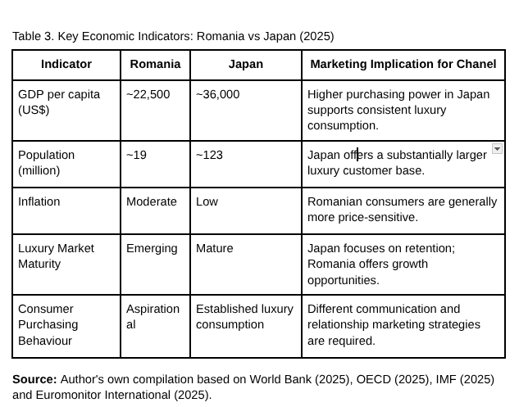

4.3 Social Environment
There are a lot of differences in consumer motivations between the two nations. Japanese customers put craftsmanship, originality and high-quality service above all, while wealth in Romania plays a bigger role in determining buying behaviour of luxury goods consumers. Thus, it is crucial for Chanel to sustain customized boutique experiences in Japan while expanding its digital storytelling and experiential marketing in Romania (Kapferer and Bastien, 2012).

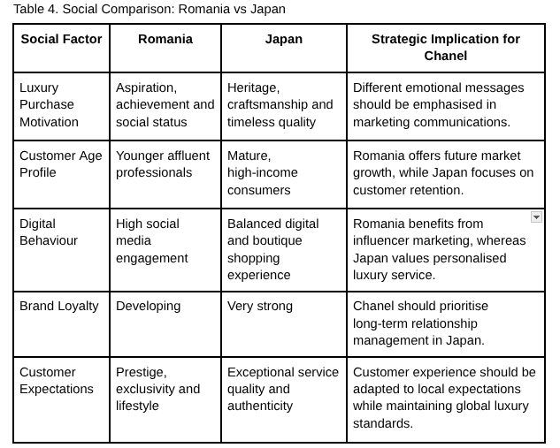

Source: Author's own comparison based on Euromonitor International (2025), De Mooij (2021), Solomon et al. (2023) and Kapferer and Bastien (2012).
4.4. Technological Environment
The use of technology is essential for a luxury retail business to maintain market competitiveness. Japan has an excellent digital framework and advanced omnichannel retailing which allows Chanel to use artificial intelligence and give consumers personalized and smooth user experience (Statista, 2025). The digital landscape of Romania is also developing rapidly, and new technologies are changing the buying behaviours of the younger generation.
It is significant for technology to serve various purposes in different countries. While Japan needs to adapt to the demanding needs of the customers, Romania is focusing mainly on education and establishing ties with consumers.

Critical evaluation
Digital transformation should enhance exclusivity rather than replace the personalised service expected in luxury retail.
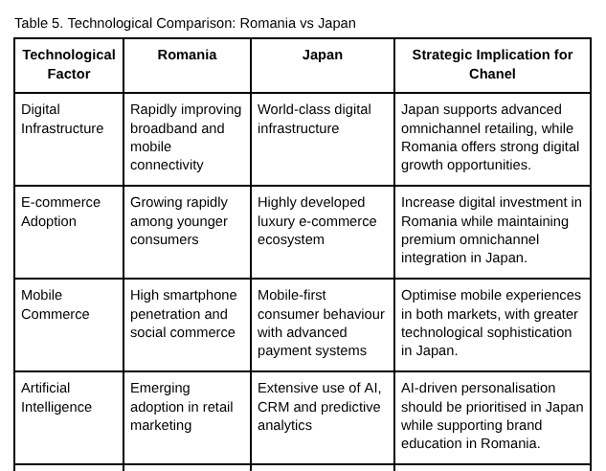

Source: Author's own comparison based on Eurostat (2025), Statista (2025), Deloitte (2024) and World Bank (2025).
4.5. Environmental Environment
Consumer expectations are shaped more than ever by environmental sustainability. Overall, it appears that Japanese consumers are more concerned about responsible sourcing, ESG metrics, and transparency than Romanian consumers, which gives more significance to brand prestige and quality (OECD 2025).
Chanel must sustain universal sustainability criteria while adjusting its communications. Japan puts a particular premium on detailed environmental reporting, and Romania must rely on the brand’s traditional emphasis on products’ quality and longevity about sustainability.
Evaluation
Sustainability has transformed from a matter of compliance into an essential factor in luxury brand value creation.
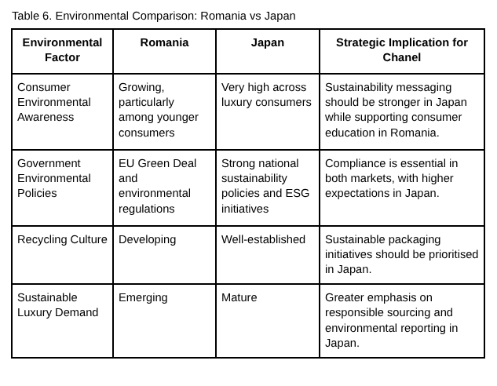
Source: Author's own comparison based on Chanel (2025), OECD (2025), European Commission (2025) and Deloitte (2024).
4.6. Legal Environment
Strong protections for intellectual property rights and consumer protection are available in both Romania and Japan. While Romania is governed by the EU regulations, such as GDPR, Japan is equipped with a comprehensive range of legislation providing protection for trademarks, contracts and superior business practices (European Commission, 2025; World Bank, 2025).
Compliance with regulations is of utmost importance for Chanel because it helps maintain its equity, reduce risks of counterfeit goods and keep the customers loyal. Also, every digital marketing activity must comply with different privacy regulations and provide a luxury brand experience everywhere.
Assessment
There is a positive atmosphere regarding regulations in both countries; however, the ongoing monitoring of the legal environment is important.
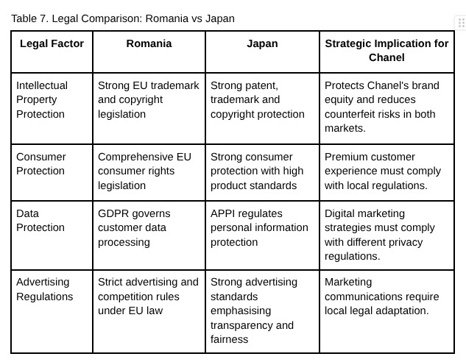
Source: Author's own comparison based on the European Commission (2025), World Bank (2025), WIPO (2025) and OECD (2025).
5. Hofstede's Cultural Dimensions Analysis
The study of Hofstede's Cultural Dimensions illustrates how countries like Japan and Romania differ culturally and how these cultural differences impact consumer behaviour and affect Chanel's international marketing strategies (Hofstede, 2001). Romania gives preference to consumer behaviours that revolve around luxury purchases because of visible status and emotional engagement, while Japan gives preference to the quality and authenticity of luxury items (Hofstede Insights, 2025).
Consumers in Romania are much more willing to engage with marketing techniques based on inspiration and lifestyle concepts, while Japan prefers marketing that involves good relations between brands and their customers (Hofstede Insights, 2025). The high uncertainty avoidance that characterizes the two nations emphasizes the importance of strong brand reputation and product authenticity, which is what Chanel does (Hofstede Insights, 2025).
In other words, Chanel needs to preserve its international brand image of luxury while changing its marketing techniques so that they fit the local cultures of Romania and Japan (Hofstede, 2001; Hofstede Insights, 2025).
Analysis
The comparison reveals that companies like Chanel can build their competitive advantages through customer engagement without changing identities. For example, consumers in Romania can be influenced through aspirational and digital marketing, while Japanese customers want more traditional marketing techniques. These findings confirm De Mooij's (2021) statement about the importance of cultural adaptation in international marketing practices and discuss the need for successful implementation of consistent marketing strategies.
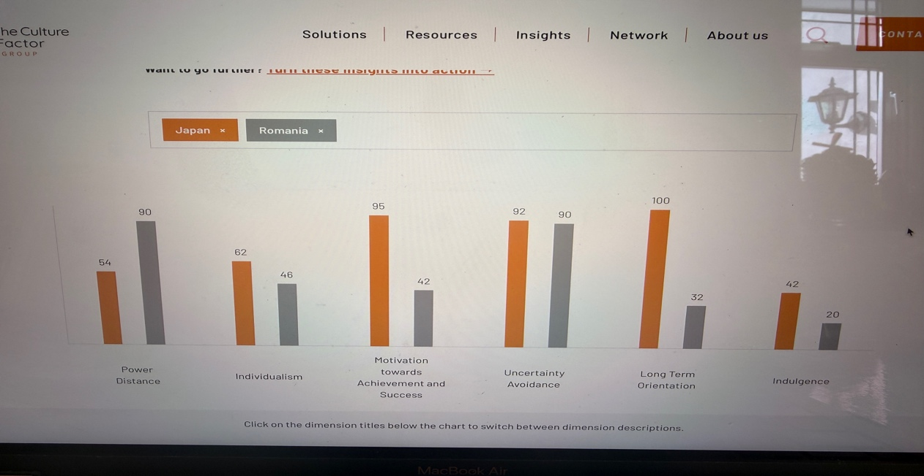

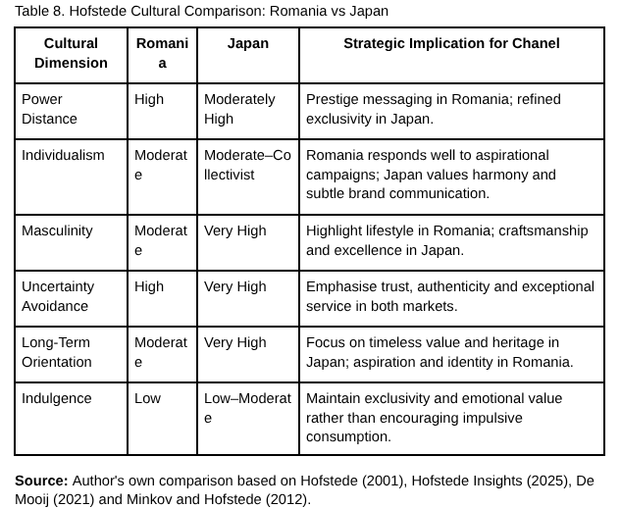
6. STP Analysis
Segmentation, Targeting and Positioning (STP) is a critical marketing model that helps businesses discover appealing consumer segments, use resources efficiently and form a unique competitive position (Kotler, Keller and Chernev, 2022). For a luxury brand like Chanel, STP is especially valuable because the company wants to remain exclusive, while also addressing the disparities in consumer tendencies around the world.

6.1 Segmentation strategy
Chanel classifies its global markets by demographic, geographic, psychographic and behavioural factors. While both Romania and Japan contain wealthy consumers, they vary greatly in their market compositions.
In Japan, Chanel focuses on wealthy people in a professional capacity such as businesspeople or loyal luxury consumers. Their purchasing decisions are mostly determined by quality, authenticity and a long-term relationship with brands.
On the other hand, Romanian luxury consumers are fewer in number but are increasing. The key market segment includes wealthy people in professional capacities, business owners and younger wealthy people, who want things that showcase their success and accomplishments. Moreover, social media is much more influential on the purchasing behaviour of luxurious consumers compared to Japan.
These contrasts indicate that market segmentation should be adapted to local conditions while remaining aligned with Chanel's global positioning as a luxuriously branded company.
6.2 Targeting Strategy
Chanel is using a concentrated targeting strategy that focuses on rich people who are ready to pay high prices for luxurious products. The company has chosen to pursue exclusive marketing rather than mass marketing.
When it comes to the Japanese market, targeting revolves around well-off clients who have the highest expectations of boutique experiences and services.
The luxury market is being developed in Romania, where the targeting consists of new categories of affluent professionals. While Japanese consumers are trustier and often buy luxury goods, Romanian consumers tend to buy luxury products less frequently.
6.3 Positioning Strategy
Chanel is known to be one of the top-tier luxury fashion houses worldwide due to its ancient history of manual work, being timeless and exclusive at the same time. This positioning holds true in various markets, yet the communication method has been adapted to harmonise with local consumers.
In Japan, the emphasis is laid on the ideas of craftsmanship, authenticity, and providing unparalleled customer service. All marketing communications concentrate on heritage and quality, which allows consumers to form expectations characteristic of luxury players.
While in Romania, Chanel promoted the premium nature of its positioning focusing on even more aspirational outcomes. Marketing has focused on elegance, exclusivity, and lifestyle while putting an accent on digital communication to inform consumers regarding the heritage and values of the brand.
The principles of global standardisation with local adaptation can be seen in the example of Chanel branding.

7. Marketing Mix (7Ps)
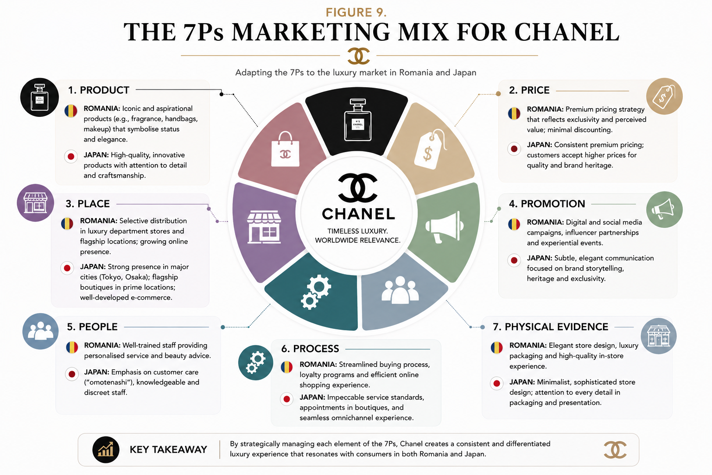
Chanel is recognized as among the most elite luxury brands globally owing to its unique combination of history, craftsmanship, ageless design, and exclusiveness. This positioning is successful in many countries; however, its marketing communication takes the values of local customers into account.
In Japan, it emphasizes craftsmanship, authenticity, and experience. In its advertising, the company refers to the elements of history and quality to meet the high expectations of luxurious customers.
In Romania, it uses the same positioning but with a more aspirational flair. There are references to elegance, exclusivity, and lifestyle in its marketing activities, and emphasis on the importance of consumer education and digital engagement.
This case illustrates the idea of global standardization coupled with local adaptation. Chanel keeps its global branding but makes its customers engage in accordance with the local market situation.
Overall, this example shows that the core of competitive advantage relies not on the change of positioning but on the development of the ways in which the same positioning is communicated.
7.1 Product Strategy
According to Kotler, Keller and Chernev (2022), product is the core element providing value to consumers and is a key for differentiating brand from competitors. In luxury goods industry, products help consumers obtain both functional benefits as well as values like symbolic meaning, emotional ties with the products and social prestige (Kapferer and Bastien, 2012). Chanel provides a wide range of products including haute couture, ready-to-wear clothes, bags, watches, jewellery, perfumes and cosmetics to support brand values, excellence and exclusivity.
Although the product itself is the same in all countries, customers’ expectations differ in case of Romania and Japan. Japanese people pay a lot of attention to precision, craftsmanship and authenticity; therefore, they expect superb quality and outstanding after-sales service from Chanel (Hofstede, 2001). Romanian consumers, in their turn, are very much influenced by aspirational brands, i.e. brand visibility. Therefore, for them the most popular products of Chanel represent symbols of success and achievement in life (Euromonitor International, 2025).
Chanel’s global product strategy ensures stability of brand identity and allows minor alterations through special lines, tailored services and country-related products.
The product strategy of Chanel effectively combines global uniformity and selective adaptation at local level. By guaranteeing that product quality and craftsmanship remain unchanged in Romania and Japan, the company creates brand equity while protecting its advantage of exclusivity (Aaker, 1996).
7.2 Pricing Strategy
Chanel is committed to a premium pricing approach around the globe, and its prices convey luxury instead of the production costs; unlike other brands, pricing for Chanel is based on luxury, quality and exclusiveness (Kotler, Keller and Chernev, 2022; Kapferer and Bastien, 2012). Consequently, even if the purchasing power status in Romania differs from Japan, Chanel has the same strategy of premium pricing to preserve its brand image and does not adopt any policies based on discounts since any promotions may result in negative perceptions about exclusiveness.
Chanel finds other ways to provide value for customers through excellent service, limited lines of collections and unique shopping experiences. For example, whereas in Romania, value is generated via the history of the brand, in Japan, the focus on authenticity and quality are more significant (World Bank, 2025). Therefore, this is a solid approach to having the brand imagery consistent in the whole world.
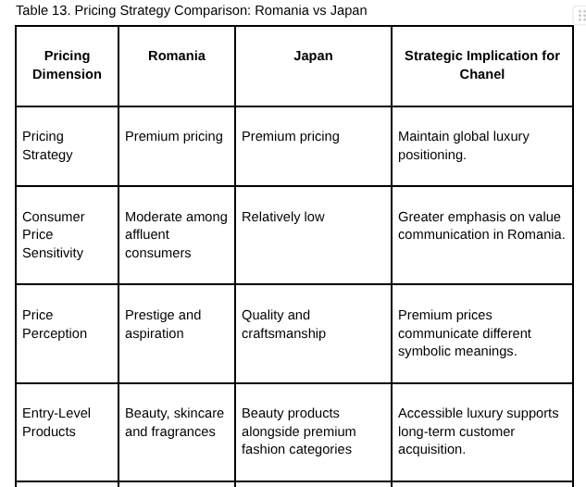
Source: Author's own comparison based on Kotler, Keller and Chernev (2022), Kapferer and Bastien (2012), Euromonitor International (2025), Statista (2025) and Chanel (2025).
7.3 Place Strategy
Chanel utilizes a selective distribution approach to maintain exclusivity, protect its brand equity and ensure premium customer experience through its own retail stores, one of the concept stores or online channels (Kotler et al., 2022; Kapferer and Bastien, 2012). In Japan, flagship stores provide customisation services, plush retail settings and seamless experiences (Hofstede, 2001). In Romania, on the other hand, Chanel is forced to rely more on authorized retailers and digital channels to spread brand awareness due to smaller luxury market size, although complete control is also maintained to minimize counterfeiting and ensure exclusivity (Euromonitor International, 2025). Therefore, Chanel’s selective distribution method provides product scarcity, customer trust and supports the premium brand image in both developed and emerging markets.
Chanel’s selective distribution strategy allows for protecting industry prestige as well as ensuring uniform customer experience in various countries around the world. Even though in Romania there is a greater reliance on digital engagement and authorized retailers, strict control over sales channels ensures the protection of brand equity.
7.4 Promotion Strategy
Chanel’s marketing strategy is based not on encouraging immediate sales, but on the strengthening of the brand identity and emotional connection with the clients (Kotler, Keller, and Chernev, 2022; Keller, 2013).
In Japan, the promotional activities are cantered on craftsmanship, history, and understated luxury thanks to the minimalist advertising, exclusive events, and chosen ambassadors (Hofstede, 2001). In Romania, Chanel uses digital promotion actively along with work with influencers and storytelling to attract young rich consumers without losing its image as a premium brand (Euromonitor International, 2025).
Overall, Chanel balances global brand consistency with local adaptation by preserving its core principles while tailoring promotional activities to each market’s culture and media consumption patterns (Levitt, 1983; Doole, Lowe, and Kenyon, 2022).
Chanel’s promotional strategy is successful due to the combination of traditional and innovative methods to communication. The consistent branding is complemented with the use of local channels of communication that help involve the target audience and promote the brand without losing its exclusivity, which proves Keller’s (2013) Brand Equity Model about the positive impact of consistent and relevant communication 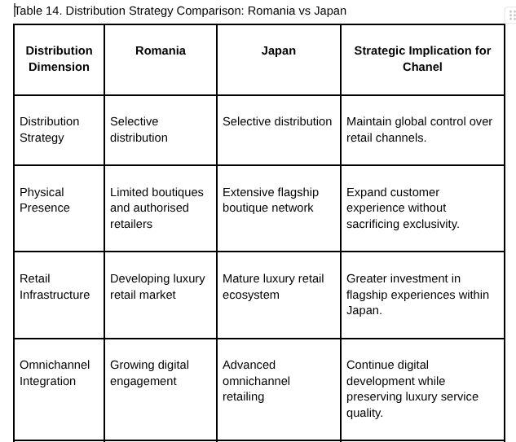on brand loyalty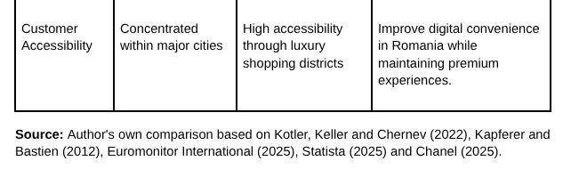
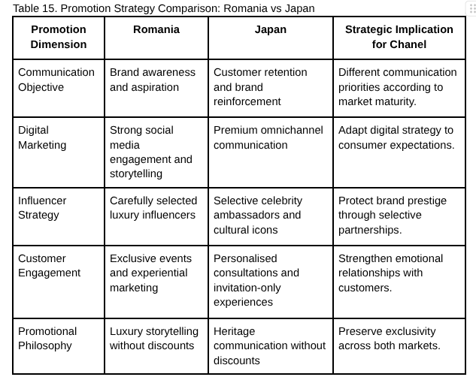
Source: Author's own comparison based on Kotler, Keller and Chernev (2022), Kapferer and Bastien (2012), Euromonitor International (2025), Statista (2025) and Chanel (2025).
7.5 People Strategy
Chanel’s competitive advantage comes from its people, who play an important role in customer satisfaction, brand image and relationship quality through their exceptional service and expertise (Booms and Bitner, 1981; Kotler, Keller and Chernev, 2022). Chanel is therefore committed to recruiting and training the best employees so that customers get a luxury experience every time they deal with the company.
In Japan, customer service is affected by the principle of homogenate, which means that employees provide customers with sincere hospitality, expert product knowledge and customized relationship management (Hofstede, 2001; Kapferer and Bastien, 2012). In Romania, the role of boutique employees is more educational when it comes to explaining the history and quality of Chanel while building trust with customers who buy luxury for the first time (Euromonitor International, 2025).
Hence, Chanel’s people strategy allows the company to maintain its competitive edge through the delivery of quality services yet considering the needs of local customers. As a result, customers receive good service, brand equity is created and customer loyalty achieved (Keller, 2013; Aaker, 1996).
7.6 Process Strategy
According to Booms and Bitner (1981) and Kotler, Keller and Chernev (2022), Chanel’s processed strategy mixes efficient systems with personalized service to create an uninterrupted and luxurious experience to meet the needs of its clients while maintaining its exclusive brand image. Digital technologies are used together with in-store practices to ensure customer satisfaction while still ensuring that personalized service is provided as expected by luxury customers.
In Japan, Chanel provides clients with private consultations, personalized advice and after-sales service, while both processes are supported by digital appointment systems and customer relationship management (CRM) software that guarantee precision and reliability expected by clients (Hofstede, 2001; Statista, 2025). In Romania, the use of digital communication technologies and online client services enhances accessibility of the luxury brand and build clients’ trust in this new luxury market (Euromonitor International, 2025).
To sum up, Chanel’s omnichannel process strategy combines operational performance with provision of personalized services, which saves the brand reputation globally; therefore, the company can adapt to changes in local markets (Kapferer and Bastien, 2012; Doole, Lowe and Kenyon, 2022).
7.7 Physical Evidence Strategy
Physical evidence is a crucial part of Chanel’s luxury strategy, for store design, the way the products are presented, packaging and the shopping environment contribute to shaping customers’ perception of the product (Booms and Bitner, 1981; Kotler, Keller and Chernev, 2022). Chanel makes sure to manage the physical evidence so that it provides its consumers with memorable luxury experience.
In Japan, shops have a minimalist and subtle design, thus showing that Japanese people like this kind of luxury (Kapferer and Bastien, 2012). In Romania, the company ensures that it follows its rules by using certified distributors and sticking to standards in packaging and branding (Euromonitor International, 2025).
Therefore, it can be said that Chanel has a uniform strategy of physical evidence around the world.
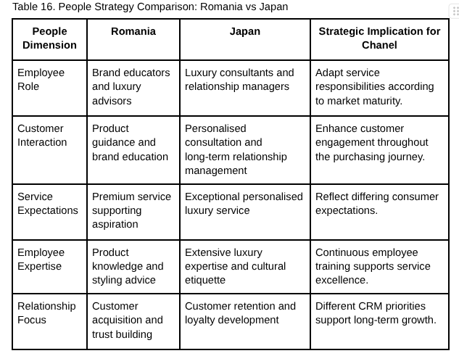
Source: Author's own comparison based on Kotler, Keller and Chernev (2022), Chanel (2025), Kapferer and Bastien (2012) and Statista (2025).

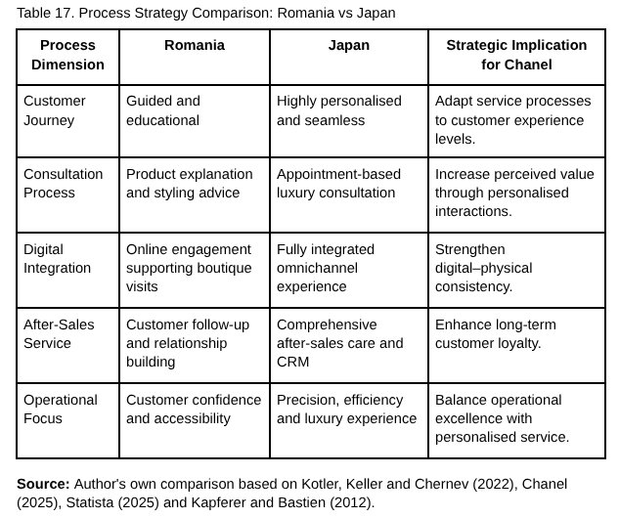
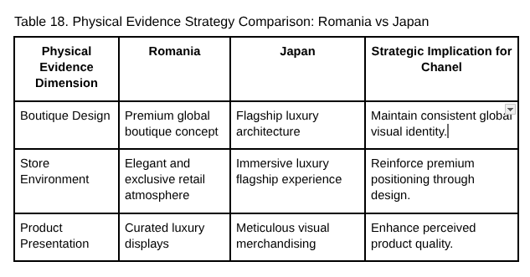

Source: Author's own comparison based on Kotler, Keller and Chernev (2022), Kapferer and Bastien (2012), Chanel (2025) and Statista (2025).

8 Evaluation of Chanel's Market Entry Strategy into Japan
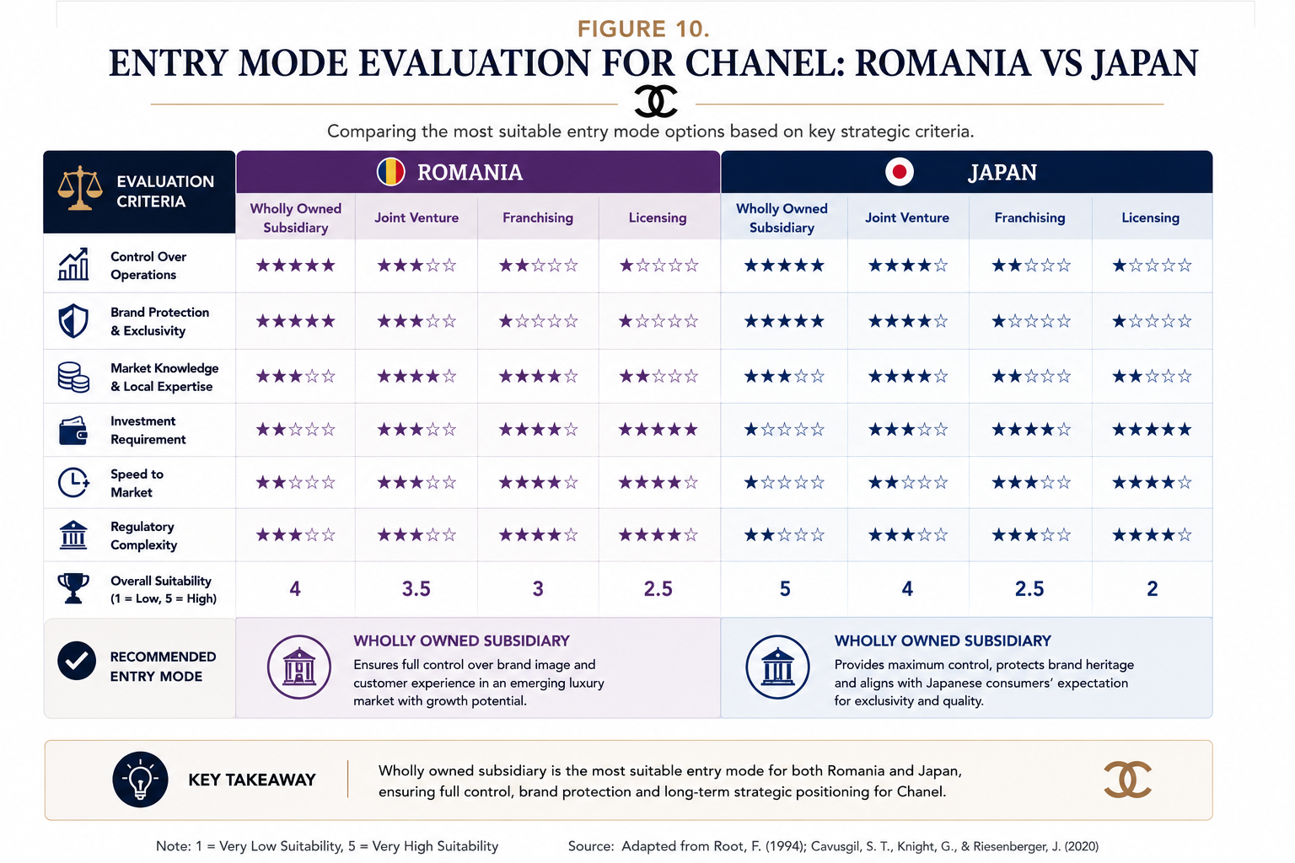
Chanel made the decision to enter Japan through the establishment of wholly owned subsidiaries. Under this way of entry, the company could preserve full ownership rights and keep total control over its retail business, marketing processes, product pricing and customer experience (Hill et al. 2023). Contrary to franchising, licensing or joint ventures, this way of entering the market allows Chanel to maintain its luxury brand image, implement uniform standards of services as well as be sure in the authenticity of the products sold (Kotler et al. 2022; Kapferer et al 2012). Even though this strategy requires huge financial investments, it enables Chanel to ensure the theory of exclusivity which is the basis of its competitive advantage.
Japan is a great place to invest into due to its high purchasing power, the developed luxury market, political stability, the advanced retail infrastructure and high appreciation of crafts and quality by consumers (Statista, 2025; World Bank, 2025). All these characteristics of the market correspond perfectly to the way Chanel positions itself in the market, allowing the company to provide personal experience for its customers while keeping the prices at premium level and ensuring high quality of service (Hofstede, 2001).
Chanel’s approach to entering the market of Japan is very well explained using Dunning’s Eclectic (OLI) Paradigm. The company possesses some substantial ownership advantages, such as a strong brand equity, amazing craftsmanship techniques, own designs of the products and loyal customers, which justifies this way of entering the market (Dunning 1988; Barney 1991). The location advantages are realized due to Japan’s stable business environment as well as strong legal protection of the intellectual property and developed luxury retail market, while the advantages of internalization provide Chanel with the opportunity to retain full control over pricing, customer service, authenticity of its products and the brand itself (Peng, 2022).
To sum up, being implemented with certain effectiveness, a strategy of establishing wholly owned subsidiaries brings huge financial risks and slows down the process of expansion since it allows the company to take a maximum level of control and to adapt it to market conditions, thus helping Chanel to achieve long-lasting competitive advantage in the luxury goods market (Root, 1994; Dunning 1988).l
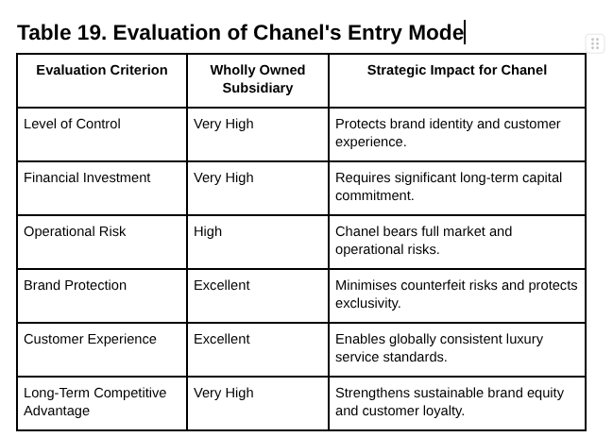
Source: Author's own evaluation based on Root (1994), Kotler, Keller and Chernev (2022) and Chanel (2025).

9. Ethical Issues in Chanel's International Marketing
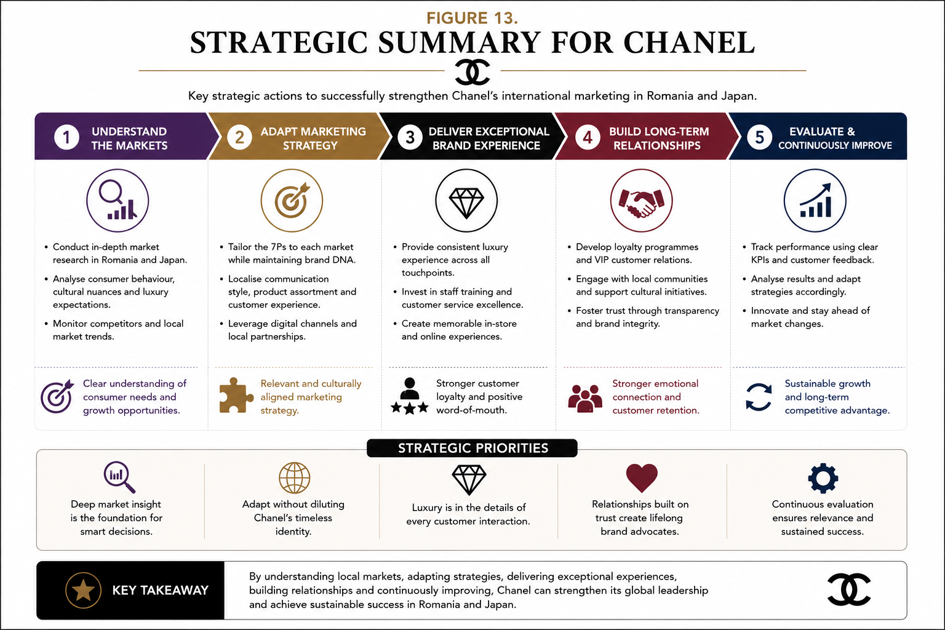
In the current international marketing landscape, ethical issues play a vital role as stakeholders such as consumers, governments, and investors continue to expect ethical conduct on the part of business organizations while promoting their interests. Brands operating in luxury markets like Chanel cannot be merely content with compliance with regulations anymore and must expand the understanding of ethical marketing to include responsible sourcing, sustainability and environmentally friendly conduct in business (Kotler, Keller, Chernev, 2022).
Lately, one of the main challenges in ethics in marketing has been related to sustainable sourcing practices adopted by organizations. Since luxury products often feature premium quality raw materials such as leather, precious metals, and exclusive textiles, unethical sourcing can be very disastrous (Chanel, 2025). To be environmentally friendly and respect nature, Chanel has started investing into renewable energy, biodiversity promotion and low-carbon production processes. However, stakeholders have started expecting actual results in the form of specific data instead of vague messages about sustainability. This means that transparency in environmental reporting will constitute a huge competitive advantage in today’s markets, especially in such countries as Japan with high standards regarding sustainability.
Another ethical issue concerns the management of supply chains. Luxury brands rely on complex supply chains that include specialized producers and artisans. While Chanel invests a lot into preserving craft and producing goods of great quality, it is essential to monitor suppliers to ensure compliance with ethical labour practices. Otherwise, if companies fail to monitor their suppliers, there may be a negative impact on their brand thanks to irresponsible production practices.
The last problem relates to ethical advertising. Most luxury brands’ ads are focused on exclusivity and aspiration, which raises questions about diversity and socially responsible advertising messages. Chanel follows the steps of other brands and has made progress in diversity in marketing; however, there is always a need to keep up with changing requirements in different countries. Thus, advertising must correspond to the issues of diversity while remaining true to the brand’s history and ideals.
In this way, ethical advertising becomes a marketing strategy that provides companies with a lot of advantages.

10. Recommendations
The analysis of Romania vis-à-vis Japan has led to the development of three strategic recommendations to improve Chanel’s international marketing.
Recommendation 1: Develop a digital personalised approach to consumers in Romania that does not compromise on exclusivity.
The emergence of wealthy consumers in Romania over the long run, especially those belonging to the younger generation of luxury goods consumers attending the digital world has inspired Chanel to enhance its customer relationship management (CRM) capabilities through personalised communications, private online events, and invitations to view new products prior to their official sale. Implementation of these measures would allow the company to reach greater levels of engagement with consumers and yet keep its brand image intact. It should be noted that personalisation as it differentiates the luxury approach from the rest is not about opening access to the goods and services to the consumers, but the opposite.
Recommendation 2: Increase sustainability transparency in both investigations.
Even though Chanel has introduced sustainable measures and resources, the audience has started demanding evidencing of the company’s ethical performance. Thus, Chanel should announce more comprehensive information regarding carbon footprint reductions, sourcing, and the overall supply chain. The recommendation is of great importance for the Japanese market, in which sustainability plays a decisive role in consumers’ purchasing behaviours, and helps the people from Romania understand the meaning of sustainability gradually.
Recommendation 3: Implement differentiated consumer experience strategies.
Chanel should keep position of the luxury brand in Japan by providing the highly personalised services. At the same time, the company should focus on providing education on experiential marketing and conducting exclusive events for the consumers in Romania. The proposed approach will enable the company to keep up with the appeal of its offerings worldwide, while adjusting its marketing touch to each market.
These recommendations allow Chanel to maintain a good balance between being a global brand and adapting to the local market, thus ensuring the competitiveness of the company.

11. Conclusion
This report has thoroughly analysed Chanel's international marketing strategy through a comparison of Romania and Japan. The results show that while both markets present similar opportunities, they greatly differ in terms of economic conditions, culture, consumer habits, and degree of market maturity. Thus, the company should not fully standardize its international marketing strategy.
Analysis shows that Japan should be a strategic priority for retention through premium service, digital innovation, and sustainability leadership. Meanwhile, Romania is an emerging luxury market whose development depends on brand awareness, customer relationships, and education of affluent consumers. These findings confirm that international marketing requires the combination of the global approach and local development.
In general, the focus on exclusivity, quality of production, and customer experience provides Chanel with a guarantee of successful development.

References

Aaker, D.A. (1996) Building Strong Brands. New York: Free Press.
Barney, J. (1991) 'Firm resources and sustained competitive advantage', Journal of Management, 17(1), pp. 99–120.
Booms, B.H. and Bitner, M.J. (1981) 'Marketing strategies and organization structures for service firms', in Donnelly, J.H. and George, W.R. (eds.) Marketing of Services. Chicago: American Marketing Association, pp. 47–51.
Chanel (2024) Chanel Sustainability Report 2024. Available at: https://www.chanel.com (Accessed: 27 July 2026).
Crane, A. and Matten, D. (2023) Business Ethics: Managing Corporate Citizenship and Sustainability in the Age of Globalization. 6th edn. Oxford: Oxford University Press.
Doole, I., Lowe, R. and Kenyon, A. (2022) International Marketing Strategy: Analysis, Development and Implementation. 9th edn. Andover: Cengage Learning.
Dunning, J.H. (1988) 'The eclectic paradigm of international production: A restatement and some possible extensions', Journal of International Business Studies, 19(1), pp. 1–31.
Euromonitor International (2025) Luxury Goods in Romania. Available at: https://www.euromonitor.com (Accessed: 27 July 2026).
Euromonitor International (2025) Luxury Goods in Japan. Available at: https://www.euromonitor.com (Accessed: 27 July 2026).
Hill, C.W.L., Hult, G.T.M. and Hult, M.A. (2023) International Business: Competing in the Global Marketplace. 14th edn. New York: McGraw-Hill Education.
Hofstede, G. (2001) Culture's Consequences: Comparing Values, Behaviors, Institutions and Organizations Across Nations. 2nd edn. Thousand Oaks, CA: Sage Publications.
Hofstede Insights (2025) Country Comparison: Romania and Japan. Available at: https://www.hofstede-insights.com (Accessed: 27 July 2026).
Kapferer, J.N. and Bastien, V. (2012) The Luxury Strategy: Break the Rules of Marketing to Build Luxury Brands. 2nd edn. London: Kogan Page.
Keller, K.L. (2013) Strategic Brand Management: Building, Measuring and Managing Brand Equity. 4th edn. Harlow: Pearson Education.
Kotler, P., Keller, K.L. and Chernev, A. (2022) Marketing Management. 16th Global edn. Harlow: Pearson.
Levitt, T. (1983) 'The globalization of markets', Harvard Business Review, 61(3), pp. 92–102.
OECD (2025) Economic Surveys: Japan 2025. Paris: OECD Publishing. Available at: https://www.oecd.org (Accessed: 27 July 2026).
OECD (2025) Economic Surveys: Romania 2025. Paris: OECD Publishing. Available at: https://www.oecd.org (Accessed: 27 July 2026).
Peng, M.W. (2022) Global Business. 5th edn. Boston: Cengage Learning.
Porter, M.E. and Kramer, M.R. (2006) 'Strategy and society: The link between competitive advantage and corporate social responsibility', Harvard Business Review, 84(12), pp. 78–92.
Root, F.R. (1994) Entry Strategies for International Markets. New York: Lexington Books.
Statista (2025) Luxury Goods Market in Japan. Available at: https://www.statista.com (Accessed: 27 July 2026).
Statista (2025) Luxury Goods Market in Romania. Available at: https://www.statista.com (Accessed: 27 July 2026).
World Bank (2025) World Development Indicators. Washington, DC: World Bank. Available at: https://data.worldbank.org (Accessed: 27 July 2026).
World Economic Forum (2025) The Global Competitiveness Report 2025. Geneva: World Economic Forum. Available at: https://www.weforum.org (Accessed: 27 July 2026).

