Foundation Assignment - Element 2 (Essay) - CPO

Melodic Techno

In this essay I will be discussing will discuss the production methods of Melodic techno, Tech House and Drum and Bass. I will aim to provide insight to the three productions and the techniques that are closely related to each genre. I will then discuss how I have translated those techniques into my productions to show why they are key elements to the genre.

Melodic techno derives from the genre techno which brings in elements of classic trance. The genre has a slower tempo and ranges between 120-128 BPM with some exceptions. The distinctions of melodic techno display dark arpeggiated melodies that are usually in a minor key engulfed with a long-reverberated atmosphere with large stereo delays inspired from trance. You can usually find either an off-beat bassline or a rolling bassline which drives the tracks, with my interpretation of the current productions I implemented a rolling bass in the track.

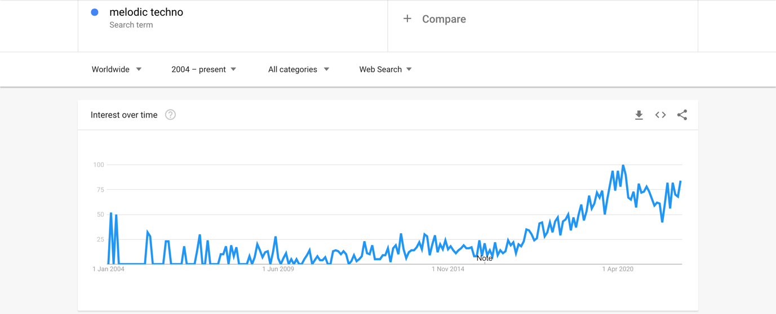
Over the last 7 years as you can see from the graph displayed below, you can see a stagnating rise in the trend of melodic techno as a genre. During around this year we saw highly established artists such as Stephen Bodzin, Tale of us, Camelphat and more, pioneer this style of music and push it forward commercially. Juxtaposing to that, trance has seen a steady decline over the last twenty years as newer sub genres have emerged that all take elements from trance. As music sales have soared with now having a $25.9 billion revenue (RICHTER, 2022), having streaming become so accessible to the world allows people to now listen to many different styles of music with a result of the landscape of commercial music changing rapidly. Songwriters/producers having all this access to so much variation of music evidently has created many different combinations of genres to which I believe has been a strong factor of the decline and rise of different genres/sub genres.

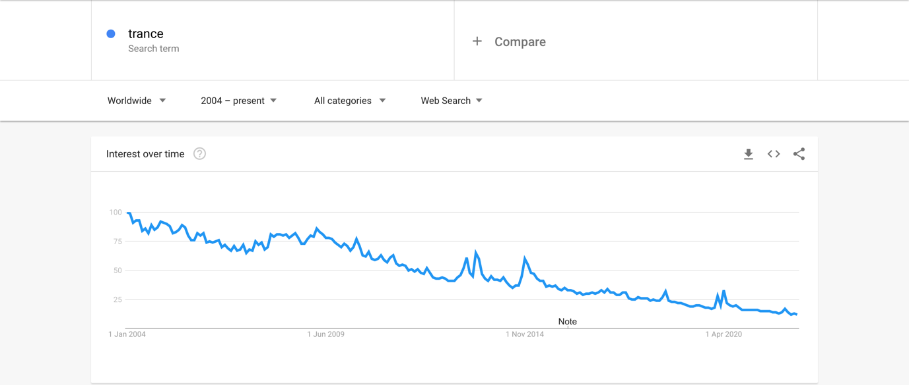

Camelphat have evolved their sound over the years from house/tech house to a darker sound evolving into melodic techno. With a release of a track called saw them storm multiple charts worldwide and gain a gold award having sold/streamed 400,000 units. Arguably this brought the genre into the forefront of commercial music to which we can see a massive rise in the popularity of melodic techno. With their most recent release ‘Silenced’ I have captured a relative sound in my production of ‘Belligerent’. I added a noisy atmosphere and an arpeggiated melody that transitions into a suspenseful breakdown/bridge that leads to an unforgiving relentless chorus. With the use of an eastern cinematic vocal, this gives the track an eerie element for listeners to latch on to. I would in future like to implement a vocal track with lyrics to make track more commercially viable.
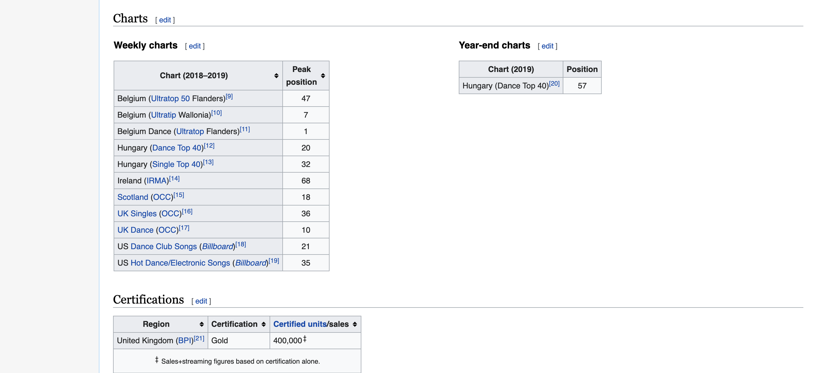
In the track ‘Belligerent’ I implemented several production and mixing techniques that are used widely in the genre. The first one is the Haas effect which is otherwise known as the “Precedence effect”. This is where you have two sounds delayed around 40 ms (Milliseconds) or less to have the perception as one sound. I used this effect on the main arpeggiated lead synth to give a directionality to the space. The second technique I have used in the production is having the sub end in mono. This centres the sound in the mix so that there is no stereo bleed from the low end which will make frequencies clash with other instruments resulting in a muddy mix. In techno/melodic techno the main drive of the tracks come from the low end as the genre is in 4/4 the groove comes from the punch of the low end in the mix. Equally of having a strong low end this must be balanced with a lot of energy in the high end too. The dynamic range within melodic techno is extremely important as the arrangement of the genre usually starts with your main verse and chorus which then builds back down to the quietest section of the track which is called the breakdown. In the breakdown it is important to really build up the tension for when the chorus comes back so that the tension is released when the drop hits. You can build up tension in many ways. As seen in this genre, you can create tension with melodies where the cut off filters are brought up and accompanied by a snare roll filled with a long reverb to add to the impact for when the chorus breaks in. A production technique I have used is to take out frequencies usually around 50/440Hz in the breakdown. This is because when the chorus comes back in, and the low frequencies appear again there is a phantom sense of more power and punch.
What I think worked well in the production of ‘Belligerent’ is that I believe I captured the melodic techno sound with a strong arpeggiated melody and a soundscape that told a story which would be ideal to play at a DJ performance. The next time I create a track in this genre, I would like to work with a vocalist to make it more radio friendly so that it could be deemed as more commercial.

Tech House

Tech house was first developed in the early 1990’s. A new style of Dj’ing in London (Clink Street Parties & Wiggle) was being experimented with by slowing down Detroit style techno tracks which had a minimalistic clean sound to them. The DJ’s responsible for this new approach were Eddie Richards, Mr.C and Lu Vukovic’s who threw parties in nightclubs and outside of the natural club environment; holding events in industrial warehouses, car parks and off the grid locations. During an interview with RA Eddie Richards explained what he was looking for in productions to integrate into his DJ sets, he said “I was looking for something that wasn’t too vocally or wasn’t too techy – it was something in the middle ground that had a groove and bassline.” < https://www.youtube.com/watch?v=74wlkDluLN0&ab_channel=ResidentAdvisor >

Implementing the Detroit sound with dub or jazzy elements from house, also including progressive house would become the foundation of the genre ‘Tech House’. <beatportal> & <Wikipedia>

Going into the early 2000’s tech house became renound for its structure and arrangement which allowed the genre open to interpretation for many producers to create these solid grooves with distorted kicks, heavily saturated drums and the use of analog synthsizers like the Roland TB-303. Due to low flight costs the genre was able to travel over Europe allowing records from one of the earliest tech house music labels like ‘Cajual Records’ to be commercialised following support from iconic DJ’s such as Carl Cox and Joris Voorn. Hitting hot spots such as Ibiza allowed the genre to become vastly exposed to a very over saturated market. It was soon after this rise in popularity that slander was given to ‘Tech House’ for its repetitiveness.

Fast forwarding to 2018, tech house saw a resurgence with festivals headlining tech house producers such as Solardo, Jamie Jones, Patrick Topping. The US’s most sort after festival Coachella would help stimulate the market again with its huge demand. With tracks like ‘Loosing it’ by a producer called Fisher gained the ‘Best Electronic Song’ award with having two platinum certifications in Italy and Australia and two gold certifications in the UK and Germany along with having a number 1 in Dance club songs in the US.

In the track I have produced called “Addictive Personality” I have taken inspiration with percussive grooves like Dennis Cruz and a solid bassline that the producer ‘Fisher’ would use. A theme involving speeches and interviews became a common place in tech house within the last 5 years to which I added in a vocal sampled from a Joe Rogan podcast talking about ‘Hunter S Thompsons’ daily routine involving his consumption of illicit substances. Solardo follow a similar theme in their track ‘On the Corner’. Due to tech house having a minimal foundation of having a thick low end with a bassline that repeats in the track, the use of other elements is crucial to ensure that it doesn’t stay repetitive.

Groove is key with the sub-genre as distorted kick drums are placed on each beat to follow the 4/4 structure, a production technique called swing and syncopation can be used to have the bassline or drums breaking up the ‘straightness’ of the groove, resulting in keeping the beat moving along. Below I have attached a screenshot of the Midi information from the bassline in the track. As you can see not all the notes are on the grid, I applied a groove swing to the notes so that there isn’t a complete regular flow of rhythm.

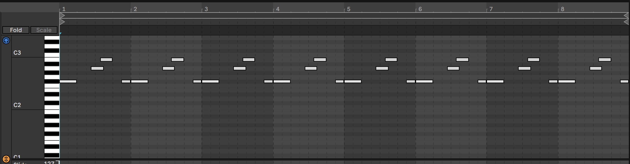

To really reinforce a low end with lots of energy and movement I have implemented another technique which can be heard largely all tech house tracks, this is sidechain compression. Side chain compression is where having one signal of sound is affected by another through volume manipulation. In this genre the kicks signal is used to manipulate the volume of the bass to create movement of one another. This is incredibly important as if this wasn’t used then the frequencies would clash which would create a ‘muddy’ mix and the sounds would cancel each other out.

I believe that I have imitated a good replication of the genre ‘tech house’ as a whole. I think that implementing a strong groove that I have would work well on a dance floor which would be for its purpose anyway. What I would change for next time is that I would produce the track with higher energy and implement more samples from house and disco to make it more appealing for the listeners. A catchy vocal rather than an a vocal talking about illicit substances would make the track more popular as the target audience could be widened.

Drum & Bass

Drum and Bass was first discovered in the UK in the early 1990’s. In this era, we saw a lot of electronic dance music boom into the industry. With the previous twenty years we saw the rise of black culture, seeing the rise of the likes of hip-hop, reggae, Detroit techno and others. These all mixed together birthed what was known as “Jungle drum & bass”. What gives Drum and Bass a distinct sound is that you’ll notice that there is a high intensity of speed and rhythm. Venturing into the early 2000’s the sound had changed from its original jungle roots to a more futurized sound. Still today there are strong connections to its roots using influences of Jamaican culture and where the genre was formed London, yet specifically Croydon. Croydon is also the home of dubstep too which is a sub-genre following from drum and bass.
Drum and bass is also very easily recognised by its fast tempo and the use of breakbeats. Jungle artists such as ‘Kodwo Eshun’ brought in short drum solos from “Amen, brother” which was a 1969 B-side by a Washington D.C soul group called ‘The Winstons’. Still today the Amen breaks are the foundation of a huge variety of drum and bass tracks. A big breakthrough in the popularity of the genre hit with ‘Goldie’s’ debut album in 1995. A few years later another pioneer ‘Fabio’ started to cut and chop elements from disco and house, particularly vocals to create another style of drum and bass known as ‘Liquid Funk’. This took a few years for it to catch onto the rest of the scene but by 2004, one of the biggest labels in the genre ‘Hospital Records’ became one of the biggest selling labels of this sub-genre from drum and bass.
With a big resurgence of the genre, we started to see new performers of the genre appear in forms of live bands such as ‘Reprazent’ and ‘Red Snapper’. A label responsible for pushing the live drum and bass sound ‘Breakbeat Kaos’ signed ‘Pendulum’ who have notoriously been one of the most notable bands of this genre.
Pendulum were formed in Australia in 2002 yet in 2003 the band relocated to England. There was instant success with their music as their first studio album ‘Hold Your Colour’ had gained an ARIA (Australian Recording Industry Association) gold award as well as a BPI (British Phonographic Industry) platinum award. Their success didn’t stop there either with their album ‘In Silico’ gaining a BPI platinum award and their album ‘Immersion’ gaining an ARIA gold award as well as a Platinum Award.
Jumping to the current date of where the Drum and bass scene is at now. In 2020, according to UKF were told by digital streaming giants Juno Download that a significance of a twenty percent rise in sales had occurred from 2019. Millions of streams from artists like ‘Teebee’, ‘Noisia’ and ‘Chase and Status’ have been leading figures in the current scene of drum and bass.
The track that I have made called ‘Galaxy’ influences some of these artists with a powerful and gritty low end, with breakbeat drums set a high tempo of 174 beats per minute. I have also tried to keep some of the roots by using a Jungle vocal so that some originality from the genre is kept. I have used production techniques such as cutting and slicing that are used very commonly in this genre especially in the break beat drums.
The production techniques that I have used that apply directly to drum and bass are the use of vocal and drum chopping/slicing. The use of sound design was important to follow as I wanted to implement some futuristic sounds such as the opening pads. As I have referenced some of ‘Noisia’s’ works, the mix was intended to be very bass heavy. Heavy distortions have been used using plug-ins like Izotope’s Trash 2. A similar production technique has been used from the melodic techno genre as bringing out the bass before the drop so when it hits there is a bigger impact. With the most important elements of the track in the genre are the drums and the bass, it is important that the two don’t clash, however you want the bass to be more prominent than the kick due to various amounts of distorted bass used throughout this production. Applying sidechain compression to the kick and bass will prevent and clashes and result in a punchy low end. The production technique of pitch bending has been implemented in the track ‘Galaxy’. I have applied pitch bending to some bass shots that can be heard in the break to give more of a sonically interesting effect.

With the track ‘Galaxy’ I think that I have taken the more modern approach of how we hear the genre today. I believe what worked well was the jungle vocal which makes the track catchier and gives something to the listener to latch onto. The drop that was created is unique in the sense that lots of different elements are used to keep the track interesting. What I would change for next time is that I would like to venture into making a different sub-genre of drum and bass, using different elements like splashy sounding drums and a more mellow melody, creating a liquid funk track. I would also be more careful of the choices of synths I have used as I feel some of the bass sounds override one another and make it sound a little bit messy. I would also make use of more samples from live instruments such as a guitar or amen drums taking inspiration from the live drum and bass bands such as pendulum.

To conclude this essay, when looking at my three productions I believe that from my interpretation they could be shown to someone with little/no musical knowledge on the subject matter and would correctly identify them to the genre. For next time, across the three productions I would like to implement some catchy lyrics and vocals that would make the tracks more commercial as electronic dance music largely is underground.

Reference List

Lombardo, S, 2020. Techno Is Officially the Bandwagon Genre

https://www.edmtunes.com/2020/10/techno-is-officially-the-bandwagon-genre/

2022. [online] Available at: <https://rateyourmusic.com/genre/melodic-techno/>

Richter, F, 2022. Streaming Drives Global Music Industry Resurgence

https://www.statista.com/chart/4713/global-recorded-music-industry-revenues/

edmheaven.com. 2022. Tech House Production Tips » edmheaven.com. [online] Available at: <https://edmheaven.com/tech-house/>

Loopmasters.com. 2022. Top 10 Drum & Bass Production Tips (How to Produce D'n'B). [online] Available at: <https://www.loopmasters.com/articles/4294-Top-10-Drum-Bass-Production-Tips-How-to-Produce-D-n-B->

Beatportal. 2022. Beatport's Definitive History of Drum & Bass. [online] Available at: <https://www.beatportal.com/features/beatports-definitive-history-of-drum-bass/>

Redbull.com. 2022. History of drum'n'bass: The genre's evolution & origins. [online] Available at: <https://www.redbull.com/gb-en/history-of-drum-and-bass-music>

