Laboratory Report: Data Capture and Analysis of an Unknown Explosive Article

Word Count 2725
Jess Eardley 2217994

Abstract
This report contains the data capturing methods used by research students during an investigative experiment to ascertain the identity of an unknown explosive article from a list of possible munitions. Blast pressure, fragment velocity, case material and explosive residue were collected using various equipment and analytical methods. The data from the trial was then analysed and used as evidence, along with literature sources, to support the conclusion that the unknown explosive article was a pipe bomb. The sources of error and some limitations of each data capturing technique were also discussed within the report.
Table of Contents
Table of Figures 2
Table of Tables 2
1 Aim 3
2 Methodology 4
2.1 Blast Pressure 5
2.2 Fragmentation Velocity 7
2.3 Fragmentation Identification 9
2.1 Explosive Residue Identification 10
3 Results and Discussion 11
3.1 Blast Pressure Results and Analysis 11
3.2 Fragment Velocity Results and Analysis 16
3.3 Forensic Swab Data and Analysis 19
4 Conclusion 21
References 22
Appendix A - Types of Munitions of Potential Interest 23
Appendix B - Example of Pipe Bomb Fragmentation 25
Appendix C - Post Blast Images 26

Table of Figures

Figure 1 Arena trial overview. 4
Figure 2 Set-up of the blast gauges. 6
Figure 3 Set-up of blast gauges in line with charge stand prior to ‘misalignment’. 6
Figure 4 Set-up of the velocity foils. 8
Figure 5 Pre-fire velocity foil set-up. 8
Figure 6 Fragmentation captured by the frag packs. 9
Figure 7 Swabbing of fragmentation pack before firing. 10
Figure 8 Swabbing of strawboard under charge stand before firing. 10
Figure 9 Post blast damage on G1. 11
Figure 10 Blast pressure results for Gauge 1 and Gauge 2. 12
Figure 11 Smoothed blast pressure data for Gauges 1 and 2. 13
Figure 12 Blast pressure date for Gauge 3. 14
Figure 13 Fragmentation samples collected form the trial. 16
Figure 14 FTIR transmittance spectra of explosive residues present on the trials site. 19
Figure 15 FITR spectra of RDX [10]. 20
Figure 16 Fragments of seamless steel pipes filled with Aluminised Ammonium Nitrate [2]. 25
Figure 17 Velocity foil 9 evidence of fragment strikes. 26
Figure 18 Arena overview post blast. 26
Figure 19 Post blast image from point 0, charge position. 27
Figure 20 Post blast image showing cable protection measures working. 27

Table of Tables

Table 1 Explosive mass and type predictions using a Kingery-Bulmash calculator. 15
Table 2 Velocity foil data showing number of fragment strikes and TOA. 17
Table 3 Fragmentation velocity calculations. 18

Aim

The aim of this report is to analyse the data collected from an energetic area trial to identify the nature of an Unknown Energetic Article (UEA), see Appendix A. The results of the trial are discussed and evaluated to identify peak over pressure, fragment velocity and explosive residues. These results are used as the evidence of the UEA’s identity, concluded at the end of this report.
This experiment mimics the real-life processes undertaken by researchers during an explosive trial. Researchers conduct these explosive trials to capture and evaluate data for understanding explosive ordinance fragmentation such as fragmentation velocities, geometries and distribution patterns [1] [2]. This analysis and using blast modelling data is used by the defence sector to aid in the development of protective armour from explosive effects for personnel, infrastructure and vehicles.

Methodology

The explosive trial was conducted at the Cranfield Ordinance Testing Evaluation Centre (COTEC). The trial site had a solid concrete foundation which the energetic trial was to take place on. The trial was arranged with the charge stand in the centre of an arena with fragmentation capture packs constructed around the charge stand in an arc, see Figure 1. The UEA was placed on the centre of the charge stand, 0.397m above ground, where a Low Voltage (LV) detonator and trigger cables were attached. The trigger cable was then connected to a shrike, for firing the explosive charge. The data capturing equipment such as blast gauges, velocity foils, fragmentation packs and all the necessary cabling was set-up by 4 groups of Ordinance Munitions & Explosives (OME) research students.
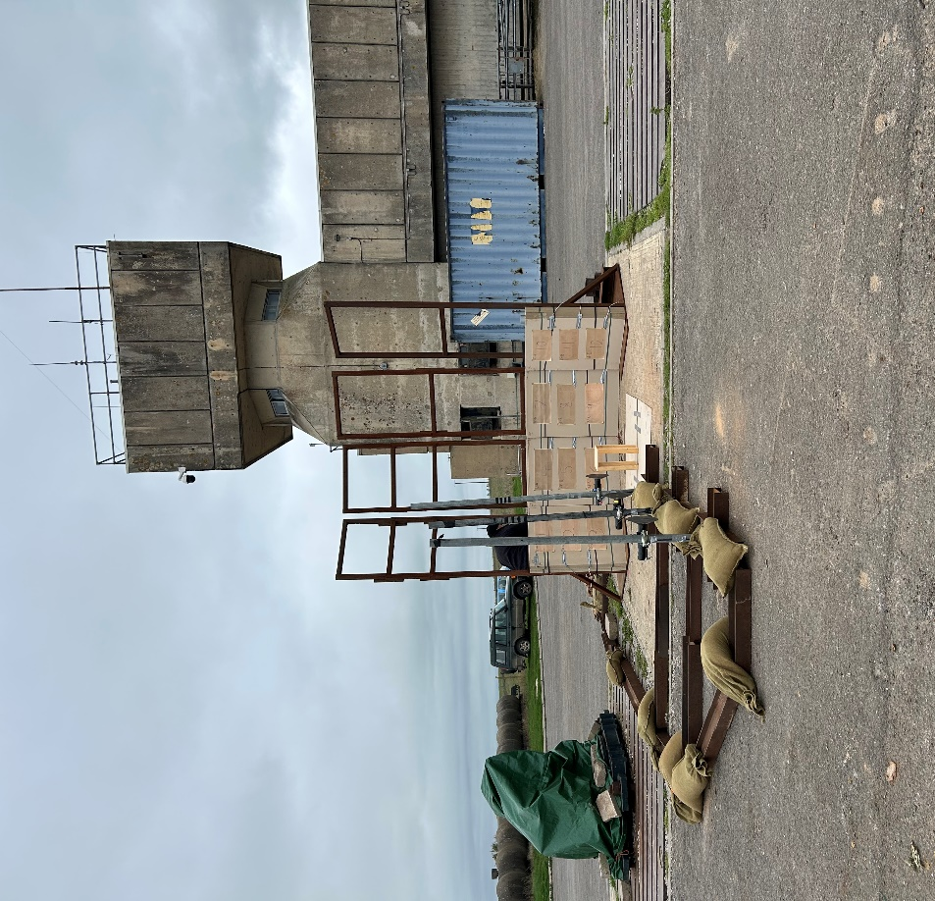
Figure 1 Arena trial overview.

Blast Pressure

During the trial, three Integrated Electronic Piezo-Electric (IEPE) pressure gauges were set-up to measure dynamic blast incident pressure [3] [4] [5]. The blast gauges were mounted into their housing, each attached separately to a pole and stand. They were positioned: at 1m, 2m and 3m, facing perpendicular to the charge stand and at 0.45m above the ground see, Figures 2 and 3. The gauges were slightly misaligned by some students for all gauges to have an interrupted view of the blast wave.
The gauges contained their own electronics for signal conditioning, therefore simplifying the set-up as they only required one cable, this served as both power and signal transmission [4] [3]. The gauge cables were taken through to the data acquisition (DAQ) unit inside the protected instrumentation room. Gauge 1 (G1) was used as the trigger method for all the pressure gauges, G1 was connected to the threshold box, which was programmed to trigger when pressure reaches a threshold value of 3kPa. A pre-trigger function, set to 10%, was used to capture the arrival of peak pressure, while the sample rate for the gauges was set to 250kHz. The gauges were presented to the students with unknown calibration status. If uncalibrated this could cause error in the data captured by the gauges during the trial. The gauges were tested by pressing firmly on the surface of the gauge while the DAQ was monitored for a pressure reading, all gauges passed the function test.
Limitations of using a blast gauge is they record environmental and electrical noise that can drown out or change pressure measurements [4]. Gauges mounted in stands can sway and vibrate during an explosive event or in windy conditions, this causes a ‘ringing ‘effect which is picked up by the sensor, to mitigate this sandbags were placed on the base of the gauge stands. Additionally, damaged cabling can cause data loss; to prevent this the cables were inspected prior to the event. Prior to the explosive event the cables were covered with steel I-beams and weighted with sandbags to prevent any damage, see Figure 2.
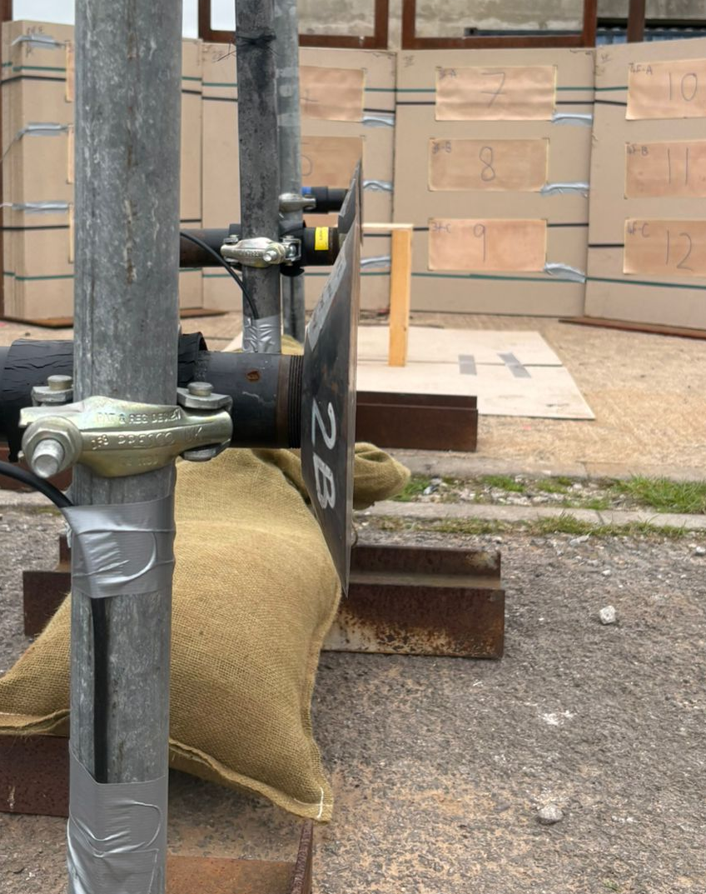
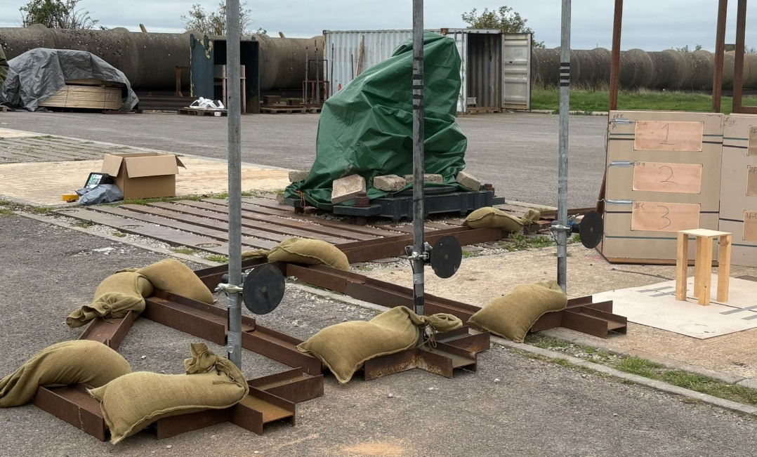
Base of gauge stand weighted with sandbag
Figure 2 Set-up of the blast gauges.
Charge Stand
Figure 3 Set-up of blast gauges in line with charge stand prior to ‘misalignment’.
Cable protection (I-beams and sandbags)
Pressure gauge (G1) and stand

Fragmentation Velocity

Velocity foils were used to capture the fragmentation velocity produced by the UEA. Velocity ‘make’ foils are constructed with a copper open circuit charged at 5v, when a conductive fragment hits the surface of the foil, the circuit is completed. A Logic Analyser (LA), a type of data acquisition unit, connected to the foils, detects the voltage rise (from 0v to +5v) and records the Time of Arrival (TOA) [2].
Velocity foils were placed horizontally, and taped to the surface of each fragment pack, three per pack. Each foil was labelled “1 to 12”, their respective positions were also noted in the corners of each foil, see Figure 4. The position of each foil was measured from the height of the charge stand with a Laser Distance Meter (LDM) [6], see Figure 5. The connective wires for each foil were placed into a junction box in numerical order. This box was used to power the foils and connect them to a LA .
A set Time Zero (T0) is required to start recording the time of the event. The method used to determine the T0 point was a Break Wire (BW) wrapped around the UEA and connected to the junction box as “Channel 1”. Once the explosive detonates the case expands breaking the thin BW and starts the clock.
The foils were not calibrated but were tested prior to the firing by touching each foil with a with conductive material and monitoring the LA for a voltage spike for each foil tested. A limitation that was considered when using the foils was if a fragment hit the foil and was stuck, completing the electrical circuit the LA would only record the TOA of the 1st and fastest fragment [2].

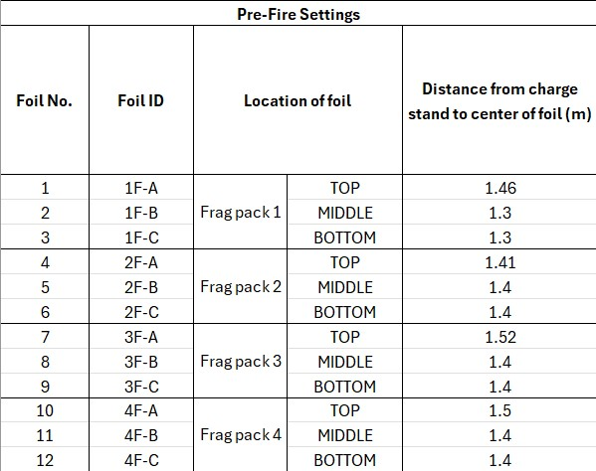
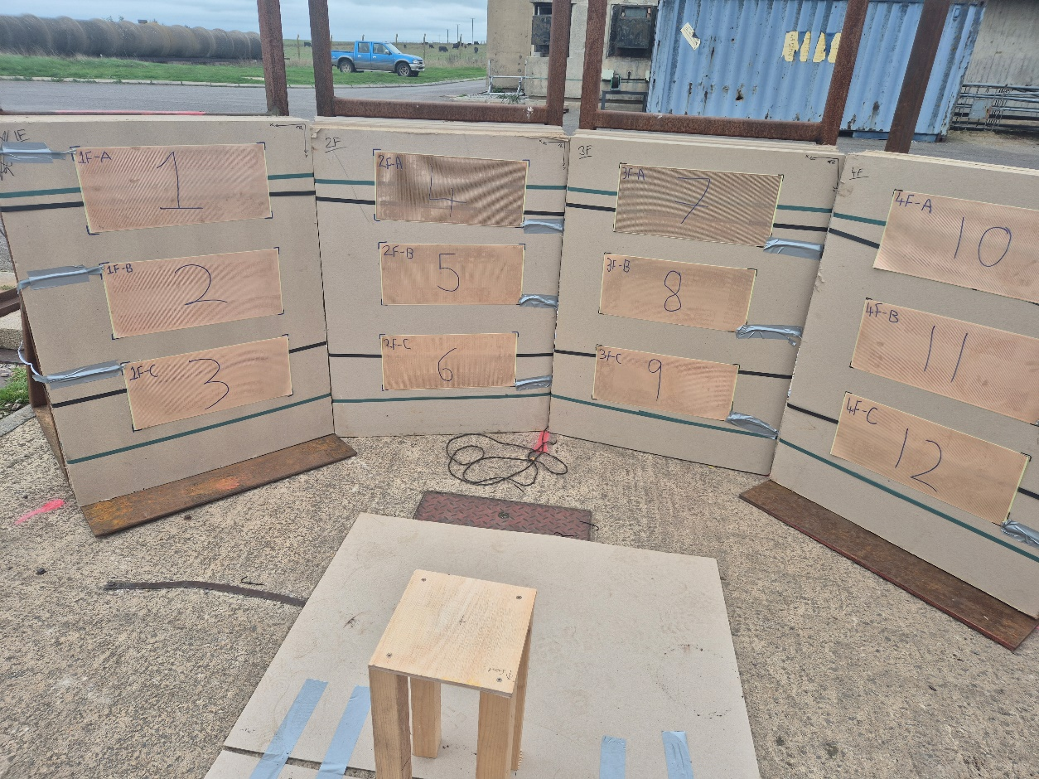
Figure 4 Set-up of the velocity foils.
Velocity foil 1, position 1F-A.
Figure 5 Pre-fire velocity foil set-up.

Fragmentation Identification

During this trial, the strawboards functioned as a fragment capture method and a mounting plane for the velocity foils, see Figure 6. Double stacked frag packs (20 strawboard sheets in each frag pack) were positioned in four locations, 1.5m from the centre of the charge in a 113° arc. They were labelled according to their position e.g. Position 1, Front pack = 1F. The fragments from the UEA were removed using plyers and cut resistant gloves, enabling closer inspection by the students to determine case material and fragmentation type.

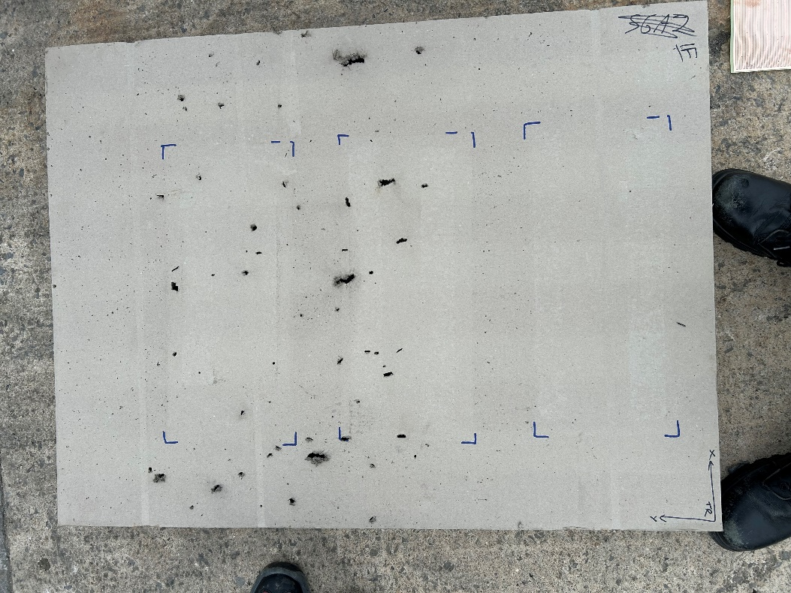
Figure 6 Fragmentation captured by the frag packs.

Explosive Residue Identification

Forensic swabs were used to take samples from the explosive site for identifying explosive residues, see Figure 7 and 8. Swabs were taken from a variety of areas, before and after, around the area of the explosive event. FTIR chemical analysis was conducted to identify explosive residues on the site. The swabs taken before the event were to be used as the background samples to calibrate the FTIR machine.
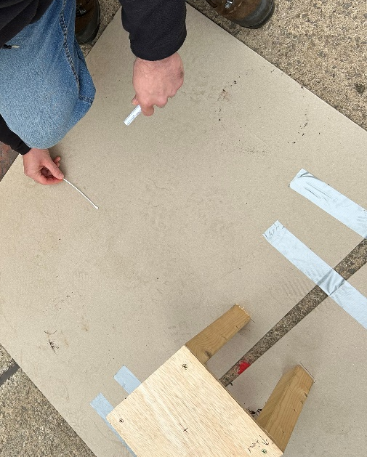
The fragmentation samples collected from the frag packs were also collected and taken back to the lab for FTIR analysis. The fragmentation was soaked in acetone overnight to remove the noise from the samples [7]. The acetone was input into the FTIR software as the cleaner to remove the acetone from the FTIR spectra.

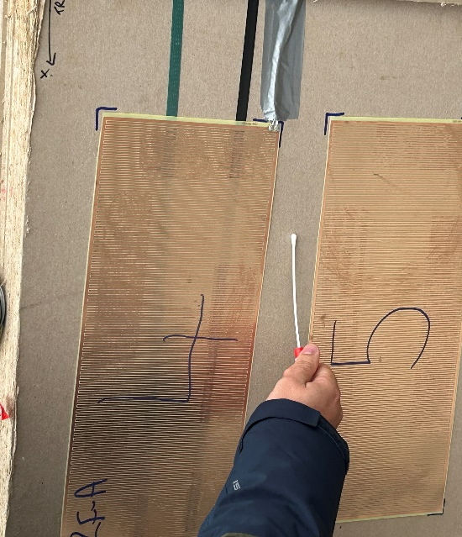
Figure 7 Swabbing of fragmentation pack before firing.
Figure 8 Swabbing of strawboard under charge stand before firing.

Results and Discussion

Blast Pressure Results and Analysis

To view the peak overpressure, positive phase duration, and negative phase of the blast pressure wave the data points were input into a graph using Excel. The units of pressure are measured in kPa, and the units of time were changed from seconds (s) to microseconds (ms) for ease of viewing on the graphs. The original data for Gauge 1 was removed and can be disregarded as it provided no usable pressure results due to a fragment strike causing ringing on the gauge evidence of the fragment strike show in Figure 9 .

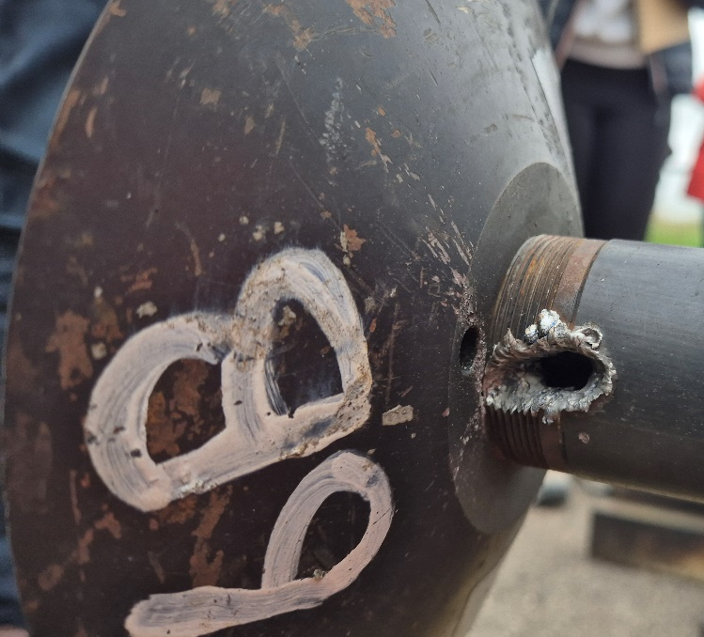
Figure 9 Post blast damage on G1.
Figure 10 shows the original raw data results for the blast pressure for Gauges 2 (G2) and 3 (G3). The pressure readings for G2 show a peak pressure of approximately 650 kPa. The pressure reading for G3 does not show a clear blast pressure reading and the peak pressure is significantly lower than G2. Figure 10 is difficult to analyse due to excessive data points and ringing noise on both gauges, therefore the data required smoothing for better visual analysis of both pressure traces.
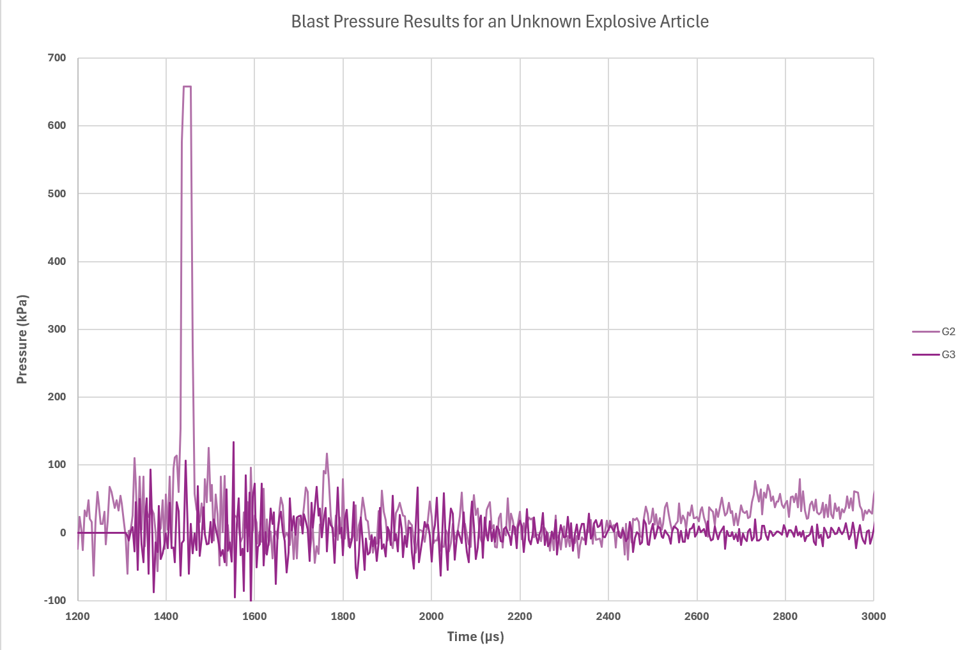
Figure 10 Blast pressure results for Gauge 1 and Gauge 2.

Figure 11 shows the smoothed pressure data using a 10-point moving average. Even though the overall data looks easier to digest the smoothed data shows a dramatic reduction in the peak pressures on both gauges when compared to the original data in Figure 10. Using this smoothed data will cause error in the calculations for the predictions in the total explosive mass, so the original peak pressures were used.
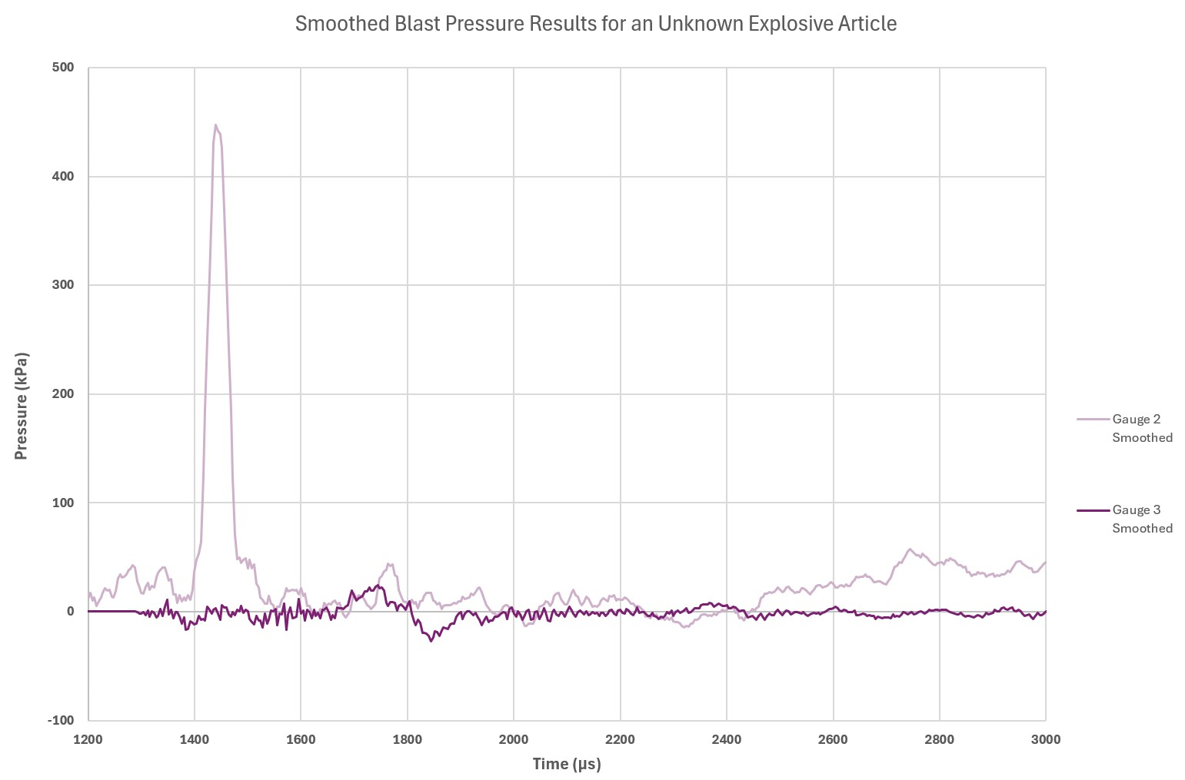
Figure 11 Smoothed blast pressure data for Gauges 1 and 2.

Figure 12 shows the original and smoothed blast pressure results for G3. The pressures are lower than expected, with a peak pressure of 140kPa compared to the pressures measured by G2. Upon closer inspection this data has a small rise in the positive over pressure and a negative phase, expected from a blast pressure result. The reduction in the recorded pressure could be explained by a scaling error.
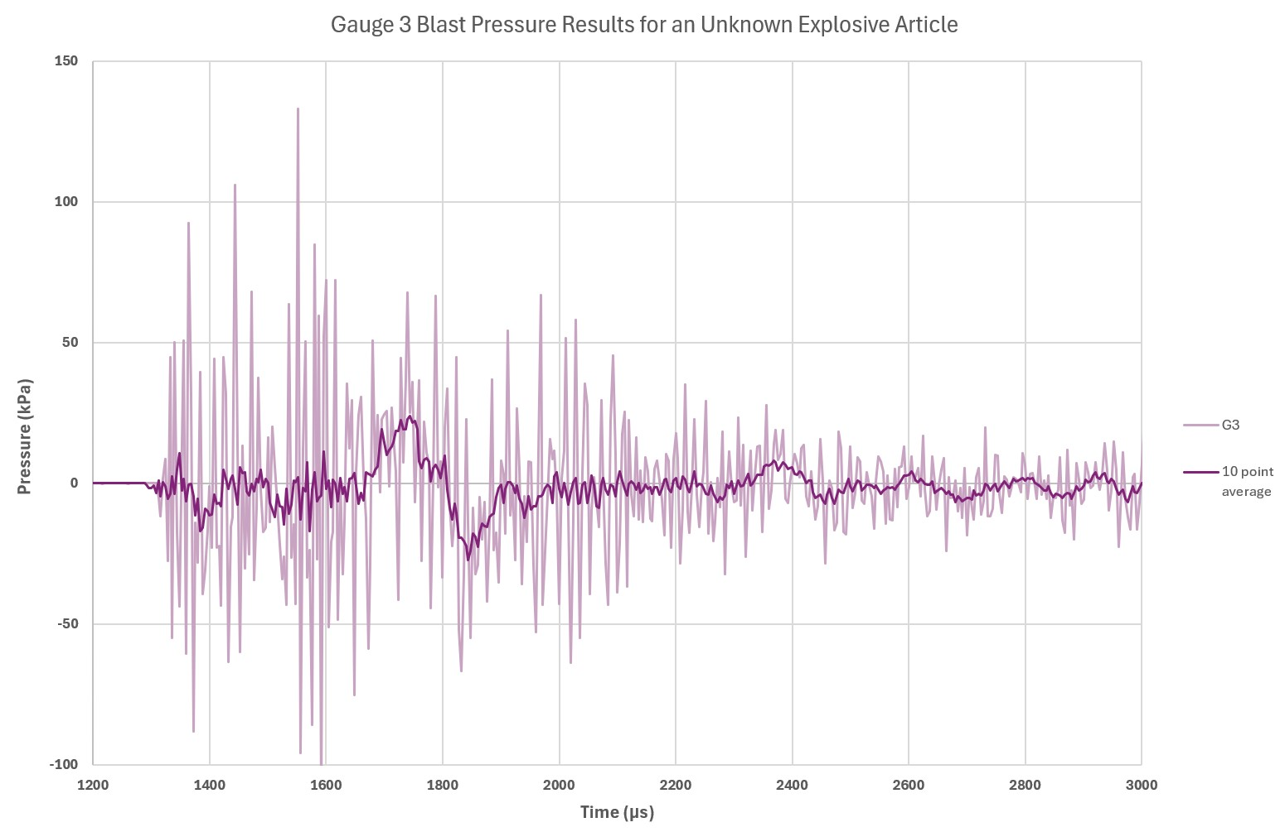
Figure 12 Blast pressure date for Gauge 3.

Using the analysed data and a Kingery-Bulmash Blast Parameter Calculator [8], predictions of the charge weight and type can be calculated. A range of 2m was used to compare the 650kPa blast pressure measured on G2 with the theoretical calculations, see Table 1.
However, the casing of the UEA will cause a lower blast pressure compared to the theoretical blast pressure calculators (Kingery Bulmash) as the energy output of the explosive is transferred into breaking apart the case instead of directly out to the surrounding atmosphere as the calculator uses a caseless charge [3] [6].

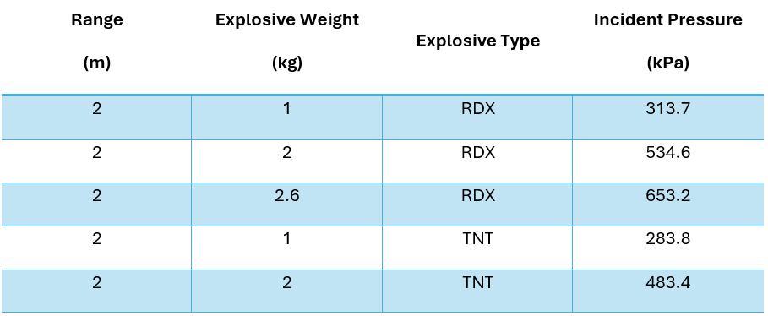
Table 1 Explosive mass and type predictions using a Kingery-Bulmash calculator.

Fragment Velocity Results and Analysis

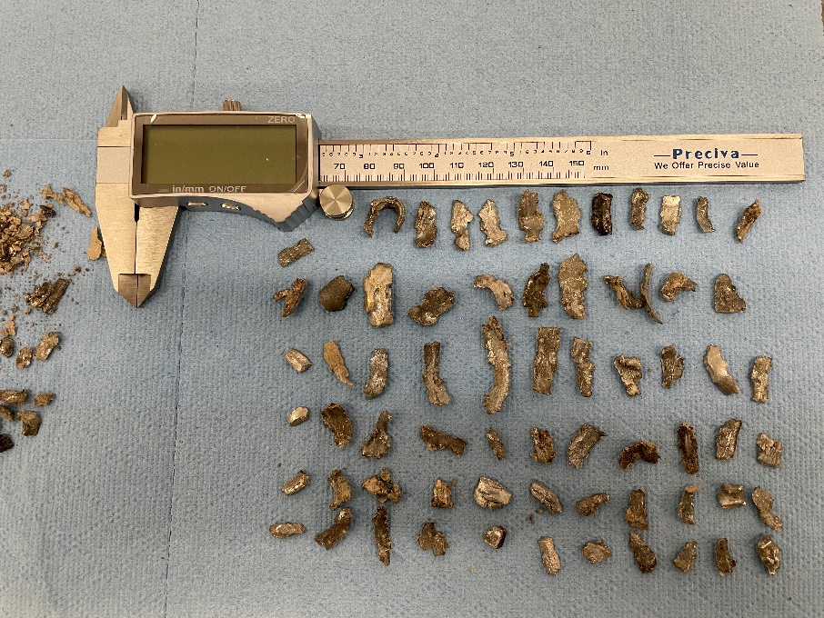
Figure 13 shows the fragments taken from the fragment packs. The fragments are grey and shiny in colour similar to steel or aluminium, closer inspection concluded the material as a type of steel. The fragments are a range of sizes and shapes showing evidence for natural fragmentation unlike preformed fragmentation which would show fragments of similar sizes and shapes. These fragments are similar to the steel fragments generated in the experiment in [2], see Appendix B.
Figure 13 Fragmentation samples collected form the trial.

Table 2 shows the number of fragment strikes and their arrival times. Some data was amended and some data discounted as there were errors and missed timing for additional fragment strikes. Any changes made to the original data are in bold. Without the use of high-speed video there is no certainty that any additional strikes were true fragment strikes, therefore only the TOA of the initial fragments were used in the analysis. Foil 9, in Table 2 is noted with a “*”, see Figure 16, in Appendix C, for the fragmentation strikes to foil 9.

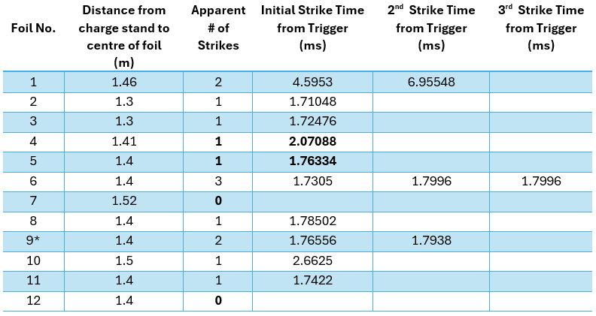
Table 2 Velocity foil data showing number of fragment strikes and TOA.

Using the distance of the foils and the initial strike time, the fragment velocities were calculated using Excel, see Table 3. The velocities in this experiment are similar to an experimental pipe bomb made from mild steel and filled with ammonium nitrate [2], the weight of the pipe ranged from 1084.3g to 1393.1g and the velocities of the fragmentation from these pipes ranged from 614 m/s to 967m/s [2].

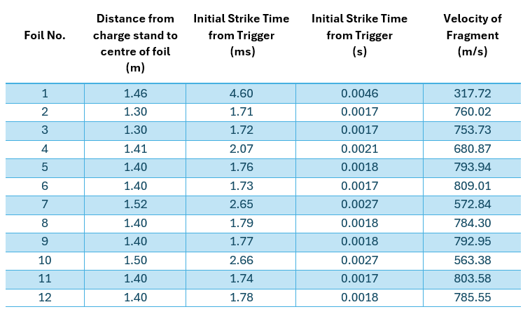
Table 3 Fragmentation velocity calculations.

A Gurney calculator [9] can be used to predict the fragment velocity if the explosive type, mass, and case mass are known. Using the weight of the case of the pipe bomb in source [2], ≈1kg, and choosing an explosive type of TNT, the mass (kg) of explosive was varied to find a theoretical fragment velocity. The mass was changed until a fragment velocity fell within the experimental ranges in Table 3. According to the Gurney calculator [9], for a fragment velocity of 752 m/s using explosive type TNT and a case weight of 1kg the mass of the explosive must be 0.1kg [9].
However, if matching to the list in Appendix A, the velocity of a fragment from the pipe bomb is 2022m/s at 1m which is much higher than the fragment velocities calculated in Table 3. This is because the velocity calculations in Table 3, do not use the density of the fragments as the fragment weight was not captured from the trial.

Forensic Swab Data and Analysis

The FTIR analysis of the swabs produced the transmittance spectra in Figure 14. There is a strong peak at 1040cm⁻¹ and 1269cm⁻¹ showing a presence of C-N bonds and a strong peak at 1593cm⁻¹ showing a presence of N-O bonds. The presence of these bonds and the similarities in the spectra in Figure 14, from source [10] could mean the sample contains a nitramine such as RDX [10]. There is also some transmittance around 3000cm⁻¹ this is evidence of another component such as a plasticiser which is used in a variety of explosives [10].
PE4, SX2 and PE8 consist of 87%-88% w/w RDX and the rest constructed of other additives such as plasticisers [7]. PE4 and other military explosives contain a taggant for identifying the explosives as a legal requirement [7]. This could explain the transmittance at 3000cm⁻¹.
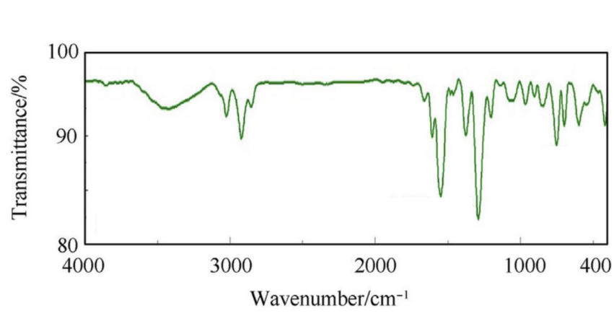
This sample could have been contaminated by the presence of other explosive residues from previous trials conducted on the COTEC range site. The sample could also show explosive residues contained in the detonator used to function the bulk high explosive.
Figure 14 FTIR transmittance spectra of explosive residues present on the trials site.

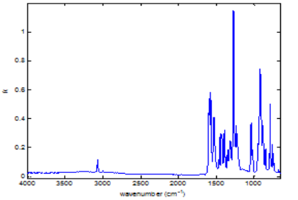

Figure 15 FITR spectra of RDX [10].

Conclusion

The evidence provided by the FTIR analysis of explosive residues, suggests evidence to support the conclusion that the explosive type used was PE8. This conclusion is further supported by additional analysis and research into plasticisers and taggants, used in military explosives, contained within JSP 333 [7].
Strong evidence was found to suggest that the UEA did not have pre-formed fragmentation. The fragmentation material and shape was compared to a pipe bomb experiment [2], which supports the conclusion that steel may have been the majority material used to encase the explosive. This evidence alone is enough to select the pipe bomb article from the list of munitions of potential interest, in Appendix A, as the identity of the UEA.
The data and calculations of the fragmentation velocity had limitations and did not provide strong usable evidence for identifying the UEA type. The fragment velocity of the pipe bomb in Appendix A, is vastly different to the velocities captured and calculated during the experiment. This difference could be explained by the Gurney calculation assumptions. These assumptions consists of a uniform material density and linear velocity profile of the fragmentation produced from a uniformly distributed explosive with a uniform case thickness.
The predictions of the charge mass using the Kingery-Bulmash calculations provided weak theoretical based evidence of the actual charge mass as these calculations are for a bare explosive charge. Therefore, this data was not used to provide evidence for the identification of the UEA.
If the UEA was an improvised item such as a pipe bomb, this could cause irregular blast wave and fragmentation data [7] which may explain the difficulty in finding a source that confirms its identity. The stemming of an improvised item will vary, if stemmed poorly or the item not filled can cause voids which if not known will cause irregular deformity of the case providing irregular blast propagation, uneven fragmentation spread and fragment velocity.
Finally, using the evidence collected from the trial, the identity of the UEA has a high probability of being a type of pipe bomb. The differences between the data given for the pipe bomb in Appendix A and the data collected during trial are due to limitations in the data capturing methods and lack of repetitions. Increasing the number of firings to more than ten enables repetition and a broader set of data resulting in an increased confidence in the identity of the UEA.

References

[1] | J. Read, P. Quinlan, S. Bloodworth-race, R. Hazael and R. Critchley, “Sustainable and economical alternatives to fragment capture,” Forensic Science, Medicine and Pathology, pp. 1-13, 2024.
[2] | L. A. da Silva, S. Johnson, R. Critchley, J. Clements, K. Norris and C. Stennett, “Experimental fragmentation of pipe bombs with varying case thickness,” Forensic Science International, vol. 306, pp. 1-8, 2020.
[3] | Kistler, “IEPE (Integrated Electronics Piezo-Electric),” Kistler, [Online]. Available: https://www.kistler.com/INT/en/iepe-integrated-electronics-piezo-electric-/C00000120.
[4] | P. L. Walter, “Air Blast and the Science of Dynamic Pressure Measurements,” [Online]. Available: https://www.pcb.com/contentstore/mktgcontent/linkeddocuments/technotes/TN-31-0714_Air_Blast_Lowres.pdf?_gl=1*wdv2oi*_up*MQ..*_ga*MTQ3ODk2NjM1Ni4xNzY3MDE3MTI5*_ga_EZDE1W5SJT*czE3NjcwMTcxMjgkbzEkZzAkdDE3NjcwMTcxMjgkajYwJGwwJGgw.
[5] | Kistler, “Piezoelectric (PE or IEPE) pressure sensors, miniature transducers, for highly dynamic measurements up to 1000 bar (15000 psi) / 603C,” [Online]. Available: https://www.kistler.com/INT/en/cp/piezoelectric-pressure-sensors-603c/P0001173.
[6] | EngineerSupply, “How to Use a Laser Distance Measurer,” [Online]. Available: https://www.engineersupply.com/how-to-use-a-laser-distance-measurer.aspx?srsltid=AfmBOor3975UNjnM44NXGjFefoXHHqAtCRhU34wEwq3P1ZdixloHJT0o.
[7] | UK Government, SERVICES TEXTBOOK OF EXPLOSIVES (JSP 333), DE&S Wpns Tech Info & Docs Pub Mgr, 2020.
[8] | United nations (IATG), “Kingery-Bulmash Blast Parameter Calculator,” [Online]. Available: https://unsaferguard.org/un-saferguard/kingery-bulmash.
[9] | United Nations (IATG), “Gurney Equations for Fragment Velocity,” [Online]. Available: https://unsaferguard.org/un-saferguard/gurney.
[10] | C. S. Yang and et al, “SPECTRAL CHARACTERIZATION OF RDX, ETN, PETN, TATP,HMTD, HMX, AND C-4 IN THE MID-INFRARED REGION,” 2014. [Online]. Available: https://moodle.uwtsd.ac.uk/pluginfile.php/1110980/mod_resource/content/1/Optical%20constants%20for%20PETN%20RDX%20and%20C4.pdf.

Appendix A - Types of Munitions of Potential Interest

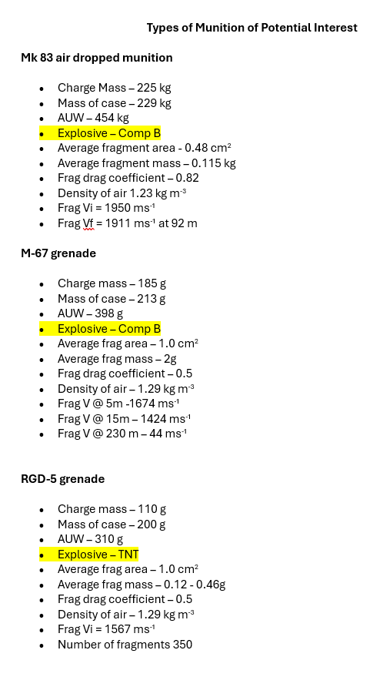

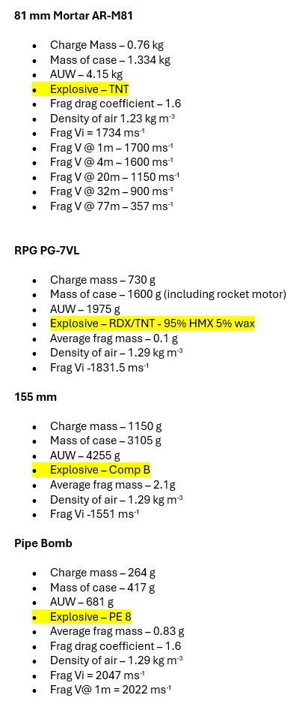

Appendix B - Example of Pipe Bomb Fragmentation

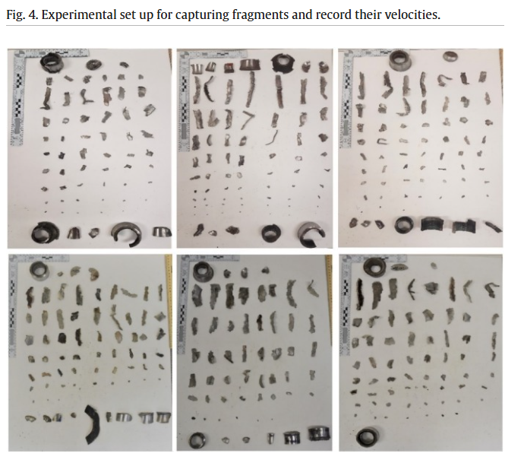
Figure 16 Fragments of seamless steel pipes filled with Aluminised Ammonium Nitrate [2].

Appendix C - Post Blast Images

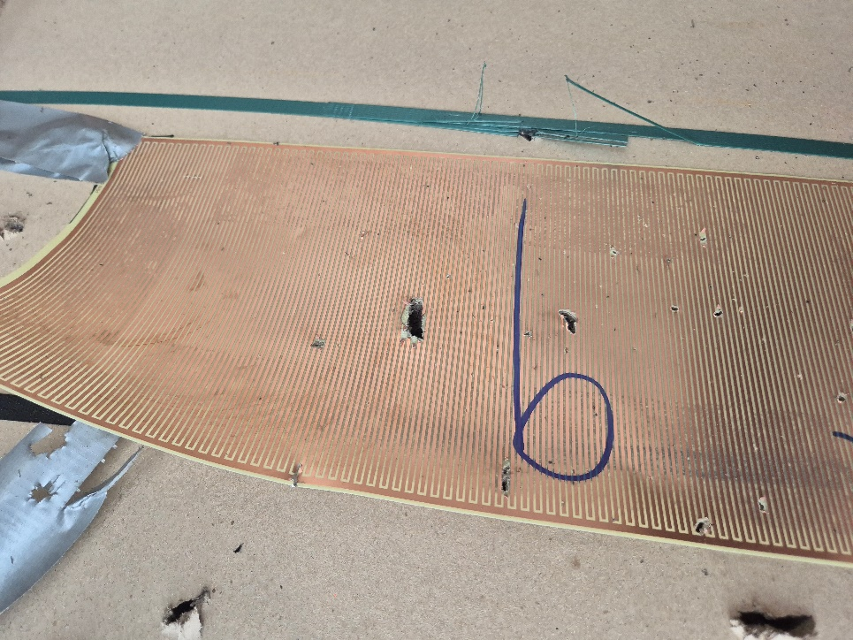

Figure 17 Velocity foil 9 evidence of fragment strikes.

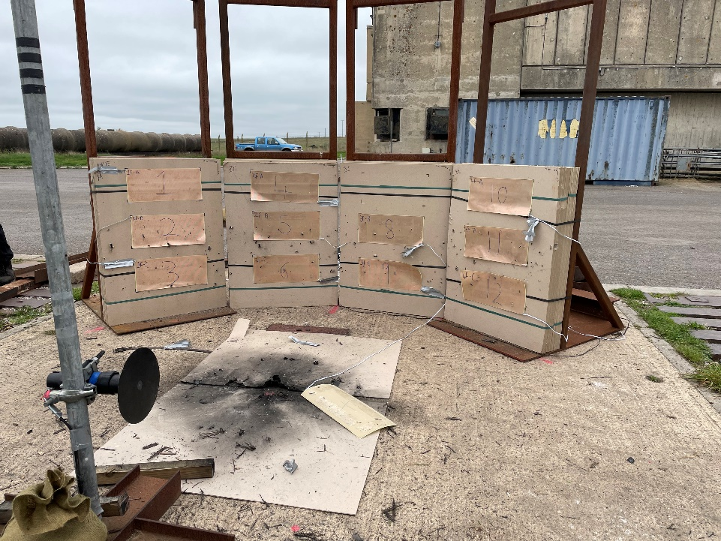
Figure 18 Arena overview post blast.

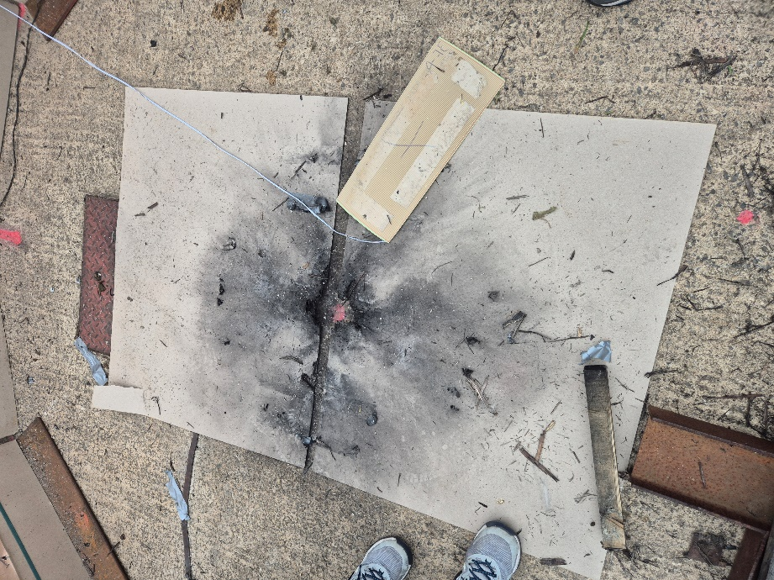
Figure 19 Post blast image from point 0, charge position.

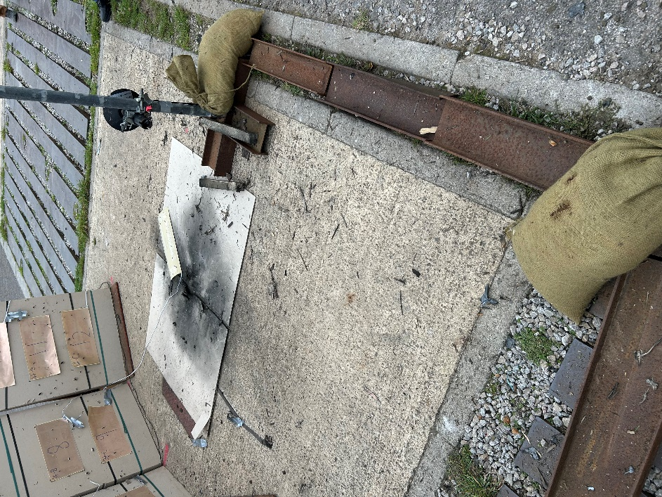
Figure 20 Post blast image showing cable protection measures working.

