University of Wales trinity saint David
Wales institute of science and art



Engineering Management, Innovation and sustainability
ACHA5012,ACMA5007

Cameron Andrews
2300898
11/11/2024

1 Introduction 2
2 Roles and responsibilities 3
3 My Own Role. 4
4 Key Personality Traits required for a structural engineer. 5
7 A list of overall group tasks and associated timings 7
8 Gateway Objectives 11
9 Two areas of concern 13
Bibliography 15

1 Introduction
For this assignment, I will develop a project plan outlining the team members and their roles, each person’s responsibilities, and my personality traits in relation to my role, referencing Belbin’s model. I will list group tasks with assigned timings and detail my own hours on tasks, task durations, rough material costs, and necessary equipment. Additionally, I will create a task-hours chart and include the team leader’s overall group chart. I'll also define a gateway objective, address two potential risks within my section, and suggest risk mitigation strategies. Finally, I will prepare a summary Gantt chart for the entire project and a specific Gantt chart for my responsibilities.

2 Roles and responsibilities

Name | Role | Individual Responsibility / Task
Efa Jones | Project Manager | Oversee the project, ensure that everyone is aware of their role and responsibilities within the team as well as maintaining organization and holding meetings.
Tamzin Cooper | Simulation | Research and decide on which type of will be more appropriate to use. Research and decide on the type of software to use. Plus run any simulation that are needed throughout the project
Harvey Levell and Harvey Hodge | Aerodynamics | Run CFD of the Morgan both roof up and roof down to determine what is better. Investigate wing profiles. And determine best possible aerodynamic set up for the wing.
Jac Evans and Rhys Thomas | Control and mechs | Design and test the code and control systems that will activate and regulate the wing relative to sensor input, determine the best system to use that will allow us to run the best angle
Hannah Bathgate and Cameron Andrews | Structural Design | Individual research on materials, mounting, fixtures Design separates mounting points  Run separate FEA tests on varying materials Determine best possible mounting location and design.

Job Roles | Summary of job role
Aerodynamics | Research and make decisions involving the aerodynamic profiles of both the Morgan and the wing, as well as run CFD for both. come up with the optimum design for the wing.
Structural | Research, study and make decisions involving the structural aspects of the rear wing, e.g. mounting points, materials and structural integrity. This role will involve running FEA runs and comparing different materials in conjunction with the research and decisions made by both the aerodynamics, control and simulation specialists.
Control/Mechatronics | Design and choose the actuation and control technique used to make the rear wing active. This will involve researching systems already used in similar applications as well as suitable alternatives that can be presented and discussed with the other departments
Simulation | Create a baseline simulation with no modifications on the desired software ready to compare simulations made with new design concepts.  Run simulations of different wing designs, compare and analyse the data to show where most improvements are being made.

3 My Own Role.
As the structural designer, I will research and develop the wing mount and wing itself. This involves selecting the best material, determining the optimal mounting position, designing the mounting system, and developing the wing structure. I will use SolidWorks for CAD design, running FEA simulations on materials like aluminium, steel, and carbon fibre to identify stress, bending, and potential failure points. Collaborating with aerodynamics, control, and simulation specialists, I will integrate aerodynamic forces, load data, and system constraints into the design, ensuring it meets all requirements. My problem-solving and critical thinking skills will help address challenges in material selection, stress analysis, and system integration.

4 Key Personality Traits required for a structural engineer.
Being a structural engineer there are multiple skills that are important for this role, for example Attention to detail, Analytical thinking, Adaptability and team collaboration. These skills are important for example Attention to detail is important as it requires precision to undertake some of the tasks, small errors can have significant consequences, as a structural engineer i will need t0 interpret lots of simulation data to determine the stress of a materials and any failure points.

 | Implement  ter | Coordinator | Shaper | Plant | Resource Investigate or | Monitor Evaluator | Teamwork  er | Complete  e Finisher
Low 033% | 0-6 | 0-6 | 0-8 | 0-4 | 0-6 | 0-5 | 0-8 | 0-3
Average 33-66% | 7-11 | 7-10 | 9-13 | 5-8 | 7-9 | 6-9 | 9-12 | 4-6
High  66-85% | 12-16 | 11-13 | 14-17 | 9-12 | 10-11 | 10-12 | 13-16 | 7-9
Very High  85100% | 17-23 | 14-18 | 18-36 | 13-  29 | 12-21 | 13-19 | 17-25 | 10-17
My  score | 10 | 13 | 13 | 5 | 4 | 13 | 9 | 8

Each of these titles are part of Belbin's Roles and they each can be separated into sections:
- Shaper
  - Strengths: Challenging, dynamic, and motivated, driving the team forward and breaking obstacles.
  - Weaknesses: Can be argumentative, pushy, or overly focused on goals, sometimes neglecting the process.
- Implementer
  - Strengths: Practical and efficient, turning ideas into structured plans reliably.
  - Weaknesses: Can be inflexible, resistant to change, and too focused on routine, missing chances for innovation.
- Completer-Finisher
  - Strengths: Detail-oriented, committed to quality, ensuring all tasks are finished to high standards.
  - Weaknesses: Prone to perfectionism, which may delay tasks, and can be overly critical of others’ work.
5 People-Oriented Roles
- Coordinator
  - Strengths: Confident and organized, good at clarifying objectives and delegating tasks, often a natural leader.
  - Weaknesses: Can appear controlling or delegate excessively, sometimes taking on too much.
- Team Worker
  - Strengths: Supportive and diplomatic, promoting team harmony and resolving conflicts.
  - Weaknesses: May be indecisive or avoid conflict, focusing on harmony at the expense of the task.
- Resource Investigator
  - Strengths: Outgoing and curious, excellent at networking and finding new opportunities or ideas.
  - Weaknesses: Can be overly optimistic, losing interest once initial excitement fades, and may lack follow-through.
6 Thought-Oriented Roles
- Plant
  - Strengths: Creative and innovative, generating original solutions to complex problems.
  - Weaknesses: Often impractical or disorganized and may struggle to communicate ideas clearly.
- Monitor Evaluator
  - Strengths: Analytical and logical, skilled in critical assessment, focusing on data and facts.
  - Weaknesses: Can be overly critical, lacking the energy to drive projects forward.
- Specialist
  - Strengths: Brings deep expertise and technical knowledge, solving specific problems effectively.
  - Weaknesses: May be narrow in focus, overly absorbed in their area, and struggle to contribute outside their specialty.
My Belbin's role. - (Belbins Roles, 2024)
A Monitor Evaluator is analytical and logical, skilled at critically assessing ideas, evaluating risks, and making rational decisions. a natural fit given my high score of 13.
An Implementer, with my average score of 10, is practical and disciplined, capable of transforming ideas into structured, actionable plans. These roles align well with strengths in problem-solving and structured planning, confirming a strong fit for tasks focused on critical assessment and efficient execution, ideal for my role.

7 A list of overall group tasks and associated timings

Simulation
- To research and decide on the type of simulation to complete. (driver in the loop or driver out of the loop). Provide sources and references to back up decisions. (15 hours)
- To research and decide on the simulation software to use. (Optimum lap, VI grade Software, BPS). Provide sources and references to back up decisions. (15 hours)
- To create a baseline simulation of the morgan plus four vehicles on optimum lap software to be ready for other subgroups to provide me with data to simulate. (10 hours)
- Conduct research into the available analysis that can be done on the optimum lap software to provide a gauge for the aerodynamicists on what I can do to help. (10 hours) - To simulate the structural integrity of the rear wing using data from the structural group. (15 hours)
- To use VI grade to create a more detailed simulation of the vehicle to allow a more in-depth aerodynamic analysis. (25 hours)
- Complete the simulations from new design concepts developed by the aerodynamicists. (30 hours)

Mechatronics
- Complete the MATLAB Onramp to gain a basic understanding of the fundamentals of MATLAB (10 hours)
- Complete the Simulink Onramp to gain a basic understanding of the fundamentals of Simulink (10 hours)
- Design a simple circuit to control a servo motor using an Arduino .(15 hours)
- Research into control devices and feedback controllers are available including their positives and negatives (10 hours)
- Research into different filter types and test them in a circuit (10 hours)
- Build a circuit that gives a position output dependant on a sensor input signal (15 hours)
- Build and test a circuit that gives a position output dependant on a combination of 4 sensor input signals with position limiters (15 hours)
- Build a model system that can move a prototype wing (20 hours)
- Adapt the system built to consider all the sensor signals required (15 hours)
- Adapt the system to take into account the loads from a full-size model (15 hours)

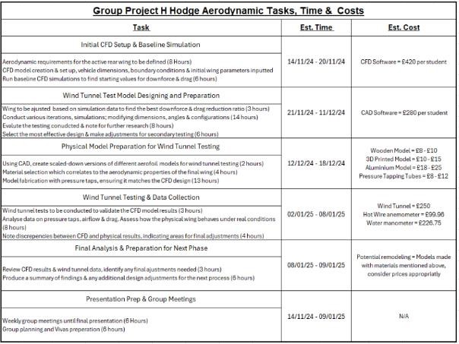
Aerodynamics

Project manager
Tasks | Hours
Organise meetings | 5
Weekly meetings x 21 | 15
create roles and responsibility sheets | 10
Create group Gantt chart | 10
Create Personal Gantt chart | 10
Create Draft for first power point | 10
Hold presentation practise sessions x4 | 30
Viva Presentation ( 9/12/24) | 25
Create Second Draft for presentation | 20
Practise Presentation x 4 | 30
2nd viva Presentation (31/03/25) | 25

My own role (structural)
Tas k no. | Task | Description | Esti  mat  ed  Hou  rs | Sta  rt  Dat  e | En  d Dat  e
1 | Project Planning | Define my objectives, determine my tasks and create a timeline for them to be completed | 10 | 04/  11/  20  24 | 08/  11/  20  24
2 | Research and information gathering | I will be researching suitable materials and mounting designs for the rear wing and correct mounting points to the car | 20 | 11/  11/  20  24 | 22/  11/  20  24
3 | Further research into required equipment | I will be researching data and information based on any equipment I will need to complete my tasks. | 15 | 25/  11/  20  24 | 29/  11/  20  24
4 | Task 1, Testing variety of materials | I will be testing different selection of materials on a wing mount and a wing to determine a baseline of material properties and how they react to different loads | 30 | 02/  12/  20  24 | 20/  12/  20  24
5 | First Viva | Will be presenting the first viva showing I can use FEA on different types of material and have an understanding of different wing profiles and mounts | 5 | 10/  12/  20  24 | 10/  12/  20  24
6 | Task 2, Designing a variety of wing mounts and wing profiles | In SolidWorks I will be creating 2-3 different style wing mounts and 2-3 different wing profiles to test using the material baseline. | 30 | 06/  01/  20  25 | 24/  01/  20  24
7 | Regular project meetings | Will be meeting once a week every week till second viva's | 10 | on  goi ng | on  goi ng
8 | Task 3, Gather the aerodynamic loads and run FEA | I will be gathering accurate aerodynamic loads and conducting accurate FEA simulations on my wing mount and mounting points | 25 | 27/  01/  20  25 | 07/  02/  20  25
9 | Task 4, Will decide on a final design that can handle all of the loads | I will be determining the best mounting position and best design for the wing profile needed. | 10 | 10/  02/  20  25 | 21/  02/  20  25
10 | Reporting and documentation | I will be logging all of my findings on wing mounts and wing profiles into a report or excel sheet | 10 | 24/  02/  20  25 | 28/  02/  20  25
11 | Prototype | I will be creating a 3d printed prototype to use for presentation and simulations | 10 | 10/  03/  20  25 | 15/  03/  20  25
12 | Final product design and review | I will be using what I learn from the prototype to make an actual scale model to finalise all of our research and findings | 10 | 16/  03/  20  25 | 24/  03/  20  25
13 | Second viva | Will be presenting the final product in the last presentation. | 5 | 01/  04/  20  25 | 01/  04/  20  25
14 | Post assessment | In a real application we would take the wing testing on a ace circuit to gather actual data |  | 01/  06/  20  25 | 10/  06/  20  25
Key
- Key Millstones are indicated in red

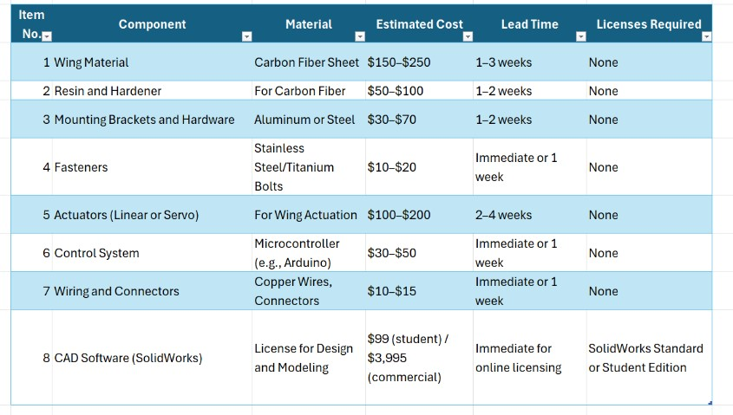
bill of materials+ specialist equipment Preliminary

8 Gateway Objectives
Objective: To finalize the CAD design, conduct FEA validation, and complete the prototype of the active rear wing, ensuring that all technical, dimensional, and performance criteria are met before proceeding
This gateway serves as a critical control point to ensure that the active rear wing design is structurally sound, meets all weight constraints, operates within the defined geometric limits.
Performance Criteria: 1. Weight Limit:
The total weight of the wing, including all components such as the main wing structure, mounts, attachment points, and any actuators or sensors must not exceed 60 kg. This weight limit ensures the vehicle maintains its desired balance, handling, and performance characteristics. Exceeding this weight could negatively impact the vehicle's aerodynamics and handling, reducing the overall efficiency of the rear wing and possibly compromising safety. The weight of all components will be calculated based on the material selected and dimensions from the CAD model. The final assembled weight will be confirmed using physical prototypes or scaling if needed.
- Safety Factor (Strength):
The wing must have a minimum safety factor of 1.5 for all primary components including the main wing structure, mounts, and attachment points under maximum aerodynamic forces. This safety factor will be verified from FEA simulations. The safety factor ensures that the wing structure can withstand real-world forces without failure. FEA simulations will be run on the CAD model, simulating the forces from aerodynamic pressure, vehicle vibrations, and any dynamic forces from the motion of the wing itself. Areas with a FoS less than 1.5 will be flagged for redesign or reinforcement.
- Geometric Positioning (Bounding Box and Vehicle Integration):
Positioning Relative to Vehicle Body: The wing must be positioned such that its aft-most point does not extend more than 100 mm rearward of the aft-most point of the vehicle body. This restriction ensures that the rear wing stays within the predefined bounds for the vehicle's aerodynamics and mechanical integration. Verification Method: This will be checked within the CAD model to ensure the wing fits within the vehicle’s existing design and constraints.
Summary of Gateway Objective
This gateway objective ensures that the active rear wing design meets all critical technical and dimensional criteria before proceeding to the next phase of physical prototype development. The wing must meet strict limits on weight, strength and dimensional positioning within the vehicle’s design. Once these have been met, I can then proceed in making the prototype.

9 Two areas of concern
First area of concern is accuracy and reliability of FEA results, due to the FEA results being a major facture in determining the effectiveness of the final product, so having inaccurate results due to incorrect load assumptions or boundary conditions can cause issues in making prototypes or the final product. To mitigate this risk, I will have to make sure I am working closely with the aerodynamics team members to make sure I am getting the correct loads and can use their results to double check my own. I can also run my own tests to calculate the stress and loads by doing hand calculations to cross reference what FEA tells me. Using these two methods I should be able to mitigate the chances of having unreliable FEA data.
Second area of concern, like having issues with FEA results another area of concern for me will be CAD designs due to the models needing to be precise and compatible with the cars geometry. Having discrepancies in the CAD file will throw off my final design. To mitigate this issue, I will be holding regular design reviews with the other structural design engineer to make sure we are both coming up with similar ideas and can both check each other’s work. And I can also make early prototype models to test fit with the car itself, with the mechatronics team members. This way I can easily identify any early issues with my designs.

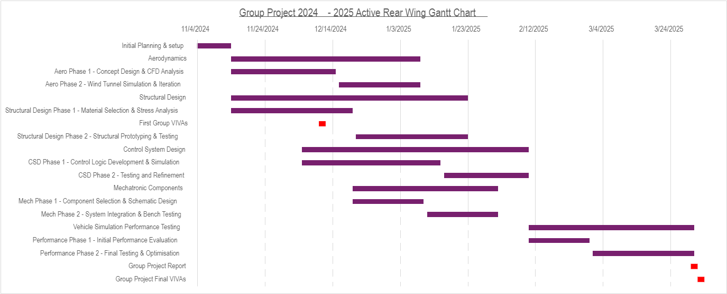
Overall Gantt Chart

Bibliography
Belbins Roles. (2024, november wednesday). Belbin. Retrieved from Belbins team roles: https://www.belbin.com/about/belbin-team-roles

