Grammar Help sheet:

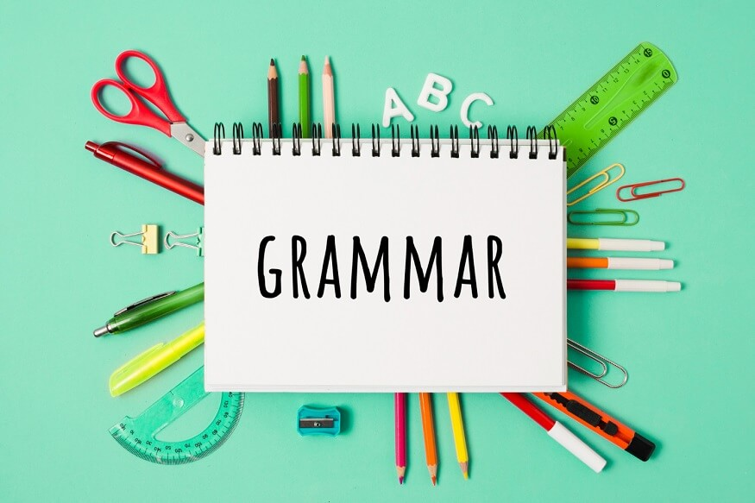

Contents
Adjectives and Adverbs 3
Verbs 5
What Are Nouns? 8
Tenses 11

Adjectives and Adverbs
  - What Are Adjectives?
Adjectives describe or modify nouns. They tell us more about a person, place, or thing.
Examples:
- A beautiful painting
- The fast car
- A happy child
Order of Adjectives:
When using more than one adjective, follow this order:
- Opinion (beautiful, ugly)
- Size (big, small)
- Age (old, young)
- Shape (round, square)
- Colour (red, blue)
- Origin (French, Asian)
- Material (wooden, plastic)
- Purpose (sleeping bag, racing car)
Example: A beautiful small old round red French wooden racing car.
  - What Are Adverbs?
Adverbs describe or modify verbs, adjectives, or other adverbs. They often tell us how, when, where, or to what extent something happens.
Examples:
- She runs quickly.
- They arrived early.
- He speaks very clearly.
Tip:
Many adverbs end in -ly, but not all (e.g., fast, well, hard).
Comparative and Superlative Adjectives
Comparative Adjectives
Used to compare two things.
Examples:
- The car is faster than the bike.
- This book is more interesting than that one.
  - Superlative Adjectives
Used to compare three or more things.
Examples:
- The train is the fastest.
- That was the most exciting movie.
  - Irregular Comparatives and Superlatives
Some adjectives don’t follow the usual rules.
Adjective | Comparative | Superlative
good | better | best
bad | worse | worst
far | farther | farthest

Verbs
  - What Are Verbs?
Verbs are action or state words. They tell us what someone or something is doing or being.
Examples:
- She runs.
- They are happy.
- I cook dinner.

- Regular vs. Irregular verbs
Regular Verbs
Follow predictable patterns in the past tense:
- Talk → Talked
- Play → Played
Rules:
- Add -d after final “e”: Close → Closed
- Double final consonant: Stop → Stopped
- Replace “y” with “ied”: Carry → Carried
  - Irregular Verbs
Do not follow regular patterns:
- Go → Went → Gone
- Buy → Bought → Bought
- Eat → Ate → Eaten

- Verb Tenses
Present Tense
- I/You/We/They cook
- He/She/It cooks
Special Forms:
- Have → Has
- Be → Am/Is/Are
Past Tense
- Regular: Talked, Played
- Irregular: Went, Bought, Sank
- Participles
Present Participle (ongoing action)
Ends in -ing: swimming, cooking, smiling
Past Participle (completed action)
- Used with auxiliary verbs: have eaten, was cooked
- Auxiliary Verbs (Helping Verbs)
Used to support other verbs:
- Be, Have, Do
Examples:
- I am eating.
- She has gone.
- They do play football.

- Modal Verbs
Express possibility, ability, permission, or obligation:
- Can, Could, May, Might, Must, Shall, Should, Will, Would
  - Transitive vs Intransitive Verbs
Transitive (needs an object)
- I eat apples.
- I surprise people.
Intransitive (no object)
- I sit.
- She sleeps.

- Gerunds and Infinitives
Gerunds (verb as noun)
- Cycling is fun.
- I enjoy reading.
Infinitives (to + verb)
- I want to cook.
- I agreed to help.
Some verbs accept both:
- I like to cook / I like cooking

What Are Nouns?
Nouns are words used to name people, places, things, ideas, or events.
Examples:
- Person: teacher, James Bond
- Place: school, Vietnam
- Thing: scissors, milk
- Idea: love, justice
- Event: wedding, celebration
  - Types of Nouns
- Concrete Nouns
Can be experienced through the five senses.
Examples: dog, flower, music, pie
Tip: Ask yourself—Can I touch it? Is it real?
- Proper Nouns
Refer to specific names and always start with a capital letter.
Examples: Big Ben, Monday, Samsung, The Godfather

- Abstract Nouns
Refer to ideas, emotions, or states that cannot be physically sensed.
Examples: love, bravery, education, justice

- Collective Nouns
Refer to a group of people, animals, or things.
Examples: a flock of birds, a pride of lions, a school of fish

- Possessive Nouns
Show ownership and use apostrophes.
Examples:
- Tony’s car
- The dog’s bone
- James’ pen / James’s pen (both are correct)

  - Apostrophes: Possession vs Contraction
- Contractions
- Do not → Don’t
- I will → I’ll
- You are → You’re
- Possession
- Singular: The dog’s tail
- Plural: The dogs’ tails
- Irregular: The men’s car
- Common Mistakes:
- They’re (they are) ≠ their (possessive) ≠ there (location)
- You’re (you are) ≠ your (possessive)

  - Plural Nouns
- Regular Plural
- Add -s or -es: box → boxes
- Irregular Plurals
- Change form: child → children, sheep → sheep
- Plural-Only Nouns
Used only in plural form:
- trousers, scissors, outskirts
  - Countable vs Uncountable Nouns
- Countable Nouns
Can be counted and have singular/plural forms.
Examples: cat, country, drink
Tip: Use “a” or “an” with singular form.
- Uncountable Nouns
Cannot be counted and usually have no plural form.
Examples: flour, wood, rain

Tenses
What Are Tenses?
Tenses show the time of an action or event. They help us understand when something happens: in the past, present, or future.
  - Present Tenses
  - Present Simple
Used for routines, facts, and general truths.
Structure:
Subject + base verb (add -s for he/she/it)
Examples:
- I play basketball on Sundays.
- He lives in Scotland.
- The plane leaves at 10am.

  - Present Continuous
Used for actions happening right now.
Structure:
Subject + am/is/are + verb + -ing
Examples:
- I am cooking dinner.
- They are playing football.

  - Present Perfect Simple
Used for actions that happened at an unspecified time before now.
Structure:
Subject + have/has + past participle
Examples:
- I have eaten lunch.
- She has gone to the shop.

  - Present Perfect Continuous
Used for actions that started in the past and are still happening.
Structure:
Subject + have/has been + verb + -ing
Example:
- I have been studying all morning.

  - Past Tenses
- Past Simple
Used for completed actions in the past.
Structure:
Subject + past form of verb
Examples:
- I talked to him yesterday.
- She ate lunch at noon.

- Past Continuous
Used for actions that were happening at a specific time in the past.
Structure:
Subject + was/were + verb + -ing
Example:
- I was reading when you called.
- Past Perfect Simple
Used for actions completed before another past action.
Structure:
Subject + had + past participle
Example:
- I had finished dinner before the movie started.
- Past Perfect Continuous
Used for actions that were ongoing before another past action.
Structure:
Subject + had been + verb + -ing
Example:
- She had been working all day.
  - Future Tenses
- Future Simple
Used for actions that will happen.
Structure:
Subject + will + base verb
Example:
- I will travel next week.

- Future Continuous
Used for actions that will be happening at a specific time in the future.
Structure:
Subject + will be + verb + -ing
Example:
- I will be studying at 8pm.

- Future Perfect Simple
Used for actions that will be completed before a future time.
Structure:
Subject + will have + past participle
Example:
- I will have finished the report by Friday.

- Future Perfect Continuous
Used for actions that will have been happening for a period of time before a future moment.
Structure:
Subject + will have been + verb + -ing
Example:
- By next year, I will have been working here for five years.

