University of Wales Trinity Saint David



Program: Certificate of Higher Education Skills for the Workplace (Health and Social Care)
Title: Portfolio-Two Tasks
Module: Introduction to Health and Social Care
Name of Student: ahamadunnishasheik
Student ID; 2528582
Lecture;dr helen parsons

Table of Contents
Task 1 (Poster for Community Antenatal Midwifery Services) 3
Task 2 (Short Essay: Domiciliary care services within the community) 5
1. Introduction 6
2. Origins and Historical Development 6
3. How Domiciliary Care Services Function Today 6
4. Significance in Enhancing Quality of Life 7
5. Conclusion 7
References 9

Task 1 (Poster for Community Antenatal Midwifery Services)

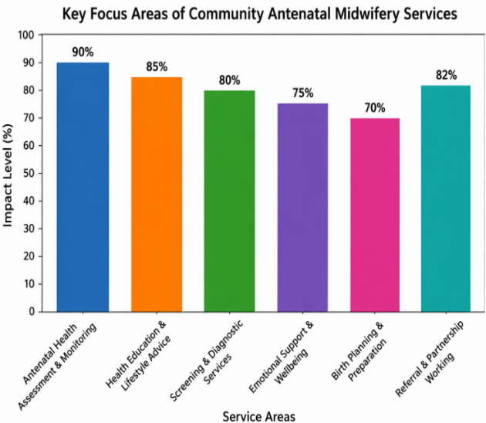





e
Community Antenatal Midwifery Services
Community antenatal midwifery services have become an essential part of maternity services in the National Health Service (NHS) in the United Kingdom. These services are offered in community settings (e.g. GP surgeries, health centres, maternity clinics and in patients' homes) with a focus on healthcare, support, education and monitoring for pregnant women during pregnancy. The community midwives typically are the first health care provider with which women come into contact after they have confirmed their pregnancy and they play a key role in encouraging healthy pregnancies and detecting potential problems early on. Their duties go beyond health assessments to emotional support, health promotion, child and family protection and preparation for the birth and parenthood of children.
Two Major Challenges Faced by Community Antenatal Midwifery Services

The community antenatal midwifery pathway is a well-defined process that helps to guide women from early pregnancy until delivery. A woman is referred to a community midwife after diagnosis of pregnancy and is invited to attend an initial booking appointment, which is typically in the first trimester. At this visit the midwife gathers information about people's medical and family history, their lifestyle and any risks that may impact their pregnancy. Women have regular antenatal appointments at which the midwife will check their blood pressure, test their urine, check on how well the baby is growing and assess the mother and baby's health. Midwives perform screening tests, blood investigations and ultrasound scans to detect potential problems and provide interventions if needed in a timely fashion. Clinical monitoring is not the only role of community midwives, they also educate on healthy eating, smoking cessation, physical activity, breastfeeding, mental health and preparation for labour and parenthood. They have a collaborative relationship with obstetricians, GP's, health visitors, social workers and mental health professionals, ensuring that care is holistic and coordinated. As a pregnancy progresses a midwife will assist women to create a birth plan and get ready for labour, giving mothers knowledge and support along the way.
The delivery of community antenatal midwifery services is still a significant challenge for health inequalities. Low socio-economic status, ethnic minority groups, refugee women and women in rural areas may have access challenges to AEC that are prohibitive. Some of these barriers can be language, cultural, transportation, economic and health literacy. Women from disadvantaged groups have been found to be at greater risk of adverse pregnancy outcomes, such as maternal complications, premature birth, low birth weight infants and maternal and infant deaths. These inequalities can be reduced by the culturally sensitive care provided by community midwives, their ability to encourage early contact with maternity services and the ease with which they can access other types of support. However, closing health inequalities is not a straightforward task and will require continued partnership working between healthcare providers, policy makers and community organisations to achieve equitable access to good quality maternity services for women.
2. Health Inequalities and Unequal Access to Care
A severe problem experienced by the community antenatal midwifery practice in the United Kingdom is a lack of midwives. Population growth, the older age of mothers, the greater proportion of obese women and more complicated pregnancies have all contributed to the higher demand for maternity services. But the growth of the workforce has not always kept pace with the rising demand. This leads to community midwives being extremely busy, understaffed and overburdened with delivering safe care. Staffing shortages can affect continuity of care, length of time between appointments and staff stress and burnout. These factors can impact care for pregnant women and can be difficult for healthcare providers trying to uphold the quality of maternity care. To meet the need and demand for the workforce, investments in recruitment, education, retention and staff wellbeing strategies must be made to sustain the effectiveness of community antenatal services.
1. Inequitable and inadequate access to resources
1902: Regulation of midwifery practice in the UK introduced in Midwives Act.
1948: The NHS was established in 1948, giving everyone access to maternity services.
1993: The report ‘Changing Childbirth' encouraged woman centred maternity care.
2016: In National Maternity Review ("Better Births") promoted personalised maternity services and continuity of care.
Current: Multidisciplinary working and personalised, evidence-based care are the main priorities of current community antenatal services.
How the service works?
Brief History of the Service
Introduction
Lifesaving Care on the Move

Task 2 (Short Essay: Domiciliary care services within the community)

Introduction
Domiciliary care services (also known as home care services) are care or support given to a person who lives in their own home or in a different type of setting besides a residential or hospital setting. The services are intended to enable people to live independently and to meet their care needs for daily living activities and health issues. Domiciliary care is especially vital for older persons, people with disabilities, those who are recovering from a bout of illness or people who have long-term health conditions. In the UK, domiciliary care has become a key component of health and social care policy, as it allows individuals to stay in their own homes and receive tailored care. Given that the population is ageing and caring for people is becoming a greater priority, then more and more people are using domiciliary care services to help maintain wellbeing and alleviate the strain on residential care homes and hospitals.

Origins and Historical Development

It is thought that the roots of domiciliary care lie in the informal care that was offered by family members, religious institutions and charitable organisations. Prior to the modern social care systems, elderly family members and people with disabilities were mainly relied on in the family home. In the nineteenth and early twentieth centuries, charitable groups started to offer support to those in need in their own homes. One of the key developments after the National Health Service (NHS) was set up in 1948, and the growth of the welfare state. These changes led to greater provision of health and social services. It was, however, the NHS and Community Care Act 1990 that had a significant impact on the development of modern domiciliary care. This law prompted local authorities to promote care in the community instead of long-term institutional care. This was a policy that began to be formed as there was an increasing recognition that there were many people who wanted to stay in their own home or community as opposed to residential facility. Since then, the provision of domiciliary care has grown significantly, as there are more policies focusing on person-centred care, technology advances and a growing focus on independence and choice.

How Domiciliary Care Services Function Today
In modern times, domiciliary care is provided by local authorities, NHS community services, private care providers and voluntary organisations. People are assessed for their needs prior to receiving support to identify the kinds of support and their intensity. A personalised care plan is drawn up based on this evaluation and to meet the individual's needs. Domiciliary care workers offer a variety of services such as personal care, bathing and dressing, preparing meals, supporting medication, mobility and domestic duties. The number of visits may be once a week to a few times a day or for specialised care, it may be several times a day.
Technologies are being increasingly utilised in domiciliary care for the benefit of people, with the use of telecare systems, emergency alarms, remote monitoring devices and electronic care records. These innovations enable better communication among professionals and better patient safety. There are a number of benefits to providing domiciliary care however there are also some challenges. The delivery of services may be inconsistent and of poor quality due to workforce shortages, funding pressures or increasing demands for services. Care workers' workloads and provision of resources is high in some areas, including an effect on continuity of care. Although the challenges exist, domiciliary care is a cost effective and person centred approach which allows individuals to be supported in their community.

Significance in Enhancing Quality of Life

Overall, the provision of domiciliary care services is significant and has a positive impact on the quality of life for service users. One of the greatest benefits is the opportunity for people to live in their own home and be independent and dignified. Having a familiar place to go can offer emotional comfort, lessen stress and help maintain mental health. Staying at home also allows someone to keep their social connections with family, friends and neighbours which helps to minimize their sense of loneliness and social isolation.
In addition, the provision of domiciliary care allows for the provision of personalised care which values individual preferences and routines. This person-centred approach improves the satisfaction of those who use services and promotes their increased involvement in decisions about their care. Domiciliary care can also help to avoid unnecessary hospital admissions, aid recovery from illness and avoid residential care placements. This therefore has an advantage for service users and as well as the wider health and social care system.

Conclusion

Domiciliary care services have developed from formal support to informal provision within the family to become an important part of the contemporary community based health and social care service. Underpinned by shifting social policies and demographic shifts, the services are now delivered in a more personalised way that allows people to live independently in their own home. Despite the difficulties facing the sector of shortage of staff and funding, domiciliary care remains a way of improving quality of life through the promotion of dignity, independence, social inclusion and wellbeing. Domiciliary care is crucial to the support available to vulnerable people in the UK and will continue to play an important role as the demand for community care grows.

References
- Department of Health (1993) Changing Childbirth: Report of the Expert Maternity Group. London: HMSO.
- Department of Health (2010) Healthy Lives, Healthy People: Our Strategy for Public Health in England. London: The Stationery Office.
- Glasby, J. (2017) Understanding Health and Social Care. 3rd edn. Bristol: Policy Press.
- National Health Service (NHS) (2024) Antenatal Care.
- National Health Service (NHS) (2024) Maternity Services Overview.
- NHS England (2016) Better Births: Improving Outcomes of Maternity Services in England. London: NHS England.
- NHS England (2024) Community Health and Care Services. London: NHS England.
- Nursing and Midwifery Council (NMC) (2023) Standards of Proficiency for Midwives. London: NMC.
- Royal College of Midwives (2024) State of Maternity Services Report. London: Royal College of Midwives.
- Skills for Care (2024) The State of the Adult Social Care Sector and Workforce in England. Leeds: Skills for Care.
- The King's Fund (2023) Social Care Explained. London: The King's Fund.
- United Kingdom Government (1990) NHS and Community Care Act 1990. London: HMSO.
- World Health Organization (2023) WHO Recommendations on Maternal and Newborn Care for a Positive Postnatal Experience. Geneva: World Health Organization.

