Stress levels in the UK
Student Number: 2026576
Name: Andrea Voros
Module: BMSW4004
Lecturer: Yohan Mendis

Table of contents
Stress levels in the UK 1
Introduction 2
Nature of the problem, scope and impact 4
PESTEL Analysis 5
Fishbone-diagram/ Cause and effect Analysis 6
Alternative Solutions of the problem 7
Implementation Plan 9
Conclusion 9
Reference List 10

Introduction
This paper will discuss the issues that exist in UK workplaces, as well as the solutions that have been identified to address these issues. Everyone in our modern society faces a variety of issues at work and at home. Work-related stress, on the other hand, has become the most common concern in the UK in recent years, and it is frequently creating major health problems. This issue is a significant divide between people's cheerful and carefree lives and the stressful weekdays, which they must bridge as a team at work. Team meetings, additional managerial support, or technological advancement can all help to alleviate workplace stress. The working environment continues to evolve, often in the context of rising job insecurity, as the world economy becomes more internationalised and economic rationalisation pushes employment restructuring, more part-time and contract work, and higher workload expectations. As a result, many people in the community believe that work is becoming a more significant cause of stress and worry. This report will go through PESTEL analysis, Fishbone diagrams, and an example of how to use a PMI analysis to solve a work-related stress problem. Finally, you will discover an action strategy for efficiently resolving workplace stress.
According to this statistics the most stressed area (work-related) is Wales, and the less stressed is Scotland. West Midlands is in the middle with 26 percent, which is not too high.

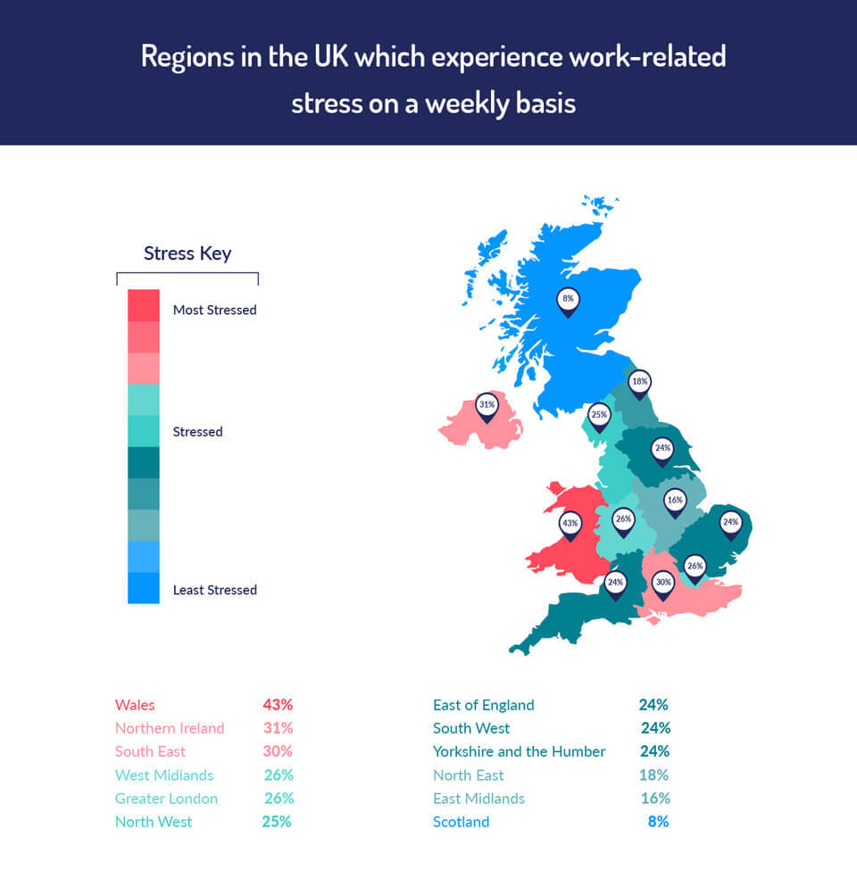

Nature of the problem, scope and impact
Employee happiness and productivity, mental and physical health, absenteeism and its financial cost, the greater impact on family function, and the possibility of employer responsibility are all effects of workplace stress. While sorrow is the most typical negative psychological consequence, other possibilities include "burnout," alcohol misuse, unexplained medical concerns, "absenteeism," chronic fatigue, and accidents, as well as sick building syndrome and repetitive strain injury. ( Journal of Psychosomatic Research 51 (2001) 697 – 7040)
Stress is a response to events or experiences in one's personal or professional life, or a mix of the two. Bereavement, divorce, postnatal depression, a physical issue, or a family history of the problem are all examples of common mental health problems that can have a single source outside of work. By enhancing working environments, you can aid in the management and prevention of stress. This could be a long term problem as it has a lot of bad impacts for individuals and the organisation too.
“When the job requirements do not meet the worker's talents, resources, or needs, detrimental physical and emotional reactions arise.”( The National Institute of Occupational Safety and Health (1999)5)

PESTEL Analysis
Environmental analysis is critical for gaining a long-term competitive advantage, detecting possibilities and challenges, and establishing fruitful partnerships with other businesses. According to a survey of the literature, many methodologies and techniques for macro environmental analysis has been applied (Lynch, 2009). PESTEL (Political, Economic, Sociocultural, Technological, Environmental, and Legal) analysis is the model investigated in this paper.
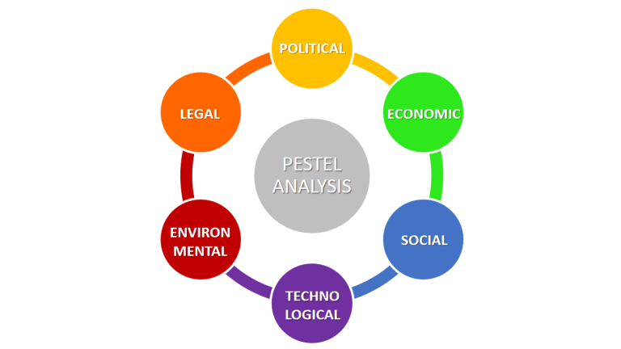

Political factor: This might include government policy, political stability or volatility in international markets, foreign trade policy, tax policy, labour laws, environmental law, trade restrictions, and so on. For example, Brexit has become a part of everyone's life, with government repercussions and both negative and positive consequences.
Environmental factor: Economic growth, interest rates, currency rates, inflation, consumer and corporate disposable income are all factors that affect employee pay and profits on a daily basis.
Social factor: Population increase, age distribution, health awareness, occupation inclinations, and other variables are among them. These traits are especially intriguing since they have a direct impact on how marketers perceive clients and what motivates them.
Technological factor: We're all aware of how quickly the world of technology evolves, and how this affects how we promote our goods. Marketing and management are affected by three technological factors: New means of creating goods and services, as well as new methods of disseminating products and services to targeted audiences, are being developed.
Environmental factor: Weather problems, climate change, air and water pollution are just a few instances of things we can't control. All we can do is work with them, or assist them through recycling processes, and Greenpeace organisations.
Legal factor: Health and safety, equal opportunity, advertising standards, consumer rights and legislation, product labelling, and product safety are some of the topics explored. In order to trade economically, companies must understand what is and is not lawful. Because each country has its own set of rules and regulations, learning them becomes a difficult task when a company trades internationally.

Fishbone-diagram/ Cause and effect Analysis
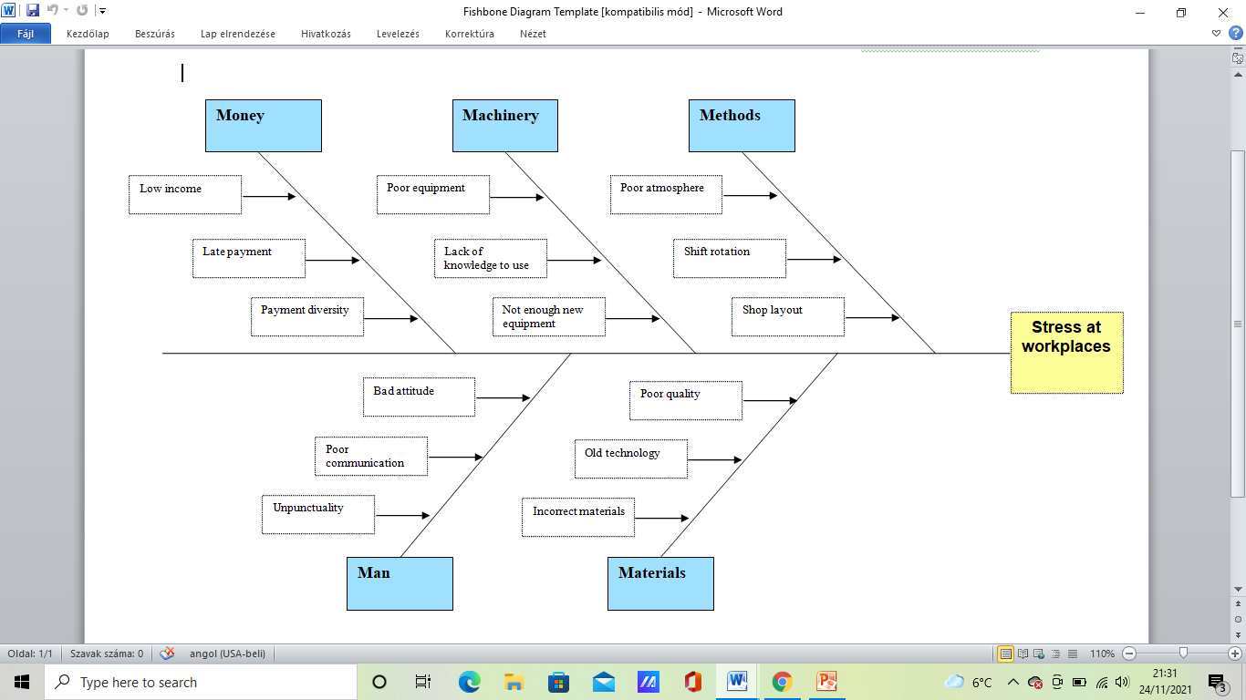
A fishbone diagram (also known as an Ishikawa diagram) is used to identify and organise the causes of a quality problem. Gradually, the notion has been used to categorise the causes of many types of problems that an organisation may encounter. As a result, the Fishbone diagram has become an extremely useful tool for risk detection. (G. Ilie & C.N. Ciocoiu, 2010)
Possible causes of the work related stress are the following:
- Money: Low income, late payments, or payment variety all have the potential to cause major issues.
- Machinery: Employees are more stressed due to a lack of modern equipment, a lack of understanding on how to utilise it, and a bad technological setup.
- Methods: Workplace issues are also being exacerbated by shop layout, bad environment, and shift rotation.
- Man: Individuals negative attitudes, poor communication among team members, and tardiness are all factors that contribute to increased stress at work on a regular basis.
- Materials: Inappropriate materials, outdated technology, and poor quality are producing additional stress and potential difficulties if no one is willing to pay for upgrades.

Alternative Solutions of the problem
- Holding team meetings to discuss the issue can assist to avoid misunderstandings and foster relationships among team members and supervisors.
- 2) Increasing an individual's income can boost productivity while also improving the work environment.
- 3) Technological advancements are a big aid in everyday work, and they may help everybody to work quicker and more efficiently.
- Extra support is the most effective way for resolving the issue and avoiding unpleasant days at work.

Everybody like to know how the additional assistance may help to reduce workplace stress so that we can utilise methods like PMI to identify it. “PMI” stands for “Plus, Minus, Interesting”. The goal is to talk about the three facets of a topic or idea: "Plus" for good aspects, "Minus" for bad aspects, and "Interesting" for features that are neither positive nor negative but may represent opportunities or worth additional debate. (John Mcdermott,2017)
Plus: People might experience more trust and comfort at work with extra assistance from supervisors, while also increasing their self-confidence. Supervisors might pay additional attention to individuals' and the team's flaws while also highlighting their virtues.
Minus: Anxiety induced by a lack of efficiency may be a negative factor, as can a lack of trust between team members and team leaders, as well as envy at work. Different mind sets, such as shy individuals and too confident ones, add to the negativity at work, as not everybody needs extra help, or not everybody can ask for it.
Interesting : When top managers provide more help to their staff, they can quickly determine what is causing the lack of productivity, and communication between them improves. Everyone has their own challenges, which they may work through with the management step by step, and then reap the advantages of their combined efforts. At the end of the day, everyone is working in a relaxed setting.

Team meetings are the other effective ways to solve the problems caused by work-related stress in the UK. “Sitting in a circle, waiting for your turn to speak, and listening respectfully . . . were norms that traveled from the kindergarten to the boardroom” (p. 4) (CIP; e.g., Liker, 2006).
Plus: People have more contact, better communication, and may combine their opinions during team meetings. The concept of team building is gaining traction, and they are making an impactful attempt to fix the problem. (cf. Kauffeld, 2006a)
Minus: Negative aspects include disagreements, a lack of tolerance, and the diversity of viewpoints. Perhaps not all employees have the time or are too self-conscious to seek for assistance.
Interesting: Sharing information, wisdom, and experience might be beneficial to everyone, and it's also fun to put members' patience to the test. Managers, on the other hand, can quickly emphasise the team's strengths and faults.” Meetings are typically held for a variety of reasons, including exchanging information, addressing issues, reaching consensus, and making decisions.” (cf. Leach et al., 2009).
According to input-process-output models of team interaction processes and performance outcomes, we anticipate that functional team meeting communication will increase team meeting success while dysfunctional communication will decrease team meeting success (e.g., Hackman & Morris, 1975). The act 4 teams coding approach (Kauffeld, 2006a; Lehmann-Willenbrock & Kauffeld, 2010;) is used to distinguish between functional and dysfunctional team meeting communication. Problem-focused communication is assumed to be naturally functional. On the other hand, procedural, socioemotional, and action-oriented communication can be either functional (excellent) or dysfunctional (poor) (negative).

Implementation Plan

- Executive managers must listen to all employees on a daily basis and have frequent team meetings to discuss any issues that arise at work.
- Effortlessly balancing all challenges in order to achieve the team's goals while avoiding gossip, disputes, and other issues.
- Managers must assist their staff both individually and as a group, as this will help to avoid the escalation of genuine workplace conflicts.
- When we wish to see obvious beneficial improvements at work, the most significant adjustments are self-development methods. Executive managers must encourage their employees to train on a regular basis for difficult situations and stressful days.
- When the working group evaluates their progress and discusses it with the team leaders, it may be a productive strategy to address any potential concerns.
- Employees must have team meetings on a regular basis to avoid new unpleasant circumstances at work and to strengthen teamwork.
- People must listen closely and watch to see what they are dealing with before they can grasp any concerns. Comprehension is a must to avoid the stress on a daily basis.

Conclusion
Stress is described as a disruption in the normal functioning of the body and mind. In an organisation, stress can occur for a variety of reasons, such as a lack of control over work, management style, and so on. In moderation, stress is beneficial to both the business and the individual. It supports in the achievement of personal and organisational goals. Too much stress, on the other hand, may be harmful to employees' bodies, brains, and psyches.This article examines the breadth and effects of work-related stress in the United Kingdom, utilising a PESTEL analysis to show how stress affects various parameters. A comprehensive version of a fishbone diagram to identify the origins of the problem is also supplied. We utilised PMI analysis to assess the problem's potential remedies as well as to select the most relevant ones. The most effective remedies for work-related stress, according to the implementation plan, are increased support from managers and team meetings where workers may ask for help in reducing stress levels.
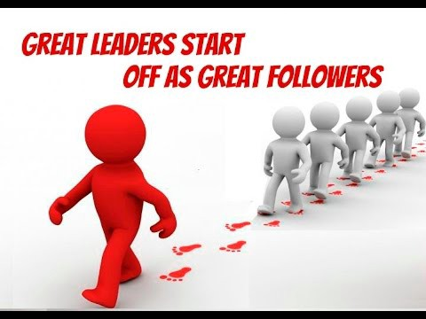

Reference List
- Journal of Psychosomatic Research 51 (2001) 697 – 704, Department of Psychological Medicine, University of Sydney and Royal North Shore Hospital, Block 4, level 5, St. Leonards, Sydney, NSW 2065, Australia Institute of Stress Medicine, University of Sydney and Royal North Shore Hospital, Block 4, level 5, St. Leonards, Sydney, NSW 2065, Australia Received 26 May 1999; accepted 13 March 2001
- A model of work stress to underpin the Health and Safety Executive advice for tackling work-related stress and stress risk assessments Stephen Palmer, Cary Cooper and Kate Thomas
- International Journal of Business and Management; Vol. 7, No. 24; 2012 ISSN 1833-3850 E-ISSN 1833-8119 Published by Canadian Center of Science and Education
- https://www.professionalacademy.com/blogs/marketing-theories-pestel-analysis/
- Ilie G. and. Ciocoiu C.N. APPLICATION OF FISHBONE DIAGRAM TO DETERMINE THE RISK OF AN EVENT WITH MULTIPLE CAUSES MANAGEMENT RESEARCH AND PRACTICE Vol. 2 Issue 1 (2010) p: 1-20
- https://blog.learningtree.com/use-pmi-analysis-encourage-critical-thinking/

Meetings Matter: Effects of Team Meetings on Team and Organizational Success
Simone Kauffeld, Nale Lehmann-WillenbrockFirst Published December 25, 2011 Research Article https://doi.org/10.1177/1046496411429599
- Kauffeld, S. (2006b). Self-directed work groups and team competence. Journal of Occupational and Organizational Psychology, 79, 1-21. doi:10.1348/096317905X53237
- Leach, D. J., Rogelberg, S. G., Warr, P. B., & Burnfield, J. L. (2009). Perceived meeting effectiveness: The role of design characteristics. Journal of Business Psychology, 24, 65-76. doi:10.1007/s10869-009-9092-6
- Hackman, J. R., & Morris, C. G. (1975). Group tasks, group interaction process, and group performance effectiveness: A review and proposed integration. Advances in Experimental Social Psychology, 8, 45-99. doi:10.1016/S0065-2601(08)60248-8
- Kauffeld, S. (2006a). Kompetenzen messen, bewerten, enwickeln [Measuring, evaluating, and developing competencies]. Stuttgart, Germany: Schäffer-Poeschel.
- Lehmann-Willenbrock, N., & Kauffeld, S. (2010). The downside of communication: Complaining circles in group discussions. In S. Schuman (Ed.), The handbook for working with difficult groups: How they are difficult, why they are difficult, what you can do (pp. 33-54). San Francisco, CA: Jossey-Bass/Wiley.

Table of Contents
Stress levels in the UK 1
Introduction 2
PESTEL Analysis 3
Fishbone-diagram/ Cause and effect Analysis 5
Alternative Solutions of the problem 6
Implementation Plan 7
Conclusion 8
Reference List 9

