Ethan Smith
Student ID - 2311689
Celebrating language and Culture – Belonging to Wales
ECIE5004

Index Page
Page 1 – Student Information Page
Page 2 – Index Page
Page 3 -6 – Main Body
Page 7 – Appendix
Page 8 – Reference List

This portfolio will explore the context of the Welsh language’s history, discuss in depth how the Welsh language has been impacted in education over the last 30 years, and then examine practical activities used today in schools across Wales to promote and implement the Welsh language in everyday learning.
The Welsh language is said to be the oldest language in Britain and has the oldest literature in Europe, which is believed to have begun between 400 and 700 AD. However, in 1536, Henry VIII prohibited the use of the Welsh language in the public administration and the legal system, meaning the English language was now the first in command. Leading on to 1549, when the Act of Uniformity was put in place by Elizabeth I, it was demanded that all aspects of public worship were to be conducted in English and that churches were to carry Welsh versions of the Book of Common Prayer and the Bible. Around this period, the first book written in Welsh appeared, and Welsh poetry reached a remarkable high point in 1792, when Iolo Morganwg founded the Gorsedd of the Bards, a cultural order that went on to play a key role in the development of the Eisteddfod festivals. Today, over a quarter of people in modern Cymru can speak or use Welsh, with the proportion even higher among children, thanks to two major education acts introduced in the 20th century. Welsh is easy to encounter in daily life. Radio Cymru began broadcasting in 1977, followed by the television channel S4C in 1982. Newspapers, regional radio stations, and bilingual road signs all help keep the language visible and vibrant (Welsh Goverment, 2025).
Nicholas Cannon OBE (2013) states, “Wales is the home of the Welsh language, an ancient and complex Celtic language totally unrelated to English. Around 560,000 people, about 20% of the population of Wales, still speak the Welsh language” (Cannon, 2013). This observation highlights the enduring cultural importance of the Welsh language by referencing Welsh as an ancient and complex Celtic language that has no relation to the English language. Cannon emphasises its distinct linguistic heritage and the deep historical roots. As quoted, “approximately 20% of Wales’s population still speaks Welsh” demonstrates the language’s resilience and how it still has massive relevance in modern society these days.
The outcome of the Education Reform Act of 1988 is the reason the national curriculum of Wales is in place today. Before the outcome of this act, there were no compulsory curriculum orders in place for any child under fourteen years old; there were only two compulsory subjects that had to be taught within schools, which were Religious Education and Physical Education. The Welsh subject was also compulsory in some parts of Wales, but not all and some schools didn’t have Welsh language taught at all. Each school in Wales had its own choice in this matter, whether to implement Welsh language lessons within its school or not. This allowed each school to choose what they felt was necessary to implement in their own school, but it also meant that there was a significant difference in teaching across schools in Wales, as each school provided different subjects and teaching methods. Now the statutory expectation is that all learners aged seven to fourteen years old are given the opportunity in all subjects, to allow them to develop their knowledge and understanding of the cultural, economic, environmental and historical aspects of Wales (Jones, 2003).
In 2015, The Well-being of Future Generations Act (Wales) came into place to ensure that Wales has the opportunity for a new mindset to give all more ambition for the Welsh language and the ability to improve the people of Wales’s social, cultural, environmental and economic well-being. Derek Walker, the Commissioner for Wales, states, “The process of improving the economic, social, environmental and cultural well-being of Wales by taking action, in accordance with sustainable development principles, aimed at achieving the well-being goals.” The framework shows five different ways of working, which are needed for the public to achieve the seven well-being goals that have been set. The goals that this act sets out goals that they will ensure an overall better place to call Wales. The aims are: A prosperous Wales, a resilient Wales, a more equal Wales, A healthier Wales, a Wales of cohesive communities, a Wales of vibrant culture and thriving Welsh and a globally responsive Wales. Each of these aims links within each of the economic, social, environmental and cultural aspects that the framework is currently trying to develop and improve (Future Generations Commissioner for Wales, n.d.).
However, even though the Commissioner for Wales made a change to the process of changing the Welsh language within schools, in 2022, an issue arose from the press that the lack of education, skills and resources that were being provided to children across Wales was poor. Teachers had been expected to teach Welsh within their school with no previous training or knowledge of doing so, which left pupils feeling as though they were not being provided with the best education. As the BBC quotes, “They [teachers] have gone through the education system where they themselves have had far more of the history of Nazi Germany or America. It's a vicious circle that we need to break. We need to encourage teachers to be aware of our history, and resources are vitally required. We need specialists in Welsh history in order to ensure the teaching profession is equipped to teach the story of Wales” (BBC, 2022).
Responding to this statement, the Welsh Government strengthened their ‘Welsh Language Bill’, which was introduced in 2021, outlining that their focus was to provide more developed resources to schools across Wales, allowing them to strengthen Welsh in education. After this ‘Welsh Language Bill’ was strengthened and implemented in more schools across Wales, the pupils felt as though they had seen a massive improvement in the delivery of Welsh being taught within their school and the skills and education of their teachers (Welsh Goverment, 2021).

Activity 1 – Tric a Chlic.
Tric a Chlic is a synthetic programme that supports learners aged three to seven with their Welsh phonics. This program is used to hear, recognise, combine and segment the Welsh language in a way that children will enjoy. This method focuses on the way the sounds are pronounced, rather than the way the Welsh alphabet is pronounced, because it allows the learners to immediately begin to recognise the phonics and use them to read simple words (see Appendix 1).
This program that the setting uses comes with lots of resources from books, phonics cards and Welsh games, which allows the learners the chance to learn Welsh in a way that they can enjoy and understand. There are resources that allow the learner to recognise sounds, form letters, blend sounds and the segmentation of forming Welsh sentences.
In my current session, we use this resource in our ‘Slot Drilio’ time each day, which is our 30-minute session for our Welsh learning. The children enjoy this as it is a fun and engaging way that they can better their understanding and knowledge of the Welsh language, which also supports their Welsh communication skills.
To conclude, Tric a Chlic has had a significant positive impact on the ability of the learners’ Welsh language and communication within the setting. The children can communicate more fluently in conversation and are also able to pronounce Welsh words accurately. This strategy also works alongside the Language, Literacy and Communication Policy that my setting currently has.

Activity 2 – Criw Cymraeg.
Criw Cymraeg are a group within the school that is run by the Welsh lead to encourage both the children and staff within the school to promote the use of the Welsh language. There is one child in each class that is part of this group, who is the “class lookout” to ensure that the teachers and pupils are speaking Welsh, the teachers are taking part in the Ffa-la-la sessions daily, and then reports back to the Welsh lead weekly and provides the outcome in the weekly Welsh assembly. Within the weekly Welsh assembly, the group go through new Welsh phrases each week, which is the school’s target to use these phrases every day in school. At each assembly, there are certificates given out to one member of each class that the Criw Cymraeg ambassador has noticed using the Welsh language within the class or on the school playground. This promotes the use of the Welsh language, as it gives the children something exciting to look forward to and something that each child wants to receive (see Appendix 2).
In my current setting, the ‘Language, Literacy and Communication Policy’ states “In developing our Siarter Iaith we have created a ‘Criw Cymraeg’ with the aim of promoting Welsh in the school, modelling use of the Welsh language at the tuck shop during break times. We aim to continue this positive practice in moving forward with our development of Siarter Iaith.” This shows that the use of this strategy is working to promote communication in the Welsh language (Reference A).
To conclude, since the school setting implemented the Criw Cymraeg into our school, there has also been a massive increase in Welsh speaking among children and the understanding of Welsh. Children are communicating more with teachers using key Welsh phrases such as “Ga i fynd i'r toiled os gwelwch yn dda?” and many more. These show that the children have an understanding of the Welsh language; they just need positive reinforcement to encourage them to keep using it. This demonstrates that implementing this initiative across schools in Wales could significantly improve the percentage of Welsh speakers.

Activity 3 –‘Ffa-la-l’.
Ffa-la-la was funded in 2014 by an experienced secondary school Welsh teacher who holds a BA from Aberystwyth University and an MA from Mountview Academy of Theatre and Arts, called Carys Gwent. This training opportunity, provided for teachers mainly for progression steps one and two, aims to provide the chance to learn and develop the use of the Welsh language. This training facility teaches key sentence patterns which are created to bring the Welsh language to life. Many schools across Wales use this training facility to ensure that children can develop their Welsh speaking from a young age, which then gives all children the key start to using the Welsh language by understanding key words and sentences that are used within schools nowadays (Ffa-la-la!, 2023).
Within the school setting, Ffa-la-la is implemented into the daily routine. There is a 30-minute time slot each day that teachers can take a Ffa-la-la session with their class. Within this session, teachers are providing to the pupils with the key sentence structure of Welsh-speaking through music. Children love and enjoy music, so by using this to our advantage, teachers can teach enjoyable sessions that children are happy and willing to participate in. There are many different sections of Ffa-la-la that provide teachers with lots of different resources to implement into learning. As schools have different topics that are taught each term, this resource can link within the current topic to work alongside the main teaching.
As stated by my current settings ‘Curriculum Policy, “Our vision is for our learners to receive a high quality and inclusive educational experience, which is rooted in Welsh values and culture. Through topics that capture their interest and stimulate their imagination, our pupils will acquire and refine new skills, knowledge and understanding progressively” (Reference B). This shows that there are visions within the school which are being met by ensuring that the Welsh values and culture are being implemented into the curriculum to provide new skills, knowledge and understanding progressively.
To conclude, both the children and staff in school look forward to participating in these sessions, which have shown a massive increase in Welsh speaking within the school and have given the children the ability to understand the key Welsh language that is used in and outside of school. Within the current setting, it was noticed from Estyn that the school’s Welsh presence and the level of Welsh speaking between staff and pupils have increased massively since the previous inspection. This was one of the school’s biggest improvements that they had seen, which Estyn said has had a significant positive impact on our school in general.

Activity 4 – Calon Caffi.
Calon Caffi was introduced in my setting by the Criw Cymraeg to allow our community to come together to develop and improve their knowledge of the Welsh language and give the Welsh speakers the chance to feel welcomed and included within our setting. Every Tuesday morning, we open the Calon caffi to the community, and every week we have over 20 parents and people from the local community, which gives the school a sense of purpose. The children love having the chance to help others and hear from the Welsh speakers’ new words and historical events that they know or have been through, allowing the children to use this information within school and tell others.
In my current setting, we have our 5 purposes, which are:
C – community
A – aspiration
L – loyalty
O – ownership
N – never give up!
As our first purpose is community, this is a way that we are improving our knowledge through our school’s purpose. We have also had S4C come into school to look at our Calon Caffi and see what it’s really about, which shows that it’s having a positive impact on both the school and the community's understanding of Welsh.
To conclude, Calon Caffi has had an overall massive impact on the level of Welsh that is spoken and understood in our school and local area. The children enjoy meeting new people, helping them with their Welsh and improving the skills which they then pass on through school. The school’s Estyn report showed how wonderful it was to see such a close community and the importance that we are showing to our Welsh culture.

Appendix.

Appendix 1 –
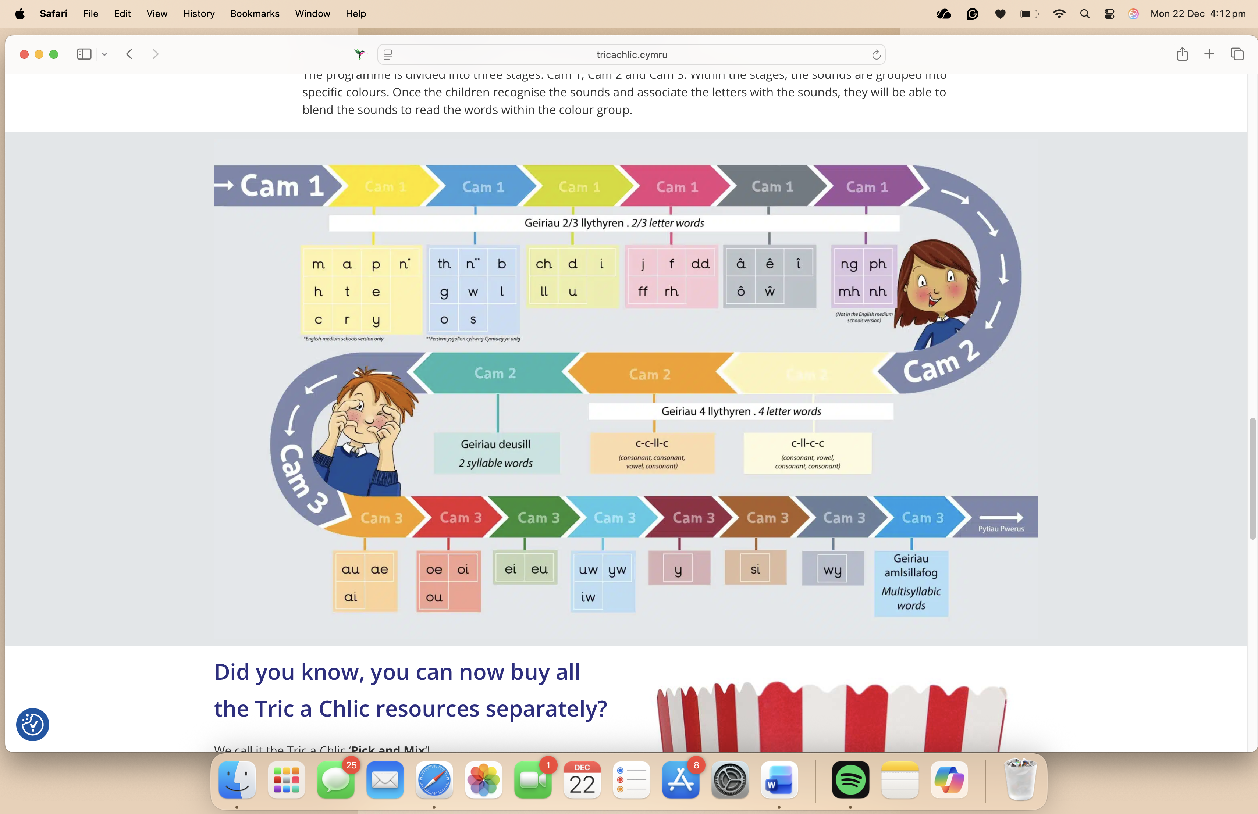
(Tric a Chlic, n.d.)

Appendix 2 –
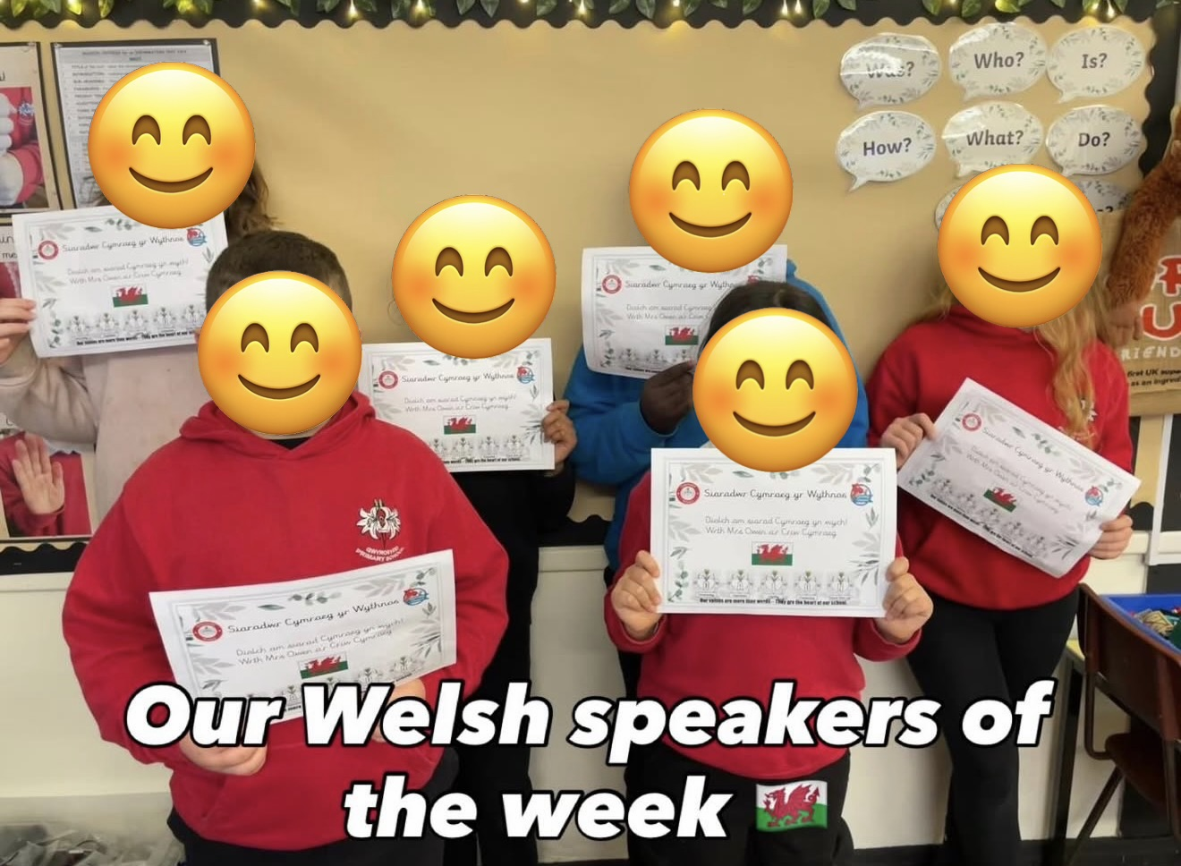
(Gwyrosydd Primary School, 2025)

Reference A - (Gwyrosydd Primary School, 2022).
Reference B - (Gwyrosydd Primary School, 2022).

Reference List.
BBC, 2022. Welsh curriculum: Wales history teaching skills gap , says adviser. [Online]
Available at: https://www.bbc.co.uk/news/uk-wales-63838713
[Accessed 22 December 2025].
Cannon, N., 2013. Wales: the language and the people. [Online]
Available at: https://www.gov.uk/government/speeches/wales-the-language-and-the-people
[Accessed 21 December 2025].
Ffa-la-la!, 2023. FFa-la-la! - Welsh made fun. [Online]
Available at: https://ffalala.co.uk/about-us/
[Accessed 21 December 2025].
Future Generations Commissioner for Wales, n.d. Well-being of Future GenerationsAct 2015. [Online]
Available at: https://futuregenerations.wales/discover/about-future-generations-commissioner/future-generations-act-2015/
[Accessed 21 December 2025].
Gwyrosydd Primary School, 2022. Curriculum Policy, Swansea: Gwyrosydd Primary School. [Accssessed 22 December 2025].
Gwyrosydd Primary School, 2022. LLC Policy, Swansea: Gwyrosydd Primary School. [Accssessed 22 December 2025].
Gwyrosydd Primary School, 2025. Instagram. [Online]
Available at: https://www.instagram.com/gwyrosyddprimaryschool/
[Accessed 22 December 2025].
Jones, G., 2003. The Cwricwlwm Cymreig, history and the story of Wales, s.l.: University of Wales Press. [Accsessed 22 December 2025].
Tric a Chlic, n.d. Tric a Chlic. [Online]
Available at: https://tricachlic.cymru/?lang=en
[Accessed 22 December 2025].
Welsh Goverment, 2021. The Co-operation Agreement, Wales: The Welsh Goverment. [Accssessed 22 December 2025].
Welsh Goverment, 2025. Poetry in motion - discover the language of Wales. [Online]
Available at: https://www.visitwales.com/info/language/poetry-motion-discover-language-wales#:~:text=Discover%20the%20origins%20and%20history,that%20it's%20Britain's%20oldest%20language.
[Accessed 21 December 2025].

