

Program: Master of Business Administration
Module: International Marketing: Principles and Practices
Module code: LCMB7026
Word count: 5221
Student Name : Samit Chanda
Student ID: 2504511
Submission Date- 27th March 2026

Table of Contents
SECTION 1: COMPARATIVE REPORT
1.0 Introduction ……………………………………………………………………… 3
2.0 Comparative Analysis of the Macroenvironment (PESTEL)……………… 3-7
3.0 STP and International Marketing Mix (7Ps) Analysis……………………… 7-12
4.0 Directional Development Strategy in Bangladesh………………………… 13
5.0 Ethical Issues in KFC's Marketing Mix……………………………………… 14-15
6.0 Recommendations……………………………………………………………… 16-17
7.0 Conclusion……………………………………………………………………… 17-18
SECTION 2: REFLECTIVE ACCOUNT
Gibb’s Reflective Model……………………………………………………………18-21
Reference List ………………………………………………………………………22-26

SECTION 1: COMPARATIVE REPORT
1.0 Introduction
KFC is a subsidiary of Yum! that is one of its flagships. Brands,Inc., is a large chain of Quick Service Restaurant (QSR) in the world and has operation in more than 31,000 outlets in over 150 countries ( Yum! ). Brands, 2023). The brand was established in 1930 by Colonel Harland Sanders in the United States and its sustained competitive strength is based on a proprietary mixture of eleven herbs and spices and a franchise system that can spread to any part of the world (Safargholi et al., 2024). In this report, the international marketing strategies of KFC are compared between the United Kingdom, which is a mature and highly regulated European market, and Bangladesh, which is an emerging economy with a rapid growth in cities in South Asia. Using the PESTEL analysis, STP models, the 7Ps marketing mix, the Growth Matrix developed by Ansoff, and the cultural dimensions as developed by Hofstede, the report focuses on how KFC manages to adjust its global competencies to succeed in two inherently distinct institutional and cultural environments. The report also addresses the ethical aspects of KFC activities and provides long-term resiliency strategic advice in the two markets.
2.0 Comparative Analysis of the Macroenvironment: PESTEL Framework
2.1 Political Factors
The United Kingdom operates within a stable democratic system supported by strong institutions and predictable regulatory frameworks. However, the post-Brexit environment has introduced structural challenges, including trade frictions, labour shortages, and supply chain disruptions that have directly affected quick-service restaurant (QSR) operators (Dhingra et al., 2017). KFC experienced these vulnerabilities during its 2018 logistics crisis, when distribution failures forced the temporary closure of over 600 outlets across the country (BBC News, 2018). Additionally, government intervention in public health policy has increased. Zoning regulations restricting new fast-food outlets within 400 metres of schools have limited expansion opportunities in certain areas (Public Health England, 2020). The Soft Drinks Industry Levy has also increased operational costs by requiring reformulation to reduce sugar content (HM Revenue and Customs, 2018).
Bangladesh operates as a parliamentary democracy but is characterised by periodic instability, including strikes and political tensions between major parties such as the Awami League and the Bangladesh Nationalist Party (World Bank, 2023a). These factors can disrupt supply chains and business continuity. Nevertheless, the government actively promotes foreign direct investment (FDI) as part of its economic development strategy, and international QSR brands are seen as symbols of progress (Rahman and Khondker, 2020). A major political risk is enforcement volatility, where regulations are applied inconsistently and sudden mobile court actions can result in fines for businesses (The Business Standard, 2024).
For KFC Bangladesh, political conditions present both opportunities and threats. Pro-FDI policies support expansion, but instability and inconsistent enforcement create uncertainty. Overall, political factors lean toward a threat due to unpredictability affecting long-term planning and operational stability.
2.2 Economic Factors
The UK is a high-income economy with GDP per capita of approximately $46,000 (World Bank, 2023b). KFC contributes around PS1.10 billion annually in Gross Value Added through its network of over 1,000 outlets (KFC UK and Ireland, 2025). However, inflation, reaching approximately 5.11% in late 2024, has reduced disposable income and increased price sensitivity among consumers (Office for National Statistics, 2024). In response, KFC UK has strengthened value-based pricing, promotional offers, and digital loyalty programmes to maintain demand and customer retention.
Bangladesh represents an emerging economy with strong growth. GDP growth has exceeded 6% annually over the past decade, and GDP per capita stands at approximately $2,688 (World Bank, 2023b; International Monetary Fund, 2023). The QSR sector is expanding at a compound annual growth rate of 7.1%, driven by a large youth population and increasing urban consumption (P&S Intelligence, 2025). However, consumers are highly price-sensitive, and lower purchasing power significantly shapes KFC's pricing and product strategies (Khanna and Palepu, 2010).
2.3 Social Factors
Social and cultural differences are a major source of divergence between the UK and Bangladesh. Hofstede's cultural dimensions framework provides a useful basis for comparison (Hofstede Insights, 2024).
In the UK, consumers operate in a highly individualistic culture, with a score of 89, meaning decisions are personal and convenience-driven (Hofstede Insights, 2024; De Mooij, 2019). The QSR market is highly competitive, with major brands such as McDonald's, Burger King, and Nando's, alongside many independent outlets. Low uncertainty avoidance (35) indicates openness to innovation and new menu items. Increasing awareness of health and sustainability has encouraged KFC to introduce plant-based options and improve transparency (Mintel, 2023).
Hofstede's Dimensions — A Comparative Summary:
Dimension | UK | Bangladesh
Power Distance | 35 (Low) | 80 (High)
Individualism | 89 (High) | 20 (Low/Collectivist)
Masculinity | 66 (High) | 55 (Moderate)
Uncertainty Avoidance | 35 (Low) | 60 (Moderate-High)
Long-Term Orientation | 51 (Moderate) | 47 (Moderate)
Indulgence | 69 (High) | 20 (Restrained)
(Source: Hofstede Insights, 2024)
The comparison reveals that UK consumer behaviour tends toward impulsive, self-directed purchasing, while Bangladeshi consumer behaviour is driven by social affiliation, family decision-making, and brand trust (De Mooij, 2019).
2.4 Technological Factors
The UK has advanced digital infrastructure, with internet penetration exceeding 97% (Statista, 2023). KFC UK has invested in technologies such as AI-driven logistics, self-service kiosks, mobile ordering, and delivery partnerships with platforms like Deliveroo and Uber Eats (DMA, 2024). These innovations enable efficient operations and personalised marketing.
In Bangladesh, internet penetration is around 40% but growing due to affordable mobile data and expanding networks (Bangladesh Telecommunication Regulatory Commission, 2023). A mobile-first ecosystem has developed, supported by platforms such as bKash and Foodpanda (Hossain and Rahman, 2022). However, digital payments remain less developed, and cash-on-delivery is still common (Siddiqui, 2021). KFC Bangladesh must adapt to lower digital maturity while leveraging mobile growth.
2.5 Environmental Factors
Environmental regulation in the UK is strict and increasingly important. The government's commitment to Net Zero emissions by 2050 creates significant sustainability obligations (UK Government, 2019). KFC UK has aligned with global sustainability targets, including reducing packaging waste and emissions (Yum! Brands, 2023). However, the QSR model still depends heavily on disposable packaging (Fletcher, 2014).
In Bangladesh, environmental regulation is less developed. Issues such as plastic waste and pollution are significant, but enforcement is inconsistent (Clean Clothes Campaign, 2023). Consumer awareness is growing, particularly among urban populations (Aziz and Afzal, 2021).
For KFC Bangladesh, weaker regulation reduces short-term costs but creates long-term risks as awareness and regulation increase. Environmental factors should be treated as an emerging strategic issue.
2.6 Legal Factors
The UK has a comprehensive legal framework governing food service, including food safety laws, consumer protection, advertising regulations, and data protection requirements (Information Commissioner's Office, 2023). Although compliance costs are high, they provide legal certainty and build consumer trust.
Bangladesh has legal frameworks such as the Consumer Rights Protection Act 2009, but enforcement is inconsistent (Siddiqui, 2021). Intellectual property protection is weaker, and regulatory ambiguity increases risk. For example, fines imposed on KFC outlets for labelling violations highlight enforcement unpredictability (The Business Standard, 2024).
Overall, the UK provides a stable legal environment, while Bangladesh presents greater uncertainty requiring flexible compliance strategies.
3.0 STP and International Marketing Mix (7Ps) Analysis
3.1 Segmentation, Targeting and positioning (STP).
Segmentation: Psychographic and behavioural segmentation is used by KFC in the UK, whereby consumers are classified according to the time of use and according to needs instead of using demographics as the basis (DMA, 2024). The most important segments are office workers who want to eat fast lunch, students who want to eat restaurant food at low prices in the late hours, and families who want to find convenient restaurants fast food on the weekend. This is a sign of an advanced and extremely competitive market whose consumer motivations are multifaceted and well-researched (Kotler et al., 2022). In Bangladesh, socio-economic status and geography are more significant in defining the segmentation. The urban upper-class population that eats foreign brands on a regular basis and an emergent middle-class youth segment that perceives KFC as a dream dining and infrequent experience divide the market (Researchgate, 2024; Hossain and Rahman, 2022). KFC in Bangladesh is focused on high-income earners who are concentrated in the major metropolitan regions unlike in the UK where the consumption of fast foods is prevalent across all income groups.
Targeting: The mass marketing approach embraced by KFC UK focuses on the demographic consumers including income, age, and lifestyle. It has a wide presence of more than 1,000 locations, which allows the company to be accessible and helps it to be a mainstream choice in dining (KFC UK and Ireland, 2025). The brand will aim at ensuring that it stays relevant in the different segments by providing value, convenience, and consistency in product quality. On the other hand, KFC Bangladesh uses a narrow based strategy whereby it targets the large urban areas: Dhaka, Chattogram, Sylhet and Coxs Bazar ( Transcom Foods Ltd, 2025). The company maintains its high status and manages logistical and supply chain issues related to the functioning of an emerging market by focusing on the highest urban income groups (Siddiqui, 2021). Such a discriminating strategy guarantees efficiency in operations, as well as strengthening brand exclusivity.
Positioning: KFC is established as a high quality, well-established quick-services restaurant in the UK that is differentiated by its heritage, Original Recipe, and consistency (KFC UK and Ireland, 2025). It is in mid-market with a position of affordability but perceived advantage of quality over some of its smaller independent rivals. KFC has a high and aspirational position in Bangladesh. It is seen as a universally reliable brand with safe, hygienic, and high-quality food that is available in the market where the threat of food safety is a major concern (Aziz and Afzal, 2021). The brand acts as a trust anchor, and consumers would be ready to spend more money and get guaranteed that the product can meet international standards, be Halal, and be of an identical quality. This stance is in stark contrast to the UK where the institutionally regulated food safety is not a differentiating factor.
3.2 International marketing mix (7Ps).
3.2.1 Product
KFC has been positioning its products globally based on its original Recipe chicken which has remained similar in all markets. Brands, 2023). Nonetheless, there is a lot of adaptation to bear local tastes. KFC in the UK has also varied its menu in accordance with emerging consumer trends especially flexitarian diets. Food products like Vegan Burger, created with Quorn, have been created to meet the needs of plant-based eats (KFC UK, 2024). Other offerings in the menu are wraps, salads, and low-calorie food that is aimed at health-conscious clients (Mintel, 2023). Seasonal promotion is also important in keeping the consumer interest. The product adaptation in Bangladesh is based on local preferences and cultural demands. Meals based on rice are a necessity, since rice is an ingredient of the daily diets (Transcom Foods Ltd, 2025). The varying menu options cater to the local tastes of the area, whereas the Family Bucket is in the centre as the dining culture in this area is collectivist, and people eat together (De Mooij, 2019). There is compliance with strict Halal, which is run during operations and this is based on religious provisions.
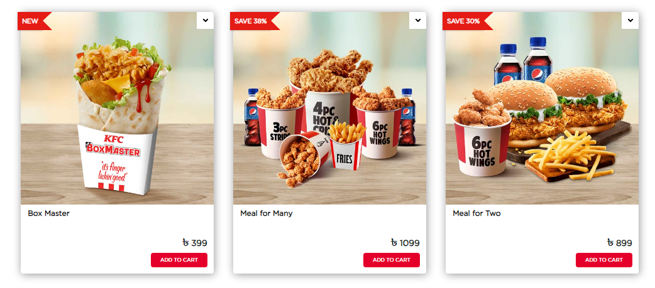
Source : KFC Bangladesh menu showing rice-based meals and family bucket offerings adapted to local culture
3.2.2 Price
The purchasing power and positioning between the two markets are also different hence their pricing strategies are very different. KFC in the UK uses competitive pricing and it is in the mid-range segment. An average meal is also priced in such a way that it is affordable and gives a value when compared to the competitors (KFC UK, 2024). Price sensitivity is also commonly dealt with through promotional offers, promotional discounts via apps, and loyalty programmes especially during times of inflation (DMA, 2024). In Bangladesh, prices are relatively high as compared to the average income levels but are lower than in absolute terms. A typical meal is a huge percentage of the expendable income, and KFC is a luxury option instead of a place to buy regularly (Bangladesh Bureau of Statistics, 2022). Such a premium pricing aids the brand in the aspirational positioning but restricts the expansion of the market penetration (Khanna and Palepu, 2010).
3.2.3 Place (Distribution)
KFC UK has a very fine and widespread distribution network with high-street stores, drive-throughs, and delivery oriented stores (KFC UK and Ireland, 2025). Collaborations with the delivery services contribute to increased accessibility and omnichannel approach (DMA, 2024). Distribution in Bangladesh is selective distributed in urban centers. The outlets have been located in high end shopping malls and commercial centres which are based on the logistical constraints as well as strategic positioning (Transcom Foods Ltd, 2025). Delivery is also offered, but it is associated with the problems of traffic congestion and the lack of infrastructure (Hossain and Rahman, 2022).
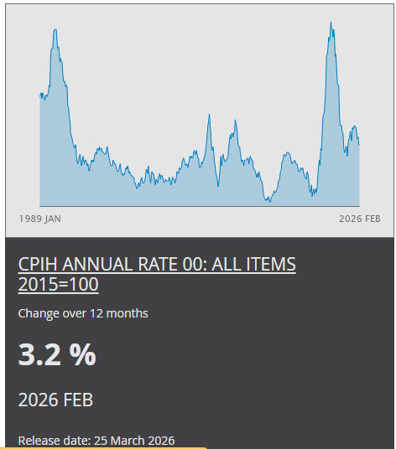
Source: UK inflation trends affecting consumer purchasing power
3.2.4 Promotion
KFC UK is the promoter that employs a unique promotional strategy that is marked with the use of humour and cultural relevance. In most cases, campaigns aim to use social media and digital marketing channels to appeal to consumers (DMA, 2024). The style of communication adopted by the brand fits the cultural setup of the Britons who prefer to be witty and self-conscious.
Promotional techniques in Bangladesh are focused on social bonding and emotion. The campaigns concentrate on family events, festivals, and experiences, especially during research of Ramadan and Eid (Transcom Foods Ltd, 2025). Facebook is one of the social media platforms that are crucial in accessing younger audiences (Rahman and Khondker, 2020).
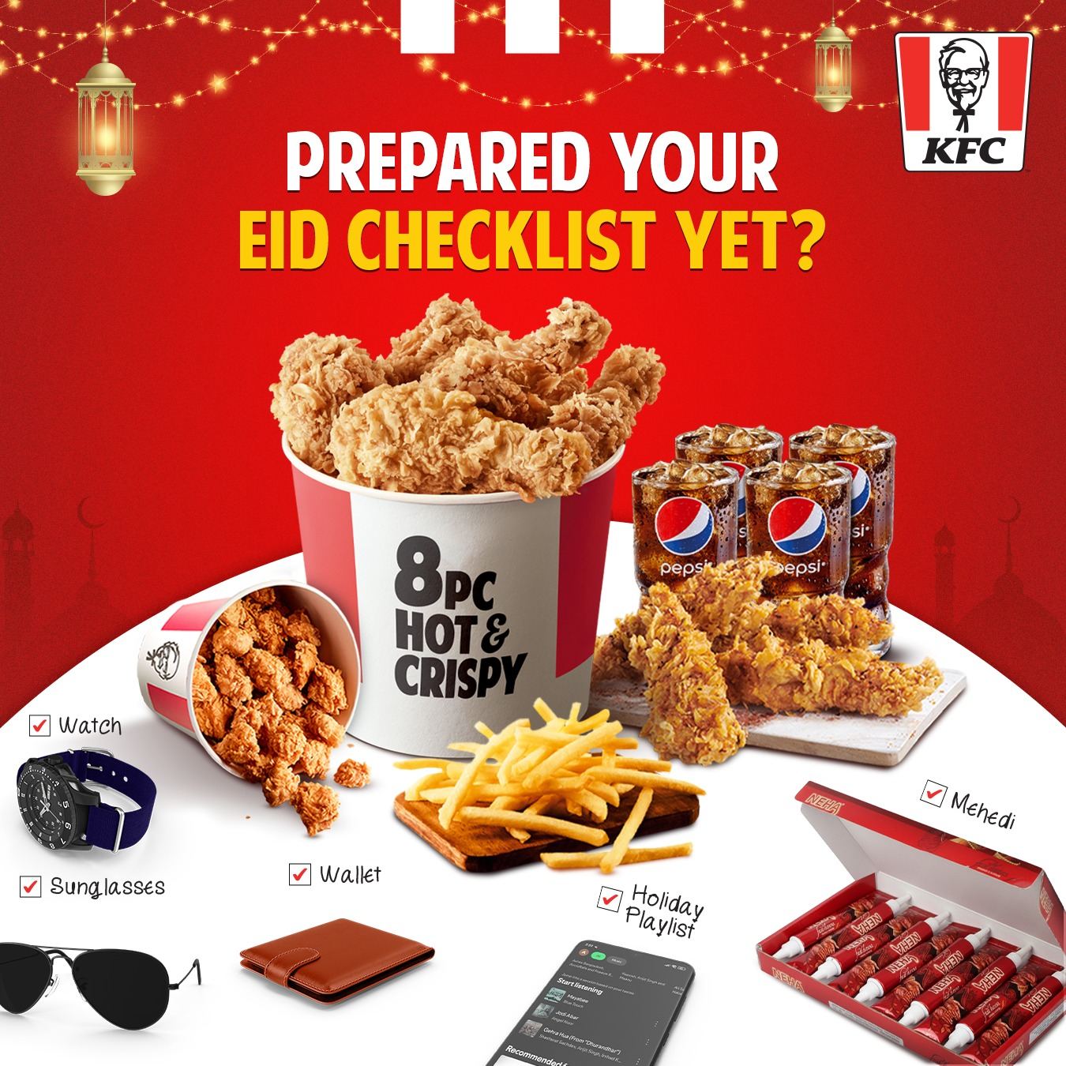
Source: KFC Bangladesh Ramadan promotional campaign focusing on family and communal dining
3.2.5 People
Efficiency and consistency are taught to the staff in a rapid environment in the UK. The service dealings are simplified, as consumers tend to prefer quick and convenient services (Jobber and Ellis-Chadwick, 2020).
Bangladesh services are more personalised. The cultural norms presuppose attentive and hospitable communication and the staff contributes to providing a high-quality dining experience (Hofstede Insights, 2024). The crucial competencies are language skills and cultural awareness.
3.2.6 Process
The UK has operational processes that focus on efficiency, and technology is used to promote it (e.g., self-service kiosks and mobile ordering systems) (DMA, 2024). These systems save time on waiting and enhance throughput.
Group dining and cash transactions are also modified to fit in the processes in Bangladesh. The service flows are focused on the experience and flexibility, but not on speed, which is associated with local consumer behaviour (Siddiqui, 2021).
3.2.7 Physical Evidence
Store design in the UK is standardised and functional, which promotes high turnover of customers and efficiency in operation (KFC UK, 2024).
Physical spaces are created to support high positioning in Bangladesh. The outlets have comfortable seats, contemporary designs, and friendly family designs, a contrast to the rest of the urban setup (Transcom Foods Ltd, 2025). Physical environment is also essential in consumer perceptions and driving brand experience overall (Hossain and Rahman, 2022).

4.0 Bangladesh Directional Development Strategy.
The strategy applied by KFC in Bangladesh can be examined through Growth Matrix created by Ansoff and the Uppsala internationalisation model (Ansoff, 1957; Johanson and Vahlne, 1977; 2009).
The KFC venture in Bangladesh in 2006 is also the form of market development strategy where an existing line of products is being launched to a new geographical market (Ansoff, 1957). Whereas the main service will be identical, localisations like rice meals, spicy flavours, and Halal will be accommodated of the product development in the new market (Johnson et al., 2017). This integrated strategy aids in effective growth in cultures that are distant (Doyle, 2008).
The company got to Bangladesh with a franchise deal with Transcom Foods Ltd using the local expertise and infrastructure (Transcom Foods Ltd, 2025). Franchising fits the markets whose institutions are complex to enable firms to mitigate the risk but gain local knowledge (Root, 1994; Hollensen, 2020). This collaboration made it possible to navigate through the regulatory system, obtain a site, and comply with operations (Safargholi et al., 2024).
Conversely, KFC UK has a more centralized corporate control, which means that there is less uncertainty in the market (Johanson and Vahlne, 2009).
The expansion of KFC can be explained by the Uppsala model as it starts with similar cultural markets such as the UK, and then it moves to even farther countries such as Bangladesh (Johanson and Vahlne, 1977). This transition was made easy by experience and partnerships (Johanson and Vahlne, 2009).
Due to a high demand, KFC Bangladesh has grown to 46 locations, and it has a huge market share (Transcom Foods Ltd, 2025; P&S Intelligence, 2025). The strategy of expansion into urban areas and local product innovation should be the target of the future (Hossain and Rahman, 2022; Aziz and Afzal, 2021).

5.0 Marketing mix of KFC ethical issues.
The ethical aspects of the KFC operation apply to both markets but they are exhibited differently based on how the regulatory system and the institutional maturity of the two countries.
5.1 Supply chain and Animal welfare Ethics.
The most salient ethical issue in the UK is the one associated with animal welfare. NGOs like Sustain have alleged that KFC is not adequately enforcing the Better Chicken Commitment (BCC) soon enough as it is still relying on fast growing chicken strains which have gross welfare problems (Sustain, 2023; Burrows, 2025). This brings out an inherent conflict between the cost effectiveness demanded by the high-volume, competitively priced product approach, and the aspirational welfare norms represented in corporate sustainability reports (Crane and Matten, 2020). Food safety and quality control are the key issues of supply chain ethics in Bangladesh. The penalties of the Bangladesh Food Safety Authority on the KFC stores regarding the use of unapproved ingredients and incorrect labeling (2024) demonstrate the lack of compliance between the international corporate requirements and the local operational practice. The latter can be partially explained by the nature of the challenges in the process of ensuring standardised procedures in a weak supply chain in an environment with haphazard regulatory application to the market (Siddiqui, 2021).
5.2 Environmental Ethics
The high-volume disposable-packaging service model has generated high environmental externalities in both markets to KFC. In the UK where consumer awareness and regulatory pressure on packaging waste and carbon emission is at its peak, KFC has already been on record with sustainable packaging and carbon reduction in line with Yum! Brands' global targets (Yum! Brands, 2023). Nevertheless, critics claim that these promises are not enough considering environmental contradictions of the fast-food form of business (Fletcher, 2014). Environmental awareness among the consumers in Bangladesh is relatively low and there is inconsistency in the enforcement of the environmental standards by the regulatory bodies. The plastic waste management and sustainable sourcing practices are some of the last aspects in which KFC Bangladesh performs poorly compared to its UK counterpart, but this is in part due to the larger institutional environment and not the failure of the company (Clean Clothes Campaign, 2023).
5.3 Ethics of Culture and Marketing.
The advertising of the consumption of western fast-food in Bangladesh poses some moral conditions concerning the power of culture and food influence. The violent advertisement of calorie-rich food stuffs to people who have been traditionally dependent on conventional diets can help amend the dietary trends with long-term social health consequences (Schor, 2004). In addition, the aspirational upward positioning of KFC within the low-income nation could lead to the emergence of consumption desires that were inaccessible to most citizens, posing a challenge to the concept of luxury consumption manufactured in the economically disparate societies as socially responsible (Crane and Matten, 2020).
5.4 Compliance Ethics about Regulations.
The comparison of the ethical performance of KFC in the two markets is an example of a larger problem facing multinational enterprises the ability to sustain similar ethical practices within an institutional setting with significantly different enforcement capabilities. Though KFC UK is a firm with a strong regulatory regime, which imposes product compliance, the less robust enforcement regime in Bangladesh leaves the company with the responsibility of self-governing, and the 2024 food safety infractions indicate that this has not been a consistent factor (The Business Standard, 2024). On the positive side, KFC has contributed significantly in both markets in the area of CSR. In the UK, the initiative to support communities affected by food poverty by the partnership with FareShare, which provides food redistribution, has provided more than three million meals (KFC UK Sustainability, 2025). The Bangladesh case of the so-called ShopnerPathshala program, where KFC stores will be used as classrooms at off-peak periods in order to provide children in underprivileged groups with education, covers the gaps in the institutions (Transcom Foods Ltd, 2025). Nevertheless, the initiatives of this kind should be critically considered in relation to the above-identified operational ethical deficiencies that may lead to a confusion of the philanthropic activity with the systemic ethical compliance (Crane and Matten, 2020).
6.0 Recommendations
On the basis of the comparative analysis, the following recommendations can be offered to enhance the international marketing strategy at KFC in the two markets:
6.1 Enhance Supply Chain in Bangladesh.
KFC ought to adopt the use of blockchain-based supply chain traceability to allow real-time confirmation of the origin of the ingredients, Halal, and food safety standards. This would directly fill the compliance gap that was unveiled by the regulatory fines in 2024 and would strengthen the consumer confidence in a highly uncertain avoidance market (The Business Standard, 2024; Hofstede Insights, 2024).
6.2 Fast-track Animal Welfare Promises in the UK.
KFC UK ought to shorten the switch to slower-growing chicken breeds and might contemplate the implementation of a Premium Welfare Range to overcome the ethical concerns of organisations like Sustain (Sustain, 2023; Burrows, 2025). This would position the product concept in line with the advanced ethical demands of the British customers and help to reduce the reputational risk.
6.3 Hyper-Local Supply Chain Development in Bangladesh.
KFC ought to consider investing in contract farming relationships with local producers of chicken in Bangladesh, to support geographic growth into tier-two cities, with technical training to attain global quality standards domestically (Hossain and Rahman, 2022). This lessens dependence on imports, cushions against fluctuations in the exchange rates and generates common economic value among the locals.
6.4 Raise Investments in E-Commerce infrastructure in Bangladesh.
With the increasing pace of mobile internet penetration, KFC Bangladesh must create a localised e-commerce platform with the support of the Bengali language, a mobile-first design, and payment via cash on delivery to reach more markets than the high-end mall locations (Siddiqui, 2021; Hossain and Rahman, 2022).
6.5 Improve UK Sustainability Communications.
KFC UK needs to enhance greater openness and external audits of its sustainability reporting so as to counteract consumer scepticism on greenwashing. Circularity commitments would be demonstrated through the introduction of evident in-store recycling programmes and take-back schemes (Yum!). Brands, 2023; Fletcher, 2014).
6.6 Implement the Tiered Pricing in Bangladesh.
Entry level menu functions and the creation of smaller portion sizes at affordable price-points may help KFC create more markets to serve in Bangladesh without sacrificing the positioning of the high-end brand. These introductory products could be supported by local sourcing efficiencies due to contract farming, which was able to reduce prices (Khanna and Palepu, 2010).
7.0 Conclusion
As this comparative analysis has shown the international marketing approach at KFC is typified by dynamism in the relationship between global standardisation and local adaptation. KFC is a well-established mass-market brand with a highly competitive, heavily regulated and digitally advanced QSR environment in the United Kingdom. The main strategic issues relate to consumer price sensitivity caused by inflation, the cost of compliance with the regulations, ethical questioning of the animal welfare practice, and the necessity to meet sustainability expectations. KFC has a very different strategic position in Bangladesh as a high growth, aspiration brand in a premium segment in an emerging economy. The obstacles are unique here institutional voids, continuity of quality throughout a delicate supply chain, Halal compliance, and control of the cultural and moral aspects of high-end positioning in a low upkeep economy.
The PESTEL and Hofstede analyses will show that social and cultural forces are most decisive forces of strategic divergence. The conversion of the British consumer culture of individualism and convenience to the Bangladeshi consumer culture of collectivism, trust and family will require radical changes on all aspects of the marketing mix: products and pricing structure, advertising communication, service planning and the physical space. The directional development analysis shows that KFC Bangladesh is in the right position to develop aggressively in the market as long as supply chain integrity and quality control are upheld as the geographic expansion takes place. Through the ethical analysis, we can see a contradiction that is typical of most multinational companies in that, in as much as promotional messages and corporate social responsibility enacted by KFC is that the company cares about the welfare of the business community, there is operational reality that does not converge with the promotional messages and the actions taken to ensure that the business operates with a sense of responsible conduct, such as the failure of the UK animal welfare and the non-compliance with food safety standards in Bangladesh. Supply chain transparency, expedited welfare undertakings, and authentic institutional investments in the two markets will be critical in closing this gap to ensure that the KFC brand stands firm over long in a global marketplace that is becoming more ESG-focused.
SECTION 2: REFLECTIVE ACCOUNT
Reflective Account Gibbs Reflective Cycle (1988)
1.0 Description
The given reflective report analyses the steps of researching, analysing, and writing the comparative report on the international marketing strategy of KFC in the United Kingdom and Bangladesh. The assignment involved utilisation of various academic models such as PESTEL, cultural dimensions as developed by Hofstede, STP, the 7ps marketing mix and the Growth Matrix formulated by Ansoff to discuss an international QSR brand available in two markets that are inherently different. The study was carried out in a number of weeks and it utilized a variety of sources, such as the articles of academic journals, corporate annual reports, governmental statistics, industry publications and the sources expert in the field as well in order to provide evidence-based analysis.
2.0 Feelings
The first feeling that I had was excitement and nervousness. The comparative aspect between a developed Western market and a developing South Asian economy was an interesting intellectual challenge on my part, as I was actually interested in analysing a brand that I have consumer familiarity with, KFC. I was, however, concerned about the depth of the work, especially the need to incorporate several analytical systems into a consistent argument and, at the same time, be critical.
One of the issues was the Bangladesh market. I was aware of the danger of cultural generalisation and I aimed to base my analysis on primary academic sources instead of shallow descriptions in the secondary sources. That is why I have extensively used the dimensions data provided by Hofstede, publications by Bangladesh Bureau of Statistics, and peer-reviewed articles on South Asian consumer behaviour (De Mooij, 2019; Aziz and Afzal, 2021). I gained confidence as the research went on and some distinct comparative patterns became evident, especially, when I could draw theory frameworks and theoretical frameworks to the observed strategic choices, such as when I could relate the dimension of collectivism to KFC stimulating Family Buckets and communal eating areas in Bangladesh.
3.0 Evaluation
There are a number of areas in which the process was effective. The PESTEL model offered a more formal macro-level base, based on which the more detailed STP and 7Ps analyses could be rationally built. It was a top-down method of analysis, as suggested by Hollensen (2020) which made it possible to place marketing mix decisions in the context of wider institutional and environmental drivers instead of talking about them in isolation.
The ethical analysis part was a challenging and rewarding experience. The uncovering of the 2024 food safety fines inflicted upon KFC Bangladesh forced me to go beyond the corporate sustainability discourses and to question the disparity between the advertisement statements and the facts of the business (The Business Standard, 2024). This gave a true critical depth to the report.
Nevertheless, some areas of improvement were realized. The first mistake I made was not realizing the challenge of locating strong academic sources that focused on the operations of KFC in Bangladesh and the available data was mostly journalistic or corporate in type, with few being peer-reviewed. Commencing with more systematic use of academic databases like Emerald Insight and Business Source Complete would have been more efficient in the literature search. Furthermore, initial determinations of the 7ps segment were too descriptive and I had to undergo a huge amount of revision to make sure that every aspect was offering real comparative analysis and not a parallel description.
4.0 Analysis
This was a great experience that taught me the necessity of using theoretical frameworks critically and not mechanically. The analytical usefulness of the PESTEL and 7Ps frameworks is that of identifying interconnections rather than systematic categorisation of information. To give an example, the realization that the high uncertainty-avoidance (social factor) in Bangladesh contributes as well to consumer readiness to pay a premium on internationally certified hygiene quality (a pricing and positioning decision) can be seen as an example of how the macro-environmental factors shift onto more specific marketing mix decisions (Johnson et al., 2017).
The Uppsala internationalisation model was interesting in terms of explaining how KFC has been systematically internationalising, especially its soft entry into the UK and network-enhanced entry into Bangladesh (Johanson and Vahlne, 1977; 2009). This theoretical application helped me better realize that psychic distance does not only have a geographic aspect but also linguistic, religious, institutional, and cultural aspects.
Based on the experiential learning cycle developed by Kolb (1984), concrete experience (reading about the Bangladesh food safety violations) triggered reflection observation on the structural tensions of the franchise-dependent multinational operations, which was followed by an abstract conceptualisation of the phenomenon of compliance gap, and active experimentation of the specific strategic recommendations to be employed to handle it.
5.0 Conclusion
I believe this assignment has also helped me enhance my appreciation of the practical aspects of international marketing in depth. Now I also understand that successful global marketing policy goes way beyond the process of merely translating a home-based strategy into foreign markets; it involves a complete re-thinking of consumer desires, cultural practices, and institutional structures, and ethical obligations. These complexities were especially helpful in revealing the comparative approach because the analysis of a single brand in two such radically different markets rendered the need to adapt the strategy in a strategic manner empirically apparent instead of being purely theoretical.
6.0 Action Plan
Moving forward, I intend to:
- Stronger research basis of future research studies, at the beginning of the research, systematic literature searches should be carried out in various academic databases, so that the analysis is based on an extensive and credible evidence basis.
- Be more critical in writing regularly, by actively engaging in the evaluation rather than description, especially by posing the question, why does this matter? and "so what is the strategic implication? during the drafting.
- Transfer these abilities to my future profession by gaining more confidence in applying strategic models, including CAGE and the Diamond created by Porter, to evaluate international market opportunities and risks in the real-life business context, particularly when working in marketing and brand management positions.
Reference List
Ansoff, H.I. (1957) 'Strategies for diversification', Harvard Business Review, 35(5), pp. 113–124.
Aziz, S. and Afzal, M.N.I. (2021) 'Consumer perceptions of international fashion brands in Bangladesh: A qualitative exploration', South Asian Journal of Business Studies, 10(2), pp. 198–215.
Bangladesh Bureau of Statistics (2022) Statistical Yearbook of Bangladesh 2022. Dhaka: Ministry of Planning, Government of Bangladesh.
Bangladesh Telecommunication Regulatory Commission (2023) Annual Report 2022–2023. Dhaka: BTRC.
BBC News (2018) 'KFC: How did the chicken cross the road?', BBC News, 20 February. Available at: https://www.bbc.co.uk/news/business-43151physiqu (Accessed: 15 March 2025).
Burrows, D. (2025) 'KFC hides stats on slower-growing birds', Foodservice Footprint. Available at: https://foodservicefootprint.com/ (Accessed: 13 January 2026).
Clean Clothes Campaign (2023) Fashioning Justice: Towards Living Wages in the Global Garment Industry. Amsterdam: Clean Clothes Campaign.
Crane, A. and Matten, D. (2020) Business Ethics: Managing Corporate Citizenship and Sustainability in the Age of Globalization. 5th edn. Oxford: Oxford University Press.
De Mooij, M. (2019) Consumer Behavior and Culture: Consequences for Global Marketing and Advertising. 3rd edn. London: Sage Publications.
Dhingra, S., Huang, H., Ottaviano, G., Pessoa, J.P., Sampson, T. and Van Reenen, J. (2017) 'The costs and benefits of leaving the EU: Trade effects', Economic Policy, 32(92), pp. 651–705.
DMA (2024) KFC UK Marketing Challenge Brief 2024. Available at: https://dma.org.uk/ (Accessed: 13 January 2026).
Doyle, P. (2008) Value-Based Marketing: Marketing Strategies for Corporate Growth and Shareholder Value. 2nd edn. Chichester: John Wiley & Sons.
Fletcher, K. (2014) Sustainable Fashion and Textiles: Design Journeys. 2nd edn. London: Routledge.
Future Startup (2025) You Are What You Eat: Bangladesh Food and Health Report 2025. Available at: https://futurestartup.com/ (Accessed: 13 January 2026).
Ghemawat, P. (2007) Redefining Global Strategy: Crossing Borders in a World Where Differences Still Matter. Boston: Harvard Business School Press.
Gibbs, G. (1988) Learning by Doing: A Guide to Teaching and Learning Methods. Oxford: Further Education Unit, Oxford Polytechnic.
HM Revenue and Customs (2018) Soft Drinks Industry Levy. London: HMRC. Available at: https://www.gov.uk/guidance/soft-drinks-industry-levy (Accessed: 15 March 2025).
Hofstede Insights (2024) Country Comparison Tool. Available at: https://www.hofstede-insights.com/country-comparison/ (Accessed: 20 March 2025).
Hollensen, S. (2020) Global Marketing. 8th edn. Harlow: Pearson Education.
Hossain, M.K. and Rahman, S. (2022) 'The emergence of modern retail in Bangladesh: Trends, challenges and opportunities', International Journal of Retail and Distribution Management, 50(6), pp. 701–720.
Information Commissioner's Office (2023) Guide to the UK General Data Protection Regulation (UK GDPR). Available at: https://ico.org.uk (Accessed: 19 March 2025).
International Monetary Fund (2023) World Economic Outlook: Bangladesh. Washington, DC: IMF.
Jobber, D. and Ellis-Chadwick, F. (2020) Principles and Practice of Marketing. 9th edn. London: McGraw-Hill Education.
Johanson, J. and Vahlne, J.-E. (1977) 'The internationalization process of the firm: A model of knowledge development and increasing foreign market commitments', Journal of International Business Studies, 8(1), pp. 23–32.
Johanson, J. and Vahlne, J.-E. (2009) 'The Uppsala internationalization process model revisited: From liability of foreignness to liability of outsidership', Journal of International Business Studies, 40(9), pp. 1411–1431.
Johnson, G., Whittington, R., Scholes, K., Angwin, D. and Regnér, P. (2017) Exploring Strategy: Text and Cases. 11th edn. Harlow: Pearson Education.
Katsikeas, C.S., Leonidou, L.C. and Zeriti, A. (2020) 'Revisiting international marketing strategy in a digital era', International Marketing Review, 37(3), pp. 405–424.
KFC UK (2024) Modern Slavery Act Statement 2024. Available at: https://www.kfc.co.uk/ (Accessed: 13 January 2026).
KFC UK and Ireland (2025) 60th Anniversary Report: The Economic and Community Impact of KFC in the UK. London: Yum! Brands. Available at: https://brand-uk.assets.kfc.co.uk/ (Accessed: 13 January 2026).
KFC UK Sustainability (2025) Our Responsibility. Available at: https://www.kfc.co.uk/our-responsibility (Accessed: 13 January 2026).
Khanna, T. and Palepu, K.G. (2010) Winning in Emerging Markets: A Road Map for Strategy and Execution. Boston: Harvard Business Press.
Kolb, D.A. (1984) Experiential Learning: Experience as the Source of Learning and Development. Englewood Cliffs, NJ: Prentice Hall.
Kotler, P., Keller, K.L., Ang, S.H., Tan, C.T. and Leong, S.M. (2022) Marketing Management: An Asian Perspective. 15th edn. Harlow: Pearson Education.
Mintel (2023) Eating Out Review — UK — 2023. London: Mintel Group Ltd.
Office for National Statistics (2024) Consumer Price Inflation, UK. Available at: https://www.ons.gov.uk (Accessed: 18 March 2025).
P&S Intelligence (2025) Bangladesh Quick Service Restaurants (QSR) Market Size and Share Analysis 2025–2032. Available at: https://www.psmarketresearch.com/ (Accessed: 13 January 2026).
Public Health England (2020) Restricting Promotions of Products High in Fat, Sugar and Salt by Location and by Price. London: PHE.
Rahman, M.M. and Khondker, H.H. (2020) 'Digitisation and changing consumer culture in Bangladesh', Asian Journal of Social Science, 48(3–4), pp. 296–318.
ResearchGate (2024) The Fast-Food Culture in Bangladesh: A Study on Youth Health Risks. Available at: https://www.researchgate.net/ (Accessed: 13 January 2026).
Root, F.R. (1994) Entry Strategies for International Markets. Revised edn. San Francisco: Jossey-Bass.
Safargholi, M., Rezaei, S. and Moghavvemi, S. (2024) 'The role of global marketing strategies on the internationalization of SMEs', International Marketing Review, 41(2), pp. 312–338.
Schor, J.B. (2004) Born to Buy: The Commercialized Child and the New Consumer Culture. New York: Scribner.
Siddiqui, K. (2021) 'International fashion retail in Bangladesh: Market dynamics and strategic challenges', Journal of International Consumer Marketing, 33(4), pp. 412–430.
Statista (2023) Digital Market Outlook: United Kingdom. Available at: https://www.statista.com (Accessed: 19 March 2025).
Sustain (2023) KFC's Aggressive Tactics to Undermine Councils' Health Policies Exposed. Available at: https://www.sustainweb.org/ (Accessed: 13 January 2026).
The Business Standard (2024) 'KFC among 3 food outlets fined in Ctg for food safety violations', The Business Standard, 23 September. Available at: https://www.tbsnews.net (Accessed: 13 January 2026).
Transcom Foods Ltd (2025) Dominant Leader in Bangladesh's Restaurant Industry. Available at: https://www.transcombd.com/ (Accessed: 13 January 2026).
UK Government (2019) Climate Change Act 2008 (2050 Target Amendment) Order 2019. London: HMSO.
World Bank (2023a) Bangladesh Development Update: Recovery and Resilience. Washington, DC: World Bank.
World Bank (2023b) World Development Indicators. Available at: https://data.worldbank.org (Accessed: 18 March 2025).
Yum! Brands (2023) Global Citizenship and Sustainability Report 2023. Louisville, KY: Yum! Brands, Inc.
Transcom Foods Ltd (2025) KFC Bangladesh Menu. Available at: https://kfcbd.com/menu (Accessed: 27 March 2026).
KFC Bangladesh (2025) Facebook promotional campaigns. Available at: https://www.facebook.com/KFCBangladesh (Accessed: 27 March 2026).
Office for National Statistics (2024) Consumer price inflation, UK. Available at: https://www.ons.gov.uk (Accessed: 27 March 2026).

