STRATEGY ASSIGNMENT
REPORT

Strategic Capability- Apple

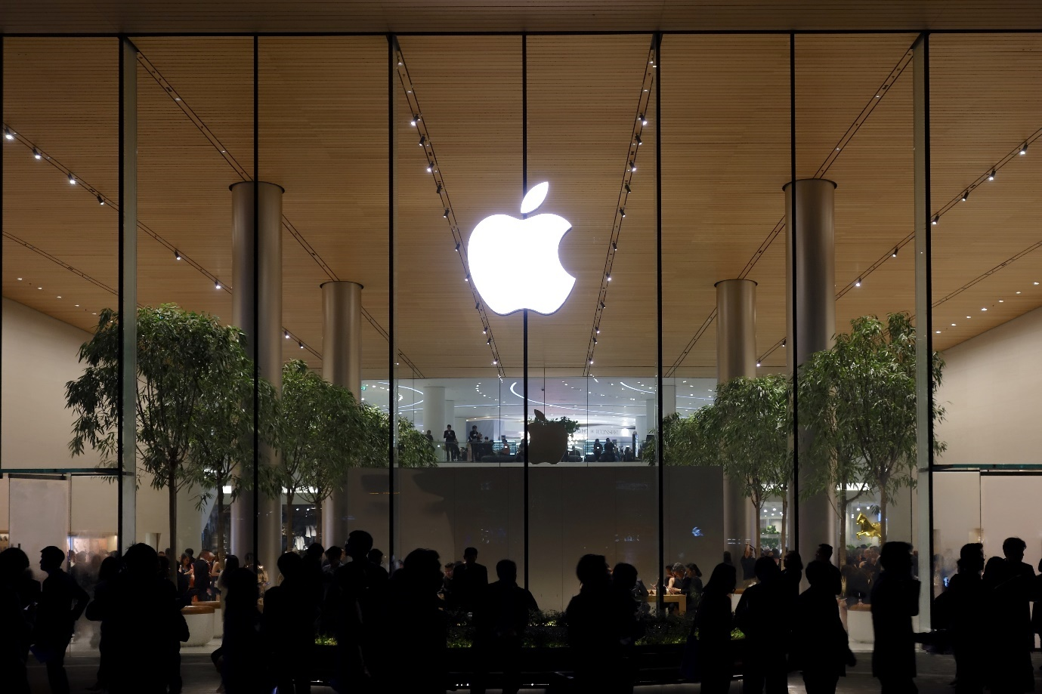

Iuliana Roxana Bocanet
2019733

Table of contents
Contents
Executive Summary 3
1.0 Introduction 4
2.0 Findings- Task 1-3 5
3.0 Conclusion/Strategic Options 23
Appendices 25
Reference List 31

Executive Summary
This paper has examined Apple's present strategy through the lens of industry models and frameworks for strategic management, delving into both internal and external environmental issues. The research concludes that Apple's present approach allows a durable competitive advantage and identifies differentiation as a strategy for the company. It then offers suggestions to further establish Apple as the market leader. It also examines the benefits and drawbacks of the models and frameworks that were employed. The findings suggest that Apple's focus on innovation and design has allowed it to maintain a strong position in the market, but also highlight the need for continuous adaptation to evolving consumer preferences and technological advancements. The report recommends that Apple continue to invest in research and development, as well as strategic partnerships, to stay ahead of competitors. Additionally, it emphasizes the importance of reassessing and adjusting the company's strategy in response to changes in the industry landscape. By following these recommendations, Apple can further solidify its position as a leader in the tech market. While investing in research and development is important, Apple must also address labour and environmental concerns to preserve a positive brand image and consumer trust. Staying ahead of competition may not be enough without ethical considerations.

1.0 Introduction
This report is intended for the CEO of Apple organisation was requested on the 8th of February 2024 and was created to conduct a strategic analysis and evaluation of Apple's strategic capability. In order to identify the organization's prospective areas of strength and development, the researcher will employ a diverse range of models and tools as methodologies. The researcher will utilize a variety of models and tools as techniques to identify the areas of strength and future areas for improvement within the organisation. These will be applied to critically evaluate how and why the company has reached its current strategic performance. Finally, the generated conclusion will outline the areas of strength and future areas for improvement within the organisation’s strategy.

2.0 Findings- Task 1-3
Task 1
Historical development of Apple
Apple Inc. was set up in 1976 by Steve Jobs, Steve Wozniak, and Ronald Wayne, who demonstrated that it is possible to launch a multi-billion-dollar international corporation from a garage (Cristoph, 2023). They were able to successfully launch Apple I with the support of Armas Clifford "Mike" Markula. A few weeks later, Wayne made the decision to withdraw from the project shortly because he was not prepared to assume the risk that was involved. On October 5, 2011, Steve Jobs passed away, marking the end of an era for Apple (Griggs, 2011).
On January 29, 2019, Apple disclosed in its quarterly earnings report that iPhone sales had declined, yet the company continued to generate billions in revenue. This was partly due to the sustained popularity of other products such as the iPad and Apple Watch, as well as services provided to existing customers. Apple unveiled the 7th-generation iPad on March 18, 2019, as part of a new product development strategy ( Cristoph, 2022). The 10.5-inch iPad Air features the A12 Bionic CPU, delivering performance that surpasses previous models by 70% and doubles the graphics capabilities. Additionally, the iPad Mini has seen a tripling in performance alongside the introduction of a larger display (Cristoph, 2022).
Specialised in the design, manufacture, and marketing of mobile communication and media devices, personal computers, and portable digital music players, Apple is well known for its sleek design and user-friendly technology (Apple annual report, 2023). The company also provides a wide variety of related software, services, accessories, networking solutions, and third-party digital content and applications. Apple Inc. has developed into a worldwide technology corporation known for its innovative products and services, which encompass the iPhone, iPad, Mac computers, and Apple Watch. From the iconic iPhone to the innovative Apple Watch, the company has revolutionized the way people communicate, work, and entertain themselves. With a dedication to quality and customer satisfaction, Apple continues to lead the industry in innovation and creativity, with a strong focus on design and user experience, becoming one of the most valuable companies in the world.

Apple’s strategic development 2019-2024
According to Dyson et.al (2007), strategic development is the process of harmonising many components of an organisation in order to improve long-term performance. This includes efficiently managing financial resources, expanding organisational capacities, and cultivating a competitive culture.
Over the last five years, Apple has been primarily focused on product innovation, expansion into new markets and regions, sustainability, and strengthening customer ties through service and ecosystem growth. One of the primary objectives of the organisation is their commitment on nurturing innovation an essential element for any technology company, which is further supported by Apple's possession of various creative, brand, and process patents. In order to solidify its position as one of the market leaders, particularly in rapidly evolving markets, Apple places significant emphasis on continuously innovating and improving both existing and new product offerings. The company employs its design and development expertise to provide consumers with an innovative operating system, apps, and a secure location to store their digital content. Apple created operating systems that integrates hardware and software to satisfy users who prefer simple tools for creating, editing, and sharing digital content. Apple also stands out for developing customised applications to fulfil user needs and a digital content ecosystem that simplifies access to music, videos, and software for customers.
The iPhone, the first model in Apple's iOS-based smartphone series, was a game-changer because of its touch screen. Customers' devotion to the Apple brand has not wavered since Steve Jobs' passing away, and the company's steady stream of fresh products and services has kept them coming back for more. The new iPhone 15 series, Apple Watch Series 8, and Apple Watch Ultra 2 are among the new Apple products that were launched in 2023. Other upcoming products include three new Macs, Home Pod, and a brand-new device called Vision Pro. Apple released macOS Sonoma and iOS 17 to the public later that month. After that, on October 30, Apple held a presentation where they unveiled new variants of the iMac and MacBook Pro (Haslam, 2024).

Apple’s Vision and Mission statements
The vision and mission statements of Apple are fundamental components that provide guidance for the organization's strategic trajectory and decision-making procedures. In addition to defining Apple's aspirations and objectives, these statements provide a strategic plan for the company to attain enduring prosperity and sustainability. An examination of Apple Inc.'s vision and mission statements can provide significant knowledge regarding the organization's fundamental principles, focal points, and dedication to pioneering advancements.
Mission Statement
“Bringing the best user experience to customers through innovative hardware, software, and services.”- Apple claims that their mission is to "create innovative products that consumers love to use, whilst generating development and learning opportunities for employees and financial and social returns for their shareholders" (Apple Inc., 2020).

Apple’s Vision statement
“To make the best products on earth and to leave the world better than we found it.“ Apple’s vision is to focus on developing the best products in the world and leading the digital music and photography revolutions Apple Inc., 2020).

Owners of the organisation
Apple had several owners over the years, including Steve Jobs and the experienced businessperson Mark Markkula. Markkula made Apple into a well-established company and its success can be recognised in the way it operates today (Gallagher, 2023) . The company operates as a parent entity and is not part of a larger organizational group, but it manages and coordinates activities within its individual business segments. Over time, Apple has changed ownership through company acquisitions and takeovers, and it currently owns and operates other companies (Podolny & Hansen, 2020).

Apple Inc. Annual Report 2022
The financial statements for the fourth quarter of the fiscal year 2022 reveal notable revenues of $394.3 billion accompanied by expenses amounting to $295.5 billion. Apple, the preeminent corporation in terms of profitability within the United States of America, attained an enormous profit. Subsequently, the organisation surged to a net profit of $99.8 billion, representing a growth of 73% from 2020 and 5.4% from 2021 (Apple Inc. Annual report, 2022) :
-Revenue: A record $90.1 billion, up 8% year over year.
-Earnings per Diluted Share (EPS): $1.29, up 4% year over year.
-Active Installed Base: Reached an all-time high for all major product categories.
-CEO Tim Cook’s Statement: Emphasized Apple’s commitment to innovation, environmental protection, user privacy, and creativity.
-CFO Luca Maestri’s Comment: Despite economic challenges, Apple invested in growth, generated significant operating cash flow, and returned value to shareholders.
-Dividend: Apple declared a cash dividend of $0.23 per share of common stock, payable on November 10, 2022.

Apple Inc. Annual Report 2023
Apple's fiscal 2023 quarterly revenue amounted to $94.8 billion, marking a 3% decrease from the previous year. In spite of the economic downturn, Apple's iPhone sales hit a new quarterly high, and the business saw record-breaking revenue from services. The number of active Apple devices hit a level that had never been seen before. The company also gave more than $23 billion to its shareholders and had strong working cash flow throughout the quarter. The board of directors gave the company more money to buy back shares ($90 billion more), and for the eleventh year in a row, they raised the quarterly payment. Overall, Apple demonstrated its resilience and strategic focus amidst the dynamic nature of the industry (Apple reports second quarter results, 2023).

- Quarterly Revenue: $94.8 billion (down 3% year over year)
- Earnings per Diluted Share: $1.52 (unchanged year over year)
- Operating Cash Flow: Strong operating cash flow of $28.6 billion
- Shareholder Returns: Over $23 billion returned to shareholders during the quarter
- Dividend: The board of directors authorized an additional program to repurchase up to $90 billion of the Company’s common stock, and the quarterly dividend was increased by 4% to $0.24 per share

Apple’s market share
IDC unveiled alarming data regarding the share of the smartphone market in 2023. Apple is the leading smartphone manufacturer. Apple has an "all-time high market share" for 2023, according to IDC, and "the number one spot annually for the first time ever." This, according to the research company, signifies "a sort of power shift" in the smartphone industry (IDC, 2024).
Apple has achieved a record market share of 20.1% in 2023, marking a growth of 3.7% from the previous year. Samsung has slipped to second place with a 13.6% decline, resulting in a 19.4% share. Xiaomi's share has decreased by 4.7%, bringing them to 12.5%, while Oppo has fallen by 9.9% to hold 8.8% of the market. Transsion, though less known, has seen a significant rise of 30%, now owning 8.1% of the market" (Amadeo, 2024). - See Fig.1
Despite the challenges posed by the COVID-19 pandemic, Apple’s iPhone sales remained resilient. While fluctuations in quarterly revenue are common, Apple’s strong sales in the fourth quarter of each year contribute to its overall success. The iPhone continues to dominate the premium smartphone market, accounting for 62 percent of sales in the first quarter of 2022 (Apple Inc.,2022). In the fourth quarter of 2023, Apple claimed a 24.7 percent share of the global smartphone market, which was an increase from the previous quarter. This growth solidified Apple’s position as a major player in the industry. Interestingly, Samsung, a long-time competitor, ranked first with a market share of 16.3 percent (Apple Inc., 2023).

Apple’s major financial stakeholders- See Fig. 6 and 7
Although at times characterised as combative, Steve Jobs' leadership significantly influenced the trajectory of the organisation. Additionally, the current leadership team is renowned in the field, diverse, and possesses experience.

- Internal stakeholders

- Leadership team (U.S. Securities and Exchange Commission, 2023):

- Arthur Levinson owns 4,590,409 shares as of January 9, 2023. Levinson joined Apple in 2000 and has served as chair of the board since 2011 . As a director, Levinson has been a part of the board's audit and finance, pay, and nominating and corporate governance committees
- Tim Cook holds 3,279,898 Apple shares, 0.02% of the total. Following Steve Jobs' passing in 2011, Cook assumed the role of Chief Executive Officer at Apple
- Apple Chief Operating Officer Jeff Williams holds 677,392 Apple shares. He manages Apple's global operations, Apple Watch, and health projects.

- Employees

Main shareholders
Around 20% of Apple's basic stock is held by the top three institutional investors as of January 9, 2023. The Vanguard Group, BlackRock Inc. and Berkshire Hathaway Inc are among its most prominent institutional owners (Cliffe, 2023) . According to U.S. Securities and Exchange Commission (2023):

- Vanguard Group possesses over 1.25 billion Apple shares, which accounts for 7.96% of the total company inventory.
- BlackRock Inc. holds 1.02 billion Apple shares, representing 6.44 percent of the company's total,
- Berkshire Hathaway Inc. owns a billion Apple shares, indicating 5.73% of total shares outstanding

- External stakeholders
Apple's key external stakeholders include customers, suppliers, competitors, pressure organisations, local communities, and the government.

Task 2
Strategic Analysis- Models

- SWOT Analysis of Apple- See Fig. 2

Implementing this approach allows for strategic decision-making aligned with the company's strengths. It assesses the company's ability to innovate products, attract new customers, adopt innovative production methods, and build a robust value chain. Moreover, it aids in pinpointing risks that could threaten the company's stability.
Strengths
An important feature of Apple's is the customisation and creativity of its products. This has helped the company gain worldwide recognition and establish itself as the most valuable brand in the world, with an estimated $241.2 billion in 2020 (Swant, 2020) according to Forbes. In 2021 Apple was exceeded by Microsoft holding a market valuation of $2.887 trillion (Reporter, 2024). Company's sales continue to boost by its stellar reputation for innovation, outstanding design, excellent user experience, and quality (Saul, 2023).

Weaknesses
Despite the sustained high demand for Apple's products, the company's prices remain elevated and are projected to rise further as a result of worldwide inflation (Kelly, 2023).
Opportunities
According to Tim Cook, Apple is devoting a great deal of resources to AI research since it is a revolutionising technology. There has been much speculation that Apple's next iOS 18 may introduce groundbreaking AI features that will transform Siri, Messages, and other Apple products. Anticipation grows as AI integration could spread to Apple Music, Pages, and Xcode, enriching the whole OS experience. Siri's upgrade with vast language models aims to streamline complex tasks and bolster Shortcuts app constructive collaboration (Clover, 2024).

Threats
Apple risks becoming irrelevant and losing market share if it fails to fulfil its customers' ever-changing needs and preferences. Grennille (2022) emphasises the need of adapting to latest trends and approaches for the brand.

- PESTLE Analysis of Apple- See Fig. 3
Apple Inc.'s strategic development is a multifaceted approach that has enabled it to remain at the forefront of the technology industry. This report incorporates a PESTLE Analysis to provide a comprehensive overview of the external factors influencing Apple's business strategies.

Political
Supply chains for Apple's most recent iPhone lineup disrupted due to Covid restrictions in China. The assembly facility of the organization located in Zhengzhou, central China, operated at reduced capacity, therefore the company announced that they expect fewer shipments than expected (Madhok, 2022). Apple adapts to trade policies and regulations in complex global political settings. To avoid tariffs and maintain supply, Apple moved some product manufacture out of China during the US-China trade dispute (Lau, 2020).

Economical
Apple's financial resilience enables it to invest in research and development, as well as market expansion, even amidst fluctuating economic conditions. For instance, during the escalation of the US-China trade war, Apple was compelled to navigate increased tariffs on its products and seek alternative suppliers to mitigate potential supply chain disruptions. Large corporations like Apple may invest in critical suppliers to ensure the continuity of essential components. An example of this is Apple's investment in Corning for the development of iPhone glass (Washington & James, 2020).

Social
Apple's brand is deeply integrated into society, emphasising the comprehension and fulfilment of consumer preferences and requirements. Apple has developed a variety of devices that increase the variety of health and wellness resources accessible to Apple Watch, iPad, and iPhone users, with the goal of increasing awareness of mental health and encouraging individuals to take charge of their own health (Desai, 2023).
Technological
Innovation is at Apple's core, with continuous advancements in technology driving its product development. Apple's strategy revolves around maximizing tech scalability. By refining ideas, they have pioneered new directions, facing obstacles. Apple's blueprint was to turn tech advances into major impacts, focusing on boosting performance and cutting costs for deep tech influence (Zaman, 2023)
Legal
Apple requires strict compliance with legal standards globally, which shapes its operational and strategic decisions otherwise the company may face significant repercussions. Apple's $85 billion services industry may face legal challenges due to upcoming regulatory judgements from US and EU authorities. It has been revealed that Google paid in excess of $26 billion in 2021 to secure its position as the default search engine on Apple devices, as well as on other smartphones and web browsers (Acton, 2024).

Environmental
The commitment to sustainability is evident in Apple's goal to become carbon neutral by 2030, influencing its production processes and supply chain management. Apple is actively collaborating with its global supply chain partners to advance its transition to carbon-neutral operations. In pursuit of its 2030 target, Apple has achieved a 40 percent reduction in emissions since 2015. This significant decrease is attributed to enhanced energy efficiency, low-carbon product design, achieving carbon neutrality in corporate operations, and steering its supply chain towards the use of renewable electricity (Apple Newsroom, 2024).

Porter’s Five Forces Model of Apple- See Fig. 4
Apple's thorough strategic planning and rigorous growth strategies cover all aspects of the company's operations, including pricing and marketing. Porter’s Five Forces Model is an excellent generic framework which can help the organisation analyse and understand the competitive environment. It outlines the options available in its quest of market supremacy in the consumer electronics and information technology/services industries. According to Porter's Model, Apple's competitive strategy is differentiation, which entails promoting the features that distinguish its items from those of competitors such as Samsung, Google (Alphabet), Microsoft, and Sony (Maverick, 2023). Apple distinguishes itself from its competitors by modern technology rather than pricing. Its goal is to captivate customers by creating an exquisite brand with visually appealing and intuitive products.
Companies such as Apple, Google, and Samsung promote innovation in the smartphone business by developing new features and technology, as well as focusing on tactics for differentiation to stand out in the market. With the exception of Google, suppliers have limited bargaining power. Market titans like Apple, Samsung, and Huawei have significant power over their smaller competitors. Major corporations' standards reduce suppliers' bargaining leverage. The fact that suppliers are unable to integrate forward suggests a lack of control. Furthermore, buyers' negotiating power is increasing as a result of improved access to product information, comparison tools, and online reviews, allowing them to make more educated purchasing decisions. This strengthens market competition. However, other elements contribute to balance buyer power. For example, the rising cost of switching as users become more familiar with operating systems and applications reduces buyer influence. As a result, product quality and reputation must be priced accordingly in order to address trade concerns. New smartphone competitors, on the other hand, do not constitute a serious threat due to high beginning costs and a variety of regulatory barriers, including rigorous consumer, environmental, safety, and product restrictions. Established businesses invest much in marketing, innovation, and customer service to improve their brand image. Different regions, such as North America, Asia-Pacific, and Europe, provide distinct opportunities with different business models, customer preferences, and regulatory frameworks, influencing the strategies of smartphone companies operating in these regions (Apple Inc., 2023). However, the sector's tough nature inhibits new enterprises from entering it. Tablets have a minimal risk of product replacement because they have a similar user interface, applications, and functions as smartphones. In addition to their entertainment and computing functions, tablets can be used as communication devices. Tablets have larger screens than smartphones, but they provide few advantages in terms of processing power, camera quality, and general functionality. Despite the industry-wide difficulty of similar designs, smartphone makers differentiate their devices by incorporating advanced camera technology, artificial intelligence integration, and design advancements to stand out in the market (Podolny & Hansen, 2020). This lack of difference among existing brands opens the door for new competitors to disrupt the market by providing innovative features, personalised services, and competitive pricing tactics, regardless of their initial brand reputation or product quality. Several reasons contribute to the fierce rivalry in the smartphone market. Established businesses must focus innovation and client retention in order to overcome stagnating demand. Apple, Samsung, and Huawei are in debt as they boost their R&D budgets (Malik, 2022). Brand loyalty drives competitiveness because successful firms keep loyal customers. Companies compete to provide innovative items that outperform each other, targeting the same demographics in the same regions. As a result, being the first to overcome interruption provides a major competitive advantage, even with minor pricing adjustments. Smartphone manufacturers must consider the fact that purchasers perform extensive research before making a purchase. Brand loyalty is extremely necessary in this market because educated consumers tend to stay loyal. Despite the increased threat of disruption, the industry's competitiveness persuades demand for unique products. Apple, known for pioneering technologies such as Face ID and Siri, maintains a competitive advantage in the market by continually inventing and setting new industry standards with their products (Podolny and Hansen, 2020).

BCG Matrix of Apple- See Fig. 5
With the implementation of the BCG Matrix, Apple is able to categorise its products as either having low growth, high growth, or high sales but low growth and referring to them as Stars, Cash Cows, Dogs, and the Question Mark.
In this case, The iPhone can be categorised as a “Star” because despite facing intense competition, the iPhone maintains a commanding market share and is seeing robust annual growth (Hilliard, 2022).
The Mac Computer series goes into the “Cash Cow" category with a substantial market share and a secure market position, generating Apple substantial profits (Apple inc.,2022).
It is possible to classify the iPad as a "Dog" due to its low market share and growth potential (Brax, 2024).
The Apple TV, which is not as popular as some of Apple's other products, could use some investment in research and development to become more recognised and potentially dominate the market (Apple TV app, n.d.) .
By employing the BCG Matrix to assess Apple's product portfolio, strategic decision-making can be enhanced. Prominent products from Apple, including the Mac (Cash cow), the iPhone (Star), sustain the company's dominant market position and generate significant revenue. Question mark products, such as the Apple TV presents opportunities for expansion.
Based on Mintzberg’s schools of strategic thought (1989), Apple’s strategy has elements from various schools. For instance:
- Design School: Apple’s focus on creating unique, user-friendly products aligns with this school.
- Positioning School: Their emphasis on market positioning and differentiation.
- Learning School: Apple’s iterative approach, learning from failures, and adapting to changing tech landscapes.
- Entrepreneurial School: Steve Jobs’ visionary leadership and disruptive innovations.

Task 3- Advantages and disadvantages of current strategy
A company's global strategy can be described as its method of engaging in international markets with the aim of leveraging global opportunities while maintaining robust leadership at the central headquarters. When a company embraces a global strategy, it exposes itself to a wealth of opportunities, as it can selectively identify and exploit trends across various markets. The benefits of this approach include size, market synergy, and cost and resource sharing. An effective worldwide strategy embraces product consistency, broad product portfolios, and flexibility to exploit changing market situations, according to different writers. However, multinational business executives may struggle to reconcile these diverse viewpoints (Ghoshal, 1987). Global strategy disadvantages originate from worldwide operational perspectives. Experts propose product standardisation, vast product assortments, adaptability, and arbitrage. Lack of a framework to harmonise opinions and recommendations makes it unclear what a 'global' strategy is (Ghoshal, 1987) . Apple has effectively executed this approach by acquiring and developing its worldwide operations, overseen by its centralized headquarters, and offering its standardized products globally. However, the downside of a global strategy is that it subjects the company to additional unwanted risk factors, such as political instability. Apple CEO Tim Cook highlighted December quarter revenue increase powered by iPhone sales and a 2024 Services revenue record, demonstrating strategic capacity: “As customers begin to experience the incredible Apple Vision Pro tomorrow, we are committed as ever to the pursuit of groundbreaking innovation — in line with our values and on behalf of our customers” ( Apple, 2024).

3.0 Conclusion/Strategic Options

Task 4
Conclusion
Based on the analysed models which comprise SWOT, PESTLE, 5 Forces Porter’s Generic, BCG and Stakeholder analysis, the strategy so far adopted by Apple leads to extraordinarily successful outcomes. There should be long-term investments in technology, research and development, and human resources to ensure the workforce and the organization are equipped to meet the challenges. The analysis highlights the diverse factors that Apple strategically navigates. Its initiative-taking approach in addressing these areas ensures Apple's sustained growth and industry leadership- See Fig. 8.
Apple should undertake a comprehensive examination of market trends and consumer demand in order to arrive at well-informed investment decisions regarding these product categories. Consistent investment in these products is imperative for their continued expansion and advancement. However, strategic decision-making is essential for increasing market share and maximising profits. The BCG model accentuates the organisational objective of investing in emerging opportunities and sustaining a well-balanced portfolio of market-leading products. Continuous innovation, whether it is creating new products or improving current range, is important.
Strategic planning needs adaptive recommendations to succeed, and it is what makes a modern business's marketing strategy complete and unique.
Overall, Apple organisation's SWOT analysis highlights the company's strengths, weaknesses, opportunities, and threats. By leveraging its strengths, addressing weaknesses, and capitalizing on opportunities, Apple can sustain its position as a leading brand in the technology industry and continue to drive innovation and growth. Brand loyalty plays a significant role in the smartphone market, and a company that can capture an informed customer is likely to retain them. However, competition is fierce, and the need for differentiated products is growing. Therefore, a company that can introduce a state-of-the-art innovation will have an advantage over its competitors.

Appendices
Fig.1
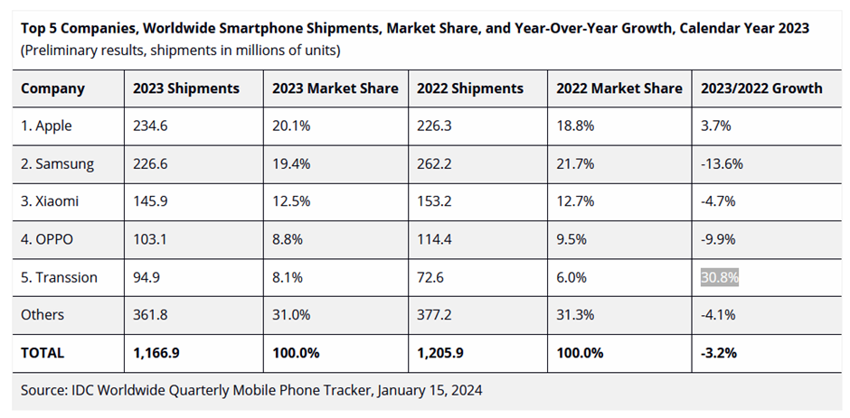
Fig. 2
Fig.3

Fig.4
Apple’s Porter Five Forces Analysis
Threat of substitute products- Moderate- Tablets can rival or replace smart phones- similar features, capabilities, and design. Tablet’s larger screens are a downside, but they can focus on computing. New alternatives are needed because differentiation is becoming tough and most models have resembling characteristics.

Threat of new entrants- Low-
Elevated production expenses; Multiple models in each category, meaning there are many possible alternatives; The regulatory environment in specific countries could be an impediment

Competitive rivalry- High-Attention has shifted to innovation and customer retention as customer demand has levelled out. The loyalty of consumers to brands is often rather high. It is imperative that smartphone manufacturers consistently innovate.
Bargaining power of suppliers- Low- The size and financial strength of suppliers are typically lower than that of smartphone producers.
Must adhere to quality standards, restricting negotiation stance.
Inability for suppliers to integrate forward

Bargaining power of buyer- Moderate- Increased competition; Customers are presented with a variety of choices;

Fig.5
BCG Matrix- Apple

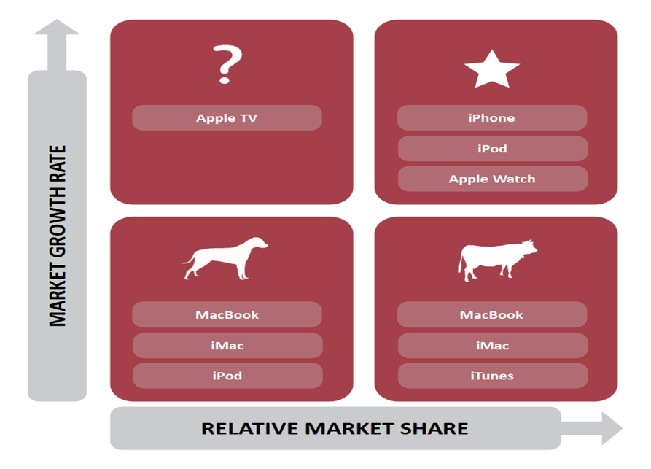
Fig.6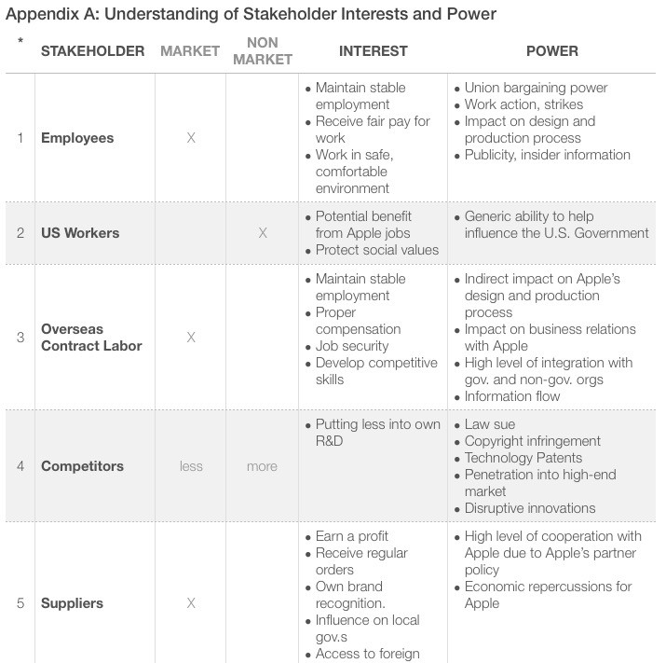

Fig.7
Stakeholders Analysis- Apple
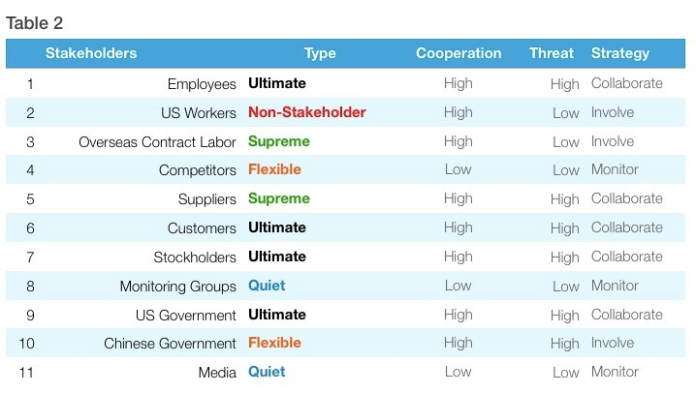

Fig. 8
Apple’s Growth
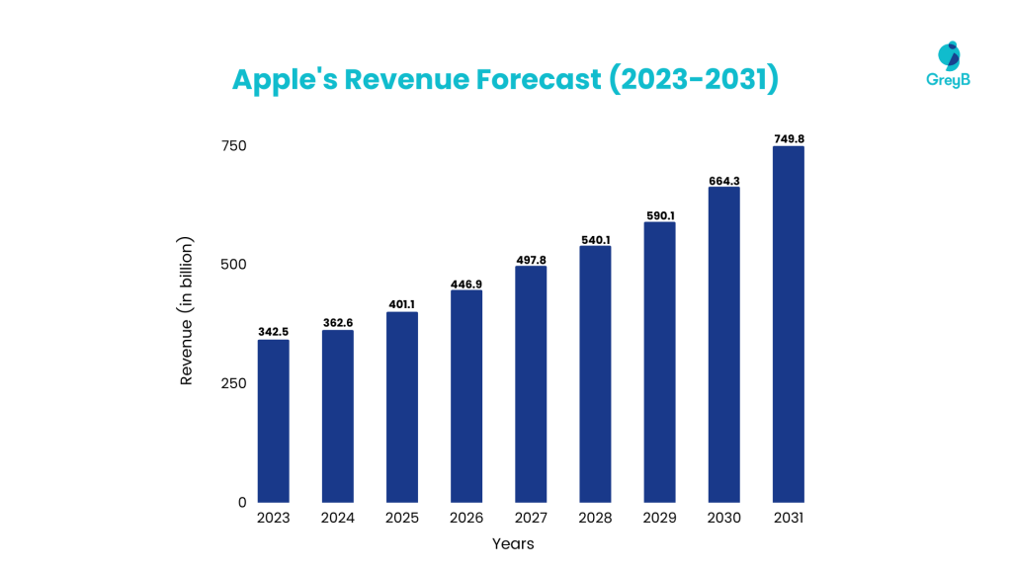

Reference List
Acton, M. (2024) Apple’s $85bn-a-year services business faces legal reckoning. Available at: https://www.ft.com/content/0f2fba8b-612e-4a27-80e0-ad3c3e5f47eb, Accessed: 15.03. 2024

Amadeo, R. (2024) Apple hits “all-time high” smartphone market share, takes #1 spot for 2023, Ars Technica. Available at: https://arstechnica.com/gadgets/2024/01/apple-hits-all-time-high-smartphone-market-share-takes-1-spot-for-2023/., Accessed 12.03.2024

Appendix A, https://teletype.in/files/21/21849f44-c19f-456d-a1e1-fd9fb4745e70.jpeg, Accessed 14.03.2024

Apple annual report, 2023, Form 10-K, United States, Securities and Exchange Commission, Washington, D.C.20549https://www.sec.gov/Archives/edgar/data/320193/000032019323000106/aapl-20230930.htm#i1cb1ba018cb1455aa66bd3f9ab0c5b1a_1499, Accessed 10.03.2024

Apple calls on global supply chain to decarbonize by 2030 (2024) Apple Newsroom. Available at: https://www.apple.com/newsroom/2022/10/apple-calls-on-global-supply-chain-to-decarbonize-by-2030/., Accessed 14.03.2024

Apple Inc. Annual meeting of shareholders and Proxy statement (2023) Apple Inc. Available at: https://d18rn0p25nwr6d.cloudfront.net/CIK-0000320193/ebbd88bb-cc8f-4e1e-8d5e-a52f8f780b94.pdf ,Accessed 15.03.2024

Apple Inc. Annual report (2020), https://www.apple.com/newsroom/2020/10/apple-reports-fourth-quarter-results/, Accessed 10.03.2024

Apple Inc. Annual report (2022) https://s2.q4cdn.com/470004039/files/doc_financials/2022/q4/_10-K-2022-(As-Filed).pdf. Available at: https://s2.q4cdn.com/470004039/files/doc_financials/2022/q4/_10-K-2022-(As-Filed).pdf., Accessed 12.03.2024

Apple reports first quarter results (2024) Apple Newsroom, Available at: https://www.apple.com/newsroom/2024/02/apple-reports-first-quarter-results/., Accessed 12.03.2024

Apple reports second quarter results (2024) Apple Newsroom. Available at: https://www.apple.com/newsroom/2023/05/apple-reports-second-quarter-results/., Accessed 12.03.2024

Apple TV app (no date) Apple (United Kingdom). Available at: https://www.apple.com/uk/apple-tv-app/., Accessed 12.03.2024

Brax, J. (2024) Apple’ s Sleek and Slim iPad Pro and iPad Air Models Set to Debut, Techable.com Tech Center. Available at: https://news.techable.com/rumors-apples-sleek-and-slim-ipad-pro-and-ipad-air-models-set-to-debut/., Accessed 10.03.2024

Christoph (2022) Timeline – The history of Apple (2010 – 2020) - Mac History, Mac History. Available at: https://www.mac-history.net/2022/12/15/timeline-the-history-of-apple-2010-2020/., Accessed 14.03.2024

Christoph, 2023, Timeline: The history of Apple since 1976 - Mac History, Mac History. Available at: https://www.mac-history.net/2022/12/16/timeline-the-history-of-apple-since-1976/., Accessed 10.03.2024

Cliffe, C. (2023) Who are Apple’s largest shareholders? available at: https://www.ig.com/uk/trading-strategies/who-are-apples-largest-shareholders-200630#information-banner-dismiss, Accessed 13.03.2024

Clover, J. (2024) Apple Spending a “Tremendous Amount of Time and Effort” on AI, Details Coming “Later This Year,” MacRumors. Available at: https://www.macrumors.com/2024/02/01/apple-ai-details-coming-later-this-year/., Accessed 12.03.2024

Desai, S. (2023) Apple provides powerful insights into new areas of health. Available at: https://www.apple.com/uk/newsroom/2023/06/apple-provides-powerful-insights-into-new-areas-of-health/, Accessed 15.03. 2024

Dyson, R.G. & Bryant, James & Morecroft, John & Brien, Frances. (2007). The Strategic Development Process. Supporting Strategy: Frameworks, Methods, and Models, Accessed 14.03.2024

Gallagher, W. (2023) Apple was founded 47 years ago, on April 1, 1976, AppleInsider. Available at: https://appleinsider.com/articles/20/04/01/apple-was-founded-44-years-ago-on-april-1-1976., Accessed 14.03.2024

Ghoshal. (1987). Strategic management journal 8 no. https://onlinelibrary.wiley.com/doi/abs/10.1002/smj.4250080503, Accessed 15.03.2024

Grennille, A. (2022) Evolving Disruptions and Shifting Consumer Preferences Underline B2C Trends In 2022, Hanover Research. Available at: https://www.hanoverresearch.com/insights-blog/evolving-disruptions-and-shifting-consumer-preferences-shape-2022-for-b2c-brands/?org=corporate., Accessed 13.03.2024

Haslam, K. (2024) New Apple Products 2024: Upcoming Apple product releases, Macworld. Available at: https://www.macworld.com/article/671090/new-apple-products.html., Accessed 14.03.2024

Hilliard, W. (2022) iPhone dominates premium smartphone market with 62% of sales in Q1 2022. Available at: https://appleinsider.com/articles/22/06/23/iphone-dominates-premium-smartphone-market-with-62-of-sales-in, Accessed 15.03.2024

IDC (2024) Apple Grabs the Top Spot in the Smartphone Market in 2023 along with Record High Market Share Despite the Overall Market Dropping 3.2%, According to IDC Tracker. Available at: https://www.idc.com/getdoc.jsp?containerId=prUS51776424 , Accessed 14.03. 2024

Kelly, G. (2023) Apple iPhones, iPads And MacBooks Are Getting More Expensive, Forbes. Available at: https://www.forbes.com/sites/gordonkelly/2023/01/25/iphone-ipad-macbook-pricing-apple-prices-worldwide-2023/., Accessed 14.03.2024

Lau, L. J. (2020). The Impacts of the Trade War and the COVID-19 Epidemic on China-U.S. Economic Relations. China Review, 20(4), 1–38. https://www.jstor.org/stable/26959852, Accessed 13.04.2024

Madhok, D. (2022) Apple expects iPhone 14 shipments to be hit by China’s Covid curbs, CNN Business. Available at: https://edition.cnn.com/2022/11/06/business/china-covid-iphone-14-shipments-hit-hnk-intl/index.html, Accessed 14.03. 2024.

Malik, M. A. R., 2022. Critical Analysis of Huawei and Apple in the view of Expert Opinion, Financial Performance and Customers' perspective. Journal of Marketing Management.jmm-net.com, Accessed 13.03.2024

Maverick, J.B. (2023) Analysing Porter&#39;s 5 Forces on Apple (AAPL), Investopedia. Available at: https://www.investopedia.com/articles/investing/111015/analyzing-porters-five-forces-apple.asp,
Accessed 14.03.2024

Mintzberg, H. (1989) The Structuring of Organizations. doi:10.1007/978-1-349-20317-8_23, Accessed 15.03.2024

Podolny, J.M. and Hansen, M.T. (2020) How Apple Is Organized for Innovation, Harvard Business Review. Available at: https://www.apple.com/careers/pdf/HBR_How_Apple_Is_Organized_For_Innovation-4.pdf , Accessed 15.03. 2024

Reporter, G.S. (2024) Microsoft beats Apple as most valuable company for first time in two years, the Guardian. Available at: https://www.theguardian.com/technology/2024/jan/12/microsoft-apple-world-valuable-company-stock-market?ref=upstract.com, Accessed 13.03.2024

Saul, D. (2023) Apple Hits $3 Trillion Market Value—And Could Soar Another $800 Billion, Forbes. Available at: https://www.forbes.com/sites/dereksaul/2023/06/30/apple-hits-3-trillion-market-value-and-could-soar-another-800-billion/., Accessed 10.03.2024

Swant, M. (2020) The World’s most valuable brands, Forbes. Available at: https://www.forbes.com/the-worlds-most-valuable-brands/#3cbba5de119c, Accessed: 14.03. 2024
Table 2, https://teletype.in/files/b7/b7874549-69f0-48b0-b12a-bb9807fb1e2e.jpeg, Accessed 14.03.2024

U.S. Securities and Exchange Commission. "Apple, Inc., Schedule 14A, Definitive Proxy Statement, Jan 12, 2023, Pages 31, 99, https://d18rn0p25nwr6d.cloudfront.net/CIK-0000320193/ebbd88bb-cc8f-4e1e-8d5e-a52f8f780b94.pdf, Accessed 12.04.2024

U.S. Securities and Exchange Commission. "Apple, Inc., Schedule 14A, Definitive Proxy Statement, Jan 12, 2023, Pages 40, 99, https://d18rn0p25nwr6d.cloudfront.net/CIK-0000320193/ebbd88bb-cc8f-4e1e-8d5e-a52f8f780b94.pdf, Accessed 14.03.2024

Washington, & James. (2020). Risk resilience and rebalancing in global value chains. http://dln.jaipuria.ac.in:8080/jspui/bitstream/123456789/14300/1/Risk-resilience-and-rebalancing-in-global-value-chains-full-report.pdf, Accessed 13.03.2024

Zaman, R. (2023) Apple’s Innovation Strategy - creating and monopolizing - THE WAVES, THE WAVES. Available at: https://www.the-waves.org/2022/03/04/apples-innovation-strategy-creating-and-monopolizing/., Accessed 12.03.2024

