BLOG POST ON FERARRI

Marketing Fundamentals
Assignment 1

MODULE: LCBB4004

Lecturer: Tushara Balendran

Name:Luca Gerardi

Student ID :2219573

Table of Contents
Background/history of the company 3
Product 3
Price 5
Place 5
Promotion 6
Reference List 8

Background/history of the company
One of the most admired manufacturers of luxury sports cars in the world is Ferrari. Enzo Ferrari is the founder of the company. In 1947, the corporation made its public debut. Ferrari unveiled a V12 engine in 1945, which went on to become one of its trademarks. The first Ferrari model, the “125 S or 125 Sport”, did not leave the factory door of the “Via Abetone Inferiore in Maranello”, Italy, until 1947, more than ten years after Enzo exist Alfa (autosprint,2022). The first Ferrari showroom and dealership in the United States was established by racing driver Luigi Chinetti at the beginning of the 1950s. Now one of the most recognisable brands that have participated in races all over the world and earned more than 5,000 awards.
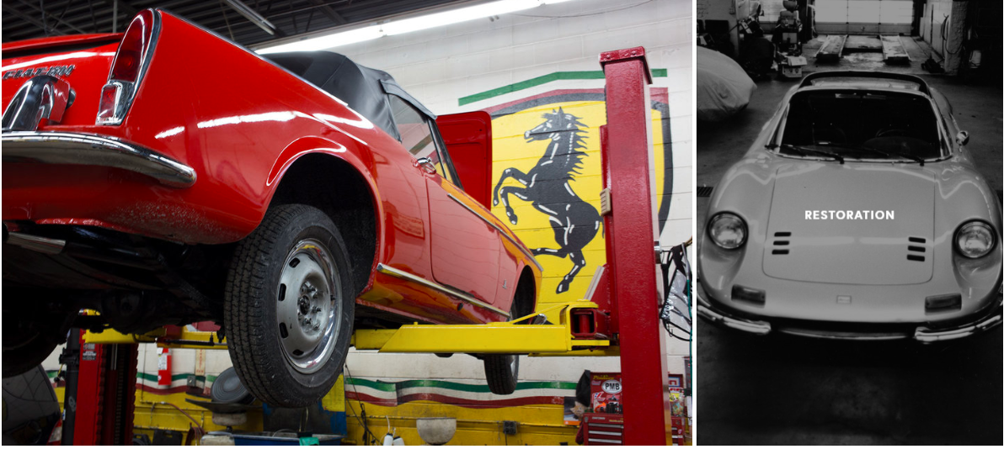
Figure 1: History
(Source: autosprint,2022)
The mission of Ferrari is to steadily boost customer productivity by integrating systems. For the workflow of the future, they consider unified communications and smart business are crucial. They want to help their clients to help use their resources as efficiently as possible (Ferrari electronic, 2022).

Product
A complete list of Ferrari cars includes 3, 5 and 6-cylinder models of every shape and size (ferrarilakeforest, 2022). It is the first in Italy to use twin-turbocharged V12 engines. The following 4-thumbnails of Ferrari cars are confirmed:
“Type: F12 Berlinetta”
“Power: 730 hp at 8,250 RPM”
“Torque: 509 lb-ft at 6,000 RPM”
“Top Speed: 211 mph”
“0-62 mph: 3.1 seconds”
“Transmission: 7-speed dual-clutch with shortened gear ratios”
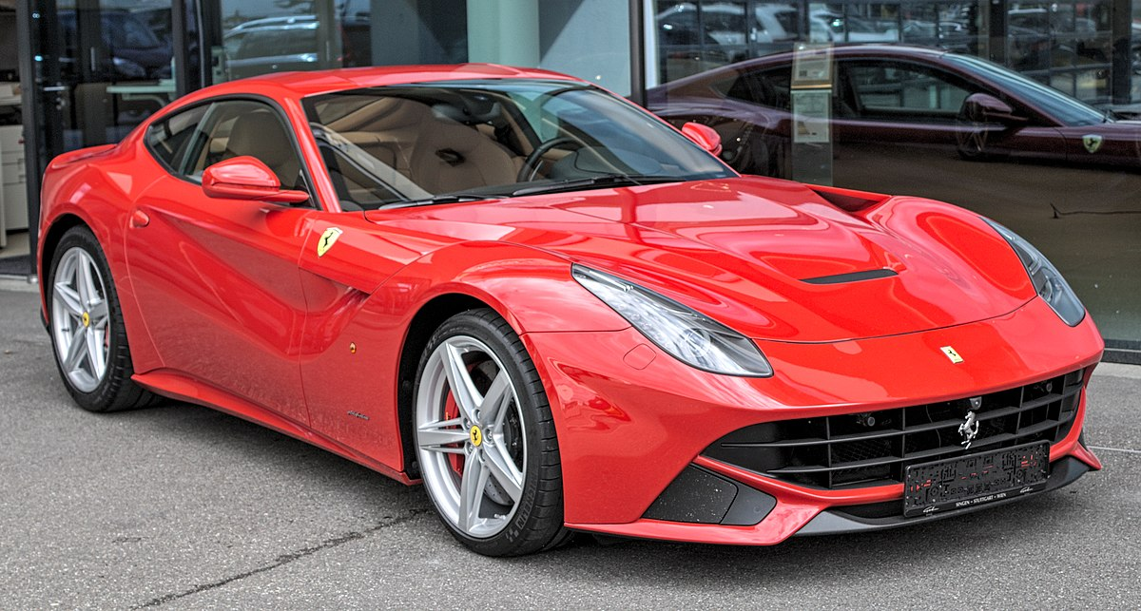
Figure 2: F12 Berlinetta
(Source: Ferrari, 2022)

Other products are:
“Type: 488 GTB”
“296 GTS”
“812 Competizione”. “812 Competizione A”
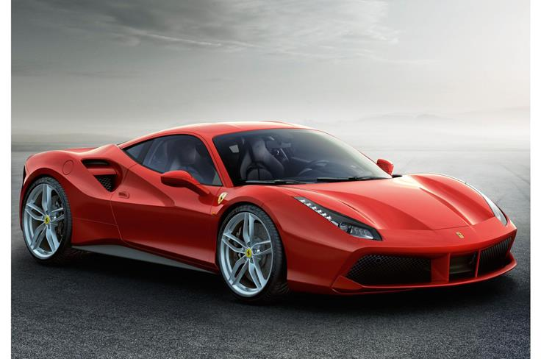
Figure 3: 488 GTB
(Source: Ferrari, 2022)

Price
Ferarri uses a Premium pricing strategy to create a premium image for its brand.
The price of the F12 Berlinetta is around £169,000 to £239,995 (AutoTrade, 2022)
Other cars' prices like the 488 GTB is varied from £152,500 to £164,950 (AutoTrade, 2022)
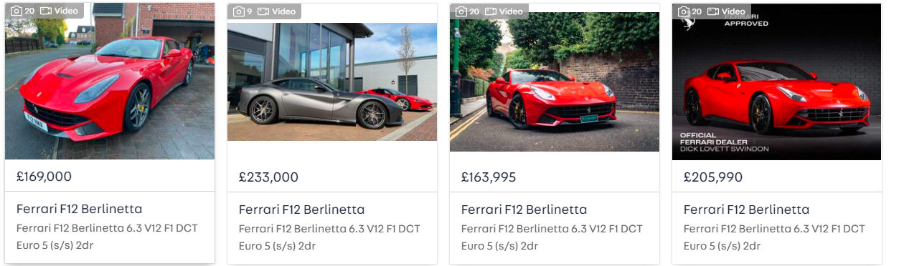
Figure 4: Price
(Source: AutoTrader, 2022)

Place
Ferrari has been invented in Maranello, Italy and slowly it take place across the world. The company operates in the UK, US, Dubai and more.
Yas Indoor World the largest theme park is situated in the centre of the intriguing Yas Island which is also the first Ferrari-branded theme park in the world. Barcelona also has a theme park where Europe’s tallest rollercoaster is placed.
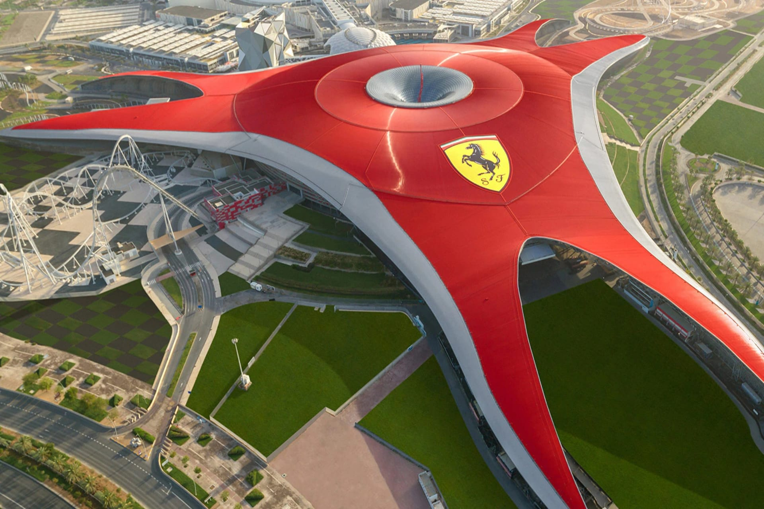
Figure 5: Ferrari World
(Source: Ferrari, 2022)
Also, Ferrari has a showroom in the Middle East, South America, North America, Asia Pacific and Africa (Ferrari, 2022).
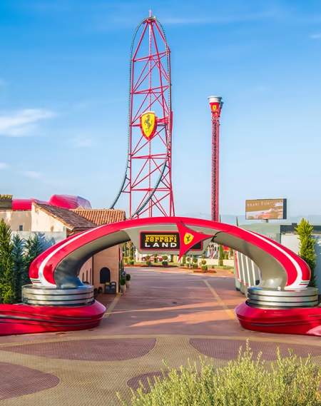
Figure 6: Ferrari Land
(Source: Ferrari, 2022)

Promotion
Ferrari is a very good sports brand that has numerous promotional activities. They are sponsoring and producing new products such as video games, art exhibitions and clothing.
The following are some of their promotional activities:
“They inaugurated the world’s largest Ferrari theme park”
“They announced that the upcoming Need for Speed game will be delayed to late 2015 due to work on an improved version of the game”
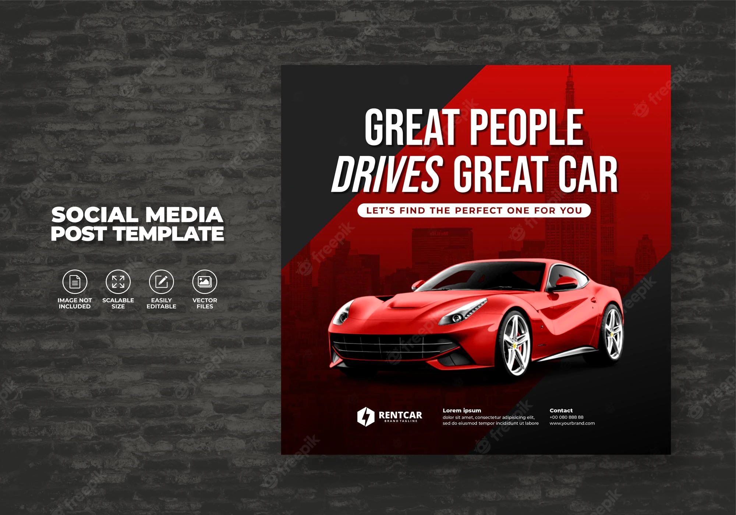
Figure 7: Ferrari Promotion
(Source: Ferrari, 2022)
Ferrari is a luxury brand with every feature possible in a sports car. Compared to other brands, it is slightly expensive but still worth it. The company has been making such cars since 1947 and has won numerous awards (Ferrari, 2022). The company observes the target market through their various promotional tools and products.

Reference List
autosprint (2022) The history of Ferrari, autosprint. autosprint. Available at: https://www.autosprintchicago.com/blog/2017/6/7/history-of-a-ferrari (Accessed: November 21, 2022).
AutoTrade (2022) Used Ferrari F12 Berlinetta cars for sale, AutoTrader UK. Available at: https://www.autotrader.co.uk/cars/used/ferrari/f12-berlinetta?refresh=true (Accessed: November 21, 2022).
AutoTrader (2022) Used Ferrari 488 GTB cars for sale, AutoTrader UK. Available at: https://www.autotrader.co.uk/cars/used/ferrari/488/gtb (Accessed: November 21, 2022).
Ferrari (2022) Ferrari dealers and official dealers, Ferrari Dealers and Official Dealers - Ferrari.com. Available at: https://www.ferrari.com/en-IN/auto/dealers (Accessed: November 21, 2022).
Ferrari electronic (2022) Mission & Vision, Ferrari electronic AG. Available at: https://www.ferrari-electronic.com/company/mission-vision.html (Accessed: November 21, 2022).
ferrarilakeforest (2022) The distinctive sound of Ferrari performance - ferrari lake forest, ferrari lake forest. Available at: http://www.ferrarilakeforest.com/ferrari-engine-sound/ (Accessed: November 21, 2022).

