
Tesla
Management ethics

Tyan Brooker Thorpe
P149779
15/01/2018

Table of Contents
Cover page 1
Table of Contents 2
Executive summary 3
Introduction 4
Main findings 5-8
Stakeholder Theory 5
Carrols pyramid………………………………………………………………………………………………………………………….6
Triple bottom line…………………………………………………………………………………………………………………..7-8
Conclusion……..………………………………………………………………………………………………………………………………….9
Appendices….…………………………………………………………………………………………………………………………………..10
Bibliography…………….…………………………………………………………………………………………………………………11-12

Executive summary
This report looks at the sustainable business in the context of Tesla, the intent is try explain what sustainable business is how Tesla is following it and how they could improve in this aspect of their business going forward. This report was compiled using a multitude of secondary research published with the majority written within the last five years of writing this report to ensure the legitimacy and relevancy of all the points discussed. What this report found was that Tesla complies with elements of all aspects of sustainable business while also taking into consideration their stake holders in their decision making process and operating on a high level on Carroll’s pyramid. This is not to suggest that there is not room for improvement in the future on the part as their weakest facet of their sustainability seems to be financial as they have made limited profits so in the future they should aim to make more profits. There is also room for improvements in Carroll’s pyramid as it seems to suggest they are operating in within ethical; they could look to push further by becoming philanthropic this could be by donating money to charities or even taking part in activities in which they do not expect a profit.
Introduction
Sustainable business is something that is difficult to define but is a lot easier to measure, Piscicelli et al (2018) offer a good perspective of what they perceive sustainable business as; Sustainable business is creating economic value while benefitting the environment and society. It can do this by aligning stakeholder groups.
Tesla is a company that primarily focuses on the long term this is even engraved into their mission statement which states, “To accelerate the advent of sustainable transport by bringing compelling mass market electric cars to market as soon as possible” (Musk, 2013). This report will focus on the challenges they face in all facets of sustainability showing how they are already sustainable such as using lithium ion batteries to reduce waste. What they could do to improve and also the challenges they face in attempting to achieve the sustainability levels.

Stakeholder Theory
Stakeholder theory was originally theorized by Edward Freeman. It is the idea that all stakeholder groups should be considered when making a decision (Mallin, 2016). By offering engagement in the decisions of the business of all stakeholder groups it fosters a community feel to a business which can lead to the long term sustainability of the business. This is as more Stakeholder groups will feel invested into the business thus making it more important to all concerned that the business survives. This is illustrated by appendix 1.
Tesla have shown instances of this by the appointment of Mr. Chang into its China operation in order to maximise the value that they offer to all stakeholder groups with someone who has excellent knowledge of the market due to previous experience in the area (Cendrowski, 2017). This is perhaps why Tesla is looking to open a factory in China (Tejada, 2017); as this will appease the government in the form of new invested capital and potentially jobs. Customers will also likely be pleased with this as it means they will be able to get their products quicker as tesla will no longer need to ship its products from the America. It also will positively influence suppliers as this could mean that they will need to supply more. However this is all speculation as it had not been confirmed meaning this can be linked to expectancy theory meaning perhaps there was only an increase in sales in China due to the news of a potential factory which would align it with more stakeholders (Cendrowski, 2017) (Hayes, 2014).This would be a dishonest and unsustainable method for Tesla to operate in the future this is as; if Tesla wants to increase sales in a new country they cannot just propose building a factory there as this will in the long run cause for them to be viewed in a dishonest manner gaining a negative brand reputation, so they must be sure to follow through with these in order to fully benefit and be operating in a positive way in accordance with stakeholder theory.

Carrols pyramid
There is a pyramid that attempts to help show how a business is acting as a corporate citizen. This is an attempt to try and illustrate how different business impact their wider community voluntarily and sometimes just within the remits of the law, this has been illustrated by appendix 2. It can be argued that Tesla seems to be operating on the upper part of the pyramid in the form of ethical, this is through the use of selling electric cars that can travel 200 miles on one charge (Grose, 2015). This means that there is the availability of a car that emits a lot lower emissions then what the market average had previously been. Showing they take into consideration ethics when they creates a new product as well as their wider environment in terms of the environmental impact.
However this should not disparage the argument that perhaps Tesla isn’t even on the pyramid as they have shown little evidence of remaining economically responsible because as Ohnsman (2016) mentions Tesla has only remained profitable for two quarters. The rebuttal to this is that Tesla is seeking long-term profits and is still a relatively new company in a new market and so is looking to establish itself as the market leader so while it might not be operating in a profitable manner at the moment with the development of new products such as the power wall it is looking into the long-term profit and benefit of society rather than the short term profits of just appeasing its shareholders (Zheng et al, 2018).

Triple bottom line
The triple bottom line (TBL) is the idea that for a business to be deemed to be sustainable it should try and benefit three different groups economic, environmental and social (Roy and Mitra, 2015). For it to be sustainable it would benefit all of these three groups. Economic through the generation of profits. Environmental by reduced waste management and perhaps a recyclable element within the business or other environmentally sustainable means. Social through benefitting society in an improved way.
Economic
Economics this is something that normally means the company will be making profit. This is something that tesla has struggled to comply with since its inception; as it has lost nearly $2billion dollars in its past two years and has over $10 billion worth of debt (Downes and Nunes, 2017). However it could be seen as Tesla complying with economic on other fronts as 2017 saw Tesla stock rise by 73% (Tepper, 2017) this is likely to appease their shareholders in the short run. Tesla have also shown the intent to try and alleviate the amount of debt which they are facing as they have recently recorded their second ever quarterly profit making $21.9 million (Ohnsman, 2016).This does begin to bring into question the long-term viability of sustainability concurrently with long run profits. Due to having only seen two quarters of profit in Tesla’s history does it still have the luxury of being able to afford to attempt to be sustainable in all three metrics with Tesla’s current business model. As it can be theorised that Tesla’s shareholder will only be willing to take the risk for a limited time, this has been seen multiple times such as in 2016 when tesla’s stock dropped by 4% (Hoover, 2016), or the time in 2014 that they announced a bad first quarter which led to the stock dropping by 10% (Howell, 2014), and the time when Goldmansachs downgraded them which led to a stock decline of 4.2% (Lehtonen, 2017).Tesla finds itself in a crisis of which it must attempt to try and resolve its issues regarding profitability before investors lose interest for the company and invest their money in another company, which could lead to their potential bankruptcy.
Social
Tesla has attempted to offer social features that will appeal to its customer base, this can be seen through the option and development of autonomous driving (Burke, 2016). But also through the use of an almost silent engine and sound deadening features (Naylor, 2016). This is not to suggest that Tesla does not face fierce competition in this area as Gibbs (2016) mentions NextEv one of tesla’s competitors is releasing a car that is the fastest electric car in world doing 0-60 mph in 2.7 seconds. However, it can be inferred that Tesla is not worried about this as they could see their product is superior with a rise in production in 2016 of 64% (Vaughan-Nichols, 2016). This is supported by the market by the fact that tesla saw their sales rise by 53% in the second quarter of 2017 (Tesla Sales Rise, 2017). This shows us that tesla is offering a product that is bringing about social change in which the market is embracing. Perhaps the reason Tesla is so confident is because they see themselves at the forefront of a new market in the shape of clean energy cars (Visser, 2012). Zachariadis (2013) research supports this idea as the sales of gasoline cars have been seen to slowdown in Germany as well as the amount of CO2 that these cars produce has significantly reduced. Evidence can be found of Tesla being at the forefront of the market with them introducing the idea of pre orders, leading to large purchases of their car before final designs were even finished (Fry, 2018); this shows that tesla has a fanatic like following by its customer due to the changes it has been able to bring to the automotive market.
Environmental
This is the look of how Tesla has an impact on its wider environment in terms as a whole planet. Bocken and Short (2016) bring in an interesting concept of the waste hierarchy as shown in appendix 3. This shows the levels of progression a company can make towards the environment in order to be construed in a way which is favourable in terms of sustainability. While Tesla have been seen as to operate on a high level of the waste hierarchy in terms of reduce, by creating a car which creates no car emissions (Hardman el al, 2015). According to the waste hierarchy it would be more environmentally preferable for Tesla to try and avoid selling, In order to create overconsumption and obsolete. This could be achieved by taking certain administrative measures to reduce the availability of purchasing from them; or even perhaps running a marketing campaign that would educate potential customers about the how much waste is still produced in the manufacturing of the car. A great example of this would be tesla’s use of Lithium ion batteries (Tesla's electric man., 2014). They could show that all the negative environment impact that the mining of lithium actually has on our planet (Drown, 2017), thus prompting them to reconsider their purchase and perhaps persuade potential customer to remain with their current car.

Conclusion
To be concluded Tesla have shown elements of being sustainable in every aspect of sustainable business. However there is definitely larger focus on certain aspects of its sustainable business. The largest aspect that Tesla likes to focus on seems to be the environment, this can be seen by Tesla’s attempt to try and be disruptive in the market by offering a car with no emissions. This is exemplified by the fact that it is written into the mission to remain environmentally sustainable. However this is not to suggest that there is not room for improvement as due to their limited compliance with the economic sustainability it seems they could try to look at making more short term profits, as otherwise they could see capital leaving. It seems Tesla is trying to accommodate this by coming up with new products such as Power wall, but they must be careful not to focus too much on a long term strategy before there investors lost interest. Tesla has shown instances of taking into account all stakeholders in their decision making so far but they must try to ascertain a way to offer short term profits to their investors to keep them interested. Tesla take social and environmental suistainablility more serious

Appendices
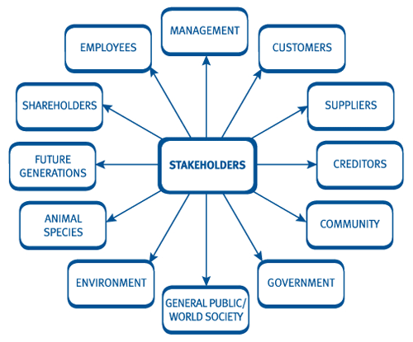
Stakeholder Theory

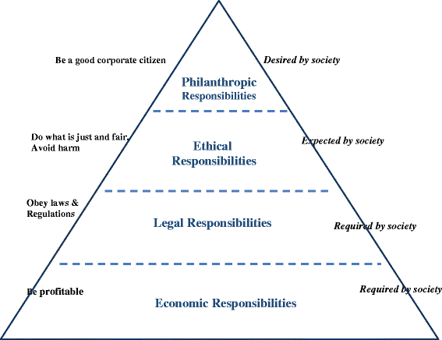

Carrols pyramid

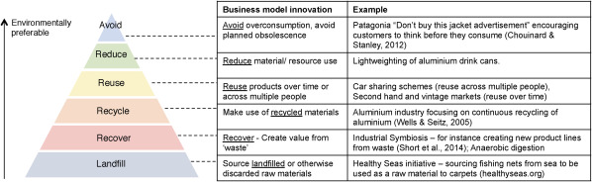
Waste hierarchy

Bibliography
Bocken, N. and Short, S. (2016). Towards a sufficiency-driven business model: Experiences and opportunities. Environmental Innovation and Societal Transitions, 18, pp.41-61.
Burke, K. (2016). Tesla to install self-driving hardware in all new vehicles. Automotive News, 90(6748), pp.6-7.
Cendrowski, S. (2017). Tesla makes a U-turn in China. Fortune, 175(8), pp.128-136.
Downes, L. and Nunes, P. (2017). Is Tesla Really a Disruptor? (And Why the Answer Matters). Harvard Business Review Digital Articles, pp.2-6.
Drown, P. (2017). Implications of a Lithium-Ion Storage Transformation. Power Engineering, 121(11), pp.62-66.
Fry, E. (2018). Tesla. Fortune, 177(1), pp.68-69.
Gibbs, N. (2016). NextEV plans Tesla Model X fighter for U.S. in late '18 or early '19. Automotive News, 90(6574), p.
Grose, T. (2015). DRIVING THE iWAY?. ASEE Prism, 24(2), p.13.
Hardman, S., Shiu, E. and Steinberger-Wilckens, R. (2015). Changing the fate of Fuel Cell Vehicles: Can lessons be learnt from Tesla Motors?. International Journal of Hydrogen Energy, 40(4), pp.1625-1638.
Hayes, J. (2014). The theory and practice of change management. 4th ed. London: Palgrave Macmillan, pp.244-250.
Hoover, K. (2016). Stocks Drop, But Tesla, Whole Foods Set Happy Tone. Investor's Business Daily.
Howell, D. (2014). Tesla Stock Drops Hard As Q1 Delivers Little Juice. Investor's Business Daily.
Lehtonen, S. (2017). Stocks Edge Lower, But Apple, Nvidia Up; Tesla Drops 4% On Goldman Downgrade. Investor's Business Daily.
Mallin, C. (2016). Corporate Governance. 5th ed.Oxford University Press: Oxford
Musk, E. (2013). The Mission of Tesla. [online] Tesla.com. Available at: https://www.tesla.com/en_GB/blog/mission-tesla [Accessed 16 Jan. 2018].
Naylor, S. (2016). Tesla Model X. Auto Express, 1426, pp.46-47.
Ohnsman, A. (2016). Tesla Zooms Into The Black With $21.9 Million Quarterly Profit As Vehicle Sales Jump. [online] forbes.com. Available at: http://Tesla Zooms Into The Black With $21.9 Million Quarterly Profit As Vehicle Sales Jump [Accessed 19 Jan. 2018].
Piscicelli, L., Ludden, G. and Cooper, T. (2018). What makes a sustainable business model successful? An empirical comparison of two peer-to-peer goods-sharing platforms. Journal of Cleaner Production, 172, pp.4580-4591.
Roy, S. and Mitra, S. (2015). Corporate Triple Bottom Line Reporting: An Empirical Study on the Indian Listed Power Companies. SDMIMD Journal of Management, 6(2), p.33.
Tejada, C. (2017). Tesla Talking To Chinese; May Set Up Car Factory. New York Times, 166(57637), p.B2.
Tepper, T. (2017). Stock X-ray: Tesla. Money, 46(7), pp.36-37.
Tesla Sales Rise. (2017). Dow Jones Institutional News.
Tesla's electric man. (2014). The Economist, 413(8916), pp.19-20.
Vaughan-Nichols, S. (2016). Tesla Will Rule the Car World. Computerworld Digital Magazine, 3(6), pp.6-8.
Visser, W. (2012). Corporate Sustainability & Responsibility: An Introductory Text on CSR Theory & Practice - Past, Present & Future. Cambridge: Kaleidoscope Futures Ltd, p.13.
Zachariadis, T. (2013). Gasoline, diesel and climate policy implications—Insights from the recent evolution of new car sales in Germany. Energy Policy, 54, pp.23-32.
Zheng, M., Wang, X., Meinrenken, C. and Ding, Y. (2018). Economic and environmental benefits of coordinating dispatch among distributed electricity storage. Applied Energy, 210, pp.842-855.

