
Hospitality & Tourism Management
Institute of Management & Health
CertHE/BA International Hotel Management
STUDENT ID:1921695
BMIH4006

Contents
Introduction 3
Student Journal 3
Component 2 5
Conclusion 8
Reference 8

Introduction
This assignment delves into the critical skills required in housekeeping, one of the pivotal units in the hospitality industry. It synthesizes academic knowledge with practical industry insights, reflecting upon the application of this theoretical understanding. It underscores the importance of housekeeping in the hospitality sector and discusses effective responses to potential challenges, exemplified by a scenario of handling a guest complaint.

Student Journal
Throughout my academic pursuit in the domain of Hospitality & Tourism Management, the revelation of the pivotal role of housekeeping in bolstering the hospitality industry's standards has been enlightening. Regrettably, the housekeeping team's indispensability is often undervalued, yet they lay the bedrock for a congenial and hospitable milieu for guests. Through a deeper exploration of this topic, I have discerned a set of quintessential skills imperative for efficacious functioning within a housekeeping team.
One skill that remains paramount is unerring attention to detail. Housekeeping's purview extends beyond cleanliness; it encapsulates assiduous maintenance of all facets of the establishment, leaving no stone unturned. My experiential learning during my internship at the Hotel Trinity underscored this, as I observed the team's meticulous approach to every task. This experiential knowledge substantiated the importance of precision and thoroughness in rendering a service.
Time management and organizational skills form the crux of housekeeping. The temporal aspect of housekeeping tasks is critical, and any delay can mar the guest's experience. My part-time housekeeping role provided me with a hands-on experience of juggling several responsibilities simultaneously, thereby refining my organizational and time management skills.
Interpersonal communication emerges as an indispensable competency within the housekeeping milieu, which extends to interactions both within the team and with guests. Despite the housekeeping team's predominant operations in the background, their episodic interface with guests necessitates proficient communication skills. These occasions may involve addressing specific guest requirements or concerns that necessitate clear and courteous dialogue (Andrews, S., 2013). Moreover, the necessity for intra-team communication is underscored by the need for efficient coordination of tasks and conflict resolution, which significantly impacts the team's overall effectiveness. Evidently, these skills are instrumental in discerning and satisfying guest expectations, consequently engendering customer satisfaction and fostering a robust rapport between guests and the establishment.
Physical resilience and agility form another pillar of the quintessential attributes required in housekeeping, given the inherently physically demanding nature of housekeeping operations. These encompass a wide array of tasks such as comprehensive cleaning, repositioning furniture, and enduring long-standing periods (Andrews, S., 2013). My personal experience in the field elucidated this reality, offering a first-hand appreciation of the physically strenuous demands of the job, thereby promoting a more empathetic understanding of the housekeepers' daily experiences.
The transition from theoretical knowledge to its pragmatic application in this field underlines the understanding that achieving proficiency in these skills can dramatically augment my performance in future hospitality roles. My theoretical understanding, bolstered by hands-on experience, provides me with the necessary tools to not only uphold the high standards of service ubiquitous in the hospitality industry but also equip others to achieve the same level of excellence. I can then contribute to the creation of a high-performing housekeeping team that excels in delivering superior customer service (Raghubalan, G. and Raghubalan, S., 2009).
The importance of housekeeping in the hospitality industry is manifold. It extends beyond the assurance of cleanliness and hygiene - foundational elements of any hospitality enterprise - to significantly influence the overall guest experience. An immaculately kept and clean environment can precipitate positive reviews and foster guest loyalty, resulting in repeat patronage (Medlik, S., 2012). Additionally, efficient housekeeping operations can yield financial advantages by enabling cost-saving through judicious resource management. It encourages the sustainable usage of cleaning materials, equipment, and energy, aligning the establishment's practices with environmentally responsible operations (Jones, P. ed., 2008).
In conclusion, my enhanced understanding of the crucial housekeeping skills – attention to detail, time management and organization, communication, and physical resilience – has been enriched through an amalgamation of academic learning and practical experiences. These competencies represent the bedrock for effective functioning within the hospitality industry.
In summation, my comprehension of the key housekeeping skills – attention to detail, time management and organization, communication, and physical resilience – has been enriched through my academic learning and practical experiences. These competencies are indispensable for effective functioning within the hospitality industry.

Component 2
Action plan
Identify Why It Happened:
Investigating the root cause of an issue is the first step in rectifying it. In this scenario, we've identified several possible reasons, namely a breakdown in communication, inadequate staffing, inefficient cleaning processes, or an oversight in the room readiness checks (Barrows, C., & others,2012.). These aspects demand further exploration to establish the exact cause.
Action Steps:
First, I'd start a conversation with the cleaning crew since it's crucial to learn about their processes directly from them. This discussion may reveal problems like rushed or incomplete cleaning owing to personnel being overworked or confused about their responsibilities (Hayes, D.K.&Ninemeier, J.D., 2009).The next step is to review the protocols and communication records for signaling the room is ready for use. Maintaining smooth operations in hotels is dependent on open lines of communication between different departments. A visitor may be given a room that isn't ready if the communication lines are faulty or the readiness signal isn't properly delivered. Finally, we'll assess the present cleaning schedules and load. Assuring a fair workload is critical for keeping employees happy and productive, which in turn leads to better service for customers (Walker, 2021). Cleaning operations may be hurried or incomplete if timelines are too tight or the workload is too heavy.
All of these measures would help in identifying the internal procedures and potential failures that contributed to the guest's displeasure. The information acquired will be crucial in developing a workable strategy to address and avoid future instances.
Immediate Rectification
Resolving guest grievances swiftly and efficiently is at the heart of hospitality management. Ensuring the highest level of customer satisfaction is paramount in maintaining the hotel's reputation and guaranteeing repeat business (Kandampully et al., 2018).
Action Steps:
A honest apology to the visitor is the first step in making things right again. A sincere apology shows that you care about the guest's feelings of distress and disappointment. It's important to show compassion and understanding and reassure the person that steps will be made right away to fix the problem (Brotherton & Wood, 2008).
Therefore, it is critical to offer a quick fix for the issue. The room should be re-assigned to the visitor when it has been cleaned and examined. Resolving the situation and restoring the guest's faith in the hotel's services depends on making sure they are satisfied with their new accommodation and don't have any repeat problems.
Providing guests with complementary services is another great way to win back their trust and turn around a bad review. A free service might be anything from a dinner at the hotel restaurant to a spa service to an upgraded room. Customer satisfaction and the willingness to make corrections are emphasised via such actions (Walker, 2016).

Preventive Measures
Preventive measures are the key to mitigate recurring incidents and maintain high standards of service quality. They are instrumental in reducing the likelihood of similar issues arising in the future (Barrows et al., 2012).
Action Steps:
Using a room ready checklist might help the housekeeping crew save time and effort by standardising the cleaning procedure. A thorough checklist guarantees that no steps are skipped and everything is taken care of. Beds are made, amenity supplies are replenished, and appliances and fixtures are tested.
Adding a quality control group to conduct random, periodic inspections may provide an additional safety net. As they are not part of the housekeeping staff, this group can objectively assess how well the rules are being followed and how clean the facility really is. Room readiness may be maintained at a constant high level by conducting routine inspections (Hayes, D.K. & Ninemeier, J.D., 2009).
Another important preventative step is training for housekeepers on how to clean properly and how to meet the expectations of guests. Training programmes like this may help employees get a deeper comprehension of their functions, therefore encouraging them to pay closer attention to detail (Brotherton & Wood, 2008).
Improve Team Effectiveness:
Enhancing team effectiveness is fundamental in delivering excellent customer service in the hospitality industry. This involves fostering a positive work culture, offering continuous training and development opportunities, and streamlining communication channels (Brotherton & Wood, 2008).
Action Steps:
First and first, it's essential to foster a constructive and cooperative atmosphere in the office. Staff morale, cooperation, and productivity may all benefit from regular team-building activities and seminars. Problem-solving activities and team challenges are two examples of team-building exercises that aim to improve communication, cooperation, and mutual understanding among members of the group (Kandampully et al., 2018).One effective method to boost worker competence and integrity is to institute ongoing training programmes. This includes both hard skills training, like how to use cleaning equipment and carry out cleaning processes, and soft skills training, such how to communicate with guests, solve problems, and handle stress. Staff workers that get regular training are better able to manage their responsibilities and whatever obstacles they may face (Walker, 2021).
Effective teamwork also relies on open lines of communication between different departments. All departments should be kept informed of room availability, special requests from guests, and schedule adjustments via a streamlined and reliable communication system. Effective communication reduces the likelihood of missteps and misunderstandings (Kasavana & Brooks, 2014).

Conclusion
In conclusion, adeptness in housekeeping is paramount to maintaining high customer satisfaction and a thriving hospitality industry. Balancing theoretical knowledge and practical application empowers professionals to identify issues, devise solutions, and instigate measures to bolster team efficiency. This reflection emphasises that effective housekeeping is not merely about cleanliness but involves a nuanced skill set, including leadership, communication, problem-solving, and strategic planning, which are essential for delivering an exceptional guest experience.

Reference
- Jones, P. ed., 2008. Handbook of hospitality operations and IT. Routledge.
- Andrews, S., 2013. Hotel front office: A training manual. Tata McGraw-Hill Education.
- Medlik, S., 2012. Dictionary of travel, tourism and hospitality. Routledge.
- Raghubalan, G. and Raghubalan, S., 2009. Hotel housekeeping: Operations and management. Oxford University Press.
- Barrows, C., Powers, T. and Reynolds, D., 2012. Introduction to Management in the Hospitality Industry. John Wiley&Sons.
- Hayes, D.K. and Ninemeier, J.D., 2009. Human resources management in the hospitality industry. John Wiley & Sons.
- Walker, J.R., 2021. Introduction to hospitality. United Kingdom: Pearson.
- Brotherton, B. and Wood, R.C., 2008. The Sage handbook of hospitality management. The SAGE Handbook of Hospitality Management, pp.1-576.
- Kandampully, J., Zhang, T.C. and Jaakkola, E., 2018. Customer experience management in hospitality: A literature synthesis, new understanding and research agenda. International Journal of Contemporary Hospitality Management, 30(1), pp.21-56.

Presentation:
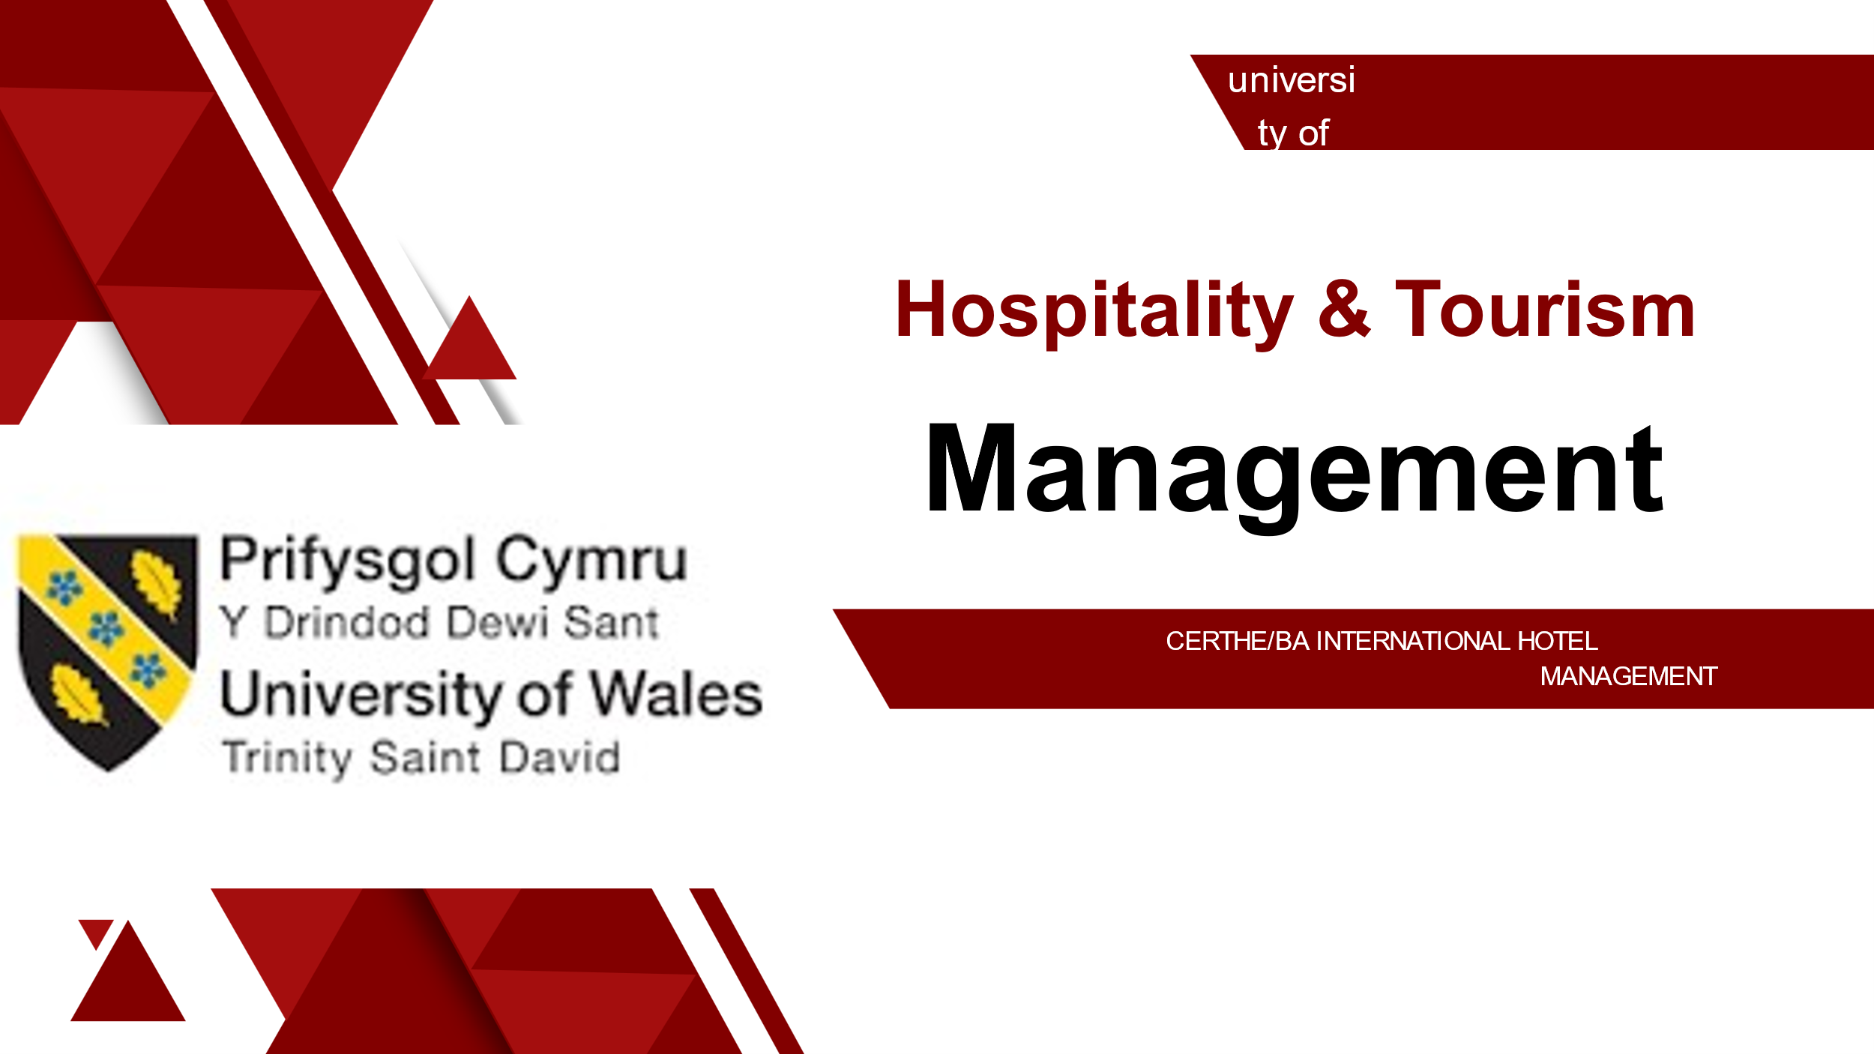
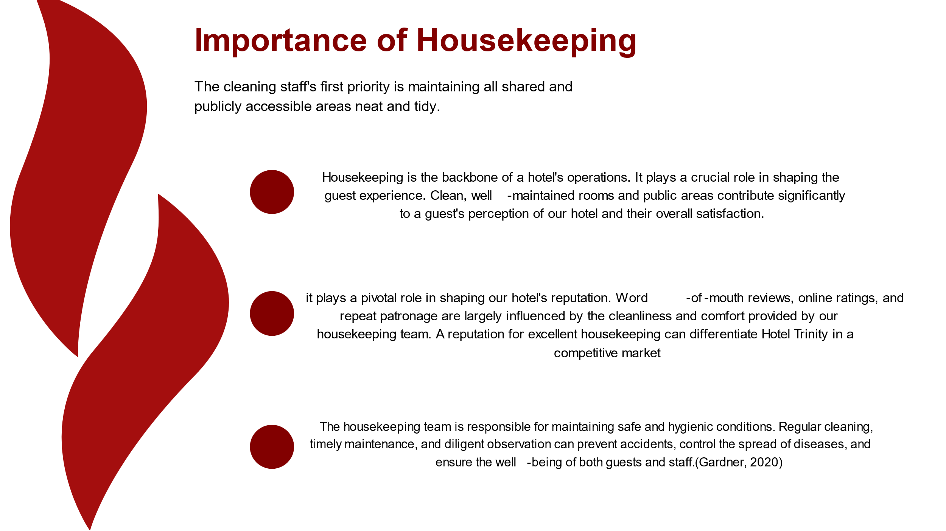
Training Notes:
Emphasize the importance of housekeeping in the hotel industry and its impact on guest experience and overall satisfaction.
Highlight the role of housekeeping in shaping the hotel's reputation through word-of-mouth reviews, online ratings, and repeat patronage.
Discuss how excellent housekeeping can give the hotel a competitive edge in the market.
Explain the responsibility of the housekeeping team in maintaining safe and hygienic conditions for the well-being of guests and staff.
Learning Outcomes:
Understand the significance of housekeeping in a hotel's operations.
Recognize the direct impact of housekeeping on guest satisfaction and the hotel's reputation.
Gain knowledge about the role of housekeeping in ensuring safety and hygiene.
Understand the competitive advantage that can be gained through excellent housekeeping.
Speaker Notes :
Housekeeping is vital to our hotel's operations, shaping the guest experience and influencing our reputation. Clean, well-maintained rooms and public areas contribute to guest satisfaction. A strong reputation for excellent housekeeping sets us apart in a competitive market. Furthermore, housekeeping ensures safety and hygiene, preventing accidents and controlling the spread of diseases. By delivering exceptional housekeeping, we enhance the guest experience, build a positive reputation, and prioritize the well-being of guests and staff.
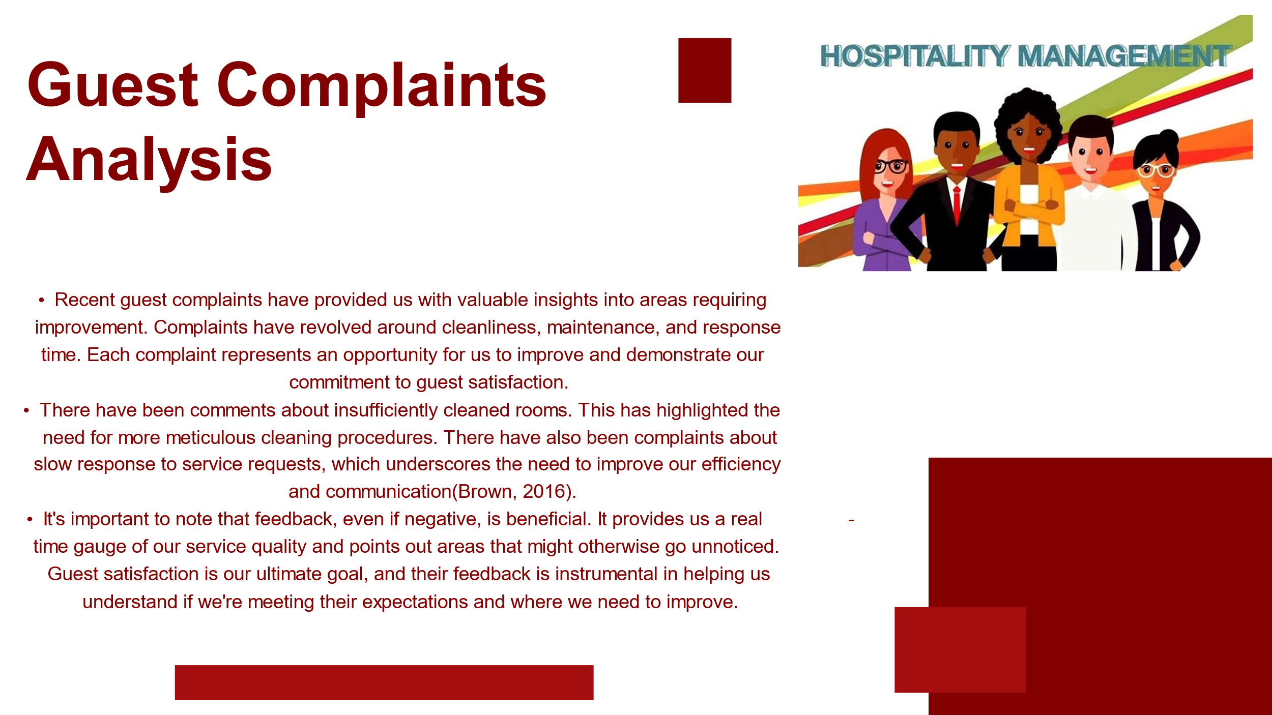
Training Notes:
Highlight the importance of analyzing guest complaints as a means of improving service quality.
Discuss specific areas of improvement mentioned in recent guest complaints, such as cleanliness, maintenance, and response time.
Emphasize the value of feedback, even if negative, in identifying areas for improvement and meeting guest expectations.
Reinforce the goal of guest satisfaction and the role of guest feedback in achieving that goal.
Learning Outcomes:
Understand the significance of analyzing guest complaints for service improvement.
Identify common areas of improvement based on guest complaints, such as cleanliness, maintenance, and response time.
Recognize the value of feedback, both positive and negative, in meeting guest expectations.
Develop an understanding of the importance of guest satisfaction and the role of guest feedback in achieving it.
Speaker Notes:
Recent guest complaints have provided valuable insights for improvement. Cleanliness, maintenance, and response time were common issues raised. Insufficiently cleaned rooms highlight the need for more meticulous cleaning procedures, while complaints about slow response underscore the importance of improving efficiency and communication. Negative feedback, though unwelcome, serves as a real-time gauge of service quality and identifies areas for improvement. Guest satisfaction is our ultimate goal, and their feedback helps us understand if we meet expectations and where we need to enhance our services.
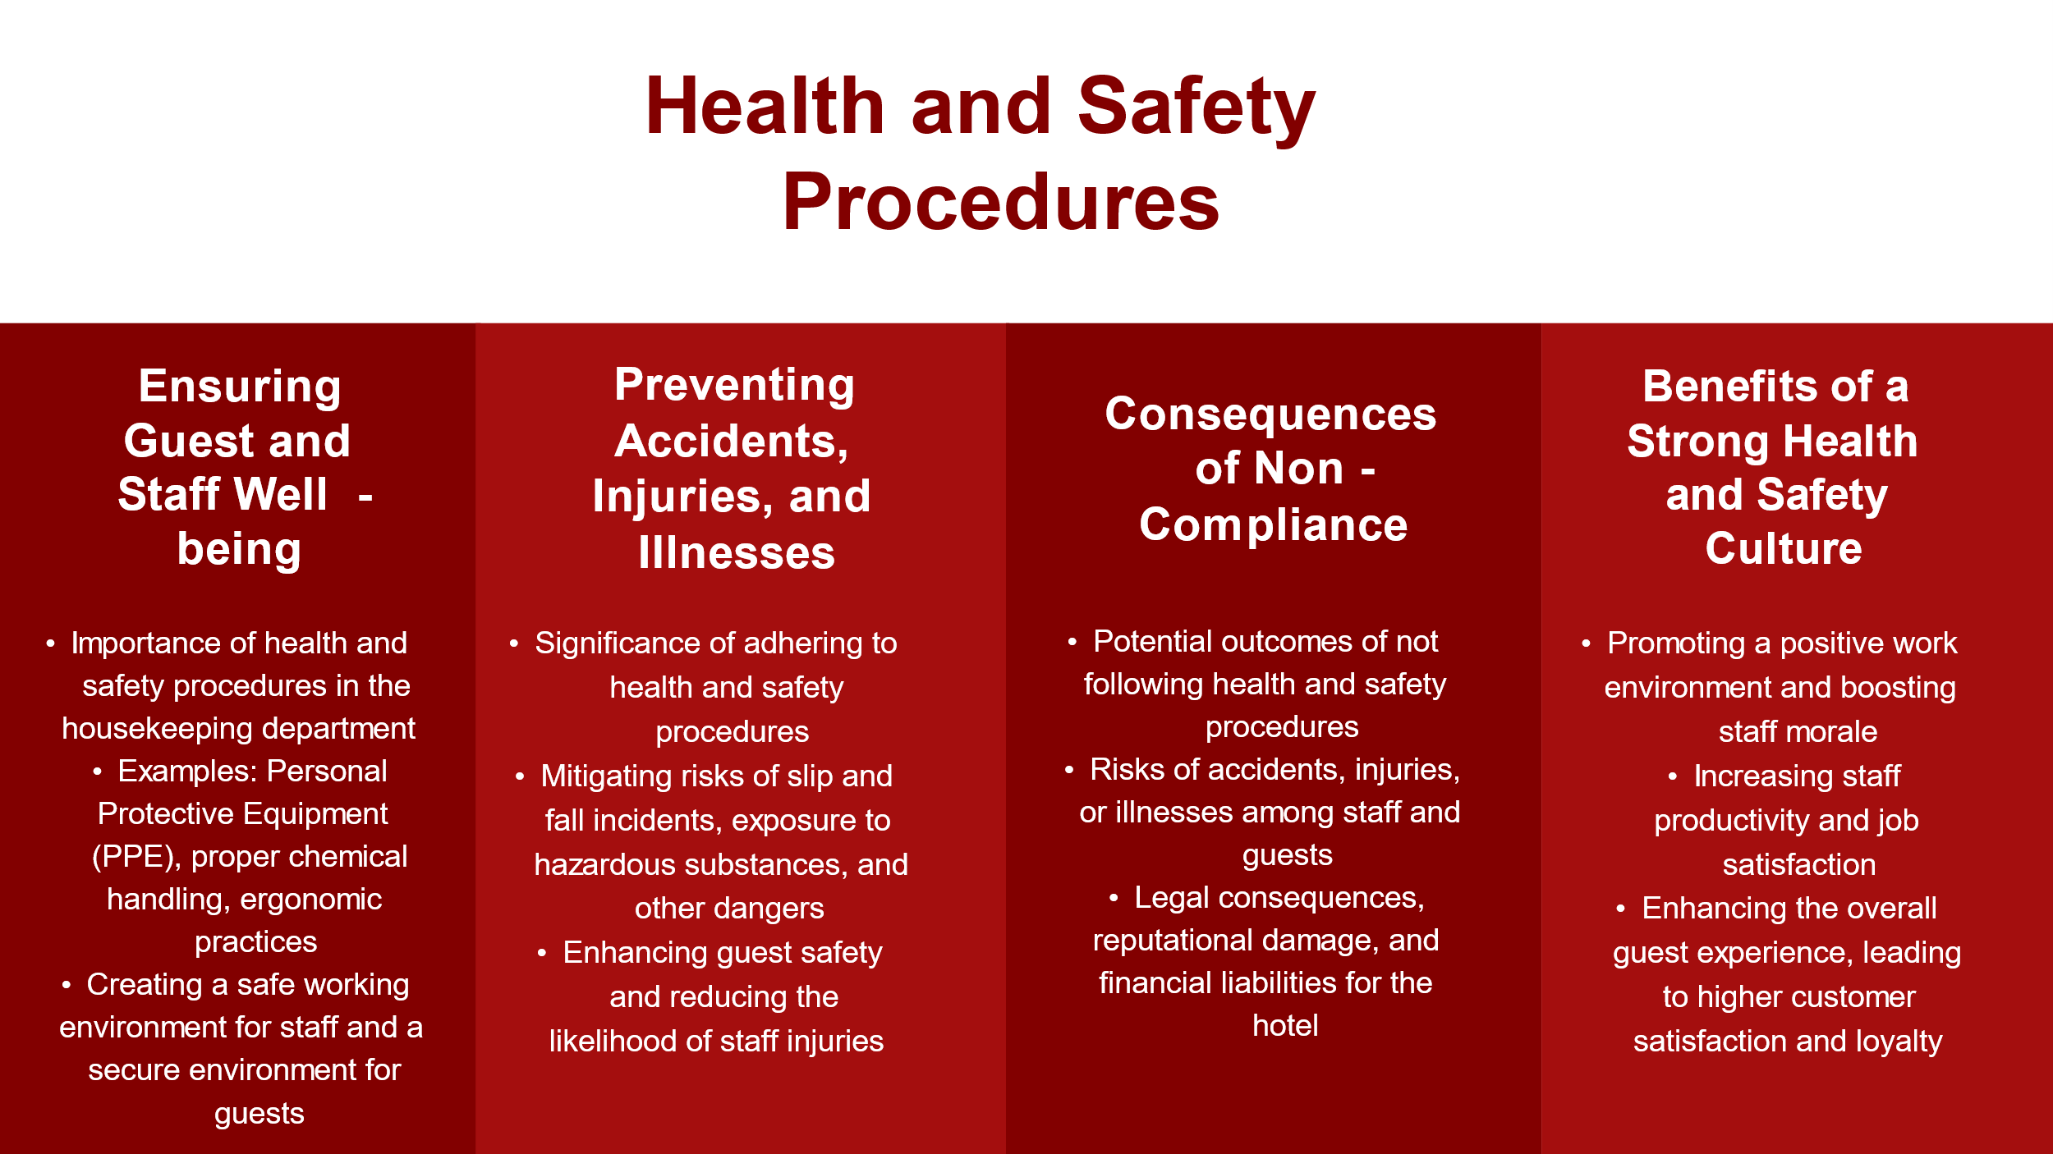
Training Notes:
Highlight the importance of health and safety procedures in the housekeeping operations of Hotel Trinity.
Discuss specific procedures, such as safe use of cleaning chemicals, guidelines for lifting heavy items, and wearing personal protective equipment.
Emphasize the role of these procedures in protecting the well-being of both guests and staff.
Explain the potential consequences of neglecting health and safety procedures, including hazards, legal action, reputation damage, and loss of trust.
Learning Outcomes:
Understand the significance of health and safety procedures in housekeeping operations.
Identify specific procedures related to the safe use of cleaning chemicals, lifting heavy items, and personal protective equipment.
Recognize the importance of these procedures in safeguarding the well-being of guests and staff.
Appreciate the potential consequences of neglecting health and safety procedures.
Speaker Notes:
The housekeeping team at Hotel Trinity has the vital responsibility of ensuring cleanliness and safety. Health and safety procedures are integral to our operations, encompassing the safe use, storage, and disposal of cleaning chemicals, following guidelines for lifting and moving heavy items, and wearing personal protective equipment when necessary. Adhering to these procedures safeguards our team from injuries and health risks, maintains a safe work environment, and prevents the spread of infections or allergies that could impact guest health. Neglecting these procedures can have severe consequences, including legal action and damage to our reputation (Author, Year).
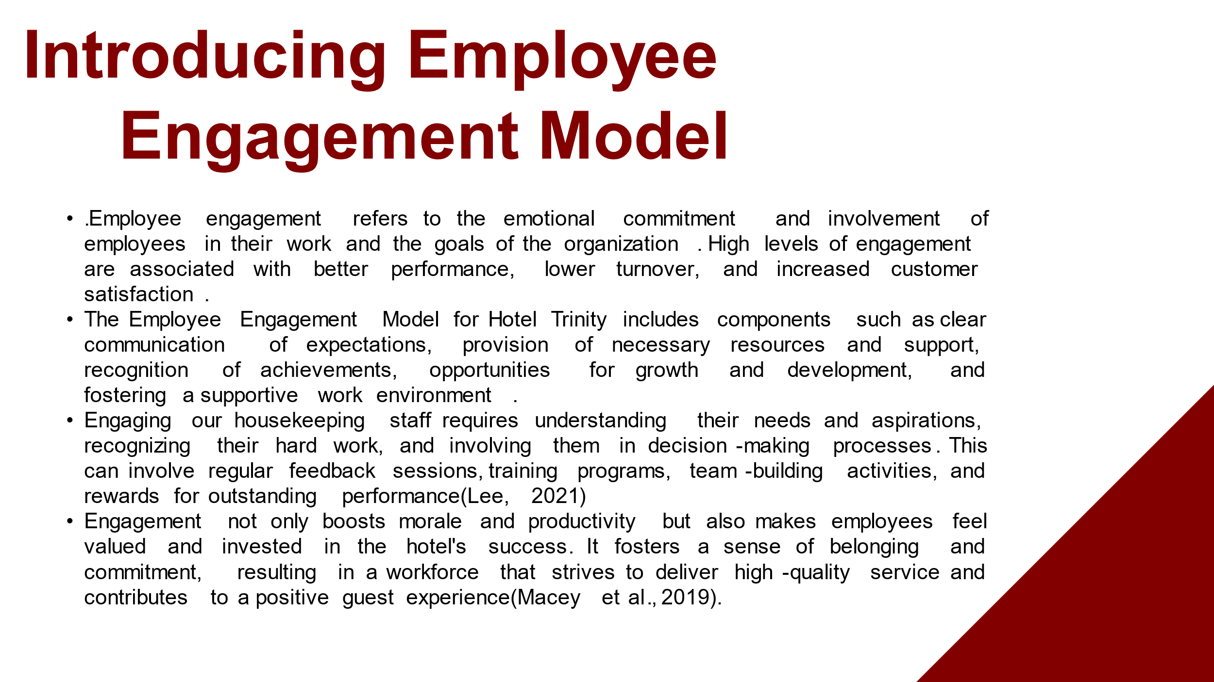
Training Notes:
Introduce the concept of employee engagement and its significance in improving performance, reducing turnover, and enhancing customer satisfaction.
Explain the components of the Employee Engagement Model for Hotel Trinity, including clear communication, provision of resources, recognition, growth opportunities, and a supportive work environment.
Emphasize the importance of understanding and meeting the needs of housekeeping staff, involving them in decision-making, and recognizing their hard work.
Discuss strategies for engaging housekeeping staff, such as feedback sessions, training programs, team-building activities, and rewards for outstanding performance.
Highlight the benefits of employee engagement, including increased morale, productivity, and a sense of commitment to the hotel's success.
Learning Outcomes:
Understand the concept and significance of employee engagement in the hotel industry.
Identify the components of the Employee Engagement Model for Hotel Trinity.
Recognize the importance of understanding and meeting the needs of housekeeping staff for engagement.
Discover strategies for engaging housekeeping staff and fostering a positive work environment.
Appreciate the benefits of employee engagement for morale, productivity, and guest satisfaction.
Speaker Notes:
Employee engagement is crucial for the success of Hotel Trinity. It refers to employees' emotional commitment to their work and the organization. By implementing the Employee Engagement Model, we can ensure clear communication, provide necessary resources and support, recognize achievements, offer growth opportunities, and foster a supportive work environment. Engaging our housekeeping staff involves understanding their needs, involving them in decision-making, providing feedback and training, organizing team-building activities, and rewarding outstanding performance. Engagement boosts morale, productivity, and guest experience, creating a committed and high-performing workforce.
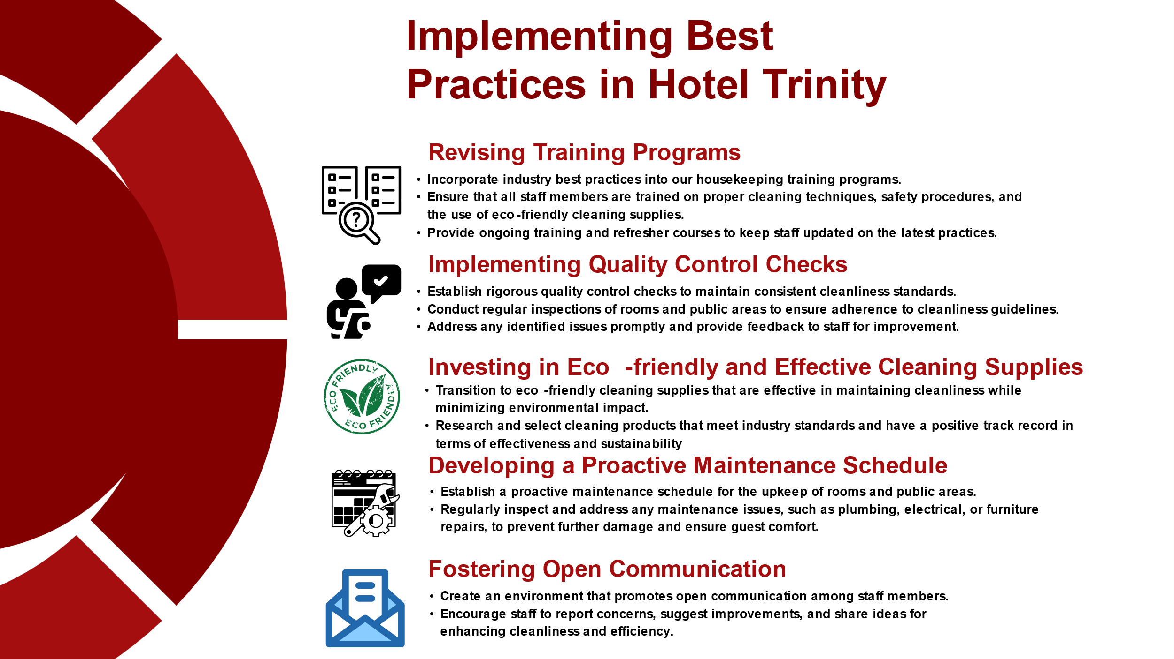
Training Notes:
Outline the actionable steps required to implement best practices in Hotel Trinity's operations.
Highlight the importance of revising training programs, implementing quality control checks, and using eco-friendly cleaning supplies.
Discuss the creation of room cleaning checklists, health and safety audits, and proactive maintenance schedules.
Emphasize the importance of fostering open communication and the collective effort required for successful implementation.
Reinforce the mindset of viewing these changes as valuable tools that enhance job effectiveness, guest experience, and the hotel's reputation.
Learning Outcomes:
Understand the actionable steps involved in implementing best practices in hotel operations.
Identify key areas for improvement, such as training programs, quality control, and sustainability practices.
Recognize the significance of room cleaning checklists, health and safety audits, and proactive maintenance.
Appreciate the importance of open communication and the collective effort in successfully implementing best practices.
Speaker Notes:
To implement best practices at Hotel Trinity, we need to take specific steps. This includes updating our training programs with industry best practices, implementing quality control checks, and using eco-friendly cleaning supplies. We will create room cleaning checklists, conduct regular health and safety audits, and establish a proactive maintenance schedule. Open communication is crucial, so everyone feels comfortable reporting concerns or suggesting improvements. It's important to see these practices as tools that enhance our effectiveness and job satisfaction while elevating the guest experience and the hotel's reputation.
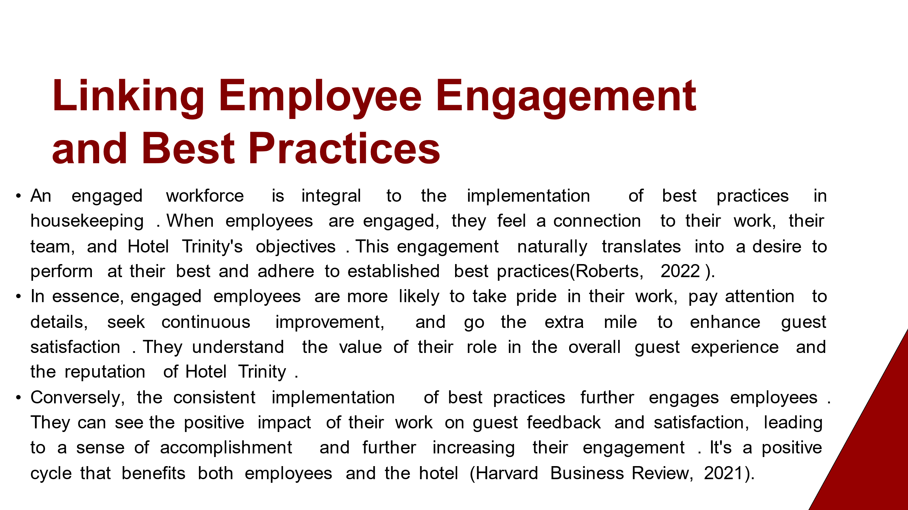
Training Notes:
Highlight the link between employee engagement and the successful implementation of best practices in housekeeping.
Explain how engaged employees are more likely to take pride in their work, pay attention to details, seek continuous improvement, and enhance guest satisfaction.
Emphasize the positive impact of consistently implementing best practices on employee engagement, as they can see the results of their work in guest feedback and satisfaction.
Discuss the positive cycle created by the connection between employee engagement and the implementation of best practices, benefiting both employees and the hotel.
Learning Outcomes:
Understand the connection between employee engagement and the successful implementation of best practices in housekeeping.
Recognize how engaged employees contribute to improved performance, attention to detail, continuous improvement, and guest satisfaction.
Appreciate the positive impact of consistently implementing best practices on employee engagement.
Gain an understanding of the reciprocal relationship between employee engagement and the successful implementation of best practices.
Speaker Notes:
Employee engagement and the implementation of best practices in housekeeping are closely linked. Engaged employees feel connected to their work and the hotel's objectives, leading to better adherence to best practices. Engaged employees take pride in their work, pay attention to details, and strive for continuous improvement, ultimately enhancing guest satisfaction. Conversely, the consistent implementation of best practices further engages employees by showing the impact of their work on guest feedback and satisfaction. This positive cycle benefits both employees and the hotel.
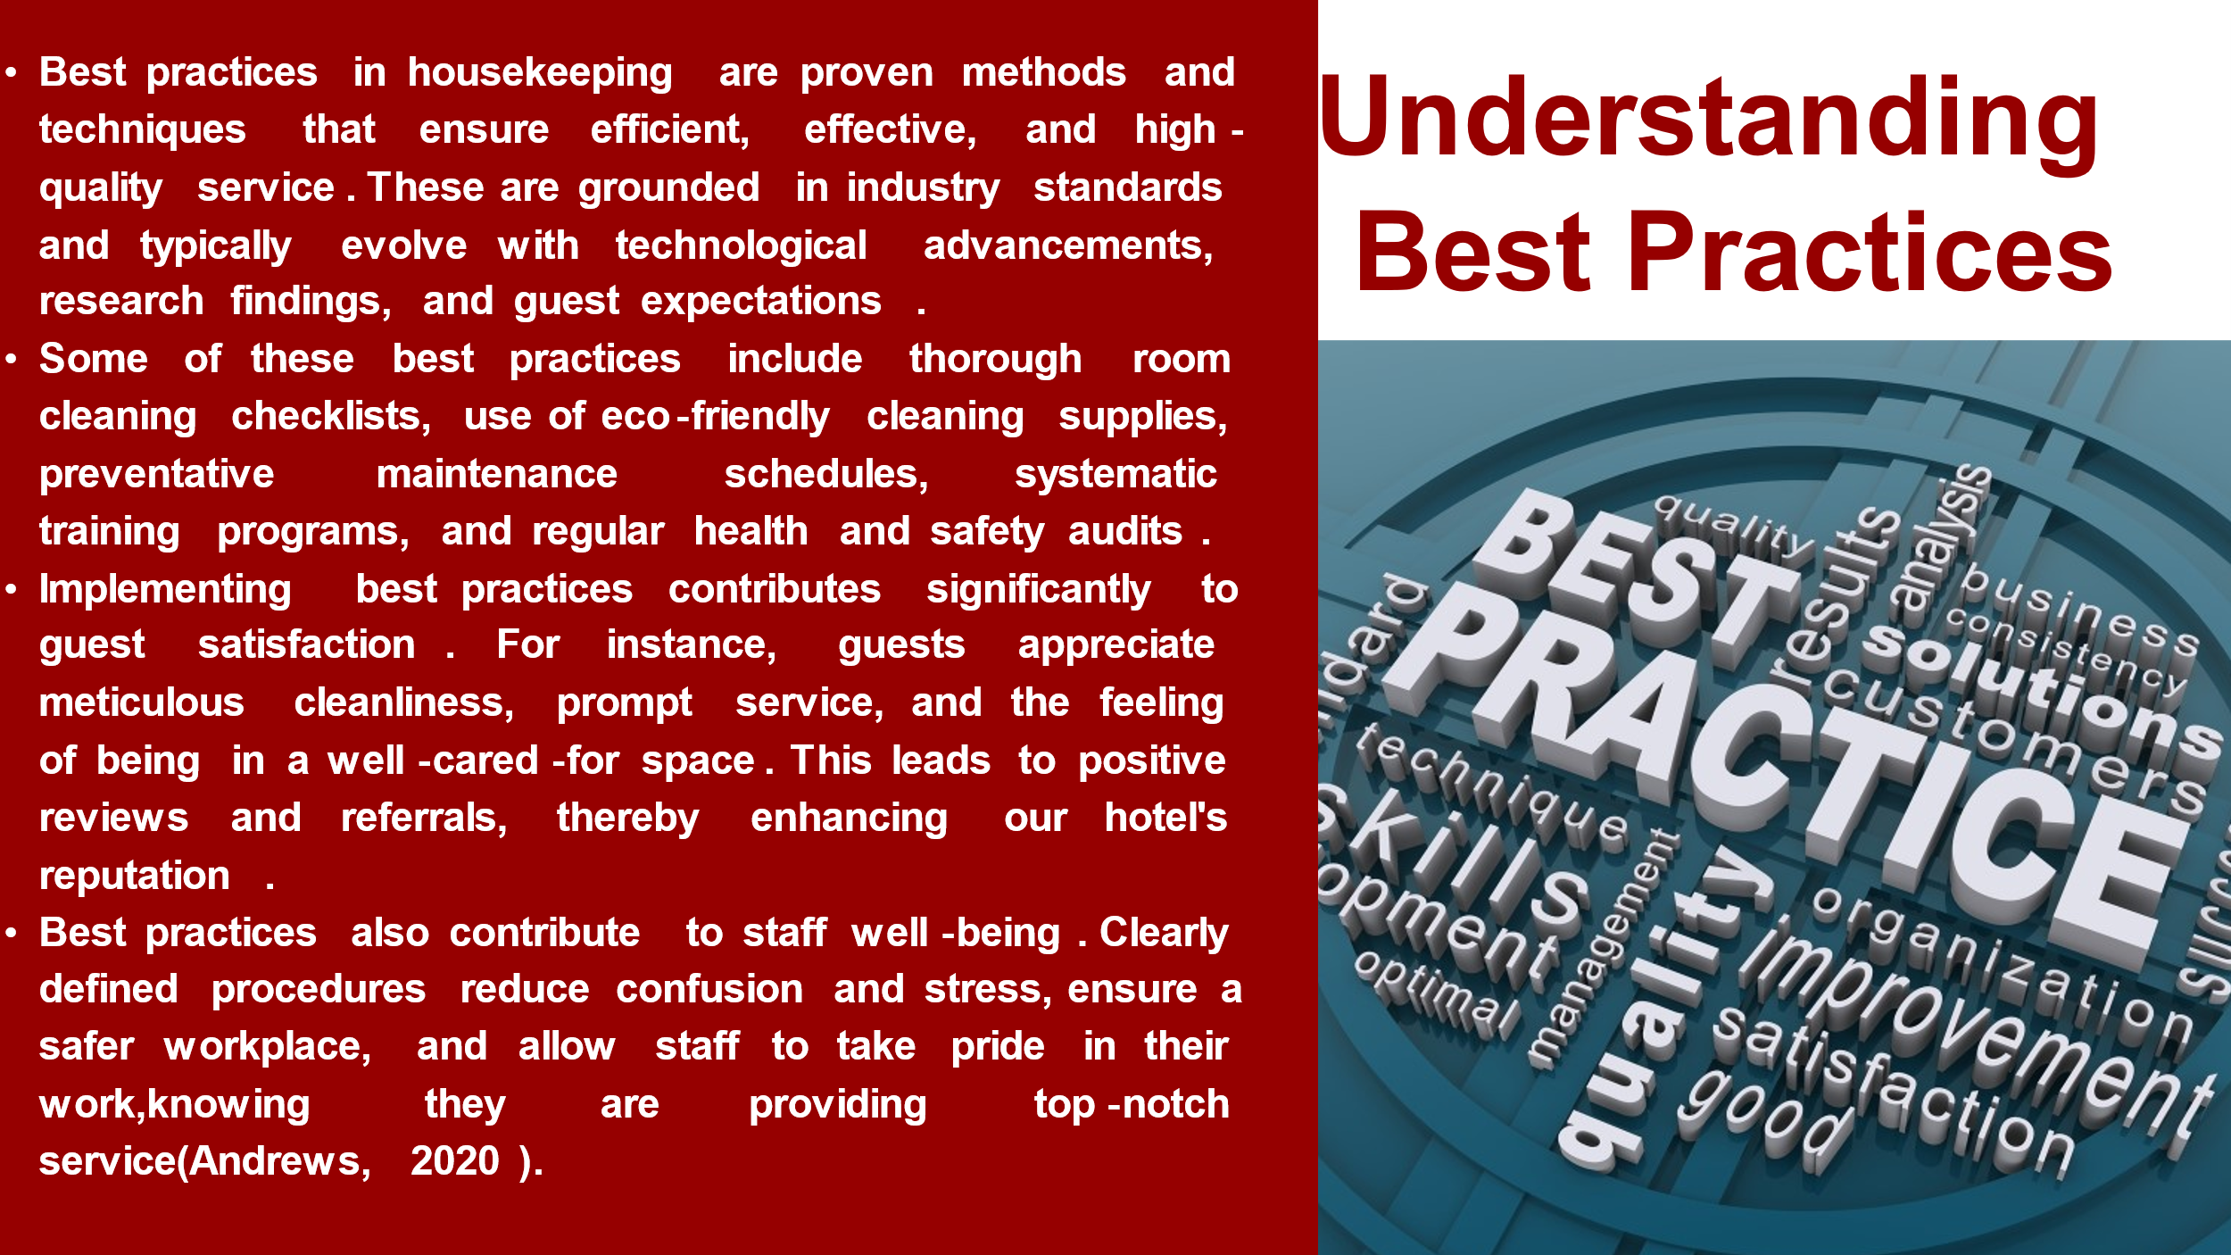
Training Notes:
Explain the concept of best practices in housekeeping and their significance in ensuring efficient, effective, and high-quality service.
Discuss specific examples of best practices, such as room cleaning checklists, eco-friendly cleaning supplies, preventative maintenance schedules, training programs, and health and safety audits.
Highlight the impact of implementing best practices on guest satisfaction, including cleanliness, prompt service, and a well-cared-for environment.
Emphasize the benefits of best practices for staff well-being, including reduced confusion and stress, a safer workplace, and a sense of pride in delivering exceptional service.
Learning Outcomes:
Understand the concept and importance of best practices in housekeeping.
Identify specific examples of best practices, including room cleaning checklists, eco-friendly supplies, maintenance schedules, training programs, and health and safety audits.
Recognize the impact of best practices on guest satisfaction, reputation, and staff well-being.
Appreciate the benefits of implementing best practices for efficiency, effectiveness, and high-quality service.
Speaker Notes:
Best practices in ousekeeping are essential for providing efficient, effective, and high-quality service. They are based on industry standards, technological advancements, research, and guest expectations. Examples include detailed room cleaning checklists, eco-friendly supplies, preventative maintenance schedules, systematic training, and health and safety audits. Implementing these practices enhances guest satisfaction, leading to positive reviews and referrals. Moreover, they contribute to staff well-being by reducing confusion and stress, ensuring a safer workplace, and fostering a sense of pride in delivering exceptional service.
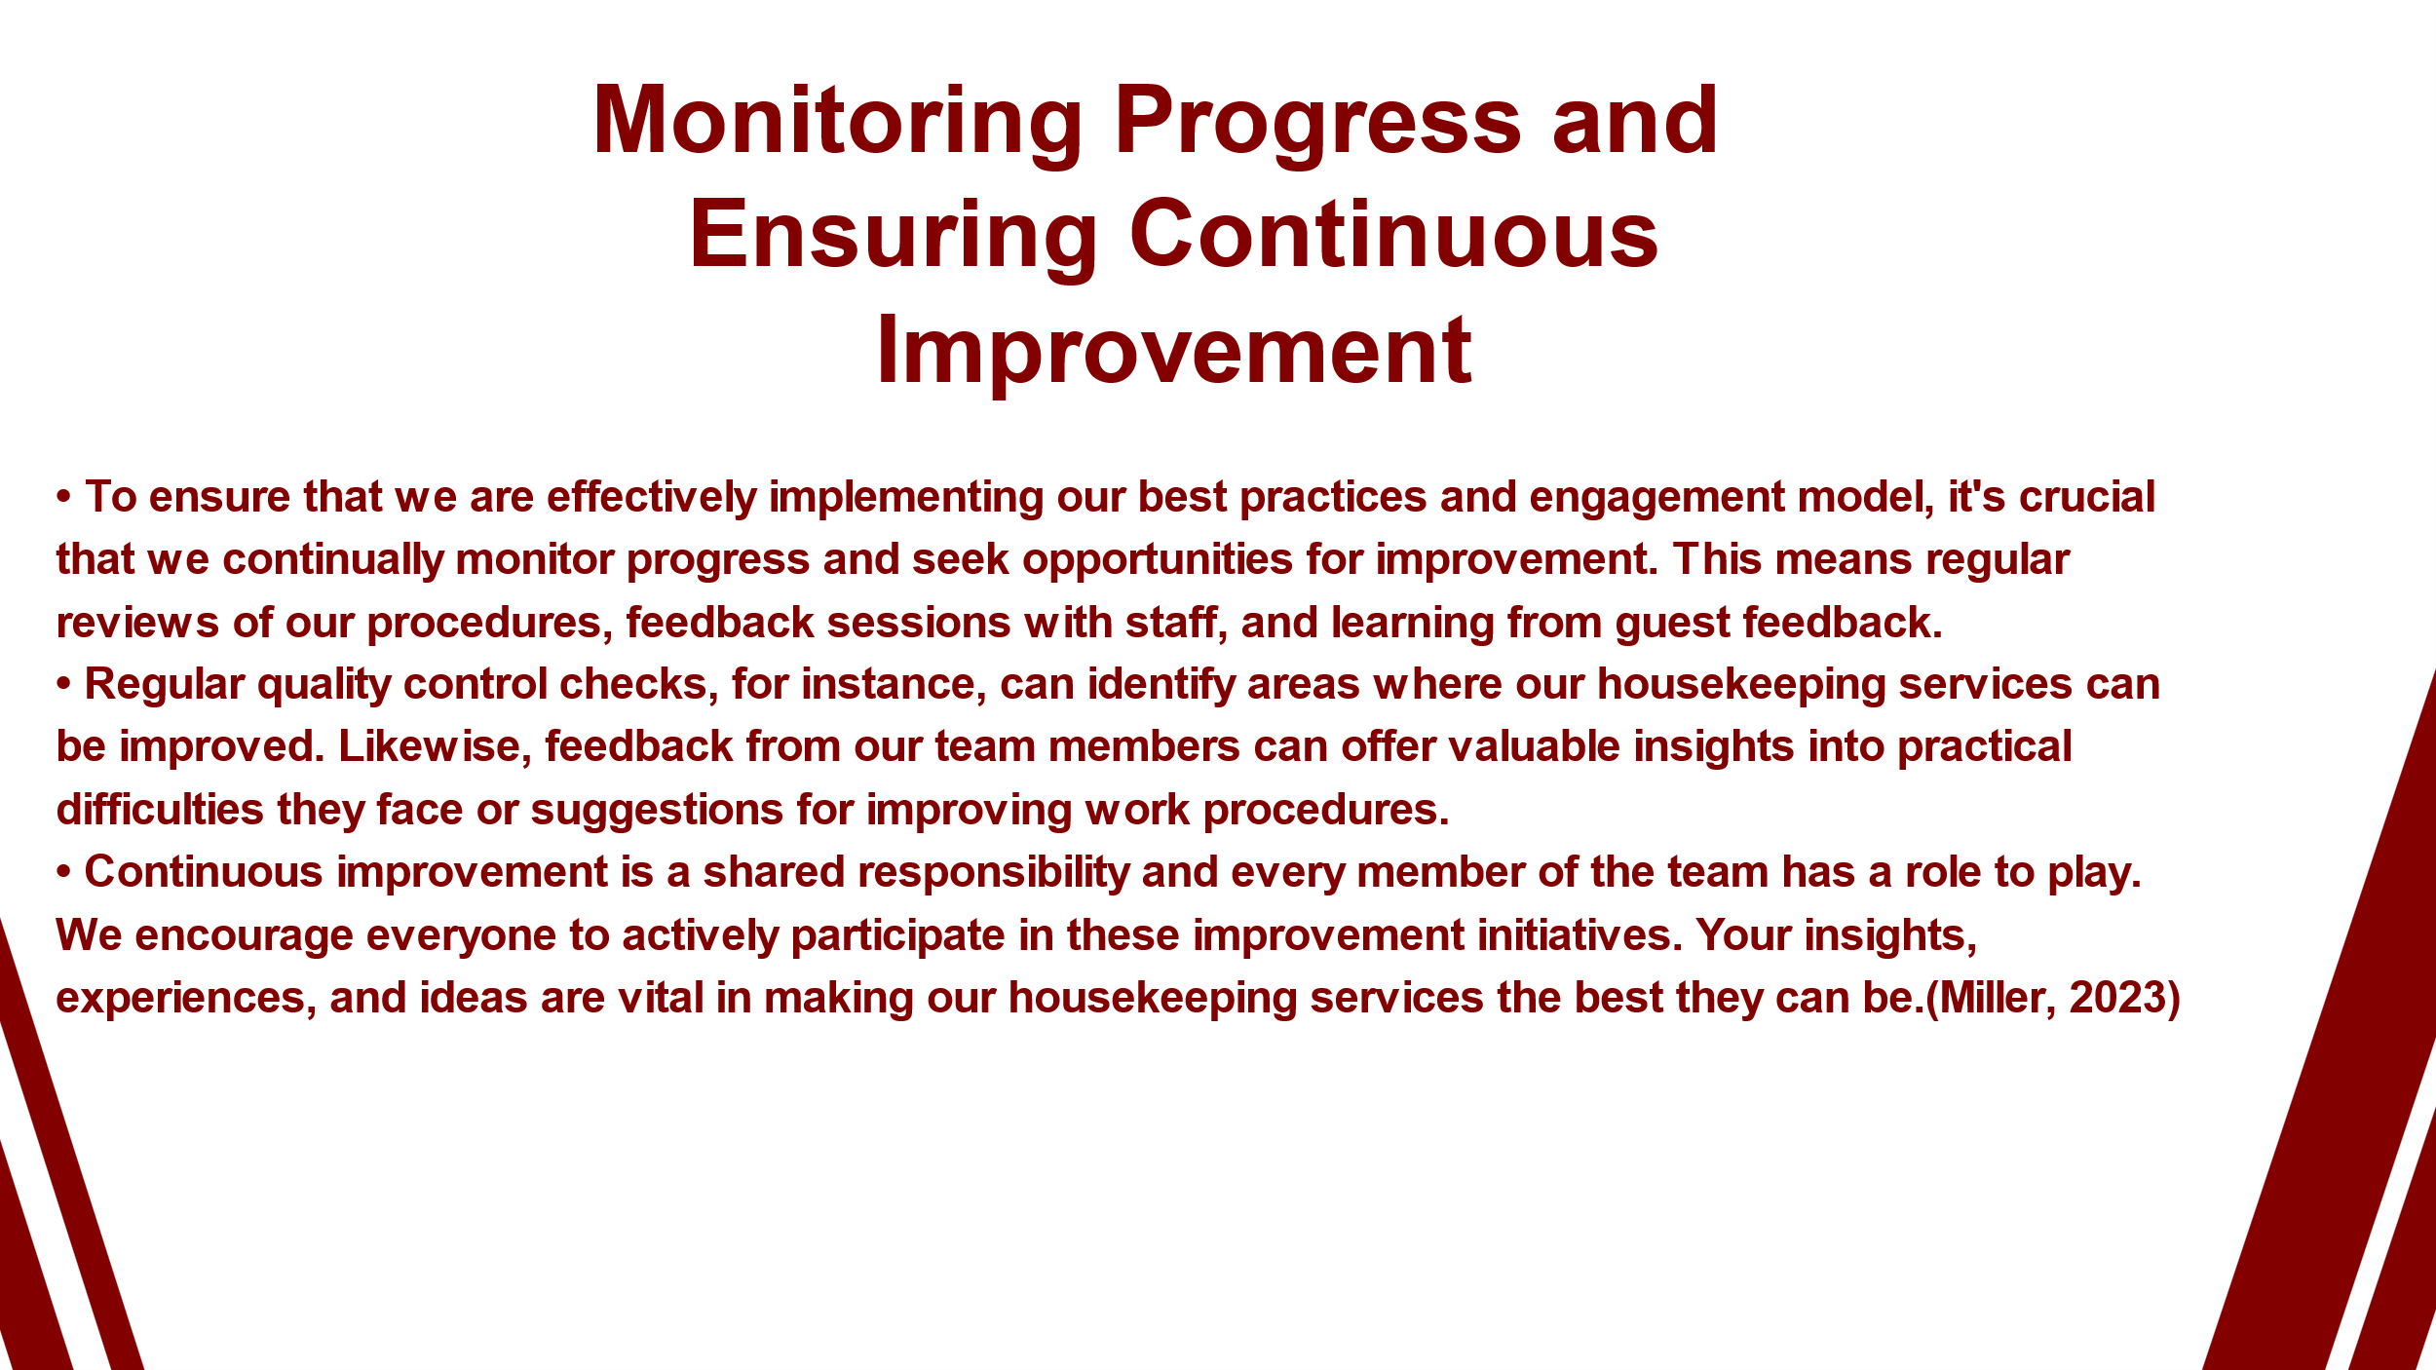
Training Notes:
Highlight the importance of monitoring progress and seeking continuous improvement in implementing best practices and the engagement model.
Discuss the need for regular reviews of procedures, feedback sessions with staff, and learning from guest feedback to identify areas for improvement.
Emphasize the value of quality control checks and feedback from team members in obtaining insights and suggestions for enhancing work procedures.
Encourage active participation from all team members in improvement initiatives, emphasizing the shared responsibility for continuous improvement.
Learning Outcomes:
Understand the significance of monitoring progress and seeking continuous improvement in implementing best practices and the engagement model.
Recognize the importance of regular reviews, feedback sessions, and learning from guest feedback in identifying areas for improvement.
Appreciate the value of quality control checks and feedback from team members in obtaining insights and suggestions.
Understand the shared responsibility for continuous improvement and the importance of active participation from all team members.
Speaker Notes:
Monitoring progress and striving for continuous improvement are vital in implementing our best practices and engagement model. Regular reviews of procedures and feedback sessions with staff help identify areas for improvement. Quality control checks and guest feedback offer valuable insights. Continuous improvement is a shared responsibility, and every team member's participation is encouraged. Your insights and ideas are crucial in making our housekeeping services the best they can be



